

**BAHRIA UNIVERSITY, (Karachi Campus)**

*Department of Software Engineering*

PROPOSAL

**Course Title: Software Construction**   **Course Code**: **: SEL 311**

**Course Instructor: Engr Misbah/Dr Salahuddin Class**: BSE- (A)

**Lab Instructor:** Engr. Asma Shaheen  **Name: ZUHAIB SHAMSHER**

PROJECT TITLE:

CLINIC MANAGEMENT SYSTEM

|  |  |  |
| --- | --- | --- |
| Name | Enrollment | Remarks |
| Zuhaib Shamsher(T.L) | 02-131222-104 |  |
| Samiullah | 02-131222-120 |  |
| Salman Ajmal | 02-131222-081 |  |
| Owais Khalique | 02-131222-054 |  |

GROUP MEMBERS LIST

Submission Date**:28/11/2024**

ABSTRACT

The Clinic Management System (CMS) is a comprehensive software solution designed to improve the efficiency of clinic operations by streamlining the management of patient records, appointments, and billing processes. This system is developed to enhance communication between patients, doctors, and administrative staff, ensuring seamless interactions and workflows. The CMS is a web-based platform that provides patients with the ability to schedule appointments, view treatment histories, and manage billing, while doctors can efficiently manage their schedules and update patient records. Administrators benefit from an oversight system that provides insights into clinic performance, user management, and financial tracking. The system adheres to healthcare regulations, including HIPAA, and incorporates essential security features like multi-factor authentication and data encryption. With a user-friendly interface and robust functionality, the CMS promises to enhance patient satisfaction, optimize clinic resources, and ensure smooth operational processes. This document outlines the project’s background, scope, resources, budget, scheduling, and the associated data flow diagrams (DFD Levels 0, 1, and 2) to provide a clear roadmap for the system's development and implementation.

Contents

**1.** **INTRODUCTION** 4

**2.** **BACKGROUND** 4

**3.** **PROJECT DEFINITION** 4

**4.** **PROJECT SCOPE** 4

**5.** **PROJECT RESOURCES** 5

**6.** **ROLES** 5

**7.** **BUDGET** 5

**8.** **SCHEDULING** 6

**9.** **DATA FLOW DIAGRAM (DFD LEVE 0,1, 2...)** 6

**10.** **CONCLUSION** 6

**11.** **APPENDIX (Mind Map/Story board)** 7

# **INTRODUCTION**

The purpose of this Software Requirements Specification (SRS) document is to clearly define the software requirements for the Clinic Management System (CMS), version 1.0. This document outlines the functional and non-functional requirements, use cases, and constraints for the CMS, which is designed to streamline clinic operations, improve patient care, and enhance communication between patients, doctors, and administrative staff. The scope of this SRS includes all key functionalities for patient management, appointment scheduling, billing, and administrative oversight, ensuring all user roles have well-defined interactions within the system*.*

# **BACKGROUND**

The Clinic Management System (CMS) is designed to improve clinic operations by automating patient management, appointment scheduling, and billing processes. Its development was initiated to enhance the interaction between patients, doctors, and administrative staff, providing a streamlined solution for modern clinics.

# **PROJECT DEFINITION**

The CMS is a software solution aimed at managing clinic activities. It focuses on patient records, appointment scheduling, billing, and doctor and administrative operations. The main objective is to ensure an efficient workflow within the clinic environment by offering a centralized platform for all users.

# **PROJECT SCOPE**

The project will develop an integrated platform accessible to patients, doctors, and administrators. It will support patient registration, appointment management, and financial handling while maintaining regulatory compliance (e.g., HIPAA). The scope includes functional and non-functional requirements such as system performance, security, and usability.

# **PROJECT RESOURCES**

Key resources for the project include:

* **Development Team:** Front-end and back-end developers using html,css,js and .net.
* **Database:** SQL Server for data storage and retrieval.
* **Hardware:** Desktop and laptop computers, tablets for mobility.
* **Software Tools:** Visual Studio, Git for version control, and a cloud-based environment.

# **ROLES**

· **Patients:** Book appointments, access billing history, and manage profiles.

· **Doctors:** Manage schedules, update patient records, and generate billing.

· **Administrators:** Oversee operations, manage users, and generate reports.

· **Developers:** Build, maintain, and update the system.

· **Testers:** Ensure system functionality through rigorous testing.

# **BUDGET**

The budget for this project covers:

* **Software Licensing:** Development tools, database management systems.
* **Labor Costs:** Developers, testers, and administrators.
* **Hardware Costs:** Servers, backup systems, and client devices.
* **Miscellaneous Expenses:** Security protocols and regulatory compliance measures.

# **SCHEDULING**

The project is scheduled in phases:

1. **Requirements Gathering and Analysis:** 5-10 days
2. **System Design:** 2 weeks
3. **Development:** 5 weeks
4. **Testing and QA:** 2 weeks
5. **Final submission:** 1 week(28 dec – 4 jan)

# **DATA FLOW DIAGRAM (DFD LEVE 0,1, 2...)**

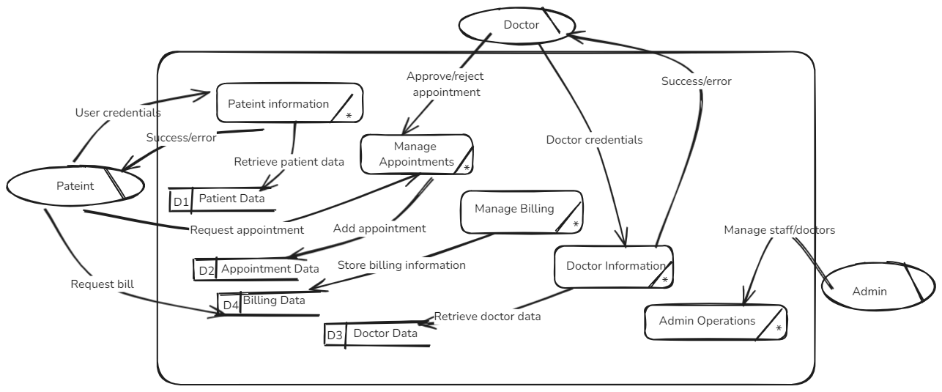

# **CONCLUSION**

The Clinic Management System is a comprehensive solution tailored to the needs of clinics to ensure efficient patient management, streamlined doctor schedules, and simplified billing processes. Its successful implementation will reduce administrative burdens and improve overall clinic performance.

# **APPENDIX (Mind Map/Story board)**

**Mind Map Overview**

**Central Node: Clinic Management System (CMS)**

1. **Patient Management**:
   * Registration, appointment booking, history viewing, notifications.
2. **Doctor Management**:
   * Schedule management, patient record updates, billing.
3. **Administrative Oversight**:
   * User management, appointment tracking, financial management.
4. **System Administration**:
   * Security, compliance, maintenance.
5. **Technical Components**:
   * Database (SQL Server), development tools (Visual Studio), front-end tech (HTML, CSS, JS), testing.

**Storyboard Overview**

1. **Home Screen**: Login/registration options; system introduction.
2. **Patient Dashboard**: Appointment booking, history, notifications.
3. **Doctor Dashboard**: Schedule management, patient records, billing.
4. **Administrator Dashboard**: User, appointment, and financial management.
5. **Appointment Booking**: Department/doctor selection, slot booking, confirmation.
6. **Billing Interface**: Bill generation by doctors, viewing by patients, admin tracking.
7. **Report Generation**: Performance reports with visual data for administrators.

**high-fidelity interfaces:**

**Login & sign up:**

**Patient dashboard :**

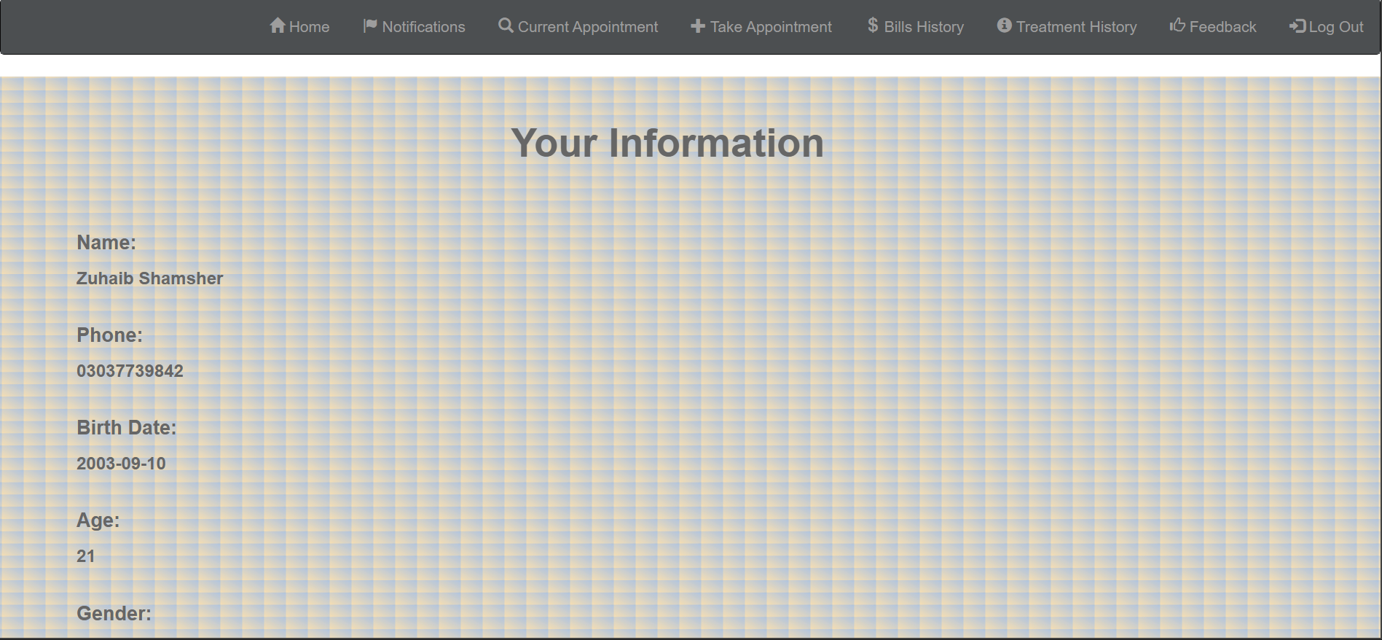

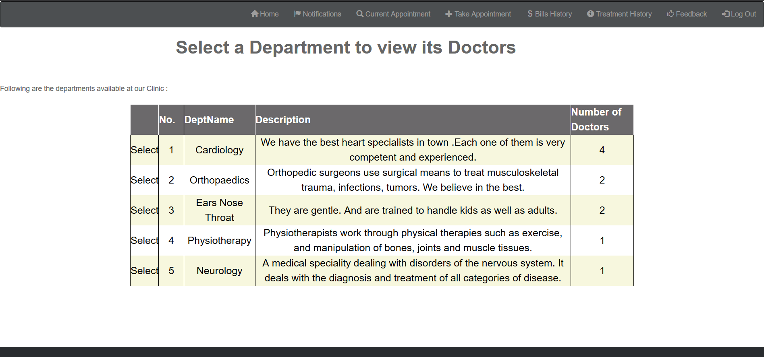

**Admin dashboard:**

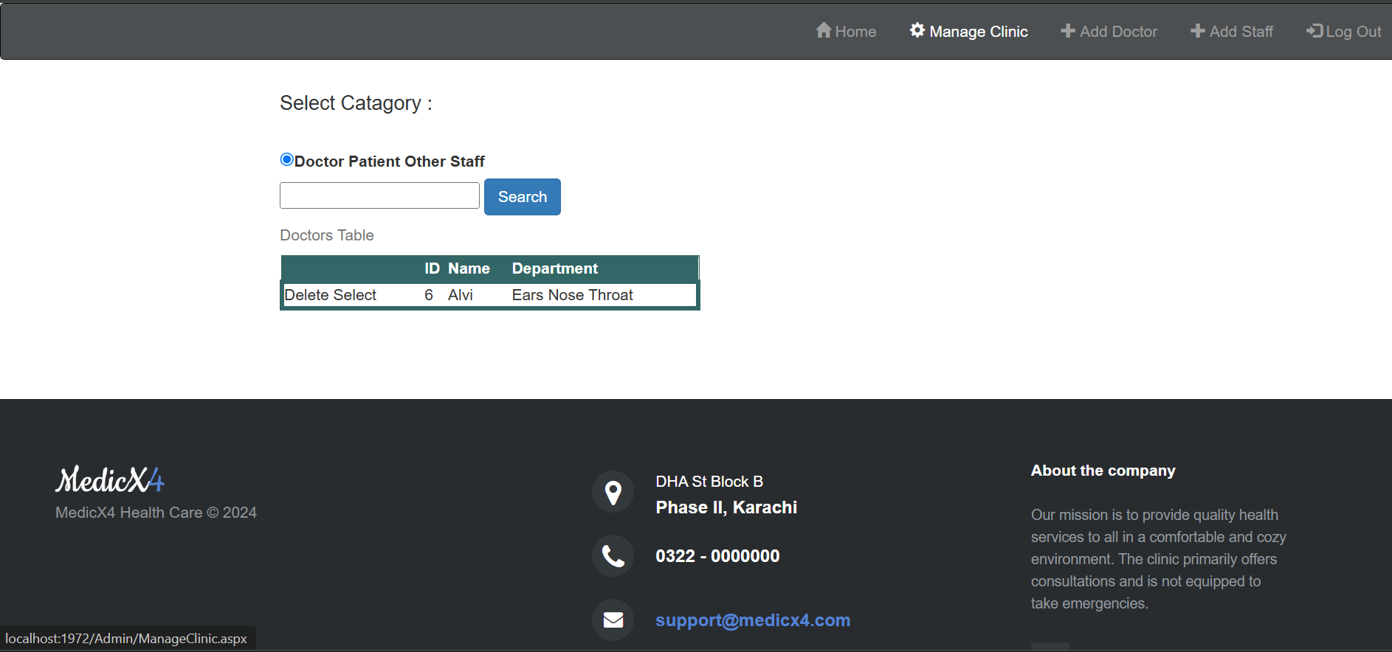

**Teacher Signature**: ______________________________________________

**Remarks**: ______________________________________________

**Submission Date**: ______________________________________________