Software Requirements Specification
for
Clinic Management System
Version 1.3 approved
Zohaib Shamsher

Four Engineers
27/9/2024

Table of Contents
Table of Contents ii
1. Introduction 1
Revision History ii
1.1 Purpose 1
1.2 Document Conventions 1
1.3 Intended Audience and Reading Suggestions 1
1.4 Product Scope 1
1.5 References 1
2. Overall Description 2
2.1 Product Perspective 2
2.2 Product Functions 2
2.3 User Classes and Characteristics 2
2.4 Operating Environment 2
2.5 Design and Implementation Constraints 2
2.6 User Documentation 2
2.7 Assumptions and Dependencies 3
3. External Interface Requirements 3
3.1 User Interfaces 3
3.2 Hardware Interfaces 3
3.3 Software Interfaces 3
3.4 Communications Interfaces 3
4. System Features 4
4.1 System Feature 1 4
4.2 System Feature 2 (and so on) 4
5. Other Nonfunctional Requirements 4
5.1 Performance Requirements 4
5.2 Safety Requirements 5
5.3 Security Requirements 5
5.4 Software Quality Attributes 5
5.5 Business Rules 5
6. Other Requirements 5
Appendix A: Glossary 5
Appendix B: Analysis Models 5
Appendix C: To Be Determined List 6

Revision History

Name | Date | Reason For Changes | Version
Zuhaib Shamsher | 26-09-24 | To finalize the requirements and to identify the features. | 1.1
Zuhaib Shamsher | 12-10-24 | Added a UML diagram to provide a visual representation of the system architecture and design. | 1.2
Zuhaib Shamsher | 29-11-24 | Added Prototypes, user interactions and some final touches | 1.3

Introduction

Purpose
The purpose of this Software Requirements Specification (SRS) document is to clearly define the software requirements for the Clinic Management System (CMS), version 1.3. This document outlines the functional and non-functional requirements, use cases, and constraints for the CMS, which is designed to streamline clinic operations, improve patient care, and enhance communication between patients, doctors, and administrative staff. The scope of this SRS includes all key functionalities for patient management, appointment scheduling, billing, and administrative oversight, ensuring all user roles have well-defined interactions within the system.

Document Conventions
This Software Requirements Specification (SRS) document follows specific conventions and standards to ensure clarity and consistency throughout the text. The conventions are as follows:

1.2.1 Typographical Conventions
- Font and Size: The document is written in Arial, size 11 for body text and Times New Roman, size 14 for headings. This choice ensures readability and professionalism.
- Bold Text: Bold text is used for section titles, key terms, and important notes to draw attention to critical information.
- Bullet Points and Numbering: Bullet points are used for lists of items, while numbered lists are used for sequential steps or requirements to enhance clarity.

1.2.2 Requirement Prioritization
- Priority Levels: Each requirement within this document is categorized by priority as High, Medium, or Low. This prioritization helps guide development focus and resource allocation.
  - High Priority: Essential for core functionality and system operations.
  - Medium Priority: Important but can be scheduled for later phases.
  - Low Priority: Nice-to-have features that enhance usability but are not critical.
- Inheritance of Priorities: Higher-level requirements are assumed to inherit the priority of their associated detailed requirements. If a higher-level requirement is marked as High priority, all associated detailed requirements will be treated with the same urgency unless explicitly stated otherwise.

1.2.3 References and Links
- References: Any referenced documents, such as external guidelines or standards, are cited in the text with a corresponding number (e.g., [1]) that refers to the list in Section 1.5 References.
- Hyperlinks: Where applicable, hyperlinks to external resources or documents are included to facilitate easy access and cross-referencing.

1.2.4 Abbreviations and Acronyms
- All abbreviations and acronyms are defined at their first occurrence in the document. A comprehensive list of terms is also provided in Appendix A: Glossary to assist in understanding.
These conventions aim to create a clear and user-friendly document that can be easily navigated and understood by all stakeholders involved in the Clinic Management System project.

Intended Audience and Reading Suggestions
This SRS is intended for various stakeholders involved in the Clinic Management System project:
- Developers: To understand the detailed requirements and implement system features effectively.
- Project Managers: To manage project scope, timelines, and resource allocation based on the defined requirements.
- Marketing Staff: To develop promotional strategies and materials based on system functionalities and benefits.
- Users (Patients and Doctors): To familiarize themselves with system capabilities and workflows.
- Testers: To derive test cases and validation strategies based on specified requirements.
It is recommended that readers start with sections 1.1 through 1.4 to understand the overall scope and context, then proceed to the detailed requirements and use cases specific to their roles.

Product Scope
The Clinic Management System (CMS) is an integrated software solution designed to enhance the operational efficiency of clinics by providing robust management tools for patient interactions, appointment scheduling, medical record management, and billing processes.
Key Features:
- Patient Management: Patients can create profiles, view treatment and billing histories, and book appointments.
- Doctor Management: Doctors can manage their schedules, update patient records, and generate bills.
- Administrative Oversight: Administrators can view clinic statistics, manage user accounts (patients and doctors), and oversee clinic operations.
Objectives and Goals:
- Improve patient satisfaction through easy access to information and appointment management.
- Enhance the efficiency of clinic operations by automating scheduling and billing processes.
- Provide a centralized platform for managing patient data and communications.
The CMS aligns with the clinic’s strategic goals of delivering quality healthcare while optimizing operational workflows. For a more comprehensive overview, refer to the separate Vision and Scope Document.

References
- IEEE Std 830-1998: IEEE Recommended Practice for Software Requirements Specifications.

Product Perspective
The Clinic Management System (CMS) is a new, self-contained product designed to address the needs of modern clinics for managing patient interactions, appointments, and billing. This system is not intended to replace any existing systems but aims to integrate various functionalities into a single, cohesive platform. The CMS will operate independently while being designed with the capability to interface with existing healthcare systems, electronic health records (EHRs), and billing software in the future.
The CMS will have the following components:
- Patient Interface: Allows patients to manage their profiles, appointments, and billing.
- Doctor Interface: Enables doctors to manage their schedules, patient histories, and billing processes.
- Administrator Dashboard: Provides tools for managing clinic operations, staff, and reports.

Product Functions
The major functions of the Clinic Management System include:
- Patient Management:
  - Profile creation and management
  - Viewing treatment and billing history
  - Appointment scheduling and management
- Doctor Management:
  - Profile management
  - Viewing and responding to appointment requests
  - Updating patient records and generating bills
- Administrative Functions:
  - Viewing clinic statistics and reports
  - Managing patient and doctor registrations
  - Staff management and oversight
These functions will be elaborated upon in Section 3.

User Classes and Characteristics
The primary user classes for the Clinic Management System include:
- Patients:
  - Frequency of Use: Regular (multiple times a month)
  - Functions Used: Profile management, appointment scheduling, billing history
  - Characteristics: Generally non-technical, may require a user-friendly interface
- Doctors:
  - Frequency of Use: Daily (multiple times per day)
  - Functions Used: Managing appointments, updating patient records, generating bills
  - Characteristics: Healthcare professionals with moderate technical expertise
- Administrators:
  - Frequency of Use: Daily (varies based on clinic size)
  - Functions Used: Managing users, viewing reports, overseeing clinic operations
  - Characteristics: Technical expertise varies; must have access to all functionalities
Understanding these user classes is critical for designing a user-friendly and effective system.

Operating Environment
The Clinic Management System will operate in the following environment:
- Hardware Platform: Standard desktop and laptop computers
- Operating System: Windows 10/11, macOS, and modern web browsers (Chrome, Firefox, Safari)
- Database Management System: SQL Server for data storage
- Network Requirements: Stable internet connection for cloud-based access
The CMS should be compatible with existing hardware commonly used in healthcare settings.

Design and Implementation Constraints
The development of the Clinic Management System will adhere to the following constraints:
- Regulatory Compliance: The system must comply with healthcare regulations (e.g., HIPAA in the U.S.) to ensure patient data privacy and security.
- Interoperability: Must be designed to interface with potential third-party systems and EHRs in the future.
- Technology Stack: Developers are required to use specific technologies (e.g., React for the frontend, Node.js for the backend).
- Security Considerations: Must implement robust authentication and authorization protocols to safeguard sensitive patient data.
- Programming Standards: Follow corporate coding standards and best practices to ensure maintainability and scalability.

User Documentation
The following user documentation will be provided with the Clinic Management System:
- User Manual: Comprehensive guide detailing system functionalities and usage instructions
- Installation Guide: Instructions for system setup and configuration.
Documentation will be delivered in both digital format (PDF, HTML) and as integrated online help within the application.

Assumptions and Dependencies

Assumptions
- User Familiarity: It is assumed that users (patients and doctors) will have basic computer and internet skills, allowing them to navigate the CMS without extensive training.
- Internet Access: The system assumes a reliable internet connection is available for all users, as the CMS is a web-based application.
- Hardware Compatibility: It is assumed that clinic staff and patients will be using standard computing devices (desktops, laptops, tablets) that meet the minimum hardware specifications for running modern web browsers.
- Regulatory Changes: It is assumed that the healthcare regulations governing data security and privacy (e.g., HIPAA) will remain consistent throughout the development and initial deployment phases.

Dependencies
- Database Management System: The CMS is dependent on a SQL Server database for data storage. Any issues related to database performance or compatibility could affect the system's functionality.
- Integration with Existing Systems: If the CMS needs to interface with other existing healthcare systems or EHRs, the project will depend on the availability of APIs and documentation for those systems.
- Development Tools and Frameworks: Development is dependent on specific tools and frameworks (e.g. , .NET). Changes in their support or updates may necessitate adjustments to the project timeline and implementation strategies.
Identifying these assumptions and dependencies is critical for risk management and ensuring the project's successful delivery. Any changes in these factors should be communicated promptly to all stakeholders.

External Interface Requirements
USER INTERFACE:

User Interfaces

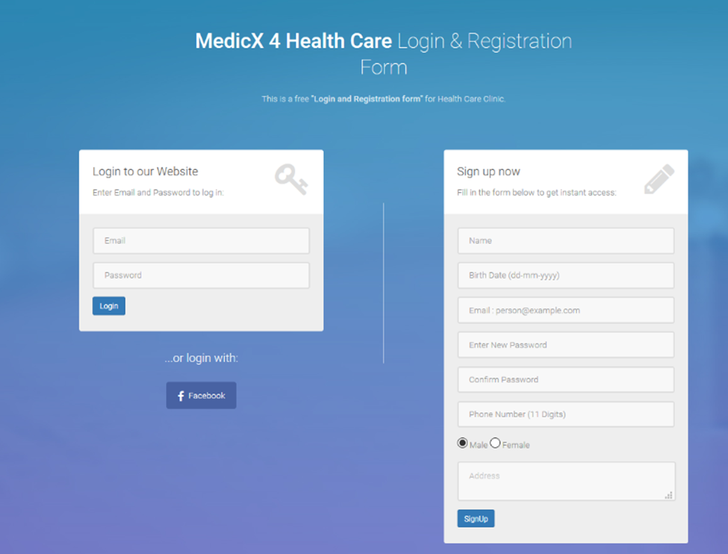

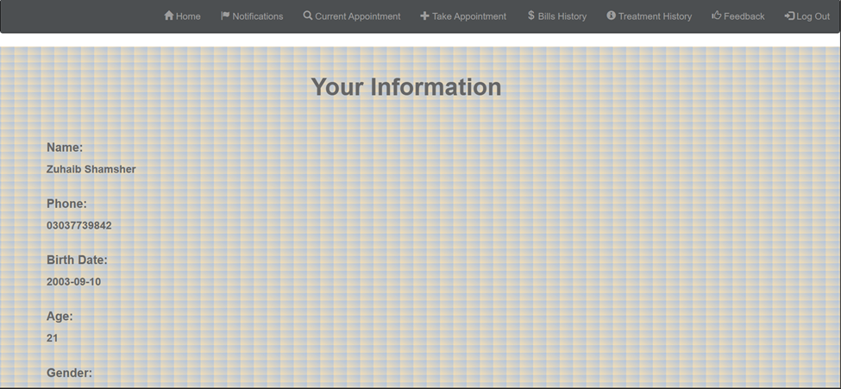

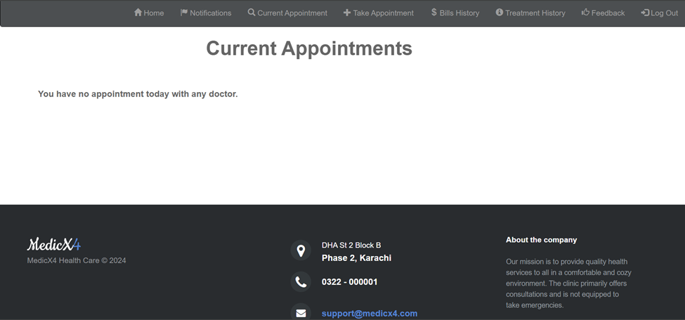

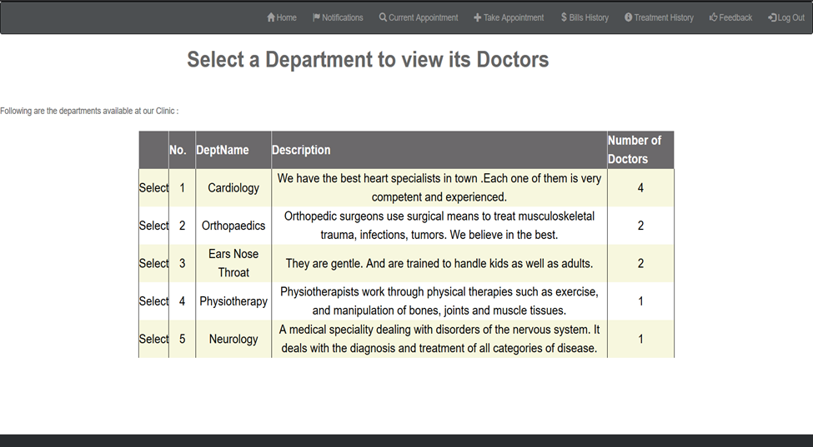

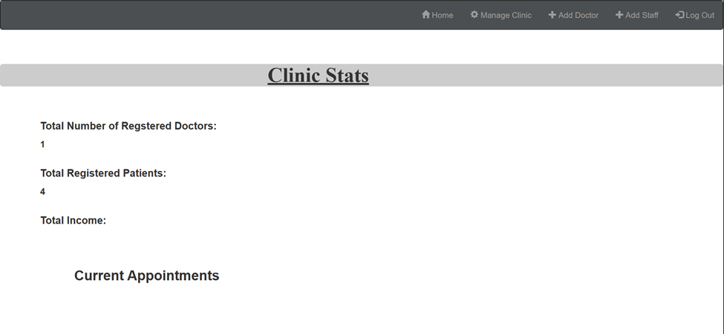

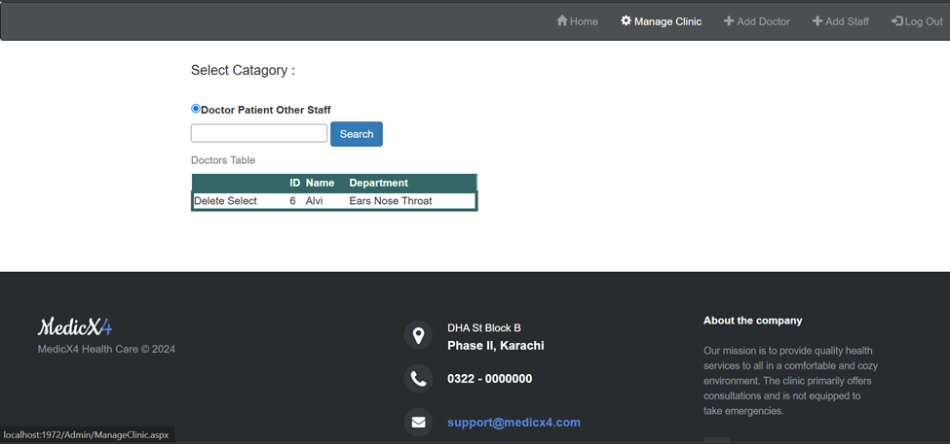

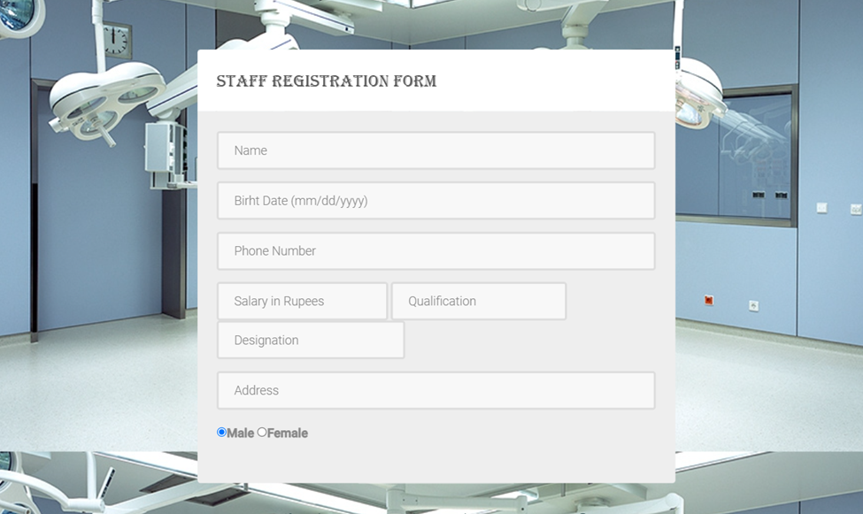
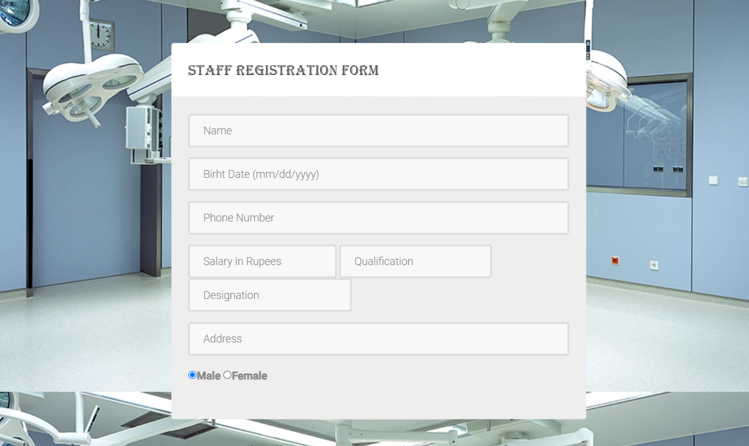

Low Fidelity:
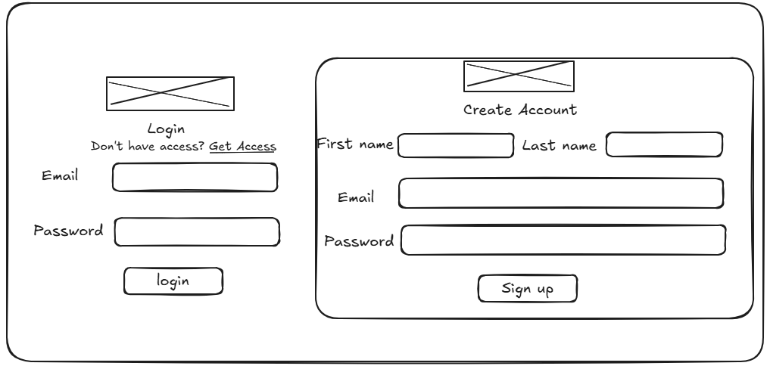
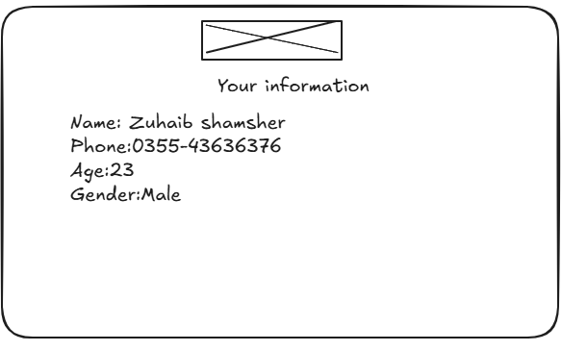
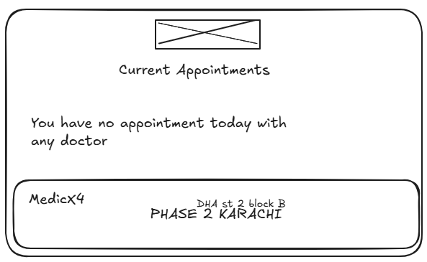

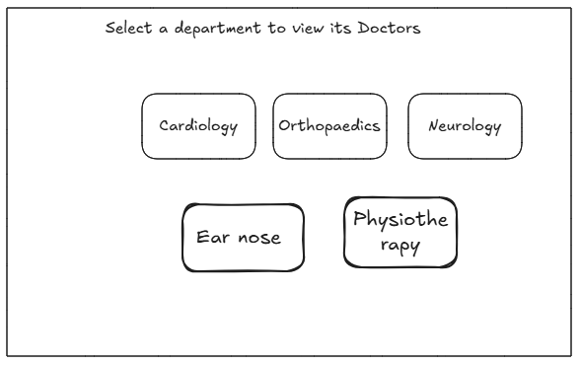
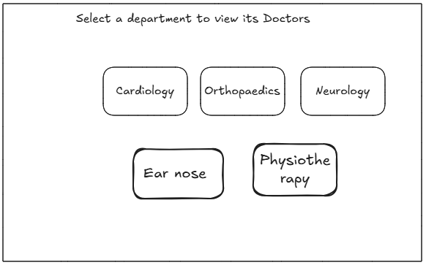
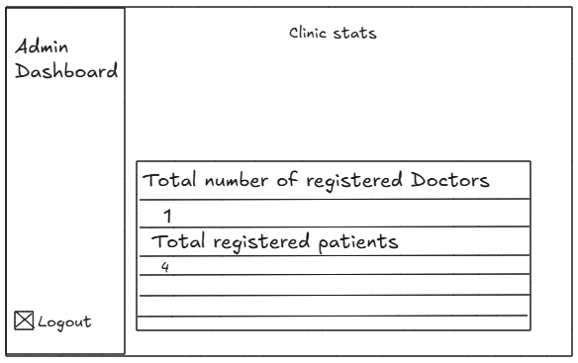

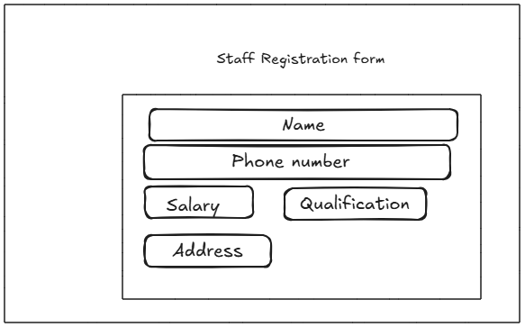

Hardware Interfaces
The Clinic Management System will primarily operate on standard hardware configurations. Key characteristics include:
- Supported Device Types:
  - Desktop and laptop computers running Windows 10/11 or macOS.
  - Tablets (iOS and Android) for mobile access.
- Data Interaction:
  - The software will not directly interact with hardware components; rather, it will communicate via standard network protocols over the internet.
- Communication Protocols:
  - The system will utilize standard HTTP/HTTPS protocols for data transmission.

Software Interfaces
The CMS will interact with various software components as follows:
- Database:
  - SQL Server : The system will use either of these database management systems for data storage, retrieval, and management.
  - Data items include user profiles, appointment records, billing information, and treatment histories.
- Operating Systems:
  - The CMS will be compatible with major web browsers (latest versions of Chrome, Firefox, Safari) running on Windows and macOS.
- Libraries and Frameworks:
  - Frontend: C#, HTML, Bootstrap, CSS, and JavaScript.
  - Backend: ASP.NET
  - Other libraries for functionalities like form validation and data visualization.
- Data Sharing:
  - Patient and doctor data will be shared between the user interface and the database. All data access will adhere to data privacy regulations.

Communications Interfaces
The CMS will require various communication functionalities, including:
- Web Browser Communication:
  - The CMS will function as a web application accessible via standard web browsers, utilizing HTTP/HTTPS protocols for secure communication.
- Message Formatting:
  - Data exchanged between the client and server will be formatted in JSON to ensure ease of use and interoperability.
- Security Measures:
  - All sensitive data transfers will employ encryption to protect patient information in compliance with healthcare regulations.
- Data Transfer Rates and Synchronization:
  - The system will be optimized for quick response times, aiming for a maximum data transfer rate of 1 second for user interactions, with real-time updates where applicable.

System Features

System Feature 1: Emergency Appointment Management
4.1.1 Description and Priority
- The system should allow doctors to postpone or cancel appointments during emergencies.
- Priority: High
4.1.2 Stimulus/Response Sequences
- Stimulus: The doctor identifies an emergency situation and requests to postpone or cancel an appointment.
- Response: The system updates the appointment status and notifies the patient of the change.
4.1.3 Functional Requirements
- REQ-1: The system shall allow doctors to mark appointments as postponed or canceled with a reason.
- REQ-2: The system shall notify affected patients via email, SMS, or in-app notifications.

System Feature 2: Responsive Design
4.2.1 Description and Priority
- The application must support access from PCs, laptops, tablets, and smartphones.
- Priority: High
4.2.2 Stimulus/Response Sequences
- Stimulus: A user accesses the application on any supported device.
- Response: The application adjusts its layout and functionality to match the device’s screen size and resolution.
4.2.3 Functional Requirements
- REQ-1: The system shall automatically adjust UI components to fit various screen sizes.
- REQ-2: The system shall ensure full functionality across devices, including tablets and smartphones.

System Feature 3: Medicine Prescription Management
4.3.1 Description and Priority
- Doctors should be able to prescribe medicines directly in the system.
- Priority: High
4.3.2 Stimulus/Response Sequences
- Stimulus: The doctor completes an appointment and inputs a prescription for the patient.
- Response: The system stores the prescription and makes it available to the patient.
4.3.3 Functional Requirements
- REQ-1: The system shall provide an interface for doctors to add, edit, and view prescriptions.
- REQ-2: The system shall allow patients to view prescribed medicines through their profiles.

System Feature 4: Appointment Request Management
4.4.1 Description and Priority
- The system should enable patients to submit appointment requests for available time slots.
- Priority: High
4.4.2 Stimulus/Response Sequences
- Stimulus: A patient submits an appointment request by selecting an available time slot.
- Response: The system confirms the request and notifies the doctor.
4.4.3 Functional Requirements
- REQ-1: The system shall allow patients to view available time slots for each doctor.
- REQ-2: The system shall ensure appointment requests are confirmed or rejected by doctors.

System Feature 5: Conflict-Free Scheduling
4.5.1 Description and Priority
- The system must ensure no overlapping appointments are scheduled for a doctor.
- Priority: High
4.5.2 Stimulus/Response Sequences
- Stimulus: A patient attempts to book an appointment for a time slot already occupied by another patient.
- Response: The system prevents the booking and displays a message indicating the slot is unavailable.
4.5.3 Functional Requirements
- REQ-1: The system shall prevent double booking of a doctor’s time slot.
- REQ-2: The system shall display only available slots to patients during appointment booking.

System Feature 6: Notification System for Appointment Status
4.6.1 Description and Priority
- The system should notify patients when their appointment requests are accepted or rejected.
- Priority: High
4.6.2 Stimulus/Response Sequences
- Stimulus: A doctor accepts or rejects an appointment request.
- Response: The system notifies the patient of the decision.
4.6.3 Functional Requirements
- REQ-1: The system shall notify patients via email, SMS, or in-app notifications about their appointment status.
- REQ-2: The system shall store notification history for patient reference.

Other Nonfunctional Requirements

Performance Requirements
The Clinic Management System must meet the following performance criteria to ensure efficient user experience:
- Response Time: The system should respond to user actions within 2 seconds under normal load conditions. This includes actions such as logging in, retrieving appointment data, and generating reports.
- Concurrent Users: The system must support at least 100 concurrent users without degradation in performance. This is crucial during peak hours when multiple patients and doctors access the system simultaneously.
- Data Processing: The system should be capable of processing appointment requests and updating records in less than 3 seconds, ensuring timely confirmations and notifications.
- Load Handling: The system must handle a minimum of 500 transactions (appointments, billing updates) per hour without performance bottlenecks.

Safety Requirements
The following safety requirements are established to mitigate potential risks associated with the use of the system:
- Data Backup: The system must implement daily automated backups of all patient data to prevent data loss. Manual backup options must also be available for administrators.
- Error Handling: The system should provide clear error messages for any failures (e.g., system crashes, invalid inputs) and guide users on corrective actions to prevent data loss.
- Emergency Procedures: In case of a system failure, a protocol must be established to revert to the last stable version of the application to minimize downtime and data inconsistencies.
- Compliance: The system must comply with relevant safety regulations, such as HIPAA, to protect patient data and ensure safe operations.

Security Requirements
To protect the integrity and privacy of user data, the following security requirements are mandated:
- User Authentication: The system must implement multi-factor authentication (MFA) for all users, requiring a combination of password and a secondary verification method (e.g., SMS code, authentication app).
- Data Encryption: All sensitive data, including patient records and payment information, must be encrypted both in transit (using TLS) and at rest.
- Access Control: Role-based access control (RBAC) must be enforced to restrict access to sensitive functionalities based on user roles (patients, doctors, administrators).
- Audit Trails: The system must maintain an audit log of all user actions related to sensitive data access and modifications to ensure accountability and traceability.

Software Quality Attributes
The following quality attributes will be prioritized to enhance system usability and maintainability:
- Usability: The system should achieve a usability score of at least 80% on user satisfaction surveys, indicating ease of use and intuitive design.
- Reliability: The system must demonstrate a minimum uptime of 99.5% to ensure availability for users.
- Maintainability: The codebase should be structured to allow for updates and modifications with minimal disruption, aiming for a maximum change request processing time of 48 hours.
- Interoperability: The CMS must be capable of integrating with existing EHR systems and other healthcare applications through well-defined APIs, adhering to industry standards.
- Testability: The system must be designed to facilitate automated testing, allowing for at least 80% of functionalities to be covered by unit and integration tests.

Business Rules
The following business rules govern the operations within the Clinic Management System:
- Appointment Scheduling: Patients can only request one active appointment at a time until their current appointment is completed. This ensures effective management of doctor availability.
- User Roles:
  - Patients can view their profiles, schedule appointments, and provide feedback on services.
  - Doctors can manage their appointments, update patient records, and generate bills.
  - Administrators have full access to manage users, view clinic statistics, and oversee all functionalities of the system.
- Feedback Submission: Patients can submit feedback only after their appointments have been marked as completed, ensuring relevant and accurate evaluations.
- Data Access: Only authorized personnel (doctors and administrators) may access patient treatment histories and sensitive billing information.

Other Requirements

5.1 Database Requirements
- Database Management System: The Clinic Management System will utilize either SQL Server as the relational database management system.
- Data Integrity: The database must enforce referential integrity, ensuring that all foreign key relationships are maintained.
- Scalability: The database must be designed to scale horizontally to accommodate increasing numbers of users and data volume over time.

5.2 Internationalization Requirements
- Language Support: The system should support English as the primary language.
- Date Formats: The system must accommodate various date formats based on user preferences and regional settings (e.g., MM/DD/YYYY or DD/MM/YYYY).

5.3 Legal Requirements
- Compliance with Regulations: The system must comply with all relevant healthcare regulations, including HIPAA for patient data protection and GDPR for users in the European Union.
- Data Retention Policy: The system should implement a data retention policy that adheres to legal requirements for storing patient records, ensuring records are kept for a minimum of seven years.

5.4 Reuse Objectives
- Code Reusability: The system should employ modular design principles to facilitate code reuse in future projects, aiming for at least 30% of components to be reusable.
- Integration with Existing Systems: The system should be designed to allow integration with other healthcare systems and applications, reducing redundancy in future developments.

Appendix A: Glossary
- CMS: Clinic Management System
- HIPAA: Health Insurance Portability and Accountability Act
- MFA: Multi-Factor Authentication
- API: Application Programming Interface
- EHR: Electronic Health Record
- TBD: To Be Determined

Appendix B: Analysis Models
Use Case Diagram:
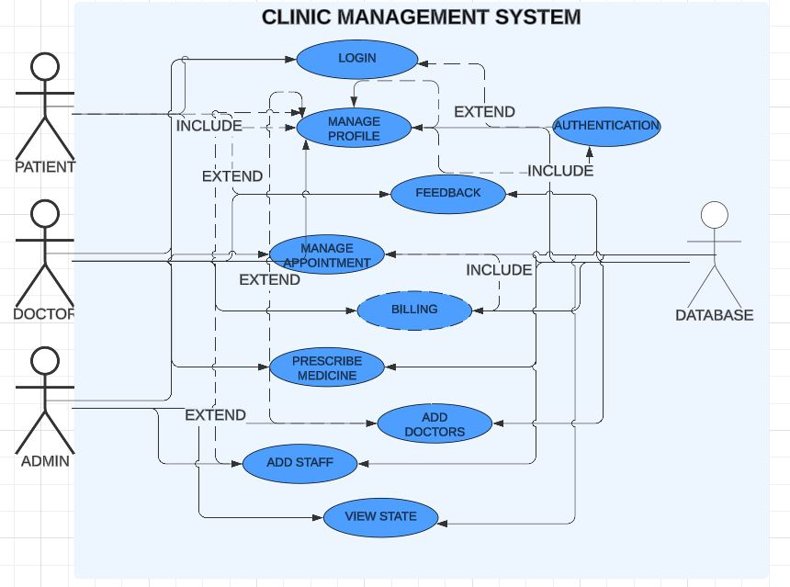

Context Diagram:
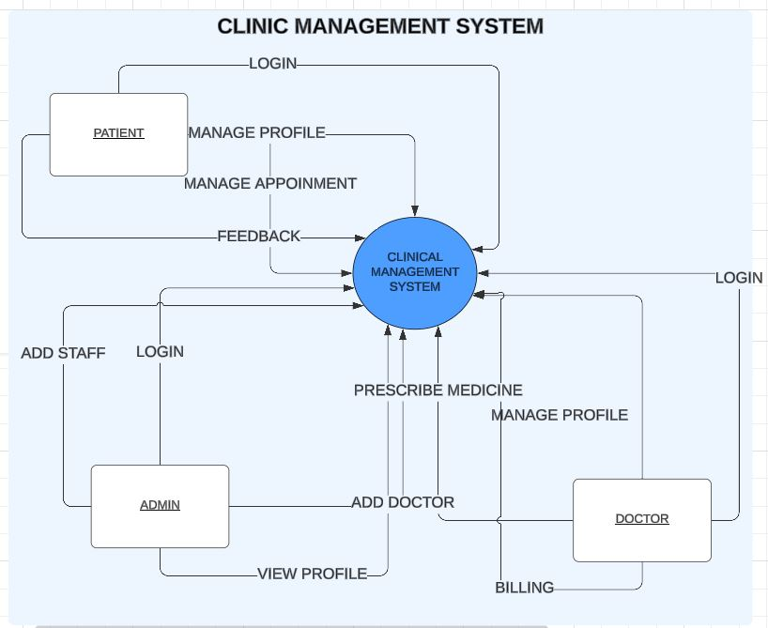

Class Diagram:
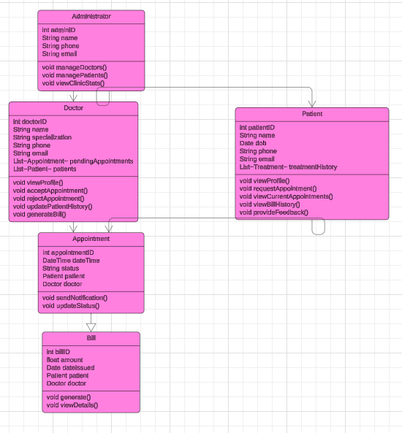

Sequence-Diagram:

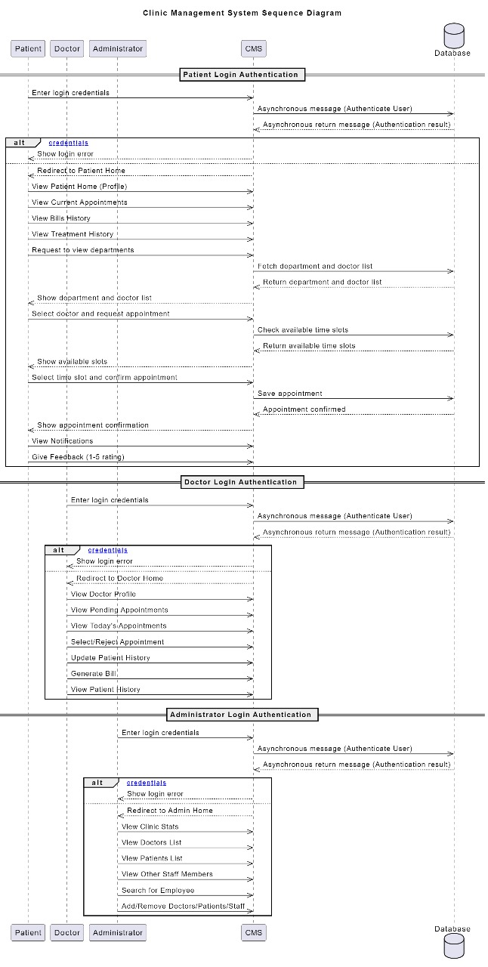

ER-Diagram:
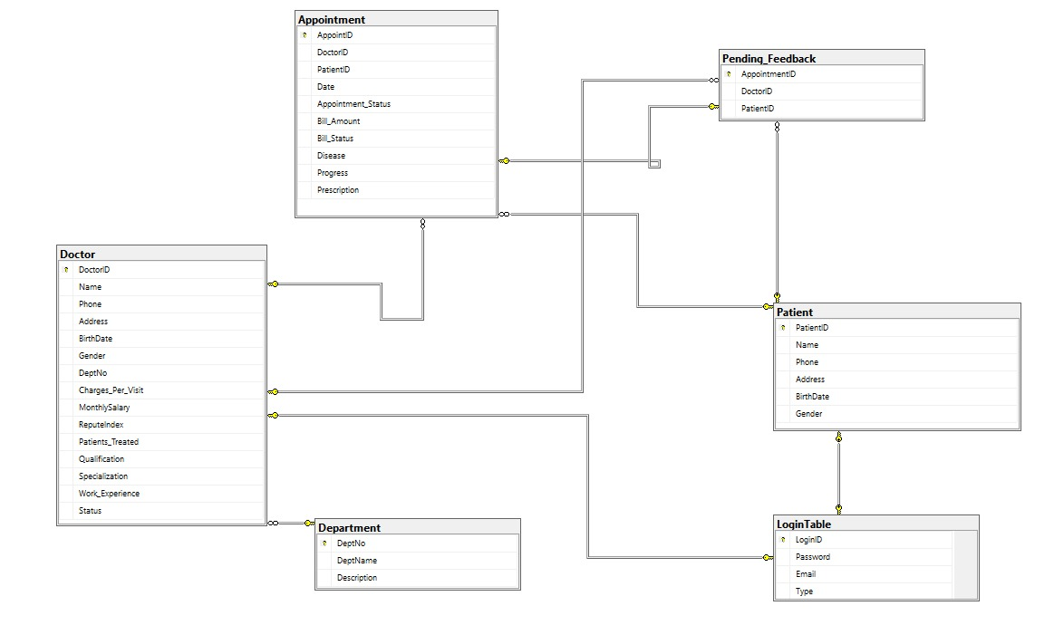

DATA FLOW DAIGRAM:
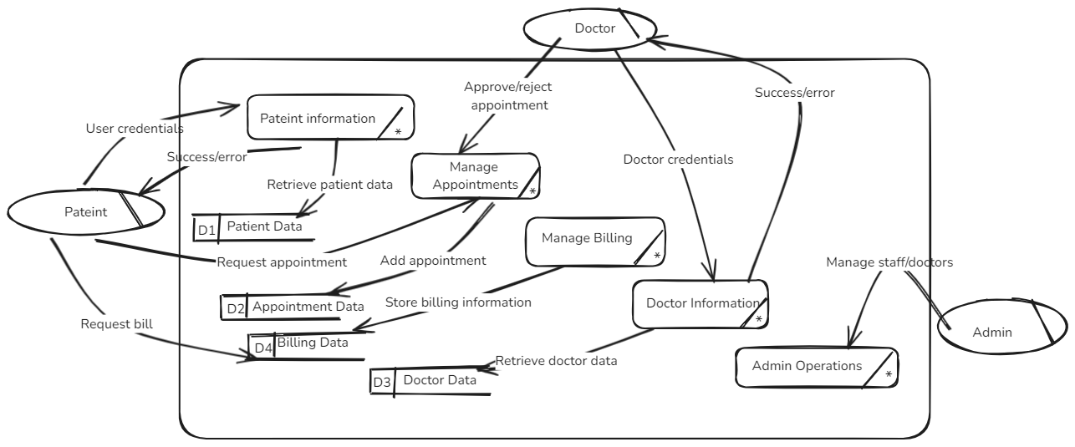

Appendix C: To Be Determined List
TBD-1: Finalization of user interface designs (mockups).
TBD-2: Specifications for third-party integrations (e.g., payment gateways).
TBD-3: Confirmation of additional language support for internationalization.
TBD-4: Detailed disaster recovery plan for data loss scenarios.

