|  |  |
| --- | --- |
| Setup | Cross-Validation Accuracy |
| Unprocessed Data | 0.752273 |
| 0-Elements ignored | 0.715139 |

Calculation of Distribution parameters

#Takes in a column vector from a data frame and fits a normal curve to

#it by finding the maximum likelihood estimates of the parameters of

#a normal distribution (i.e. mean and sd), given the data in the

#column. If ignore_zeros is true, it'll ignore the zeros in the

#column

fit_normal <- function(col, ignore_zeros) {

if (ignore_zeros == F) {

return(list(mean(col), sd(col)))

} else {

zeros_excluded <- col[which(col != 0)]

return(list(mean(zeros_excluded), sd(zeros_excluded)))

}

}

#Finds the parameters of the normal distribution fitted to the values

#of the rows of the training data frame that correspond to people

#with diabetes (i.e. class == 1)

param_preg_yes <- fit_normal(training_df[which(training_df$class == 1),"preg"], F)

param_plas_yes <- fit_normal(training_df[which(training_df$class == 1),"plas"], F)

param_pres_yes <- fit_normal(training_df[which(training_df$class == 1),"pres"], F)

param_skin_yes <- fit_normal(training_df[which(training_df$class == 1),"skin"], F)

param_test_yes <- fit_normal(training_df[which(training_df$class == 1),"test"], F)

param_mass_yes <- fit_normal(training_df[which(training_df$class == 1),"mass"], F)

param_pedi_yes <- fit_normal(training_df[which(training_df$class == 1),"pedi"], F)

param_age_yes <- fit_normal(training_df[which(training_df$class == 1),"age"], F)

#Finds the parameters of the normal distribution fitted to the values

#of the rows of the training data frame that correspond to people

#without diabetes (i.e. class == 0)

param_preg_no <- fit_normal(training_df[which(training_df$class == 0),"preg"], F)

param_plas_no <- fit_normal(training_df[which(training_df$class == 0),"plas"], F)

param_pres_no <- fit_normal(training_df[which(training_df$class == 0),"pres"], F)

param_skin_no <- fit_normal(training_df[which(training_df$class == 0),"skin"], F)

param_test_no <- fit_normal(training_df[which(training_df$class == 0),"test"], F)

param_mass_no <- fit_normal(training_df[which(training_df$class == 0),"mass"], F)

param_pedi_no <- fit_normal(training_df[which(training_df$class == 0),"pedi"], F)

param_age_no <- fit_normal(training_df[which(training_df$class == 0),"age"], F)

Calculating the Naïve Bayes’ Predictions

#Goes through the test data, and determines the posterior probability

#of the person having diabetes given the feature data

prob_of_diabetes_yes <- length(which(training_df$class == 1)) / nrow(training_df)

posterior_prob_of_diabetes_yes <- log(dnorm(testing_df[j,"preg"], param_preg_yes[[1]], param_preg_yes[[2]])) +

log(dnorm(testing_df[j,"plas"], param_plas_yes[[1]], param_plas_yes[[2]])) +

log(dnorm(testing_df[j,"pres"], param_pres_yes[[1]], param_pres_yes[[2]])) +

log(dnorm(testing_df[j,"skin"], param_skin_yes[[1]], param_skin_yes[[2]])) +

log(dnorm(testing_df[j,"test"], param_test_yes[[1]], param_test_yes[[2]])) +

log(dnorm(testing_df[j,"mass"], param_mass_yes[[1]], param_mass_yes[[2]])) +

log(dnorm(testing_df[j,"pedi"], param_pedi_yes[[1]], param_pedi_yes[[2]])) +

log(dnorm(testing_df[j,"age"], param_age_yes[[1]], param_age_yes[[2]])) +

log(prob_of_diabetes_yes)

#Goes through the test data, and determines the posterior probability

#of the person not having diabetes given the feature data

prob_of_diabetes_no <- length(which(training_df$class == 1)) / nrow(training_df)

posterior_prob_of_diabetes_no <- log(dnorm(testing_df[j,"preg"], param_preg_no[[1]], param_preg_no[[2]])) +

log(dnorm(testing_df[j,"plas"], param_plas_no[[1]], param_plas_no[[2]])) +

log(dnorm(testing_df[j,"pres"], param_pres_no[[1]], param_pres_no[[2]])) +

log(dnorm(testing_df[j,"skin"], param_skin_no[[1]], param_skin_no[[2]])) +

log(dnorm(testing_df[j,"test"], param_test_no[[1]], param_test_no[[2]])) +

log(dnorm(testing_df[j,"mass"], param_mass_no[[1]], param_mass_no[[2]])) +

log(dnorm(testing_df[j,"pedi"], param_pedi_no[[1]], param_pedi_no[[2]])) +

log(dnorm(testing_df[j,"age"], param_age_no[[1]], param_age_no[[2]])) +

log(prob_of_diabetes_no)

classified <- 0

if (posterior_prob_of_diabetes_yes >= posterior_prob_of_diabetes_no) {

classified <- 1

}

Test-train split code

#Given a number, gives ~80% of them a lable of 1 and 20% of them a

#label of 0. The number of rows in a data frame will be passed here

#to split them into test-train groups.

test_train_split <- function(num_rows) {

newCol <- rbinom(n = num_rows, size = 1, prob = 0.8)

split <- list(which(newCol == 1), which(newCol == 0))

return(split)

}

|  |  |  |
| --- | --- | --- |
| Method | Testing Set Accuracy | Training Set Accuracy |
| Gaussian + untouched | 0.7239 | 0.7082 |
| Gaussian + stretched | 0.8362 | 0.8255 |
| Bernoulli + untouched | 0.8442 | 0.8382 |
| Bernoulli + stretched | 0.8176 | 0.8035 |
| 10 trees + 4 depth + untouched | 0.8511 | 0.8447 |
| 10 trees + 4 depth + stretched | 0.8540 | 0.8506 |
| 10 trees + 16 depth + untouched | 0.9550 | 0.9981 |
| 10 trees + 16 depth + stretched | 0.9595 | 0.9990 |
| 30 trees + 4 depth + untouched | 0.8669 | 0.8626 |
| 30 trees + 4 depth + stretched | 0.8743 | 0.8726 |
| 30 trees + 16 depth + untouched | 0.9641 | 0.9989 |
| 30 trees + 16 depth + stretched | 0.9687 | 0.9998 |

Oritinal Mean Images

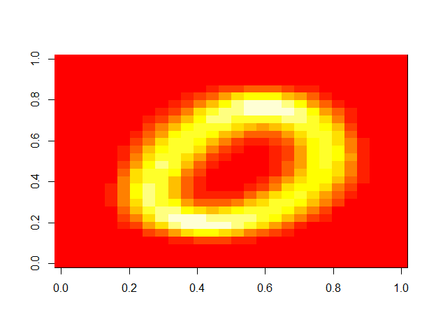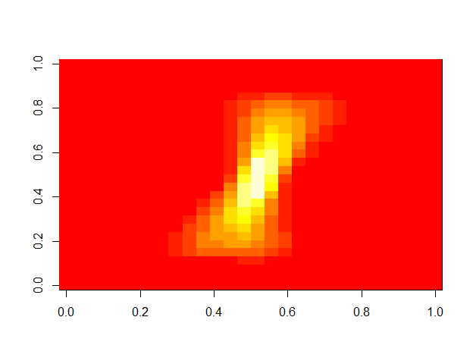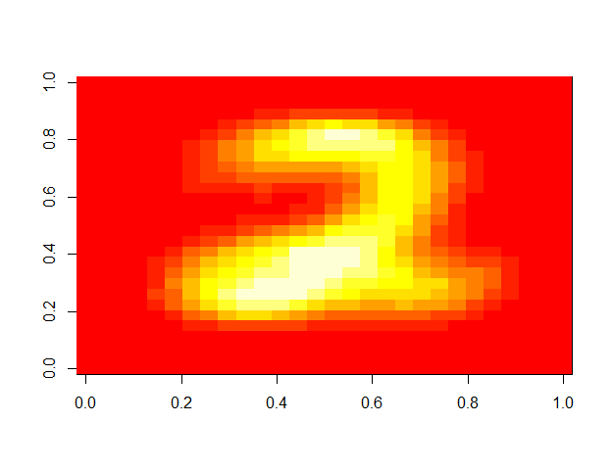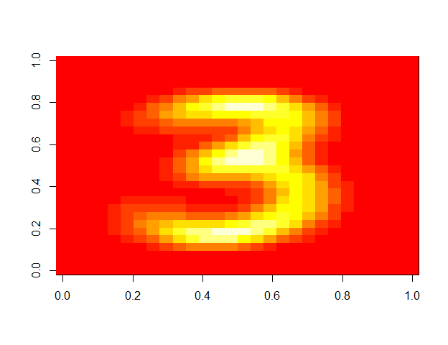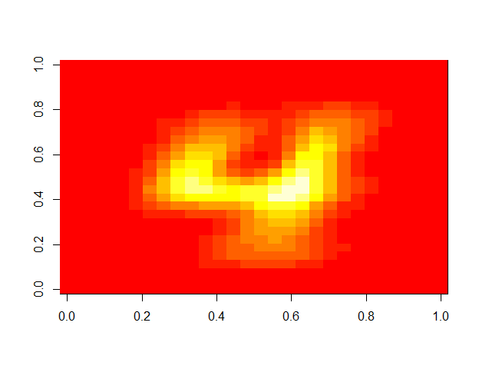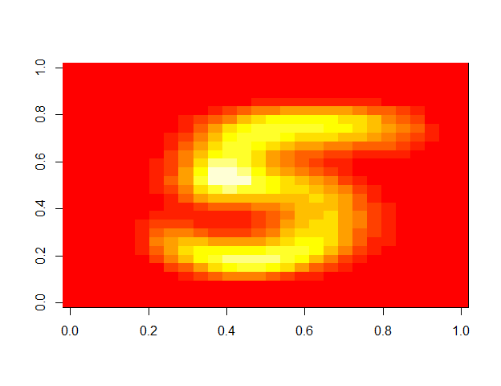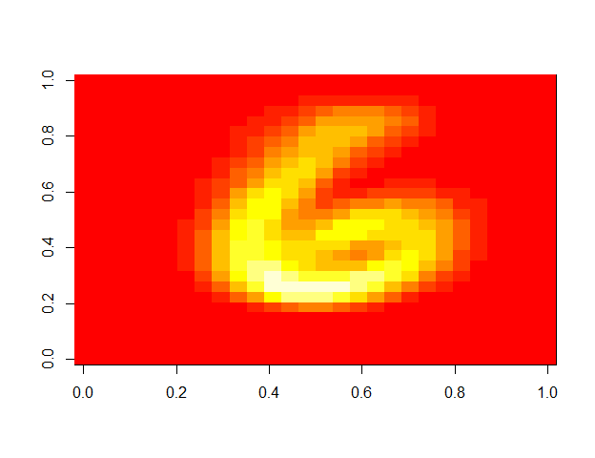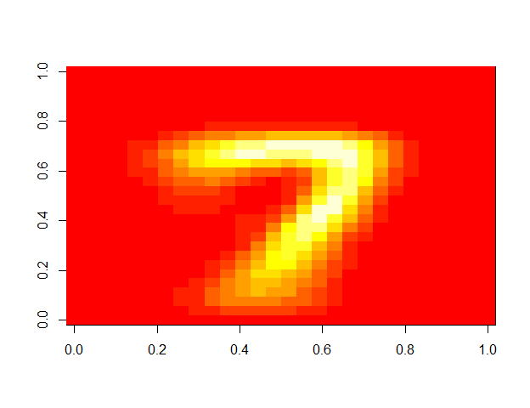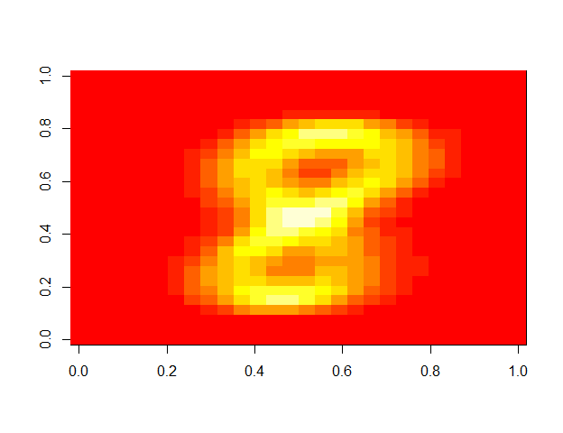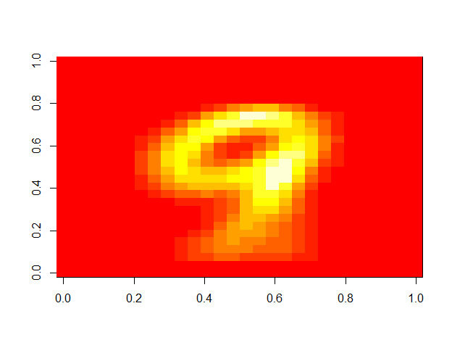

After applying threshold of 110

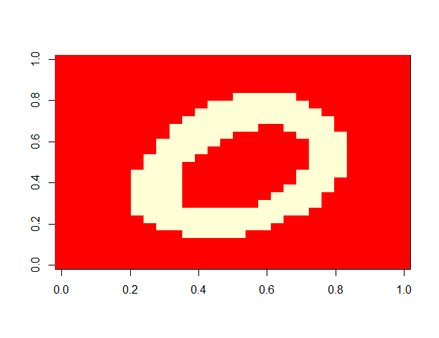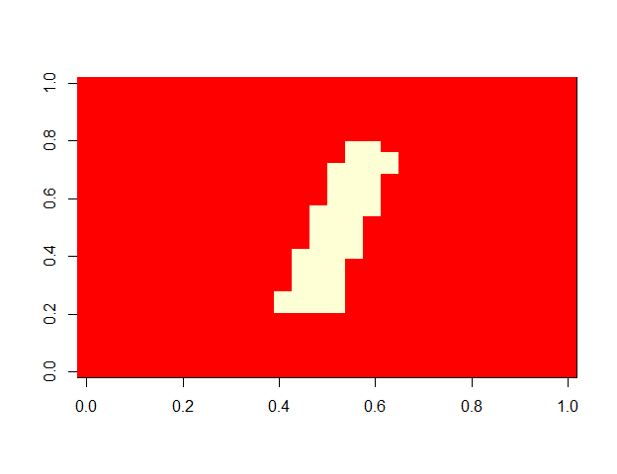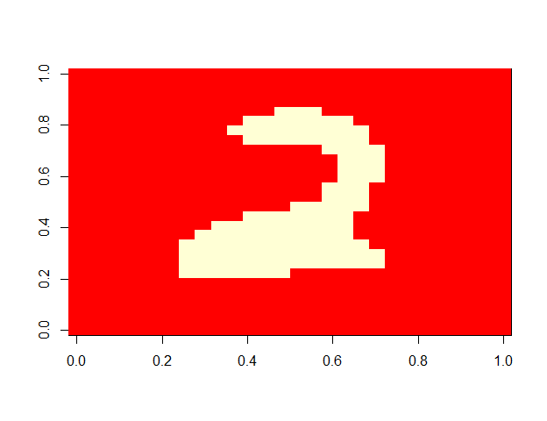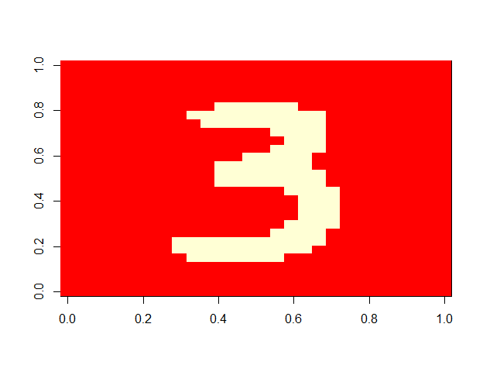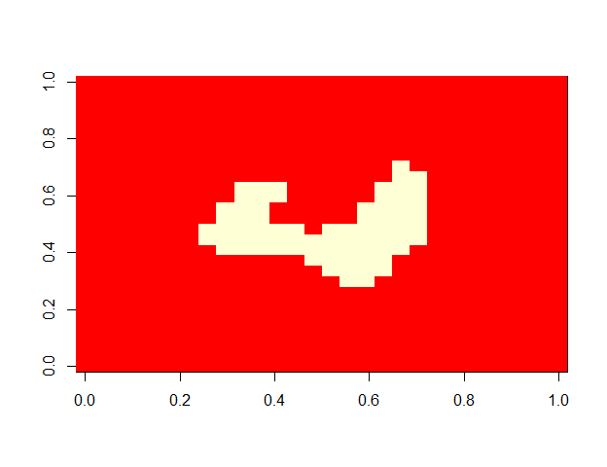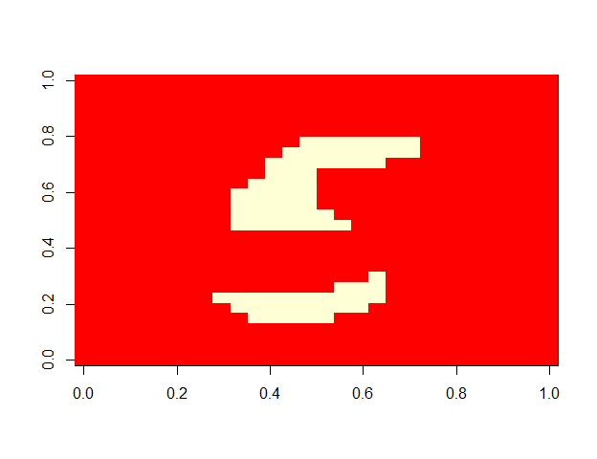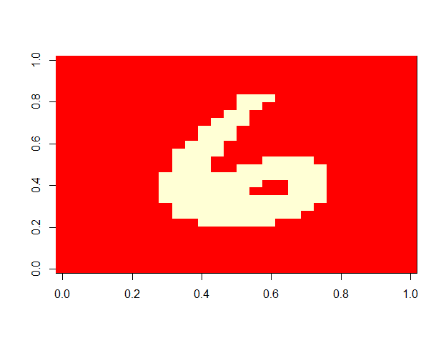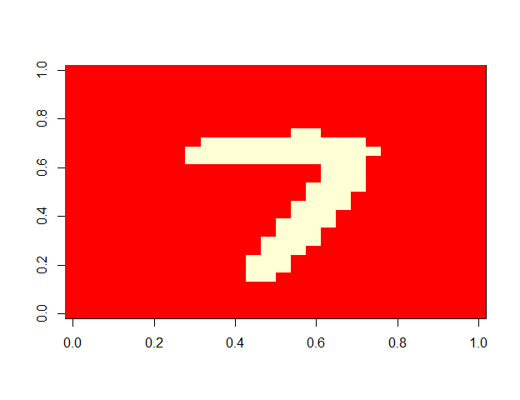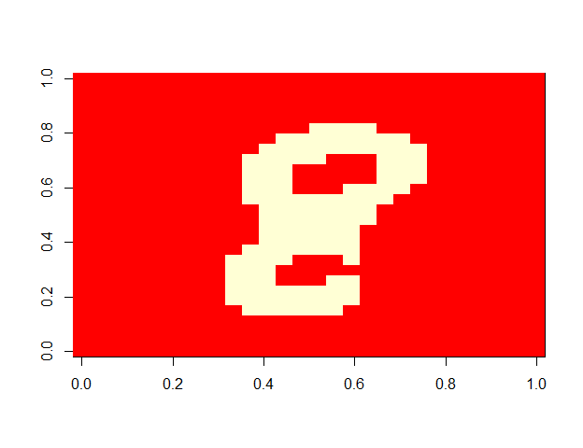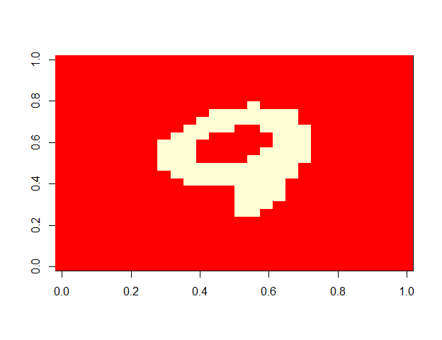

Normal Distribution Parameter Calculation

#Finds average training image for each digit

avg_imgs <- list(

avg_img_0 <- find_average_image(training_images[which(vec == 0)]),

avg_img_1 <- find_average_image(training_images[which(vec == 1)]),

…

avg_img_9 <- find_average_image(training_images[which(vec == 9)])

)

avg_imgs <- rapply(avg_imgs, function(x) ifelse(x > 110, 255, 0), how = "replace")

#Finds sd for each digit

sd_imgs <- list(

sd_img_0 <- find_sd_image(training_images[which(vec == 0)]),

sd_img_1 <- find_sd_image(training_images[which(vec == 1)]),

…

sd_img_9 <- find_sd_image(training_images[which(vec == 9)])

)

Bernoulli Distribution Parameters

bern_avg_imgs <- list(

bern_avg_img_0 <- bern_find_average_image(training_images[which(vec == 0)]),

bern_avg_img_1 <- bern_find_average_image(training_images[which(vec == 1)]),

…

bern_avg_img_9 <- bern_find_average_image(training_images[which(vec == 9)])

)

Calculation of Naïve Bayes’ predictions. These function are for the calculation of the untouched image prediction. The function for the touched images are almost identical

#Given a matrix, finds the posterior distributions for each digit,

#and returns the most likely value

determine_digit <- function(mat) {

lst_of_posterior_probs <- c()

for (k in 0:9) {

avg_img <- avg_imgs[[k+1]]

sd_img <- sd_imgs[[k+1]]

accum <- 0.1 + sum(log(0.0000000001 + dnorm(mat, avg_img, sd_img + 10)))

lst_of_posterior_probs <- c(lst_of_posterior_probs, accum)

}

return(which(lst_of_posterior_probs == max(lst_of_posterior_probs))[1] - 1)

}

#Given a matrix, finds the posterior distributions for each digit,

#and returns the most likely value

bern_determine_digit <- function(mat) {

mat[which(mat != 0)] <- 1

lst_of_posterior_probs <- c()

for (k in 0:9) {

avg_img <- bern_avg_imgs[[k+1]]

accum <- 0.1 + sum(log(0.0000000001 + dbinom(mat, avg_img, size = 1))) # for (i in 1:nrow(mat)) {

lst_of_posterior_probs <- c(lst_of_posterior_probs, accum)

}

return(which(lst_of_posterior_probs == max(lst_of_posterior_probs))[1] - 1)

}

gaussian_untouched_guesses <- lapply(testing_images, determine_digit)

gaussian_untouched_guesses_training <- lapply(training_images, determine_digit)

bern_untouched_guesses <- lapply(testing_images, bern_determine_digit)

bern_untouched_guesses_training <- lapply(training_images, bern_determine_digit)

Training of decision trees

#Creates the random forest models

model_training_untouched_10_4 <- h2o.randomForest(y = 1,

training_frame = h2o_df_training_untouched,

ntrees = 10, max_depth = 4)

model_training_touched_10_4 <- h2o.randomForest(y = 1,

training_frame = h2o_df_training_touched,

ntrees = 10, max_depth = 4)

...

model_training_touched_30_16 <- h2o.randomForest(y = 1,

training_frame = h2o_df_training_touched,

ntrees = 30, max_depth = 16)

Calculation of decision tree prediction

#Predictions

testing_untouched_10_4 <- predict(model_training_untouched_10_4, h2o_df_testing_untouched)

length(which(as.vector(testing_untouched_10_4[,1]) == vec2))

testing_untouched_10_16 <- predict(model_training_untouched_10_16, h2o_df_testing_untouched)

length(which(as.vector(testing_untouched_10_16[,1]) == vec2))

...

testing_touched_30_16 <- predict(model_training_touched_30_16, h2o_df_testing_touched)

length(which(as.vector(testing_touched_30_16[,1]) == vec2))

**Full Code**

**Question 1**

library(ggplot2)

data <- read.csv("pima-indians-diabetes.csv", header = T)

names(data) <- c("preg", "plas", "pres", "skin", "test", "mass", "pedi",

"age", "class")

#Given a number, gives ~80% of them a lable of 1 and 20% of them a

#label of 0. The number of rows in a data frame will be passed here

#to split them into test-train groups.

test_train_split <- function(num_rows) {

newCol <- rbinom(n = num_rows, size = 1, prob = 0.8)

split <- list(which(newCol == 1), which(newCol == 0))

return(split)

}

#Takes in a column vector from a data frame and fits a normal curve to

#it by finding the maximum likelihood estimates of the parameters of

#a normal distribution (i.e. mean and sd), given the data in the

#column. If ignore_zeros is true, it'll ignore the zeros in the

#column

fit_normal <- function(col, ignore_zeros) {

if (ignore_zeros == F) {

return(list(mean(col), sd(col)))

} else {

zeros_excluded <- col[which(col != 0)]

return(list(mean(zeros_excluded), sd(zeros_excluded)))

}

}

#######PART A##########

accuracy <- c()

for (i in 1:10) {

#Gets a test-train split

lst <- test_train_split(nrow(data))

training_df <- data[lst[[1]],]

testing_df <- data[lst[[2]],]

#Finds the parameters of the normal distribution fitted to the values

#of the rows of the training data frame that correspond to people

#with diabetes (i.e. class == 1)

param_preg_yes <- fit_normal(training_df[which(training_df$class == 1),"preg"], F)

param_plas_yes <- fit_normal(training_df[which(training_df$class == 1),"plas"], F)

param_pres_yes <- fit_normal(training_df[which(training_df$class == 1),"pres"], F)

param_skin_yes <- fit_normal(training_df[which(training_df$class == 1),"skin"], F)

param_test_yes <- fit_normal(training_df[which(training_df$class == 1),"test"], F)

param_mass_yes <- fit_normal(training_df[which(training_df$class == 1),"mass"], F)

param_pedi_yes <- fit_normal(training_df[which(training_df$class == 1),"pedi"], F)

param_age_yes <- fit_normal(training_df[which(training_df$class == 1),"age"], F)

#Finds the parameters of the normal distribution fitted to the values

#of the rows of the training data frame that correspond to people

#without diabetes (i.e. class == 0)

param_preg_no <- fit_normal(training_df[which(training_df$class == 0),"preg"], F)

param_plas_no <- fit_normal(training_df[which(training_df$class == 0),"plas"], F)

param_pres_no <- fit_normal(training_df[which(training_df$class == 0),"pres"], F)

param_skin_no <- fit_normal(training_df[which(training_df$class == 0),"skin"], F)

param_test_no <- fit_normal(training_df[which(training_df$class == 0),"test"], F)

param_mass_no <- fit_normal(training_df[which(training_df$class == 0),"mass"], F)

param_pedi_no <- fit_normal(training_df[which(training_df$class == 0),"pedi"], F)

param_age_no <- fit_normal(training_df[which(training_df$class == 0),"age"], F)

num_correct <- 0

for (j in 1:nrow(testing_df)) {

#Goes through the test data, and determines the posterior probability

#of the person having diabetes given the feature data

prob_of_diabetes_yes <- length(which(training_df$class == 1)) / nrow(training_df)

posterior_prob_of_diabetes_yes <- log(dnorm(testing_df[j,"preg"], param_preg_yes[[1]], param_preg_yes[[2]])) +

log(dnorm(testing_df[j,"plas"], param_plas_yes[[1]], param_plas_yes[[2]])) +

log(dnorm(testing_df[j,"pres"], param_pres_yes[[1]], param_pres_yes[[2]])) +

log(dnorm(testing_df[j,"skin"], param_skin_yes[[1]], param_skin_yes[[2]])) +

log(dnorm(testing_df[j,"test"], param_test_yes[[1]], param_test_yes[[2]])) +

log(dnorm(testing_df[j,"mass"], param_mass_yes[[1]], param_mass_yes[[2]])) +

log(dnorm(testing_df[j,"pedi"], param_pedi_yes[[1]], param_pedi_yes[[2]])) +

log(dnorm(testing_df[j,"age"], param_age_yes[[1]], param_age_yes[[2]])) +

log(prob_of_diabetes_yes)

#Goes through the test data, and determines the posterior probability

#of the person not having diabetes given the feature data

prob_of_diabetes_no <- length(which(training_df$class == 1)) / nrow(training_df)

posterior_prob_of_diabetes_no <- log(dnorm(testing_df[j,"preg"], param_preg_no[[1]], param_preg_no[[2]])) +

log(dnorm(testing_df[j,"plas"], param_plas_no[[1]], param_plas_no[[2]])) +

log(dnorm(testing_df[j,"pres"], param_pres_no[[1]], param_pres_no[[2]])) +

log(dnorm(testing_df[j,"skin"], param_skin_no[[1]], param_skin_no[[2]])) +

log(dnorm(testing_df[j,"test"], param_test_no[[1]], param_test_no[[2]])) +

log(dnorm(testing_df[j,"mass"], param_mass_no[[1]], param_mass_no[[2]])) +

log(dnorm(testing_df[j,"pedi"], param_pedi_no[[1]], param_pedi_no[[2]])) +

log(dnorm(testing_df[j,"age"], param_age_no[[1]], param_age_no[[2]])) +

log(prob_of_diabetes_no)

classified <- 0

if (posterior_prob_of_diabetes_yes >= posterior_prob_of_diabetes_no) {

classified <- 1

}

if (classified == testing_df[j, "class"]) {

num_correct <- num_correct + 1

}

}

accuracy <- c(accuracy, num_correct / nrow(testing_df))

}

average_accuracy <- mean(accuracy)

#######PART B##########

#Almost the same as PART A. Teh only idfference is that in some of the

#columns, the zeros are being considered as missing values and excluded.

accuracy <- c()

for (i in 1:10) {

#Gets a test-train split

lst <- test_train_split(nrow(data))

training_df <- data[lst[[1]],]

testing_df <- data[lst[[2]],]

#Finds the parameters of the normal distribution fitted to the values

#of the rows of the training data frame that correspond to people

#with diabetes (i.e. class == 1)

param_preg_yes <- fit_normal(training_df[which(training_df$class == 1),"preg"], F)

param_plas_yes <- fit_normal(training_df[which(training_df$class == 1),"plas"], F)

param_pres_yes <- fit_normal(training_df[which(training_df$class == 1),"pres"], T)

param_skin_yes <- fit_normal(training_df[which(training_df$class == 1),"skin"], T)

param_test_yes <- fit_normal(training_df[which(training_df$class == 1),"test"], F)

param_mass_yes <- fit_normal(training_df[which(training_df$class == 1),"mass"], T)

param_pedi_yes <- fit_normal(training_df[which(training_df$class == 1),"pedi"], F)

param_age_yes <- fit_normal(training_df[which(training_df$class == 1),"age"], T)

#Finds the parameters of the normal distribution fitted to the values

#of the rows of the training data frame that correspond to people

#without diabetes (i.e. class == 0)

param_preg_no <- fit_normal(training_df[which(training_df$class == 0),"preg"], F)

param_plas_no <- fit_normal(training_df[which(training_df$class == 0),"plas"], F)

param_pres_no <- fit_normal(training_df[which(training_df$class == 0),"pres"], T)

param_skin_no <- fit_normal(training_df[which(training_df$class == 0),"skin"], T)

param_test_no <- fit_normal(training_df[which(training_df$class == 0),"test"], F)

param_mass_no <- fit_normal(training_df[which(training_df$class == 0),"mass"], T)

param_pedi_no <- fit_normal(training_df[which(training_df$class == 0),"pedi"], F)

param_age_no <- fit_normal(training_df[which(training_df$class == 0),"age"], T)

num_correct <- 0

for (j in 1:nrow(testing_df)) {

#Goes through the test data, and determines the posterior probability

#of the person having diabetes given the feature data

prob_of_diabetes_yes <- length(which(training_df$class == 1)) / nrow(training_df)

posterior_prob_of_diabetes_yes <- log(dnorm(testing_df[j,"preg"], param_preg_yes[[1]], param_preg_yes[[2]])) +

log(dnorm(testing_df[j,"plas"], param_plas_yes[[1]], param_plas_yes[[2]])) +

log(dnorm(testing_df[j,"pres"], param_pres_yes[[1]], param_pres_yes[[2]])) +

log(dnorm(testing_df[j,"skin"], param_skin_yes[[1]], param_skin_yes[[2]])) +

log(dnorm(testing_df[j,"test"], param_test_yes[[1]], param_test_yes[[2]])) +

log(dnorm(testing_df[j,"mass"], param_mass_yes[[1]], param_mass_yes[[2]])) +

log(dnorm(testing_df[j,"pedi"], param_pedi_yes[[1]], param_pedi_yes[[2]])) +

log(dnorm(testing_df[j,"age"], param_age_yes[[1]], param_age_yes[[2]])) +

log(prob_of_diabetes_yes)

#Goes through the test data, and determines the posterior probability

#of the person not having diabetes given the feature data

prob_of_diabetes_no <- length(which(training_df$class == 1)) / nrow(training_df)

posterior_prob_of_diabetes_no <- log(dnorm(testing_df[j,"preg"], param_preg_no[[1]], param_preg_no[[2]])) +

log(dnorm(testing_df[j,"plas"], param_plas_no[[1]], param_plas_no[[2]])) +

log(dnorm(testing_df[j,"pres"], param_pres_no[[1]], param_pres_no[[2]])) +

log(dnorm(testing_df[j,"skin"], param_skin_no[[1]], param_skin_no[[2]])) +

log(dnorm(testing_df[j,"test"], param_test_no[[1]], param_test_no[[2]])) +

log(dnorm(testing_df[j,"mass"], param_mass_no[[1]], param_mass_no[[2]])) +

log(dnorm(testing_df[j,"pedi"], param_pedi_no[[1]], param_pedi_no[[2]])) +

log(dnorm(testing_df[j,"age"], param_age_no[[1]], param_age_no[[2]])) +

log(prob_of_diabetes_no)

classified <- 0

if (posterior_prob_of_diabetes_yes >= posterior_prob_of_diabetes_no) {

classified <- 1

}

if (classified == testing_df[j, "class"]) {

num_correct <- num_correct + 1

}

}

accuracy <- c(accuracy, num_correct / nrow(testing_df))

}

average_accuracy <- mean(accuracy)

**Question 2**

library(h2o)

#Stores training labels in a vector called vec

to.read.label = file("train-labels.idx1-ubyte", "rb")

readBin(to.read.label, integer(), n=2, size=4, endian="big")

vec <- readBin(to.read.label, integer(), n=60000, size=1, endian="big")

#Stores training images in a list called images

to.read.img = file("train-images.idx3-ubyte", "rb")

readBin(to.read.img, integer(), n=4, endian="big")

training_images <- list()

training_images_size <- 1

for(i in 1:60000) {

m = matrix(readBin(to.read.img,integer(), size=1, n=28*28, endian="big", signed = F),28,28)

m <- m[,28:1]

training_images[[training_images_size]] <- m

training_images_size <- training_images_size + 1

}

training_images <- rapply(training_images, function(x) ifelse(x > 128, 255, 0), how = "replace")

#Testing Thresholding on a small list

# img_lst <- list(training_images[[3]], training_images[[321]])

# img_lst <- rapply(img_lst, function(x) ifelse(x > 100, 255, 0), how = "replace")

#Stores training labels in a vector called vec

to.read.label = file("t10k-labels.idx1-ubyte", "rb")

readBin(to.read.label, integer(), n=2, size=4, endian="big")

vec2 <- readBin(to.read.label, integer(), n=10000, size=1, endian="big")

#Stores training images in a list called images

to.read.img = file("t10k-images.idx3-ubyte", "rb")

readBin(to.read.img, integer(), n=4, endian="big")

testing_images <- list()

testing_images_size <- 1

for(i in 1:10000) {

m = matrix(readBin(to.read.img,integer(), size=1, n=28*28, endian="big", signed = F),28,28)

m <- m[,28:1]

testing_images[[testing_images_size]] <- m

testing_images_size <- testing_images_size + 1

}

testing_images <- rapply(testing_images, function(x) ifelse(x > 128, 255, 0), how = "replace")

#Finds the average value for each pixel and returns the resulting

#matrix

find_average_image <- function(lst_of_images) {

return(Reduce('+', lst_of_images)/length(lst_of_images))

}

bern_find_average_image <- function(lst_of_images) {

lst <- lapply(lst_of_images, function(x) {x[which(x != 0)] <- 1; return(x)})

return(Reduce('+', lst)/length(lst))

}

#Finds the standard deviation for each pixel and returns the resulting

#matrix

#Code obtained from: https://stackoverflow.com/questions/39351013/standard-deviation-over-a-list-of-matrices-in-r

find_sd_image <- function(lst) {

n <- length(lst)

rc <- dim(lst[[1]])

ar1 <- array(unlist(lst), c(rc, n))

round(apply(ar1, c(1, 2), sd), 2)

}

#Finds average training image for each digit

avg_imgs <- list(

avg_img_0 <- find_average_image(training_images[which(vec == 0)]),

avg_img_1 <- find_average_image(training_images[which(vec == 1)]),

avg_img_2 <- find_average_image(training_images[which(vec == 2)]),

avg_img_3 <- find_average_image(training_images[which(vec == 3)]),

avg_img_4 <- find_average_image(training_images[which(vec == 4)]),

avg_img_5 <- find_average_image(training_images[which(vec == 5)]),

avg_img_6 <- find_average_image(training_images[which(vec == 6)]),

avg_img_7 <- find_average_image(training_images[which(vec == 7)]),

avg_img_8 <- find_average_image(training_images[which(vec == 8)]),

avg_img_9 <- find_average_image(training_images[which(vec == 9)])

)

avg_imgs <- rapply(avg_imgs, function(x) ifelse(x > 110, 255, 0), how = "replace")

#Finds sd for each digit

sd_imgs <- list(

sd_img_0 <- find_sd_image(training_images[which(vec == 0)]),

sd_img_1 <- find_sd_image(training_images[which(vec == 1)]),

sd_img_2 <- find_sd_image(training_images[which(vec == 2)]),

sd_img_3 <- find_sd_image(training_images[which(vec == 3)]),

sd_img_4 <- find_sd_image(training_images[which(vec == 4)]),

sd_img_5 <- find_sd_image(training_images[which(vec == 5)]),

sd_img_6 <- find_sd_image(training_images[which(vec == 6)]),

sd_img_7 <- find_sd_image(training_images[which(vec == 7)]),

sd_img_8 <- find_sd_image(training_images[which(vec == 8)]),

sd_img_9 <- find_sd_image(training_images[which(vec == 9)])

)

bern_avg_imgs <- list(

bern_avg_img_0 <- bern_find_average_image(training_images[which(vec == 0)]),

bern_avg_img_1 <- bern_find_average_image(training_images[which(vec == 1)]),

bern_avg_img_2 <- bern_find_average_image(training_images[which(vec == 2)]),

bern_avg_img_3 <- bern_find_average_image(training_images[which(vec == 3)]),

bern_avg_img_4 <- bern_find_average_image(training_images[which(vec == 4)]),

bern_avg_img_5 <- bern_find_average_image(training_images[which(vec == 5)]),

bern_avg_img_6 <- bern_find_average_image(training_images[which(vec == 6)]),

bern_avg_img_7 <- bern_find_average_image(training_images[which(vec == 7)]),

bern_avg_img_8 <- bern_find_average_image(training_images[which(vec == 8)]),

bern_avg_img_9 <- bern_find_average_image(training_images[which(vec == 9)])

)

#Given a matrix, finds the posterior distributions for each digit,

#and returns the most likely value

determine_digit <- function(mat) {

lst_of_posterior_probs <- c()

for (k in 0:9) {

avg_img <- avg_imgs[[k+1]]

sd_img <- sd_imgs[[k+1]]

accum <- 0.1 + sum(log(0.0000000001 + dnorm(mat, avg_img, sd_img + 10)))

lst_of_posterior_probs <- c(lst_of_posterior_probs, accum)

}

return(which(lst_of_posterior_probs == max(lst_of_posterior_probs))[1] - 1)

}

#Given a matrix, finds the posterior distributions for each digit,

#and returns the most likely value

bern_determine_digit <- function(mat) {

mat[which(mat != 0)] <- 1

lst_of_posterior_probs <- c()

for (k in 0:9) {

avg_img <- bern_avg_imgs[[k+1]]

accum <- 0.1 + sum(log(0.0000000001 + dbinom(mat, avg_img, size = 1))) # for (i in 1:nrow(mat)) {

lst_of_posterior_probs <- c(lst_of_posterior_probs, accum)

}

return(which(lst_of_posterior_probs == max(lst_of_posterior_probs))[1] - 1)

}

gaussian_untouched_guesses <- lapply(testing_images, determine_digit)

gaussian_untouched_guesses_training <- lapply(training_images, determine_digit)

bern_untouched_guesses <- lapply(testing_images, bern_determine_digit)

bern_untouched_guesses_training <- lapply(training_images, bern_determine_digit)

length(which(gaussian_untouched_guesses == vec2))

length(which(bern_untouched_guesses == vec2))

length(which(gaussian_untouched_guesses_training == vec))

length(which(bern_untouched_guesses_training == vec))

find_vertical_ink_range <- function(img) {

top <- min(apply(img, 2, function(x) return(min(which(x != 0)))))

bottom <- max(apply(img, 2, function(x) return(max(which(x != 0)))))

return(c(top, bottom))

}

find_horizontal_ink_range <- function(img) {

left <- min(apply(img, 1, function(x) return(min(which(x != 0)))))

right <- max(apply(img, 1, function(x) return(max(which(x != 0)))))

return(c(left, right))

}

#Resizes an image to a given width and height. Returns the matrix

#Code obtained from https://stackoverflow.com/questions/35786744/resizing-image-in-r

resize_image <- function(img, new_width, new_height) {

new_img = apply(img, 2, function(y){return (spline(y, n = new_height)$y)})

new_img = t(apply(new_img, 1, function(y){return (spline(y, n = new_width)$y)}))

new_img[new_img < 0] = 0

new_img = round(new_img)

return (new_img)

}

#A vector with the numbers in the list images, cropped by 4 pixels on

#each side.

bounded_box_images_training <- lapply(training_images, function(x) {

vert <- find_vertical_ink_range(x);

hor <- find_horizontal_ink_range(x);

return(x[vert[1]:vert[2], hor[1]:hor[2]])

})

#bounded_box_images_training <- rapply(bounded_box_images_training, function(x) ifelse(x > 220, 255, 0), how = "replace")

#A vector with the numbers in the list images, cropped by 4 pixels on

#each side.

bounded_box_images_testing <- lapply(testing_images, function(x) {

vert <- find_vertical_ink_range(x);

hor <- find_horizontal_ink_range(x);

return(x[vert[1]:vert[2], hor[1]:hor[2]])

})

#bounded_box_images_testing <- rapply(bounded_box_images_testing, function(x) ifelse(x > 220, 255, 0), how = "replace")

resized_bounded_box_images_training <- lapply(bounded_box_images_training, resize_image, 20, 20)

resized_bounded_box_images_testing <- lapply(bounded_box_images_testing, resize_image, 20, 20)

touched_avg_imgs <- list(

touched_avg_img_0 <- find_average_image(resized_bounded_box_images_training[which(vec == 0)]),

touched_avg_img_1 <- find_average_image(resized_bounded_box_images_training[which(vec == 1)]),

touched_avg_img_2 <- find_average_image(resized_bounded_box_images_training[which(vec == 2)]),

touched_avg_img_3 <- find_average_image(resized_bounded_box_images_training[which(vec == 3)]),

touched_avg_img_4 <- find_average_image(resized_bounded_box_images_training[which(vec == 4)]),

touched_avg_img_5 <- find_average_image(resized_bounded_box_images_training[which(vec == 5)]),

touched_avg_img_6 <- find_average_image(resized_bounded_box_images_training[which(vec == 6)]),

touched_avg_img_7 <- find_average_image(resized_bounded_box_images_training[which(vec == 7)]),

touched_avg_img_8 <- find_average_image(resized_bounded_box_images_training[which(vec == 8)]),

touched_avg_img_9 <- find_average_image(resized_bounded_box_images_training[which(vec == 9)])

)

touched_avg_imgs <- rapply(touched_avg_imgs, function(x) ifelse(x > 110, 255, 0), how = "replace")

touched_sd_imgs <- list(

touched_sd_img_0 <- find_sd_image(resized_bounded_box_images_training[which(vec == 0)]),

touched_sd_img_1 <- find_sd_image(resized_bounded_box_images_training[which(vec == 1)]),

touched_sd_img_2 <- find_sd_image(resized_bounded_box_images_training[which(vec == 2)]),

touched_sd_img_3 <- find_sd_image(resized_bounded_box_images_training[which(vec == 3)]),

touched_sd_img_4 <- find_sd_image(resized_bounded_box_images_training[which(vec == 4)]),

touched_sd_img_5 <- find_sd_image(resized_bounded_box_images_training[which(vec == 5)]),

touched_sd_img_6 <- find_sd_image(resized_bounded_box_images_training[which(vec == 6)]),

touched_sd_img_7 <- find_sd_image(resized_bounded_box_images_training[which(vec == 7)]),

touched_sd_img_8 <- find_sd_image(resized_bounded_box_images_training[which(vec == 8)]),

touched_sd_img_9 <- find_sd_image(resized_bounded_box_images_training[which(vec == 9)])

)

touched_bern_avg_imgs <- list(

touched_bern_avg_img_0 <- bern_find_average_image(resized_bounded_box_images_training[which(vec == 0)]),

touched_bern_avg_img_1 <- bern_find_average_image(resized_bounded_box_images_training[which(vec == 1)]),

touched_bern_avg_img_2 <- bern_find_average_image(resized_bounded_box_images_training[which(vec == 2)]),

touched_bern_avg_img_3 <- bern_find_average_image(resized_bounded_box_images_training[which(vec == 3)]),

touched_bern_avg_img_4 <- bern_find_average_image(resized_bounded_box_images_training[which(vec == 4)]),

touched_bern_avg_img_5 <- bern_find_average_image(resized_bounded_box_images_training[which(vec == 5)]),

touched_bern_avg_img_6 <- bern_find_average_image(resized_bounded_box_images_training[which(vec == 6)]),

touched_bern_avg_img_7 <- bern_find_average_image(resized_bounded_box_images_training[which(vec == 7)]),

touched_bern_avg_img_8 <- bern_find_average_image(resized_bounded_box_images_training[which(vec == 8)]),

touched_bern_avg_img_9 <- bern_find_average_image(resized_bounded_box_images_training[which(vec == 9)])

)

gaussian_touched_guesses <- lapply(resized_bounded_box_images_testing, determine_digit_touched)

gaussian_touched_guesses_training <- lapply(resized_bounded_box_images_training, determine_digit_touched)

bern_touched_guesses <- lapply(resized_bounded_box_images_testing, bern_determine_digit_touched)

bern_touched_guesses_training <- lapply(resized_bounded_box_images_training, bern_determine_digit_touched)

length(which(gaussian_touched_guesses == vec2))

length(which(bern_touched_guesses == vec2))

length(which(gaussian_touched_guesses_training == vec))

length(which(bern_touched_guesses_training == vec))

#Given a matrix, finds the posterior distributions for each digit,

#and returns the most likely value

determine_digit_touched <- function(mat) {

lst_of_posterior_probs <- c()

for (k in 0:9) {

avg_img <- touched_avg_imgs[[k+1]]

sd_img <- touched_sd_imgs[[k+1]]

accum <- 0.1 + sum(log(0.0000000001 + dnorm(mat, avg_img, sd_img + 10)))

lst_of_posterior_probs <- c(lst_of_posterior_probs, accum)

}

#print(lst_of_posterior_probs)

return(which(lst_of_posterior_probs == max(lst_of_posterior_probs))[1] - 1)

}

#Given a matrix, finds the posterior distributions for each digit,

#and returns the most likely value

bern_determine_digit_touched <- function(mat) {

mat[which(mat != 0)] <- 1

lst_of_posterior_probs <- c()

for (k in 0:9) {

avg_img <- touched_bern_avg_imgs[[k+1]]

accum <- 0.1 + sum(log(0.0000000001 + dbinom(mat, avg_img, size = 1))) # for (i in 1:nrow(mat)) {

lst_of_posterior_probs <- c(lst_of_posterior_probs, accum)

}

#print(lst_of_posterior_probs)

return(which(lst_of_posterior_probs == max(lst_of_posterior_probs))[1] - 1)

}

####################

#This part of the code deals with the random forest genreation

####################

h2o.init()

#Takes a matrix, and converts it into a row vector

convert_to_row <- function(mat) {

return(c(mat))

}

#Converts training data into a data frame, where each row is

#a lable for the digi, followed by 784 pixel values

make_df_for_h2o <- function(col_labels, img_list) {

lst <- lapply(img_list, convert_to_row)

names(lst) <- 1:length(lst)

df <- data.frame(as.character(col_labels), t(as.data.frame(lst)))

return(df)

}

#Creates the data frames for the four sets.

h2o_training_untouched <- make_df_for_h2o(vec, training_images)

h2o_training_touched <- make_df_for_h2o(vec, resized_bounded_box_images_training)

h2o_testing_untouched <- make_df_for_h2o(vec2, testing_images)

h2o_testing_touched <- make_df_for_h2o(vec2, resized_bounded_box_images_testing)

#Turns the above data frames into h2o frames

h2o_df_training_untouched <- as.h2o(x = h2o_training_untouched)

h2o_df_training_touched <- as.h2o(x = h2o_training_touched)

h2o_df_testing_untouched <- as.h2o(x = h2o_testing_untouched[,-1])

h2o_df_testing_touched <- as.h2o(x = h2o_testing_touched[,-1])

#Creates the random forest models

model_training_untouched_10_4 <- h2o.randomForest(y = 1,

training_frame = h2o_df_training_untouched,

ntrees = 10, max_depth = 4)

model_training_touched_10_4 <- h2o.randomForest(y = 1,

training_frame = h2o_df_training_touched,

ntrees = 10, max_depth = 4)

model_training_untouched_10_16 <- h2o.randomForest(y = 1,

training_frame = h2o_df_training_untouched,

ntrees = 10, max_depth = 16)

model_training_touched_10_16 <- h2o.randomForest(y = 1,

training_frame = h2o_df_training_touched,

ntrees = 10, max_depth = 16)

model_training_untouched_30_4 <- h2o.randomForest(y = 1,

training_frame = h2o_df_training_untouched,

ntrees = 30, max_depth = 4)

model_training_touched_30_4 <- h2o.randomForest(y = 1,

training_frame = h2o_df_training_touched,

ntrees = 30, max_depth = 4)

model_training_untouched_30_16 <- h2o.randomForest(y = 1,

training_frame = h2o_df_training_untouched,

ntrees = 30, max_depth = 16)

model_training_touched_30_16 <- h2o.randomForest(y = 1,

training_frame = h2o_df_training_touched,

ntrees = 30, max_depth = 16)

#Predictions

testing_untouched_10_4 <- predict(model_training_untouched_10_4, h2o_df_testing_untouched)

length(which(as.vector(testing_untouched_10_4[,1]) == vec2))

testing_untouched_10_16 <- predict(model_training_untouched_10_16, h2o_df_testing_untouched)

length(which(as.vector(testing_untouched_10_16[,1]) == vec2))

testing_untouched_30_4 <- predict(model_training_untouched_30_4, h2o_df_testing_untouched)

length(which(as.vector(testing_untouched_30_4[,1]) == vec2))

testing_untouched_30_16 <- predict(model_training_untouched_30_16, h2o_df_testing_untouched)

length(which(as.vector(testing_untouched_30_16[,1]) == vec2))

testing_touched_10_4 <- predict(model_training_touched_10_4, h2o_df_testing_touched)

length(which(as.vector(testing_touched_10_4[,1]) == vec2))

testing_touched_10_16 <- predict(model_training_touched_10_16, h2o_df_testing_touched)

length(which(as.vector(testing_touched_10_16[,1]) == vec2))

testing_touched_30_4 <- predict(model_training_touched_30_4, h2o_df_testing_touched)

length(which(as.vector(testing_touched_30_4[,1]) == vec2))

testing_touched_30_16 <- predict(model_training_touched_30_16, h2o_df_testing_touched)

length(which(as.vector(testing_touched_30_16[,1]) == vec2))

training_untouched_10_4 <- predict(model_training_untouched_10_4, h2o_df_training_untouched)

length(which(as.vector(training_untouched_10_4[,1]) == vec))

training_untouched_10_16 <- predict(model_training_untouched_10_16, h2o_df_training_untouched)

length(which(as.vector(training_untouched_10_16[,1]) == vec))

training_untouched_30_4 <- predict(model_training_untouched_30_4, h2o_df_training_untouched)

length(which(as.vector(training_untouched_30_4[,1]) == vec))

training_untouched_30_16 <- predict(model_training_untouched_30_16, h2o_df_training_untouched)

length(which(as.vector(training_untouched_30_16[,1]) == vec))

training_touched_10_4 <- predict(model_training_touched_10_4, h2o_df_training_touched)

length(which(as.vector(training_touched_10_4[,1]) == vec))

training_touched_10_16 <- predict(model_training_touched_10_16, h2o_df_training_touched)

length(which(as.vector(training_touched_10_16[,1]) == vec))

training_touched_30_4 <- predict(model_training_touched_30_4, h2o_df_training_touched)

length(which(as.vector(training_touched_30_4[,1]) == vec))

training_touched_30_16 <- predict(model_training_touched_30_16, h2o_df_training_touched)

length(which(as.vector(training_touched_30_16[,1]) == vec))

**References**

Obtained a code snippet from

<https://stackoverflow.com/questions/35786744/resizing-image-in-r>

Received help with function, from the following SO pages

<https://stackoverflow.com/questions/54448330/r-repeatedly-apply-function-to-corresponding-elements-of-matrices-and-collect/54448573?noredirect=1#comment95706806_54448573>

<https://stackoverflow.com/questions/54429714/r-converting-a-list-of-lists-into-a-data-frame/54429927#54429927>