

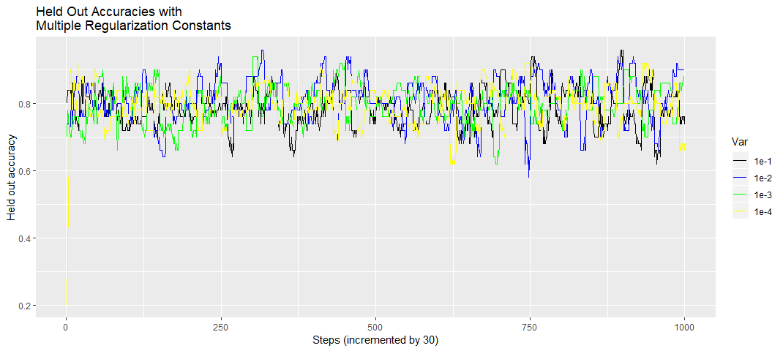

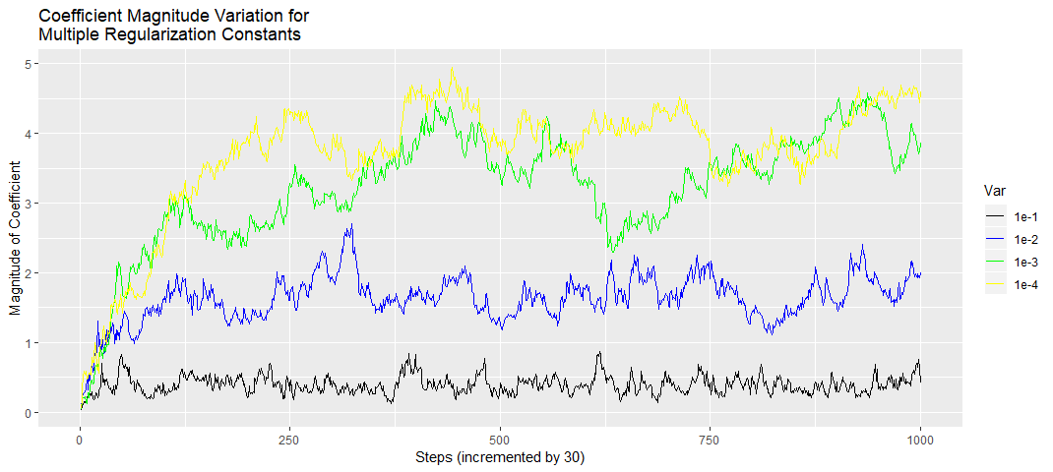

After running the code 7 times, I obtained the following table of cross-validation accuracies

|  |  |  |  |  |  |  |  |  |
| --- | --- | --- | --- | --- | --- | --- | --- | --- |
| $$λ$$ | 1 | 2 | 3 | 4 | 5 | 6 | 7 | Average accuracy |
| $$1e^{-4}$$ | 0.809235 | 0.813607 | 0.815874 | 0.806334 | 0.79973 | 0.81139 | 0.805773 | 0.808849 |
| $${1e}^{-3}$$ | 0.812034 | 0.805219 | 0.814501 | 0.809752 | 0.79973 | 0.80309 | 0.795032 | 0.805623 |
| $${1e}^{-2}$$ | 0.800373 | 0.800559 | 0.814959 | 0.80041 | 0.795005 | 0.802859 | 0.797046 | 0.801602 |
| $${1e}^{-1}$$ | 0.764692 | 0.786114 | 0.791857 | 0.797904 | 0.768902 | 0.763662 | 0.786082 | 0.779887 |

It seems that the accuracies from the first three values of $λ$ are relatively close. However, looking at the held-out accuracy plot, the $1e^{-2}$ value seemed to be getting the best accuracies. So I decided to go with that.

The learning rate was $\frac{1}{0.01*s+50}$, where $s$ is the season number.. This was chosen, because as the number of seasons increases, the step size decreases, because we assume that the algorithm is close to converging.

batch_size <- 1

#Split the data into 90% training, and 10% validation data

split <- test_train_split(nrow(training_data))

held_out_accuracies_lambda_1 <- c()

coefficient_magnitude_1 <- c()

a_1 <- c(0,0,0,0,0,0)

b_1 <- 1

for (k in 1:100) {

#print(paste("Lengths of a and b:", length(a), length(b)))

step_size <- 1/(0.01*k + 50)

ret_vec <- do_season(split[[1]], 1e-4, a_1, b_1, 1, step_size)

#print(paste("ret_vec:",length(ret_vec)))

a_1 <- ret_vec[11:16]

b_1 <- ret_vec[17]

#print(c(a,b))

held_out_accuracies_lambda_1 <- c(held_out_accuracies_lambda_1, ret_vec[1:10])

coefficient_magnitude_1 <- c(coefficient_magnitude_1, ret_vec[18:27])

print(paste("Done season", k))

}

test_predictions_1 <- lapply(split[[2]], function(x) {return(ifelse(sum(a_1*training_data[x,])+b_1> 0, 1, -1))})

accuracy_1 <- length(which(test_predictions_1 == labels[split[[2]]]))/length(split[[2]])

…

held_out_accuracies_lambda_4 <- c()

coefficient_magnitude_4 <- c()

a_4 <- c(0,0,0,0,0,0)

b_4 <- 0

for (k in 1:100) {

#print(paste("Lengths of a and b:", length(a), length(b)))

step_size <- 1/(0.01*k + 50)

ret_vec <- do_season(split[[1]], 1e-1, a_4, b_4, 1, step_size)

#print(paste("ret_vec:",length(ret_vec)))

a_4 <- ret_vec[11:16]

b_4 <- ret_vec[17]

#print(c(a,b))

held_out_accuracies_lambda_4 <- c(held_out_accuracies_lambda_4, ret_vec[1:10])

coefficient_magnitude_4 <- c(coefficient_magnitude_4, ret_vec[18:27])

print(paste("Done season", k))

}

test_predictions_4 <- lapply(split[[2]], function(x) {return(ifelse(sum(a_4*training_data[x,])+b_4 > 0, 1, -1))})

accuracy_4 <- length(which(test_predictions_4 == labels[split[[2]]]))/length(split[[2]])

#Performs a step of the stochastic gradient descent process. Returns a vector containing

#a and b.

do_step <- function(rows, lambda, a, b, batch_size, step_size) {

batch <- sample(rows, 1)

gamma <- labels[batch]*(sum(a*unlist(training_data[batch,])) + b)

if (gamma >= 1) {

a <- a - step_size*lambda*a

} else {

a <- a - step_size*(lambda*a - labels[batch]*unlist(training_data[batch,]))

b <- b - step_size*(-labels[batch])

}

return(c(a,b))

}

#Does an iteration of a season. Involves taking 300 steps. Every 30 steps, it checks

#the current a and b values agains the hold-out set, and keeps track of the accuracy.

#It also keeps track of the magnitude of the vector a. The function returns

#the accuracies (every 30 steps), a, b, and the magnitude of a (every 30 steps)

do_season <- function(rows, lambda, a, b, batch_size, step_size) {

#Get held out set for the season

hold_out <- sample(rows, 50, replace = F)

#Vectors to store accuracies agains hold out set and magnitude of a, every 30 steps.

store_accuracies <- c()

mag_a <- c()

#Take 300 steps. Every 30 steps, calculate accuracy of held out set.

for (step in 1:300) {

if ((step > 0) && ((step %% 30) == 0)) {

#Test agains hold out set. Store the accuracy in a vector.

predictions <- lapply(hold_out, function(x) {return(ifelse(sum(a*training_data[x,])+b > 0, 1, -1))})

store_accuracies <- c(store_accuracies, length(which(predictions == labels[hold_out]))/50)

mag_a <- c(mag_a, sum(a*a))

}

#Get updated values after stepping.

new_u <- do_step(rows, lambda, a, b, batch_size, step_size)

a <- new_u[1:6]

b <- new_u[7]

}

return(c(store_accuracies, a, b, mag_a))

}

**Full Code**

library(ggplot2)

library(dplyr)

library(tidyr)

################DATA SETUP#####################

training_data <- read.csv("training_data.csv")

training_data <- training_data[,c(1,3,5,11,12,13,15)]

testing_data <- read.csv("testing_data.csv")

testing_data <- testing_data[,c(1,3,5,11,12,13)]

#Scales the feature variables to have mean of 0 and variance of 1

training_means <- apply(training_data[,1:6], 2, mean)

training_sds <- apply(training_data[,1:6], 2, sd)

testing_means <- apply(testing_data, 2, mean)

testing_sds <- apply(testing_data, 2, sd)

#training_data[,1:6] <- ((training_data[,1:6] - training_means)/training_vars)

training_data[,1:6] <- as.data.frame(Map("-", training_data[,1:6], training_means))

training_data[,1:6] <- as.data.frame(Map("/", training_data[,1:6], training_sds))

#testing_data <- apply(testing_data, 2, function(x) {return((x - mean(x))/var(x))})

testing_data <- as.data.frame(Map("-", testing_data, testing_means))

testing_data <- as.data.frame(Map("/", testing_data, testing_sds))

names(training_data) <- c("age", "fnlwgt", "edu-num", "gain", "loss", "hours", "income")

income <- training_data[,7]

labels <- ifelse(income == income[1], 1, -1)

training_data <- training_data[,1:6]

names(testing_data) <- c("age", "fnlwgt", "edu-num", "gain", "loss", "hours")

######################FUNCTIONS#########################

#Given a number, gives ~90% of them a lable of 1 and 10% of them a

#label of 0. The number of rows in a data frame will be passed here

#to split them into test-train groups.

test_train_split <- function(num_rows) {

newCol <- rbinom(n = num_rows, size = 1, prob = 0.9)

split <- list(which(newCol == 1), which(newCol == 0))

return(split)

}

#Performs a step of the stochastic gradient descent process. Returns a vector containing

#a and b.

do_step <- function(rows, lambda, a, b, batch_size, step_size) {

batch <- sample(rows, 1)

gamma <- labels[batch]*(sum(a*unlist(training_data[batch,])) + b)

if (gamma >= 1) {

a <- a - step_size*lambda*a

} else {

a <- a - step_size*(lambda*a - labels[batch]*unlist(training_data[batch,]))

b <- b - step_size*(-labels[batch])

}

return(c(a,b))

}

#Does an iteration of a season. Involves taking 300 steps. Every 30 steps, it checks

#the current a and b values agains the hold-out set, and keeps track of the accuracy.

#It also keeps track of the magnitude of the vector a. The function returns

#the accuracies (every 30 steps), a, b, and the magnitude of a (every 30 steps)

do_season <- function(rows, lambda, a, b, batch_size, step_size) {

#Get held out set for the season

hold_out <- sample(rows, 50, replace = F)

#Vectors to store accuracies agains hold out set and magnitude of a, every 30 steps.

store_accuracies <- c()

mag_a <- c()

#Take 300 steps. Every 30 steps, calculate accuracy of held out set.

for (step in 1:300) {

if ((step > 0) && ((step %% 30) == 0)) {

#Test agains hold out set. Store the accuracy in a vector.

predictions <- lapply(hold_out, function(x) {return(ifelse(sum(a*training_data[x,])+b > 0, 1, -1))})

store_accuracies <- c(store_accuracies, length(which(predictions == labels[hold_out]))/50)

mag_a <- c(mag_a, sum(a*a))

}

#Get updated values after stepping.

new_u <- do_step(rows, lambda, a, b, batch_size, step_size)

a <- new_u[1:6]

b <- new_u[7]

}

return(c(store_accuracies, a, b, mag_a))

}

########LEARNING AND CROSS VALIDATION##############

batch_size <- 1

#Split the data into 90% training, and 10% validation data

split <- test_train_split(nrow(training_data))

held_out_accuracies_lambda_1 <- c()

coefficient_magnitude_1 <- c()

a_1 <- c(0,0,0,0,0,0)

b_1 <- 1

for (k in 1:100) {

#print(paste("Lengths of a and b:", length(a), length(b)))

step_size <- 1/(0.01*k + 50)

ret_vec <- do_season(split[[1]], 1e-4, a_1, b_1, 1, step_size)

#print(paste("ret_vec:",length(ret_vec)))

a_1 <- ret_vec[11:16]

b_1 <- ret_vec[17]

#print(c(a,b))

held_out_accuracies_lambda_1 <- c(held_out_accuracies_lambda_1, ret_vec[1:10])

coefficient_magnitude_1 <- c(coefficient_magnitude_1, ret_vec[18:27])

print(paste("Done season", k))

}

test_predictions_1 <- lapply(split[[2]], function(x) {return(ifelse(sum(a_1*training_data[x,])+b_1> 0, 1, -1))})

accuracy_1 <- length(which(test_predictions_1 == labels[split[[2]]]))/length(split[[2]])

held_out_accuracies_lambda_2 <- c()

coefficient_magnitude_2 <- c()

a_2 <- c(0,0,0,0,0,0)

b_2 <- 0

for (k in 1:100) {

#print(paste("Lengths of a and b:", length(a), length(b)))

step_size <- 1/(0.01*k + 50)

ret_vec <- do_season(split[[1]], 1e-3, a_2, b_2, 1, step_size)

#print(paste("ret_vec:",length(ret_vec)))

a_2 <- ret_vec[11:16]

b_2 <- ret_vec[17]

#print(c(a,b))

held_out_accuracies_lambda_2 <- c(held_out_accuracies_lambda_2, ret_vec[1:10])

coefficient_magnitude_2 <- c(coefficient_magnitude_2, ret_vec[18:27])

print(paste("Done season", k))

}

test_predictions_2 <- lapply(split[[2]], function(x) {return(ifelse(sum(a_2*training_data[x,])+b_2 > 0, 1, -1))})

accuracy_2 <- length(which(test_predictions_2 == labels[split[[2]]]))/length(split[[2]])

held_out_accuracies_lambda_3 <- c()

coefficient_magnitude_3 <- c()

a_3 <- c(0,0,0,0,0,0)

b_3 <- 0

for (k in 1:100) {

#print(paste("Lengths of a and b:", length(a), length(b)))

step_size <- 1/(0.01*k + 50)

ret_vec <- do_season(split[[1]], 1e-2, a_3, b_3, 1, step_size)

#print(paste("ret_vec:",length(ret_vec)))

a_3 <- ret_vec[11:16]

b_3 <- ret_vec[17]

#print(c(a,b))

held_out_accuracies_lambda_3 <- c(held_out_accuracies_lambda_3, ret_vec[1:10])

coefficient_magnitude_3 <- c(coefficient_magnitude_3, ret_vec[18:27])

print(paste("Done season", k))

}

test_predictions_3 <- lapply(split[[2]], function(x) {return(ifelse(sum(a_3*training_data[x,])+b_3 > 0, 1, -1))})

accuracy_3 <- length(which(test_predictions_3 == labels[split[[2]]]))/length(split[[2]])

held_out_accuracies_lambda_4 <- c()

coefficient_magnitude_4 <- c()

a_4 <- c(0,0,0,0,0,0)

b_4 <- 0

for (k in 1:100) {

#print(paste("Lengths of a and b:", length(a), length(b)))

step_size <- 1/(0.01*k + 50)

ret_vec <- do_season(split[[1]], 1e-1, a_4, b_4, 1, step_size)

#print(paste("ret_vec:",length(ret_vec)))

a_4 <- ret_vec[11:16]

b_4 <- ret_vec[17]

#print(c(a,b))

held_out_accuracies_lambda_4 <- c(held_out_accuracies_lambda_4, ret_vec[1:10])

coefficient_magnitude_4 <- c(coefficient_magnitude_4, ret_vec[18:27])

print(paste("Done season", k))

}

test_predictions_4 <- lapply(split[[2]], function(x) {return(ifelse(sum(a_4*training_data[x,])+b_4 > 0, 1, -1))})

accuracy_4 <- length(which(test_predictions_4 == labels[split[[2]]]))/length(split[[2]])

###########################PLOT GENERATION###########################33

df_coefficient_magnitudes <- data.frame(coefficient_magnitude_1, coefficient_magnitude_2,

coefficient_magnitude_3, coefficient_magnitude_4)

names(df_coefficient_magnitudes) <- c("1e-4", "1e-3", "1e-2", "1e-1")

df_coefficient_magnitudes %>%

gather(Var, Val) %>%

mutate(x = rep(1:1000, 4)) %>%

ggplot(aes(x, Val)) +

geom_line(aes(color = Var)) +

xlab("Steps (incremented by 30)") +

ylab("Magnitude of Coefficient") +

ggtitle("Coefficient Magnitude Variation for \nMultiple Regularization Constants") +

scale_color_manual(values = c("black", "blue", "green", "yellow"))

df_accuracies <- data.frame(held_out_accuracies_lambda_1, held_out_accuracies_lambda_2,

held_out_accuracies_lambda_3, held_out_accuracies_lambda_4)

names(df_accuracies) <- c("1e-4", "1e-3", "1e-2", "1e-1")

df_accuracies %>%

gather(Var, Val) %>%

mutate(x = rep(1:1000, 4)) %>%

ggplot(aes(x, Val)) +

geom_line(aes(color = Var)) +

xlab("Steps (incremented by 30)") +

ylab("Held out accuracy") +

ggtitle("Held Out Accuracies with \nMultiple Regularization Constants") +

scale_color_manual(values = c("light green", "black", "light blue", "light yellow"))

#################FINAL TEST FOR SUBMISSION######################

#I trained on the entire data set, and did more seasons so that I could be more confident

#that we saw all the points, and of convergence.

a_final <- c(0,0,0,0,0,0)

b_final <- 0

for (k in 1:450) {

#print(paste("Lengths of a and b:", length(a), length(b)))

step_size <- 1/(0.01*k + 50)

ret_vec <- do_season(c(1:nrow(training_data)), 1e-2, a_final, b_final, 1, step_size)

#print(paste("ret_vec:",length(ret_vec)))

a_final <- ret_vec[11:16]

b_final <- ret_vec[17]

print(paste("Done season", k))

}

test_predictions_final <- lapply(c(1:nrow(testing_data)), function(x) {return(ifelse(sum(a_final*testing_data[x,])+b_final > 0, 1, -1))})

test_predictions_final_labels <- lapply(test_predictions_final, function(x) {return(ifelse(x == 1, ">50K", "<=50K"))})

sink("submission.txt")

rapply(test_predictions_final_labels, print)

sink()

**REFERENCES**

Received help from the following Stack Overflow post

<https://stackoverflow.com/questions/54543101/r-ggplot2-legend-not-appearing-for-line-graph?noredirect=1#comment95888194_54543101>