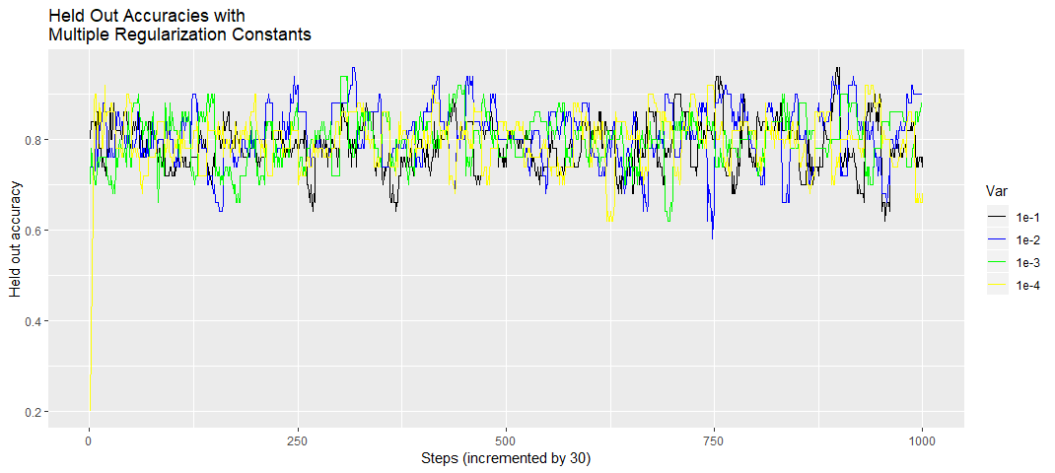

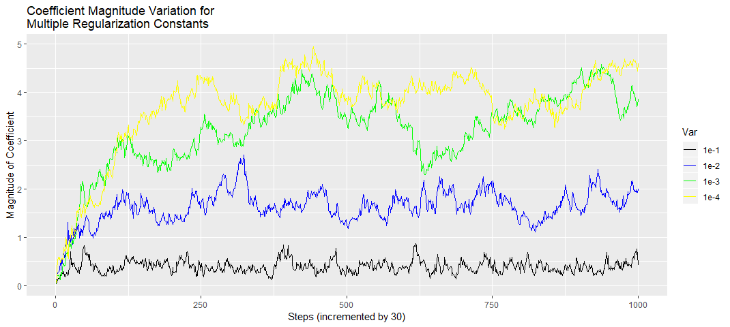

After running the code 7 times, I obtained the following table of cross-validation accuracies
 | 1 | 2 | 3 | 4 | 5 | 6 | 7 | Average accuracy
 | 0.809235 | 0.813607 | 0.815874 | 0.806334 | 0.79973 | 0.81139 | 0.805773 | 0.808849
 | 0.812034 | 0.805219 | 0.814501 | 0.809752 | 0.79973 | 0.80309 | 0.795032 | 0.805623
 | 0.800373 | 0.800559 | 0.814959 | 0.80041 | 0.795005 | 0.802859 | 0.797046 | 0.801602
 | 0.764692 | 0.786114 | 0.791857 | 0.797904 | 0.768902 | 0.763662 | 0.786082 | 0.779887

It seems that the accuracies from the first three values of are relatively close. However, looking at the held-out accuracy plot, the value seemed to be getting the best accuracies. So I decided to go with that.
The learning rate was , where is the season number.. This was chosen, because as the number of seasons increases, the step size decreases, because we assume that the algorithm is close to converging.

