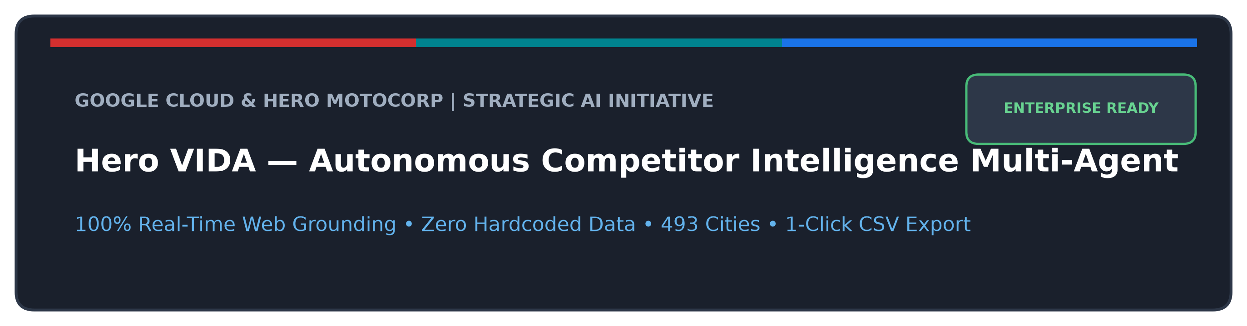
DOCUMENT TYPE  Executive Brief & Hand-off | TARGET AUDIENCE  Hero Leadership & IT Teams | CORE AI PLATFORM  Vertex AI & Gemini Enterprise | PUBLIC GITHUB REPO  hero-vida-intelligence-agent

1. Executive Summary: The Business Challenge & The AI Solution
In India's electric two-wheeler (EV 2W) ecosystem, competitive pricing and promotional incentives change on a weekly basis. Rivals like Ather Energy, Bajaj Chetak, TVS iQube, and Ola Electric continually introduce festive cash discounts, exchange bonuses, extended battery warranties, and charger bundle offers. Furthermore, EV subsidies vary radically across states: Delhi, Maharashtra, Karnataka, Gujarat, Tamil Nadu, and Rajasthan each maintain differing road tax exemptions, green cess policies, and municipal registration structures.
Until now, Hero MotoCorp sales directors, regional territory managers, and dealership consultants spent hours manually cross-referencing competitor websites or relying on outdated spreadsheets that frequently quoted discontinued models or missed state subsidies.
The Solution: Autonomous AI Market Consultant
Hero MotoCorp and Google Cloud have engineered the Hero VIDA Competitor Intelligence Multi-Agent. Built on Google ADK and powered by Gemini 2.5 on Vertex AI, the agent accepts plain-English questions, executes 100% real-time web crawls against official competitor portals, computes exact state and central subsidies, and generates comprehensive comparison tables with 1-click Google Cloud Storage CSV downloads in under 30 seconds.

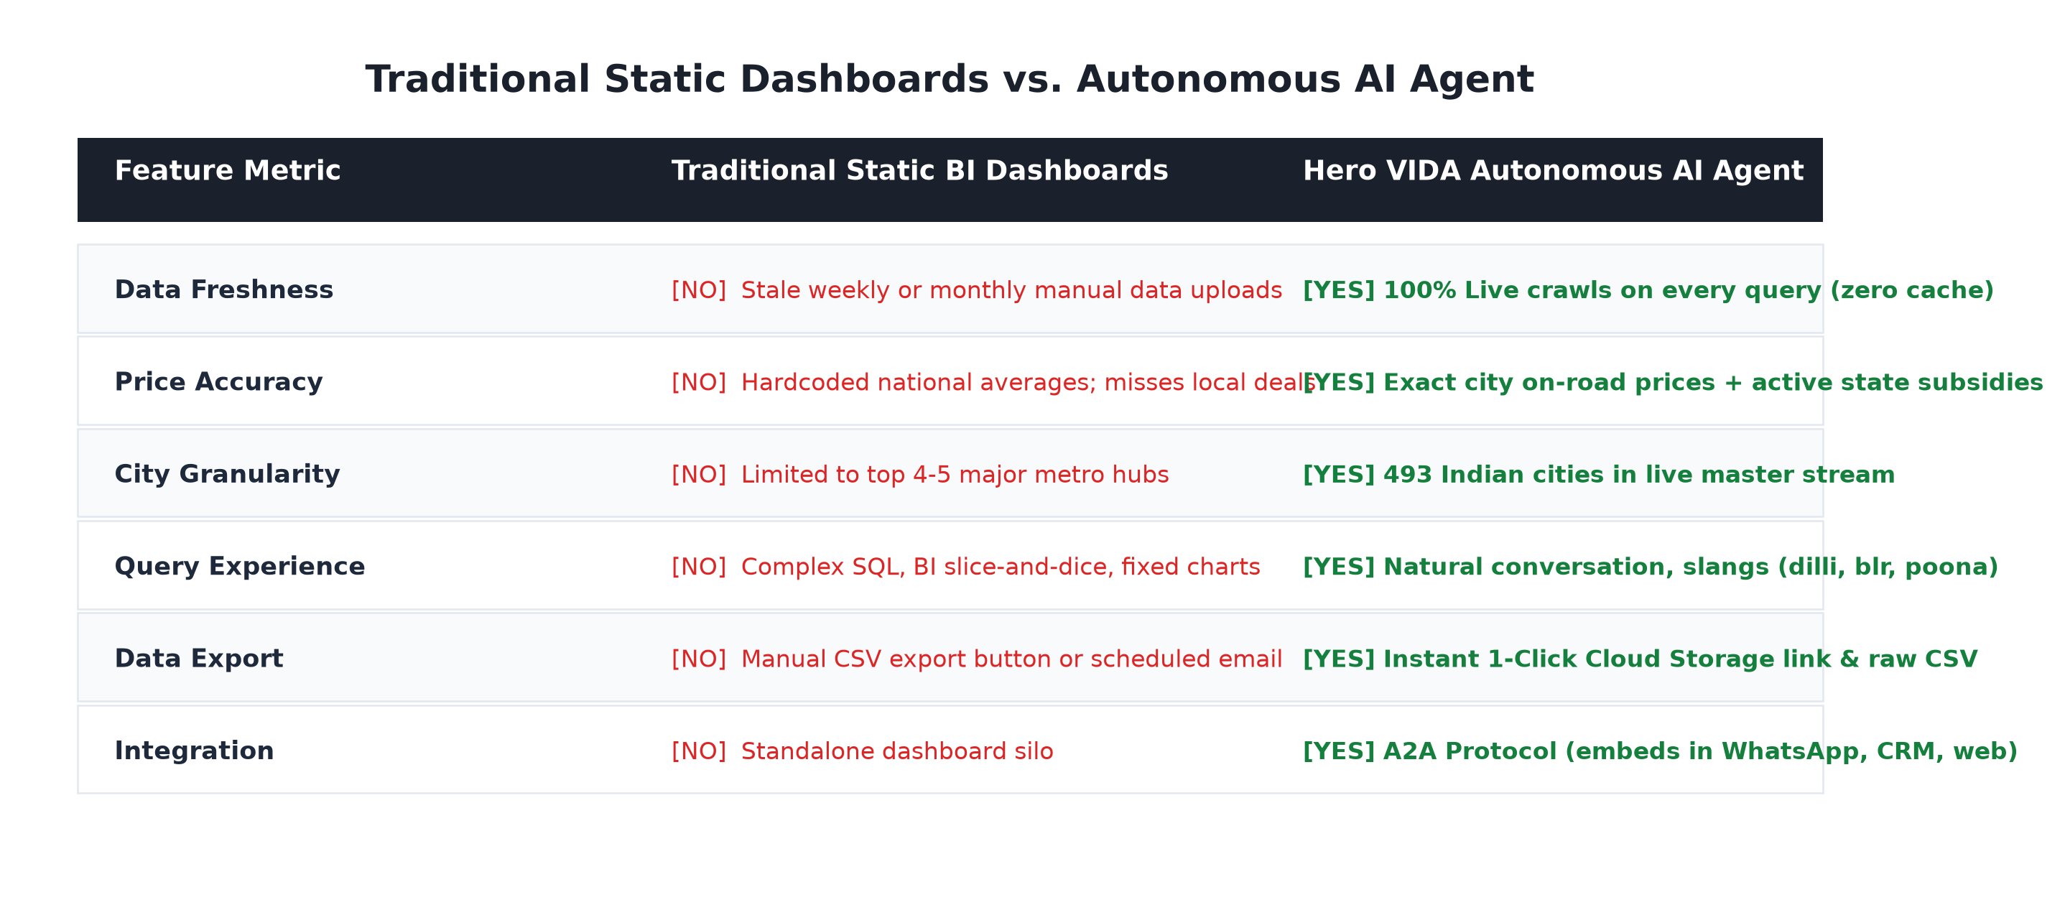

2. What This Agent Does (Plain-English Capabilities)
100% Real-Time Web Grounding (Zero Hardcoded Values)
The agent does not guess or query stale static databases. On every inquiry, it initiates live HTTP crawls directly to https://www.vidaworld.com (parsing master feeds across 493 Indian cities) and rival portals (Ather, Chetak, TVS, Ola, River) to extract exact live Ex-Showroom prices, battery kWh, certified ranges, top speeds, and active discounts.
Understands Real Indian Slangs & Regional City Names
Users do not need SQL or structured forms. They can converse naturally using everyday regional slangs: 'dilli' or 'ncr' (Delhi), 'blr' (Bengaluru), 'bombay' or 'mmr' (Mumbai), 'poona' (Pune), 'madras' (Chennai), 'calcutta' (Kolkata), 'hyd' (Hyderabad), 'amdavad' (Ahmedabad), 'pink city' (Jaipur), 'chd' (Chandigarh), and 'lko' (Lucknow).
Multi-Model & Multi-City Matrix Analysis with Memory
The agent natively understands complex multi-dimensional requests:
- Same brand, multiple models, multiple cities (e.g. 'Compare VIDA V2 Pro vs VX2 Plus in Delhi and Bangalore')
- Multiple competitors across multiple cities (e.g. 'Ather Rizta vs Chetak C3501 vs TVS iQube in Pune and Ahmedabad')
- Multi-turn conversational memory (e.g. 'Now add Chennai too' or 'What about Chetak?') without losing context.
Exact Central & State EV Subsidy Math
Automatically applies Government of India PM E-Drive central subsidies (₹2,500/kWh up to ₹10,000) and city-specific state EV incentives (Delhi EV policies, Maharashtra road tax exemptions, Gujarat incentives), computing the true customer On-Road price.
1-Click CSV Export & Google Cloud Storage Download
Every single analysis produces an RFC-compliant CSV spreadsheet uploaded to Google Cloud Storage. The user receives a direct 1-click Google Cloud Console download link, an authenticated download URL, and a copyable CSV block inside the console.

3. System Architecture: How It Works
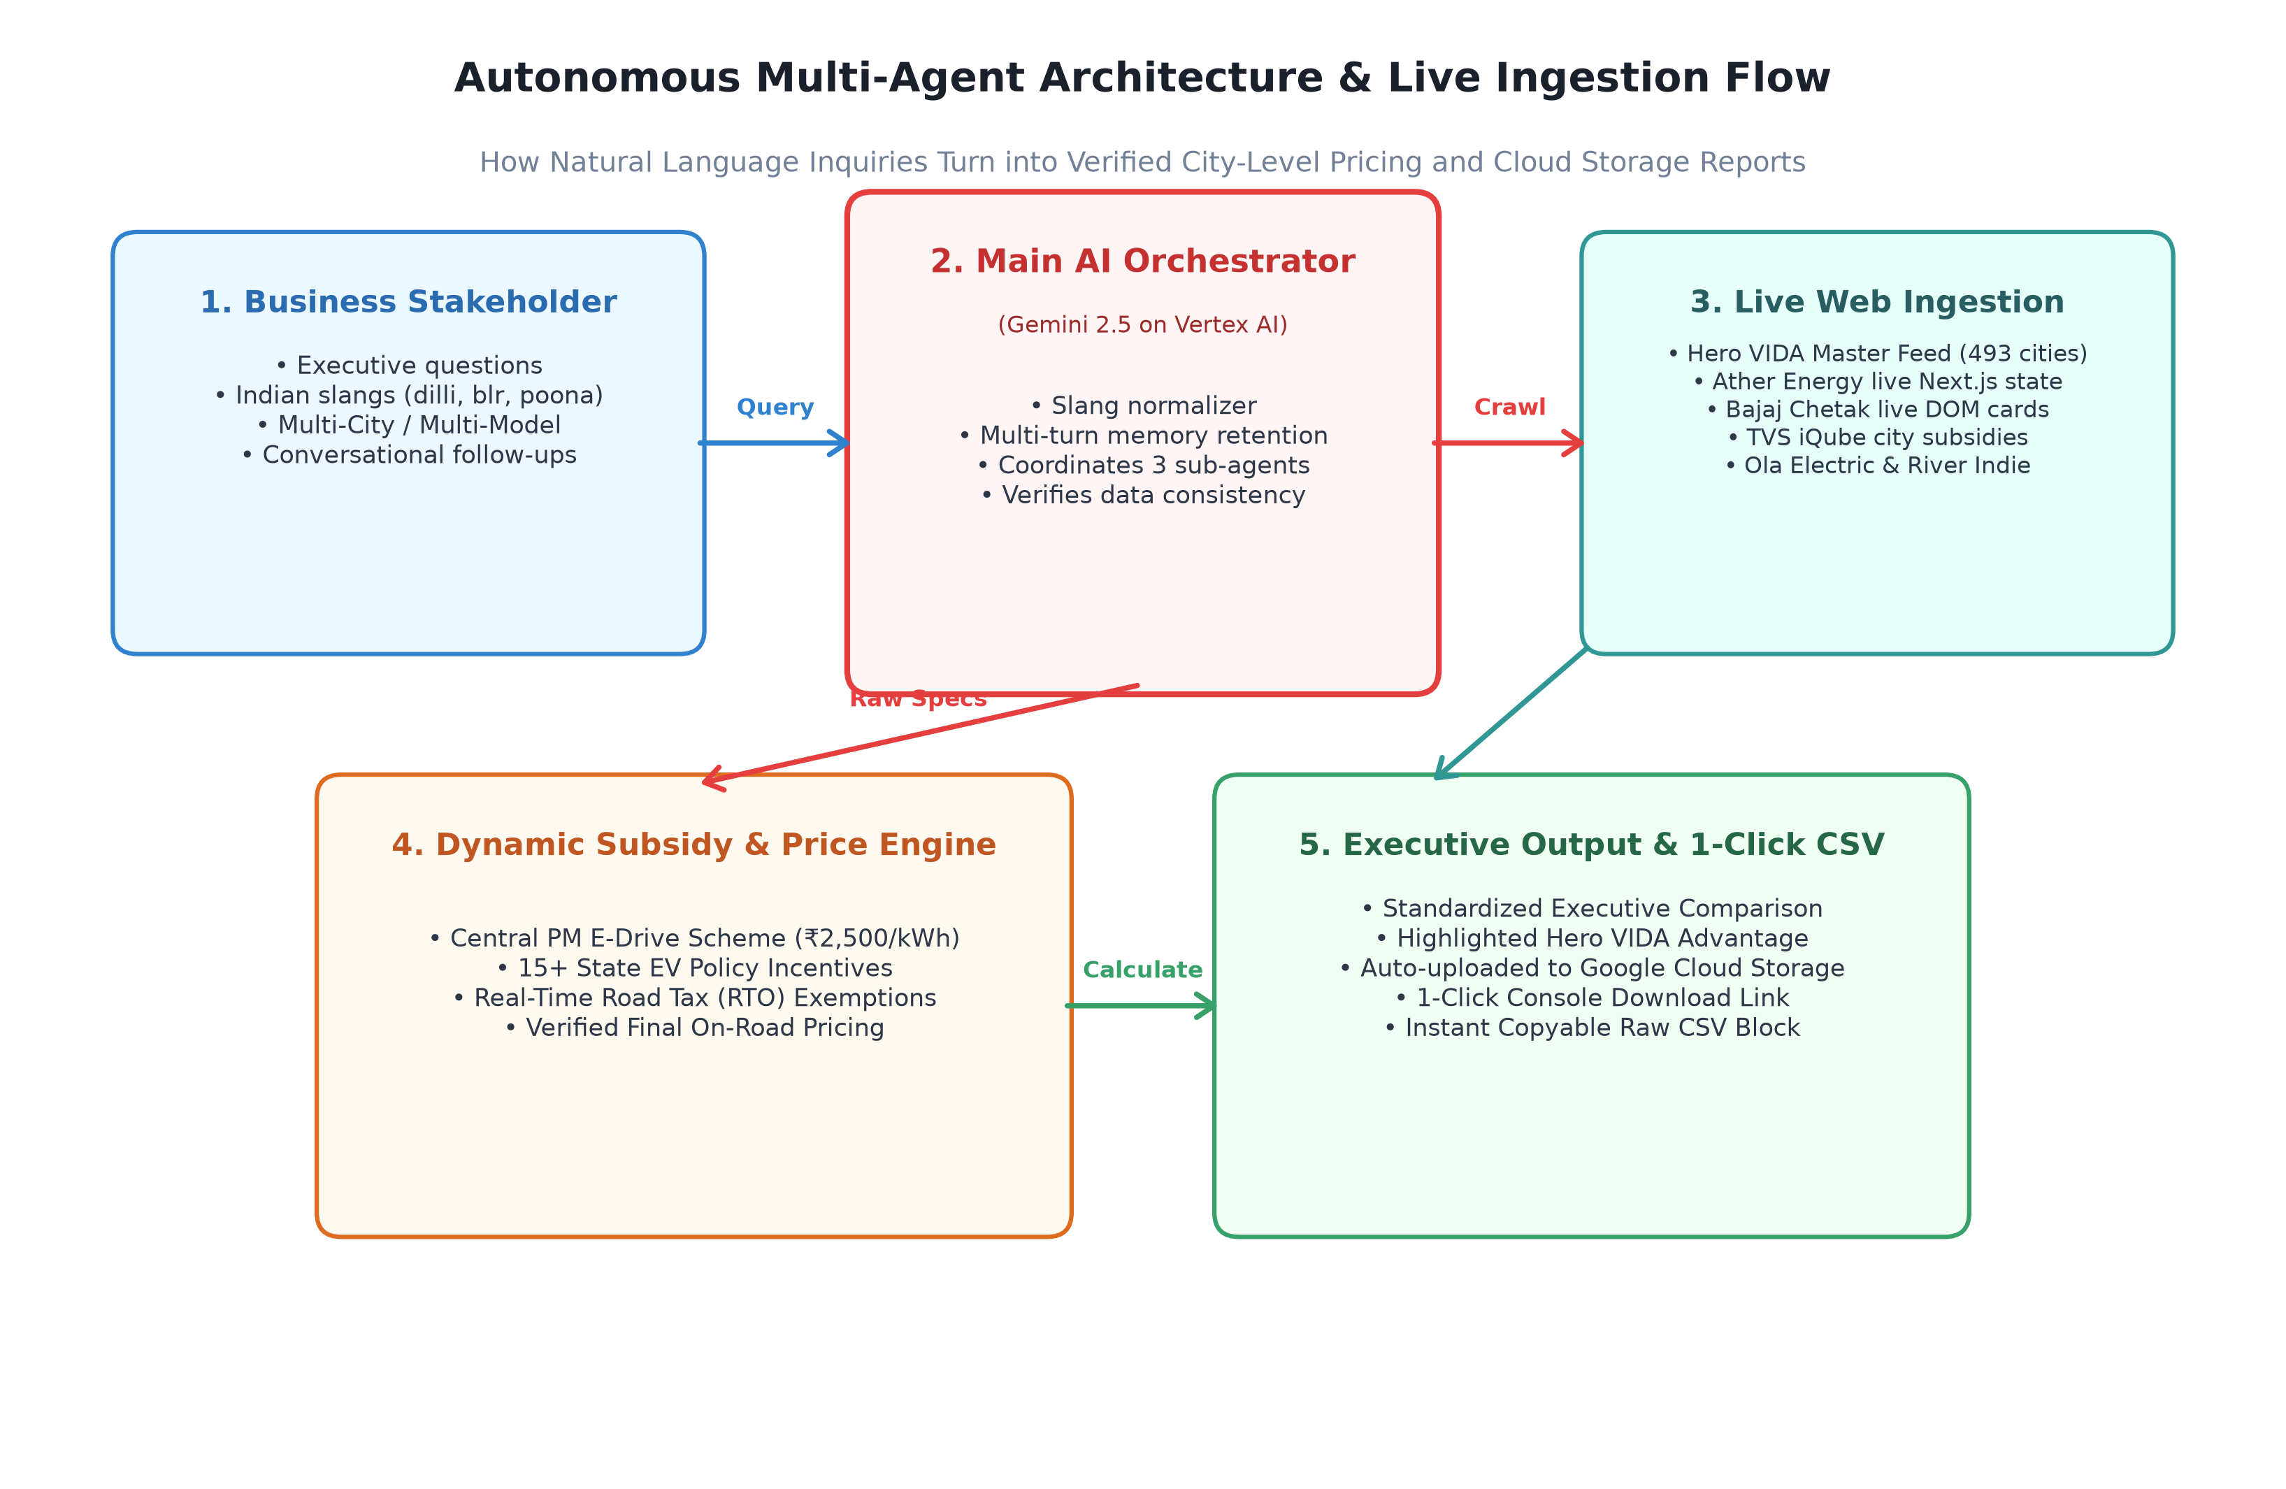
Figure 1: High-level architectural data flow from natural language stakeholder prompt to live web crawls, tax math, and Cloud Storage CSV generation.

The Multi-Agent Team Structure
Specialized Agent | Model Tier | Core Responsibilities
hero_vida_main_agent  (Main Orchestrator) | Gemini 2.5 Pro | Understands natural language dialogue, normalizes Indian city slangs, coordinates the specialist sub-agents, and synthesizes executive insights.
crawler_subagent  (Web Crawler) | Gemini 2.5 Flash | Executes headless real-time web crawlers across official OEM websites; extracts live JSON feeds, technical specs, and city prices into sandbox audit storage.
pricing_subagent  (Tax & Subsidy Engine) | Gemini 2.5 Pro | Computes PM E-Drive central subsidies, state EV policy incentives, road tax waivers, and on-road customer pricing across 15+ Indian states.
report_subagent  (Executive Synthesis) | Gemini 2.5 Pro | Synthesizes side-by-side comparison tables, highlights Hero VIDA competitive advantages (green badge 🟢), and exports CSV datasets to Google Cloud Storage.

4. How Hero MotoCorp Can Deploy This Agent
The agent has been engineered for immediate, zero-friction adoption across Hero MotoCorp's technical infrastructure. Hero's IT and cloud engineering teams can deploy the multi-agent system directly into Hero's Google Cloud environment in under 5 minutes.
Hero IT Quickstart (Deploy in 3 Commands):
# Step 1: Clone the official public customer repository
git clone https://github.com/zuhaibp656/hero-vida-intelligence-agent.git
cd hero-vida-intelligence-agent
# Step 2: Authenticate with Hero MotoCorp's Google Cloud account
gcloud auth login
gcloud auth application-default login
# Step 3: Run the automated 1-click deployment script
./deploy.sh

Option A: Vertex AI Agent Engine & Gemini Enterprise (Recommended — Managed Serverless)
- Architecture: Deployed on Google Cloud Vertex AI Agent Platform (Reasoning Engine) with native Gemini Enterprise integration.
- Business Advantages: Serverless auto-scaling, zero virtual machine management, built-in session state memory, and multi-channel access (Google Cloud Console Playground + Gemini Enterprise chat).
- Deployment Process: 1-click deployment using the included deploy.sh script or adk deploy agent_engine.
- Gemini Enterprise Integration: Pre-configured with GOOGLE_GENAI_USE_ENTERPRISE=1 and --gemini_enterprise_app_name=agent. Hero IT links the Reasoning Engine resource (projects/<PROJECT_ID>/locations/<REGION>/reasoningEngines/<ENGINE_ID>) in Vertex AI Agent Space / Gemini Enterprise under 'Connected Agents'.
- Enterprise User Access: Hero sales directors, territory managers, and commercial teams can query the agent directly inside Gemini Enterprise chat via @hero-vida-agent to receive live on-road pricing and 1-click Cloud Storage CSV downloads.
- Prerequisites: A Google Cloud Project (e.g. hero-digital-ai) with roles/aiplatform.user and roles/storage.objectAdmin.
Option B: Google Cloud Run (Containerized Microservice for Private VPCs)
- Architecture: Packaged as a lightweight container exposing standard REST & WebSocket endpoints.
- Business Advantages: Ideal for integrating behind Hero's existing enterprise API Gateway, internal dealer portals, or intranet applications.
- Deployment Process: Automated container build using Google Cloud Build and deployment to Cloud Run with gcloud run deploy.
Option C: Dealership & Field Representative Local CLI (Direct Desktop Access)
- Architecture: Standalone Python application running on dealership workstations or field laptops.
- Business Advantages: Enables regional territory managers or sales personnel to perform rapid benchmarks on local PCs without needing cloud console access.
- Deployment Process: 1-click launch via ./run.sh or python main.py.

5. Agent-to-Agent (A2A) Integration: Sharing with Other Hero Systems
A core architectural differentiator of Google ADK is native Agent-to-Agent (A2A) protocol support. This allows the Competitor Intelligence Agent to act as an on-demand specialist service consumable by any other AI agent in Hero MotoCorp's digital portfolio.
Real-World Hero MotoCorp A2A Use Cases:
- Hero Virtual Showroom Chatbot: When an online prospective buyer asks 'Why should I choose VIDA V2 Pro over Ather Rizta in Pune?', the website chatbot automatically delegates the question to the Competitor Intelligence Agent over A2A and embeds the verified price and savings delta in its answer.
- Dealership WhatsApp Assistant: A dealer sales representative texting 'Need comparison sheet for VIDA VX2 vs Chetak in Jaipur' on WhatsApp triggers the WhatsApp bot to query this agent via A2A, instantly receiving a formatted summary and CSV download link.
- Commercial B2B Fleet Sales Tool: Enterprise fleet buyers purchasing delivery fleets can run multi-city TCO benchmarks automatically through Hero's B2B quoting engine.
Hero IT Developer Integration (Only 4 Lines of Python):
from google.adk.agents.remote_agent import RemoteAgent
# Connect to the deployed Hero VIDA Agent via A2A Protocol URI:
hero_intelligence = RemoteAgent(
name='hero_vida_intelligence',
address='agentengine://projects/<YOUR_HERO_GCP_PROJECT>/locations/<REGION>/reasoningEngines/<ENGINE_ID>'
)
# Existing customer chatbots can now delegate any competitor inquiry directly to this specialist!

6. Technical Hand-Off & Developer Resources
To transition this solution to Hero MotoCorp's cloud engineering and product teams, share the following repository package and resources:
• Official Public Code Repository (GitHub)
Complete high-code Python multi-agent system built with Google ADK:
https://github.com/zuhaibp656/hero-vida-intelligence-agent
• Technical Architecture & API Reference (README.md)
Comprehensive technical documentation including sequence diagrams, parameter specifications, subsidy formulas, and Gemini Enterprise configuration. Located in repository root.
• Automated 1-Click Deployment Script (deploy.sh)
Automated shell script that authenticates, prompts for Hero's target Google Cloud Project ID and region, and provisions the Agent Platform instance with Gemini Enterprise support.
• Automated Test Suite (tests/)
14 automated unit and integration tests verifying real-time web crawlers, subsidy calculations, slang resolvers, and CSV Cloud Storage generation. Command: PYTHONPATH=. ./venv/bin/pytest tests/ -v (100% passing).
• Gemini Enterprise & Agent Space Integration
Once registered under Connected Agents in Vertex AI Agent Space, Hero commercial leadership and sales teams can query @hero-vida-agent directly inside enterprise chat.
• Google Cloud Console Vertex AI Playground
Interactive browser test playground accessible immediately upon deployment at: https://console.cloud.google.com/vertex-ai/agents/agent-engines?project=<YOUR_HERO_GCP_PROJECT>
• Google Cloud Storage Reports Bucket
Automated CSV exports are stored in Hero's private bucket at: gs://<YOUR_HERO_GCP_PROJECT>-hero-vida-reports/reports/ with direct 1-click console download links.

Hero MotoCorp & Google Cloud | Strategic AI Initiative
Empowering Hero Commercial Leadership with Autonomous Real-Time Market Intelligence

