THE MECHANISM LAYER
Advanced Nutrition,
Muscle & Metabolism
What actually separates elite athletes, coaches, and researchers from the average gym-goer — a mechanism-first report on growth, fat loss, recovery, individual response, and the limits of current science.
10 advanced domains · 12 research figures · 32 references · evidence-rated throughout

How to read this report
This isn't a beginner guide. It assumes you already own calories, macros, protein targets, and supplement basics, and it goes straight for the mechanisms — the cellular and systemic machinery that decides why two people on the identical program get different results. Three conventions:
- Evidence is rated inline so you know how much to trust each claim: [Very strong] [Strong] [Moderate] [Weak] [Speculative] .
- Every figure is built from study data and captioned with its source and how to read it.
- Each domain closes with the consensus, the live debates, what's still unknown, and the practical leverage.
THE THESIS IN ONE LINE
The average lifter optimizes the visible 5% (timing, supplements). The elite optimize the invisible 80% — adherence, energy, protein, recovery, and matching the plan to the individual. This report is the invisible 80%.

01 Individual Differences in Muscle Growth
Key question: why can two people run the identical program and get dramatically different results? The honest answer the average lifter never internalizes: a large fraction of your response is set by biology you didn't choose — and the program is only part of the story.
Consensus findings
The response to resistance training is enormously variable. In Hubal's landmark unilateral-training study and Bamman's cluster analyses, gains ranged from essentially zero to enormous on the same protocol — fiber cross-sectional area changes spanning roughly −7% to +52% across individuals. ^{[1] [2]} Researchers formally cluster trainees into non-, moderate, and extreme responders.
The mechanisms that separate high from low responders are now reasonably well mapped: high responders show greater satellite-cell proliferation and myonuclear addition, larger increases in ribosome biogenesis (translational capacity), a bigger myofibrillar protein-synthesis response, higher intramuscular androgen-receptor content, and elevated IGF-1 mRNA variants. ^{[2] [3]} [Strong]
FIG 1.1 The response range on one identical program
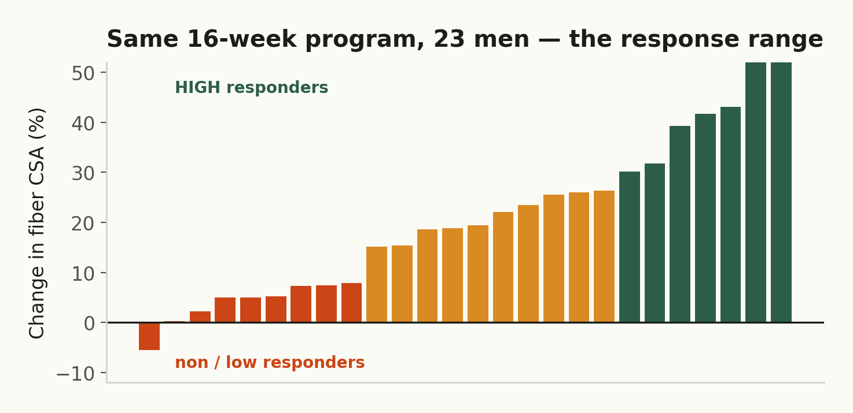
Reconstructed from Hubal 2005 / Bamman cluster data: identical training, wildly different hypertrophy. High responders (green) versus non/low responders (orange). [1,2]
The satellite-cell mechanism
Muscle fibers are giant multinucleated cells, and each nucleus can only service so much cytoplasm (the myonuclear domain). To grow substantially, a fiber must add nuclei — and it borrows them from satellite cells, the muscle's resident stem cells. Petrella & Bamman (2008) showed extreme responders both started with more satellite cells and added myonuclei during training, while non-responders did neither. ^{[2]} [Strong]
FIG 1.2 How a fiber recruits the nuclei it needs to grow
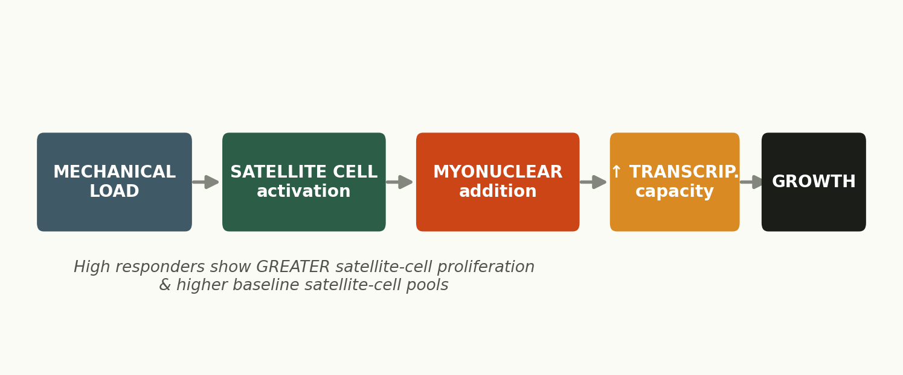
The satellite-cell → myonuclear-addition pathway. High responders have larger baseline satellite-cell pools and proliferate more. [2,3]
FIG 1.3 The biomarkers that differ between responders
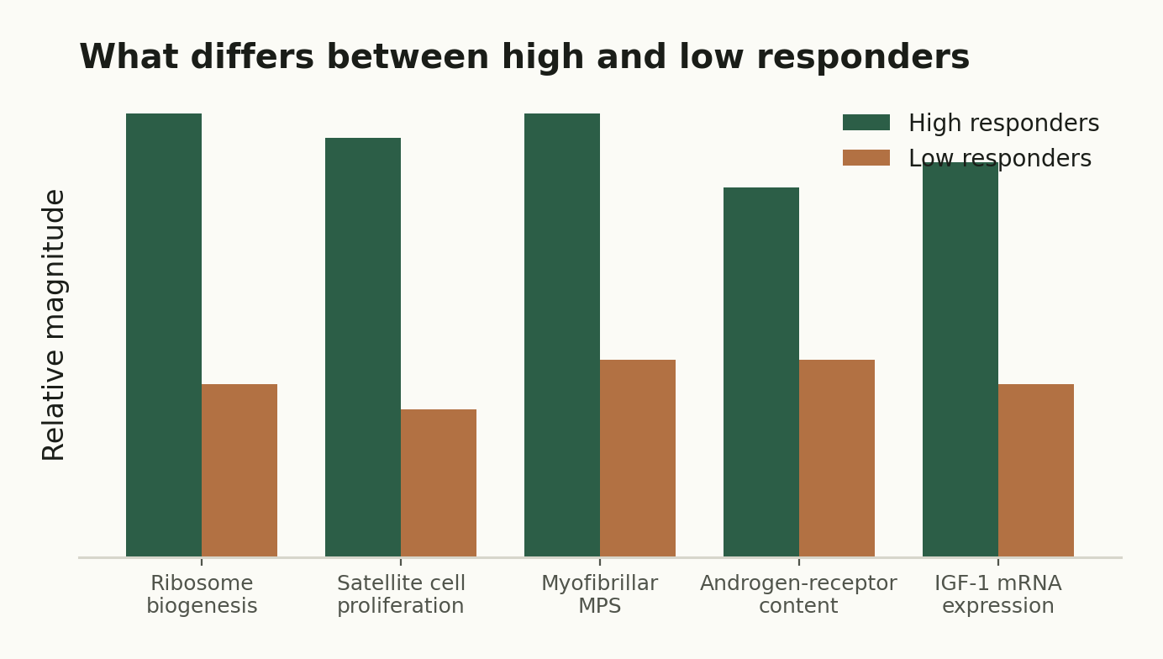
Composite of mechanisms reported to differ between high and low responders following training. [3]
Muscle memory — and why it's real at the cellular level
Once you build those extra myonuclei, in-vivo imaging suggests they're largely retained even through long detraining — they don't die when the fiber shrinks. On retraining, the nuclear machinery is already in place, so regrowth is faster. Layered on top is an epigenetic memory: DNA-methylation marks from prior training prime growth-related genes for years. ^{[4] [5]} [Moderate]
Major debates & current uncertainties
- Genetics is real but messy: single-gene candidates (ACTN3, ACE, myostatin variants) each explain only a sliver of the variance — it's highly polygenic, and no test predicts your response well yet.
- Is the myonuclear-domain ceiling fixed, or can fibers grow meaningfully before adding nuclei? Still contested.
- The permanence of myonuclei has been challenged by some rodent work — strong in animals, harder to prove definitively in humans.
PRACTICAL LEVERAGE
You cannot change your responder status — but you can stop comparing your results to someone else's program. Auto-regulate to your own recovery and progression, give a stimulus more time before judging it, and remember the cellular point: if you've trained before, your myonuclei are banked. Comebacks are fast.
Landmark studies: Hubal 2005 (MSSE) variability; Petrella/Bamman 2008 (JAP) satellite-cell cluster analysis; Roberts & Haun 2018 (Front Physiol) responder review; Bruusgaard 2010 (PNAS) myonuclear permanence; Seaborne 2018 (Sci Rep) epigenetic memory.

02 Nutrient Partitioning
Key question: what determines where your calories actually go — into muscle or into fat? This is the variable that decides whether a surplus builds you or just softens you, and a deficit strips fat or strips muscle.
Consensus findings
The P-ratio (partitioning ratio) is the fraction of an energy imbalance that comes from lean tissue rather than fat. Forbes (1987/2000), later refined by Hall (2007), established that the single biggest predictor of partitioning during over- or under-feeding is starting body-fat level: leaner individuals partition a surplus toward lean mass, while higher-body-fat individuals gain proportionally more fat. ^{[6] [7]} [Moderate]
FIG 2.1 Leaner bodies send surplus calories to muscle
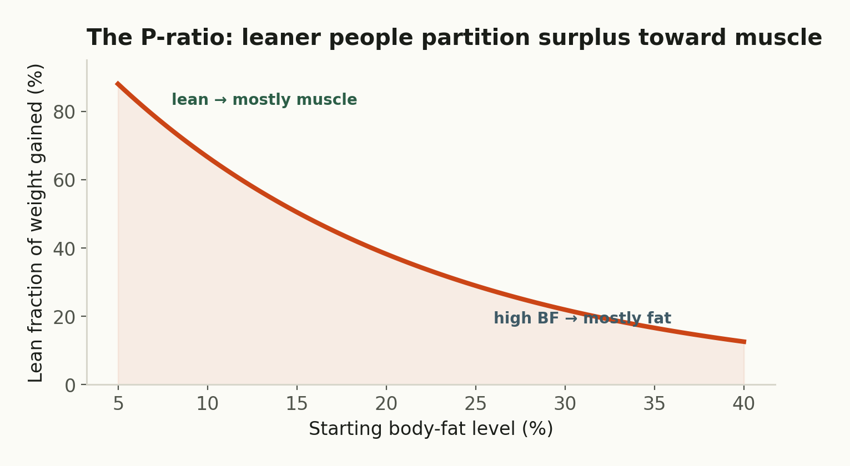
Forbes/Hall model: the lean fraction of weight gained falls as starting body fat rises. The basis for 'don't bulk from a high body-fat level.' [6,7]
The other levers: training is the dominant signal telling the body to keep/build muscle; protein supplies and spares it; insulin sensitivity and muscle glycogen status route nutrients (full, sensitive muscle stores incoming carbs as glycogen rather than shunting them to fat). Carb versus fat overfeeding also differs — Horton (1995) found excess fat is stored more efficiently (~90–95%) than excess carbohydrate (~70–75%). ^{[8]} [Moderate]
Major debates
- How far does the overfeeding P-ratio data transfer to training lifters? Henselmans argues higher body-fat raises your muscular ceiling; Nuckols counters that impaired partitioning during a bulk is effectively impaired hypertrophy. Both have a point — it's unresolved.
- Is there an optimal body-fat 'window' to bulk from (often cited ~10–15% for men)? Plausible and popular, but the precise numbers are extrapolation, not hard data.
Current uncertainties & emerging research
Adipocyte biology (fat-cell number vs size), local inflammation, and adipose insulin sensitivity all modulate partitioning in ways we can't yet quantify per individual. Emerging work on adipose–muscle crosstalk and personalized glycemic response hints at future individualized partitioning models, but nothing is clinic-ready. [Weak]
PRACTICAL LEVERAGE
Start a gaining phase from a reasonably lean state, keep the surplus modest, train hard (the partitioning signal), keep protein high, and place carbs around training when muscle is most insulin-sensitive. You're not changing thermodynamics — you're biasing where the calories land.
Landmark studies: Forbes 2000; Hall 2007 (Br J Nutr) Forbes revisited; Horton 1995 (AJCN) carb vs fat overfeeding.

03 Body-Fat Regulation
Key question: why do some people stay lean almost effortlessly while others fight continuously? Because body fat is an actively defended variable, and the vigor of that defense differs between people.
Consensus findings
Fat mass is regulated by a feedback system centered on leptin, secreted by fat tissue in proportion to its size. Leptin's evolutionary job is to defend against fat loss: when fat (and thus leptin) falls, the brain reads famine and responds with more hunger, lower energy expenditure, and downshifted thyroid and reproductive function. ^{[9] [10]} [Strong]
FIG 3.1 The starvation alarm that defends your fat stores
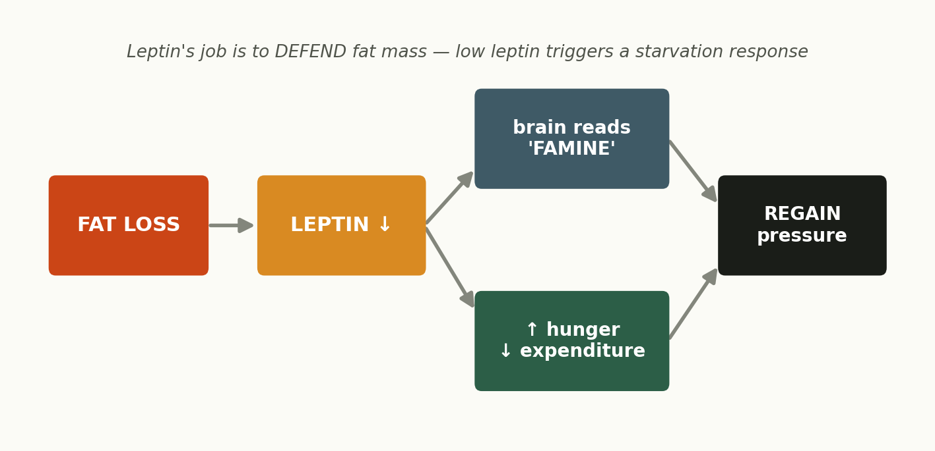
Falling leptin during fat loss triggers a coordinated defense — the biology behind plateaus and post-diet regain. [9,10]
Sumithran's NEJM trial showed these appetite-hormone adaptations (leptin down, ghrelin up) persist at least a year after weight loss — maintenance is fighting active biology, not just willpower. ^{[11]} [Strong]
Leptin resistance, set-point vs settling-point
In obesity, leptin is high yet the brain stops responding — leptin resistance — so the satiety signal fails even with ample stores. ^{[10]} The classic set-point model (a fixed defended weight) is now seen as too rigid; the settling-point view — weight settles where biology and environment balance — fits the data better. The modern synthesis is a defended range, guarded hardest at its lower edge and shiftable by the food environment. [Moderate]
Debates & uncertainties
- Why do individuals differ so much in defense vigor? Genetics, developmental fat-cell number, and environment all contribute — but per-person prediction is beyond us.
- Is leptin resistance a cause or a consequence of obesity? Distinguishing them is genuinely hard (the Myers/Schwartz debate).
- Leptin therapy works dramatically in true deficiency/lipodystrophy but disappoints in common obesity — a humbling reminder the system is redundant.
PRACTICAL LEVERAGE
Respect the defense. Use modest deficits, periodic maintenance breaks to let leptin recover, high protein and fibre to fight the hunger surge, and prioritize sleep (poor sleep worsens the hormonal picture). The lean-'effortlessly' person usually has both favorable biology and an environment and habits that keep the defended range low.
Landmark studies: Sumithran 2011 (NEJM); leptin physiology reviews (Myers/Schwartz); Rosenbaum & Leibel on adaptive thermogenesis.

04 Advanced Cell Signaling
Key question: what cellular processes truly switch muscle growth and breakdown on and off? Everything you do — eat, lift, diet, sleep — ultimately routes through a handful of molecular switches.
The two opposing arms
Growth is net of two programs. The build arm runs IGF-1 / mechanical load → Akt → mTORC1, which ramps up protein synthesis (via S6K1, 4E-BP1) and ribosome biogenesis. The breakdown arm runs energy stress → AMPK and FOXO transcription factors, which switch on the atrophy genes MuRF1 and Atrogin-1 (the ubiquitin-proteasome system) and autophagy. Bodine & Glass's 2001 work mapped this Akt/mTOR↔FOXO axis and remains foundational. ^{[12] [13]} [Strong]
FIG 4.1 The molecular seesaw of growth and atrophy
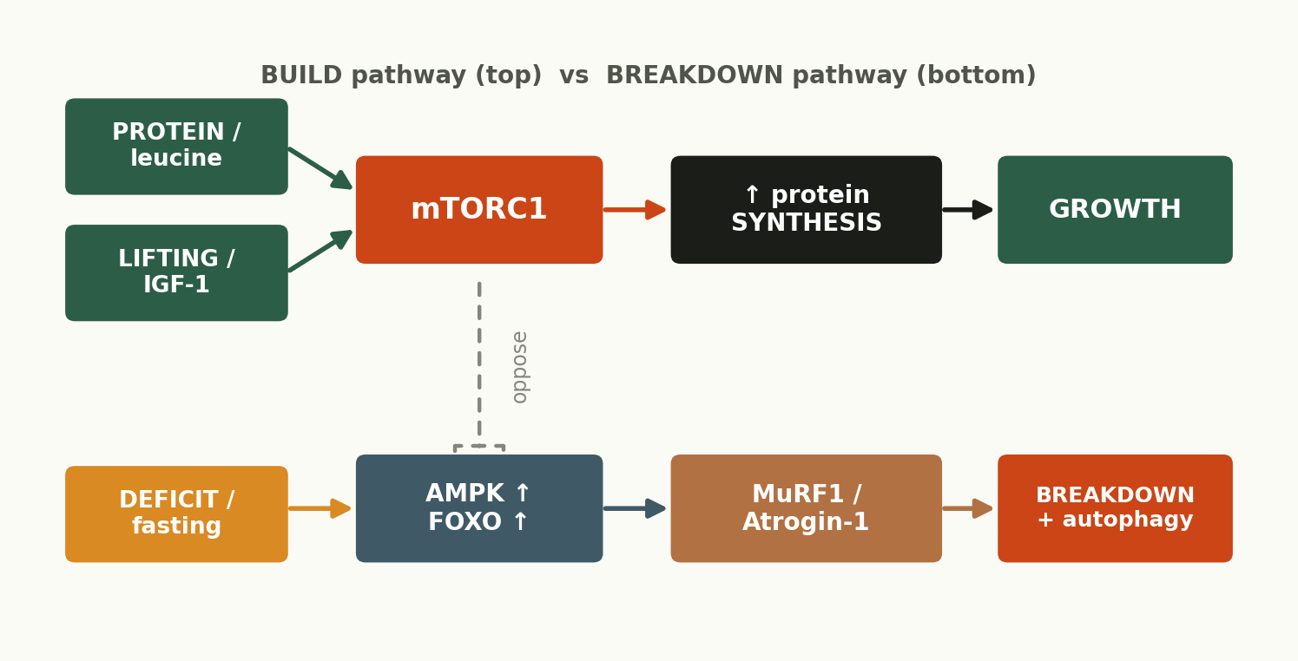
IGF-1/lifting → mTORC1 drives synthesis (top); energy stress → AMPK/FOXO → MuRF1/Atrogin-1 drives breakdown (bottom). Akt also restrains FOXO, coupling the arms. [12,13]
mTORC1 vs mTORC2, and the AMPK brake
Switch | What activates it | What it does
mTORC1 | Leucine, IGF-1/Akt, mechanical load, energy abundance | Master driver of protein synthesis & ribosome biogenesis — the 'grow' signal
mTORC2 | Growth-factor signaling (PI3K) | Regulates Akt, cytoskeleton, metabolism — supports the growth program upstream
AMPK | Low energy (high AMP:ATP), fasting, endurance | The 'conserve' sensor — inhibits mTORC1, switches on fat oxidation & autophagy
FOXO | Low Akt signaling, energy/stress | Transcribes atrophy genes (MuRF1, Atrogin-1) and autophagy

The nuance most people miss: autophagy isn't the enemy
Autophagy (cellular self-cleaning) sounds catabolic, but basal autophagy is required for healthy muscle — it clears damaged proteins and organelles. The goal isn't to suppress it; it's to cycle between anabolic (fed/trained) and clean-up (fasted/recovery) states. This is the molecular root of why you can't be maximally anabolic 24/7. [Moderate]
Debates & emerging research
- How necessary is mTORC1 specifically for load-induced hypertrophy? Rapamycin studies suggest important but not the whole story — mechanotransduction has mTOR-independent components.
- Myostatin (a brake on growth) and follistatin are exciting targets, but human 'myostatin-inhibitor' supplements are unproven. [Speculative]
- Mechanically-activated pathways (e.g. via titin, focal adhesions) are an active frontier — we don't fully know how the cell 'feels' tension.
PRACTICAL LEVERAGE
You already pull these levers without the jargon: leucine-rich protein + hard training spike mTORC1; a deficit/endurance work raises AMPK/FOXO. The takeaway is integrative — you bias the seesaw over a phase, you don't pin it. And no supplement meaningfully 'hacks' mTOR beyond getting protein and training right.
Landmark studies: Bodine et al. 2001 (Nat Cell Biol & Science) Akt/mTOR & MuRF1/Atrogin-1; Saxton & Sabatini 2017 (Cell) mTOR review.

05 Recovery Physiology
Key question: what limits adaptation before training even becomes productive? Recovery — and the elite track it, while the average lifter only tracks the workout.
Consensus findings
Adaptation happens between sessions. Push training load past your recovery capacity and you slide along a continuum: functional overreaching (a planned short overshoot that supercompensates), to non-functional overreaching (stalled progress, needs weeks to recover), to overtraining syndrome (months of underperformance). The hallmark is unexplained performance decline despite rest. ^{[14]} [Strong]
FIG 5.1 Adaptation has a ceiling set by recovery
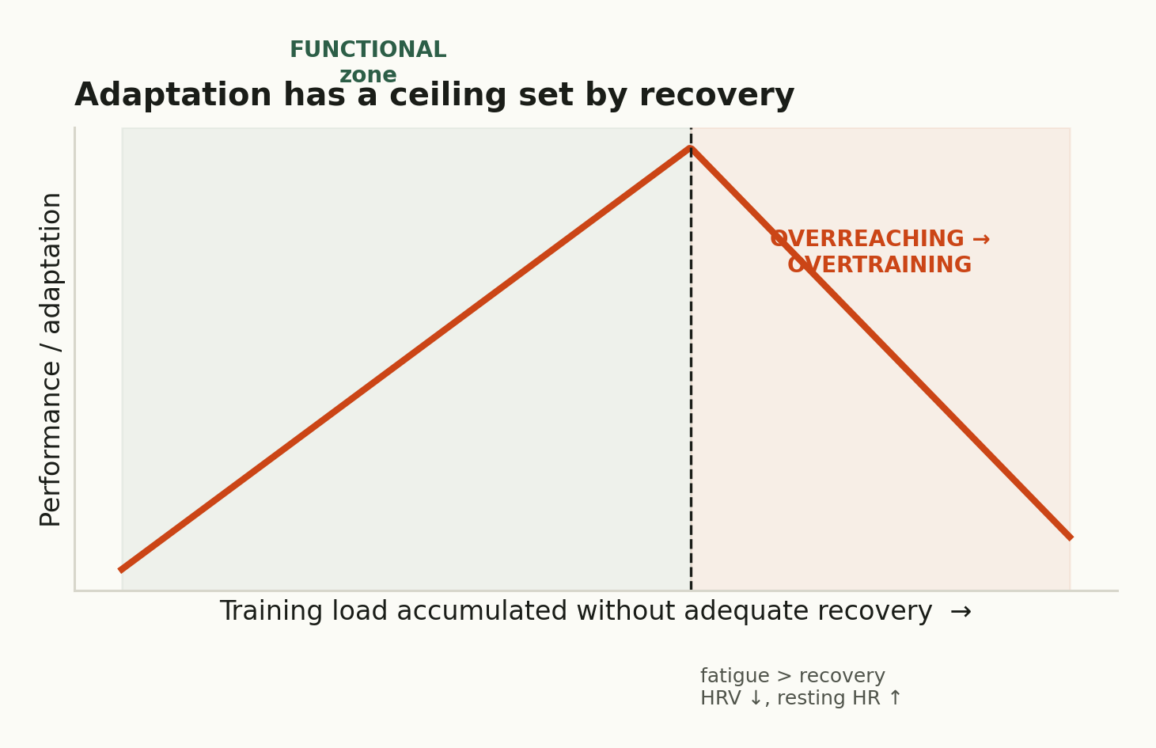
Load applied faster than you recover tips you from the functional zone into overreaching/overtraining — performance falls, HRV drops, resting HR rises. [14]
HRV and the autonomic window
Heart-rate variability — beat-to-beat variation, driven largely by parasympathetic (vagal) tone — is the best practical, non-invasive proxy for autonomic recovery status. Higher resting HRV generally signals a recovered, parasympathetically-dominant state ready to train; a suppressed HRV with elevated resting heart rate flags accumulated fatigue or systemic stress. Trends matter far more than single readings. ^{[15]} [Moderate]
Sleep as the master recovery variable
Sleep is the single highest-leverage recovery input. On an identical diet, short sleep redirected loss from fat toward muscle (Nedeltcheva), and acute sleep loss suppresses muscle protein synthesis and shifts the hormonal milieu (cortisol up, testosterone down). ^{[16]} [Strong]
Debates & uncertainties
- Recovery biomarkers (CK, cortisol, testosterone:cortisol ratio, HRV) are noisy individually — no single marker reliably diagnoses overtraining; the diagnosis is still largely clinical (performance + symptoms).
- How much is 'central' (CNS/autonomic) vs 'peripheral' (muscle) fatigue? Genuinely unresolved and likely individual.
- Optimal HRV-guided training improves outcomes in some studies but not all — promising, not settled.
PRACTICAL LEVERAGE
Sleep 7–9 h non-negotiably. Watch HRV trends and resting HR as an early-warning system. Programme deloads every ~4–8 weeks. Treat life stress as training stress — they share the same recovery budget. The athlete who recovers can train productively more often; that compounds over years.
Landmark studies: Meeusen et al. 2013 (ECSS/ACSM overtraining consensus); Plews 2013 (Sports Med) HRV in athletes; Nedeltcheva 2010 (Annals) sleep & body composition.

06 Appetite & Food Reward
Key question: what really determines hunger and adherence? Two systems — a homeostatic 'how much energy do I have' system and a hedonic 'how much do I want this' reward system — and modern food hijacks the second.
The homeostatic system
Hunger is hormonally orchestrated: ghrelin (stomach) drives hunger and rises before meals; leptin signals long-term energy stores; PYY and GLP-1 (gut) signal fullness after eating, especially after protein and fibre. Dieting pushes this whole system toward hunger and keeps it there. ^{[11]} [Strong]
The reward system — and why it overrides fullness
Separately, the brain's dopamine circuitry encodes 'wanting' and reward prediction. Hyperpalatable foods — engineered sugar/fat/salt/texture combinations rare in nature — hit reward hard and weaken satiety, so you eat past fullness. Hall's tightly controlled 2019 trial showed people ate ~500 kcal/day more on an ultra-processed diet matched for macros, eating faster and gaining weight — the food itself drove the overconsumption. ^{[17]} [Strong]
On a deficit, this gets worse: energy restriction up-regulates the reward value of sweet, dense food via hunger-neuron (AgRP) circuitry — your brain makes junk feel more rewarding precisely when you're trying to resist it.
Debates & uncertainties
- Is 'food addiction' a valid clinical construct? Hotly debated — the reward overlap with addiction is real, but the framing is contested.
- Which specific food property (energy density? texture? the sugar-fat combo?) drives hyperpalatability most? Being actively dissected.
PRACTICAL LEVERAGE
Adherence is engineered, not willed. Build meals from high-satiety, less-processed whole foods (protein, fibre, volume) that spike the fullness hormones and don't hijack reward. Don't ban the foods you love — schedule them — because rigid restriction inflames the reward system. The environment you set up beats the willpower you summon.
Landmark studies: Hall et al. 2019 (Cell Metab) ultra-processed RCT; Sumithran 2011 (NEJM) appetite hormones.

07 Metabolic Flexibility
Key question: what separates a metabolically healthy person from a metabolically 'stuck' one? The ability to switch fuels cleanly on demand.
Consensus findings
Metabolic flexibility is the capacity to switch fuel oxidation to match availability: burn fat when fasted, switch crisply to glucose when carbs arrive. The flexible person makes this transition cleanly; the inflexible person (typical of obesity and type-2 diabetes) is partially stuck — blunted fat oxidation when fasted and impaired glucose oxidation when fed. Goodpaster & Sparks (2017) and Galgani/Ravussin (2008) anchor the modern view, building on the Randle cycle and Kelley's limb-balance work. ^{[18] [19]} [Strong]
FIG 7.1 Clean fuel-switching vs being metabolically 'stuck'
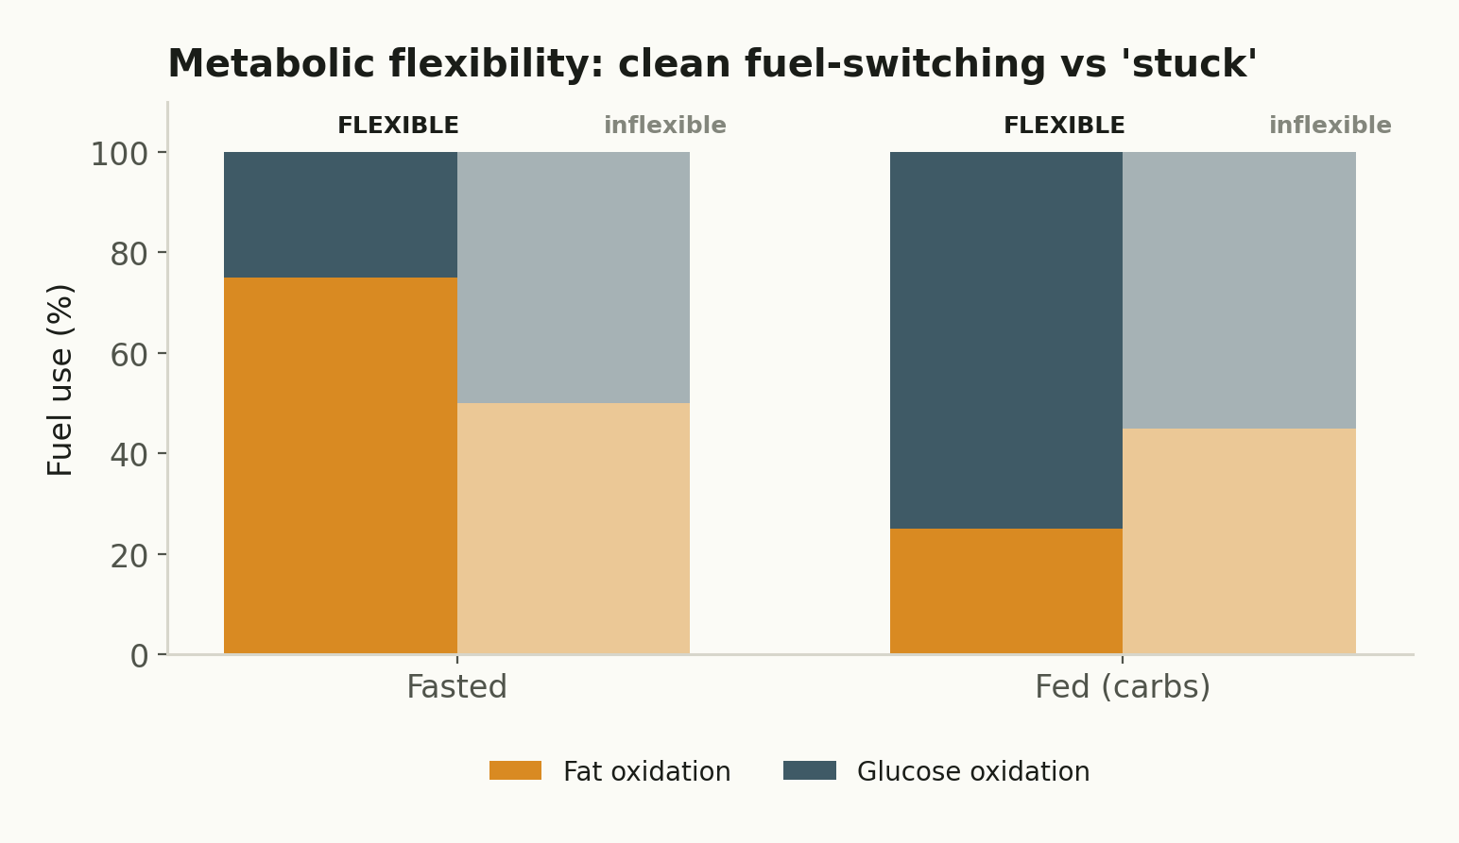
A flexible metabolism shifts decisively between fat (fasted) and glucose (fed); an inflexible one blunts both transitions. Schematic after Goodpaster/Sparks & Galgani/Ravussin. [18,19]
What builds flexibility
- Mitochondrial density and quality — more, healthier mitochondria oxidize fat better. Endurance and resistance training both improve this (mitochondrial biogenesis).
- Muscle mass and insulin sensitivity — bigger, sensitive muscle is a better glucose sink.
- Not being in chronic surplus — overfeeding and ectopic fat (intramyocellular lipid) drive inflexibility.
Debates & uncertainties
The field is honestly messy: much 'inflexibility' measured by respiratory-quotient change during an insulin clamp turns out to be downstream of impaired glucose uptake rather than a separate defect (Galgani 2008), and the best way to measure flexibility is disputed. Whether improving flexibility per se (vs just improving fitness and leanness) independently helps is unresolved. [Moderate]
PRACTICAL LEVERAGE
You don't train 'metabolic flexibility' directly — you earn it. Build muscle, train (both lifting and some cardio) to grow mitochondria, stay out of chronic surplus, and keep insulin sensitivity high. Flexibility is the readout of a fit, lean, muscular, active body — not a protocol you buy.
Landmark studies: Goodpaster & Sparks 2017 (Cell Metab); Galgani, Moro & Ravussin 2008 (AJP-Endo); Kelley & Mandarino limb-balance studies.

08 The Gut–Muscle Axis
Key question: can gut health actually influence muscle gain and performance? Emerging evidence says plausibly yes — through bacterial metabolites — but the human, trained-athlete data is still thin. This is the frontier.
Consensus (such as it is)
Gut bacteria ferment dietary fibre into short-chain fatty acids — acetate, propionate, butyrate (roughly a 60:20:20 mix) — which enter circulation and reach muscle. Mechanistically, butyrate suppresses the FOXO3a/Atrogin-1 atrophy pathway and supports mTOR signaling (sparing muscle), while acetate enhances mitochondrial function and glucose metabolism. Lower SCFA-producing bacteria track with sarcopenia (age-related muscle loss). ^{[20] [21] [22]} [Weak] to [Moderate]
FIG 8.1 Fibre → microbiome → SCFAs → muscle signaling
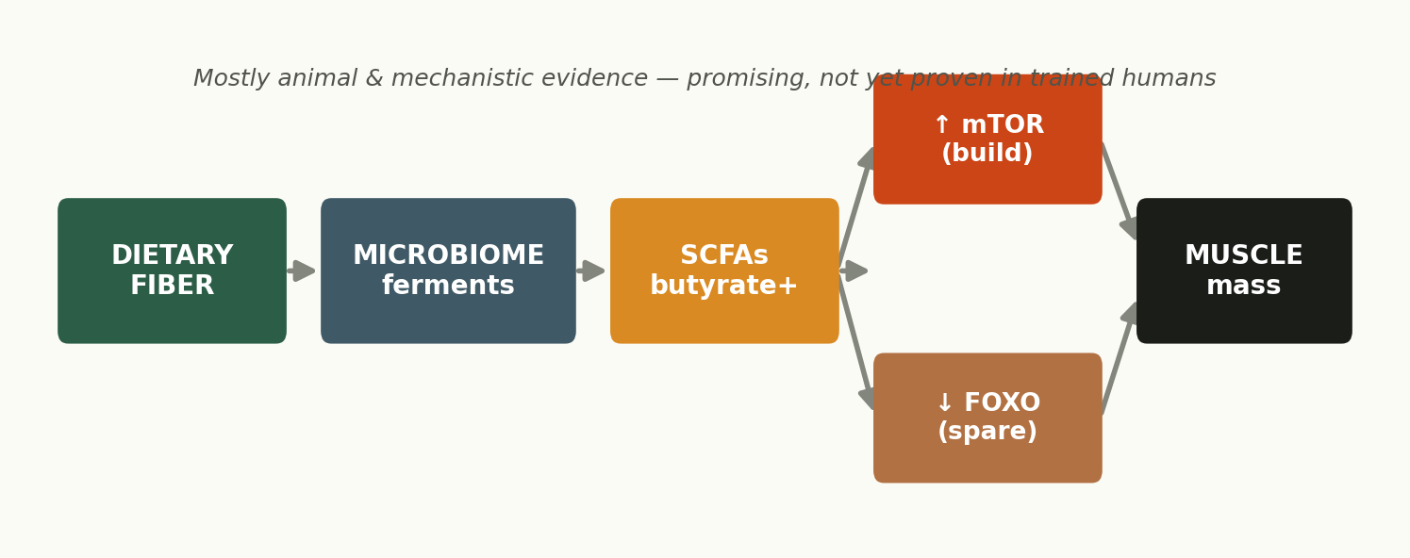
The proposed gut–muscle axis: fermentation products signal to the same growth/atrophy pathways from Section 4. Mostly animal & mechanistic so far. [20,21,22]
Why caution is warranted
Most of the encouraging data is animal, in-vitro, or in aging/clinical populations — not healthy, trained lifters. A Mendelian-randomization study did suggest the microbiome causally affects muscle mass via butyrate in menopausal women, which is promising, but extrapolating to a 25-year-old chasing hypertrophy is a leap. ^{[23]} [Speculative]
Debates & emerging research
- Does manipulating the microbiome (probiotics, specific fibres) improve performance or hypertrophy in trained humans? Largely untested — current strain-specific claims outrun the evidence.
- Direction of causation: does training shape the microbiome, the microbiome shape muscle, or both? Likely bidirectional; hard to disentangle.
PRACTICAL LEVERAGE
Don't buy 'gut-gains' supplements. The evidence-based move is also the boring one: eat plenty of varied fibre (25–40 g/day) and fermented foods, which supports SCFA production and a diverse microbiome as a byproduct of generally good eating. Treat dedicated gut-for-muscle protocols as speculative until human trials land.
Landmark studies: Frampton 2020 (Nat Metab) SCFAs & muscle; Lustgarten 2019 (Front Physiol) gut microbiome & muscle; Lv 2021 (J Cachexia Sarcopenia Muscle) butyrate & muscle mass.

09 Longevity vs Performance
Key question: do the strategies that maximize muscle conflict with those that maximize lifespan? At the molecular extremes, yes — but for almost everyone, the conflict is smaller than it looks.
The genuine tension
Muscle growth wants high mTOR and IGF-1 — abundant protein, a surplus, anabolic signaling. Several longevity pathways push the opposite way: caloric restriction, lower mTOR/IGF-1, and higher AMPK/sirtuin activity with more autophagy are repeatedly linked to slowed aging in models. The CALERIE RCT found ~25% caloric restriction modestly slowed a DNA-methylation measure of aging (DunedinPACE) in healthy non-obese adults. ^{[24]} [Moderate]
FIG 9.1 Do muscle and longevity goals collide?
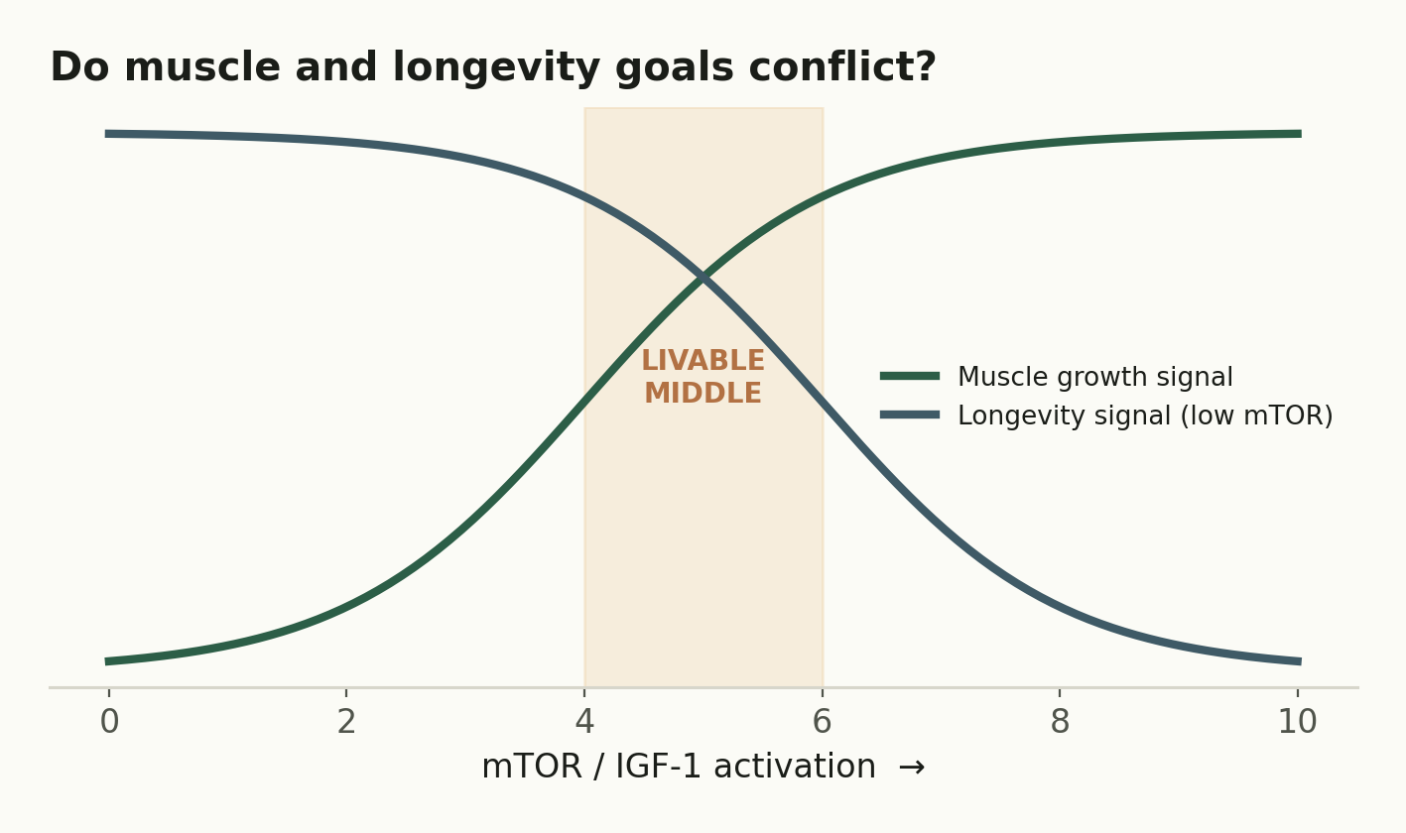
Muscle-growth signaling and longevity signaling pull in opposite directions on mTOR/IGF-1 — but there's a wide livable middle. [24]
Why the conflict is overstated for real people
- Muscle mass and strength are themselves powerful predictors of longevity and all-cause mortality — being muscular and strong protects you in aging.
- The mTOR concern is about chronic, systemic, maximal activation; intermittent anabolic spikes from training and adequate protein aren't the same as perpetual overfeeding.
- Protein-and-aging is nuanced: higher protein is protective in older adults (fighting sarcopenia) even if the lowest IGF-1 maximizes lifespan in a Petri dish.
Debates & uncertainties
Almost all strong longevity-pathway data is from model organisms; the human RCT evidence (CALERIE) shows small effects on aging biomarkers, not proven lifespan extension. The optimal protein intake for the muscle-vs-longevity tradeoff across the lifespan is genuinely unknown and probably age-dependent (higher when older). [Moderate] to [Speculative]
PRACTICAL LEVERAGE
Occupy the middle, which is wide and friendly: resistance-train, eat adequate (not absolutely maximal) protein, stay lean and mostly whole-food/Mediterranean, avoid chronic over- and under-eating, and keep building/keeping muscle. For the vast majority, muscle and healthspan goals converge far more than they conflict — the conflict only bites at the extremes (perpetual heavy bulk vs aggressive lifelong restriction).
Landmark studies: Waziry/Belsky 2023 (Nature Aging) CALERIE & pace of aging; Fontana & Longo on CR and mTOR/IGF-1.

10 Research Mastery
Key question: how do you independently judge a nutrition or fitness claim? This is the meta-skill that lets you evaluate everything else in this report — and ignore 90% of the internet.
Rank the evidence
Not all studies carry equal weight. A meta-analysis of RCTs sits at the top; a single RCT can show causation; cohort/observational data shows only association; mechanistic, animal, and anecdote sit at the base — great for hypotheses, weak for conclusions. When headlines clash, the one higher on the pyramid usually wins. [Very strong]
FIG 10.1 The hierarchy of evidence
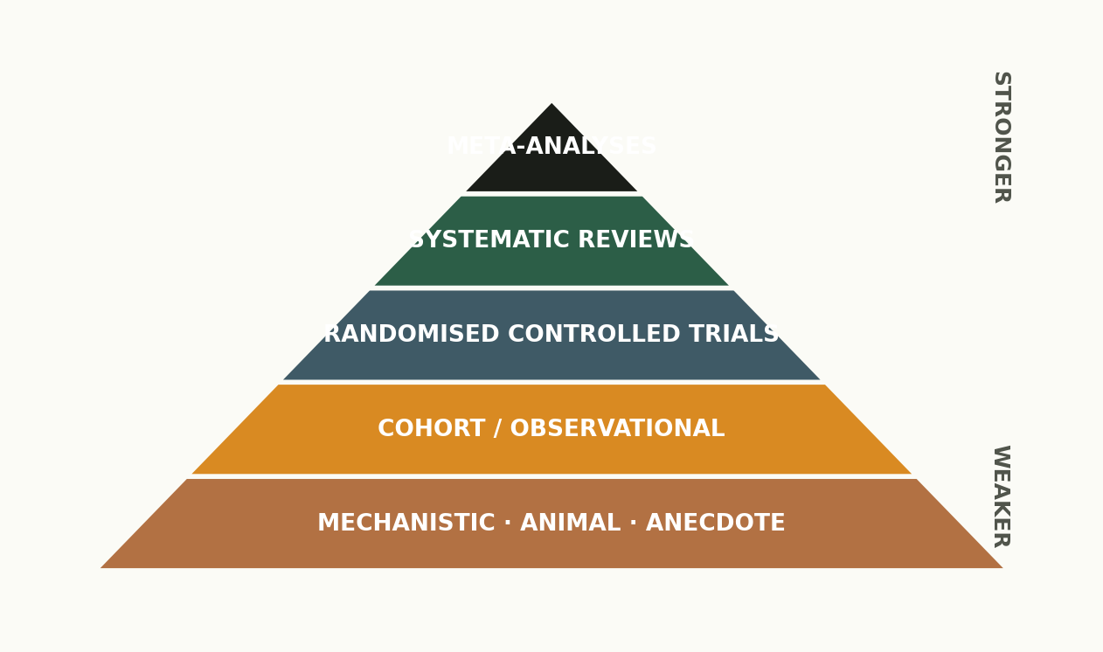
Trust scales with position. Most viral nutrition claims live at the base (a mouse study, one influencer's n=1) but are sold as if they sat at the top.
Statistics that actually matter
Concept | What it really tells you | The trap
p-value | Chance the result is a fluke if there were no true effect | Says nothing about size or importance; p<0.05 ≠ meaningful
Confidence interval | Plausible range of the true effect | Wide intervals = high uncertainty (often small samples)
Effect size | HOW BIG the effect is | A 'significant' result can be trivially small
Publication bias | Positive results get published more | Inflates the apparent strength of an effect

The three traps to spot before you share a study
- Correlation vs causation — 'coffee drinkers live longer' may reflect wealth or lifestyle, not coffee.
- Cherry-picking — quoting the one trial that agrees and ignoring the body of evidence.
- Mechanistic fallacy — 'X raises insulin in a dish, therefore X makes you fat' skips the entire gap between a mechanism and a real-world outcome.
PRACTICAL LEVERAGE
Before believing any claim, ask three questions: Where does it sit on the pyramid? Is the effect big enough to matter, not just statistically significant? And does it agree with the weight of evidence, or is it one cherry-picked study? That filter alone puts you ahead of most coaches.
Recommended sources: MASS Research Review, Stronger by Science, Examine.com, ISSN position stands; researchers Stuart Phillips, Brad Schoenfeld, Eric Helms, Alan Aragon.

Synthesis: The Mechanism Layer, Integrated
FIG 12.1 Where the real-world leverage actually is
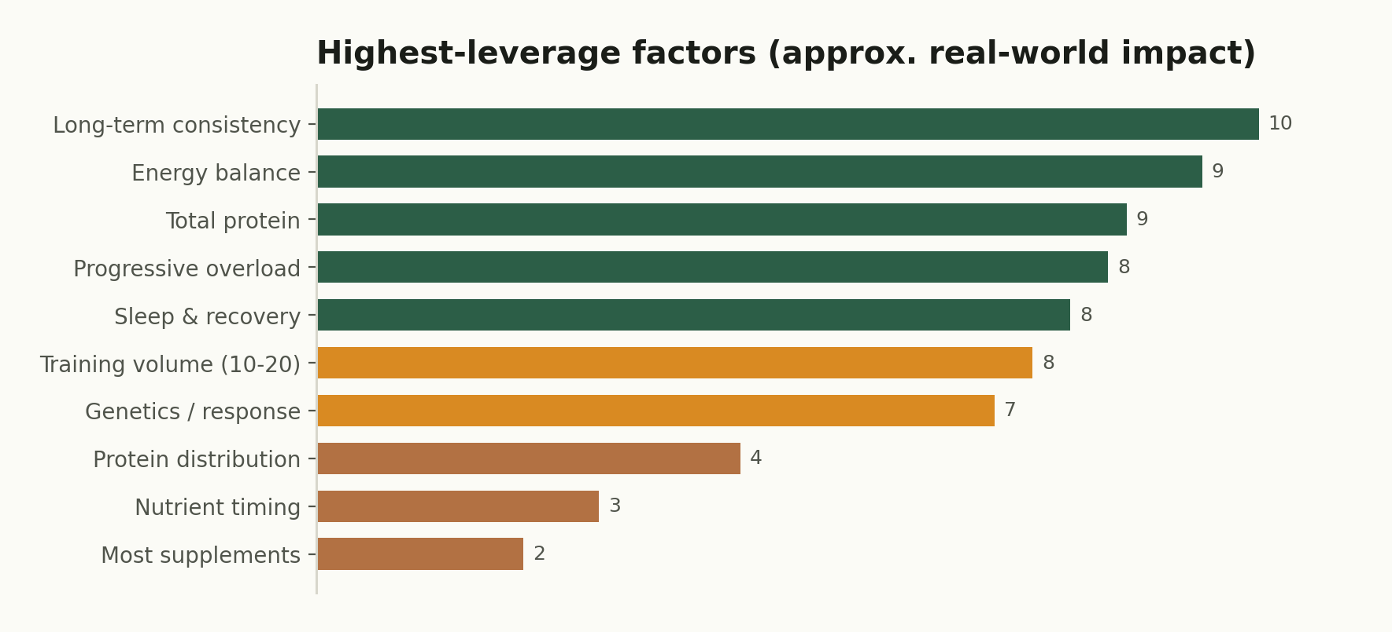
Approximate magnitude of impact on physique/performance outcomes. The elite obsess over the top; the average lifter obsesses over the bottom.

Top 20 highest-leverage insights
- Long-term consistency dwarfs every other variable. Years > weeks.
- Your responder status is real — stop judging a program by someone else's results.
- Myonuclei bank — prior training means fast comebacks; muscle memory is cellular.
- Partition by starting lean — gain from a leaner state for a better P-ratio.
- Body fat is defended; leptin fights your cut and keeps fighting after.
- It's a seesaw: mTOR (build) vs AMPK/FOXO (conserve). You bias it; you can't pin it.
- Recovery is the ceiling on adaptation — train the recovery, not just the session.
- Sleep is the master recovery drug and it's free.
- Adherence is engineered, not willed — manage food reward and environment.
- Hyperpalatable food overrides fullness even at matched macros.
- Protein high, distributed — the most robust nutrition lever for muscle and satiety.
- Modest surplus, modest deficit — the extremes just add fat or cost muscle.
- Carbs around training exploit peak insulin sensitivity for partitioning.
- Don't slash fat — it's hormonal infrastructure.
- Metabolic flexibility is earned, a readout of being fit, lean, and muscular.
- Volume 10–20 sets/muscle/wk, near failure, progressed over time.
- Diet breaks & deloads manage the biology that fights you.
- Creatine is the one elite-evidence supplement; most others are polish.
- Muscle predicts longevity — the build vs lifespan conflict is overstated.
- Rank the evidence — significance ≠ importance; one study ≠ the truth.

Biggest misconceptions in fitness nutrition
- 'Same program = same results.' Response variance is huge and largely biological.
- 'The anabolic window is 30 minutes.' It's hours; daily total dominates.
- 'Insulin/carbs make you fat.' Chronic surplus does; insulin is normal partitioning.
- 'Dieting permanently wrecks your metabolism.' Adaptation is largely reversible; appetite persists, not damage.
- 'You must bulk hard to grow.' Lean gaining builds the same muscle, less fat.
- 'Supplements/timing are where the magic is.' They're the visible 5%; the invisible 80% is adherence, energy, protein, recovery.
- 'Gut/biohacks unlock gains.' Mostly speculative in trained humans.

What elite coaches understand that average lifters don't
- They optimize the invisible 80% (adherence, energy balance, protein, recovery, individualization) before touching the visible 5%.
- They auto-regulate to the individual in front of them — adjusting volume, deficit, and progression to that person's recovery and response, not a template.
- They think in phases and years, sequencing bulk/cut/maintain/recomp rather than chasing everything at once.
- They treat recovery, sleep, and stress as training variables with a shared budget.
- They read primary research and weight evidence — so they're unmoved by the latest viral study or supplement.

What science still does not know
- How to predict an individual's training response in advance (it's polygenic and we can't yet test for it usefully).
- Whether the overfeeding P-ratio data transfers cleanly to training lifters, and the true optimal body-fat range to bulk from.
- Whether leptin resistance is cause or consequence of obesity, and how to safely re-sensitize it.
- How much of load-induced hypertrophy is truly mTOR-dependent vs mTOR-independent mechanotransduction.
- Whether the gut–muscle axis matters in healthy trained humans, or only in aging/disease.
- The optimal protein intake balancing muscle vs longevity across the lifespan.
- Whether HRV-guided training reliably beats well-designed fixed programming.

Highest-ROI areas for future study
- Individualized response prediction — polygenic scores + biomarkers to forecast who responds to what.
- Human gut–muscle trials in trained populations — does manipulating the microbiome do anything for performance?
- Protein & longevity across the lifespan — RCTs resolving the mTOR/IGF-1 tradeoff with real endpoints.
- Practical recovery monitoring — validating HRV/biomarker-guided autoregulation against hard outcomes.
- Re-sensitizing the defended fat range — interventions that lower the weight the body defends, not just current weight.
THE CLOSING THOUGHT
The mechanisms in this report are fascinating, but notice where they all point: they explain why the boring fundamentals work, rather than replacing them. The elite aren't elite because they found a secret mechanism to exploit — they're elite because they understand the machinery well enough to trust the fundamentals and execute them, consistently, for years, while individualizing along the way. That understanding is the edge. You now have it.
A note on scope: this report is educational and reflects current consensus, not individualized medical or dietary advice. Several mechanistic areas (gut–muscle, longevity, some signaling) are deliberately rated weak/speculative — that honesty is the point. If a cut ever brings relentless fatigue, mood or sleep disruption, or food/body thoughts that feel distressing, ease off and consult a qualified professional. Sustainable beats optimal-on-paper.

REFERENCES
[1] Hubal MJ, et al. Variability in muscle size and strength gain after unilateral resistance training. Med Sci Sports Exerc. 2005;37(6):964–972.
[2] Petrella JK, Kim J-S, Mayhew DL, Cross JM, Bamman MM. Potent myofiber hypertrophy during resistance training in humans is associated with satellite cell-mediated myonuclear addition: a cluster analysis. J Appl Physiol. 2008;104(6):1736–1742.
[3] Roberts MD, Haun CT, et al. Physiological differences between low versus high skeletal muscle hypertrophic responders to resistance exercise training. Front Physiol. 2018;9:834.
[4] Bruusgaard JC, et al. Myonuclei acquired by overload exercise precede hypertrophy and are not lost on detraining. PNAS. 2010;107(34):15111–15116.
[5] Seaborne RA, et al. Human skeletal muscle possesses an epigenetic memory of hypertrophy. Sci Rep. 2018;8:1898.
[6] Forbes GB. Body fat content influences the body composition response to nutrition and exercise. Ann N Y Acad Sci. 2000;904:359–365.
[7] Hall KD. Body fat and fat-free mass inter-relationships: Forbes's theory revisited. Br J Nutr. 2007;97(6):1059–1063.
[8] Horton TJ, et al. Fat and carbohydrate overfeeding in humans: different effects on energy storage. Am J Clin Nutr. 1995;62(1):19–29.
[9] Friedman JM. Leptin and the endocrine control of energy balance. Nat Metab. 2019;1:754–764.
[10] Myers MG, Leibel RL, Seeley RJ, Schwartz MW. Obesity and leptin resistance: distinguishing cause from effect. Trends Endocrinol Metab. 2010;21(11):643–651.
[11] Sumithran P, et al. Long-term persistence of hormonal adaptations to weight loss. N Engl J Med. 2011;365(17):1597–1604.
[12] Bodine SC, et al. Akt/mTOR pathway is a crucial regulator of skeletal muscle hypertrophy; Identification of ubiquitin ligases (MuRF1/MAFbx) required for muscle atrophy. Nat Cell Biol / Science. 2001.
[13] Saxton RA, Sabatini DM. mTOR signaling in growth, metabolism, and disease. Cell. 2017;168(6):960–976.
[14] Meeusen R, et al. Prevention, diagnosis and treatment of the overtraining syndrome: ECSS/ACSM joint consensus. Med Sci Sports Exerc. 2013;45(1):186–205.
[15] Plews DJ, et al. Training adaptation and heart rate variability in elite endurance athletes. Sports Med. 2013;43(9):773–781.
[16] Nedeltcheva AV, et al. Insufficient sleep undermines dietary efforts to reduce adiposity. Ann Intern Med. 2010;153(7):435–441.
[17] Hall KD, et al. Ultra-processed diets cause excess calorie intake and weight gain. Cell Metab. 2019;30(1):67–77.
[18] Goodpaster BH, Sparks LM. Metabolic flexibility in health and disease. Cell Metab. 2017;25(5):1027–1036.
[19] Galgani JE, Moro C, Ravussin E. Metabolic flexibility and insulin resistance. Am J Physiol Endocrinol Metab. 2008;295(5):E1009–E1017.
[20] Frampton J, et al. Short-chain fatty acids as potential regulators of skeletal muscle metabolism and function. Nat Metab. 2020;2:840–848.
[21] Liu X, et al. Role and mechanism of short-chain fatty acids in skeletal muscle homeostasis and exercise performance. Nutrients. 2025;17(9):1463.
[22] Lustgarten MS. The role of the gut microbiome on skeletal muscle mass and physical function: 2019 update. Front Physiol. 2019;10:1435.
[23] Lv W-Q, et al. Human gut microbiome impacts skeletal muscle mass via microbial synthesis of butyrate among healthy menopausal women. J Cachexia Sarcopenia Muscle. 2021;12(6):1860–1870.
[24] Waziry R, Belsky DW, et al. Effect of long-term caloric restriction on the pace of biological aging: CALERIE trial. Nat Aging. 2023;3:248–257.
[25] Longland TM, et al. Higher vs lower protein during energy deficit + intense exercise. Am J Clin Nutr. 2016;103(3):738–746.
[26] Morton RW, et al. Protein supplementation and resistance-training gains: systematic review/meta-analysis. Br J Sports Med. 2018;52(6):376–384.
[27] Schoenfeld BJ, Ogborn D, Krieger JW. Dose-response between weekly resistance-training volume and hypertrophy. J Sports Sci. 2017;35(11):1073–1082.
[28] Byrne NM, et al. Intermittent energy restriction (MATADOR). Int J Obes. 2017;41(10):1560–1569.
[29] Iraki J, Fitschen P, Espinar S, Helms E. Nutrition recommendations for bodybuilders in the off-season. Sports. 2019;7(7):154.
[30] Whittaker J, Wu K. Low-fat diets and testosterone in men: meta-analysis. J Steroid Biochem Mol Biol. 2021;210:105878.
[31] Kreider RB, et al. ISSN position stand: creatine. J Int Soc Sports Nutr. 2017;14:18.
[32] Aragon AA, Schoenfeld BJ. Nutrient timing revisited: is there a post-exercise anabolic window? J Int Soc Sports Nutr. 2013;10:5.
Citations anchor the figures and core mechanistic claims; some landmark references are named from the established literature. Read primary sources before high-stakes decisions.

