|  |
| --- |
| **Telephone Directory** |
| Installation instructions |
|  |
|  |
|  |
| ***Zuhair Haider Darwish*** |
|  |
|  |

Contents

Instruction to install Telephone Directory (TelDir) 4

Install notepad++ after you download from (http://notepad-plus-plus.org/) 4

Install xampp 9

Start Apache (web server ) & start MySQL database 17

Test installation 18

Clean the web site located (default) C:\xampp\htdocs 19

Copy the TelDir web site to (default) C:\xampp\htdocs 20

Congratulations: You have successfully installed TelDir 24

Inserting data using phpMyAdmin http://localhost/phpmyadmin 25

Using Excel to insert data 28

Using Excel to insert data using Import from phpMyAdmin 38

# Instruction to install Telephone Directory (TelDir)

## Install notepad++ after you download from (<http://notepad-plus-plus.org/>)

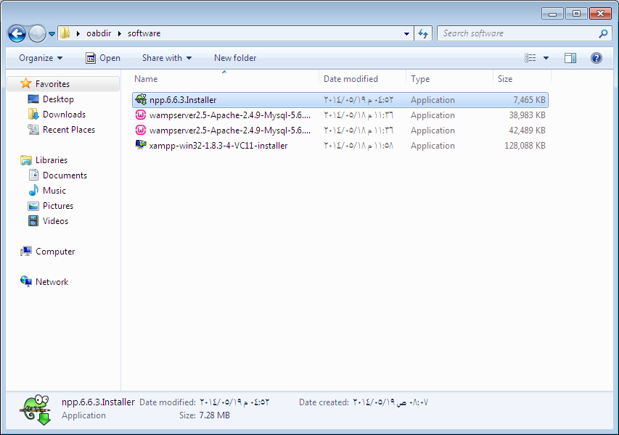

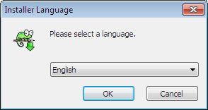

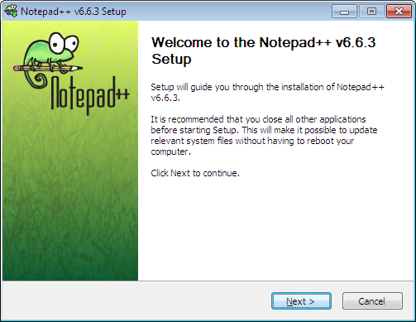

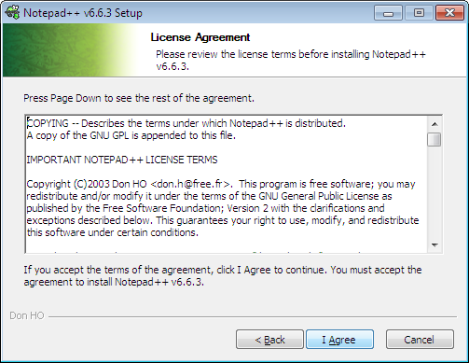

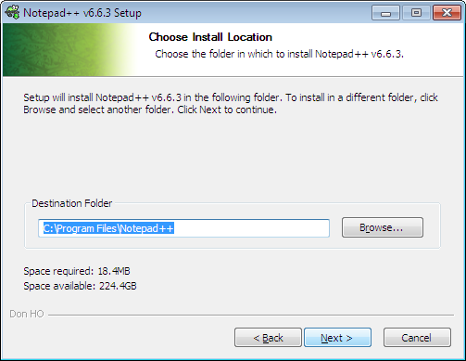

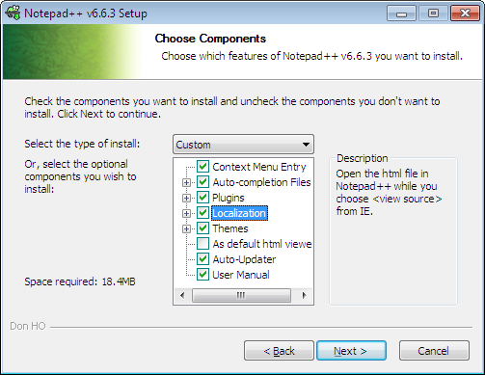

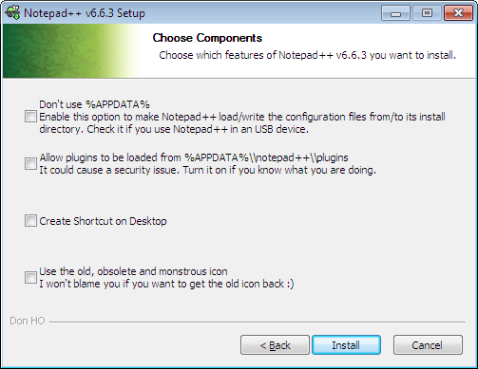

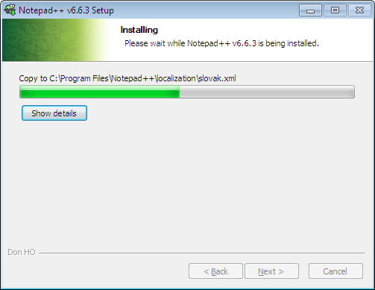

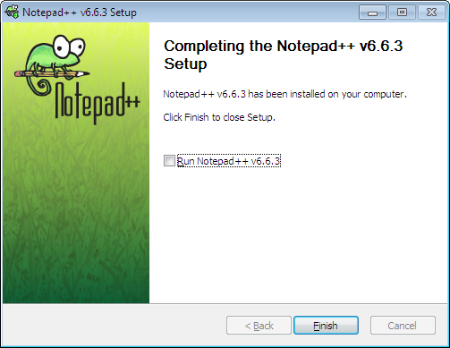

## Install xampp

**XAMPP is an easy to install Apache distribution containing MySQL, PHP, and Perl. You can download from (**[**https://www.apachefriends.org/download.html**](https://www.apachefriends.org/download.html)**)**

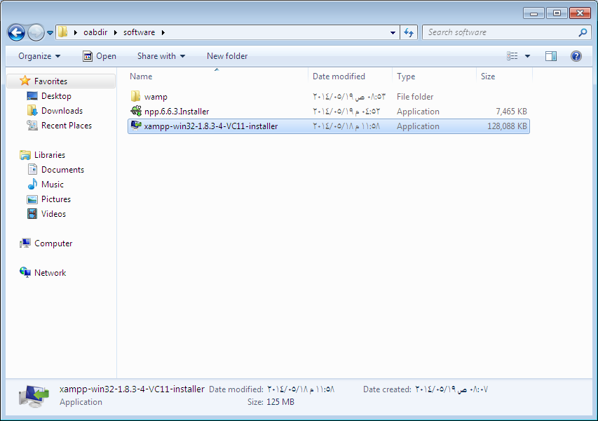

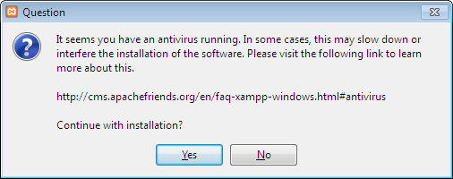

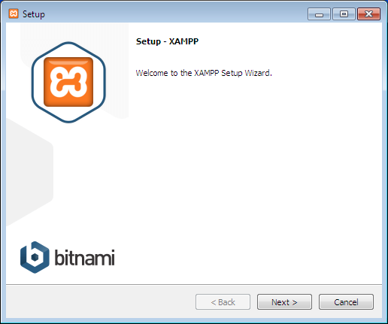

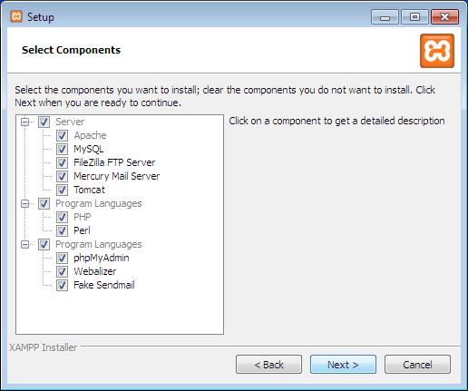

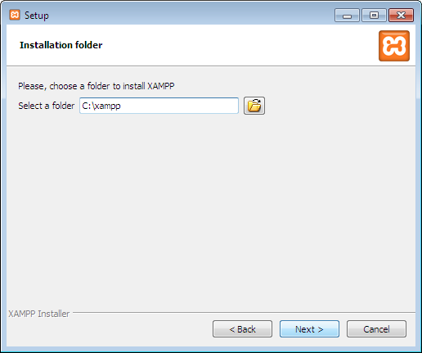

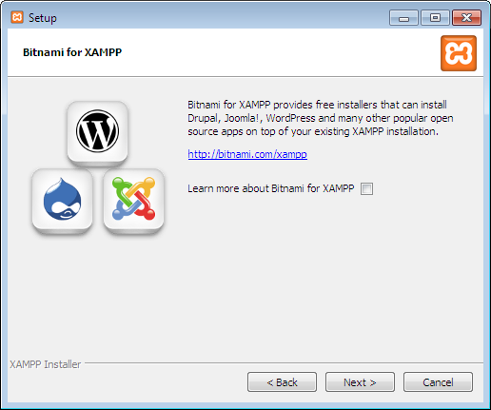

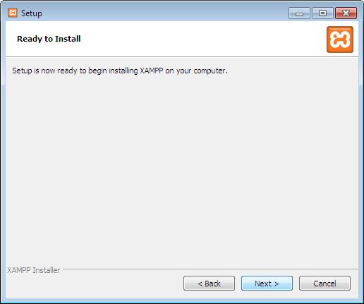

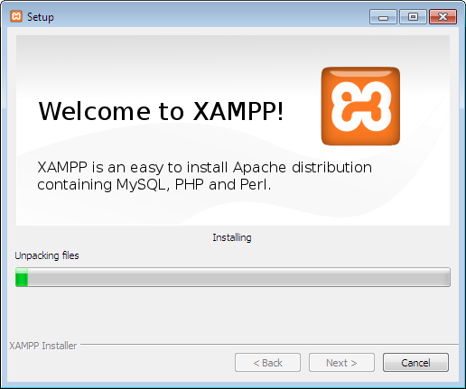

**Click finish to start control panel**

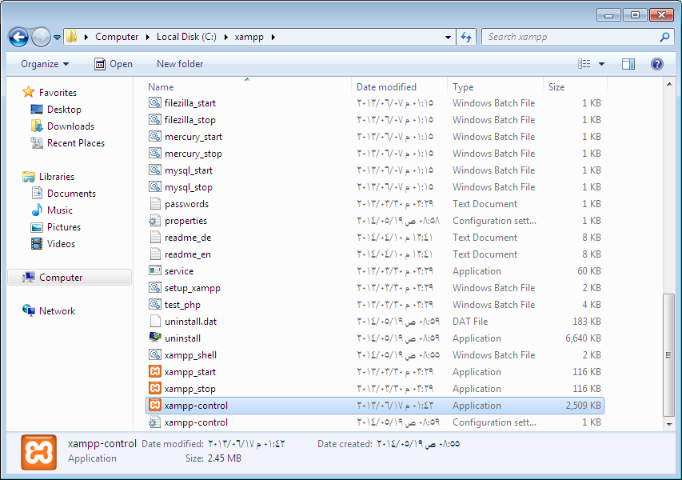

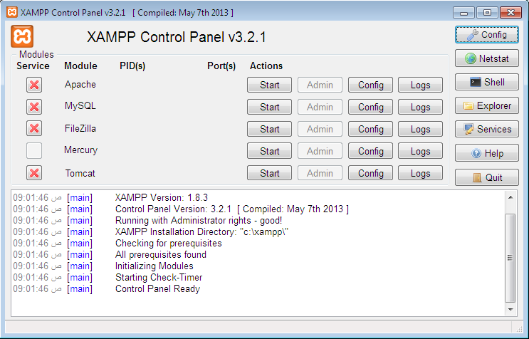

## Start Apache (web server ) & start MySQL database

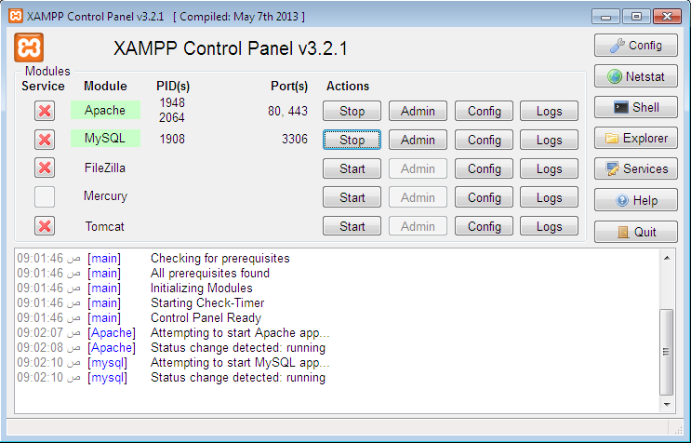

**Apache Web server will open TCP port 80 and 443**

**MySQL database will open TCP port 3306**

## Test installation

**Open web browser and type** [**http://localhost/**](http://localhost/) **(sometime it will not work because of internet disconnect from the internet or add local IP address )**

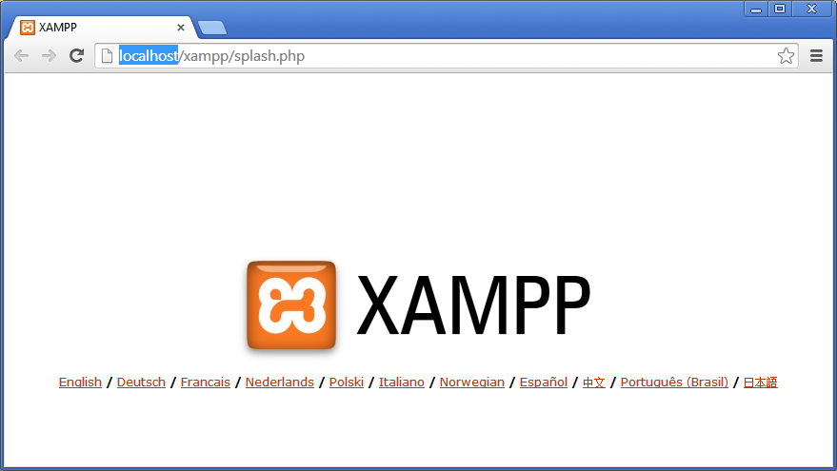

**Congratulations:  
You have successfully installed XAMPP on this system!**

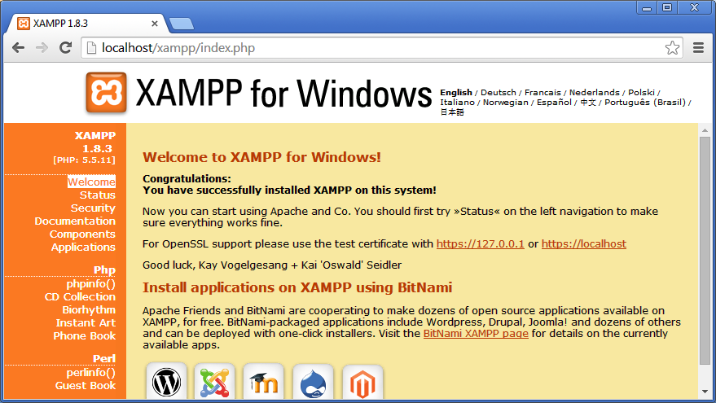

**Recommended to read documentation it is useful**

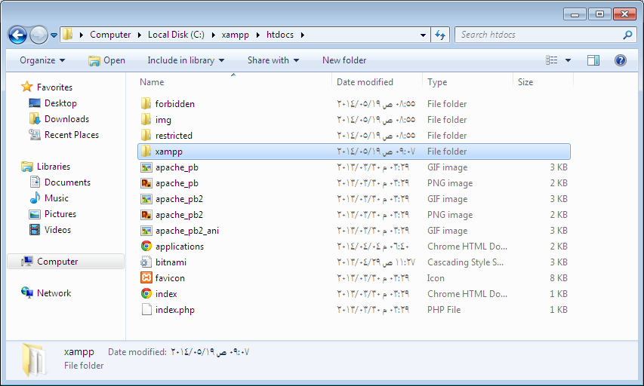

## Clean the web site located (default) C:\xampp\htdocs

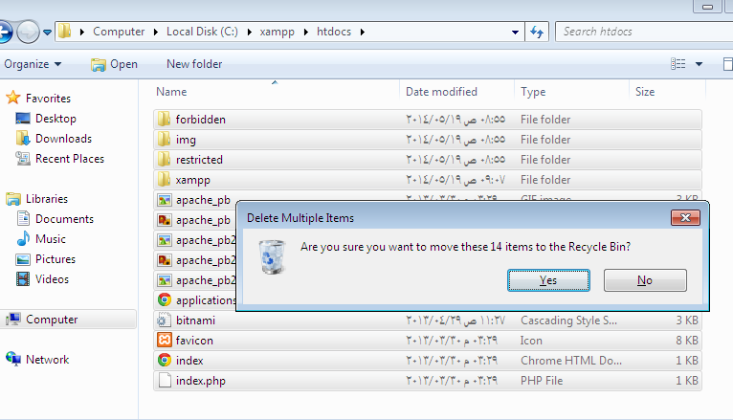

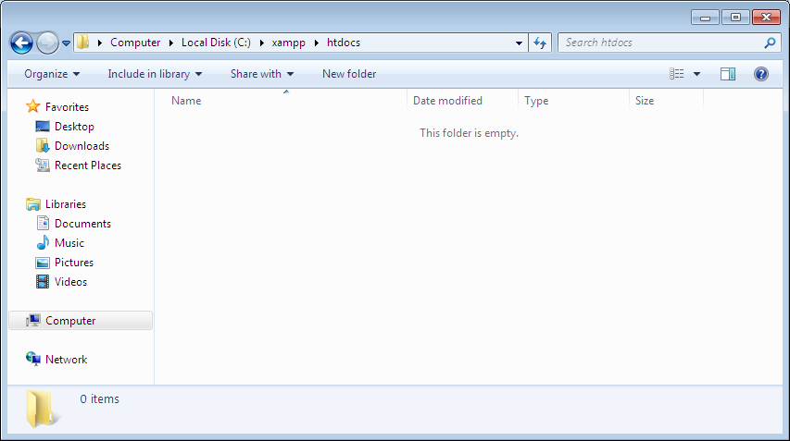

## Copy the TelDir web site to (default) C:\xampp\htdocs

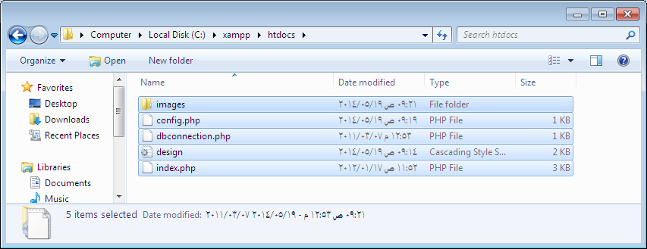

**Create Database**

**Open config.php stored the database connection file**

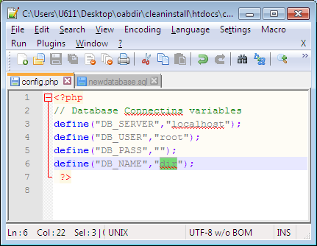

**Database name is dir as mentioned above**

**Visit the site phpmyadmin <http://localhost/phpmyadmin>**

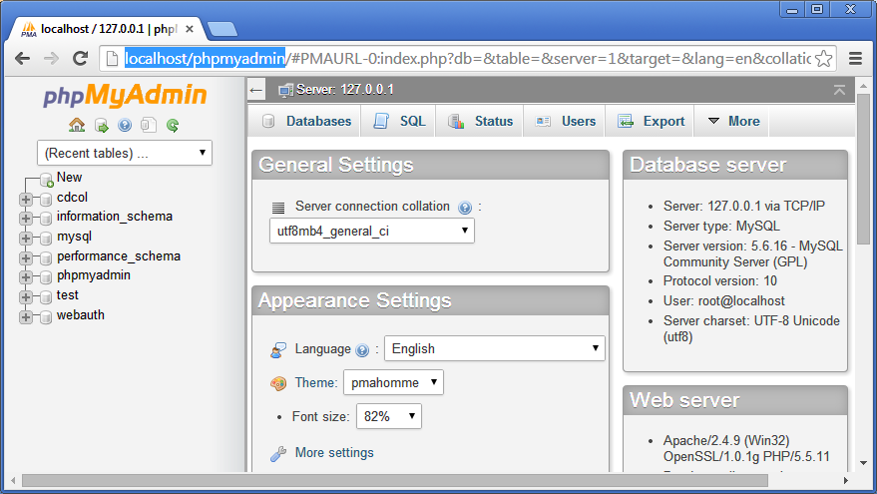

**Open database directory newdatabase.sql copy the entire content to clipboard (Ctrl+A , Ctrl+C)**

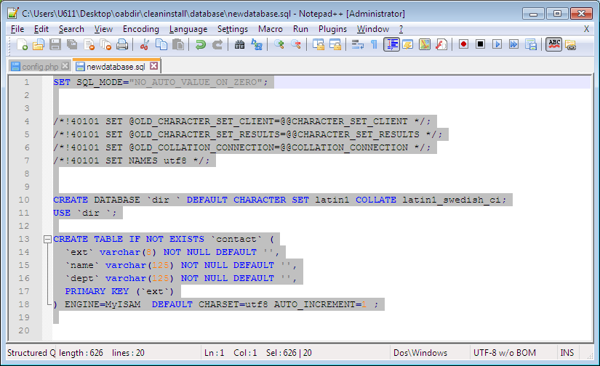

**At web browser phpMyAdmin**

**Click in SQL at ment**

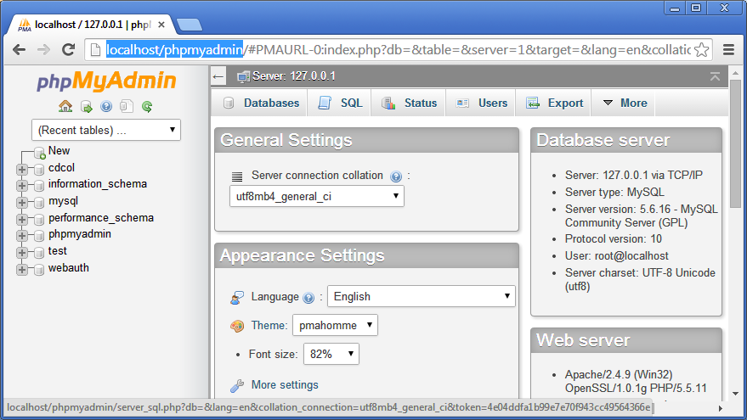

**Past at sql window the content of newdatabase.sql**

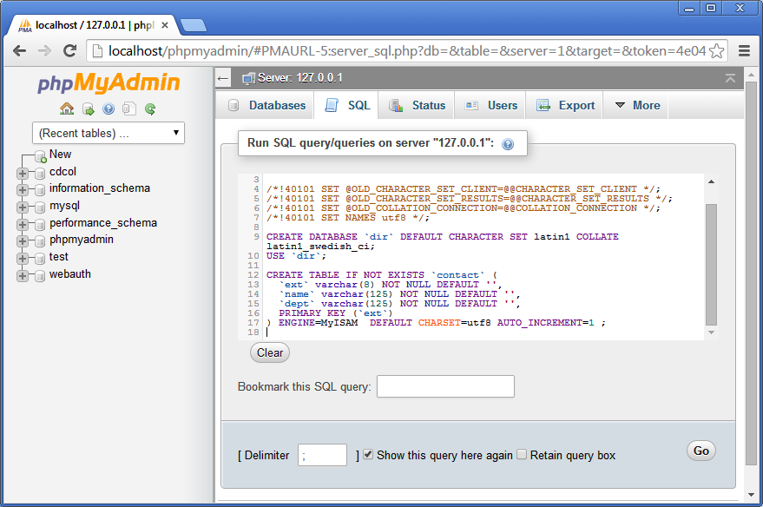

**Click Go**

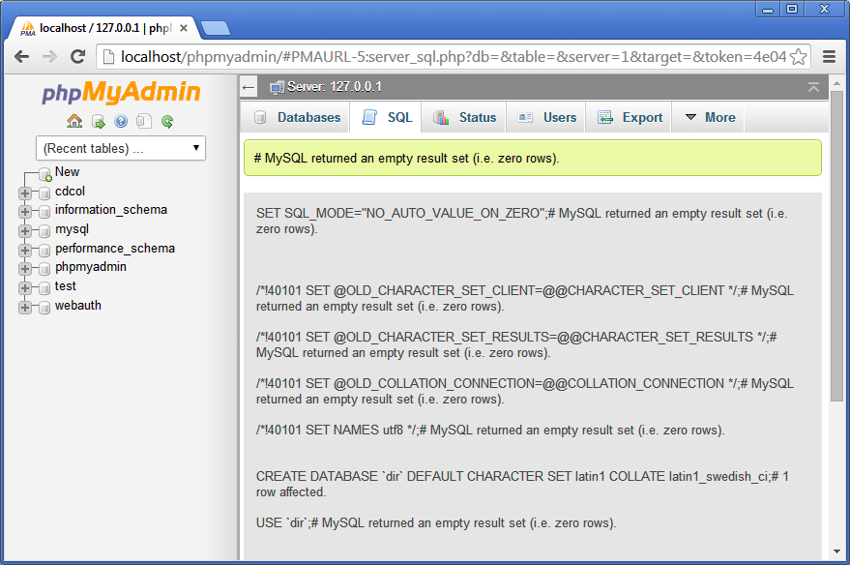

## Congratulations: You have successfully installed TelDir

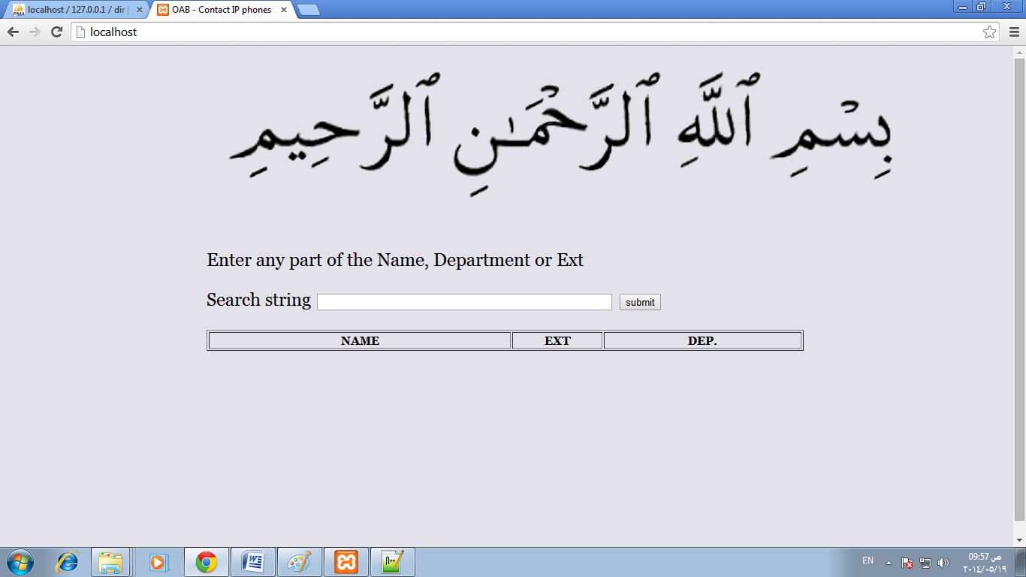

**Application installed ; however no data in database**

**There are three methods to insert data to the database**

Inserting data using phpMyAdmin http://localhost/phpmyadmin 25

Using Excel to insert data 28

Using Excel to insert data using Import from phpMyAdmin 38

## Inserting data using phpMyAdmin <http://localhost/phpmyadmin>

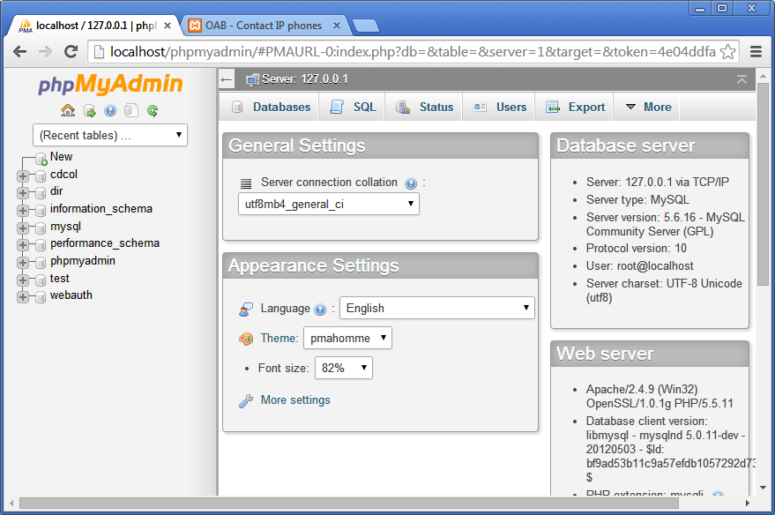

**Go database**

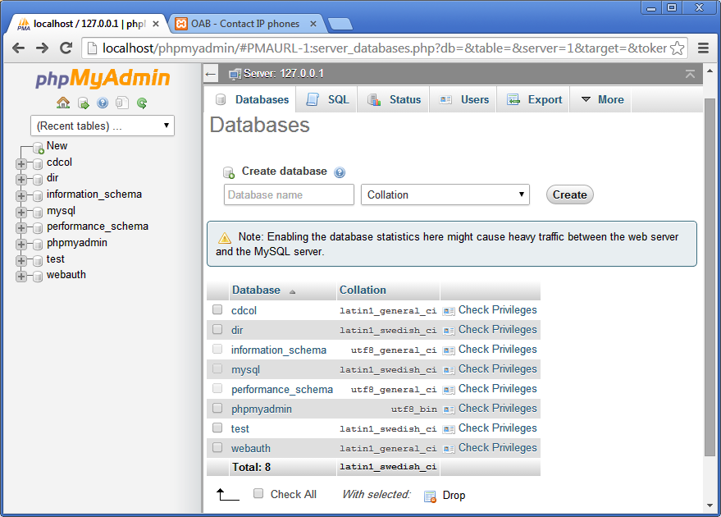

**Choose dir database by clicking on it and then click on contact table**

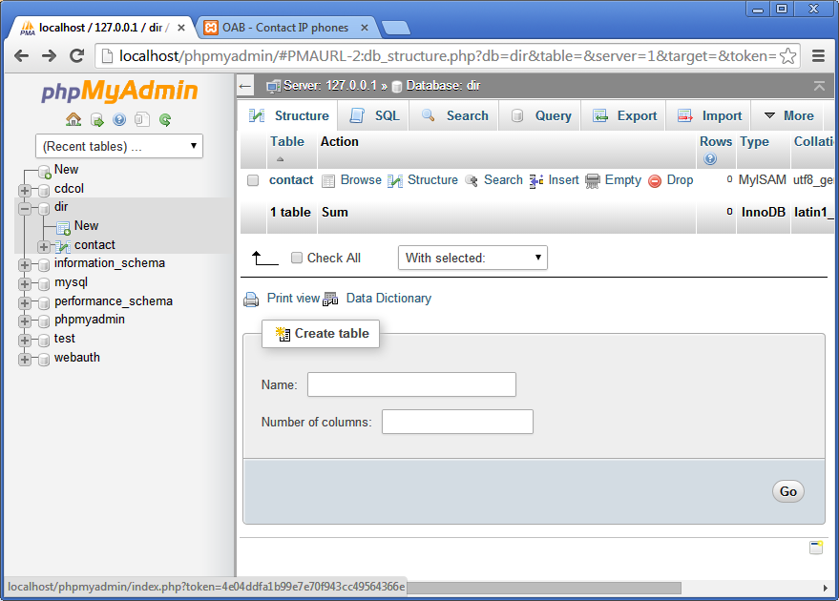

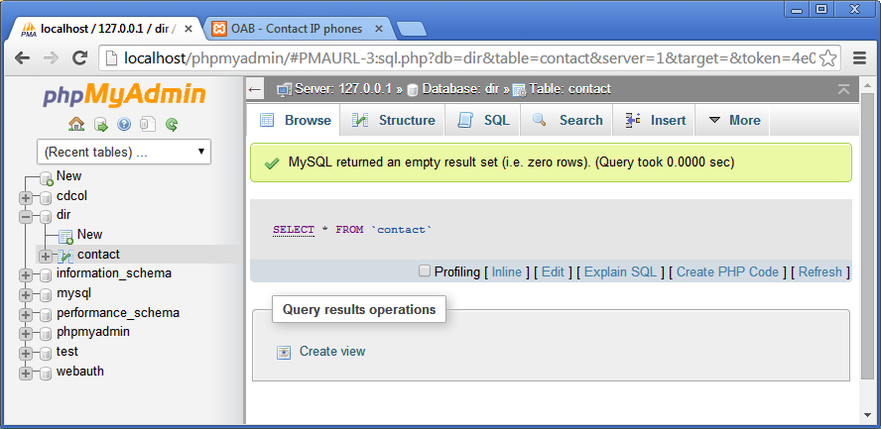

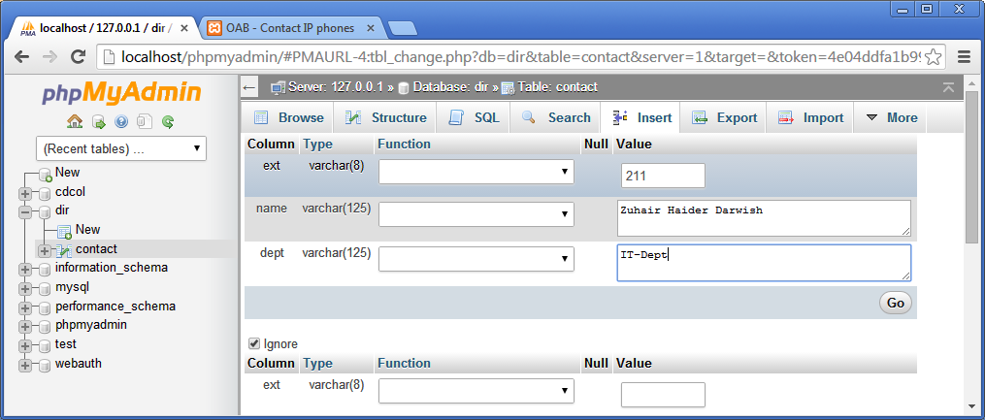

**After click on Go check the application**

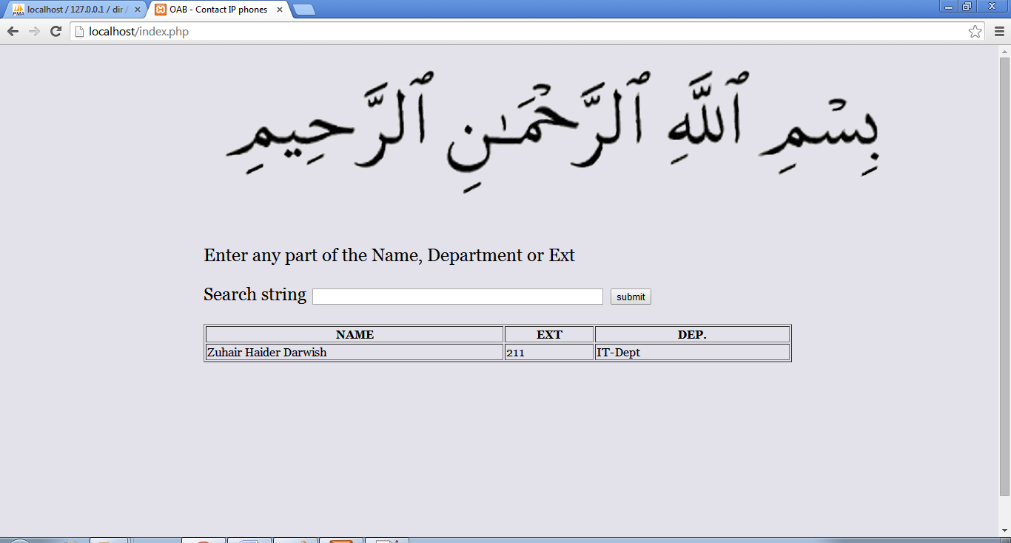

**Congratulations , It works !!!!!**

## Using Excel to insert data

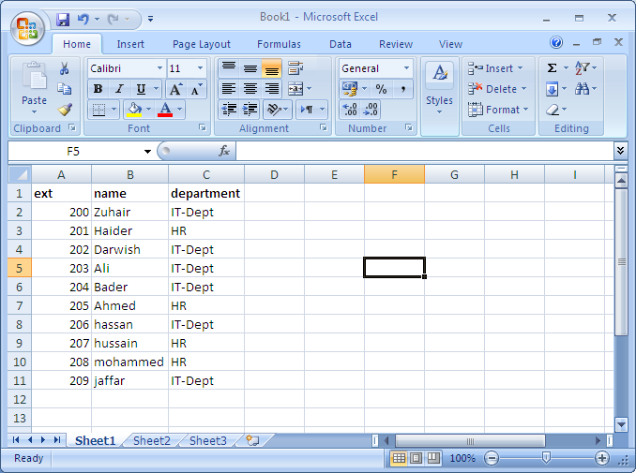

**This sample data need to be added to the database**

**Add at the begging of the table column with 🡪 *** and the End 🡪 &&&** 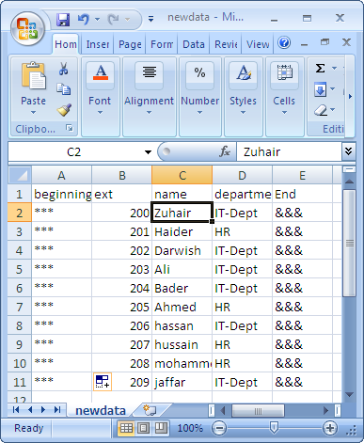

**Menu 🡪 Save As 🡪 Other formats**

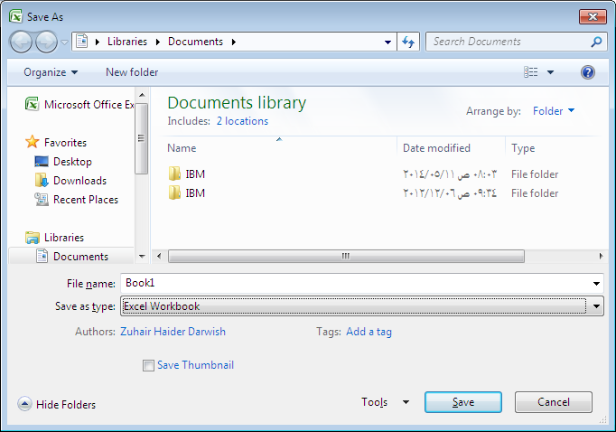

**Save as type 🡪 CSV ( comma delimited )**

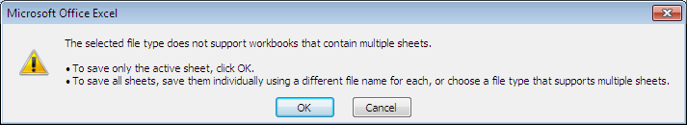

**Click ok**

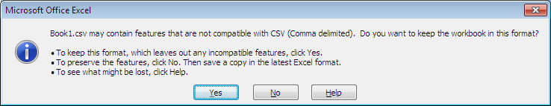

**Click Yes**

**Open the save file with notepad++**

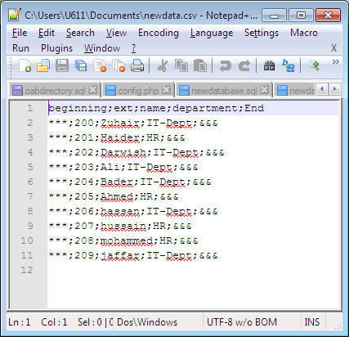

**The file saved by Excel it show ; instead of , (comma ) anyway I am going use the notepad++ to fix all these problems**

**Search 🡪 replace   
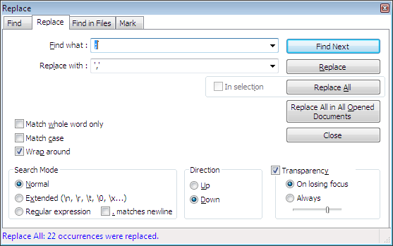**

**Find what 🡪 ;  
Replace with 🡪 ‘,’ single quote comma single quote**

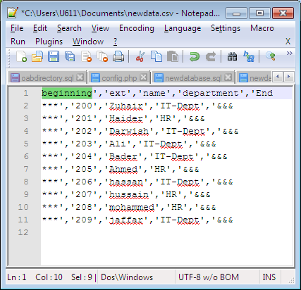

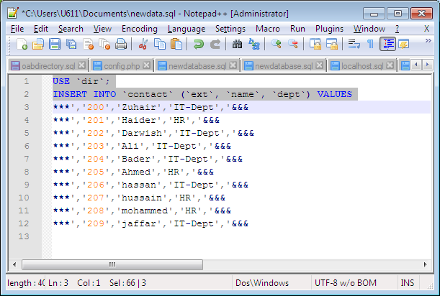

**Search 🡪 replace**

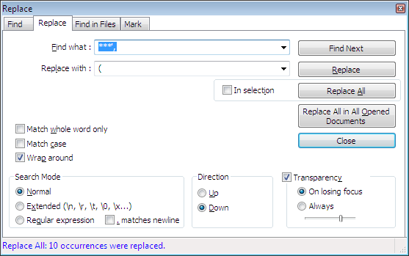

Find what : 🡪 **\*\*\*',**

Replace with 🡪 (  
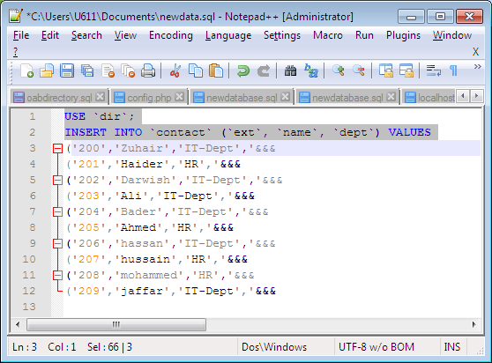

Find what : 🡪,'&&&

Replace with 🡪 ),

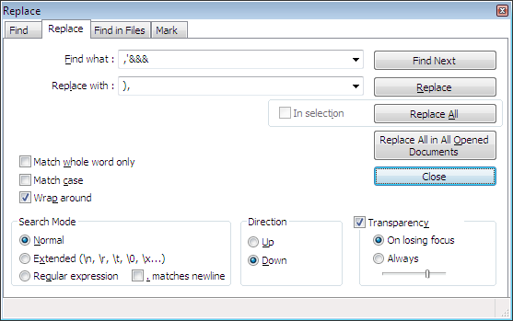

**Replace the header line at the top of the file with following**

**USE `dir`;**

**INSERT INTO `contact` (`ext`, `name`, `dept`) VALUES**

And do not forget to change the last , to ;

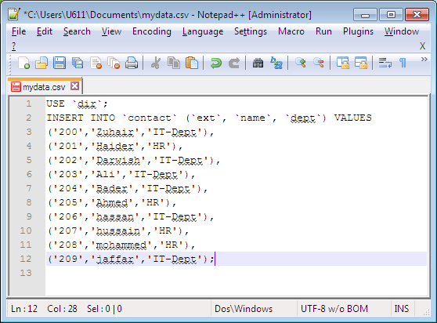

Copy the entire file content to the clipboard and past in phpmyadmin at SQL window and click Go

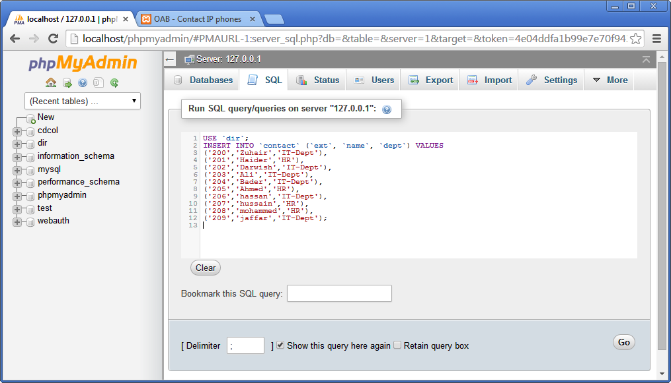

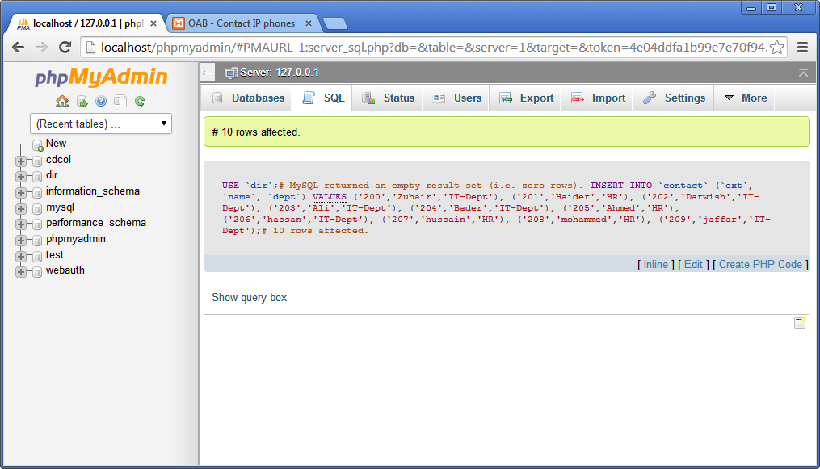

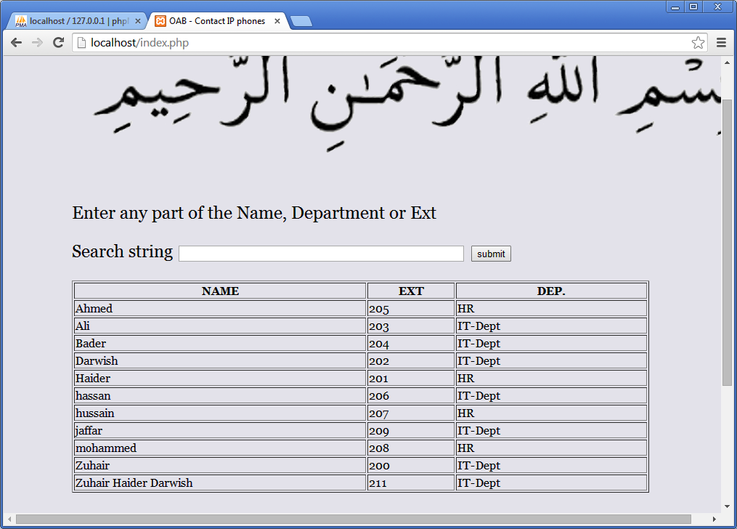

**Congratulations , It works !!!!!**

## Using Excel to insert data using Import from phpMyAdmin

The Excel file

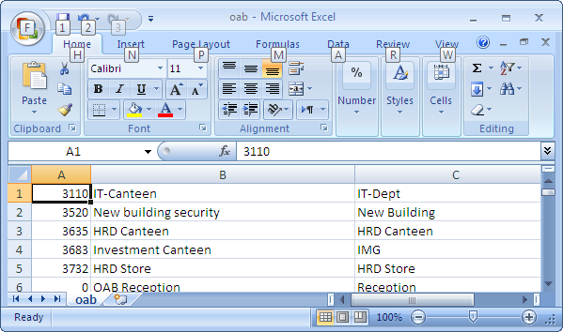

Note : No header

Save As 🡪 Other Formats

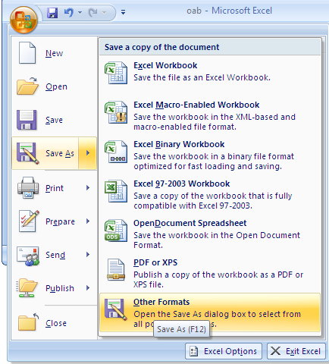

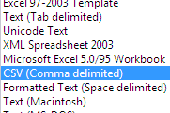

**Choose CSV (Comma delimited)**

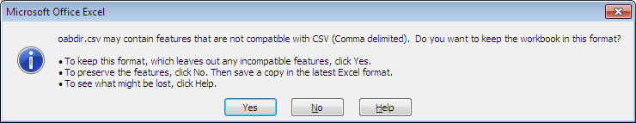

**Yes**

**Open the phpMyAdmin :** <http://localhost/phpmyadmin>

Menu Databases

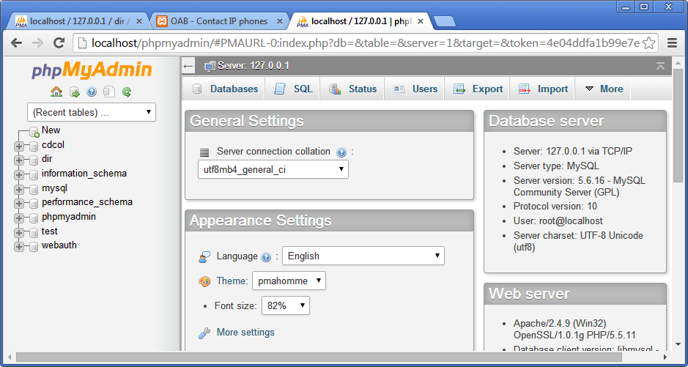

Click on the database ( our dir )

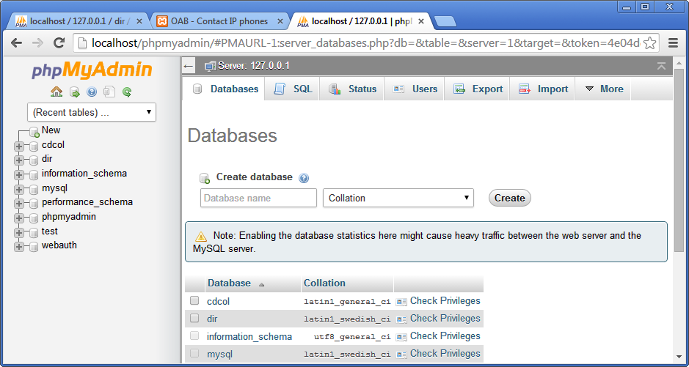

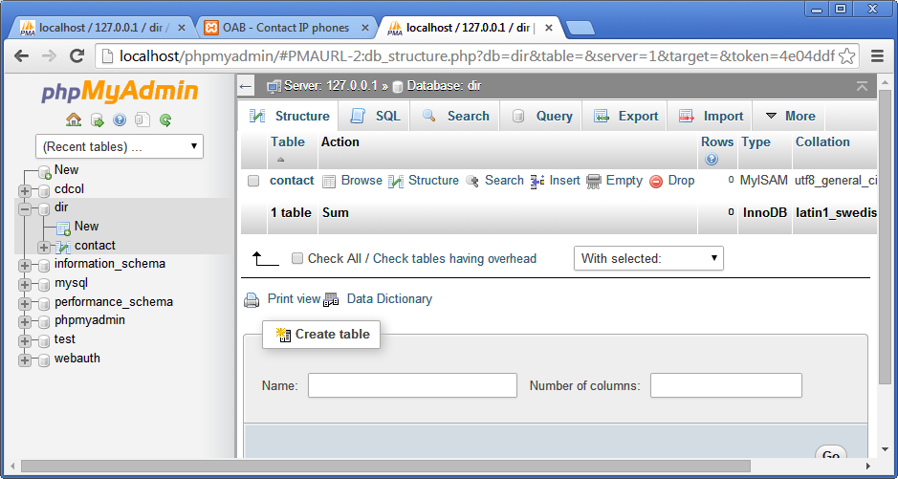

Click on the table ( our contact )

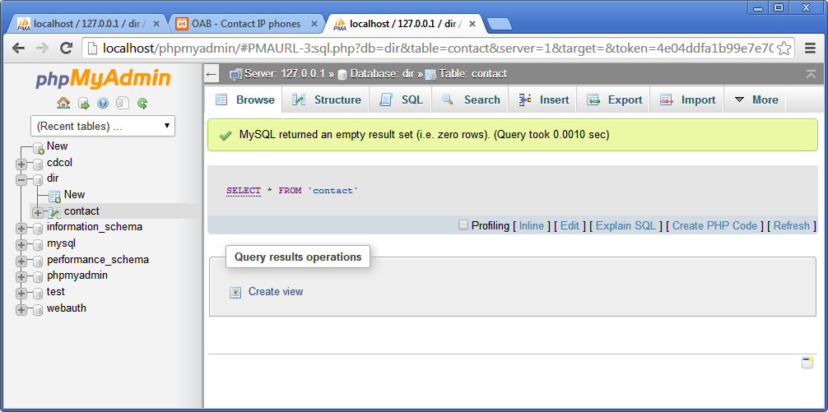

click on 🡪 Import

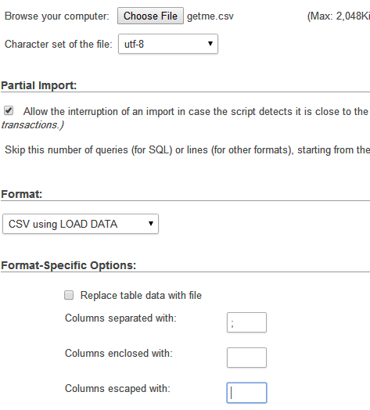

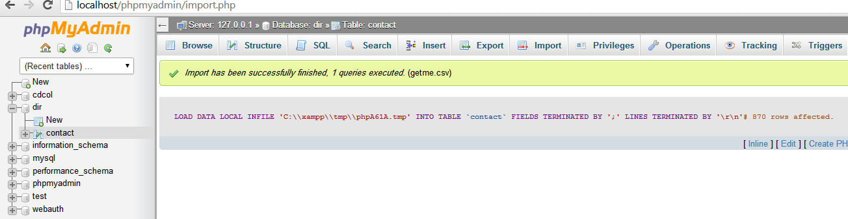

**Congratulations , It works !!!!!**

**If you need any help please do not hesitate to contact me** [**zuhairhd@gmail.com**](mailto:zuhairhd@gmail.com)

**Zuhair H Darwish**