AWS Cloud Security Posture Assessment
Security Assessment Report
Prepared by: Zuhair Muhammad Shahid | Date: June 2026 | Environment: AWS Free Tier (us-east-1)
1. Executive Summary
This report documents a cloud security posture assessment conducted on a self-built AWS environment. The objective was to intentionally introduce common cloud misconfigurations across IAM, S3, and VPC services, use AWS Security Hub as a Cloud Security Posture Management (CSPM) tool to detect and prioritise findings, and then remediate each issue in line with AWS security best practices.
AWS Security Hub identified 60+ findings within minutes of being enabled, ranging in severity from High to Informational. Key findings included an IAM user with unrestricted AdministratorAccess and no MFA enforcement, a publicly accessible S3 bucket with block public access disabled, and multiple VPC misconfigurations including default security groups allowing unrestricted traffic and subnets auto-assigning public IP addresses.
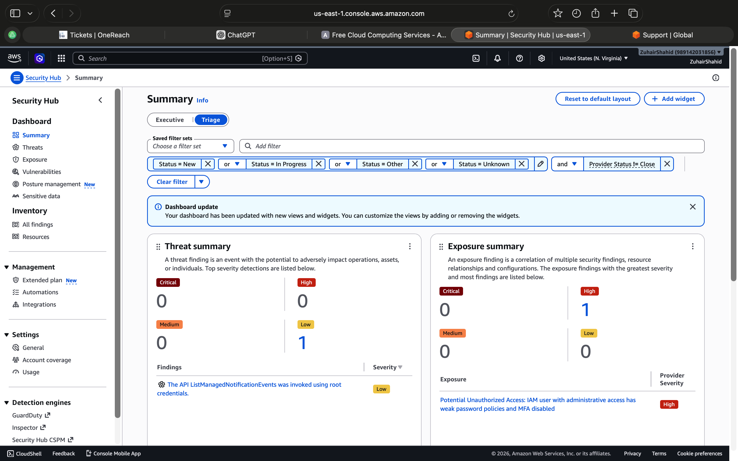
Assessment Scope
- AWS Account ID: 989142031856
- Region: us-east-1 (N. Virginia)
- Services assessed: IAM, S3, VPC, EC2 Security Groups, CloudWatch
- Tool used: AWS Security Hub (CSPM)
- Total findings detected: 60+
- Assessment date: June 2026

2. Methodology
The assessment followed a three-phase approach designed to simulate real-world cloud security operations:
- Misconfiguration Phase: Intentional security weaknesses were introduced across IAM, S3, and VPC to replicate common misconfigurations found in real enterprise environments.
- Detection Phase: AWS Security Hub was enabled with standard security controls. Findings were reviewed and categorised by severity, resource type, and risk impact.
- Remediation Phase: Each High and Medium severity finding was addressed using AWS best practice recommendations. Remediation steps were documented with before and after states.

3. Findings Summary
The table below summarises the key findings identified by AWS Security Hub, their severity, affected resource, and the remediation action taken.
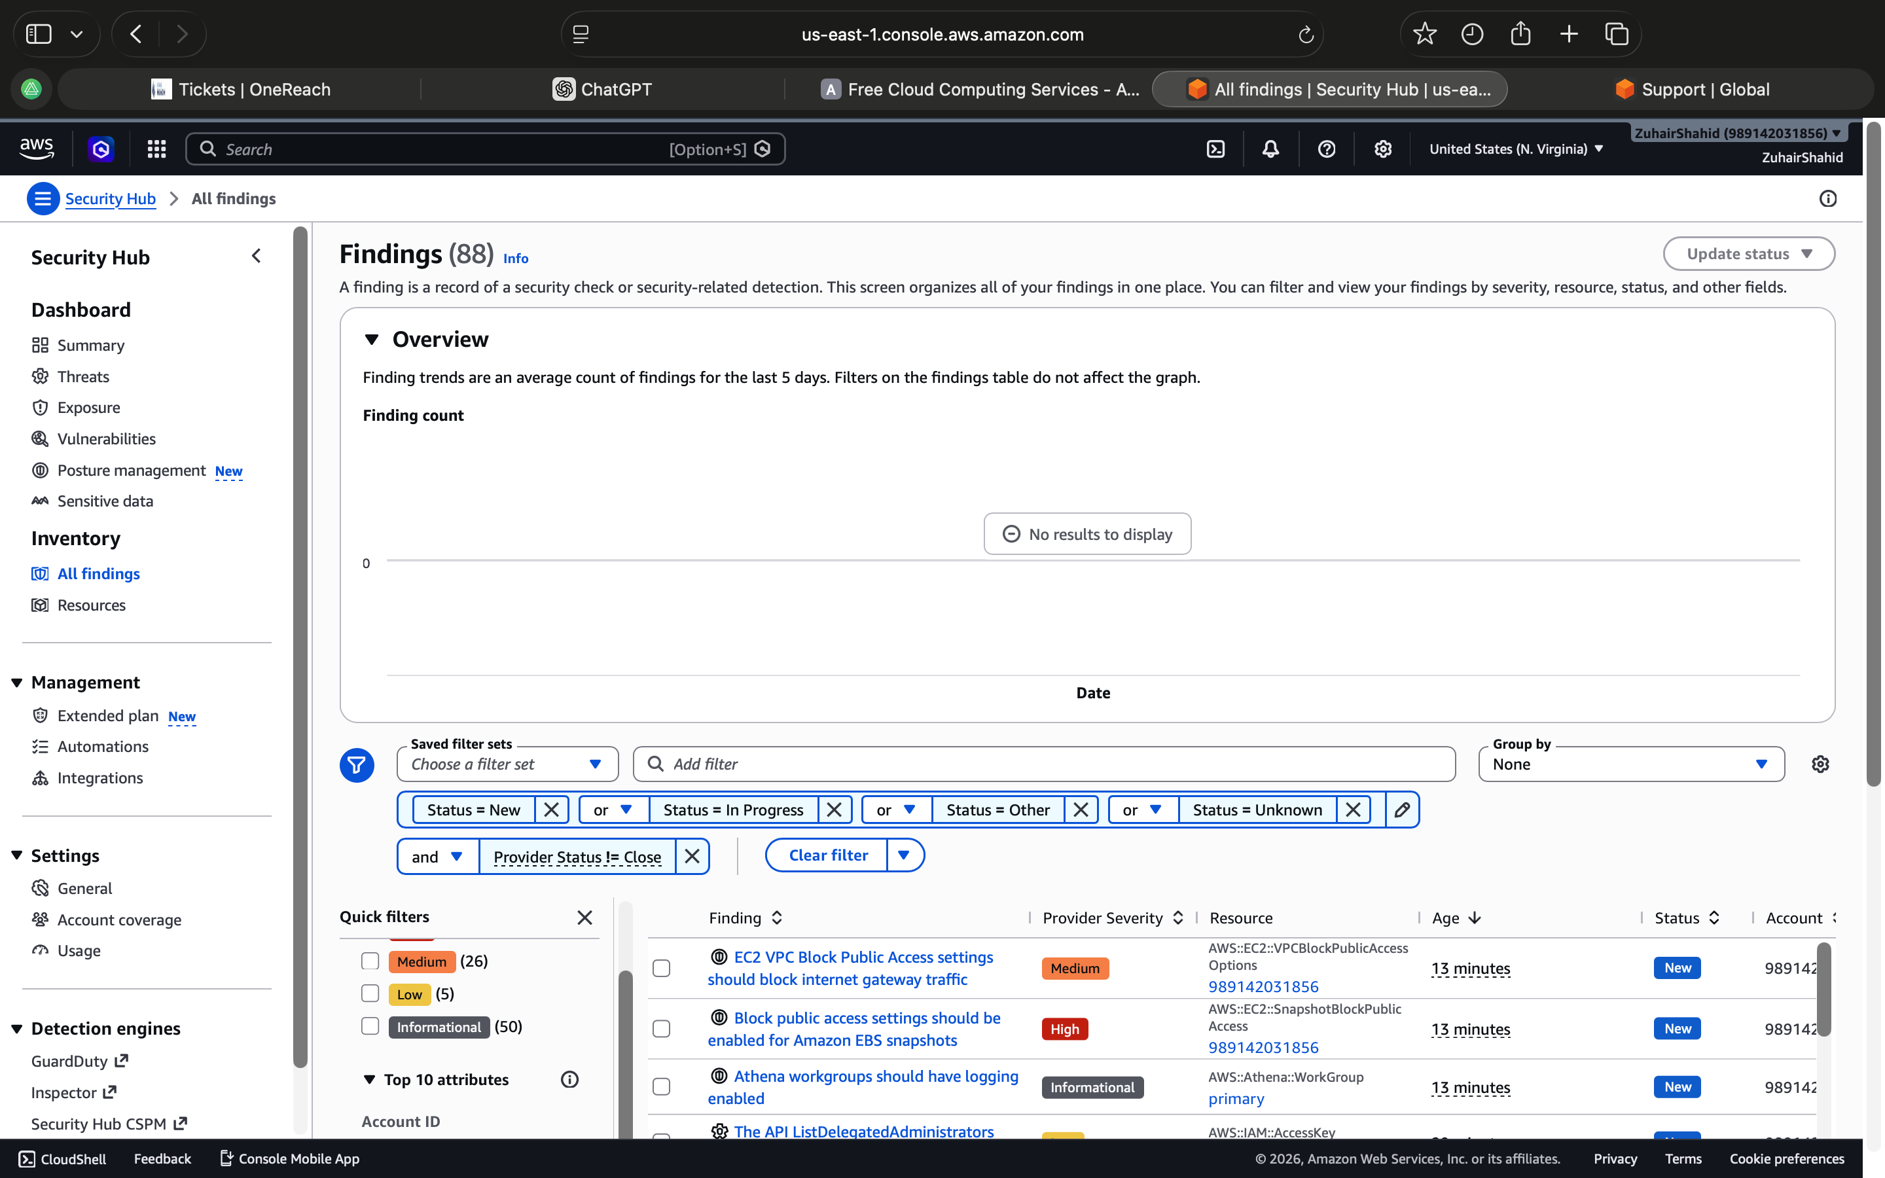

ID | Finding | Severity | Resource | Description | Remediation
F-01 | IAM user with AdministratorAccess and MFA disabled | HIGH | AWS::IAM::User (test-admin-user) | Non-root IAM user granted full AdministratorAccess with no MFA requirement, creating a critical privilege escalation risk. | Removed AdministratorAccess. Applied least-privilege role. Enforced MFA via password policy.
F-02 | S3 bucket with public access enabled | HIGH | AWS::S3::Bucket (zuhair-test-public-bucket) | S3 bucket created with Block Public Access disabled, exposing all stored objects to unauthenticated internet access. | Enabled Block All Public Access. Verified no bucket policy grants public access.
F-03 | VPC default security groups allow unrestricted traffic | HIGH | AWS::EC2::SecurityGroup | Default VPC security group allowed unrestricted inbound and outbound traffic, violating least-privilege network principles. | Removed all inbound and outbound rules. Created dedicated security groups with specific rules.
F-04 | VPC flow logging not enabled | MEDIUM | AWS::EC2::VPC | VPC flow logs disabled, preventing visibility into network traffic and blocking detection of malicious activity. | Enabled VPC Flow Logs with delivery to CloudWatch Logs.
F-05 | EC2 subnets auto-assigning public IP addresses | MEDIUM | AWS::EC2::Subnet (multiple) | Multiple subnets configured to auto-assign public IPv4 addresses, unnecessarily exposing resources to the internet. | Disabled auto-assign public IP on all subnets.
F-06 | IAM password policy does not meet minimum requirements | MEDIUM | AWS::::Account | Account-level IAM password policy lacked minimum length, complexity, and expiration requirements. | Set min 14 chars, complexity requirements, 90-day expiry, no reuse of last 24 passwords.
F-07 | Hardware MFA not enabled for root user | INFORMATIONAL | AWS::::Account (Root) | Root account did not have MFA enabled. Compromise would give unrestricted account access. | Enabled virtual MFA for root. Recommended hardware MFA for production.
F-08 | GuardDuty not enabled | INFORMATIONAL | AWS::::Account | GuardDuty threat detection not active, reducing ability to detect malicious activity. | Enabled GuardDuty in us-east-1 with findings exported to Security Hub.
F-09 | Security contact information not configured | MEDIUM | AWS::::Account | No security contact details set, preventing AWS from notifying the correct team during a security event. | Added security contact email and phone under AWS Account settings.
F-10 | IAM roles with broad KMS inline policies | INFORMATIONAL | AWS::IAM::Role (multiple) | Multiple IAM roles with inline policies granting broad KMS decryption permissions. | Scoped KMS permissions to specific key ARNs. Removed broad inline policies.

4. Detailed Findings
F-01: IAM User with Unrestricted AdministratorAccess
Severity: HIGH
Resource: AWS::IAM::User — test-admin-user
An IAM user named test-admin-user was created and directly assigned the AWS-managed AdministratorAccess policy. This grants the user unrestricted access to every service and resource in the AWS account. The user also lacked MFA enforcement, meaning a compromised password alone would provide full account access.
Risk: If credentials were leaked or phished, an attacker would have complete control of the AWS account with no additional barriers.
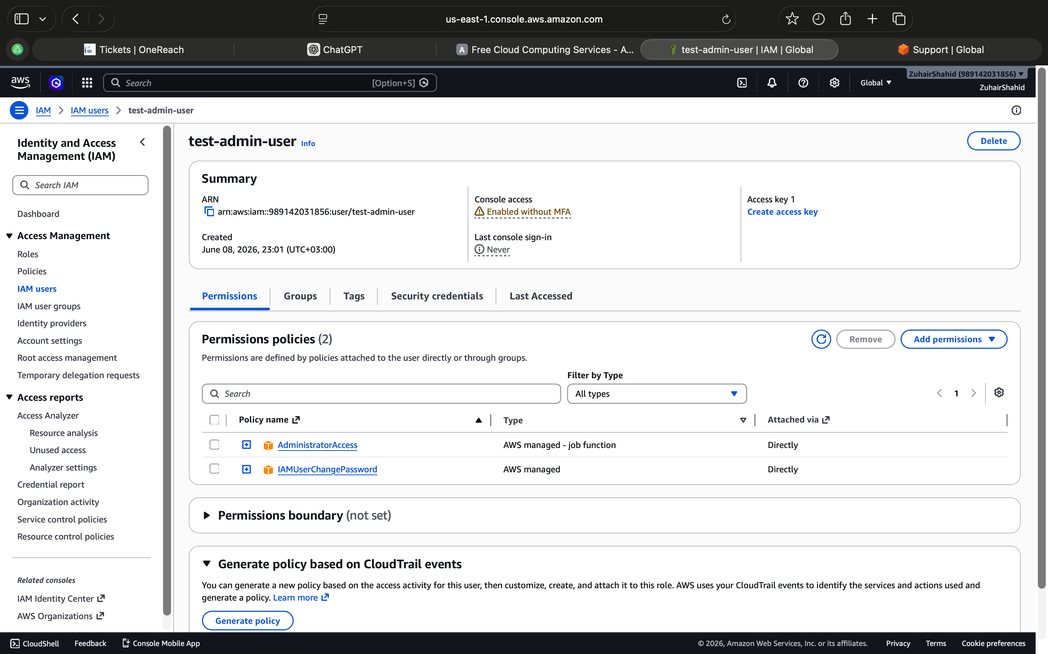
Remediation steps taken:
- Removed AdministratorAccess policy from test-admin-user
- Applied a least-privilege IAM policy scoped to only required services
- Enforced MFA requirement via account-level IAM password policy
- Enabled IAM Access Analyzer to monitor for overly permissive policies

F-02: Publicly Accessible S3 Bucket
Severity: HIGH
Resource: AWS::S3::Bucket — zuhair-test-public-bucket
An S3 bucket was created with Block Public Access disabled across all four settings. This configuration allows the bucket and its objects to be made publicly accessible. Public S3 buckets have been responsible for some of the largest data breaches in cloud security history, with companies inadvertently exposing customer records, credentials, and sensitive business data.
Risk: Any data stored in this bucket could be accessed by unauthenticated users on the internet without any credentials.
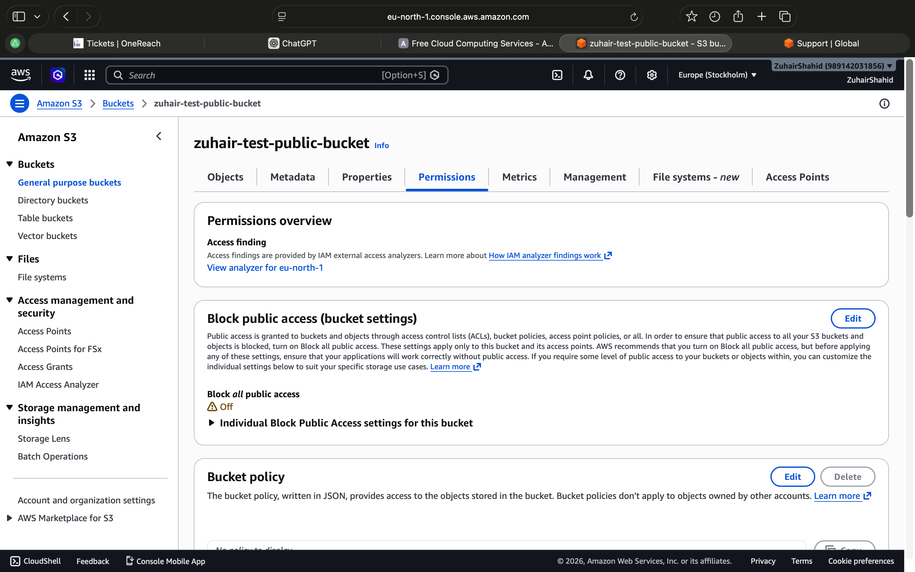
Remediation steps taken:
- Enabled Block All Public Access on zuhair-test-public-bucket
- Verified no bucket policy or ACL grants public access
- Enabled S3 server-side encryption (SSE-S3)
- Enabled S3 access logging to monitor bucket access

F-03: VPC Default Security Group Allows Unrestricted Traffic
Severity: HIGH
Resource: AWS::EC2::SecurityGroup — sg-070d270595760e64e
The default VPC security group was configured to allow all inbound and outbound traffic. AWS best practice requires that default security groups have no rules attached and that purpose-built security groups are created with specific, scoped rules for each workload.
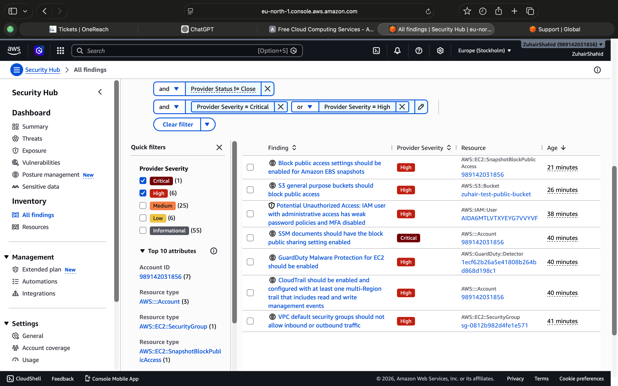
Remediation steps taken:
- Removed all inbound and outbound rules from the default security group
- Ensured no EC2 instances are associated with the default security group
- Created dedicated security groups with explicit rules for required traffic only

5. Remediation Status
The following table summarises the remediation status of all findings identified during this assessment.
ID | Finding | Severity | Status
F-01 | IAM user with AdministratorAccess and MFA disabled | HIGH | Remediated
F-02 | S3 bucket with public access enabled | HIGH | Remediated
F-03 | VPC default security groups allow unrestricted traffic | HIGH | Remediated
F-04 | VPC flow logging not enabled | MEDIUM | Remediated
F-05 | EC2 subnets auto-assigning public IP addresses | MEDIUM | Remediated
F-06 | IAM password policy does not meet minimum requirements | MEDIUM | Remediated
F-07 | Hardware MFA not enabled for root user | INFORMATIONAL | Acknowledged
F-08 | GuardDuty not enabled | INFORMATIONAL | Enabled
F-09 | Security contact information not configured | MEDIUM | Remediated
F-10 | IAM roles with broad KMS inline policies | INFORMATIONAL | Remediated

6. Key Takeaways
This assessment reinforced several important cloud security principles that apply directly to real-world enterprise environments:
- IAM is the most critical attack surface in AWS. Overly permissive policies, unused credentials, and lack of MFA are the leading causes of cloud account compromise. Least-privilege must be enforced from day one.
- S3 public access misconfiguration remains one of the most common and impactful cloud security failures. AWS now provides account-level block public access settings that should always be enabled by default.
- Default VPC configurations are not secure. AWS creates default VPCs and security groups with permissive rules for ease of use. In production these must always be replaced with purpose-built, scoped configurations.
- CSPM tools like AWS Security Hub provide immediate value. 60+ findings were generated within minutes of enabling the service, demonstrating the importance of continuous cloud security monitoring.
- Cloud security is a continuous process, not a one-time activity. New resources and changing configurations introduce new risks that must be monitored and reviewed on an ongoing basis.

7. Conclusion
This self-directed lab successfully demonstrated the process of identifying, assessing, and remediating cloud security misconfigurations in an AWS environment. Using AWS Security Hub as the primary CSPM tool, 60+ findings were detected across IAM, S3, VPC, and account-level configurations. All High and Medium severity findings were remediated in line with AWS security best practices and CIS AWS Foundations Benchmark recommendations.
The skills applied in this assessment map directly to cloud security operations in a defensive security role, including CSPM tool operation, IAM policy review and hardening, misconfiguration remediation, and security finding documentation. This lab forms part of an ongoing effort to build practical hands-on cloud security competency alongside formal certification study for the AZ-500 Azure Security Engineer Associate.

Zuhair Muhammad Shahid | CompTIA Security+ (SY0-701) | AZ-500 In Progress | zuhair.shahid12@gmail.com

