

Altair Meetups
User Guide
Group meetups, RSVPs and the meetup map for neighborhood dog-walking groups
Version 1.0 · October 29, 2026
Android (Expo Go) · Hosted Supabase backend
Contents
1. About Altair Meetups 2
What you can do 2
Who this guide is for 2
2. Getting started 2
What you need 2
Key terms 2
3. Signing in and out 3
Signing out 3
4. Your groups and meetups 3
Reading a meetup card 4
5. Meetup details 4
6. RSVPs and the meeting point 4
Before you RSVP: an approximate area 4
After you RSVP: the exact meeting point 4
Withdrawing an RSVP 5
When you cannot RSVP 5
7. Creating a meetup 5
Rules the app checks 5
8. Editing a meetup (hosts) 6
9. Cancelling a meetup (hosts) 6
10. Live walk (demo) 7
11. Privacy: who can see what 8
Your home location is never shared 8
People outside a group see nothing 8
12. Messages and what they mean 8
13. Troubleshooting 9
14. For evaluators: running Altair 10
1. Install 10
2. Configure 10
3. Set up the database 10
4. Start the server and the app 10
5. Optional: tests and demos 10
Appendix A. Demo accounts 11

1. About Altair Meetups
Altair Meetups helps members of small neighborhood walking groups plan dog walks together. Any member can post a meetup with a title, a start time and a public meeting place. Other members of the same group can see it, say they are going (RSVP) and find the meeting point on a map.
Meetups are private to their group. People outside a group see nothing about its meetups, and the exact meeting point is shared only with the people who are actually coming.

What you can do
- Browse your groups and their upcoming meetups, soonest first.
- Open a meetup to see when and roughly where it is, who is hosting and who is going.
- RSVP to reveal the exact meeting point, and withdraw if your plans change.
- Create a meetup for one of your groups.
- Edit or cancel a meetup you host.
- Try the Live walk (demo) map, which animates simulated walkers.

Who this guide is for
Sections 2 to 12 are for anyone using the app. Section 14 is for evaluators and developers who need to run the app and its server on their own machine.

2. Getting started

What you need
- An Android phone or emulator with Expo Go (SDK 58) installed. iOS works too.
- An Altair account. For trying the app, use one of the demo accounts in Appendix A.
- A running Altair server and app build. If someone shared the app with you, this is already done; otherwise see Section 14.
The screenshots in this guide were taken in Expo Go on Android. The round gear button that appears on them belongs to Expo Go’s developer tools, not to Altair.

Key terms
Term | Meaning
Group | A neighborhood walking group. You can belong to several groups, or none.
Meetup | A planned walk in one group: a title, a start time and a meeting point.
Host | The member who created a meetup. Only the host can edit or cancel it.
RSVP | Saying you are going. It adds you to the attendee list and reveals the exact meeting point.
Approximate area | A circle of about 400 m around (but not centered on) the meeting point, shown before you RSVP.

3. Signing in and out
Altair signs you in with your email address and password.  - Open the app. The Welcome back screen appears.  - Enter your Email and Password. Tap the eye icon to show or hide the password.  - Tap Sign in. Your groups and meetups load.  Demo accounts. Under Try a demo account, tap a face (Avery, Jordan, Sam, Riley, Taylor) to fill in that email address. You still type the password; see Appendix A.  Signing out  Tap the sign-out icon at the top right of the meetups screen. Your session ends on this device and cached meetup data is cleared, so the next person who signs in cannot see it.  If you see “That email and password don’t match an account.”, check both fields and try again. | 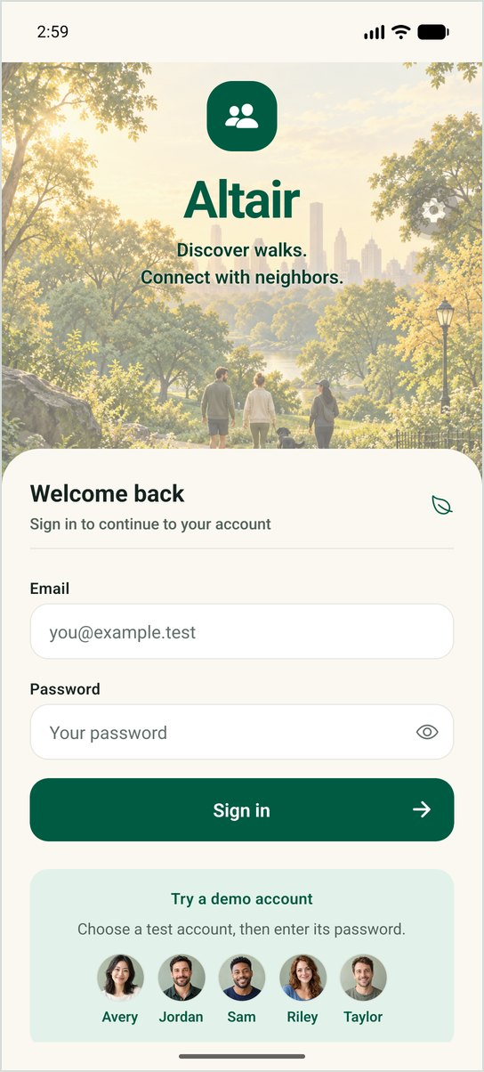  Figure 1. Sign-in with demo accounts

4. Your groups and meetups
After signing in you see Your groups and the Upcoming meetups of the selected group.  - Tap a group card to select it. A check mark shows which group is selected.  - Scroll Upcoming meetups. They are listed soonest first, and cancelled meetups stay in the list, clearly marked.  - Pull down on the list to refresh it.  - Tap a meetup to open its details.  If a group has no meetups yet, you see No meetups yet with a button to create one. If you do not belong to any group, the app says so; a group member has to add you first. | 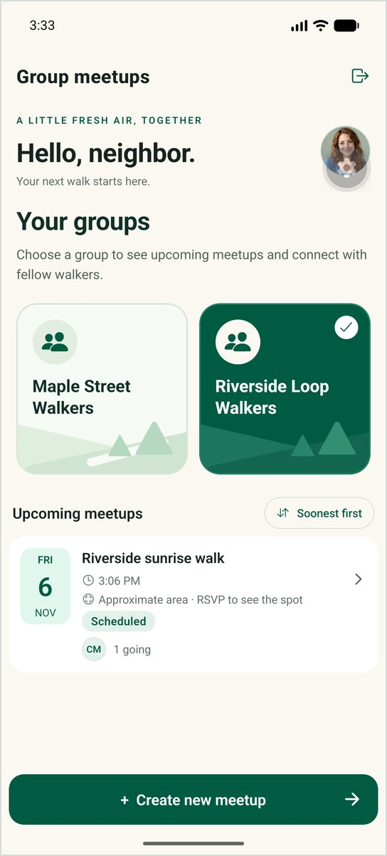  Figure 2. Groups and upcoming meetups

Reading a meetup card
Part of the card | What it tells you
Date tile and time | When the walk starts, in your device’s time zone.
Location line | The exact place name if you are going or hosting; otherwise “Approximate area · RSVP to see the spot”.
Status badge | Scheduled or Cancelled.
Your meetup / You’re going | Shown when you host the meetup or have RSVP’d.
Going count | How many members have RSVP’d.

5. Meetup details
The details screen shows everything you are allowed to see about a meetup:
- The title, date and start time, status, and who is hosting.
- The Meeting point map: an approximate area or the exact point (see Section 6).
- Who’s going: the names of members who have RSVP’d.
- The actions available to you: RSVP, withdraw, and for the host, edit and cancel.
Pull down to refresh. If the meetup cannot be loaded, you see a message with a Try again button.

6. RSVPs and the meeting point
Before you RSVP: an approximate area  Until you RSVP, the map shows a shaded circle of about 400 m. The meeting point is somewhere inside it, but the circle is deliberately not centered on it, and the place name is hidden. This is enough to decide whether a walk is near you.  After you RSVP: the exact meeting point  Tap RSVP — I’m going. The map immediately switches to a pin on the exact meeting point, the place name and coordinates appear, and you are added to Who’s going. You do not need to sign out or restart the app. | 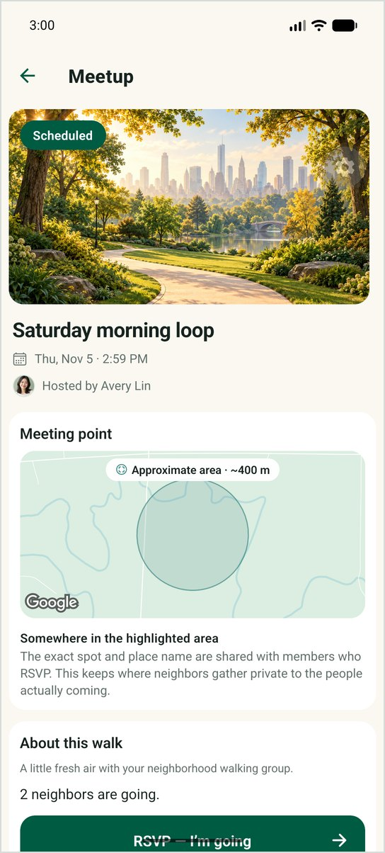  Figure 3. Before RSVP | 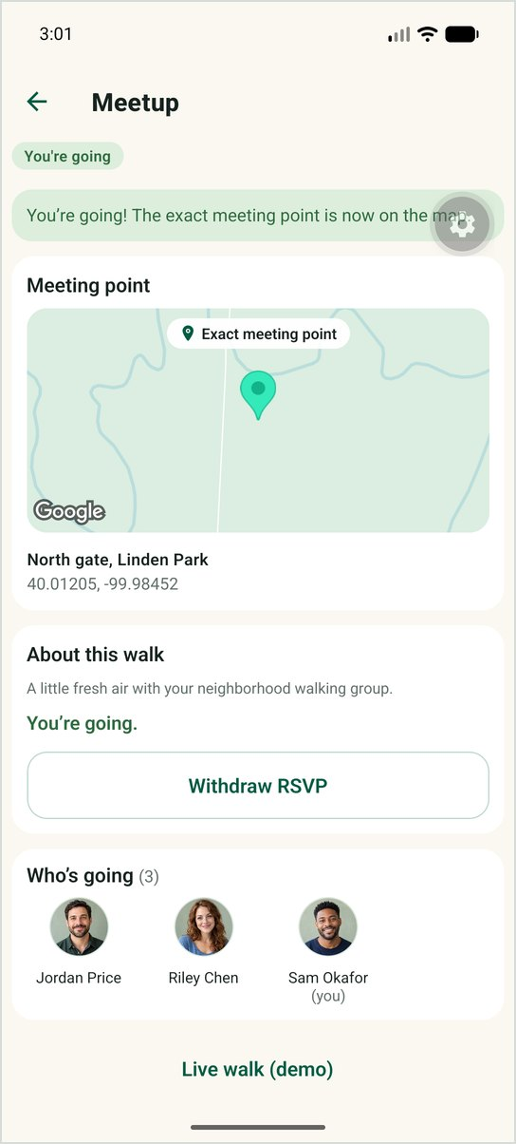  Figure 4. After RSVP

Why the exact spot is hidden until you RSVP
A meetup says where a neighbor will be at a specific time, often early or late and alone with a dog. Sharing the exact spot only with people who are actually coming keeps that information with the people who need it. The host always sees the exact point of their own meetup.

Withdrawing an RSVP
- Open a meetup you are going to.
- Tap Withdraw RSVP.
- You see “Your RSVP was withdrawn.” You leave the attendee list and the map returns to the approximate area.

When you cannot RSVP
- Cancelled meetups accept no new RSVPs. If you were already going, you can still withdraw.
- Meetups that have started accept no new RSVPs.
- RSVPing twice is harmless; you are only listed once.

7. Creating a meetup
- On the meetups screen, select the group and tap Create new meetup.  - If you belong to more than one group, choose the Group at the top of the form.  - Enter a Title, for example “Saturday morning loop”.  - Set the Date and start time. It must be in the future.  - Under Meeting point, enter the Place name of a public place, then tap the map to drop a pin (drag it to adjust) or type the Latitude and Longitude.  - Tap Create meetup. The new meetup opens with a confirmation, and your group can see it straight away.  If something is wrong, the message appears next to the field. The server checks the same rules again, so a meetup can never be saved with invalid details. | 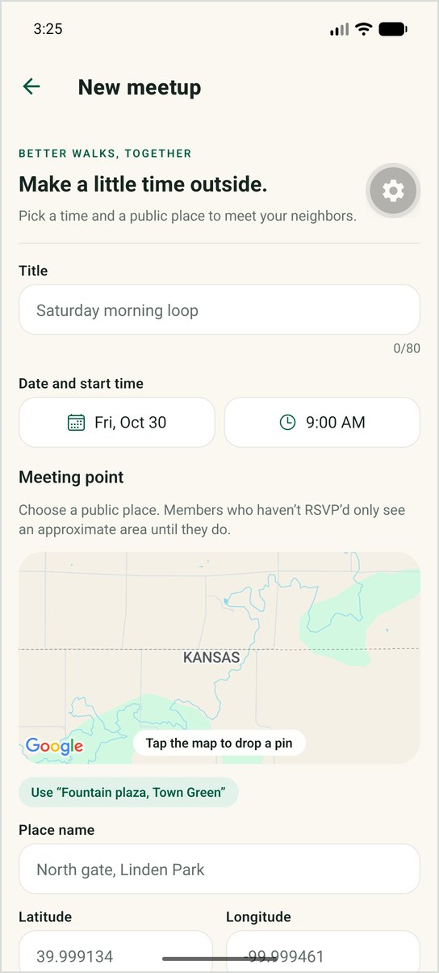  Figure 5. The New meetup form

Rules the app checks
Field | Rule
Title | Required; 1 to 80 characters. Spaces at the start and end are removed.
Date and start time | Required; must be later than now.
Place name | Required; 1 to 120 characters. Use a public place, never a home address.
Latitude / Longitude | Required; latitude −90 to 90, longitude −180 to 180.
Group | Must be one of your groups. You are always recorded as the host.

8. Editing a meetup (hosts)
Only the host can edit a meetup, and only while it is scheduled. Other members do not see the Edit meetup button.  - Open your meetup and tap Edit meetup. The form opens with the current details.  - Change the title, start time or meeting point.  - Tap Save changes. You return to the meetup with “Changes saved.”  - A new start time must still be in the future.  - The group and the host cannot be changed.  - If you move the meeting point, members who have not RSVP’d see a new approximate area around the new spot.  - Cancelled meetups cannot be edited. | 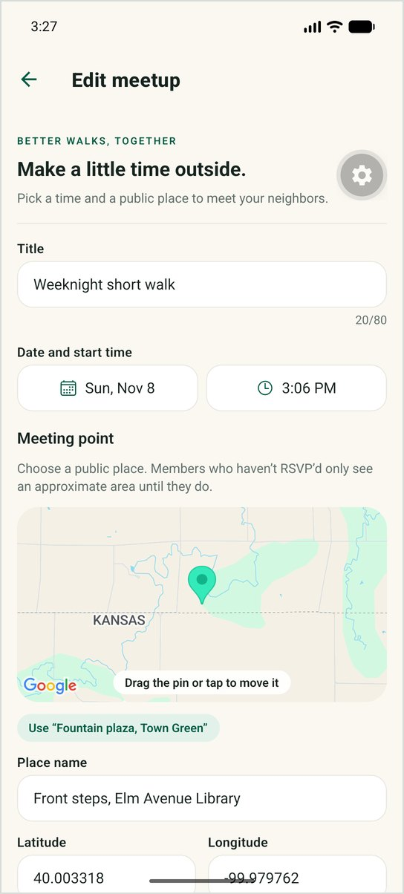  Figure 6. Editing a meetup you host

9. Cancelling a meetup (hosts)
Only the host can cancel a meetup. Cancelling is final: a cancelled meetup cannot be reopened.
- Open your meetup and scroll to Cancel meetup.
- Tap Cancel meetup. A dialog asks you to confirm.
- Tap CANCEL MEETUP to confirm, or KEEP IT to go back.
 | 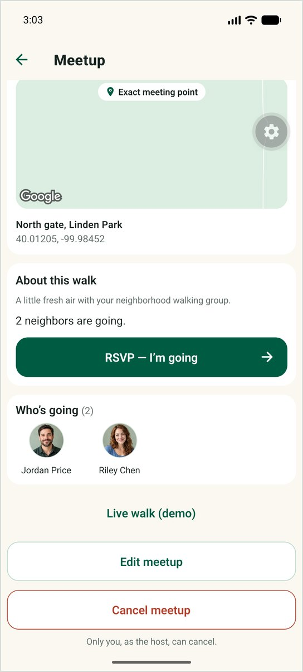  Figure 7. Host actions | 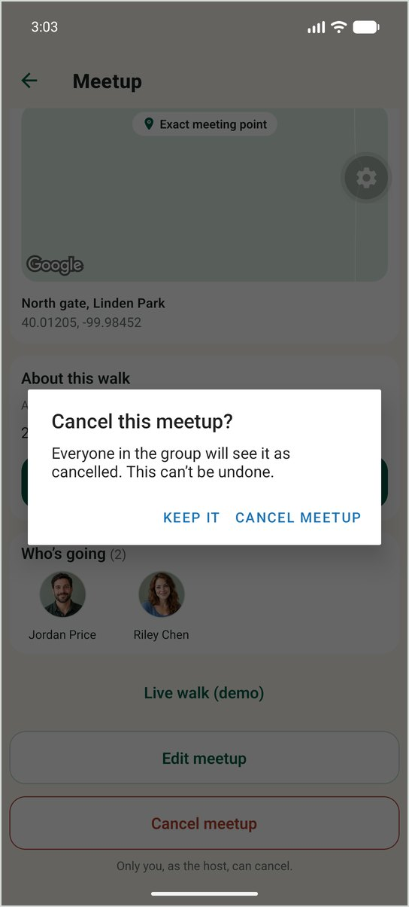  Figure 8. Confirming | 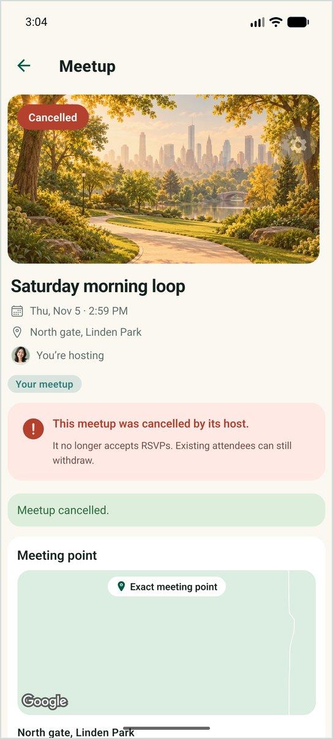  Figure 9. Cancelled

After cancelling, the meetup stays visible to the group, marked Cancelled. It accepts no new RSVPs, existing attendees stay listed, and anyone who was going can still withdraw.
Tell your group
The app does not send notifications. If you cancel or change a walk, let your attendees know directly.

10. Live walk (demo)
Live walk (demo) shows how a group could follow a walk on a live map. It uses simulated walkers only; no real person’s location is collected or shown, and your own location is never used.  - Open a scheduled meetup that you host or are going to, and tap Live walk (demo).  - The panel at the bottom shows Live once connected.  - Walkers appear as round avatars (W1, W2, …) and move smoothly between updates. Only walkers on or near the visible map are drawn; the panel shows how many there are in total and how many are on screen.  Only the host and members who RSVP’d can open the live walk. For evaluators: start the simulator with npm run live:simulate (Section 14). | 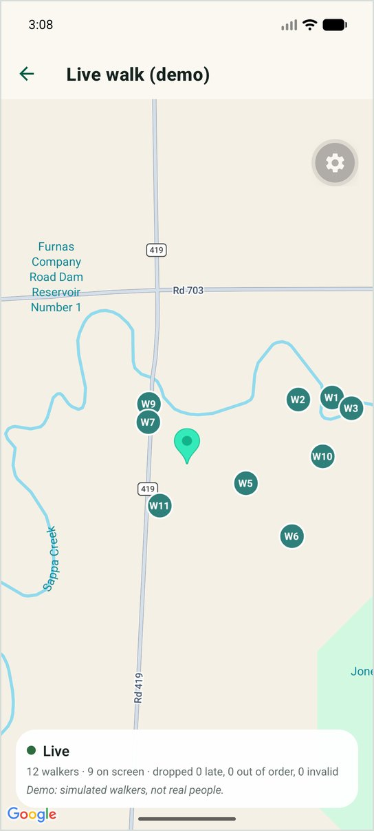  Figure 10. Live walk with simulated walkers

11. Privacy: who can see what
Access is enforced by the server and the database, not just by hiding buttons in the app.
Information | Outside the group | Member, not going | Member, going | Host
Title, time and status | No | Yes | Yes | Yes
Who is going (names) | No | Yes | Yes | Yes
Meeting point | No | Approximate area | Exact place and pin | Exact place and pin
Edit and cancel | No | No | No | Yes, while scheduled
Live walk (demo) | No | No | Yes | Yes

Your home location is never shared  Your profile may contain a home location for other features. Altair Meetups never shows it to anyone, never puts it on a map, and never uses it to calculate anything.  People outside a group see nothing  Someone who is not a member of a group cannot see its meetups, who is going, or where they meet, in the app or by calling the server directly. A signed-in user who belongs to no group simply sees that they are not in any walking group yet. | 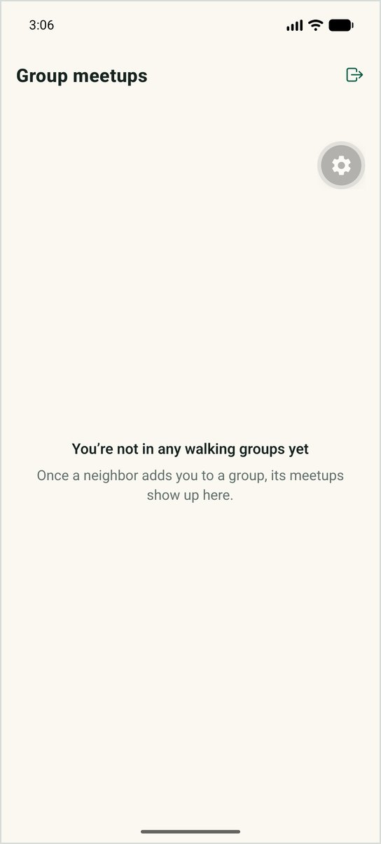  Figure 11. A user in no group

12. Messages and what they mean
Message | What it means | What to do
Sign in required / Your session is invalid or has expired | You are signed out, or your session ended. | Sign in again.
That email and password don’t match an account. | The credentials are wrong. | Check the email and password.
Start time must be in the future | The chosen time has already passed. | Pick a later date or time.
Title is required / Meeting point name is required | A required field is empty. | Fill in the field.
Latitude must be between -90 and 90 | The coordinates are not valid. | Tap the map instead of typing them.
This meetup has been cancelled and no longer accepts RSVPs | The host cancelled the meetup. | Nothing; you can still withdraw an existing RSVP.
This meetup has already started and no longer accepts RSVPs | The start time has passed. | Nothing.
Only the member who created this meetup can … it | You are not the host. | Ask the host.
Meetup not found / Group not found | It does not exist, or you are not in its group. | Check that you are signed in with the right account.
Could not reach the server | No connection to the Altair server. | Check your connection; see Section 13.

13. Troubleshooting
Problem | Likely cause | Fix
“App is not configured …” on start | The app’s settings file is missing. | Evaluators: create mobile/.env (Section 14) and restart the app.
“Could not reach the server” | The server is not running, or the device cannot reach it. | Start the server; use http://10.0.2.2:4000 on the Android emulator or your computer’s LAN IP on a phone.
Sign-in keeps failing for a demo account | Wrong password, or too many attempts in a short time. | Use the password in Appendix A; wait a few minutes and retry.
No groups shown | Your account is not in any group. | A group member must add you. Taylor is intentionally in no group.
I can’t see the exact meeting point | You have not RSVP’d. | Tap RSVP — I’m going.
No Edit or Cancel button | You are not the host, or the meetup is cancelled. | Only the host can edit or cancel a scheduled meetup.
The map stays blank | Map tiles are still loading. | Wait a moment or pull to refresh.
Expo Go says the project is incompatible | Expo Go is for a different SDK. | Install Expo Go for SDK 58.

14. For evaluators: running Altair
This section summarizes the README in the repository. It needs Node.js 22.13 or later and a hosted Supabase project; Docker is not required.

1. Install
git clone <repository> altair && cd altair
npm ci

2. Configure
Copy .env.example to .env and mobile/.env.example to mobile/.env, then fill them in from your Supabase project. Use the publishable (anon) key, never the service-role key, and the Session pooler connection string with your real database password.

3. Set up the database
npm run db:inspect # read-only check of the database
npm run db:push:dry # preview the migrations
npm run db:push # apply the migrations
npm run db:seed # demo accounts, groups and reference meetups
Windows PowerShell
Use npm run db:push:dry for the preview. Do not use npm run db:push -- --dry-run: PowerShell drops the --, so the migrations would really be applied.

4. Start the server and the app
npm run server # API on http://localhost:4000
npm run mobile # then press "a" for the Android emulator
Where the app runs | EXPO_PUBLIC_API_URL
Android emulator | http://10.0.2.2:4000
iOS simulator | http://127.0.0.1:4000
Phone with Expo Go | http://<your computer’s LAN IP>:4000

5. Optional: tests and demos
npm run test:offline # no network or credentials needed
npm run test:hosted # against your Supabase project
npm run db:reset-reference # restore the three reference meetups
npm run live:simulate # simulated walkers for the live walk demo

Appendix A. Demo accounts
Every demo account uses the password altair-fixture-pass. These accounts are for demonstration and testing only.
Name | Email | Groups | Good for trying
Avery Lin | avery@example.test | Maple Street Walkers | Hosting: edit and cancel “Saturday morning loop”
Jordan Price | jordan@example.test | Maple Street Walkers | Going to Saturday; hosts “Weeknight short walk”
Sam Okafor | sam@example.test | Maple Street Walkers | Before/after RSVP: approximate vs exact point
Riley Chen | riley@example.test | Both groups | Switching groups; going to Saturday only
Morgan Ellis | morgan@example.test | Riverside Loop Walkers | Hosts “Riverside sunrise walk”
Casey Moreno | casey@example.test | Riverside Loop Walkers | Going to Riverside sunrise walk
Quinn Adler | quinn@example.test | Riverside Loop Walkers | Member who has not RSVP’d
Taylor Brooks | taylor@example.test | None | Outsider: sees no groups or meetups

Place names and coordinates in the demo data are fictional and do not match the real-world map labels at those coordinates.

