Contents

Executive summary 2

1.0 Introduction 3

2.0 Risk Management Process 4

2.1 Integration of Quantitative Risk Analysis 5

2.2 Interventions and Their Frequency 5

3.0 Methodology 5

3.1 Theory behind QRA and Process 5

3.1.1 Data Collection: 6

3.1.2 Probabilistic Modeling: 6

3.1.3 Scenario Analysis: 6

3.1.4 Sensitivity Analysis 6

3.1.5 Cost Contingency Adjustment 6

3.2 Limitations of Risk Analysis and Modeling 6

3.3 Application of Theory 7

3.3.1 Risks Quantitatively Assessed at Risk Reviews 7

3.3.2 Model Built in @Risk from Contents of Register 7

3.3.3 Distribution Selections and Justifications 8

4.0 Output 9

4.1 Key Influencing Risks 10

5.0 Conclusion and Recommendation 11

References 12

Appendices 14

# 

# Executive summary

The executive summary distills key insights from the extensive report on the Glasgow Subway Rail Project. The report systematically delves into the project's Quantitative Cost Risk Analysis (QCRA) methodology, Output and the identification of top influencing risks.

In terms of QCRA methodology, the project adopts a systematic and adaptive approach. Regular risk reviews quantitatively assess identified risks using @Risk software to construct a bespoke model. Probability distributions such as Uniform, PERT and Triangular are judiciously selected based on variable characteristics and historical data aligning theoretical foundations with practical application.

The analysis visually portrays the cumulative probability of the project exceeding specific cost thresholds. Confidence level estimations (P80 and P95) provide insights into budget overruns indicating varying probabilities of exceeding the budget at different confidence levels, with a current 20% chance at 80% confidence (P80) and 5% at 95% confidence (P95). Despite a £5.7 million contingency fund, QCRA results suggest an additional £2.3 million may be needed. The project faces an 88% chance of staying within its £270 million budget, with a 12% likelihood of costs ranging from £275 million to £330 million. The existing contingency falls short requiring potential additional funding from the client if costs exceed £270 million. Regular reassessment is crucial for effective risk management. The current contingency fund of £5.7 million is identified as insufficient prompting a recommendation for a contingency review to align with potential risks and ensure financial resilience.

The report also identifies the top 10 key influencing risks, encompassing factors like Restricted Working Times, Interfaces with Local Businesses and Geotechnical Survey Accuracy. These risks collectively contribute over 60% (P80) and over 50% (P95) of the risk of budget overruns, necessitating proactive and tailored risk treatment strategies for each influencing factor.

# 1.0 Introduction

This report delves into the outcomes of a Quantitative Cost Risk Assessment (QCRA) recently conducted for the Glasgow Subway Rail Project which is a significant initiative with a budget of £270 million. Despite positive strides, Project Directors express concerns about the sufficiency of the remaining £5.7 million in the contingency fund to address potential risks and their impacts—an essential aspect of project management designed for effective risk mitigation and management (Shaji, 2022).

This provides a detailed analysis of the QCRA findings, outlining identified risks, their potential impacts and associated costs. It also scrutinizes the current state of the project's contingency fund thereby evaluating its adequacy to cover remaining risks and offers recommendations for optimizing its use for efficient risk management (PENSERINI, 2020)

The QCRA was initiated to gauge the adequacy of the contingency fund in managing evolving project uncertainties. This quantitative analysis aims to reveal potential cost implications tied to identified risks, enabling Project Directors to make informed decisions on resource allocation and ensure sufficient funds are available for effective risk mitigation (Deere et al., 2005)

Timely execution of the QCRA at this pivotal stage in the Glasgow Subway Rail Project is crucial which offers a precise evaluation of potential risks impacting subsequent phases. This facilitates informed decision-making, resource allocation and the implementation of timely risk mitigation measures as the project progresses (Cantoni et al., 2021)

The Glasgow Subway Rail Project is a landmark initiative aimed at enhancing the city's public transportation infrastructure. With a budget of £270 million, the project encompasses various phases including track laying, station construction and systems integration. The subway system is expected to play a pivotal role in alleviating transportation challenges and fostering economic development in the region.

In a preceding (QRA) conducted by Sarkar & Dutta, they applied a Monte Carlo model with 10,000 iterations to assess the identified risks associated with an underground train tunnel situated in the capital city of a South Asian country. The project, with a budget set at INR 3532.9 million and a projected timeline of 4351.12 days, yielded a throughput result indicating potential overruns of approximately 22.5% in project cost and 23.5% in project duration (Sakar, 2011). By delving into the specifics of cost estimation, the QCRA adds a layer of precision to risk management efforts.

# 2.0 Risk Management Process

The risk management process is a multifaceted and systematic approach designed to identify, assess and address potential risks throughout the lifecycle. This process involves several stages, each contributing to understanding and management of risks.

**Risk Identification:** The initial phase involves identifying potential risks that could impact the project. This encompasses both internal and external factors. Techniques such as brainstorming sessions, document reviews and lessons learned from similar projects are employed to compile a comprehensive list of potential risks (Olsson, 2007).

**Risk Assessment:** The identified risks are then assessed to determine their likelihood and potential impact on the project's objectives. Qualitative assessments including probability and impact matrices, categorize risks based on their severity (Aven, 2016). This qualitative analysis forms the foundation for subsequent risk management decisions.

**Quantitative Risk Analysis**: One of the pivotal components of the risk management process is Quantitative Risk Analysis (QRA). This involves a detailed numerical analysis of the identified risks providing a more precise estimation of the potential cost impacts (Morgan, 1993). For the Glasgow Subway Rail Project, QRA is particularly critical in quantifying the financial implications associated with various risks.

**Risk Mitigation Planning:** A comprehensive risk mitigation plan is formulated based on the assessments. This plan outlines specific actions and strategies to reduce the probability or impact of identified risks. Mitigation measures may involve process improvements, resource reallocation or the establishment of contingency plans to ensure a proactive response to potential challenges (Shahzad et al., 2008).

**Monitoring and Control:** The risk management process is not static; it requires continuous monitoring and control. Regular reviews of identified risks, their status and the effectiveness of mitigation measures are conducted (Haimes, 2005). This ensures that the risk management plan remains adaptive to the evolving nature of the project.

## 2.1 Integration of Quantitative Risk Analysis

Quantitative Risk Analysis is strategically embedded within the Glasgow Subway Rail Project's risk management process to enhance decision-making through a more granular understanding of financial implications.

## 2.2 Interventions and Their Frequency

Strategic interventions are integral to the risk management process, serving as proactive measures to address identified risks. The frequency of these interventions is tailored to the evolving nature of the project and the critical milestones it reaches.

**Regular Risk Reviews:** Regular risk reviews are conducted to reassess the identified risks and their status. These reviews are typically scheduled at regular intervals with the frequency determined by the project phase and complexity (de Swiet, 1992). Monthly or quarterly reviews may be common during active project phases.

**QRA Updates:** QRA is not a one-time activity; it is an iterative process. Updates to the QRA are performed at key project milestones or when significant changes occur (Vinnem et al., 1996). For instance, as the project progresses, new data becomes available and the risk landscape may evolve which in turn necessitating updates to the quantitative analysis.

**Contingency Release Triggers:** These are pre-established conditions that prompt the release of additional contingency funds. These triggers are set based on specific project milestones or events. The frequency of assessing these triggers may be tied to project phases or critical decision points (McNeil et al., 2015).

# 3.0 Methodology

## 3.1 Theory behind QRA and Process

Quantitative Risk Analysis involves translating uncertainties and potential risks into numerical values, providing decision-makers with a quantitative understanding of the potential impacts on project objectives. The theoretical foundation of QRA within the Glasgow Subway Rail Project comprises several key components:

3.1.1 Data Collection: QRA commences with the collection of pertinent data, encompassing cost estimates, project schedules and historical information (Gupta et al., 2018). This data serves as the foundation for a robust numerical analysis thereby facilitating a more accurate representation of the project's financial landscape.

3.1.2 Probabilistic Modeling: Central to QRA is probabilistic modeling, employing statistical techniques to model the uncertainty associated with various project parameters such as Monte Carlo simulation which involves simulating risk analysis hundreds of times in appropriate ranges to the scenario (Rider et al., 2000). Through this modeling, QRA captures the dynamic and uncertain nature of project variables.

3.1.3 Scenario Analysis: QRA explores diverse scenarios to assess the range of possible project outcomes. By considering various combinations of risks and their impacts, it provides decision-makers with a comprehensive view of the financial implications under different circumstances. This information proves invaluable for strategic decision-making (Purnus et al., 2013).

3.1.4 Sensitivity Analysis**:** Sensitivity analysis is identifies the most influential variables that impact project costs (He at al., 2018). Understanding these key factors allows project managers to prioritize their focus and allocate resources effectively to mitigate risks that pose the greatest threat to the project's financial success.

3.1.5 Cost Contingency Adjustment**:** The insights derived from QRA contribute to adjustments in the cost contingency. If the analysis reveals a higher level of risk or uncertainty then the project team may opt to allocate additional funds to the contingency (Gupta et al., 2018). This ensures the availability of sufficient resources to address unforeseen challenges without jeopardizing project timelines or financial integrity.

## 3.2 Limitations of Risk Analysis and Modeling

While QRA is a powerful tool, it is not immune to limitations that warrant consideration:

**Assumption Dependency**: QRA relies on assumptions about the probability distributions of variables. If these assumptions are inaccurate then the QRA results may not reflect the actual risks accurately (Escande et al., 2016).

**Data Limitations:** The quality of its results heavily depends on the availability and accuracy of historical data and project information. Incomplete or unreliable data can compromise the validity of the analysis (Haimes, 2005).

**Complexity and Resources**: Implementing QRA can be resource-intensive and requires a level of expertise. The complexity may hinder its practicality for smaller projects or organizations with limited resources (Purnus et al., 2013).

## 3.3 Application of Theory

3.3.1 Risks Quantitatively Assessed at Risk Reviews**:**

Regular risk reviews serve as pivotal forums within the Glasgow Subway Rail Project where risks are not merely identified but quantitatively assessed. This involves a nuanced evaluation that goes beyond qualitative considerations, assigning numerical values to both the likelihood and impact of identified risks.

3.3.2 Model Built in @Risk from Contents of Register**:**

The heart of the quantitative risk assessment lies in the construction of a robust and tailored model using the @Risk software. This model-building process involves extracting relevant data from the project's risk register. The risk register serves as a repository of identified risks, their characteristics and potential impacts. By integrating this data into it, the model becomes a dynamic representation of the project's risk landscape. The software facilitates a probabilistic modeling approach which allows for a more nuanced and accurate representation of uncertainties (Melnick, 2008). The Monte Carlo technique stands as a prevalent method in Quantitative Cost Risk Assessment (QCRA). This approach involves selecting variables from a probability density function based on their likelihood, using triangular or other distribution functions to quantify risk factors by forecasting pessimistic, normal, and optimistic values. The process generates a distribution of probable outcomes and assesses the occurrence likelihood and effects of defined risks over 10000 iterations. Despite its utility, QCRA's reliance on subjective judgments, encompassing the project team's knowledge and intuitions, remains a drawback (Morgan, 1993). The Monte Carlo method offers an advantage which is addressing any problem, irrespective of its dimension or nonlinearity.

3.3.3 Distribution Selections and Justifications**:**

Selecting appropriate probability distributions for project variables is a critical aspect of the QRA methodology within the Glasgow Subway Rail Project. This step involves a meticulous process guided by both the nature of each variable and historical data. Assumptions, such as stable economic conditions (McNeil et al., 2015), play a guiding role in this process. The team considers the inherent characteristics of each variable thereby recognizing that different types of variables may follow different distribution patterns. The risk model employs 3-point estimates, presenting probability distributions for simulation with minimum, most likely and maximum values. The @Risk software in Microsoft Excel utilizes Uniform, Triangular and Pert distributions to calculate the risk model cost. Each distribution is chosen based on specific risk parameters and applied strategically in the report, ensuring a comprehensive assessment of the project's cost uncertainties.

Uniform Distribution**:** The Uniform Distribution assumes equal likelihood for all possible outcomes. In the Glasgow Subway Rail Project, this distribution is aptly applied to variables where a broad spectrum of values is plausible and there is no inherent bias toward any specific value (Clemen, 1999). For instance, when estimating certain material costs or the duration of a particular project phase, the Uniform Distribution accommodates the uncertainty by not favoring any particular value. In this case, just one out of the 20 potential risk is a uniform distribution (GCU-SWS-071).

PERT Distribution: The PERT Distribution becomes relevant when uncertainty surrounds the exact values of variables. It incorporates a weighted average, providing more weight to the most likely value within a range. For the Glasgow Subway Rail Project, the PERT Distribution find application in variables like project duration or resource costs. By emphasizing the most likely value, it allows the model to reflect the team's best estimates while accommodating the inherent uncertainty surrounding these estimates (Kirytopoulos et al., 2008). Three out of the potential risks belong to this (GCU-SWS-007, GCU-SWS-114 and GCU-SWS-002).

Triangular Distribution: The Triangular Distribution is a valuable tool when there is more knowledge about the range and a specific value is deemed more likely within that range. In the context of the Glasgow Subway Rail Project, variables with known minimum and maximum values where a specific outcome within that range is anticipated, is represented using a Triangular Distribution (Platon et al., 2014). This distribution adds a level of sophistication to the model, capturing the project team's insights into the most likely outcomes within a given range. In this case the remaining 16 risks in the register falls under this category.

# 4.0 Output

The S-curve in Fig 2 is a graphical representation that depicts the cumulative probability of the Glasgow Subway Rail Project exceeding certain cost thresholds. The curve begins at 0% which is positioned on the left side of the graph indicating that there is a 0% chance of the project cost falling below the lowest possible cost. As the curve ascends, it reflects the increasing probability of the project cost exceeding a specific amount. The steep incline signifies a rapid escalation in this probability until it levels off indicating a relatively constant likelihood of the project cost surpassing a certain amount.

The S-curve not only provides a visual narrative but also allows for the estimation of the probability of the Glasgow Subway Rail Project exceeding its budget at different confidence levels. At a confidence level of 80% (P80), there is a 20% chance that the project cost will exceed £6,921,923.13. For stakeholders seeking a higher confidence level such as 95% (P95), the probability reduces to 5% indicating that there is a 5% chance the project cost will exceed £7,974,995.99.

The contingency fund for the project is currently £5.7m. However, the QCRA results indicate that an additional £2.3m of contingency may be required to cover the remaining cost risk of the project. The project team should carefully monitor the project's progress and reassess the contingency fund requirements regularly.

These estimations serve as invaluable benchmarks aiding decision-makers in setting realistic expectations and allocating resources effectively. The dynamic nature enables continuous monitoring and adjustment, allowing the project team to respond proactively to emerging financial risks.

Also according to the findings in Fig4 shows there is an 88% probability that the project will stay within its £270 million budget. There is a 12% likelihood that the project costs could fall within the range of £275 million to £330 million, a 1% chance for costs between £335 million and £390 million and a 0.5% probability for costs within £395 million to £450 million with the existence of a very small possibility (0.5%) that the project expenses could surpass £450 million.

The table further indicates that the existing contingency fund of £5.7 million falls short of covering the entire cost risk. Consequently, if the project costs exceed £270 million, the project team would need to explore additional funding from the client.

## 4.1 Key Influencing Risks

The top 10 key influencing risks in Fig 3 are the inputs that exert the most significant impact on the probability of the Glasgow Subway Rail Project exceeding its budget. These inputs are:

|  |  |
| --- | --- |
| Input | Risk Title |
| GCU-SWS-094/Cost | Restricted Working Times |
| GCU-SWS-114/Cost | Interfaces with local businesses |
| GCU-SWS-002/Cost | Local council impose additional scope |
| GCU-SWS-063/Cost | Additional tunnel monitoring requirements |
| GCU-SWS-099/Cost | Existing infrastructure unable to accommodate new infrastructure |
| GCU-SWS-162/Cost | Statutory Bodies Approvals are delayed/granted with conditions |
| GCU-SWS-013/Cost | Fuctuations in material prices |
| GCU-SWS-062/Cost | Geotechnical Survey Accuracy/Unforeseen Ground Conditions |
| GCU-SWS-026/Cost | Service connections are more complex |
| GCU-SWS-101/Cost | Breakdowns/Failure of Key Plant |

These risks exert the most significant impact on the probability of the Glasgow Subway Rail Project exceeding its budget. These inputs account for over 60% of the risk of the project exceeding its budget at P80 and over 50% exceeding its budget at P95.

# 5.0 Conclusion and Recommendation

The Glasgow Subway Rail Project's embrace of Quantitative Risk Analysis (QRA) and the graph analysis reflects a commendable shift towards a more data-driven and nuanced approach to risk management. Compared to previous analyses, the project's current methodology showcases a heightened precision by leveraging on tools like @Risk software and probability distributions for a more sophisticated risk assessment (Rider et al., 2000). These advancements contribute to a clearer understanding of uncertainties and aid stakeholders in making informed decisions with increased confidence.

The expected outcomes derived from the S-curve analysis especially at confidence levels of 80% (P80) and 95% (P95) offer crucial insights into potential budget overruns. These estimations not only set realistic expectations but also prompt a reassessment of the remaining contingency (£5.7 million). The current evaluation suggests a potential shortfall in covering emerging risks adequately signaling the need for a contingency review. Adjusting the contingency fund to align with the insights provided by the QRA is imperative to maintain financial resilience throughout the project's lifecycle (Creemer et al., 2014).

The identification of the top 10 key influencing risks, collectively responsible for over 60% (P80) and over 50% (P95) of the risk of budget overruns directs attention to critical areas requiring focused risk treatment. Proactive risk management should extend beyond identification to strategic mitigation measures. This involves employing a combination of risk avoidance, reduction, transfer and acceptance strategies tailored to each influencing factor. Continuous monitoring and reassessment of these risks are pivotal for adapting treatment measures to evolving project conditions.

In moving forward, recommendations include a comprehensive contingency review, enhanced risk treatment strategies for key influencing risks, continuous monitoring mechanisms and transparent communication with stakeholders (Galway, 2004). The Glasgow Subway Rail Project, by adopting these recommendations can fortify its risk management framework thereby ensuring adaptability and resilience in the face of evolving financial challenges. This conclusion emphasizes the ongoing nature of risk management — a dynamic process that demands continuous improvement, collaboration and a commitment to excellence (Abrahamsson, 2002).

# References

Abrahamsson, M. (2002). Uncertainty in quantitative risk analysis: characterisation and methods of treatment (Vol. 1024). Univ.

Aven, T. (2016). Risk assessment and risk management: Review of recent advances on their foundation 253(1) 1-13.

Cantoni, B., Penserini, L., Vries, D., Dingemans, M.M., Bokkers, B.G., Turolla, A., Smeets, P.W. and Antonelli, M. (2021). Development of a quantitative chemical risk assessment (QCRA) procedure for contaminants of emerging concern in drinking water supply. Water Research, 194, p.116911.

Clemen, R. T., & Winkler, R. L. (1999). Combining probability distributions from experts in risk analysis. Risk analysis, 19, 187-203.

Creemers, S., Demeulemeester, E., & Van de Vonder, S. (2014). A new approach for quantitative risk analysis. Annals of Operations Research, 213, 27-65.

de Swiet, M. (1992). Regular Review. BMJ, 305, 567-74.

Deere, D. and Davison, A. (2005). The Ps and Qs of risk assessment. Water, October.

Escande, J., Proust, C., & Le Coze, J. C. (2016). Limitations of current risk assessment methods to foresee emerging risks: Towards a new methodology?. Journal of Loss Prevention in the Process Industries, 43, 730-735.

Galway, L. (2004). Quantitative risk analysis for project management. A Critical Review, WR-112-RC, http://www. rand. org/pubs/working_papers/2004/RAND_WR112. pdf.

Gupta, V.K. and Thakkar, J.J. (2018). A quantitative risk assessment methodology for construction project. Sādhanā, 43(7) p.116.

Haimes, Y. Y. (2005). Risk modeling, assessment, and management. John Wiley & Sons.

He, R., Li, X., Chen, G., Wang, Y., Jiang, S., Zhi & C. (2018). A quantitative risk analysis model considering uncertain information. Process Safety and Environmental Protection, 118 361-370.

Kirytopoulos, K. A., Leopoulos, V. N., & Diamantas, V. K. (2008). PERT vs. Monte Carlo Simulation along with the suitable distribution effect. International Journal of Project Organisation and Management, 1(1) 24-46.

McNeil, A. J., Frey, R., & Embrechts, P. (2015). Quantitative risk management: concepts, techniques and tools-revised edition. Princeton university press.

Melnick, E. L., & Everitt, B. S. (2008). Encyclopedia of quantitative risk analysis and assessment (Vol. 1). John Wiley & Sons.

Morgan, M. and G. (1993). Risk analysis and management. Scientific American, 269(1) 32-41.

Needham, M.L. and Crisler, K.J. (1995), July. QCRA-a packet data multiple access protocol for ESMR systems. In 1995 IEEE 45th Vehicular Technology Conference. Countdown to the Wireless Twenty-First Century (Vol. 1 pp. 336-340). IEEE.

Olsson, R. (2007). In search of opportunity management: Is the risk management process enough?. International journal of project management, 25(8) 745-752.

PENSERINI, L. (2020). Development of a quantitative risk assessment procedure for the optimization of drinking water supply systems.

Platon, V., & Constantinescu, A. (2014). Monte Carlo Method in risk analysis for investment projects. Procedia Economics and Finance, 15, 393-400.

Purnus, A., & Bodea, C. N. (2013). Considerations on project quantitative risk analysis. Procedia-Social and Behavioral Sciences, 74, 144-153.

Rider, G., Milkovich, S., Stool, D., Wiseman, T., Doran, C., & Chen, X. (2000). Quantitative risk analysis. Injury control and safety promotion, 7(2), 115-133.

Sarkar, D. and Dutta, g. (2011). A framework of project risk management for the underground corridor construction of metro rail. Indian Institute of Management.

Shahzad, B., Safvi, S. and A. (2008). Effective risk mitigation: a user prospective. International Journal of Mathematics and Computers in Simulation, 2(1) 70-80.

Shaji, J.A., 2022. Quantitative risk analysis procedure for economic project sustainability. Sustainability, Agri, Food and Environmental Research, 10.

Vinnem, J. E., Pedersen, J. I., & Rosenthal, P. (1996, June). Efficient risk management: use of computerized QRA model for safety improvements to an existing installation. In SPE International Conference and Exhibition on Health, Safety, Environment, and Sustainability? (pp. SPE-35775). SPE.

# Appendices

**Key formulas used**

* Triangular: =RiskTriang (minimum, most likely, maximum)
* Uniform: =RiskUniform (minimum, maximum)
* Pert: =RiskPert (minimum, mostlikely, maximum)
* Discrete: =RiskDiscrete (Outcome1:Outcome2, Probability1:Probability2)
* Binomial: =RiskBinomial (Outcome, Probability)
* Cumulative Sum: =RiskOutput (“GCU RAIL SCHEME”) + SUM (first risk output: last risk output)

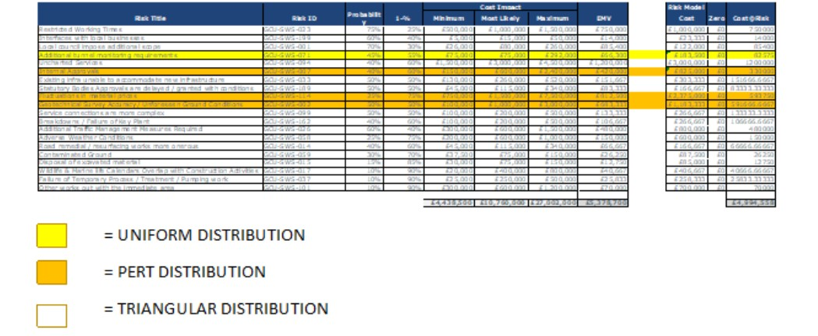

**Fig 1:** A screenshot of the risk model register

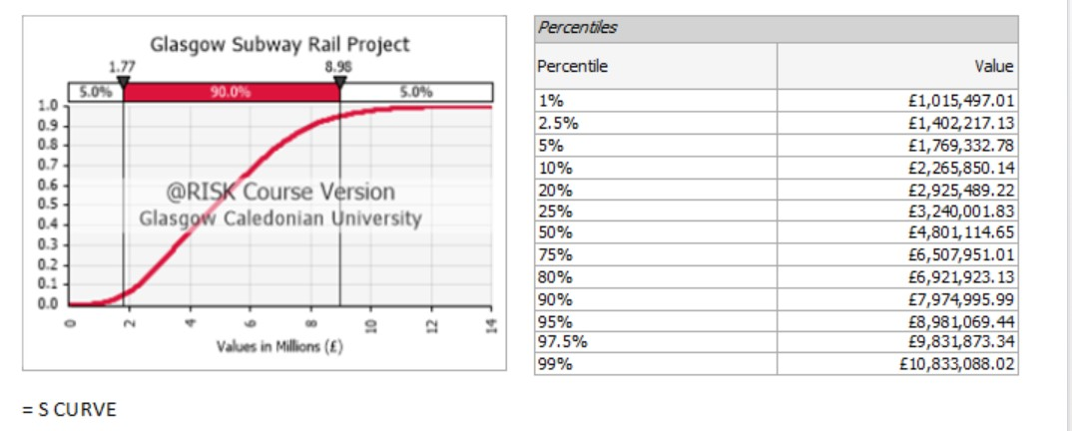

**Fig 2**: The S-curve

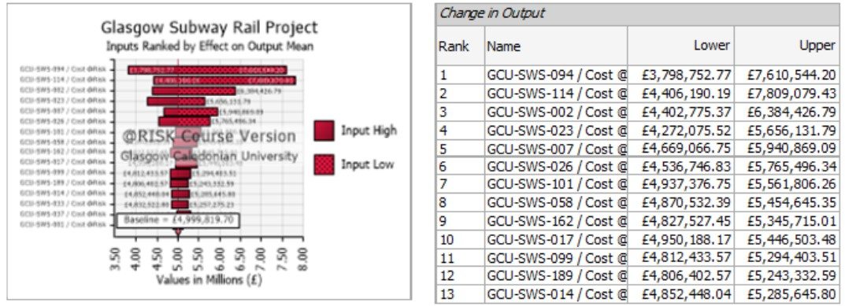

**Fig 3**: Change in Output table

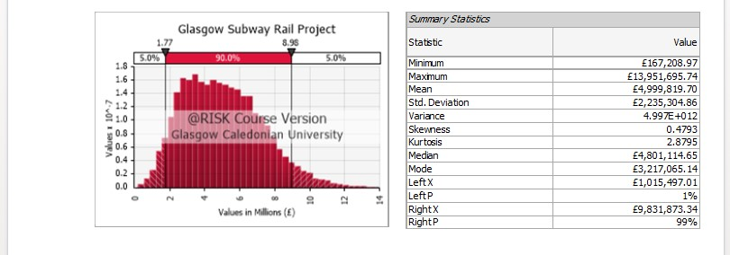

**Fig 4**: Summary statistic table

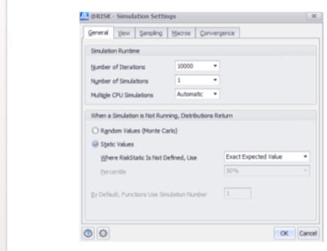

**Fig 5:** 10,000 Iterations Settings of @risk Software