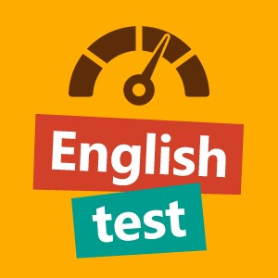

Уровень сложности теста: средний (Intermediate).

1. Mark is a good cook.

I agree to you.

2. Are you ___ at the moon?

look

3. Would you be happy if tomorrow were a holiday?

Yes, I am

4. Where can I buy beer?

When you are 18 years old.

5. I want you to ___ here with me.

staying