Set Up Bridge Connection In Windows
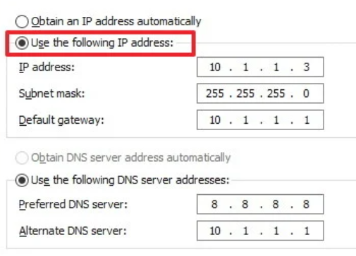

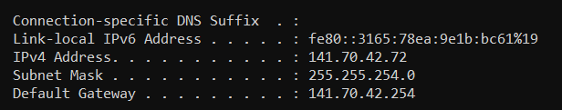

https://www.windowscentral.com/how-set-and-manage-network-bridge-connection-windows-10

