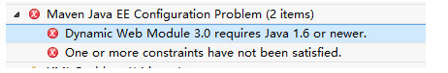

<build>

<plugins>

<!-- define the project compile level -->

<plugin>

<groupId>org.apache.maven.plugins</groupId>

<artifactId>maven-compiler-plugin</artifactId>

<version>2.3.2</version>

<configuration>

<source>1.8</source>

<target>1.8</target>

</configuration>

</plugin>

</plugins>

</build>

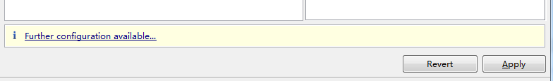



Settings.xml

<http://www.cnblogs.com/yakov/archive/2011/11/26/maven2_settings.html>

