Global continuous phenomics reveals trait- and scale-specific environmental geography of thistle capitula
Blinded submission candidate — scientific HOLD retained

Abstract

Aim
Broad-scale plant trait datasets often summarize taxa by species means or coarse categorical states. We asked whether public photographs can instead recover repeated continuous capitulum phenotypes and determine how the present geography of each trait aligns with predeclared environmental gradients at head, photograph, within-taxon, among-taxon and sampled-global scales. We then asked whether those decomposed traits can be summarized by one whole-capitulum syndrome or retain partly independent spatial structure.

Location
Global.

Time period
Observations dated 1985–2026; climate normals for 1981–2010.

Major taxa studied
Source-assigned taxa of Cirsium and allied Cardueae.

Methods
An object detector localized capitula and deterministic image functions measured a frozen 27-endpoint continuous-trait contract spanning orientation, visible colour, outline and finer involucral and armature-like image geometry. The final trait universe contained 46,276 spatially thinned observations from 259 taxa; 22 endpoints were measured and five remained explicit unexecuted rows. We quantified observation-level variation compressed by taxon means and retained coordinates to map endpoint support. Within- and among-taxon models tested nine predictors in six predeclared blocks: thermal, hydric, radiative/atmospheric, mechanical, growing-season water input and resource/productivity. Global multiplicity correction was followed by broad-space and historical-placement gates. Secondary complete-18 analyses evaluated taxon morphospace, within/among measurement-module organization and environmental redundancy.

Results
Across the 22 measured endpoints, 0.814–0.986 of raw observation-level variation occurred below taxon means; equal-replication endpoint medians were 0.287–0.585. Across the canonical 234-row endpoint-gradient grid, seven pairs were supported at both scales, 18 within taxa only, three among taxa only, 152 at neither scale and 54 were not comparable. Sampling was uneven: Europe plus North America contributed 92.26% of observations and the two most observed taxa 54.03%. Across 674 sampling perturbations, 16/26 selected within-taxon and 10/10 selected among-taxon pairs retained direction throughout. Five within-taxon pairs passed the broad-space screen, but only four also retained direction in every sampling scenario. Two among-taxon pairs—lower chroma with higher shortwave radiation and a larger signed head-axis angle relative to EXIF-image vertical with higher annual precipitation—passed the broad-space screen, retained direction across sampling perturbations and retained direction and P < 0.05 on all 52 historical-placement trees. The expanded 127-taxon × 18-endpoint morphospace remained multidimensional: its first three principal components explained 42.3% cumulatively, and within- and among-taxon association geometries were only partly aligned (Spearman = 0.3663).

Main conclusions
Global public photographs can move broad-scale trait ecology beyond species means and coarse categories by preserving repeated quantitative distributions and locating each continuous phenotype in present geographic and environmental space. Environmental organization is trait- and scale-dependent, not one climate-associated capitulum syndrome; whole-capitulum analyses provide a secondary synthesis rather than replacing decomposed traits. The two final rows are adaptive-pattern candidates under current sequential controls, not demonstrations of adaptation or mechanism. The resulting state-and-gate map supplies EAzami with continuous components that can be functionally validated, mapped through repeated nuclear history, tested for independent versus retained or reticulate origins, and only then evaluated for convergence or adaptive convergence.

Introduction
Comparative trait ecology links organismal attributes to environmental filtering, species interactions and ecosystem functioning, but broad syntheses often represent each species by one or a few characteristic values. This simplification is useful when measurements are sparse, yet it can conceal variation among populations and individuals that affects niche breadth, interaction strengths and coexistence (Messier et al. 2010; Albert et al. 2011; Bolnick et al. 2011; Violle et al. 2012). Intraspecific variation can constitute a substantial share of community-level plant trait variation (Siefert et al. 2015). Global resources such as TRY and BIEN have transformed cross-species ecology (Kattge et al. 2011, 2020; Maitner et al. 2018), but their broad-scale utility necessarily relies heavily on taxon-level summaries and unevenly replicated measurements. A complementary challenge is therefore to recover the geographic distribution of phenotype itself rather than only a representative value for each species.
A second simplification is categorical description. Many conspicuous plant characters are recorded as states—upright versus nodding, pale versus pigmented, globose versus elongate, spiny versus weakly armed—even when the underlying phenotype varies continuously. Categories are valuable for taxonomy and identification, but they discard distances within and between states and can obscure spatial variation within a named taxon. Moving from categories to explicitly defined numerical traits makes it possible to ask not only which forms occur, but how much phenotype varies, where that variation occurs and whether different components of morphology occupy different environmental spaces.
Public biodiversity photographs provide an unusually large source of repeated observations for this purpose. Computer-vision studies have demonstrated detection and taxonomic recognition in heterogeneous citizen-science imagery (Van Horn et al. 2018; Wäldchen & Mäder 2018; Rzanny et al. 2019), and multimodal methods are beginning to infer continuous plant traits (Sharma et al. 2026). If each assessable structure can instead be converted into a numerical phenotype—an angle, colour coordinate, outline statistic or contour metric—photographs can become a distributed phenotypic sampling network. Their value is then not simply the number of species represented, but the ability to retain repeated measurements across populations, regions and environmental gradients and thereby construct a quantitative geography of visible phenotype.
This opportunity is inseparable from sampling and measurement bias. Citizen-science records reflect observer behaviour, accessibility and taxonomic preference as well as organism occurrence (Troudet et al. 2017; Di Cecco et al. 2021). Illumination, camera processing, occlusion and viewpoint can alter image-derived colour, orientation and contour measurements. An unassessable photograph is not evidence that a trait is biologically absent. A defensible image-phenomics workflow must therefore preserve trait-specific missingness, measurement provenance and the nesting of heads within photographs, and must interpret outputs as visible image phenotypes rather than error-free biological measurements. These limitations constrain biological interpretation, but they do not remove the descriptive value of measuring phenotype continuously when uncertainty and assessability are explicit.
Trait–environment associations must also be separated by biological scale. A relationship can arise because observations assigned to the same taxon vary across space, because taxa with different median phenotypes occupy different environments, or because both traits and environments reflect shared history. These are complementary descriptions of phenotypic geography, not interchangeable causal tests. Within-taxon analyses isolate spatial covariation after removing time-invariant taxon differences, whereas among-taxon analyses describe environmental sorting of taxon-level phenotypes and require additional attention to phylogenetic non-independence and uncertain placement. A within-taxon gradient is not automatically the small-scale version of taxon turnover, and an among-taxon association cannot be read backwards as plasticity.
A further challenge arises when several measurements belong to one complex reproductive structure. The Asteraceae capitulum is a flower-like pseudanthium in which orientation, visible corolla traits, gross outline and involucral architecture are expressed together. Continuous decomposition is valuable precisely because those components need not share the same geography or environmental gradient. A final whole-capitulum synthesis can test whether the endpoints are partly organized, but it must not erase the trait-specific patterns by forcing them into one syndrome. Floral integration theory motivates partial organization among subsets of traits (Diggle 2014); whether that organization is similar within and among taxa remains a secondary empirical question rather than the starting unit of inference.
The Carduus–Cirsium group is informative because one capitulum combines several conspicuous phenotype components on the same structure. Floral orientation can modify radiation load, temperature, precipitation exposure, pollinator presentation and reproductive performance (Chen et al. 2013; van der Kooi et al. 2019; Creux et al. 2021); summer-blooming Cardueae, including Cirsium, can maintain capitula below surrounding air temperature under hot conditions (Herrera 2025). Visible floral colour may integrate temperature, drought, soil chemistry, herbivory and pollinator responses (Narbona et al. 2018; Vaidya et al. 2018; Borghi et al. 2019; Dalrymple et al. 2020; Sullivan & Koski 2021; Grossenbacher et al. 2026). In Cirsium palustre, purple, white and intermediate morphs varied with exposure, population size and year, and white flowers received preferential pollination in some local conditions (Mogford 1972, 1974a,b, 1978). White-flowered forms are also documented in East Asian Cirsium (Kitamura 1932), but colour alone does not delimit evolutionary lineages in the Taiwanese C. japonicum complex (Chang et al. 2026). Floral displays and scent can attract both pollinators and antagonists (Ohashi & Yahara 1998, 2000, 2002; Theis 2006; Theis et al. 2007), while visually defensive structures need not have their assumed function (Hanley et al. 2007). These studies provide candidate functional interpretations, but they do not determine in advance how image-derived phenotype should covary globally.
Environmental representation presents a related problem. A small set of bioclimatic variables provides a transparent low-dimensional baseline, whereas adding many correlated rasters can turn a biological analysis into a post hoc screen. Mean and seasonal temperature and precipitation summarize broad climate, but radiation, atmospheric drying, wind, growing-season water input and potential productivity may carry additional process-relevant information. The appropriate test is therefore not whether one added predictor happens to be significant, but whether a predeclared process representation adds multivariate information beyond the low-dimensional core, and whether that redundancy result differs within and among taxa.
This multiscale view is especially relevant in a genus with recent regional diversification, high visible disparity and difficult history. New World Cirsium exhibits high ecological diversity despite low nuclear-rDNA divergence (Kelch & Baldwin 2003), and precipitation and semiaridity correlate with North American diversification (Siniscalchi et al. 2023). Genus-wide phylogenomics identifies late-Neogene diversification and rapid Pleistocene radiations associated with dispersal, isolation and ecological specialization (Moreyra et al. 2025). Hybridization, polyploidy and incomplete sampling further complicate a single bifurcating history (Ackerfield et al. 2020; Bureš et al. 2024; Chang et al. 2026). We use this context to motivate a global description of the present phenotype field, not to infer adaptive radiation or the history that generated individual associations.
We therefore developed a global public-image phenomics workflow whose first goal is descriptive but quantitatively explicit: to replace coarse state assignments and single taxon means with repeated continuous measurements of visible capitulum phenotype. Object detection localizes visible capitula, deterministic functions quantify orientation, visible corolla colour and outline, and suitable images provide additional continuous measurements of involucral and armature geometry when assessable. The resulting framework treats each trait as a defined numerical variable with its own image requirements and failure state rather than forcing all photographs into common categories.
We asked four linked questions. First, how much repeated visible phenotype diversity is lost when thistle taxa are represented by categories or one taxon mean? Second, which predeclared environmental gradients align with orientation, visible colour, outline and finer involucral or armature-like image geometry, including unsupported trait–gradient pairs? Third, at which level—head, photograph, within-taxon geography, among-taxon turnover or the sampled global domain—is each pattern expressed, and how robust is it to spatial, regional and incomplete historical controls? Fourth, after those components have been resolved, can they be summarized by one whole-capitulum syndrome, or is the phenotype multidimensional and only partially organized across scales?
These questions define the endpoint of Azami Chapter 1: a quantitative reconstruction of the present spatial state of continuous capitulum traits. Azami freezes each trait definition, its uncertainty, present distribution, environmental association, scale class and measurement/q/sampling-composition/spatial/historical gate status. EAzami then proceeds through four gates: candidate-function annotation and validation; repeated functional-trait history on a nuclear ancestry set; discrimination of retention, independent origin, ancestral polymorphism and introgression; and convergence or adaptive-convergence tests. Adaptive convergence requires comparable selection pressure and reproductive-fitness evidence; neither spatial association nor repeated history alone establishes cause.

Methods

Study design and spatial cohort
We used public biodiversity photographs to quantify continuous capitulum phenotypes across source-assigned taxa of Cirsium and allied Cardueae. Source names were retained as operational taxonomic units because the photograph records do not resolve a genus-wide taxonomy. The analysis unit was a coordinate-bearing observation rather than one species-level database row.
The exhaustive source stream contained 406,582 detector-positive observations from 286 taxa. Coordinate filtering retained 392,989 observations from 271 taxa, and a positional-accuracy threshold of 10 km retained 297,293 observations from 259 taxa. Before examining trait values, we retained one observation per taxon by 0.25-degree cell, yielding the frozen spatial cohort of 46,276 observations from 259 taxa. Dates ranged from 1985 to 2026. Missing or unassessable image measurements were never encoded as biological absence or zero.

From photographs to a 27-endpoint continuous-trait contract
A single-class YOLO11n detector localized visible capitula at a confidence threshold of 0.25. Detection defined image regions of interest only; downstream traits were calculated with deterministic image functions. The category-free contract registered 27 continuous endpoints across orientation, visible corolla colour, gross outline, floral display, involucral architecture, armature-like projection geometry and validation-only surface-image modules.
Orientation was the signed head-axis angle relative to EXIF-oriented image vertical: 0 degrees upward, 90 degrees horizontal and 180 degrees downward. Image vertical is reproducible but is not a gravity measurement. Colour was represented in visible CIELAB space by lightness, chroma and the sine and cosine of circular hue. Outline and contour variables were dimensionless ratios or normalized geometry. Fine involucral, armature-like and surface endpoints were retained as image phenotypes and were not relabelled as botanical spine length, stiffness, hair density, glands or secretion.
The final artifact-backed run measured 22 of 27 endpoints. Eighteen of 19 inferential endpoints were available; visible_floret_fraction and four descriptive colour-composition fractions remained explicit unexecuted_no_measurement rows. Hue sine and cosine formed one joint circular inferential unit, producing 26 units from the 27 registered endpoints.

Trait geography and information retained below taxon means
For every endpoint we recorded observation and taxon counts, latitude and longitude limits, and occupancy in 5-degree geographic cells. To quantify information compressed by a one-row-per-taxon database, we decomposed total observation-level sums of squares into variation below and between source-assigned taxon means. Because abundant taxa could dominate the raw partition, we also ran 500 deterministic equal-replication resamples with two observations per eligible taxon. These quantities describe visible image-phenotype variation; they are not heritability, genetic variance or plasticity estimates.

Six predeclared environmental blocks
Nine predictors formed six biological hypothesis blocks. Thermal conditions comprised annual mean temperature and temperature seasonality (CHELSA BIO1 and BIO4). Hydric conditions comprised annual precipitation and precipitation seasonality (BIO12 and BIO15). Radiative and atmospheric exposure comprised mean shortwave radiation and vapour-pressure deficit. Mechanical exposure was represented by mean near-surface wind. Growing-season water input was represented by climatic growing-season precipitation, and resource/productivity by modelled potential net primary productivity. Growing-season precipitation was not taxon-specific flowering-season rainfall, and potential NPP was not measured local resource supply.
All predictors had to retain at least 98% coverage in the phenotype-blind spatial cohort. The nine-variable environmental table was constructed before endpoint-specific missingness filtering; no unavailable variable could be substituted after observing trait associations.

Within- and among-taxon environmental associations
Within-taxon models used taxon-demeaned standardized traits and predictors, no intercept, and taxon-clustered standard errors. Eligibility required at least 100 observations, ten taxa and two observations per retained taxon. Joint hue used the magnitude and direction of its standardized sine and cosine coefficients under 9,999 permutations restricted within taxa.
Among-taxon models paired taxon trait medians with taxon environmental medians. The primary scope required at least five trait observations per taxon and at least 20 taxa; a separately corrected sensitivity required two observations. Linear endpoints used standardized univariate slopes and 9,999 taxon-label permutations. Joint hue used paired permutations of the sine and cosine slopes.
Benjamini-Hochberg correction formed one global family across all successful unit by predictor rows separately for within taxa, among-taxon minimum-five and among-taxon minimum-two scopes. Historical endpoint tiers did not split multiplicity or remove rows. Each primary minimum-five row was classified as supported at both scales, within taxa only, among taxa only, neither, or not comparable.

Sampling-composition sensitivity
Every globally FDR-supported row entered a separately frozen retrospective sensitivity; all atlas rows remained reported regardless of entry. Sampling perturbations were selected without using trait outcomes. Within-taxon rows were refitted with equal total weight per taxon. Both scales omitted each of the ten most observed taxa separately and the two most observed taxa jointly, omitted each of six broad geographic regions separately, and retained only observations explicitly classified as native by the frozen WCVP/TDWG join. Linear rows had to retain coefficient sign; circular rows had to remain within 90 degrees of the original coefficient vector. We reported direction and effect-magnitude stability only and calculated no post-selection P or q values.

Broad-space and historical-placement sensitivity
Globally FDR-supported rows were refitted with a second-order spherical-coordinate basis. Passage required a spatial permutation P below 0.05, preserved sign for a linear endpoint and residual eight-nearest-neighbour Moran P of at least 0.05. This was a broad geographic sensitivity, not removal of every spatial process.
Among-taxon rows passing the broad-space gate were then fitted by univariate Pagel-lambda PGLS on 52 audited dated-backbone placement trees: two deterministic scenarios and 50 randomized within-genus placements. A final candidate had to retain direction and P below 0.05 on every tree. Because only 54 historical-atlas taxa were direct backbone tips, this procedure is a placement sensitivity rather than a resolved species-tree correction.

Secondary whole-capitulum synthesis
After endpoint-level inference was complete, a secondary complete-18 analysis asked whether the measured traits reduced to one capitulum syndrome. Standardized taxon medians were analysed by principal components, and within- versus among-taxon association matrices were compared by measurement module. This synthesis did not select endpoints or alter the endpoint-level multiplicity families.

Claim boundary
The study is a retrospective exploratory analysis of visible image phenotypes and their present spatial associations. It does not identify plasticity, local adaptation, selection, causal environmental mechanisms, botanical identity of validation-only proxies, independent evolutionary origins or convergence. The two final rows are termed adaptive-pattern candidates under current sequential controls, not demonstrations of adaptation.

Results

Continuous photographs recovered variation hidden by taxon means
The frozen spatial cohort contained 46,276 observations from 259 source-assigned taxa. Twenty-two of 27 registered endpoints were measured, producing 374,255 analysis-eligible observation by endpoint values. Coverage ranged from 909 observations and 85 taxa for validation-only surface proxies to 40,510 observations and 253 taxa for visible CIELAB lightness and chroma. Measured endpoints occupied 190 to 431 five-degree cells.
Across the 22 measured endpoints, 0.8137 to 0.9863 of raw observation-level variation occurred below source-assigned taxon means. The equal-replication median ranged from 0.2869 for hue sine to 0.5846 for basal taper ratio. Thus, even after limiting each eligible taxon to two observations, one taxon mean compressed 28.7-58.5% of visible variation, while the unbalanced observed sample compressed 81.4-98.6%.

Environmental associations were endpoint- and scale-specific
Eight predictors had complete coverage and wind had 99.989% coverage. The within-taxon atlas contained 189 executed tests and 45 explicit unexecuted rows; 26 executed rows passed the global FDR family. Supported rows occurred in all six blocks, including orientation with annual mean temperature, chroma with VPD, several involucral geometry endpoints with precipitation metrics, surface-image endpoints with temperature or growing-season precipitation, and joint hue across multiple gradients.
The primary among-taxon atlas contained 180 successful tests, 45 unexecuted rows and nine no-finite-variation rows. Ten rows passed its separate global FDR family. Linear associations comprised a larger orientation angle with annual precipitation (standardized effect 0.3044, q = 0.0210), a larger orientation angle with growing-season precipitation (0.2581, q = 0.0338), lower chroma with higher shortwave radiation (-0.3454, q = 0.0060), and greater bract projection-peak density with VPD (0.4437, q = 0.0468). Joint hue was associated with BIO1, BIO4, BIO15, radiation, wind and NPP. Seven rows repeated in the minimum-two sensitivity.
Across the complete 234-row primary scale grid, seven rows were supported at both scales, 18 within taxa only, three among taxa only, 152 at neither scale and 54 were not comparable. The three among-only rows were orientation with annual precipitation, orientation with growing-season precipitation and chroma with radiation. Most supported involucral and surface-proxy rows were within-taxon only.

Sampling was extensive but strongly uneven
Europe contributed 23,337 observations (50.43%) and North America 19,357 (41.83%); together they contributed 92.26%. The Northern Hemisphere contributed 94.91%. Cirsium vulgare contributed 28.54%, C. arvense 25.49% and the ten most observed taxa 79.93%. The taxon-level median was six observations; 51 of 259 taxa had one observation and 150 had fewer than ten.
All 674 declared sampling scenarios were evaluable. All ten selected among-taxon pairs retained direction in every applicable scenario. Sixteen of 26 selected within-taxon pairs retained direction throughout; ten reversed in at least one scenario. Four of the five within-taxon broad-space passes were also directionally stable throughout. Projection roughness with radiation reversed under equal taxon weighting and after jointly omitting the two dominant taxa.

Broad-space and historical gates retained two among-taxon candidates
Five within-taxon rows passed the broad-space gate: orientation-BIO1, chroma-VPD, involucre length/width-BIO15, projection roughness-radiation and surface high-frequency energy-BIO1. Their spatial standardized effects were 0.0265, -0.0421, 0.0602, -0.1392 and 0.1235, respectively. These rows describe within-taxon spatial covariation and were not treated as plasticity or local adaptation.
Two among-taxon rows passed the broad-space gate. Chroma decreased with radiation (spatial beta = -0.7124, spatial P = 0.001, residual Moran P = 0.217), and orientation angle increased with annual precipitation (spatial beta = 0.2861, spatial P = 0.017, residual Moran P = 0.082). Both retained direction in all 18 applicable sampling scenarios; their minimum effect-magnitude ratios were 0.615 and 0.781.
Both rows retained direction and P below 0.05 on all 52 historical-placement trees. Chroma-radiation PGLS beta was -0.3454 with P = 0.000024 and Pagel lambda = 0 throughout. Orientation-precipitation PGLS beta ranged from 0.3044 to 0.3045, P from 0.000201 to 0.000231 and lambda from 0 to 0.0537. They are therefore adaptive-pattern candidates under the current sequential controls, not evidence that an adaptive mechanism or independent origin has been demonstrated.

Whole-capitulum synthesis did not collapse the trait atlas
The expanded 127-taxon by 18-endpoint morphospace remained multidimensional: the first three principal components explained 42.3% cumulatively. Measurement-module contrasts were modest, and the correspondence between within- and among-taxon association geometry was partial (Spearman = 0.3663). Whole-capitulum structure therefore summarized, but did not replace, the decomposed endpoint results.

Discussion

A method for spatially explicit continuous phenomics
The primary contribution is a change in what broad-scale trait data preserve. Instead of assigning one categorical state or mean to each taxon, public photographs yielded repeated numerical measurements with coordinates and endpoint-specific missingness. The raw and equal-replication partitions show that substantial visible phenotype information sits below taxon means. This information is unavailable to a species-mean database even when the database value itself is accurate.
The method is not merely an automated scoring device. It connects a declared image measurement, its assessability and uncertainty, repeated within-taxon distributions, mapped geographic support and an explicit within- versus among-taxon estimand. That connection makes it possible to separate a present within-taxon gradient from taxon turnover and to display unsupported rows without converting missing observations to trait absence.

There is no single climate-associated capitulum syndrome
The 234-row scale grid rejects a scale-invariant whole-head response. Most supported involucral and surface-image associations occurred only within taxa, while orientation-precipitation, orientation-growing-season precipitation and chroma-radiation occurred only among taxa. Seven rows were supported at both scales, but most involved joint visible hue and several retained residual spatial structure. A coefficient at one biological scale therefore cannot be read automatically as the process operating at another.
The secondary 18-endpoint synthesis reinforces this conclusion. The first three principal components captured less than half of taxon-level variation, and within- and among-taxon association geometries were only partly aligned. A whole-capitulum summary is useful for describing partial organization, but it should not erase the endpoint-specific geography that made the result visible.

The two candidates are robust patterns, not demonstrated mechanisms
Taxa from higher-radiation environments had lower photographed CIELAB corolla chroma. Radiation-responsive floral pigment regulation is biologically plausible: UV-B can induce petal anthocyanin accumulation, and geographic variation in floral anthocyanins can covary with solar UV (Hennayake et al. 2006; Peach et al. 2020). However, visible chroma is a colour-space distance, not an anthocyanin assay or UV-reflectance measurement. The negative coefficient cannot be translated directly into more or less pigment synthesis. Calibrated visible and UV reflectance, petal chemistry or pathway expression, and common-garden radiation manipulation are required.
Taxa from wetter environments had a larger angle on the frozen 0-up, 90-horizontal, 180-down image scale, which is consistent with more downward presentation. Experimental work in a nodding Asteraceae supports rain shielding as a plausible function of downward flowers (Chen et al. 2013). Yet EXIF image vertical is not gravity, and Azami did not measure flowering-period rain interception, pollen wetting, viability or fitness. Gravity-referenced three-dimensional orientation and experimental angle manipulation are required before a rain-protection mechanism can be claimed.
Both candidates survived global multiplicity correction, broad-space screening, residual spatial diagnostics, all tested sampling-composition directions and 52 historical-placement trees. Those checks make the patterns difficult to explain by the particular tested sampling, broad spatial trend or within-genus grafting scenario. They do not establish heritability, selection, fitness advantage, causal mediation or independent evolutionary origin.

Uneven citizen-science sampling remains part of the result
The dataset is geographically extensive but not a probability sample. Europe and North America supplied more than 92% of observations, two taxa supplied 54%, and many taxa were sparsely represented. The retrospective sampling audit makes that imbalance visible rather than claiming to remove it. Directional stability for all ten selected among-taxon rows and 16 of 26 selected within-taxon rows is useful, but it does not make the sample globally representative or create a new confirmatory test.
Measurement limitations are equally important. Camera processing affects visible colour; two-dimensional outline depends on viewpoint; image vertical does not supply gravity; and fine involucral and surface variables require independent botanical calibration. Five registered endpoints were unexecuted, including visible floret fraction. Independent detector boxes, reference measurements, developmental-stage labels, paired flower-background colour controls and repeat-photo remeasurement remain required before submission claims can be strengthened.

From Azami to EAzami
Azami fixes the present: continuous trait definitions, uncertainty, current geographic support, environmental alignment, biological scale and robustness status. EAzami should then proceed in order: validate candidate functions; reconstruct when and how often admitted functional states arose on a nuclear ancestry set; distinguish independent origins from retention, ancestral polymorphism and introgression; and test convergence or adaptive convergence only when common selection pressure and reproductive-fitness evidence are available. Spatial association alone cannot perform any of those historical or causal promotions.

Overall implication
Public photographs can recover a quantitative geography of visible phenotype that species categories and means compress. In thistle capitula, the recovered field is multidimensional and scale dependent. The clearest current among-taxon patterns are lower visible chroma under higher radiation and a larger image-referenced orientation angle under higher annual precipitation. Their value is that they now define precise botanical, physiological and evolutionary tests—not that those mechanisms have already been solved.

Conclusion and declarations
Starting from 27 registered continuous endpoints, Azami Chapter 1 recovered 22 measured, coordinate-bearing capitulum phenotypes across 46,276 public observations and 259 source-assigned taxa. Taxon means compressed 81.4-98.6% of raw visible variation and 28.7-58.5% after equalizing replication. Environmental organization was endpoint- and scale-specific rather than one capitulum syndrome. Two among-taxon rows—lower visible chroma with higher shortwave radiation and a larger image-referenced orientation angle with higher annual precipitation—retained support through the current multiplicity, sampling-composition, broad-space and historical-placement gates.
These are adaptive-pattern candidates under current sequential controls, not demonstrations of adaptation or mechanism. The radiation-responsive pigment and rain-shielding interpretations remain testable hypotheses. Citizen-science sampling is uneven, and independent detector, trait-measurement and botanical validation remain open. No claim is made about plasticity, heritability, selection, causal environmental response, independent origins or convergence.

Declarations
Ethics approval was not required for analysis of publicly available biodiversity observations. Source photographs will not be redistributed beyond their individual licence terms. Author contributions, funding, acknowledgements, conflicts of interest and corresponding-author details must be completed by the authors in the journal submission system and separate title page. The current repository package remains a submission candidate on scientific HOLD until the external validation gates listed in EXTERNAL_COMPLETION_GATES.md are closed.

References
Ackerfield, J., Susanna, A., Funk, V. A., Kelch, D. G., Park, D. S., Thornhill, A. H., … Dirmenci, T. (2020). A prickly puzzle: Generic delimitations in the Carduus–Cirsium group (Compositae: Cardueae: Carduinae). Taxon, 69, 715–738. https://doi.org/10.1002/tax.12288
Albert, C. H., Grassein, F., Schurr, F. M., Vieilledent, G. & Violle, C. (2011). When and how should intraspecific variability be considered in trait-based plant ecology? Perspectives in Plant Ecology, Evolution and Systematics, 13, 217–225. https://doi.org/10.1016/j.ppees.2011.04.003
Bolnick, D. I., Amarasekare, P., Araújo, M. S., Bürger, R., Levine, J. M., Novak, M., … Vasseur, D. A. (2011). Why intraspecific trait variation matters in community ecology. Trends in Ecology & Evolution, 26, 183–192. https://doi.org/10.1016/j.tree.2011.01.009
Borghi, M., Perez de Souza, L., Yoshida, T. & Fernie, A. R. (2019). Flowers and climate change: a metabolic perspective. New Phytologist, 224, 1425–1441. https://doi.org/10.1111/nph.16031
Bureš, P., Del Guacchio, E., Šmerda, J., Özcan, M., Blizňáková, P., Vavrinec, M., … Zedek, F. (2024). Intergeneric hybrid origin of the invasive tetraploid Cirsium vulgare. Plant Biology, 26, 749–763. https://doi.org/10.1111/plb.13653
Chang, C.-Y., Liao, P.-C., Tzeng, H.-Y., Kusumi, J., Su, Z.-H. & Tseng, Y.-H. (2026). Phylotranscriptomics and genome-size evidence clarify the Taiwanese Cirsium japonicum complex and delimit C. brevicaule and allied East Asian thistles. BMC Plant Biology, 26, 545. https://doi.org/10.1186/s12870-026-08097-6
Chen, J. G., Yang, Y., Zhang, Z. Q., Niu, Y. & Sun, H. (2013). A nodding capitulum enhances the reproductive success of Cremanthodium campanulatum (Asteraceae) at high elevations in the Sino-Himalayan Mountains. Plant Ecology & Diversity, 6, 487–494. https://doi.org/10.1080/17550874.2012.702793
Creux, N. M., Brown, R. I., Garner, A. G., Saeed, S., Scher, C. L., Holalu, S. V., … Harmer, S. L. (2021). Flower orientation influences floral temperature, pollinator visits and plant fitness. New Phytologist, 232, 868–879. https://doi.org/10.1111/nph.17627
Dalrymple, R. L., Kemp, D. J., Flores-Moreno, H., Laffan, S. W., White, T. E., Hemmings, F. A. & Moles, A. T. (2020). Macroecological patterns in flower colour are shaped by both biotic and abiotic factors. New Phytologist, 228, 1972–1985. https://doi.org/10.1111/nph.16737
Di Cecco, G. J., Barve, V., Belitz, M. W., Stucky, B. J., Guralnick, R. P. & Hurlbert, A. H. (2021). Observing the observers: How participants contribute data to iNaturalist and implications for biodiversity science. BioScience, 71, 1179–1188. https://doi.org/10.1093/biosci/biab093
Diggle, P. K. (2014). Modularity and intra-floral integration in metameric organisms: plants are more than the sum of their parts. Philosophical Transactions of the Royal Society B: Biological Sciences, 369, 20130253. https://doi.org/10.1098/rstb.2013.0253
Grossenbacher, D. L., Lo, M. S., Waddington, M. E., O'Dell, R. & Kay, K. M. (2026). Soil and climate contribute to maintenance of a flower color polymorphism. American Journal of Botany, 113, e70018. https://doi.org/10.1002/ajb2.70018
Hanley, M. E., Lamont, B. B., Fairbanks, M. M. & Rafferty, C. M. (2007). Plant structural traits and their role in anti-herbivore defence. Perspectives in Plant Ecology, Evolution and Systematics, 8, 157–178. https://doi.org/10.1016/j.ppees.2007.01.001
Hennayake, C. K., Kanechi, M., Yasuda, N., Uno, Y. & Inagaki, N. (2006). Irradiation of UV-B induces biosynthesis of anthocyanins in flower petals of rose, Rosa hybrida cv. 'Charleston' and 'Ehigasa'. Environment Control in Biology, 44, 103–110. https://doi.org/10.2525/ecb.44.103
Herrera, C. M. (2025). Flowers that cool themselves: Thermal ecology of summer-blooming thistles in hot Mediterranean environments. Ecological Monographs, 95, e70007. https://doi.org/10.1002/ecm.70007
Kattge, J., Díaz, S., Lavorel, S., Prentice, I. C., Leadley, P., Bönisch, G., … Wirth, C. (2011). TRY—a global database of plant traits. Global Change Biology, 17, 2905–2935. https://doi.org/10.1111/j.1365-2486.2011.02451.x
Kattge, J., Bönisch, G., Díaz, S., Lavorel, S., Prentice, I. C., Leadley, P., … Wirth, C. (2020). TRY plant trait database—enhanced coverage and open access. Global Change Biology, 26, 119–188. https://doi.org/10.1111/gcb.14904
Kelch, D. G. & Baldwin, B. G. (2003). Phylogeny and ecological radiation of New World thistles (Cirsium, Cardueae–Compositae) based on ITS and ETS rDNA sequence data. Molecular Ecology, 12, 141–151. https://doi.org/10.1046/j.1365-294X.2003.01710.x
Kitamura, S. (1932). 日本産新菊科植物: 摘要 [New Compositae from Japan: abstract; in Japanese]. Acta Phytotaxonomica et Geobotanica, 1, 56–60. https://doi.org/10.18942/bunruichiri.KJ00001078744
Maitner, B. S., Boyle, B., Casler, N., Condit, R., Donoghue, J., Durán, S. M., … Enquist, B. J. (2018). The BIEN R package: a tool to access the Botanical Information and Ecology Network (BIEN) database. Methods in Ecology and Evolution, 9, 373–379. https://doi.org/10.1111/2041-210X.12861
Messier, J., McGill, B. J. & Lechowicz, M. J. (2010). How do traits vary across ecological scales? A case for trait-based ecology. Ecology Letters, 13, 838–848. https://doi.org/10.1111/j.1461-0248.2010.01476.x
Mogford, D. J. (1972). The ecological genetics of flower colour variation in Cirsium palustre [DPhil thesis]. University of Oxford. https://doi.org/10.5287/ora-mj5dwmwbx
Mogford, D. J. (1974a). Flower colour polymorphism in Cirsium palustre. 1. Heredity, 33, 241–256. https://doi.org/10.1038/hdy.1974.90
Mogford, D. J. (1974b). Flower colour polymorphism in Cirsium palustre. 2. Pollination. Heredity, 33, 257–263. https://doi.org/10.1038/hdy.1974.91
Mogford, D. J. (1978). Pollination and flower colour polymorphism, with special reference to Cirsium palustre. In A. J. Richards (Ed.), The pollination of flowers by insects (pp. 191–199). London: Academic Press for the Linnean Society of London.
Moreyra, L. D., Susanna, A., Calleja, J. A., Ackerfield, J. R., Arabacı, T., Blanco-Gavaldà, C., … Roquet, C. (2025). A thorny tale: The origin and diversification of Cirsium (Compositae). Molecular Phylogenetics and Evolution, 204, 108285. https://doi.org/10.1016/j.ympev.2025.108285
Narbona, E., Wang, H., Ortiz, P. L., Arista, M. & Imbert, E. (2018). Flower colour polymorphism in the Mediterranean Basin: occurrence, maintenance and implications for speciation. Plant Biology, 20, 8–20. https://doi.org/10.1111/plb.12575
Ohashi, K. & Yahara, T. (1998). Effects of variation in flower number on pollinator visits in Cirsium purpuratum (Asteraceae). American Journal of Botany, 85, 219–224. https://doi.org/10.2307/2446309
Ohashi, K. & Yahara, T. (2000). Effects of flower production and predispersal seed predation on reproduction in Cirsium purpuratum. Canadian Journal of Botany, 78, 230–236. https://doi.org/10.1139/B99-182
Ohashi, K. & Yahara, T. (2002). Visit larger displays but probe proportionally fewer flowers: counterintuitive behaviour of nectar-collecting bumble bees achieves an ideal free distribution. Functional Ecology, 16, 492–503. https://doi.org/10.1046/j.1365-2435.2002.00644.x
Peach, K., Liu, J. W. & Mazer, S. J. (2020). Climate predicts UV floral pattern size, anthocyanin concentration, and pollen performance in Clarkia unguiculata. Frontiers in Plant Science, 11, 847. https://doi.org/10.3389/fpls.2020.00847
Rzanny, M., Mäder, P., Deggelmann, A., Chen, M. & Wäldchen, J. (2019). Flowers, leaves or both? How to obtain suitable images for automated plant identification. Plant Methods, 15, 77. https://doi.org/10.1186/s13007-019-0462-4
Sharma, A., Trost, J., Lusk, D., Dollinger, J., Schrader, J., Rossi, C., … Kattenborn, T. (2026). PlantTraitNet: An uncertainty-aware multimodal framework for global-scale plant trait inference from citizen science data. Proceedings of the AAAI Conference on Artificial Intelligence, 40(46), 39239–39248. https://doi.org/10.1609/aaai.v40i46.41272
Siefert, A., Violle, C., Chalmandrier, L., Albert, C. H., Taudiere, A., Fajardo, A., … Wardle, D. A. (2015). A global meta-analysis of the relative extent of intraspecific trait variation in plant communities. Ecology Letters, 18, 1406–1419. https://doi.org/10.1111/ele.12508
Siniscalchi, C. M., Ackerfield, J. R. & Folk, R. A. (2023). Diversification and biogeography of North American thistles (Cirsium: Carduoideae: Compositae): drivers of a rapid continent-wide radiation. International Journal of Plant Sciences, 184, 322–341. https://doi.org/10.1086/724310
Sullivan, C. N. & Koski, M. H. (2021). The effects of climate change on floral anthocyanin polymorphisms. Proceedings of the Royal Society B: Biological Sciences, 288, 20202693. https://doi.org/10.1098/rspb.2020.2693
Theis, N. (2006). Fragrance of Canada thistle (Cirsium arvense) attracts both floral herbivores and pollinators. Journal of Chemical Ecology, 32, 917–927. https://doi.org/10.1007/s10886-006-9051-x
Theis, N., Lerdau, M. & Raguso, R. A. (2007). The challenge of attracting pollinators while evading floral herbivores: patterns of fragrance emission in Cirsium arvense and Cirsium repandum (Asteraceae). International Journal of Plant Sciences, 168, 587–601. https://doi.org/10.1086/513481
Troudet, J., Grandcolas, P., Blin, A., Vignes-Lebbe, R. & Legendre, F. (2017). Taxonomic bias in biodiversity data and societal preferences. Scientific Reports, 7, 9132. https://doi.org/10.1038/s41598-017-09084-6
Vaidya, P., McDurmon, A., Mattoon, E., Keefe, M., Carley, L., Lee, C.-R., … Anderson, J. T. (2018). Ecological causes and consequences of flower color polymorphism in a self-pollinating plant (Boechera stricta). New Phytologist, 218, 380–392. https://doi.org/10.1111/nph.14998
van der Kooi, C. J., Kevan, P. G. & Koski, M. H. (2019). The thermal ecology of flowers. Annals of Botany, 124, 343–353. https://doi.org/10.1093/aob/mcz073
Van Horn, G., Mac Aodha, O., Song, Y., Cui, Y., Sun, C., Shepard, A., … Belongie, S. (2018). The iNaturalist Species Classification and Detection Dataset. In Proceedings of the IEEE Conference on Computer Vision and Pattern Recognition, 8769–8778. https://doi.org/10.1109/CVPR.2018.00914
Violle, C., Enquist, B. J., McGill, B. J., Jiang, L., Albert, C. H., Hulshof, C., … Messier, J. (2012). The return of the variance: intraspecific variability in community ecology. Trends in Ecology & Evolution, 27, 244–252. https://doi.org/10.1016/j.tree.2011.11.014
Wäldchen, J. & Mäder, P. (2018). Machine learning for image-based species identification. Methods in Ecology and Evolution, 9, 2216–2225. https://doi.org/10.1111/2041-210X.13075

Data and code availability
A versioned submission-candidate bundle containing the blinded Main and Supporting Information files, derived tables, model outputs, figure sources and SHA-256 reproducibility manifests accompanies this repository. The public GitHub repository is not an anonymous review link; before journal submission, the exact bundle will be copied without Git history or account identifiers to an anonymized read-only location for editors and reviewers. Source photographs will not be redistributed beyond their individual licence terms. GitHub Actions artifacts are temporary execution records and are not the durable archive. After the independent validation gates, author metadata and repository licence are complete, the exact supporting version will be deposited in a durable repository with a persistent digital object identifier, and this statement will be replaced with the final repository name, DOI and access terms.

Figures
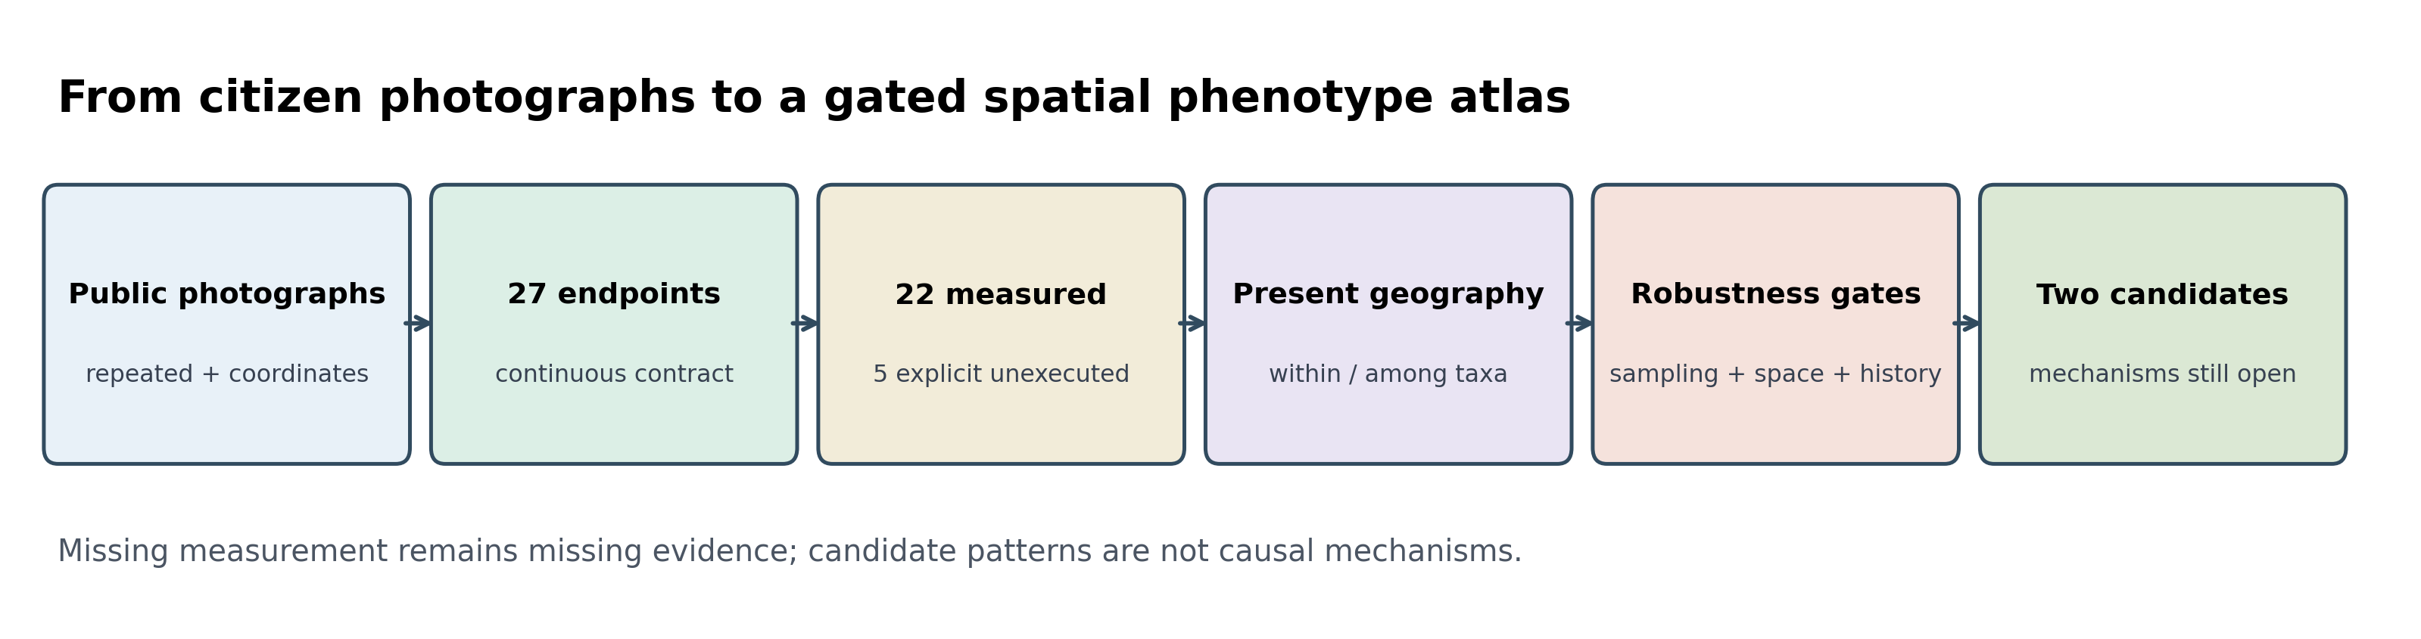
Figure 1. From public photographs to a gated continuous spatial phenotype atlas.
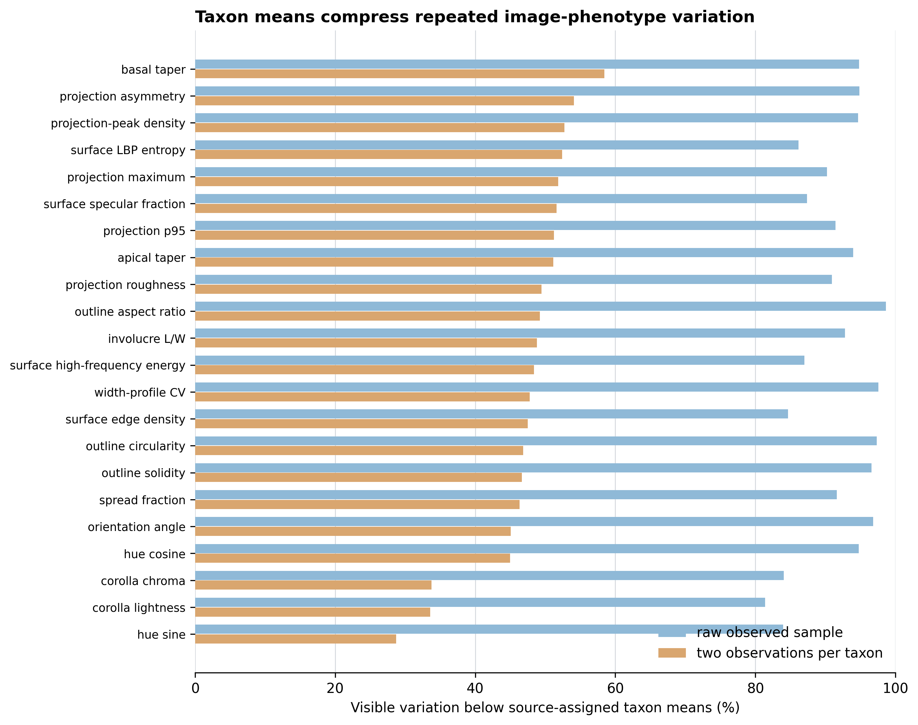
Figure 2. Visible image-phenotype variation compressed by taxon means.
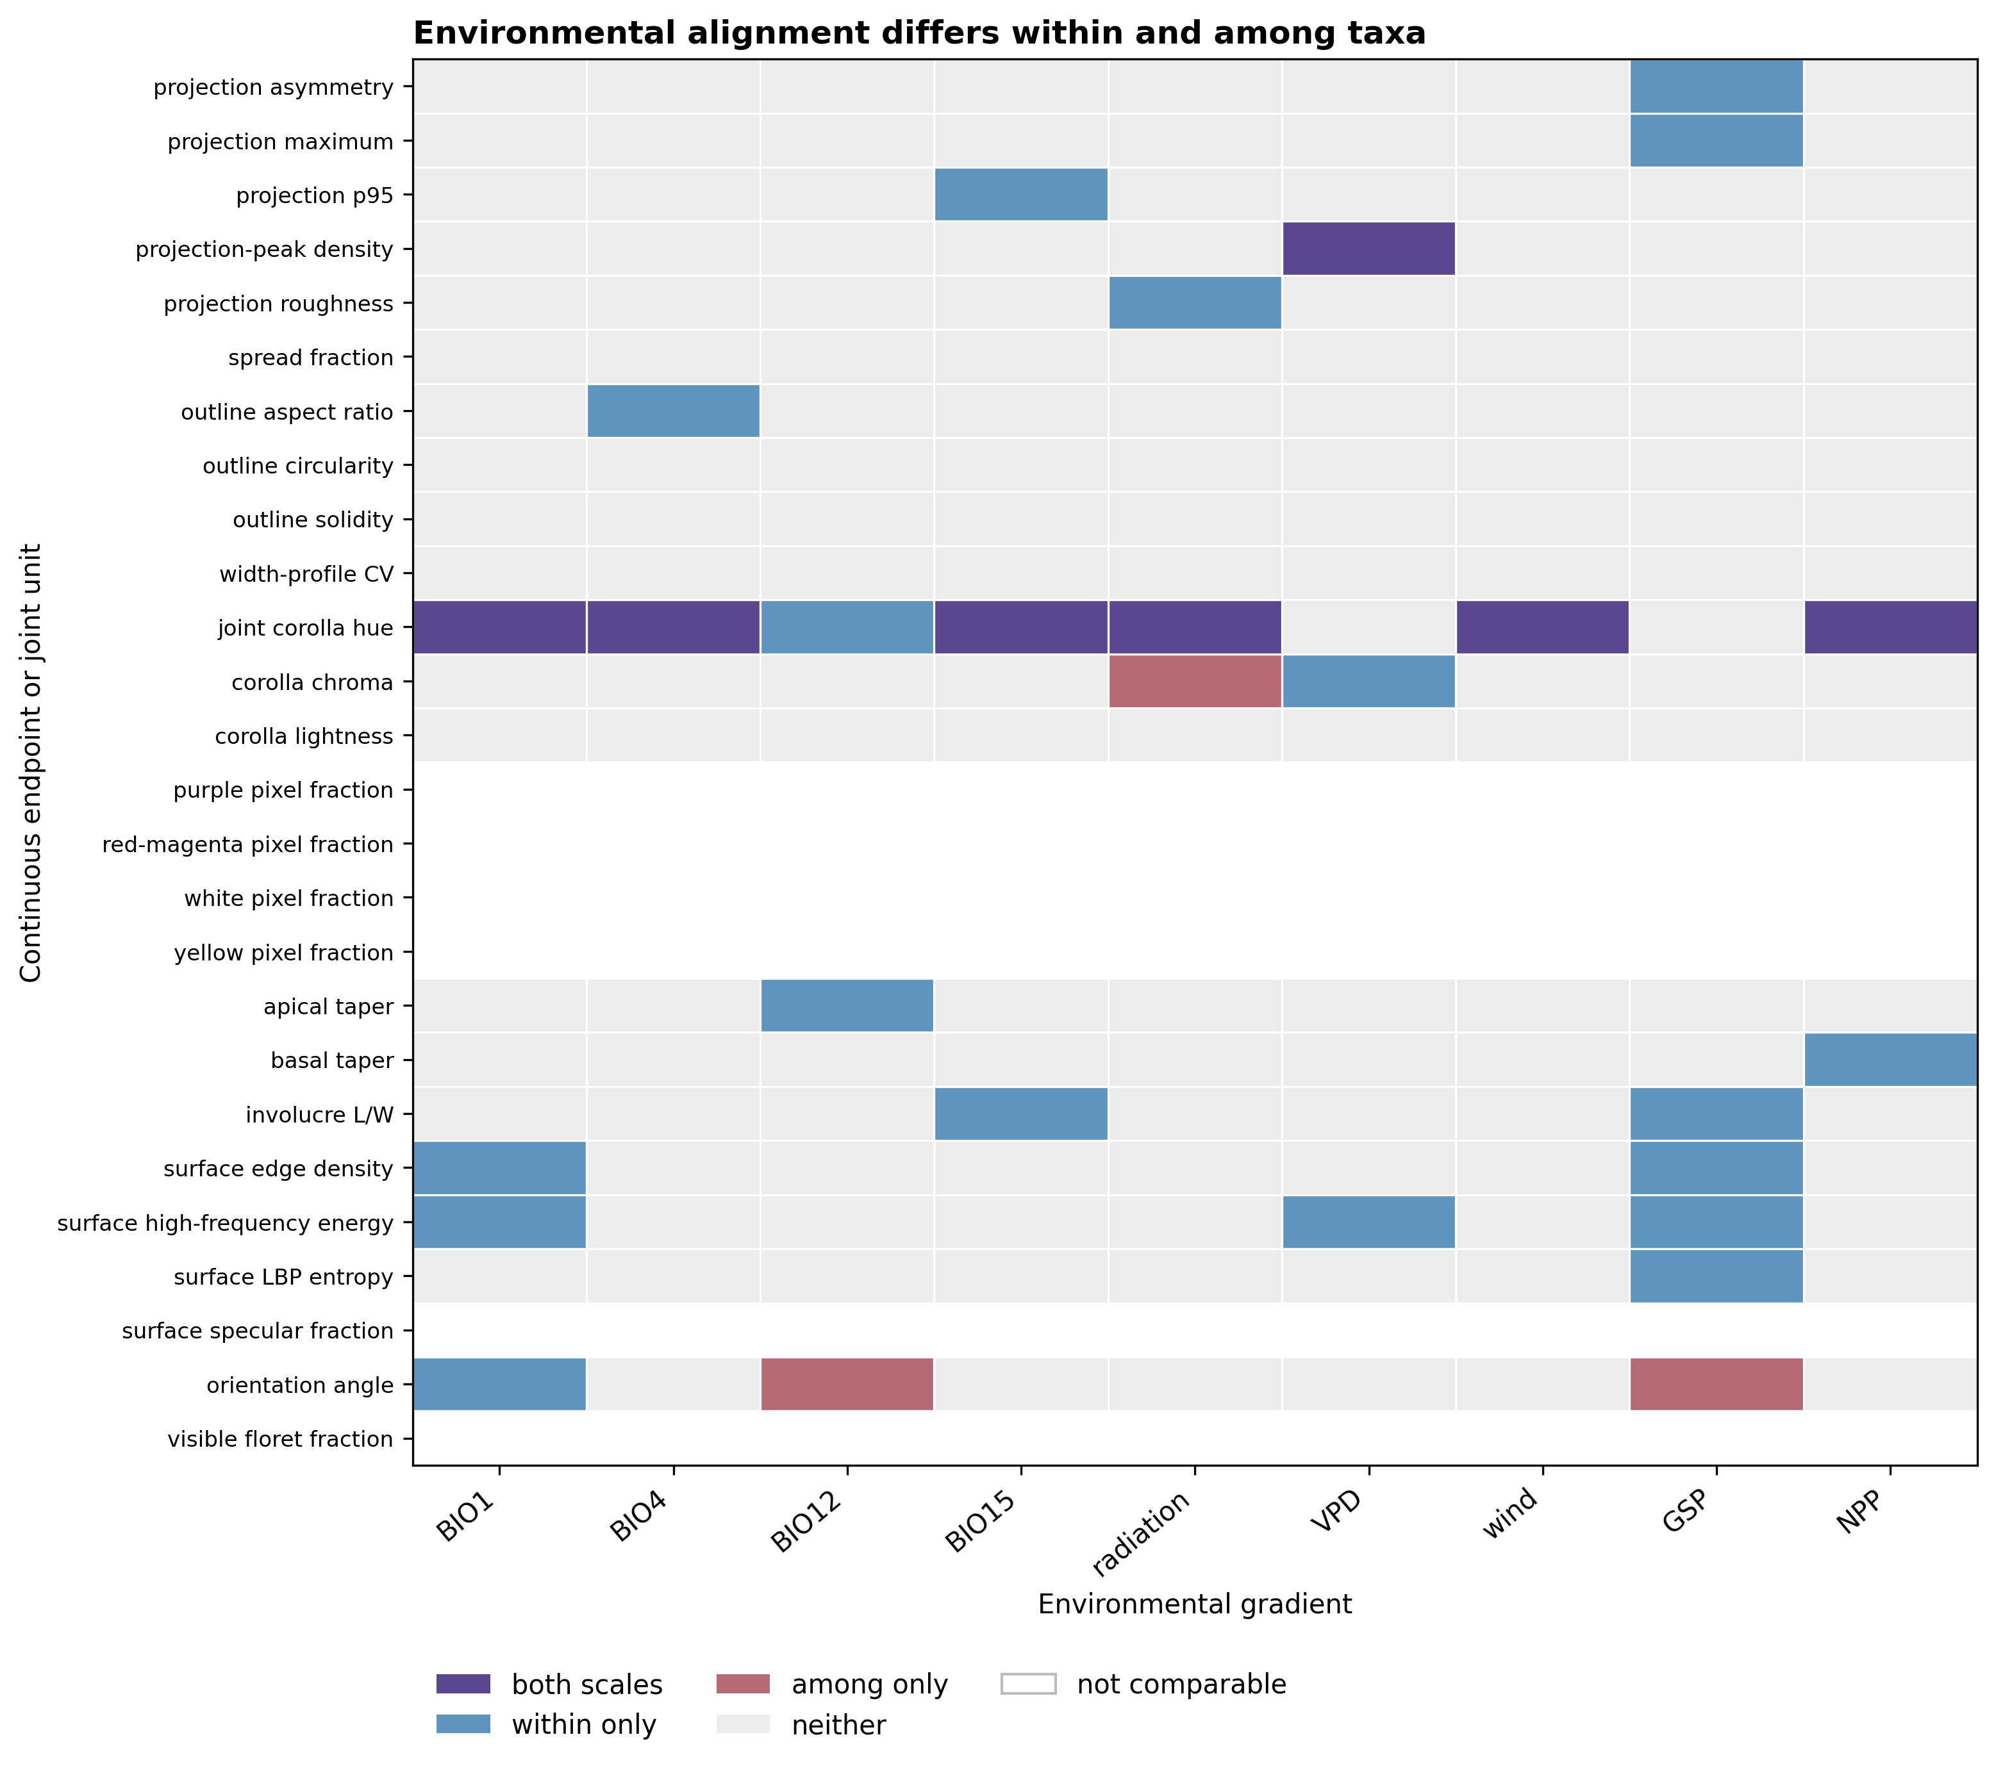
Figure 3. Endpoint-specific environmental alignment at within- and among-taxon scales.
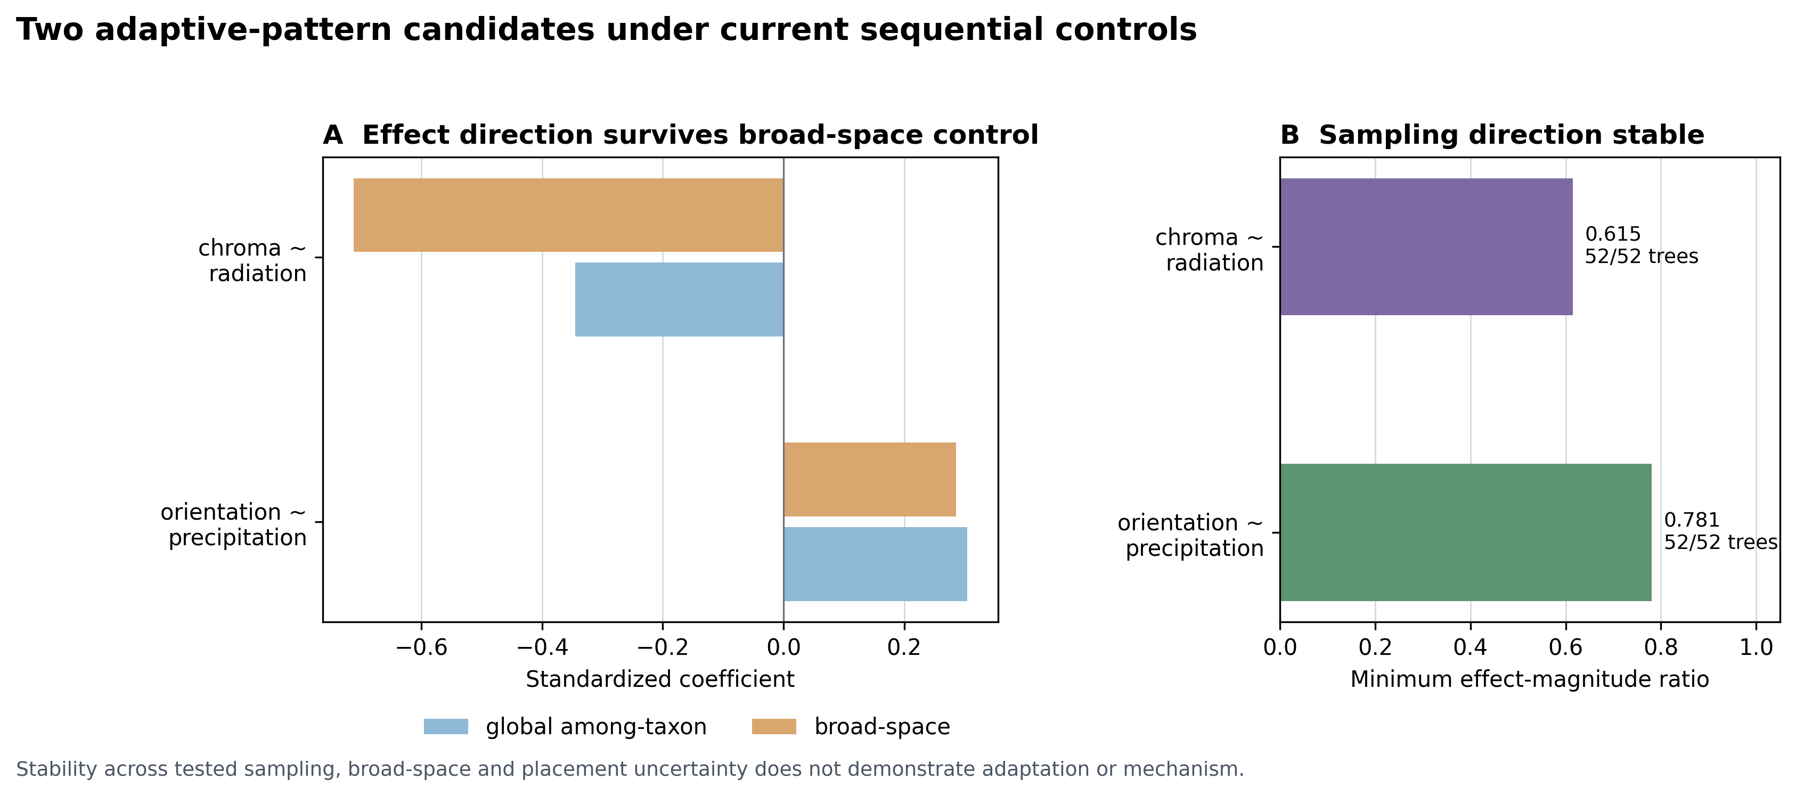
Figure 4. Sequential robustness of the two final adaptive-pattern candidates under current controls.

