Supporting Information — Azami Chapter 1 v2

Supporting Information

Appendix S1. Full-27 continuous-trait and full-environment analysis

S1.1 Frozen cohort and endpoint status
The phenotype-blind spatial cohort retained one observation per source-assigned taxon by 0.25-degree cell after a positional-accuracy threshold of 10 km. It contained 46,276 observations from 259 taxa. The registered universe contained 27 endpoints: 22 were measured and five remained explicit unexecuted rows. Hue sine and cosine formed one joint circular inferential unit. Endpoint status, measurement counts and validation boundaries are given in v2_full27_endpoint_inventory.csv.

S1.2 Geographic support and taxon-mean information loss
For each measured endpoint, v2_full27_trait_geography.csv records geographic limits and occupied 5-degree cells. v2_full27_variance_decomposition.csv reports the fraction of observation-level sums of squares below taxon means and 500 equal-replication resamples with two observations per eligible taxon. Missing measurements were not treated as zeros. The partitions describe visible image phenotypes rather than genetic variance or plasticity.

S1.3 Environmental predictors
Nine predictors were frozen in six blocks: thermal (BIO1, BIO4), hydric (BIO12, BIO15), radiative/atmospheric (shortwave radiation, VPD), mechanical (wind), growing-season water input (GSP) and resource/productivity (potential NPP). Eight had complete coverage and wind had 99.989% coverage, exceeding the 98% gate. GSP was a climatic layer rather than species-specific flowering-season rain; NPP was modelled potential productivity rather than measured resources.

S1.4 Within- and among-taxon models
Within-taxon models used taxon-demeaned standardized traits and predictors with taxon-clustered uncertainty. Among-taxon models used standardized taxon trait and environment medians with 9,999 taxon-label permutations. The primary among-taxon scope required five observations per taxon; minimum two formed a separately corrected sensitivity. Benjamini-Hochberg correction was applied once across all successful unit by predictor rows within each scope. Complete output, including unsupported and unexecuted rows, is in v2_full27_environment_within.csv, v2_full27_environment_among.csv and v2_full27_environment_cross_scale.csv.

S1.5 Sampling-composition sensitivity
All 26 within-taxon and ten among-taxon globally supported rows entered a retrospective direction-only audit. The declared perturbations were equal total weight per taxon for within-taxon rows, omission of each top-ten taxon and the top two jointly, omission of each of six broad regions, and a native-only restriction. All 674 scenarios were evaluable. Sixteen within-taxon and all ten among-taxon pairs retained direction in every applicable scenario. The audit did not calculate post-selection P values and does not correct the public-image data into a probability sample.

S1.6 Broad-space sensitivity
Globally supported rows were refitted with a second-order spherical-coordinate basis. Passing required spatial P below 0.05, sign preservation for a linear endpoint and residual Moran P of at least 0.05. Five within-taxon and two among-taxon rows passed. Joint hue rows failed because residual spatial autocorrelation remained detectable. Full results are in spatial/v2_full27_spatial_within.csv and spatial/v2_full27_spatial_among.csv.

S1.7 Historical-placement sensitivity
The two spatially retained among-taxon rows were tested on 52 audited dated-backbone placement trees. Both retained direction and P below 0.05 on every tree. Only 54 historical-atlas taxa were direct backbone tips; most were within-genus placements. These results quantify stability to the tested placement uncertainty and do not constitute a resolved species-tree or network correction. Full model and summary tables are in historical/v2_full27_historical_placement_models.csv and historical/v2_full27_historical_placement_summary.csv.

S1.8 Interpretation limits
The analysis is retrospective exploratory. Directional stability is not causal evidence. Visible CIELAB chroma is not anthocyanin concentration or UV reflectance; EXIF image vertical is not gravity; and image-derived involucral or surface variables are not botanical spine, hair, gland or secretion measurements. The results do not establish phenotypic plasticity, local adaptation, selection, fitness benefit, independent origin or convergence.

Supplementary data-file index
All files below are under analysis_outputs/v2_full27_environment_atlas_2026-08-27/ in the repository and in the submission bundle.
- v2_full27_endpoint_inventory.csv: all 27 registered endpoint statuses.
- v2_full27_trait_geography.csv: endpoint-specific geographic coverage.
- v2_full27_variance_decomposition.csv: raw and equal-replication information-loss partitions.
- v2_full27_environment_within.csv: complete within-taxon atlas.
- v2_full27_environment_among.csv: complete among-taxon minimum-five and minimum-two atlases.
- v2_full27_environment_cross_scale.csv: primary matched scale classification.
- sampling/v2_full27_sampling_composition_scenarios.csv: all 674 perturbation rows.
- sampling/v2_full27_sampling_composition_summary.csv: endpoint-level sampling stability.
- spatial/v2_full27_spatial_within.csv and spatial/v2_full27_spatial_among.csv: broad-space sensitivities.
- historical/v2_full27_historical_placement_models.csv and historical/v2_full27_historical_placement_summary.csv: 52-tree sensitivity.

Supporting figure captions
Figure S1. Taxon-mean information loss across all measured endpoints. Raw observation-level and equal-replication fractions below source-assigned taxon means. Values describe visible image phenotypes.
Figure S2. Endpoint by environmental-gradient support at within- and among-taxon scales. Every registered inferential unit is retained; unsupported and unexecuted combinations remain visible.
Figure S3. Sequential robustness of the two final candidates. Global among-taxon, broad-space, sampling-composition and 52-tree placement evidence for chroma-radiation and orientation-annual-precipitation. The display summarizes robustness, not causal adaptation.

Supporting figures
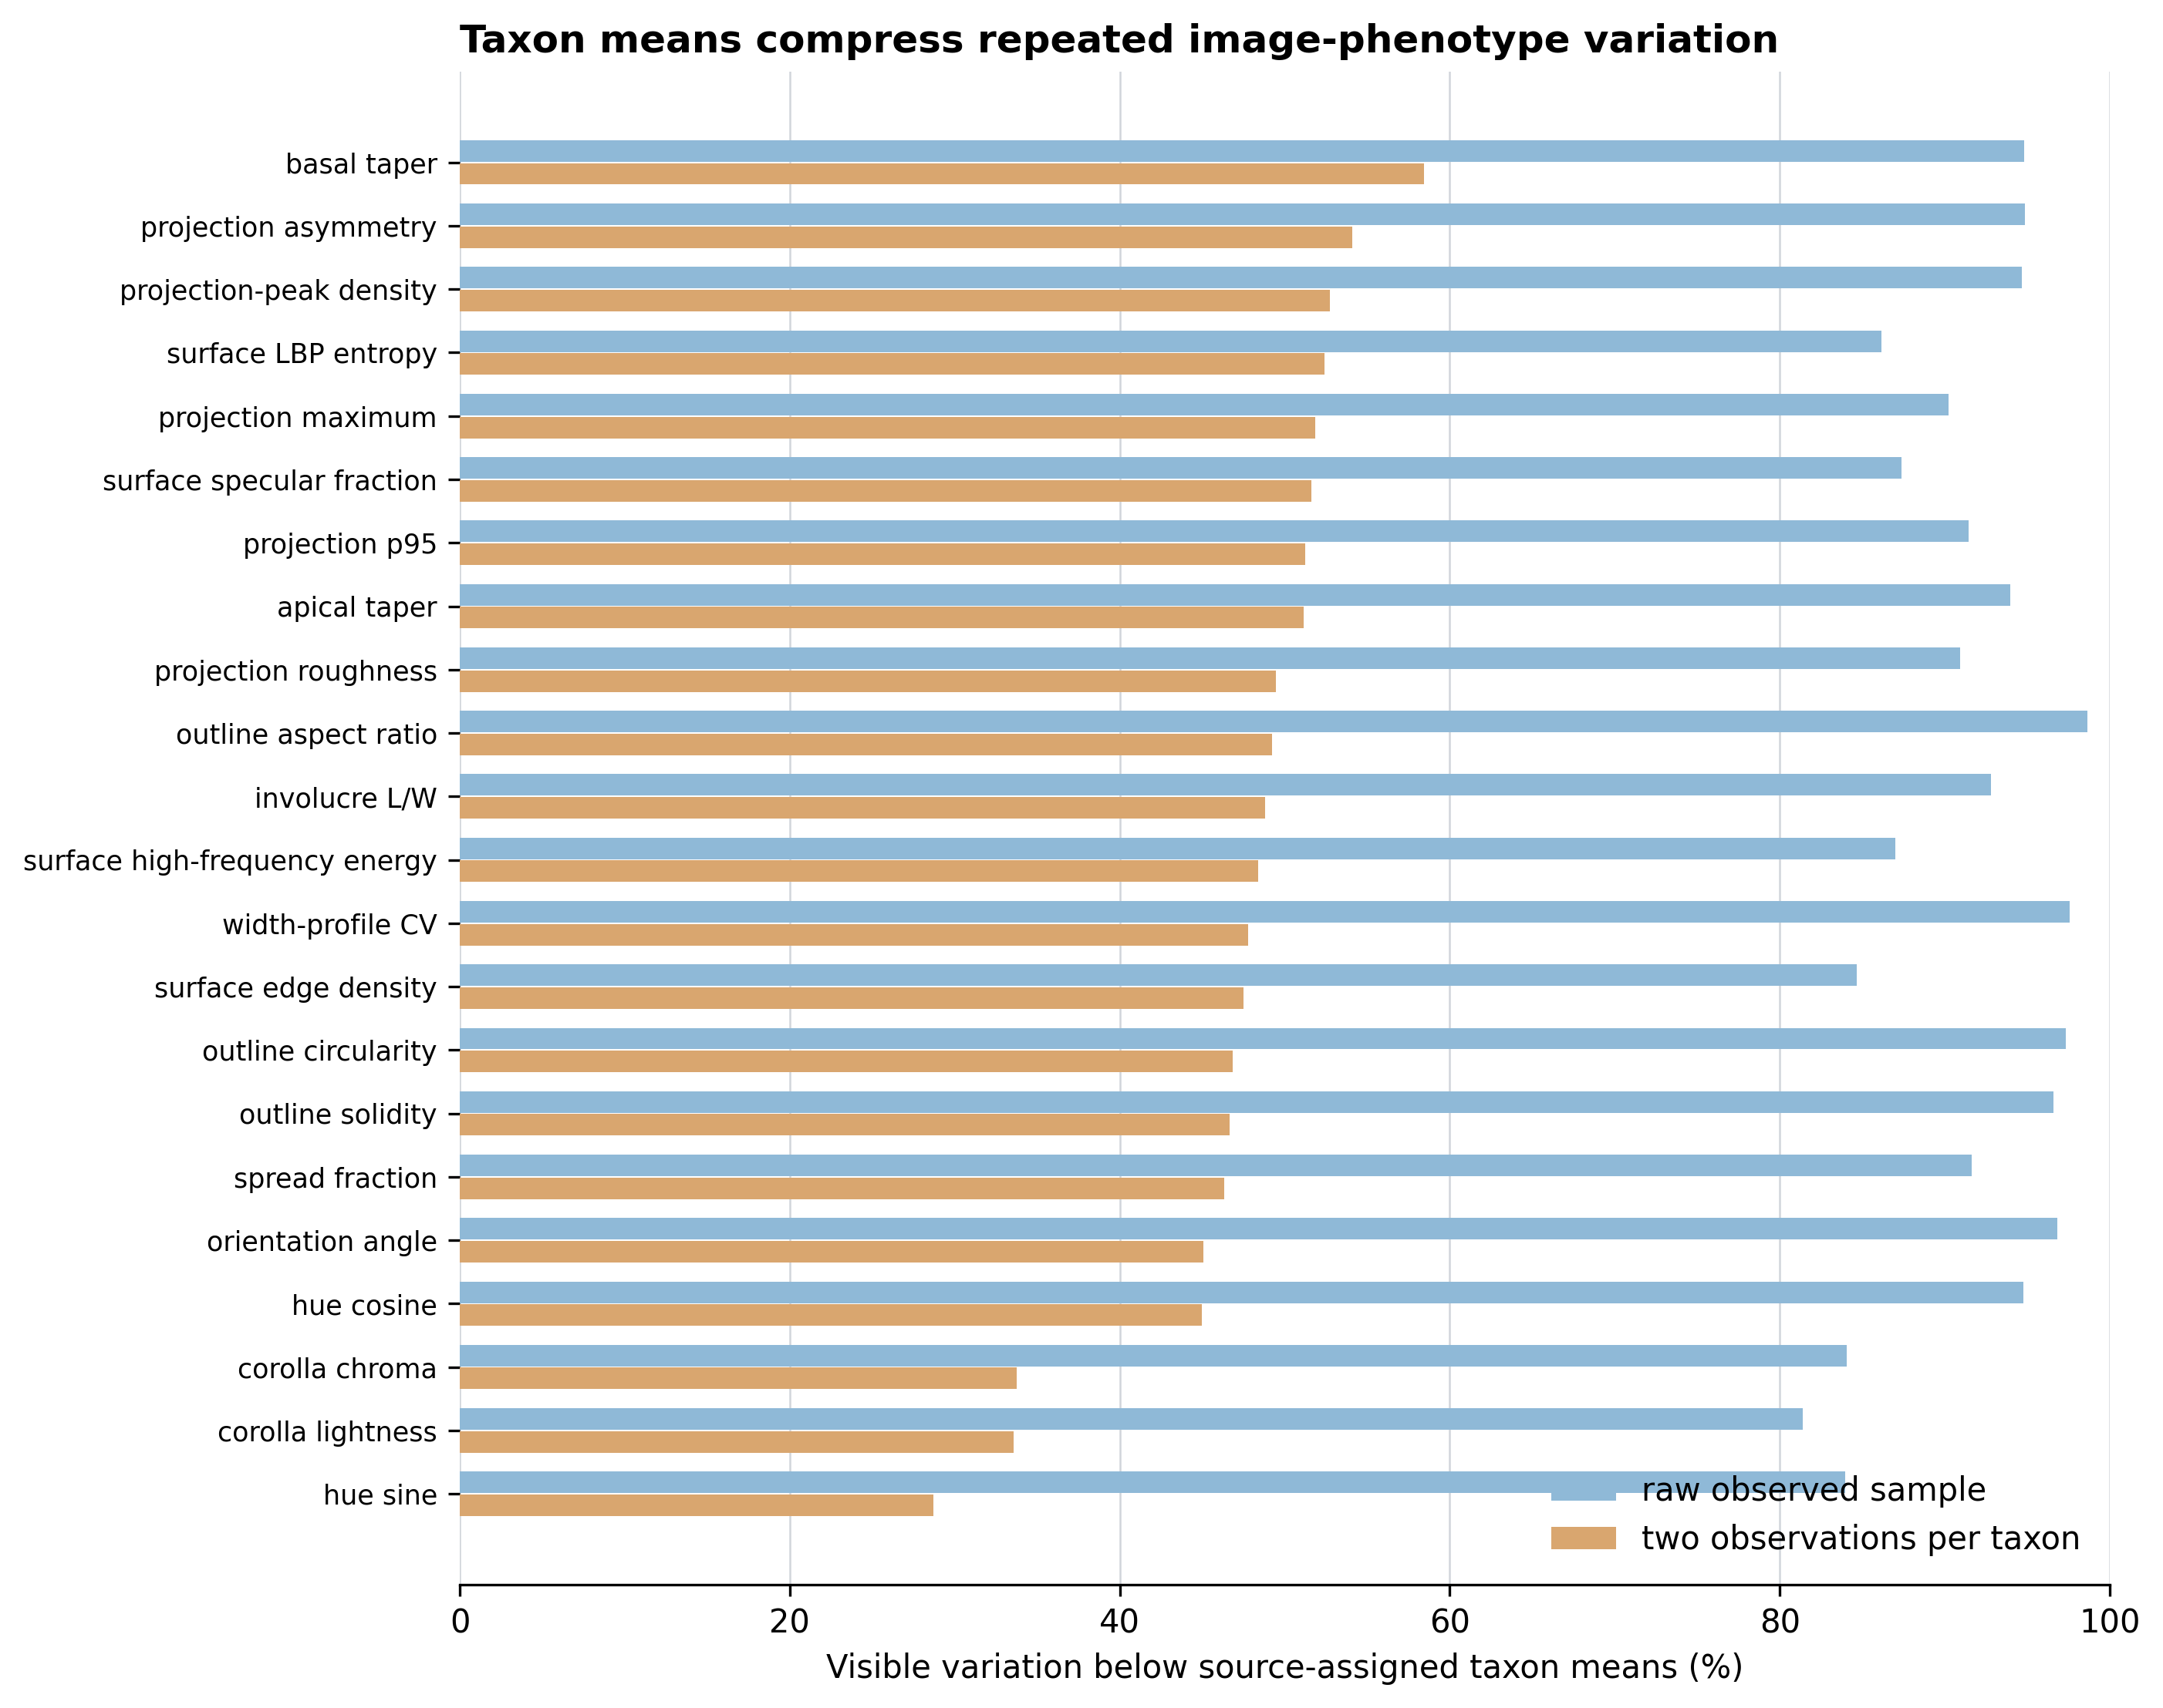
Figure S1. Taxon-mean information loss across all 22 measured endpoints.
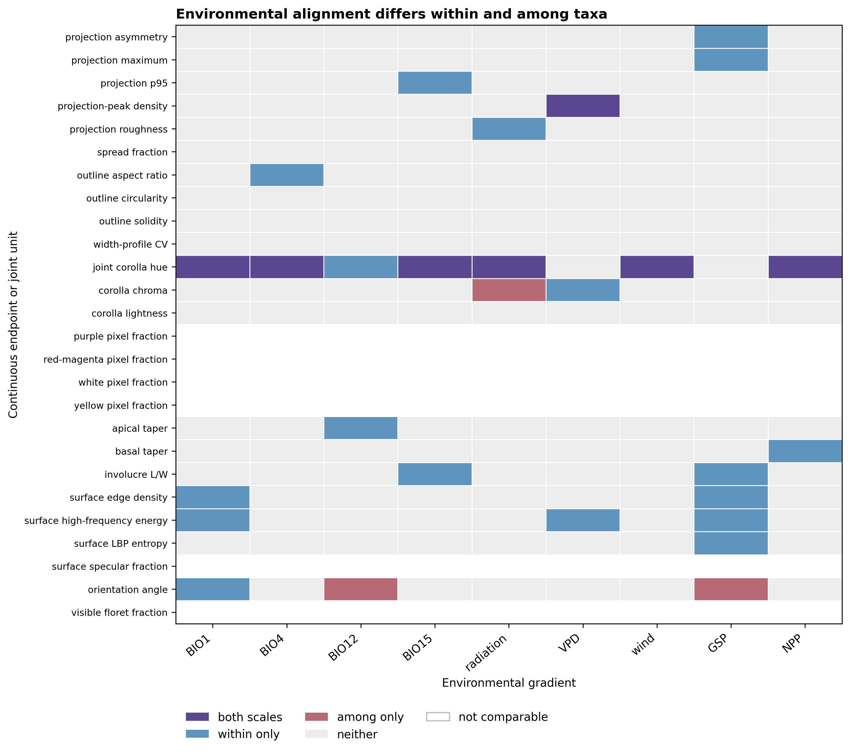
Figure S2. Complete within- and among-taxon endpoint-gradient classification.
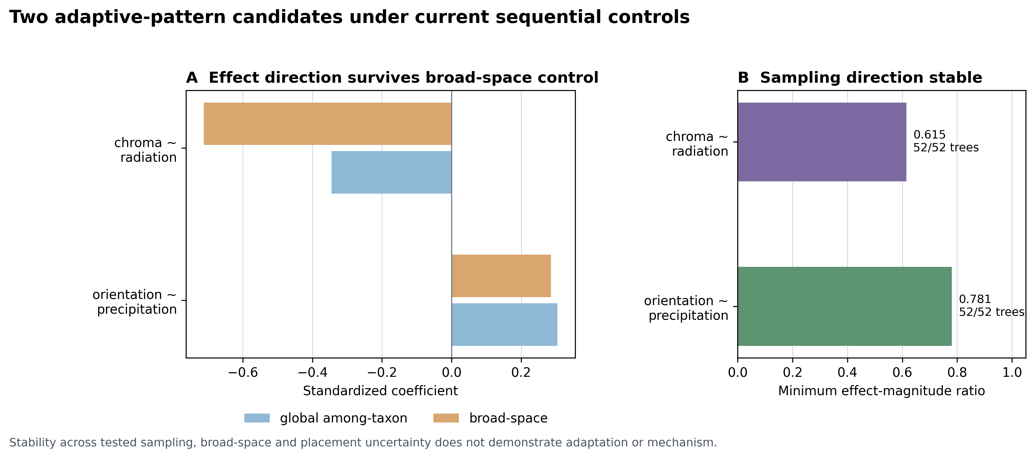
Figure S3. Sampling, broad-space and historical-placement robustness of the two candidates.

