Project Title-Customer Churn Prediction

# Introduction:

Customer churn prediction is a vital component for customer relationship management and business analysis. It involves the usage of strategies like “Data Analysis” and “Machine Learning” to forecast when and why the customers may stop using a product or service.

The primary goal of customer churn prediction is to identify at risk customers early on and take proactive measures to retain them.By analyzing historical data of the customers and various business factors that may influence businesses can develop many predictive strategies which may help them in maintaining their customers and will probably help in increasing their customer services.

# About Phase 3:

The phase 3 is all about data preprocessing of the given csv file for the purpose of performing various operations such as analysis, exploratory data analysis and visualizing of the dataset.

# Phase 3 of Customer Churn Prediction:

The phase 3 of the project customer churn prediction refers to visualizing of the data using the “IBM Cognos Tool”. The various charts displayed in this document are Bar chart,Pie chart,Line chart and scatter plot.

# About the “IBM Cognos Tool”:

The IBM Cognos tool is used for analyzing the files such as csv files and other files to visualize data from them.

# 1)Pie Chart:

The first chart is about visualizing the data using cognos.The attributes used here are Gender to gender and the comparison of various payment methods.The pie chart is given below.

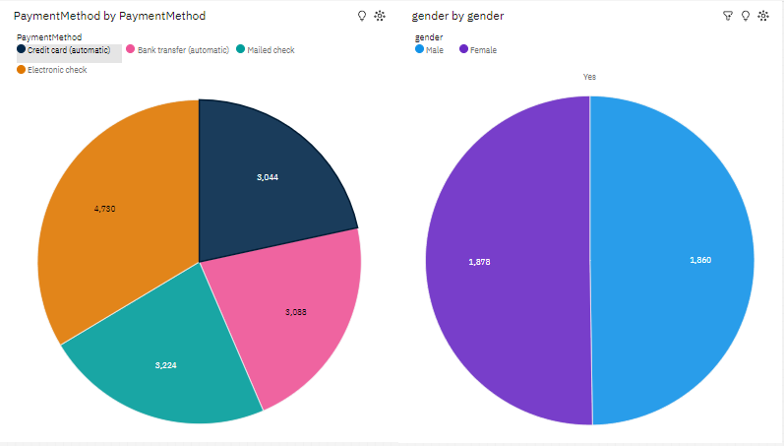

# 2)Bar Chart:

The second chart is the bar chart which is used for visualizing the contents such as churn by gender to gender as well as the various payments method used in the dataset are compared here.

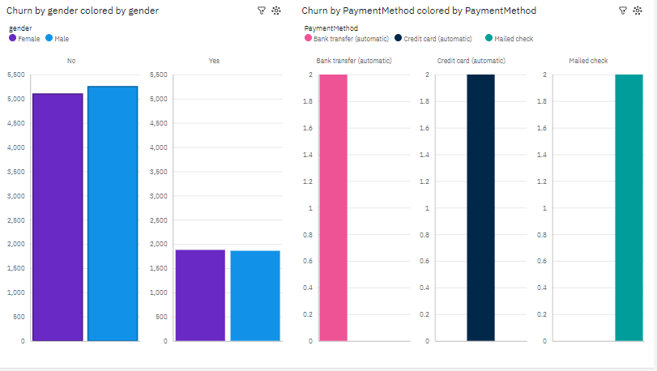

# 3)Scatterplot:

Scatterplot is the most commonly used graph which is used for depicting the relationship of two entities or objects.Here we have used multiple properties which are involved in payment methods.

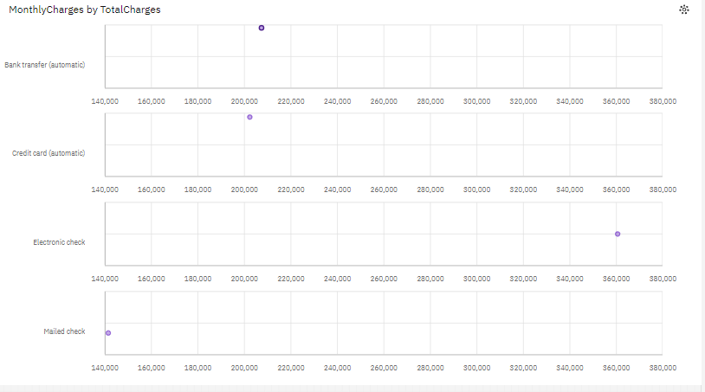

# 4)Line chart:

The line chart is considered to be the most basic chart or graph used for representation.Here the line chart visualizes the different relationships or the properties used here.

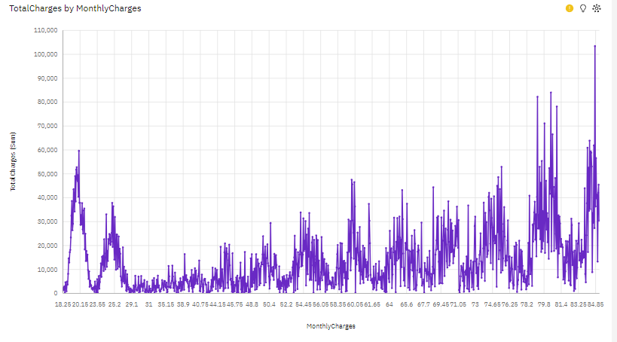

# Conclusion:

The task given here of visualizing the different charts using cognos analytics tool is done here.The different charts are depicted above and their respective explainations are given with them. About the user friendliness of cognos,it takes a little bit of time to study the uploaded the csv file provided and to give out the insights from that file which further help in visualization of the data.