DSAI 6226 DATA ENGINEERING · UNIT 5
Lab 5: touch a real cloud warehouse
One aggregate in the BigQuery sandbox, and the pipeline design behind it
Team | Team E: Mhina Lukurunge, Samwel Mmari, Asajile Mwakyalabwe, Essa Mohamedali, Paschal Bizulu
Dataset | adult_analytic, the denormalised view of the warehouse. 32,561 records, 24 columns, 5.35 MB as CSV.
Warehouse | BigQuery sandbox, on-demand pricing, no billing account attached
Project | dsai6226-team-e.adult.adult_analytic, region africa-south1 (Johannesburg)
Repository | github.com/zukazudo/dsai6226-data-engineering
Date | 13 September 2026

1. The query, and what it cost to answer
The aggregate is the allocation question from Lab 1: how many eligible candidates sit in each occupation and education segment. The same question has now been answered on a laptop, in PostgreSQL, in DuckDB, and in a cloud warehouse. Only the last one prices the answer.

The figure to write down
Query | Predicted scan | Measured | Agrees
The aggregate, six columns referenced | 1,898,872 bytes (1.81 MB) | 1.81 MB | yes
SELECT star over all twenty-four | 5,604,157 bytes (5.34 MB) | 5.34 MB | yes

Both predictions were exact. They were computed from the data before the sandbox was opened, by the method in section 2, and the console reported the same two figures to the precision it displays.

The job, as the console recorded it
Bytes processed | 1.81 MB
Bytes billed | 10 MB the per-table minimum, so the 1.81 MB is rounded up
Duration | 494 ms
Location | africa-south1
Rows returned | 87 segments, matching the local warehouse exactly
Cost | Nothing. The sandbox includes the first 1 TB scanned each month.

The allocation query, priced before it runs
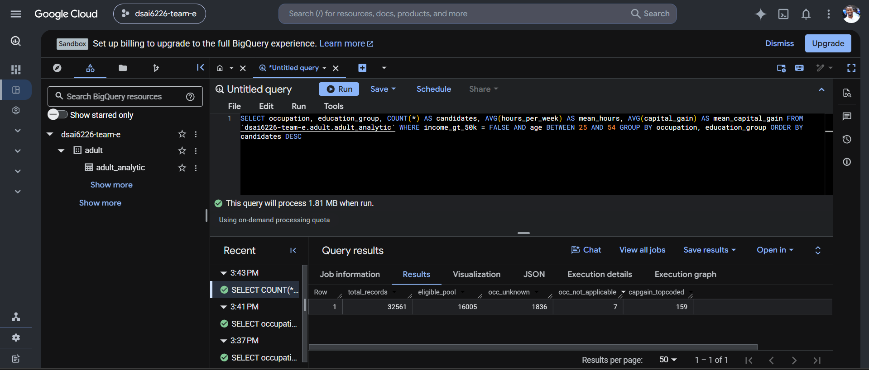
The figure this lab exists to produce, on the line below the editor: this query will process 1.81 MB when run. BigQuery prices a query from its text before executing anything, so the cost is known while there is still time to change the query. The predicted figure, computed locally from the column widths, was 1,898,872 bytes.

The load, verified against Lab 1
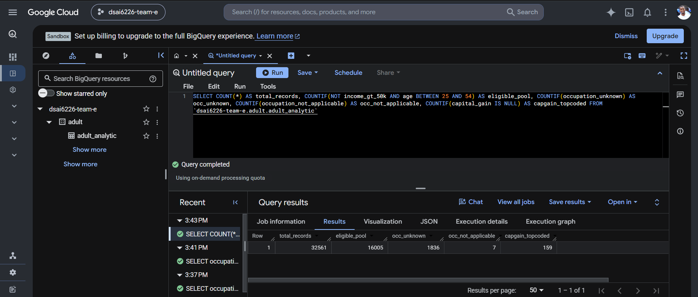
The counts query, run in the same session. Every figure matches the local warehouse: 32,561 records, an eligible pool of 16,005, 1,836 occupations recorded as unknown, 7 as not applicable, and 159 top-coded capital gains. Nothing was lost between the source CSV, the warehouse, the export and the upload. The Sandbox badge in the header confirms that no billing account is attached.

A correction to the slogan
Unit 5 calls SELECT star the most expensive words in the cloud. Testing that produced a more precise answer, and it is the most useful thing this lab taught us.
Wrapping the table in a subquery that selects everything, then aggregating the same six columns, was expected to scan all twenty-four. It did not. The console still reported 1.81 MB, because BigQuery prunes columns the query never references, even through the subquery. The literal words SELECT star cost nothing.
What is billed is the set of columns a query actually references. The only way to reach the full 5.34 MB was a query that genuinely returns every column, a plain SELECT * FROM adult_analytic with no aggregation, which leaves nothing to prune.
Why this matters more than the slogan
Told that SELECT star is expensive, an engineer rewrites their SELECT lists and expects a saving. On a warehouse that prunes, much of that work changes nothing. The rule that survives testing is narrower: you pay for the columns your query needs, so the saving comes from needing fewer columns, not from how the FROM clause is written. It is also why the honest ratio here is three and not a hundred.

2. Why that number is the cost driver
On-demand BigQuery bills for the bytes a query reads, not for how long it takes. A query reads only the columns it names, so the bill is decided when the SELECT list is written.
That makes the figure predictable. Column widths are fixed by type, and NULL costs nothing, so the scan can be computed from the data without going near the cloud. The sizes used are the published ones: 8 bytes for an integer, 1 byte for a boolean, and 2 bytes plus the UTF-8 length for a string.
scripts/bq_bytes.py does this for the whole table. The six columns the aggregate needs come to 1.81 MB of the table's 5.34 MB.

Where the bytes are
Column | Bytes | Share | Read by the query
education_group | 613,608 | 10.9% | yes
marital_status | 534,458 | 9.5%
occupation | 473,535 | 8.4% | yes
native_country | 468,920 | 8.4%
relationship | 362,070 | 6.5%
education | 339,732 | 6.1%
age | 260,144 | 4.6% | yes
hours_per_week | 259,808 | 4.6% | yes
capital_gain | 259,216 | 4.6% | yes
income_gt_50k | 32,561 | 0.6% | yes
the other fourteen | 2,040,105 | 36.4%

Two things fall out of that table. The wide, repetitive text columns dominate: five string columns account for over 40 per cent of the table. And the booleans are almost free, at one byte each, which is why the Lab 2 decision to carry a flag beside every censored measure costs almost nothing to scan.
The lecture says a hundredfold. We measured three.
Unit 5 puts the saving from partitioning plus column selection at up to a hundred times. On this table, column selection alone gives 3.0 times, and the reason is worth stating and not hiding. The hundredfold figure assumes two things this dataset does not have: a very wide table, where the columns you need are a small fraction of the total, and a partition key, so a filter can skip whole days of data unread. This table has twenty-four columns and the query needs six of them, including the two widest strings. It also has no date column at all, because it is a single 1994 snapshot and not a time series, so there is nothing to partition on. Three times is the honest number for this shape of data.

What it would actually cost
If the table were | Scanned per query | Cost at $5 per TB
5.34 MB, as it is | 5.34 MB | $0.000027
1 GB | 1 GB | $0.005
100 GB | 100 GB | $0.50
1 TB | 1 TB | $5.00

The saving here is real in bytes and zero in money
BigQuery bills a minimum of 10 MB per table per query, and the sandbox includes the first 1 TB scanned each month at no charge. Both versions of this query therefore round to the same bill, which is nothing. Reporting a three times saving as a cost saving on this dataset would be wrong. The ratio is the lesson, and it only becomes money when the table is large enough for the meter to notice: at 1 TB per query, the same three times is $3.33 saved every time someone runs it.

3. The pipeline, every box and every arrow
The design below is the pipeline this project already builds, drawn with cloud services in place of local ones. The stages are the same because the problems are the same: land the raw file untouched, validate before modelling, keep what fails, and serve only results.
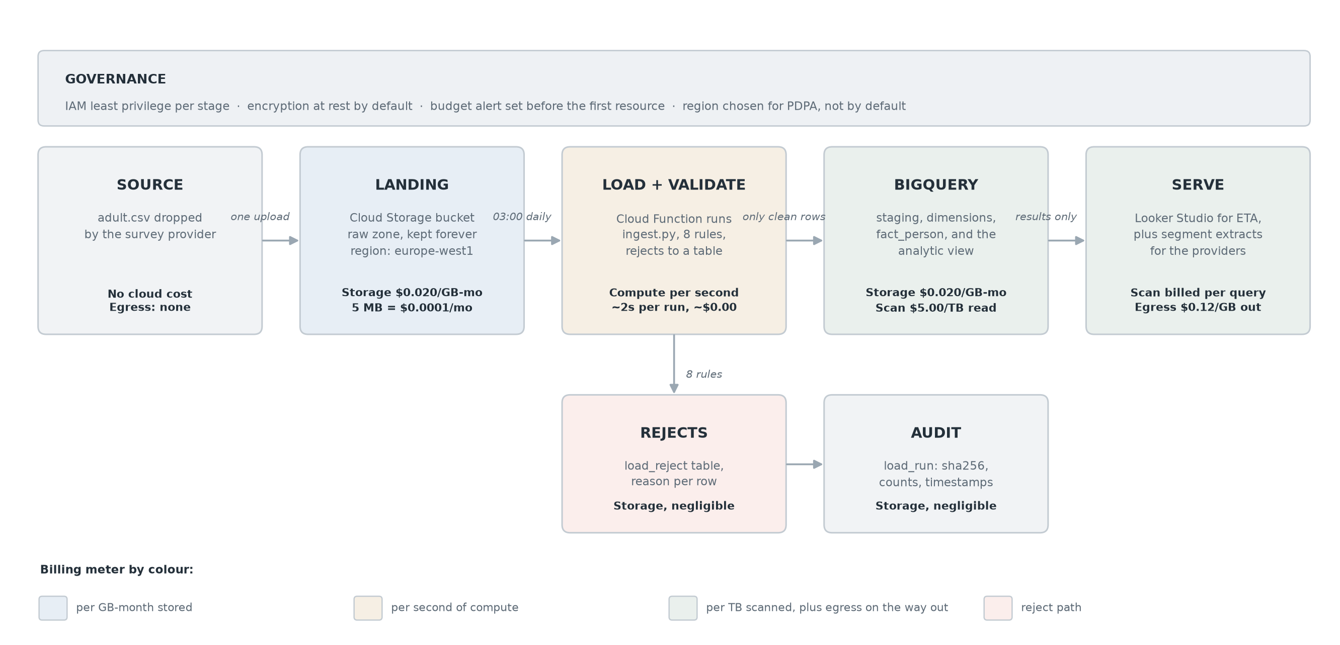

The cost note on each box
Stage | Service | Meter | At this size
Source | The provider's file drop | None | No cloud cost
Landing | Cloud Storage, raw zone | Storage, per GB-month | 5 MB, about $0.0001 a month
Load and validate | Cloud Function running ingest.py | Compute, per second | About 2 seconds a run
Rejects | BigQuery table, reason per row | Storage | Negligible
Audit | BigQuery load_run table | Storage | Negligible
Warehouse | BigQuery: staging, dims, fact | Storage, plus scan per query | $5 per TB read
Serve | Looker Studio, segment extracts | Scan per query, egress out | $0.12 per GB leaving

List prices are those published for europe-west1 at the time of writing and change regularly. The lecture's advice to read the provider's pricing page is the correct habit; these figures are a snapshot, not a quotation.

Three design choices worth defending
The raw file goes up once and never comes back down. Egress is billed per gigabyte leaving the cloud. Uploading 5 MB and pulling back an 87-row aggregate is the right shape. Pulling the whole table down to a laptop to answer each question would pay egress every time, for an answer that is a few kilobytes.
The reject path is a box, not an exception. Most pipeline diagrams draw only the happy path. Lab 3 produced eight validation rules and a table that records what failed and why, so it earns a box. It is also nearly free: rejects are rare and small.
There is no partition key, and the design says so. The usual advice is to partition by date so a query reads only the days it needs. This dataset is one 1994 snapshot with no date column, so there is nothing to partition on. In a live version the partition key would be the ingestion date the Lab 3 loader already records, which would let a query read one day instead of the whole history.

4. Which region, and why it is a legal question
Unit 5 makes the point that region is a legal decision under Tanzania's Personal Data Protection Act, not only a technical one. That deserves care here, because the honest answer has two halves.
For this dataset, the PDPA does not bite. adult.csv is public United States census microdata from 1994, already de-identified and published openly by the UCI repository. It contains no Tanzanian data subject and no identifiable person. Claiming a compliance obligation over it would be a misreading.
For the pipeline this design describes, it would. The consumer in the Lab 1 statement receives outcome records back from delivery providers: enrolments, completions, income at 24 months. Those are records about identifiable living people. The moment that return path exists, the region holding them stops being a latency choice.
Three consequences follow, and they are the reason the design names a region and does not accept a default.
- The default is not a defence. Cloud consoles offer a nearest or most convenient region. Under the PDPA, cross-border transfer of personal data requires adequate safeguards, and having clicked through a default is not one.
- Latency is the wrong tiebreaker for batch work. AWS Cape Town and Azure South Africa are the nearest major regions, while much analytics capacity still sits in Europe. The lecture is clear that 100 to 200 milliseconds is irrelevant to a nightly batch load and only matters for interactive applications. Choosing a distant region for a batch pipeline costs nothing in practice, so the choice is free to be made on legal grounds.
- Personal data and derived aggregates can live in different places. The 87-row segment summary this lab produces contains no personal data at all. A design that keeps identifiable records in one region and publishes only aggregates elsewhere reduces both the legal surface and the egress bill.

What we actually chose, and why
The dataset was created in africa-south1, the Johannesburg region. Unit 5 names AWS Cape Town and Azure South Africa as the nearest major regions and says much analytics capacity still sits in Europe. For BigQuery that is now out of date: africa-south1 appears in the region list and accepted the dataset without complaint.
Proximity is not compliance, and it would be wrong to imply otherwise. Johannesburg is still outside Tanzania, so a transfer of personal data there would still need safeguards under the PDPA. What an African region buys is a shorter hop and a jurisdiction inside the same continental conversation, which makes those safeguards easier to argue. The point is that the choice was made, can be defended, and that no default was accepted.
What we would put in the register
Raw and modelled records in a single named region, chosen for the jurisdiction of the data subjects, not for latency. Least privilege per stage, so the loader can write to staging and nothing else. A budget alert configured before the first resource is created, which the lecture rightly calls free to set and priceless the day something runs away.

5. Reproducing this
The sandbox is free and needs no card. It does need a Google sign-in, which is the only step that cannot be scripted. Everything below was carried out on 13 September 2026 and can be repeated from a clone.
- Export the sample. Already done, and in the repository as cloud/adult_analytic.csv. Rebuild it with python scripts/ingest.py followed by the export in sql/05_analytic.sql.
- Open the sandbox at console.cloud.google.com/bigquery and sign in. A project is created automatically, with a name like sunlit-flare-123456.
- Create a dataset in the project, then a table inside it, uploading the CSV with schema auto-detect on. Name the table adult_analytic.
- Paste each query from sql/06_bigquery.sql, replacing PROJECT.DATASET with your own. Read the estimate the editor shows before pressing Run.
- Record both figures and compare them against the prediction. Ours agreed exactly.
- Confirm the load is faithful. The counts query returns 32,561 records, an eligible pool of 16,005, 1,836 unknown occupations, 7 not applicable and 159 top-coded capital gains. Every one matches the Lab 1 figures, so nothing was lost between the CSV, the warehouse, the export and the upload.

Checking the prediction
A prediction that survives contact with the real meter is evidence that the pricing model is understood. Both of ours did, to the precision the console displays. Had the measured scan come out larger, the usual cause is schema auto-detect giving a column a wider type than expected, for example reading an integer column as a string.

python scripts/bq_bytes.py

Appendix. What Unit 5 asked, and where it is answered
The unit's own checklist | Where this document answers it
Explain storage and compute separation, and why it changes pricing | Section 2: the bill follows bytes read, not time, which is only possible because compute is rented per query against data sitting still
Know the four meters: storage, compute time, bytes scanned, egress | Section 3, one meter named on every box of the diagram
Say why which region is a legal question under the PDPA | Section 4, including why it does not apply to this dataset and would apply to the pipeline
Run a real query in the sandbox and note its bytes processed | Section 1: 1.81 MB processed, 10 MB billed, in africa-south1

