Matthew Brown

2/3/2021

HW 1. Excel Challenge Report (lines 55-60)

Problem statements/Analysis:

1. Given the provided data, what are three conclusions we can draw about Kickstarter campaigns?
   1. Based on the chart below, the most Kickstarter campaigns created between May 17, 2009 and March 15, 2007 where in the category “Theater” (1369 analyzed campaigns). However, the table indicates that the campaigns most likely to be successful are in the next most populated category of music (680 analyzed campaigns, 79% success rate), where “successful” is defined as number of successful campaigns divided by total campaigns of all states excluding live.

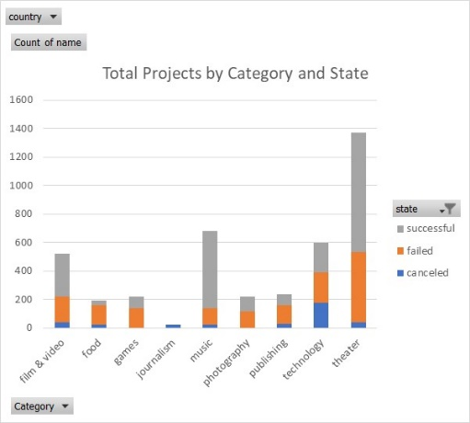 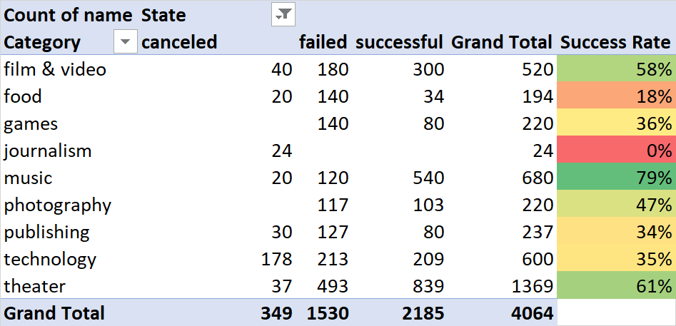

* 1. Per the chart Total Campaigns by Sub-Category and State below, campaigns in the sub-category plays make up more than a quarter of the campaigns. Of the 1066 plays campaigns, more than half (671) are from the US, and these have a success rate of 62%. Plays worldwide have a success rate of more than 66%. From the chart Music Campaigns by Sub-Category and State, campaigns in the music category, sub-categories rock, classical music, electronic music, and metal all have a 100% success rate, indie rock has an 88% success rate, and all others (faith, jazz, and world music) have 0% success rates.

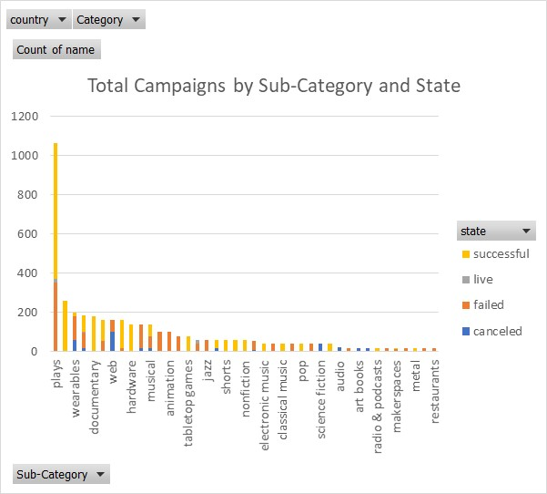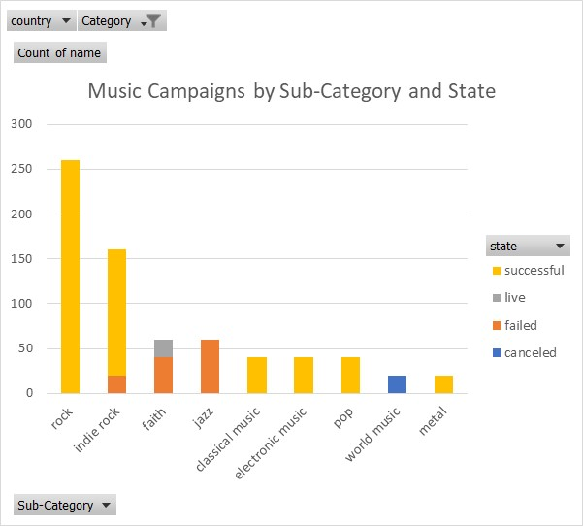

* 1. Based on the chart Total Projects by Launch Month and State, the highest number of successful projects were launched in May and the lowest number of successful projects were launched in December. This behavior is consistent in the theater category and music category. The highest numbers of failed projects were launched in January, June, July, and October. Looking at success rates by month in the table below, projects launched between February and May had the highest likelihood of success. The maximum success rate for theater campaigns was 67% from those launched in May, and the maximum success rate for music campaigns was 87% from those launched in June.

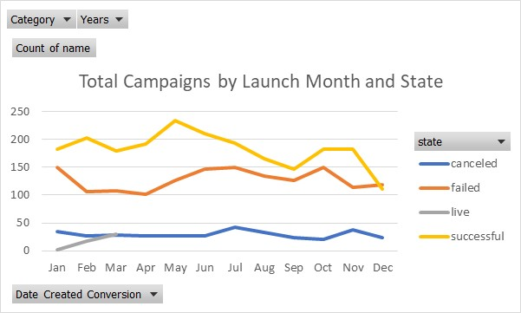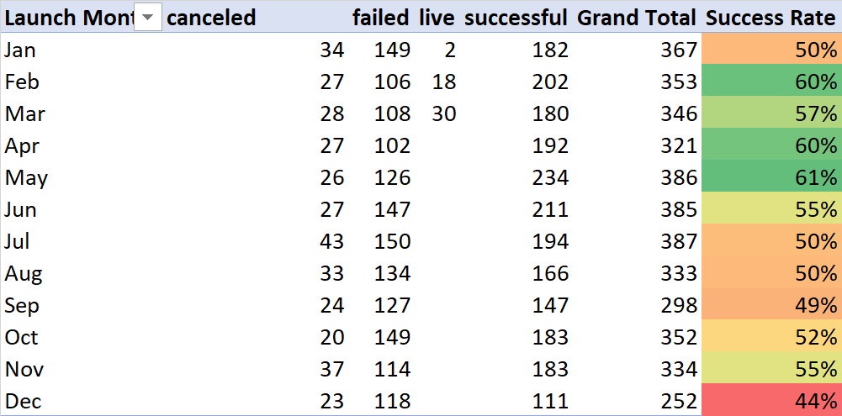

Conclusions:

* + - 1. The most competition in Kickstarter campaigns exists in the theater category, but the highest likelihood of success is in the music category.
      2. Kickstarter campaigns for plays within the theater category represent more than a quarter of the total but have a mediocre success rate. However, music (particularly rock, classical music, electronic music, metal, and to a slightly lesser extent indie rock) may represent an untapped market with a higher likelihood of success.
      3. Kickstarters for Plays launched in May tended to be more likely to succeed and music campaigns launched in June tended to be more likely to succeed, so these should be the target launch months for these types of projects respectively.

1. What are some limitations of this dataset?
   1. The data is not uniformly distributed over the time range. The table below shows that the years from 2009 to 2017 do not contain the same number of projects. However, 2014, 2015 and 2016 are somewhat comparable. There may be special reasons for this behavior, such as 2009 was the site’s launch year, and adoption may have taken a while from both campaigners and backers.

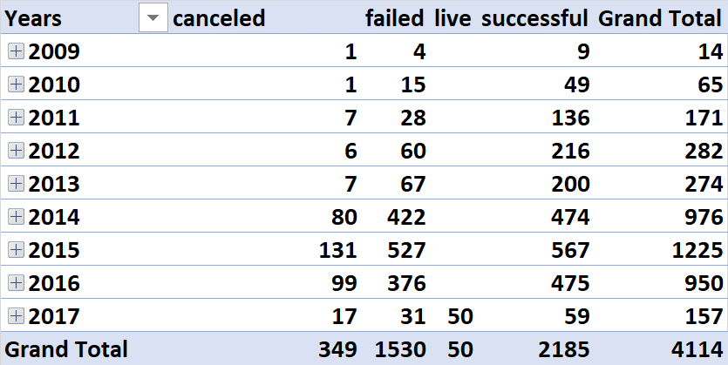

* 1. The raw numbers of projects submitted are not equal across categories (as we have seen). The category “theater” and even the subcategory “plays” might need to be split for better analysis.
  2. The raw numbers of projects submitted are not equal across countries as shown in the table below. Since the US has more campaigns than any other country combined, global conclusions may be difficult.

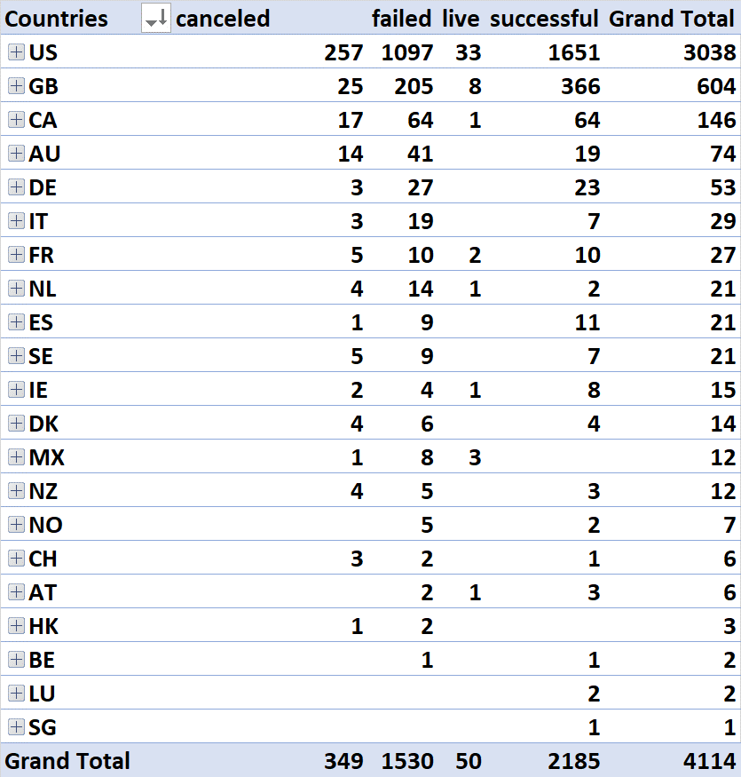

* 1. We have not created a field for duration that a project was open, although it could be done with the existing data. Length of time a campaign runs may be an indicator of potential success.
  2. While the data set may imply some factors that lead to success or failure, we do not have insight into root cause of a campaign moving to the states “failed” or “canceled”.

1. What are some other possible tables and/or graphs that we could create?

Aside from charts to help deal with the limitations mentioned above, these would be helpful:

* 1. Chart of projects by state based on stratifying how much money they were asking for. Additional drilldowns into category, sub category, and year might be helpful.
  2. Percent funded by category, sub category and year.
  3. Average donation by category, sub category and year
  4. While a definition of Staff Pick would be needed first, Staff Pick by campaign state might be a predictor of success.
  5. Number of backers by category.
  6. State of projects by stratification of duration with a drilldown into category, sub category and year