IOT-ENABLED WASTE MANAGEMENT SYSTEM
FOR REDUCING WASTE IN RESIDENTIAL BUILDINGS

DZUL DANISH AR-RAHMAN BIN KHAIRULASWARI
52224122563

BACHELOR OF INFORMATION TECHNOLOGY (HONS) IN INTERNET OF THINGS

MALAYSIAN INSTITUTE OF INFORMATION TECHNOLOGY
UNIVERSITI KUALA LUMPUR

OCTOBER 2024

IOT-ENABLED WASTE MANAGEMENT SYSTEM
FOR REDUCING WASTE IN RESIDENTIAL BUILDINGS

DZUL DANISH AR-RAHMAN BIN KHAIRULASWARI
(52224122563)

Report Submitted to Fulfilment of the Requirements for the Bachelor of Information Technology (Hons) (Internet of Things) University Kuala Lumpur

DECLARATION

I declare that this report is my original work, and all references have been cited adequately as required by the university.



Date: 26 June 2025 Signature:……………………………
Full Name: Dzul Danish Ar-Rahman Bin Khairulaswari
ID No: 52224122563

APPROVAL

We have supervised and examined this report and verify that it meets the program and university’s requirements for the Bachelor of Information Technology (Hons) (Internet of Things).



Date: 26 June 2025 Signature: ……………………………………….
Supervisor: Dr Haidawati Binti Mohamad Nasir
Official Stamp:

Date: 26 June 2025 Signature: ………………………………………..
Co-Supervisor: Fuead Bin Ali Official Stamp:

ACKNOWLEDGEMENT

First and foremost, I would like to express my deepest gratitude to my supervisor, Assoc. Prof. Ts. Dr. Haidawati Binti Mohamad Nasir, for her invaluable guidance, encouragement, and continuous support throughout the development of this project. Her insightful advice, technical knowledge, and constructive feedback have played a crucial role in helping me complete this work successfully. I would also like to extend my sincere thanks to my Final Year Project coordinators, Ts. Faridah Binti Yahya and Sir Azmi Bin Ahmad, for their consistent assistance, timely reminders, and support in managing the administrative and academic aspects of the project. Their efforts in ensuring the smooth execution of the project schedule are truly appreciated. In addition, I am grateful to the faculty and staff of Universiti Kuala Lumpur MIIT for providing a conducive learning environment and access to the necessary resources that facilitated the completion of this project. Lastly, I wish to thank my family and friends for their unwavering support, patience, and motivation throughout my journey.

CONTENTS

CHAPTER 1: INTRODUCTION
1.1 Introduction …………………………………………………......... 1 - 2
1.2 Project Theme ………………………………………………....... 2 - 3
1.3 Project Statement ................................................................... 3 - 4
1.4 Project Objectives .................................................................. 4
1.5 Project Scope ......................................................................... 4 - 5
CHAPTER 2: LITERATURE REVIEW
2.1 Introduction ............................................................................. 6
2.2 Related Works ........................................................................ 6
2.2.1 Study on Waste Generation and Composition in Rapid Residential Development of Suburban Areas in the Kuala Selangor District, Selangor ........................................................................................................... 6 - 8
2.2.2 An Internet of Things Based Smart Waste Management System Using LoRa and TensorFlow Deep Learning Model ......................................... 8 - 10
2.2.3 IoT Based Smart Garbage System for Efficient Food Waste Management ....................................................................................................... 10 - 11
2.3 Comparison ............................................................................ 11 - 12
2.4 Conclusion .............................................................................. 12
CHAPTER 3: METHODOLOGY
3.1 Introduction ............................................................................. 13
3.2 Methodology Model Waterfall ................................................. 13 - 14
3.3 Requirements ......................................................................... 14
3.3.1 Objectives, Scopes and Constraints ............................ 14 - 15
3.3.2 Gantt Chart .................................................................. 15
3.3.3 Budget ......................................................................... 16
3.4 Design .................................................................................... 17
3.4.1 Block Diagram ............................................................. 17 - 18
3.4.2 Flowchart ..................................................................... 18 - 19
3.4.3 Schematic Diagram ..................................................... 19 - 20
3.5 Development .......................................................................... 20
3.5.1 Hardware Development ............................................... 20 - 21
3.5.2 Software Development ................................................ 21
3.5.3 Future Development .................................................... 22
3.6 Testing .................................................................................... 22
3.6.1 Software Testing .......................................................... 22
3.6.2 Hardware Testing ........................................................ 22 - 23
3.6.3 End-to-end Testing ...................................................... 23
3.7 Maintenance ........................................................................... 23
3.8 Software and Hardware Requirements .................................. 23
3.8.1 Hardware ..................................................................... 24 - 25
3.8.2 Software ....................................................................... 25 - 27
CHAPTER 4: RESULTS AND DISCUSSION
4.1 Introduction ............................................................................. 28
4.2 Results .................................................................................... 28
4.2.1 Project Prototype Overview .......................................... 28 - 31
4.2.2 Mobile App Dashboard ................................................. 31 – 32
4.2.3 Visual Records ............................................................. 33 - 35
4.3 Database (Firebase) ................................................................ 35 - 38
4.4 Discussion ............................................................................... 38 - 39
CHAPTER 5: CONCLUSION
5.1 Introduction ............................................................................... 40
5.2 Future Recommendations ........................................................ 40 - 41
5.3 Summary .................................................................................. 41
REFERENCES

ABSTRACT

This project introduces an IoT-enabled waste management system designed to mitigate excessive organic waste accumulation in residential buildings. The system utilizes an ESP32 microcontroller connected to an ultrasonic sensor for measuring bin fill levels, an MQ135 gas sensor for monitoring air quality, and an RFID reader for user authentication. Residents are required to scan their RFID cards before and after disposing of waste, enabling user-specific tracking and accountability. Real-time sensor data is formatted in JSON and transmitted to Firebase Realtime Database and Firestore via HTTP, ensuring structured and reliable cloud storage. A Flutter-based mobile application allows building management to visualize disposal events and environmental data efficiently. Threshold-based logic is applied to identify overuse or deteriorating air quality, enabling proactive maintenance. The prototype demonstrates that a low-cost, modular IoT solution can support data-driven decision-making and foster environmentally responsible waste disposal practices within a residential context.

CHAPTER 1: INTRODUCTION

1.1 Introduction
Organic waste management in residential buildings is significantly challenged in Malaysia due to ineffective tracking and disposal control. These inefficiencies result in environmental degradation and operational difficulties for residential management teams. With the expansion of urban areas, the need for innovative and sustainable systems of waste management increases.
A study conducted in Puncak Alam, a rapidly developing area in Kuala Selangor, found that household waste generation averaged 1.0 kg per capita per day, with each household producing approximately 2.5 kg daily. Notably, organic waste constituted 60% of the total household waste composition. (Yatim et al., 2019)
This significant organic waste proportion underlines the increasing need for active management strategies to reduce environmental impacts. According to the Malaysian Investment Development Authority, waste generation in Malaysia increased to 38,000 tons per day in the year 2018, with a recycling rate of 17.5%. This is significantly higher compared to the 19,000 tons recorded per day in 2005 and presents the increasing waste management challenges in Malaysia. (Malaysian Investment Development Authority [MIDA], n.d.)
Dealing with the challenges related to waste management in urban residential settings demands innovation and sustainable systems, especially concerning organic waste. In this respect, IoT can serve to be one of the effective solutions as it can allow real-time tracking and monitoring through advanced sensors and connected networks. This technology provides a much more efficient and transparent process that is environmentally clean in managing wastes. (Bridgera, n.d.)

This project is focused on the design and implementation of an IoT-enabled waste management system suitable for residential buildings. The sensors, RFID technology, and mobile application integrated within the system will assist in real-time data collection, and monitoring for efficient methods of organic waste disposal. The proposed system will utilize IoT for enhanced operational efficiency and minimal environmental impact within urban residential waste management.
1.2 Project Theme
This project focuses on implementing an IoT-enabled waste management system to optimize organic waste disposal in residential buildings. The system integrates various sensors and hardware components to collect and transmit data to a mobile application, enabling real-time monitoring of key parameters such as air quality and waste level. RFID technology is incorporated to track residents’ waste disposal behaviour, promoting accountability and fostering sustainable practices.
- Ultrasonic Sensor:
  - Measures waste level disposed of by each resident, ensuring compliance with waste disposal limits.
  - Provides data for tracking waste disposal trends and identifying inefficiencies.
- MQ135 Sensor:
  - Monitors methane gas and other pollutants released by decomposing waste.
- Sends alerts when gas levels exceed safety thresholds, reducing health risks and environmental hazards.
- RFID Module:
  - Identifies residents during waste disposal, logging the frequency and volume of waste they discard.

- Flutter Framework:
  - Used to develop a cross-platform mobile application for Android.
  - Provides a user-friendly interface to display real-time data, trends, and alerts for both residents and management.
- Firebase:
  - Serves as the cloud-based storage system for all collected data.
  - Ensures real-time synchronization with the mobile app, enabling efficient monitoring and reporting.
1.3 Problem Statement
Many residential buildings today lack structured systems for managing organic waste, leading to unregulated disposal practices. Residents often discard waste without restrictions, resulting in increased management costs and fostering unsustainable habits. This approach neglects the importance of responsible waste management.
Global urbanization exacerbates this issue, with daily waste production on the rise. Organic waste, in particular, contributes to environmental problems such as methane emissions and resource wastage. Moreover, unmanaged organic waste can lead to health hazards, foul odours, and pest infestations, further deteriorating the quality of life in residential communities. Without effective tracking and control mechanisms, these challenges will persist, jeopardizing environmental sustainability and community well-being. Without effective tracking and control mechanisms, these challenges persist, threatening environmental sustainability and community well-being. (Climatesort, n.d.)
To address these pressing concerns, this project proposes an IoT-enabled waste management system specifically designed for residential buildings. The system integrates cutting-edge technologies, including advanced sensors, RFID modules, and mobile applications, to ensure real-time data collection, continuous monitoring, and instant notifications. By leveraging IoT capabilities, this solution enables building management teams to gain valuable insights into residents' waste disposal habits, monitor bin fill levels, and detect environmental hazards like methane gas emissions.
1.4 Project Objective
The objectives of this project are:
- Utilize ultrasonic sensors, and MQ135 gas sensors to accurately measure waste volume, monitor bin fill levels, and detect methane concentrations, ensuring a comprehensive understanding of bin status.
- Incorporate RFID technology to log and track individual residents’ waste disposal activities, fostering a culture of accountability and transparency in waste management.
- Develop a Flutter-based mobile application to display real-time sensor data, notify management of threshold breaches (e.g., full bins or hazardous gas levels), and enhance operational efficiency.
- Store and manage sensor data securely in Firebase, enabling seamless data access, analysis, and reporting for improved waste management strategies.
1.5 Project Scope
This project aims to develop a smart waste management system with the following scope:
Inclusions:
- Sensor Integration: Load sensors, ultrasonic sensors, and MQ135 gas sensors will be used to monitor waste volume, bin fill levels, and methane concentrations.
- Resident Tracking: RFID technology will log waste disposal activities to promote accountability.
- Mobile Application: A Flutter-based app will provide real-time data visualization, notifications, and alerts for threshold breaches.
- Cloud Data Management: Sensor data will be stored and managed in Firebase for analysis and reporting.
Exclusions:
- The project will not include large-scale deployment across multiple sites or integration with external waste processing systems.
- Advanced machine learning algorithms or predictive analytics are beyond the scope of this project.
Assumptions:
- The prototype system will be tested in a controlled environment using the real mobile application to demonstrate functionality.
- Test scenarios will mimic realistic waste disposal conditions to validate the system’s effectiveness.
- Users will interact with the actual mobile application for monitoring purposes during prototype testing.
CHAPTER 2 : LITERATURE REVIEW

2.1 Introduction
The rapid advancements in IoT (Internet of Things) technology have paved the way for innovative solutions in waste management. Existing studies explore the significance of waste management in various aspects and highlight the potential of IoT-based solutions, such as LoRa communication and deep learning with TensorFlow, to enhance efficiency and sustainability. These efforts aim to improve waste management practices by addressing current challenges. By examining the strengths, limitations, and existing statistics, this review emphasizes the need for a system to reduce the organic waste generated by residents.
2.2 Related Works
The existing applications and research projects serve as important references and guidelines for this study. Selected projects have been reviewed based on their features and technologies, which align with the development goals of this system. This section provides a detailed explanation of the functionalities and methodologies employed in these projects. The insights gained from these works serve as a foundation to enhance and refine the features of the proposed system.
2.2.1 Study on Waste Generation and Composition in Rapid Residential Development of Suburban Areas in the Kuala Selangor District, Selangor
The literature review focuses on analysing waste generation and composition in the rapidly developing suburban area of Puncak Alam, Kuala Selangor (Siti Rohana Mohd Yatim, 2019). Municipal solid waste
(MSW) is highlighted as a growing concern in Malaysia, constituting 65% of the total waste generated. A significant proportion of this waste, over 50%, is food waste, which is primarily disposed of in poorly managed landfills. These practices result in severe environmental issues such as groundwater contamination, odour emission, and greenhouse gas production due to organic waste degradation.
The methodology in this study is well-organized, using stratified sampling to capture diverse household data. Daily waste collection and weighing over four weeks provide reliable data on waste generation. Separating waste into categories such as food waste, plastic, paper, and metal allows for detailed composition analysis. Focusing on food waste is significant, as it contributes heavily to landfill issues. However, including socio-economic factors like household income or family size could enhance the analysis.
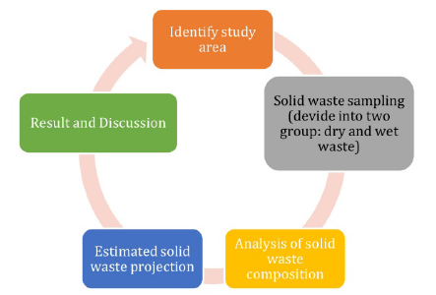
Figure 2.1: Research methodology flow

In this study, 200 households were selected through stratified sampling to assess the waste generation rate and composition. The findings indicate that the average waste generation per capita is 1.0 kg/day, with each household generating approximately 2.5 kg/day. Organic waste accounted for 65% of the total waste composition, followed by recyclable materials such as paper (8%), plastic (9%), glass (3%), and metal (4%). The dominance of organic waste highlights the potential for composting as an effective management strategy to mitigate environmental hazards.
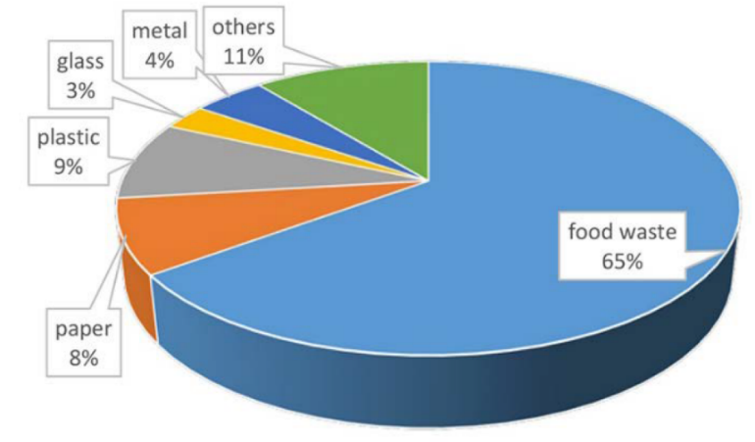
Figure 2.2: Percentage of waste composition from the study area

The study emphasizes the inefficiencies in current waste management practices, including the prevalence of open dumpsites and a lack of infrastructure for source separation and recycling. Recommendations for sustainable waste management in the study area include the promotion of recycling programs, the introduction of composting for organic waste, and the adoption of anaerobic digestion technologies to reduce greenhouse gas emissions and conserve landfill space. These strategies aim to address the challenges posed by increasing population and urbanization, which contribute to rising waste generation and environmental degradation.
2.2.2 An Internet of Things Based Smart Waste Management System Using LoRa and TensorFlow Deep Learning Model
The paper (Sheng et al., 2020) proposes a smart waste management system integrating IoT and artificial intelligence to optimize waste handling processes. The design includes a bin equipped with a camera for real-time object detection and ultrasonic sensors to monitor fill levels. A Raspberry Pi serves as the main processing unit, controlling waste segregation through servo motors and directing waste into designated compartments for metal, plastic, paper, and general waste. Additional features, such as RFID modules for personnel identification and GPS for location tracking, enhance functionality. The system operates autonomously, reducing manual intervention while ensuring efficient waste separation.
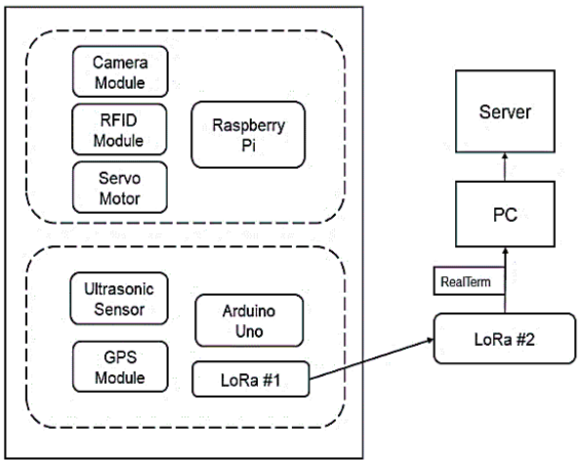
Figure 2.3: Block Diagram representing the overall system

LoRa technology is a key component, enabling long-range, low-power communication for transmitting bin status and location to a central server. The TensorFlow framework, integrated with a lightweight SSD MobileNetV2 model, performs object detection and classification directly on the Raspberry Pi. This approach minimizes data transmission latency by processing waste images locally. The combination of LoRa's communication efficiency and TensorFlow's real-time detection capability allows the system to manage waste effectively, even in remote or large urban areas.

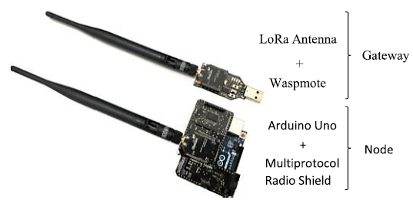
Figure 2.4: LoRa with wasp mote and multiprotocol radio shield.
Despite its innovations, the system has limitations. The accuracy of the object detection model is constrained by the size and diversity of the training dataset, affecting its ability to classify certain waste types. Additionally, the system is designed to handle only one piece of waste at a time, which may reduce efficiency in high-traffic areas. Expanding the training dataset, increasing model training iterations, and developing solutions to handle simultaneous waste inputs could further enhance the system’s capabilities. These improvements would increase the model’s robustness and adaptability to real-world scenarios.
2.2.3 IoT Based Smart Garbage System for Efficient Food Waste Management
This paper in (Hong et al., 2014) proposed an IoT-based smart garbage system (SGS) designed to manage food waste efficiently through interconnected smart garbage bins (SGBs), routers, and servers. The SGBs operate on battery power for mobility and are integrated into a wireless mesh network for reliable communication. The system includes two domains: a service domain, where residents interact with SGBs to dispose of food waste, and an administration domain, where data is processed, analysed, and managed.
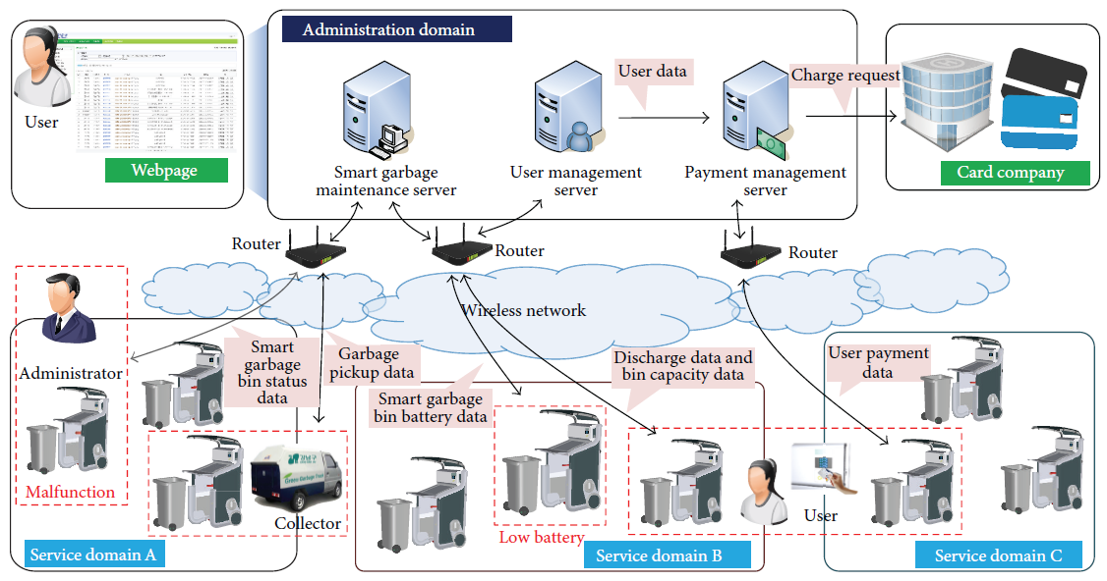
Figure 2.5 :Overview of smart garbage system.
An adaptive user-oriented charge policy is implemented to motivate residents to reduce food waste. The policy adjusts fees based on monthly reductions in food waste, encouraging sustainable practices. The SGS also features an energy-efficient operation, employing techniques such as sleep mode for SGBs and cooperative communication between bins to optimize battery life.
The system was piloted in the Gangnam district, Seoul, for one year. Results showed a 33% reduction in food waste and a 16% improvement in energy efficiency. The hardware includes RFID readers for user authentication, load cells for weight measurement, and a web-based platform for monitoring and managing waste disposal activities.
The study concluded that the SGS not only reduces food waste but also provides a scalable, sustainable waste management solution suitable for urban environments.
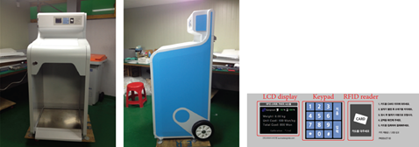
Figure 2.6: Smart garbage bin, LCD, keypad and RFID reader
2.3 Comparison
The comparison table summarizes the key features, strengths, and limitations of the reviewed studies. It highlights different approaches, such as IoT integration and advanced waste management strategies, to address various challenges. This analysis helps identify gaps and informs the development of the proposed system.
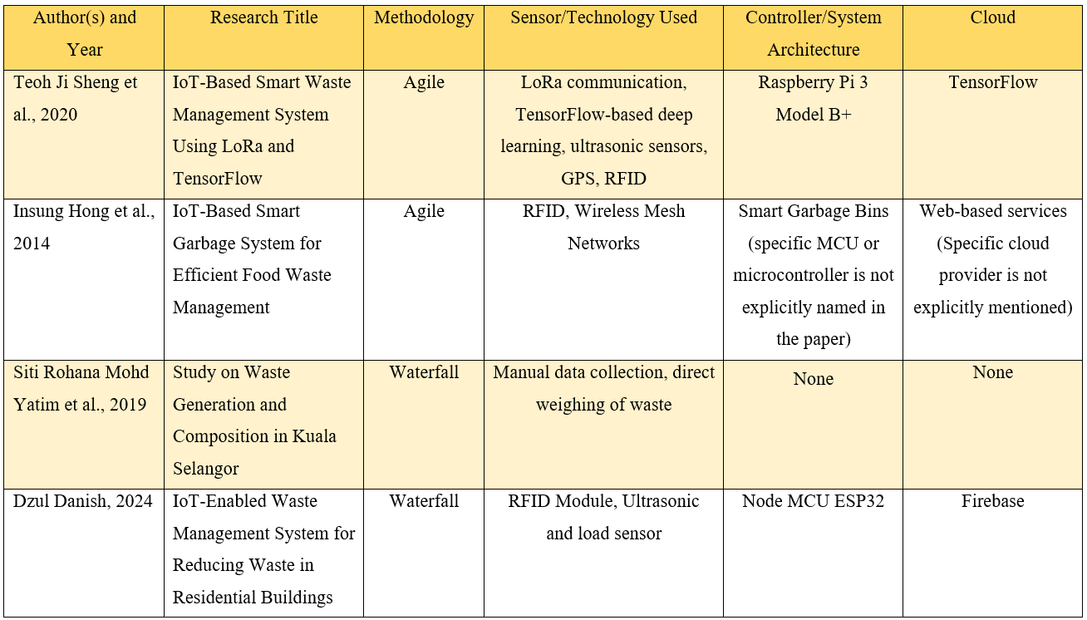
Table 2.1: Comparison of existing studies and project with the proposed system

2.4 Conclusion
This literature review highlights the transformative potential of IoT and advanced technologies in revolutionizing waste management practices. Studies like the waste generation analysis in Kuala Selangor and IoT-based innovations demonstrate the importance of cutting-edge solutions to address persistent challenges in waste handling. These technologies, emphasizing organic waste reduction, precise segregation, and sustainability, leverage tools like object detection, GPS tracking, and adaptive charge policies to achieve efficiency and energy conservation.
However, the reviewed works reveal gaps, such as the need for larger datasets for object recognition, optimized systems for high-traffic areas, and better integration of socio-economic factors. These limitations underscore the need for a robust and adaptable system that addresses inefficiencies while fully utilizing IoT and artificial intelligence. The proposed system aims to build on these studies, setting a benchmark in reducing organic waste and promoting a sustainable future.

CHAPTER 3 : METHODOLOGY

3.1 Introduction
This chapter outlines a systematic, step-by-step process designed to guide the creation and development of the project. It details the necessary steps required to achieve the objectives outlined in Chapter 1, providing a clear roadmap for project implementation. Additionally, this methodology establishes the framework for ensuring that deliverables are effectively achieved. By using this approach, suitable methods for implementation, testing, and documentation are identified, ensuring the project meets its intended purpose.
3.2 Methodology Model Waterfall
The Waterfall methodology was selected for this project due to its structured and linear approach, which aligns effectively with the project's requirements. This methodology organizes the work into five phases; including requirement analysis, design, implementation, testing, and maintenance, ensuring that each phase is completed before progressing to the next.
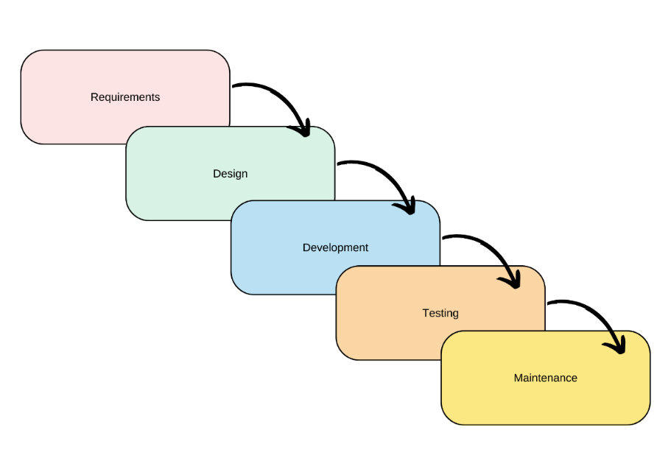
Figure 3.1: Waterfall methodology model

Its sequential nature provides clarity in defining objectives and deliverables, minimizing uncertainties and reducing risks. The Waterfall model is particularly well-suited for projects with well-defined requirements, to support progress tracking and quality assurance throughout the development process.
3.3 Requirements
The requirements process serves as the foundation for identifying and understanding the project's needs, ensuring that all objectives, scope, and constraints are clearly defined from the outset. This step is critical for aligning the project's goals with stakeholder expectations and setting a clear direction for subsequent planning and development. Additionally, in this phase, a Gantt chart is designed to outline the project timeline, tasks, and milestones, while a proposed budget is developed to allocate resources effectively.
3.3.1 Objectives, Scopes and Constraints
The primary objective of this project is to leverage advanced sensors, including ultrasonic sensors, and MQ135 gas sensors, to monitor waste volume, bin fill levels, and methane concentrations with precision. RFID technology will be implemented to log and track individual residents' waste disposal activities, fostering a sense of accountability and transparency. Additionally, a Flutter-based mobile application will be developed to provide users with real-time data visualization and notifications, ensuring efficient and user-friendly waste management.
The scope of this project includes integrating sensors to monitor waste volume, bin fill levels, and methane concentrations, as well as using RFID technology to track residents’ waste disposal activities. A Flutter-based application will provide real-time data visualization and notifications, while Firebase will manage and store data for efficient reporting and analysis.
However, the project is subject to certain constraints to maintain focus and feasibility. It will not involve large-scale deployment across multiple sites or integration with external waste processing systems. Furthermore, advanced analytics, such as machine learning or predictive algorithms, are excluded from the scope. Additionally, the project may face challenges with the inaccuracy of load sensors, which could impact the precision of waste measurements. Alternative methods and sensors are being researched to address this issue. Similarly, the MQ135 gas sensor, while useful, is a general-purpose sensor and may not provide the specificity required for detecting organic waste gases.
3.3.2 Gantt Chart
The Gantt chart outlines the timeline and schedule for FYP1 and FYP2, serving as a planning and control tool for the IoT-based Waste Management System. It provides a clear view of the project’s activities, goals, and timelines, highlighting major tasks like title confirmation, report writing, prototype construction, app development, and testing. The chart enables progress tracking to ensure all activities are completed on time, achieving project goals within the set timeline.
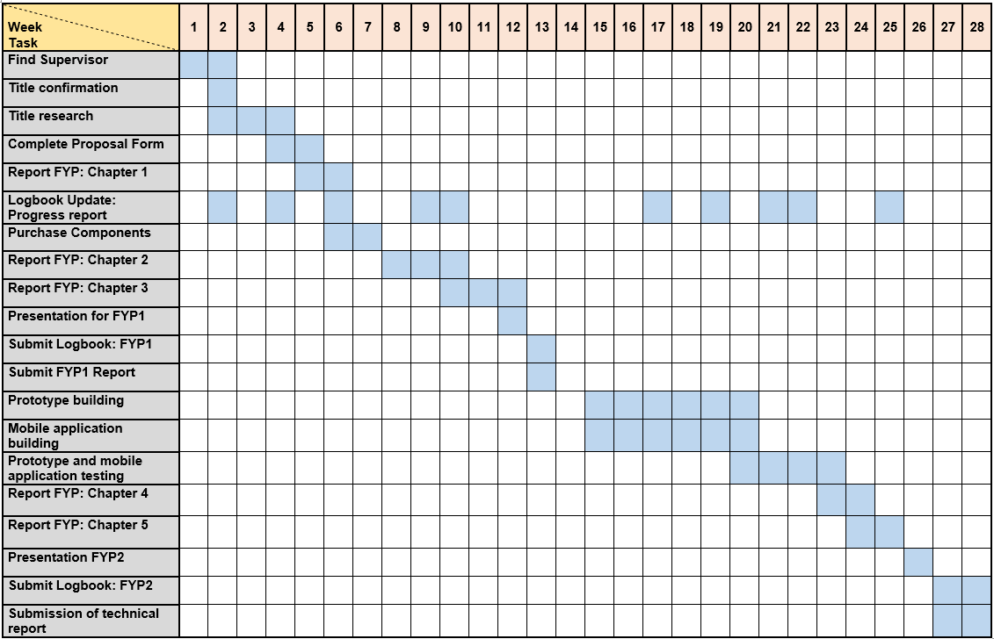
Figure 3.2: Gantt Chart of FYP Weekly Flow

3.3.3 Budget
The budgeting process for this project involves detailing the expenses needed to design, develop, and implement the project's hardware and software components. Tables 3.1 and 3.2 provide an overview of the budget allocation for hardware and software requirements.
No. | Item | Quantity | Total Cost (RM)
1 | ESP32 | 1 | 29.00
2 | Jumper Wire | 1 | 2.50
3 | RFID Module | 1 | 20.00
4 | LCD I2C | 1 | 11.00
5 | Breadboard | 1 | 3.00
6 | Battery 3.7V | 1 | 8.00
7 | Node MCU Expansion | 1 | 8.50
7 | MQ135 Sensor | 1 | 8.40
9 | Ultrasonic Sensor | 1 | 3.50
Total |  |  | 101.80
Table 3.1: List of hardware costs

No. | Software Components | Price (RM)
1 | Arduino IDE | Free
2 | Visual Studio Code | Free
3 | Flutter Framework | Free
4 | Firebase | Free
Table 3.2: List of software costs

3.4 Design
The design phase focuses on creating a comprehensive blueprint for the system, built upon the requirements established in the previous phase. This phase involves the development of various diagrams, such as block diagrams, flowcharts, and schematic diagrams (including circuit designs), to visually represent the structure, processes, and interactions within the system. These diagrams provide a clear illustration of how each component functions and integrates with others.
3.4.1 Block Diagram
The block diagram illustrates the system architecture and its key components. At the core is the NodeMCU ESP32, which serves as the primary controller, managing data collection and communication. Various sensors, including an ultrasonic sensor, and MQ135 air quality sensor, are connected to the ESP32, providing environmental and operational data. An RFID module is also integrated with the ESP32 to enable identification or authentication functionalities.
The ESP32's built-in WIFI module facilitates wireless communication, transmitting data to a Firebase cloud database. This database acts as a centralized storage system, ensuring real-time data availability. The Flutter framework is used to develop the mobile application, which interacts with the Firebase database, allowing users to monitor and manage the system remotely. This setup ensures seamless data flow, real-time monitoring, and efficient system management.
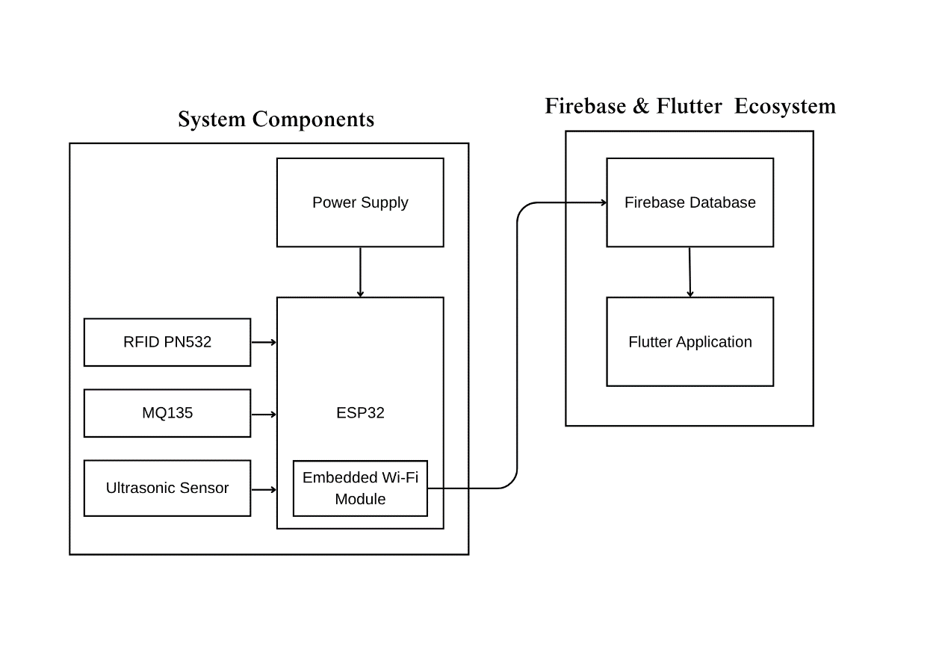
Figure 3.3: Block diagram of the project

3.4.2 Flowchart
The flowchart illustrates the sequence of operations for the system, starting with the initialization of the ESP32 Wi-Fi module. Once initialized, the system attempts to establish a connection between the microcontroller and the network. If the connection is unsuccessful, the process loops until a connection is established. Upon a successful connection, users are prompted to scan their RFID for authentication. If authentication fails, the system prompts for a re-scan until successful authentication is achieved. Once authenticated, users can proceed to place waste in the garbage bin.
When the waste is deposited, the garbage bin uses the ultrasonic sensor to calculate the level of the waste thrown by the user. This data is immediately uploaded to the Firebase database, where it is added to the user's monthly total for organic waste disposal. Simultaneously, the system measures values from the ultrasonic and MQ135 air quality sensors, which are also uploaded to Firebase. The system continuously verifies whether any sensor readings exceed predefined thresholds. If a threshold is surpassed, a push notification is sent to the management for further action. Otherwise, the data is displayed in the mobile application, allowing users or administrators to monitor the system's status. This flow ensures efficient operation, real-time data logging, and effective tracking of individual waste contributions for enhanced waste management.
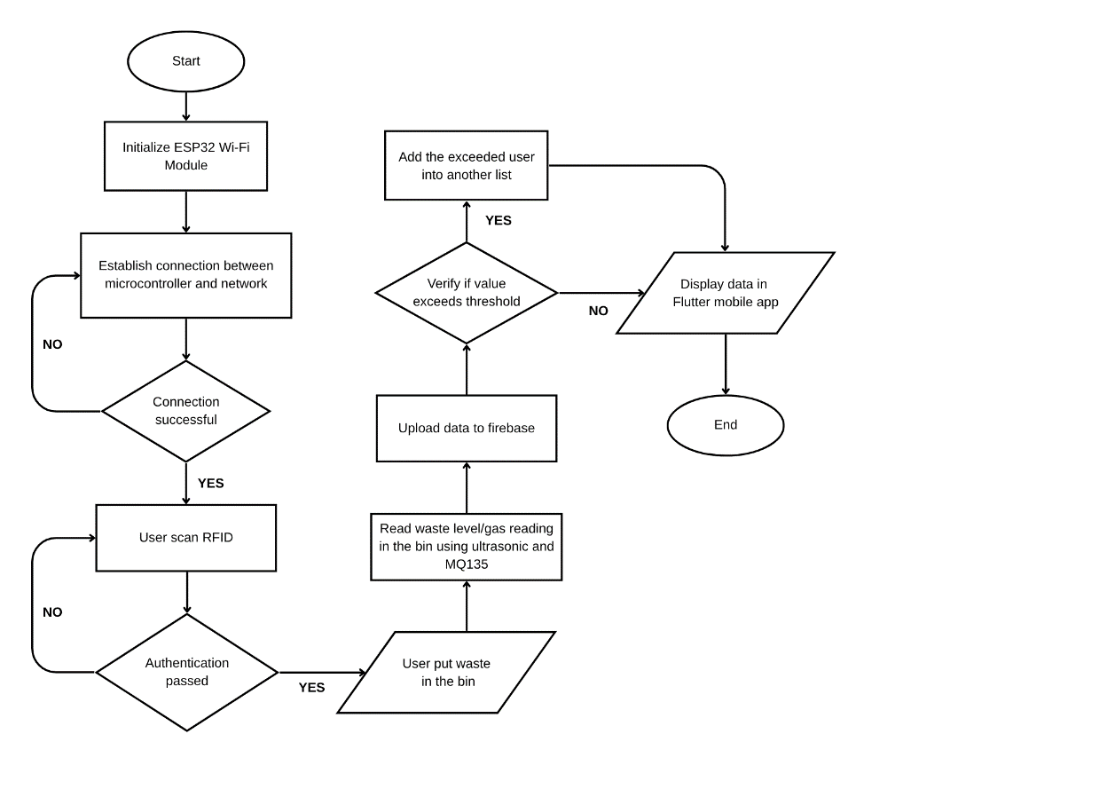
Figure 3.4: Flowchart of waste management tracking

3.4.3 Schematic Diagram
The diagram represents the hardware circuit layout for the system, showcasing the connection between the ESP32 microcontroller and various peripheral components. The RFID module (RC522) is connected to the ESP32 to enable user authentication via RFID cards. The ultrasonic sensor (HC-SR04) is integrated to measure the distance or the fill level of the garbage bin. The MQ135 gas sensor is connected to monitor air quality, detecting gases such as carbon dioxide or ammonia.
Additionally, a load cell and its amplifier (HX711) are connected to the ESP32 to measure the weight of the waste deposited into the bin, enabling the system to calculate and store the total organic waste for each user. An OLED display module is integrated to provide real-time feedback, such as system status or sensor readings. All components are powered through the ESP32, and connections are established via a breadboard to ensure the proper flow of data and signals between the components. This configuration facilitates seamless interaction between hardware elements to achieve the system's functionalities effectively.
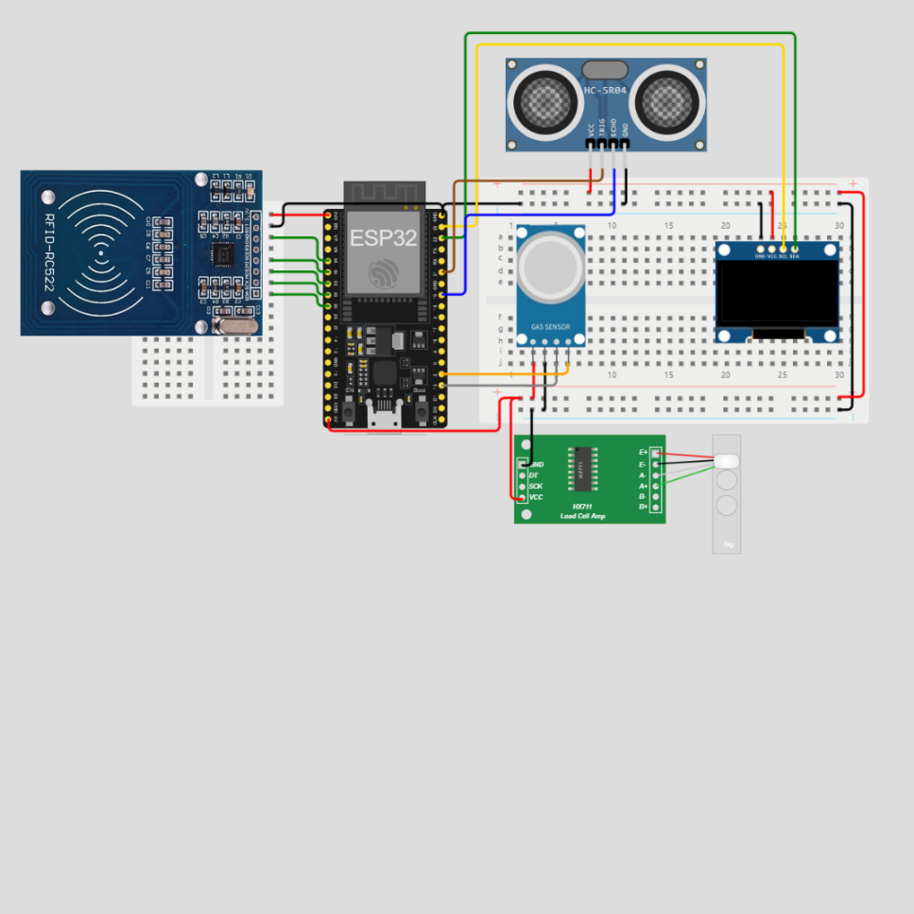
Figure 3.5: Schematic diagram of the project

3.5 Development
3.5.1 Hardware Development
For FYP1, significant progress has been made by setting up an early wiring connection for the project using the stated components, including the ultrasonic sensor, MQ135 gas sensor, and other essential hardware. However, the functionality of these components, particularly their coding, has not yet been implemented. This setup was created to provide a preliminary view of the project and understand the overall design without relying on a finalized model. This approach allows for better visualization of the system's layout and potential adjustments before full implementation.
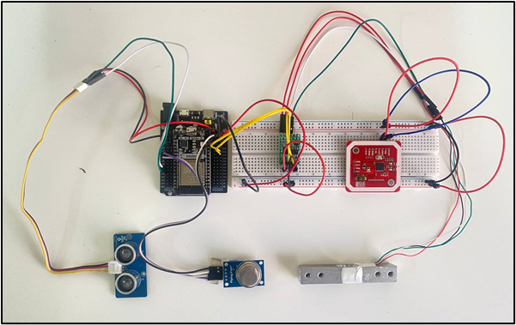
Figure 3.6: Early development of the project.

3.5.2 Software Development
This is the early design for the Flutter application, created using Canva as a medium to prototype the app's user interface. The design serves as a reference for implementing the actual app in Flutter later on. It provides a clear layout of the app's main features, including garbage level monitoring, CO2 level alerts, resident waste records, and warning notifications. By visualizing the app's structure and functionality beforehand, this design helps streamline the development process and ensures that the final product aligns with the intended user experience.

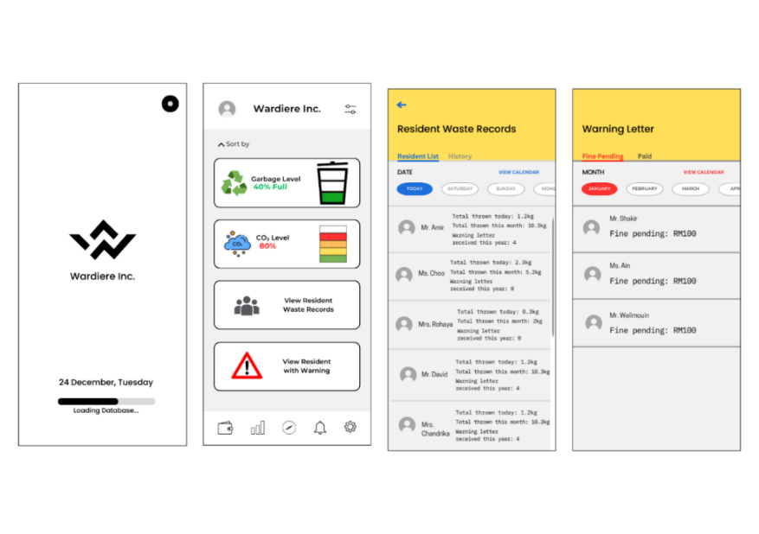
Figure 3.7: User interface of the application

3.5.3 Future Development
As part of future development, a prototype will be created using a model garbage bin to simulate the project's functionality. This prototype will integrate the hardware components, such as sensors and microcontrollers, with the software developed in Flutter to establish an end-to-end connection. This step will finalize the project by ensuring seamless communication between the hardware and software.
Additionally, future iterations may involve exploring alternatives to improve system performance and flexibility. For example, finding a more accurate and suitable replacement for the load sensor and MQ135 sensor to better meet the project’s requirements. Furthermore, the IoT medium currently utilizing Flutter and Firebase could also be re-evaluated. Other platforms, such as ThingSpeak and React Native, may be considered to identify the best option for data management, visualization, and scalability, ensuring the system remains adaptable and optimized for future use.
3.6 Testing
3.6.1 Software Testing
Testing for the IoT-enabled waste management system starts with software testing. This phase ensures the correct functionality of the software components, focusing on system interactions and performance. System testing validates the interactions between different modules, such as RFID authentication, weight measurement, air quality monitoring, and data transmission to Firebase. Performance testing ensures the system can handle multiple users and large amounts of data without lag or failure.
3.6.2 Hardware Testing
- Unit Testing: Test individual hardware components like the load sensor, MQ135 sensor, ultrasonic sensor, and RFID module to confirm functionality.
- Integration Testing: Ensure the components work when connected to the ESP32.
- Stress Testing: Simulate extreme conditions (e.g., overloading the bin, harsh environments) to evaluate system robustness.
- Field Testing: Deploy the system in a controlled environment (e.g., a residential building) to observe real-world performance.
3.6.3 End-to-end Testing
End-to-end testing combines software and hardware testing in a unified environment, simulating real-world usage. This phase ensures the entire system functions as intended, from RFID authentication and waste measurement to real-time data updates in Firebase and the mobile application.
3.7 Maintenance
The maintenance phase emphasizes ensuring the system's continuity in performance and reliability post-deployment. To enhance the overall system, regular monitoring is conducted monthly, and feedback is gathered from both management and residents to identify areas for improvement in both software and hardware components. This feedback is carefully analyzed to refine the system and enhance the stakeholders' experience. Regular maintenance is essential for identifying and addressing bugs, as well as ensuring that sensors and other components continue to operate smoothly and efficiently over time.
3.8 Hardware and Software Requirements
This section outlines the key hardware and software components required to achieve the objectives of this project. It includes a detailed list of sensors, controllers, and software tools that play a crucial role in the development and implementation of the system. By identifying these components, the project ensures that all necessary resources are in place to meet the functional and operational goals. Below is a comprehensive overview of the hardware and software utilized in the development of this innovative project.
3.8.1 Hardware
- ESP32
The core component of the project’s system for data processing and transmission is the ESP32 microcontroller, which features built-in Wi-Fi capabilities. This enables seamless real-time connection to the Firebase database for storing and retrieving data. With its low power consumption and high processing efficiency, the ESP32 is an ideal choice for this project, ensuring cost-effectiveness without compromising performance.
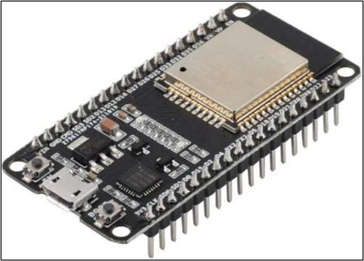
Figure 3.8: ESP32 microcontroller

- MQ135 and Ultrasonic Sensor
The MQ135 gas sensor is an integral component of the system, designed to monitor air quality by detecting harmful gases such as ammonia, carbon dioxide, and other pollutants. Its high sensitivity and reliability make it ideal for ensuring the environment around the waste bin remains safe and free from hazardous emissions. The data collected by the MQ135 is transmitted to the Firebase database, enabling real-time monitoring and necessary actions when gas levels exceed predefined thresholds.

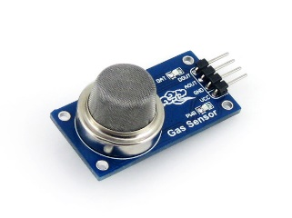
Figure 3.10: MQ135 gas sensor

The ultrasonic sensor is used to measure the fill level of the waste bin by calculating the distance between the sensor and the surface of the waste. Its precision and consistency make it a key element for real-time monitoring, allowing the system to send timely notifications when the bin approaches full capacity.

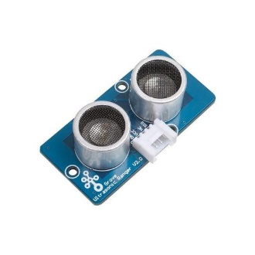
Figure 3.11: Ultrasonic sensor

- RFID Module
The RFID module enables user authentication by scanning RFID cards, ensuring only authorized users can access the waste bin. It reads unique tags assigned to users, with the data processed by the ESP32 and stored in the Firebase database. This promotes accountability and efficient waste tracking while seamlessly integrating into the system.

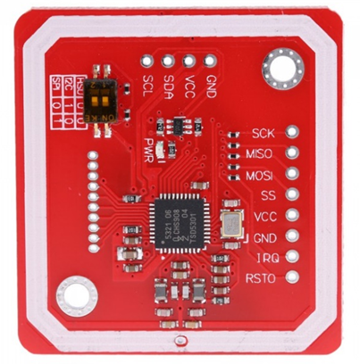
Figure 3.12: RFID module
3.8.2 Software
- Flutter
The Flutter application acts as the front-end interface of the project, providing a user-friendly platform for monitoring and interacting with the system. It retrieves real-time data from the Firebase database, including sensor readings such as waste bin fill levels, air quality metrics, and the weight of waste deposited. Additionally, the application sends push notifications whenever a resident's waste disposal exceeds the predefined threshold, ensuring timely alerts and promoting effective waste management.


Figure 3.13: Flutter for application front-end interface

- Firebase serves as the cloud-based database for the system, providing a reliable medium for storing and managing data. It facilitates real-time synchronization of sensor readings, user activity, and waste tracking information between the ESP32 and the Flutter application. With its robust and scalable infrastructure, Firebase ensures secure and efficient data handling, making it an integral part of the system's architecture.

Figure 3.14: Firebase acts as database for the system
- Arduino IDE
The Arduino IDE was used to program the ESP32 microcontroller, enabling interaction with sensors, actuators, and Firebase. Its compatibility with various libraries ensured precise functionality for processing sensor data, managing RFID authentication, and handling real-time data transmission


Figure 3.15: Arduino IDE for ESP32 programming

- Visual Studio Code
Visual Studio Code was utilized to develop the Flutter application, offering robust support for Flutter and Dart programming. Its powerful extensions and debugging tools streamlined the creation of the app’s user interface and integration with Firebase for data retrieval and notifications. These tools facilitated efficient development of the project’s hardware and software components.

Figure 3.16: Visual Studio Code for Flutter application development

CHAPTER 4: RESULT AND DISCUSSION

4.1 Introduction
This chapter presents the results obtained from the design, implementation, and evaluation of the IoT-Enabled Waste Management System for Reducing Waste in Residential Buildings. It focuses on the integration and testing of key sensors, including the ultrasonic sensor, MQ135 gas sensor, and RFID module, as well as the cloud-connected Flutter mobile application. Results are discussed in terms of sensor performance, RFID accuracy, data transmission reliability, and user interface functionality. The effectiveness of the system in simulating real-world waste disposal scenarios is also analysed, alongside challenges encountered during deployment. This section concludes with key insights and observations that inform potential system enhancements.
4.2 Results
This section presents the outcomes of the developed IoT-Enabled Waste Management System, focusing on the functionality of the mobile application, integration of sensors such as the ultrasonic and MQ135 gas sensor, and features like RFID-based user identification and real-time data logging. The results demonstrate the system’s ability to monitor waste levels and air quality, track disposal activity, and store data effectively in the cloud
4.2.1 Project Prototype Overview
The prototype consists of two main components: a sensor and wiring enclosure, and a simulated waste bin. The first component houses the ESP32 microcontroller, ultrasonic sensor, MQ135 gas sensor, RFID module, and associated wiring. This setup is neatly organized within a dedicated box to protect and structure the electronics. The second component is a layered bin model built using stacked boards to simulate
varying waste levels. By adjusting the number of layers inside the bin, different fill levels can be tested to evaluate the ultrasonic sensor’s accuracy and system responsiveness. This modular setup allows controlled testing of sensor readings and system behaviour under simulated real-world conditions.
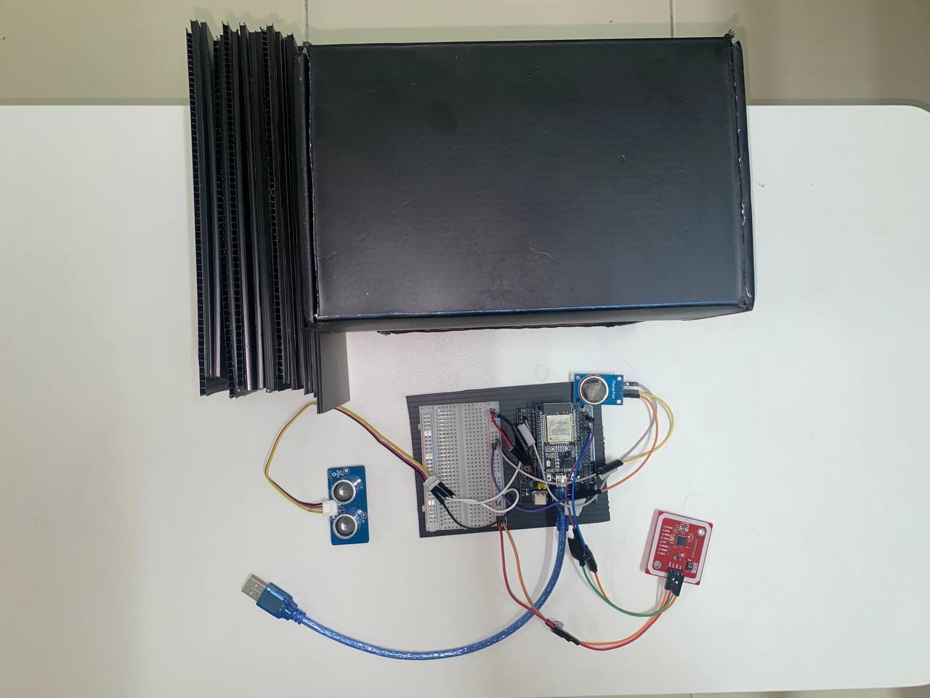
Figure 4.1: Top overview of the prototype
The positioning of each sensor in the prototype was carefully planned to ensure accurate data collection and efficient system performance. The ultrasonic sensor was installed inside the upper box, mounted on the top-facing surface. This placement allows it to directly measure the fill level of the simulated bin from above, minimizing blind spots and ensuring consistent distance readings.
The MQ135 gas sensor was positioned outside and beside the box rather than inside it. This decision was made to prevent artificially high readings caused by trapped gas within the enclosure, which would not reflect actual environmental conditions in a real-world setting. Placing the sensor externally allows for a more realistic assessment of surrounding air quality.
The RFID module was mounted on the side of the upper box to allow for easy and quick scanning by users simulating waste disposal actions. Its side-facing position ensures accessibility without interfering with the other sensors.
All wiring components, along with the ESP32 microcontroller, were housed securely in the lower box. This separation not only protects the electronics from accidental disturbance but also keeps the wiring organized and reduces electromagnetic interference between components.
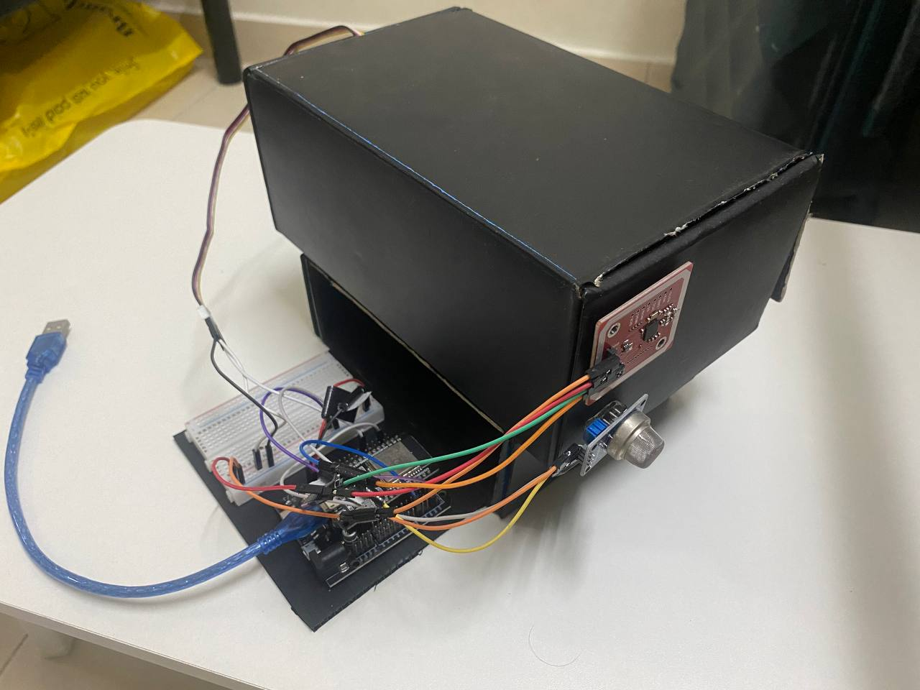
Figure 4.2: Overview of the components connected to the box

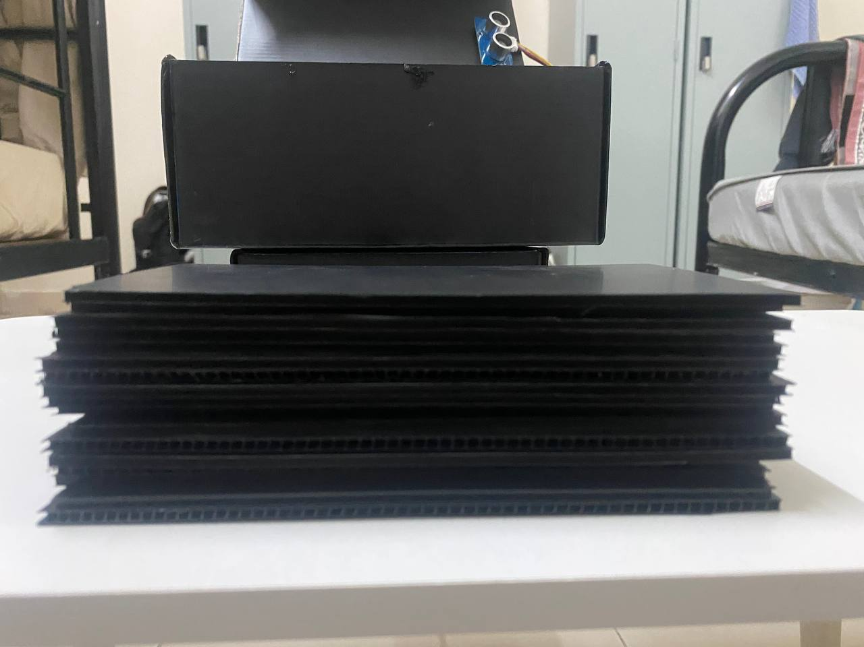
Figure 4.3: Side overview of the prototype

Components | Pin/Label | ESP32 GPIO Pin | Details
MQ135 | A0 (Analog Out) | GPIO 14 | Analog input to measure gas concentration
MQ135 | VCC | 5V | Power Supply
MQ135 | GND | GND | Common ground
Ultrasonic Sensor | Trig | GPIO 16 | Triggers ultrasonic pulse
Ultrasonic Sensor | Echo | GPIO 17 | Receives echo pulse
Ultrasonic Sensor | VCC | 5V | Power Supply
Ultrasonic Sensor | GND | GND | Common ground
RFID Module | SCL | GPIO 22 | I2C clock line
RFID Module | SDA | GPIO 21 | I2C data line
RFID Module | VCC | 5V | Power Supply
RFID Module | GND | GND | Common ground
Table 4.1: Wiring configuration table

4.2.2 Mobile App Dashboard
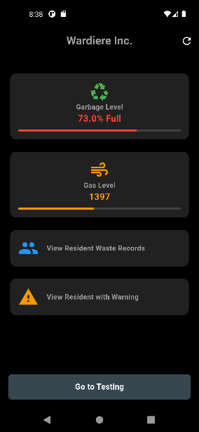
Figure 4.4: Main dashboard of the mobile application
The mobile application developed for this IoT-enabled waste management system is specifically designed for use by the building manager or person-in-charge of overseeing waste handling in a residential environment. Its main purpose is to provide a centralized platform to monitor real-time waste conditions and take appropriate actions when necessary.
The first key feature is the Garbage Level indicator, which visually shows the current fill status of the waste bin using data collected from the ultrasonic sensor. This helps the manager determine when the bin is nearly full and schedule timely waste collection before it overflows. Below it, the Gas Level section displays the concentration of harmful gases detected by the MQ135 gas sensor that was placed outside the bin. This information is critical for identifying unhealthy conditions caused by waste decomposition and ensuring a safe environment around the disposal area.
The application also provides tools for managing resident-specific data. The View Resident Waste Records button allows the manager to view individual waste disposal activity linked through RFID tags, enabling efficient tracking and auditing of waste contributions by each resident. Another important feature is the View Resident with Warning button, which filters and displays only residents whose waste behavior triggers alerts such as consistently exceeding waste thresholds or contributing to poor air quality. This enables the manager to take corrective actions, such as issuing reminders or enforcing guidelines.

4.2.3 Visual Records
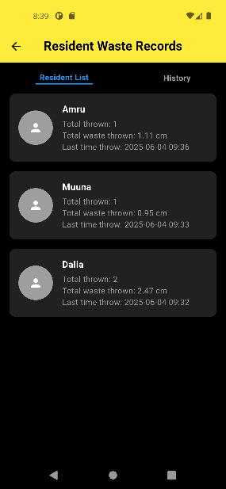
Figure 4.5: List of residents registered in the app
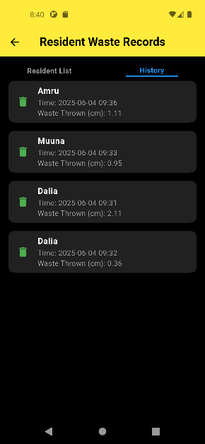
Figure 4.6: History of every resident disposal activity
The mobile application includes a dedicated section for managing and displaying waste records associated with individual residents. When a resident disposes of waste, the system detects their identity through an RFID tag and logs the corresponding disposal data. This data is then stored in a structured format within a cloud database (e.g., Firebase), which includes key details such as the number of times the resident has thrown waste, the total amount or height of the waste deposited, and the timestamp of the most recent disposal. This information is retrieved and displayed in the Resident Waste Records page of the app, where each entry shows the user profile along with their total waste activity. The app provides a transparent overview for building managers to review resident contributions, identify waste patterns, and ensure accountability in shared disposal facilities.
The History tab within the Resident Waste Records section serves as a chronological log of all waste disposal activities carried out by residents. Each time a resident throws waste into the smart bin, the system logs a new entry that includes the resident identifier, the exact timestamp of the event, and the corresponding waste measurement. This measurement is captured using the ultrasonic sensor installed in the bin, which accurately detects the height or volume of waste deposited during that specific interaction. Unlike the Resident List tab which summarizes overall data per resident, the History tab provides detailed insight into individual disposal events, making it easier for managers to audit behavior, detect anomalies, and monitor waste trends over time.
The information in this tab is particularly useful for evaluating resident participation and identifying peak disposal periods. It also supports data transparency and can serve as a reference for resolving disputes or validating alerts. Each record is visually structured with a clear time and measurement label, accompanied by an icon to indicate a waste event, ensuring the interface remains user-friendly and informative. Overall, the History tab enhances the traceability and accountability of the waste management process, contributing to more efficient decision-making and sustainable waste practices in residential buildings.
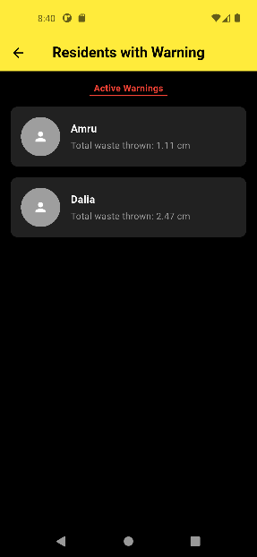
Figure 4.7: Residents with warnings listed exceeding threshold set

Additionally, on the Residents with Warning page as shown on Figure 4.7, which automatically highlights users who have exceeded predefined thresholds such as frequent disposals or high accumulated waste volume. These warnings help the manager quickly identify and address potential issues, such as improper waste habits or overuse of shared bins. The separation of regular records and warnings streamlines management tasks, allowing for proactive engagement with residents while maintaining a well-documented digital waste tracking system. This organized approach to storing and displaying resident waste data improves monitoring efficiency and supports sustainable waste management practices within the residential building.
4.3 Database (Firebase)
The system collects data from various sensors—such as the ultrasonic sensor for measuring the waste bin level and the MQ-135 gas sensor for air quality. The data is read in real time and processed using the ESP32 microcontroller. Once collected, the data is formatted into JSON objects using the ArduinoJson library and then sent to Firebase using HTTP requests. For instance, in the function pushToRTDB(String uid), multiple sensor readings and timestamps are compiled into a structured JSON document.
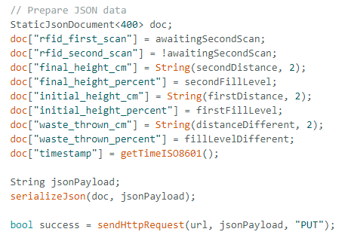
Figure 4.8: Sending data for the realtime database

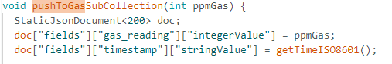
Figure 4.9: Sending data for the Firebase database

This JSON payload is subsequently uploaded to Firebase Realtime Database (RTDB) through an HTTP PUT request. In a similar manner, air quality data obtained from the gas sensor is sent to Firestore using the pushToGasSubCollection(int ppmGas) function. The sendHttpRequest(...) function ensures that the structured JSON is transmitted correctly to the intended Firebase endpoint. All collected data entries are stored in JSON format across both Firebase RTDB and Firestore. This approach not only makes the data human-readable but also ensures that it can be easily downloaded or integrated into analytics platforms through Firebase’s web interface.
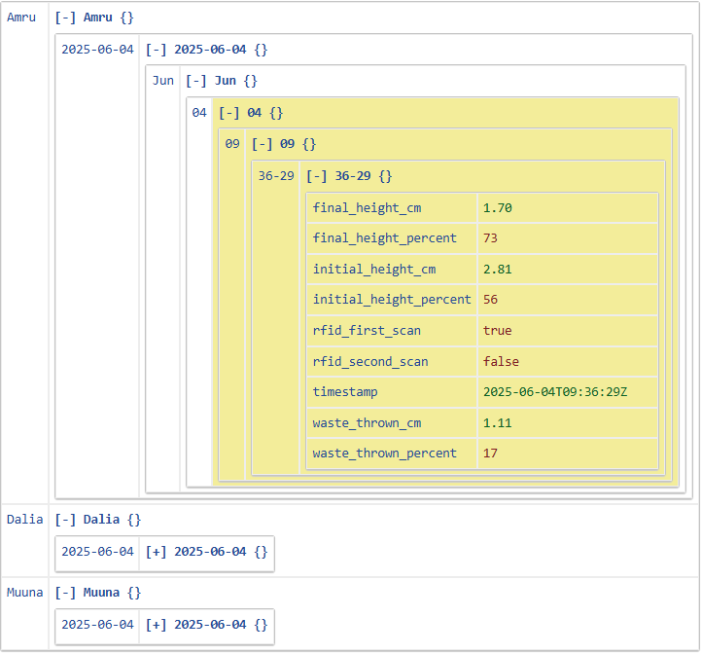
Figure 4.10: The downloaded JSON file viewed in gridview
The Firebase Realtime Database stores user interaction data in a structured JSON format. The records are categorized according to user ID, date, and timestamp, allowing each transaction to be uniquely identified. Each log includes the initial and final height of the waste in both centimeters and percentage, as well as calculated values for waste thrown and flags indicating the status of RFID scans. These data entries validate that the ultrasonic sensor accurately detects changes in waste levels, and that the RFID system successfully verifies user identity before allowing interaction. Furthermore, the structured data format facilitates traceability and simplifies data analysis to evaluate the system’s performance over time.
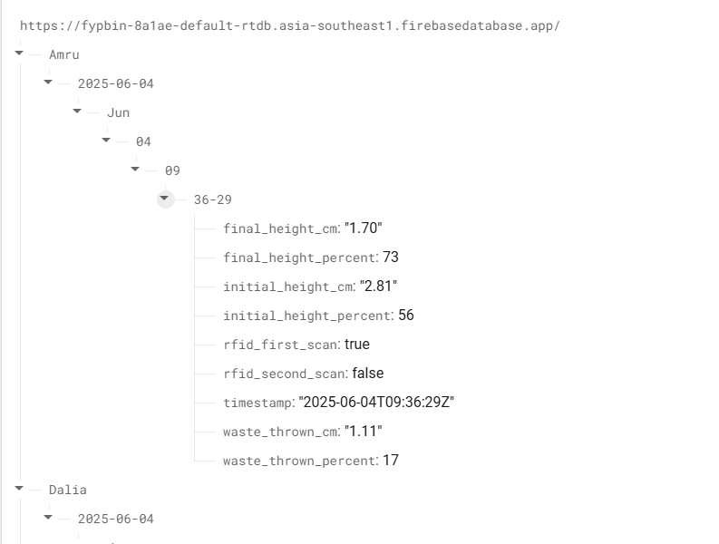
Figure 4.11: Data stored in Firebase realtime database

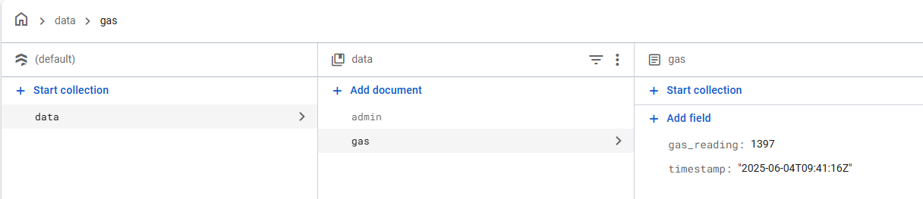
Figure 4.12: Data stored in Firestore database
In addition to the RTDB, the Firestore database is used to log gas sensor readings under a designated collection. Each entry includes a gas concentration value and an associated timestamp in ISO 8601 format, which supports precise environmental monitoring. These readings represent the air quality near the waste bin, as detected by the MQ-135 gas sensor. The database effectively logs values in real time, confirming the accuracy and functionality of the averaging algorithm and sensor interfacing. This additional data layer allows identification of instances where poor air quality correlates with increased waste levels, potentially serving as a trigger for administrative alerts or maintenance procedures.
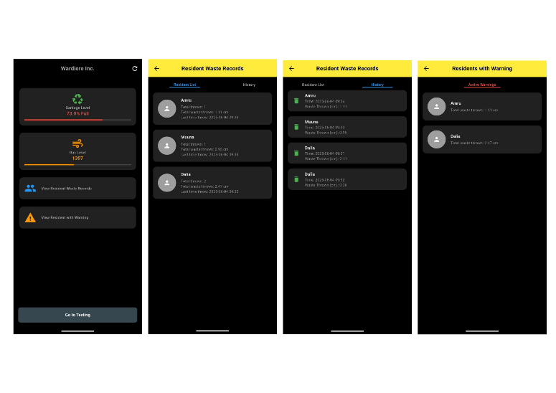
Figure 4.13: Final outcome of the mobile application
4.4 Discussion
The developed system successfully achieved its intended objectives by integrating multiple hardware components and cloud-based software systems to monitor and manage waste disposal activities within residential buildings. The ultrasonic sensor measured the distance between the waste level and the top of the bin to determine the fill level, while the MQ-135 gas sensor captured air quality data surrounding the waste bin. These data points were collected through the ESP32 microcontroller and transmitted over Wi-Fi to be stored in the Firebase platform in real time.
The Firebase Realtime Database provided a reliable medium for recording disposal events from individual users. Each record was associated with a unique user ID, timestamp, and a complete set of sensor readings, including the initial and final bin levels as well as the calculated amount of waste disposed. In parallel, the Firestore database stored gas sensor readings alongside precise timestamps, enabling environmental trends to be tracked and correlated with disposal activity. These implementations confirm that the system not only achieves accurate sensing and logging of user activity but also introduces an efficient method for environmental tracking within the context of waste management.
By automating the data collection process and offering centralized cloud storage, the system provides an intelligent waste monitoring solution that eliminates the need for manual supervision. It enhances transparency and accountability by associating disposal activities with specific users and enables data-driven decision-making for building management. The mobile application, accessible only to the building’s administrative team, allows for real-time monitoring and historical review of waste-related data, aligning with the project's primary goal of improving operational efficiency in residential waste management.
CHAPTER 5: CONCLUSION

5.1 Introduction
This chapter provides a concluding overview of the IoT-enabled Smart Waste Management System developed for residential environments. The system aimed to optimize waste tracking and management through the integration of embedded sensors, cloud services, and a mobile application for building management oversight. It utilized real-time data from ultrasonic, gas, and RFID sensors to monitor waste activity and securely transmit data to Firebase, offering a centralized platform for waste analytics. The project demonstrates how IoT can be leveraged to improve operational efficiency, accountability, and sustainability in waste disposal systems.
5.2 Future Recommendations
Although the system has proven functional in its current prototype form, several enhancements can be implemented to improve performance, reliability, and user interaction:
- Replace Ultrasonic with Load Cell: To improve accuracy in waste measurement, especially in irregularly shaped bins, substituting the ultrasonic sensor with a load cell will provide more reliable data based on weight rather than estimated distance.
- Integrate Display at Bin Level: A small LCD or digital display can be added to the bin to show the weight of waste disposed in real time. This would promote user awareness and potentially encourage better waste practices among residents.
- Expand Admin Features in the App: Future versions of the mobile application could offer richer analytics such as user history, load trends, and predictive fill levels using machine learning.
- Improve Network Redundancy: Offline data caching and automatic syncing when reconnected can enhance robustness in areas with inconsistent Wi-Fi coverage.
5.3 Summary
The Smart Waste Management System achieved its primary goal of tracking waste disposal in residential buildings through sensor-based automation and real-time cloud connectivity. It successfully captured fill levels, monitored gas emissions, and authenticated users via RFID before logging events to Firebase. The mobile application provided building administrators with a functional interface to monitor and analyse waste data. While effective, further refinements in hardware accuracy and system interactivity are recommended to support real-world scalability and long-term deployment in smart residential infrastructures.

REFERENCES
Bridgera. (n.d.). IoT-Based Smart Waste Management System. Retrieved from https://bridgera.com/iot-based-smart-waste-management-system

Climatesort. (n.d.). Waste Management in Urban Areas. Retrieved from https://climatesort.com/waste-management-urban-areas/

Mahamid, I. (2023). Influence of Design Quality on Material Waste in Residential Building Projects. Revista Ingenieria de Construccion, 38(2). doi: 10.7764/RIC.00068.21

Malaysian Investment Development Authority (MIDA). (n.d.). Sustainable Waste Management in Malaysia: Opportunities and Challenges. Retrieved from https://www.mida.gov.my/sustainable-waste-management-in-malaysia-opportunities-and-challenges/

Ramly, R., Sajak, A. A. B., & Rashid, M. (2019). IoT recycle management system to support green city initiatives. Indonesian Journal of Electrical Engineering and Computer Science, 15(2). doi: 10.11591/ijeecs.v15.i2.pp1037-1045

Siti Rohana Mohd Yatim, K. H. K. H. K. N. I. Z. A. R. N. A. Z. F. A. S. A. A. (2019). Study on Waste Generation and Composition in Rapid Residential Development of Sub Urban Area in Kuala Selangor District, Selangor. Journal of Wastes and Biomass Management (JWBM), 1(1), 1–5. Retrieved from https://jwbm.com.my/archives/1jwbm2019/1jwbm2019-01-05.pdf
Hong, I., Park, S., Lee, B., Lee, J., Jeong, D., & Park, S. (2014). IoT-Based Smart Garbage System for Efficient Food Waste Management. Scientific World Journal, 2014. https://doi.org/10.1155/2014/646953

Sheng, T. J., Islam, M. S., Misran, N., Baharuddin, M. H., Arshad, H., Islam, M. R., Chowdhury, M. E. H., Rmili, H., & Islam, M. T. (2020). An Internet of Things Based Smart Waste Management System Using LoRa and Tensorflow Deep Learning Model. IEEE Access, 8. https://doi.org/10.1109/ACCESS.2020.3016255

Siti Rohana Mohd Yatim, K. H. K. H. K. N. I. Z. A. R. N. A. Z. F. A. S. A. A. (2019). Study on Waste Generation and Composition in Rapid Residential Development of Sub Urban Area in Kuala Selangor District, Selangor. Journal of Wastes and Biomass Management (JWBM), 1(1), 1–5. https://jwbm.com.my/archives/1jwbm2019/1jwbm2019-01-05.pdf

