Supplementary Materials: Bird diversity and community varies with proximity to trails in urban and peri-urban green spaces
Chloe A. Cull¹, Mackenzie Guest¹, Isabella C. Richmond¹, Ana Morales², Carly D. Ziter¹, Barbara Frei^{1,2}
1 Department of Biology, Concordia University, Montreal, QC, Canada
2 Science and Technology Branch, Environment and Climate Change Canada, Montreal, QC, Canada
Statement of Ethics Compliance All details of animal monitoring were approved by Concordia University’s Animal Care Facility (Protocol no. 30017925) and by The Canadian Wildlife Service (Permit no. SC-98).

Supplementary Materials A: Model Equations

Model 1: distance from trail + management
The models contained both distance from trail (close vs far) and park management (formal vs informal):
$$y_{i}∼α_{park}+β_{0}+far_{i}*β_{far}+informal_{i}*β_{informal}+ϵ_{i}$$
- $y_{i}$ was modelled as both species richness and Shannon.
- $α$ and $β_{0}$ both represent intercepts, $α$ is used for random effects and $β_{0}$ for fixed effects
- Parkrepresents the park where the measurements took place
- Far represents one of the distance categories from the trail (i.e., close vs far)
- Informal represents one of the management categories (i.e., formal vs informal)
- $ϵ_{i}$ represents residual error

Model 2: stem density
The models contained both stem density and the interaction between distance to trail and stem density:
$$y_{i}∼α_{park}+γ_{distance}+stem dens_{i}*β_{stem dens}+stem dens_{i}*β_{distance}+ϵ_{i}$$
- $y_{i}$ was modelled as both species richness and Shannon.
- $α$ and $γ$ both represent intercepts, $α$ is used for random effects and $γ$ for fixed interaction effects
- Park represents the park where the measurements took place
- Distance represents the distance from the trail (i.e., close vs far)
- Stem dens represents the stem density of the transect
- $ϵ_{i}$ represents residual error

Model 3: basal area
The models contained both basal area and the interaction between distance to trail and basal area :
$$y_{i}∼α_{park}+γ_{distance}+basal area_{i}*β_{basal area}+basal area_{i}*β_{distance}+ϵ_{i}$$
- $y_{i}$ was modelled as both species richness and Shannon.
- $α$ and $γ$ both represent intercepts, $α$ is used for random effects and $γ$ for fixed interaction effects
- Park represents the park where the measurements took place
- Distance represents the distance from the trail (i.e., close vs far)
- Basal area represents the basal area of the transect
- $ϵ_{i}$ represents residual error

Model 4: trail activity
The models contained both average trail activity and the interaction between distance to trail and average trail activity:
$$y_{i}∼α_{park}+γ_{distance}+activity_{i}*β_{activity}+activity_{i}*β_{distance}+ϵ_{i}$$
- $y_{i}$ was modelled as both species richness and Shannon.
- $α$ and $γ$ both represent intercepts, $α$ is used for random effects and $γ$ for fixed interaction effects
- Park represents the park where the measurements took place
- Distance represents the distance from the trail (i.e., close vs far)
- Activity represents the average human activity level on the trail
- $ϵ_{i}$ represents residual error

Supplementary Materials B: Model Diagnostic Plots
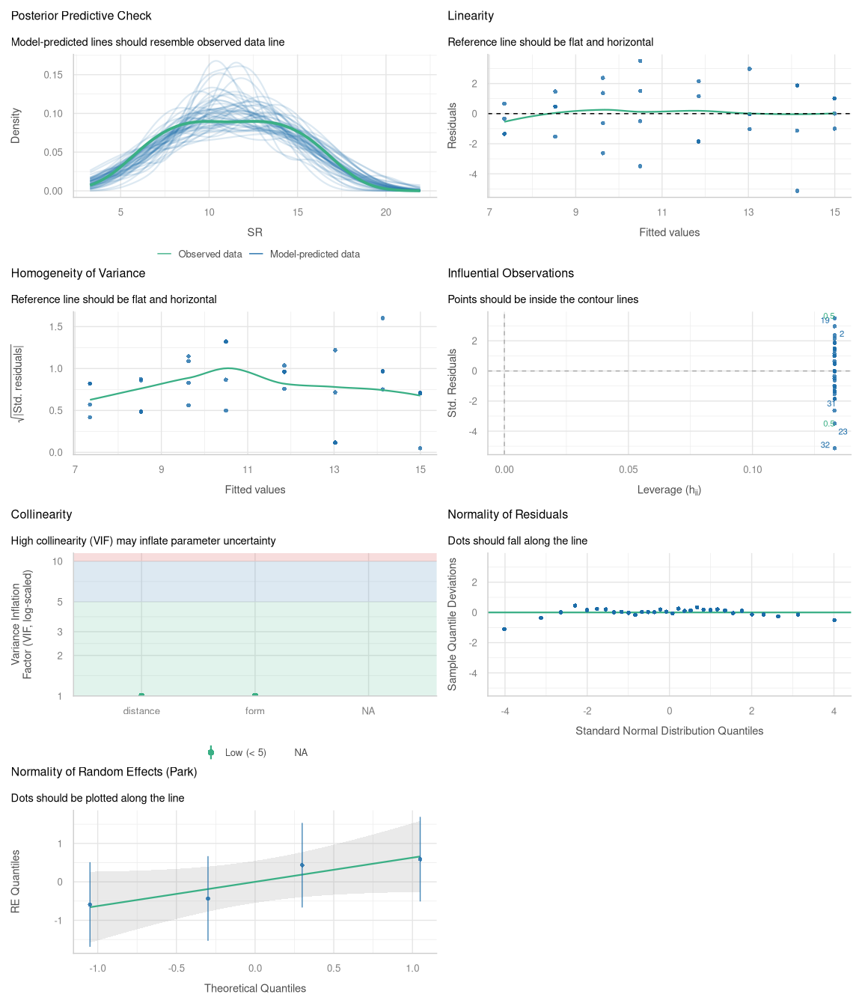
Figure B1. Model diagnostic plot where species richness is the response variable and distance to trail and greenspace management type are explanatory variables.
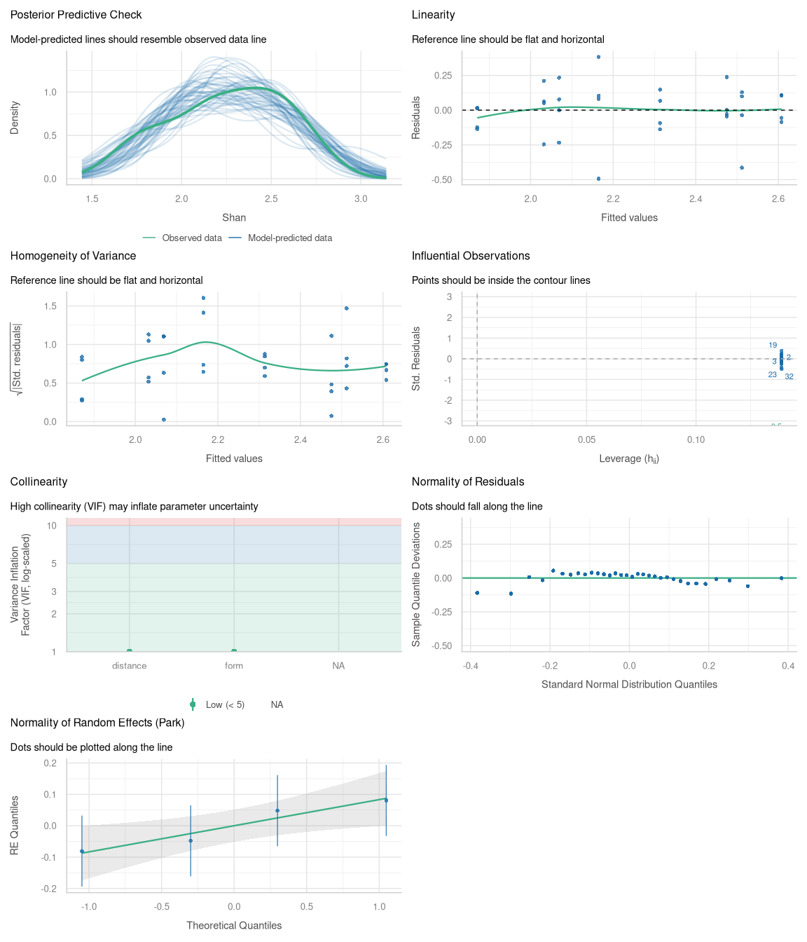
Figure B2. Model diagnostic plot where Shannon diversity is the response variable and distance to trail and greenspace management type are explanatory variables.
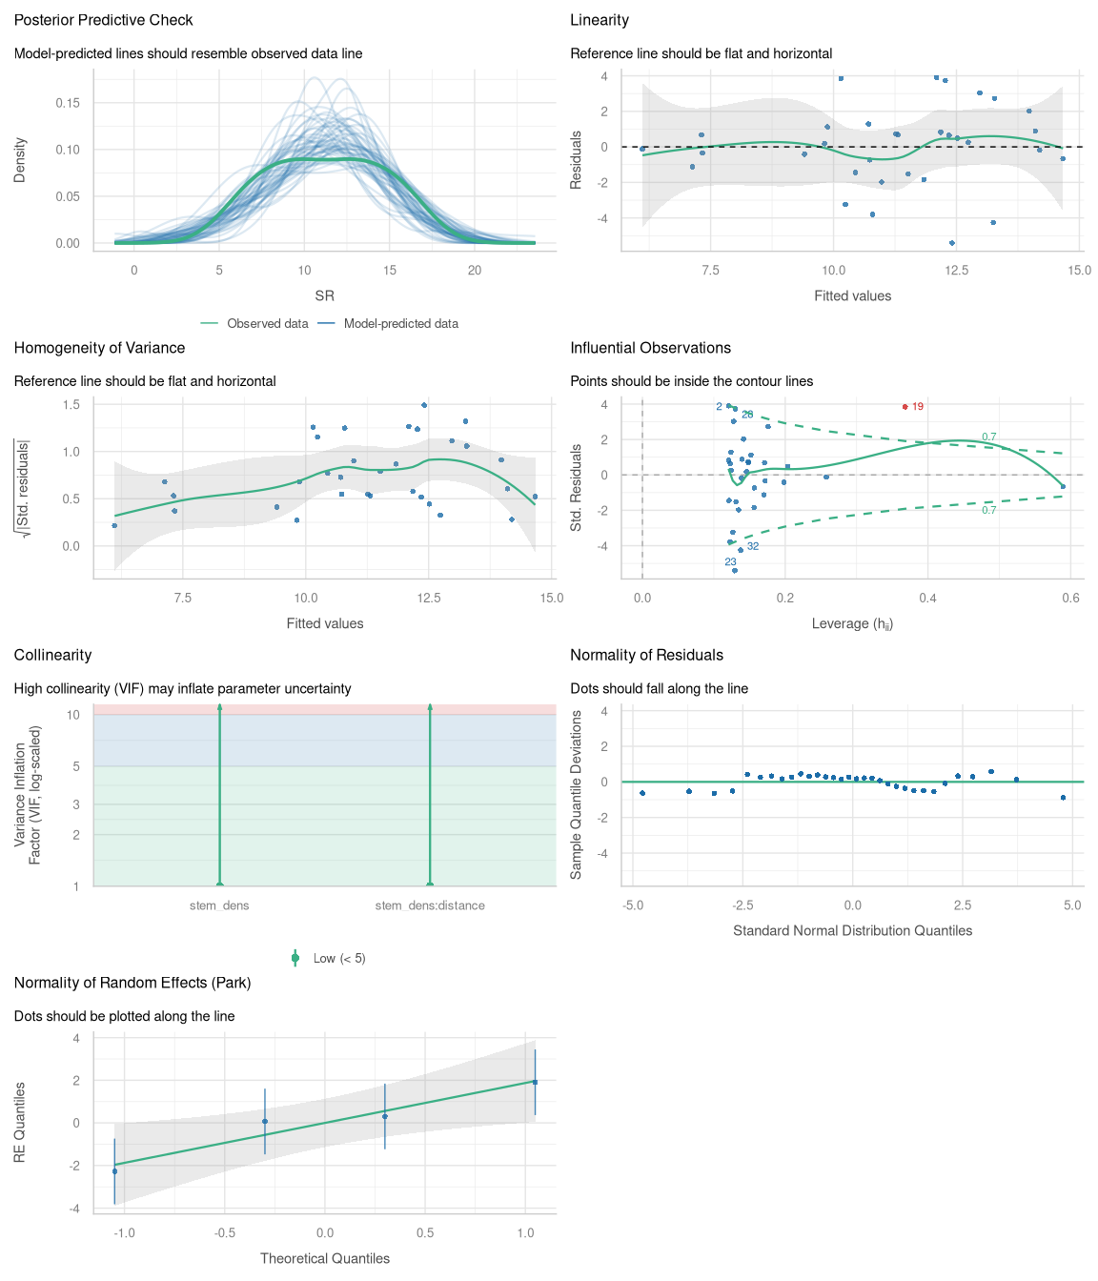
Figure B3. Model diagnostic plot where species richness is the response variable and stem density and the interaction between stem density and distance to trail are the explanatory variables.
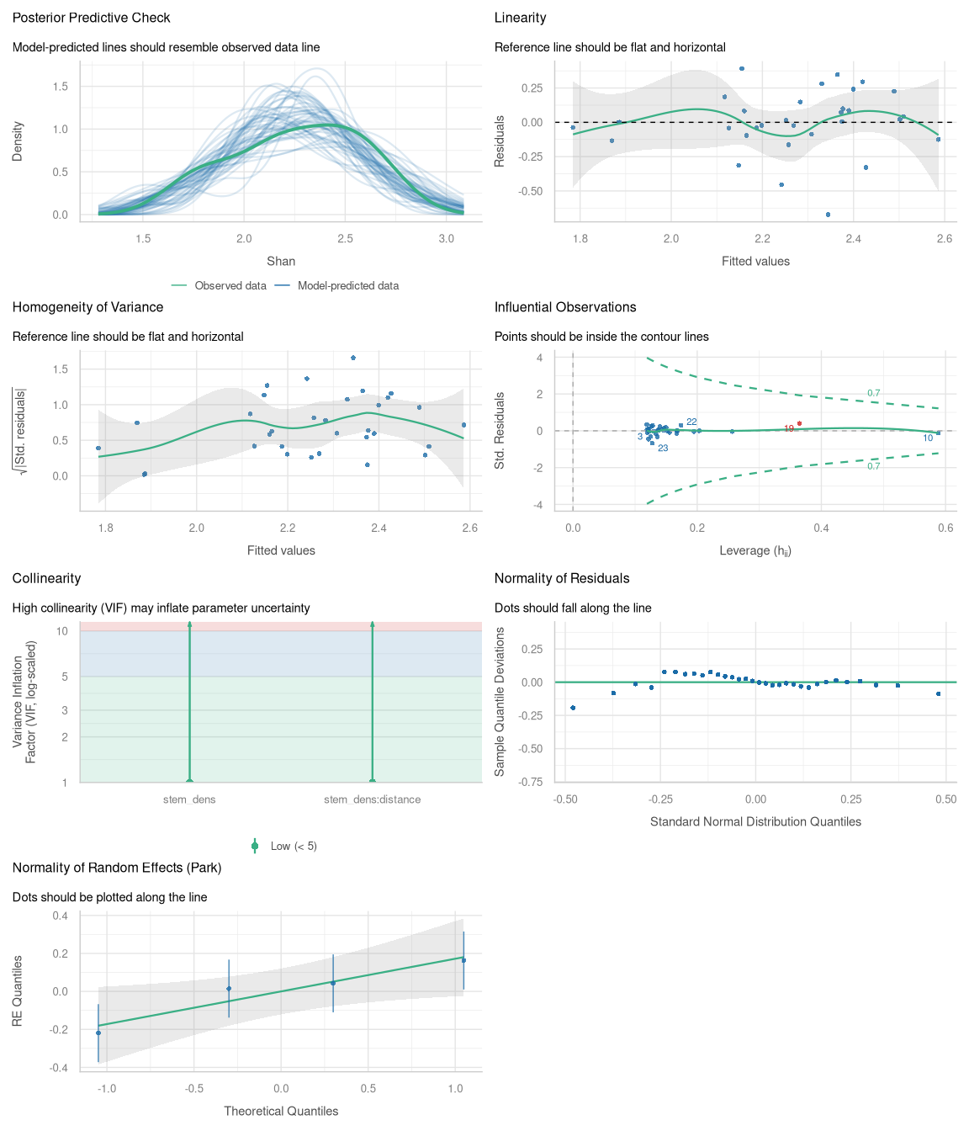
Figure B4. Model diagnostic plot where Shannon diversity is the response variable and stem density and the interaction between stem density and distance to trail are the explanatory variables.
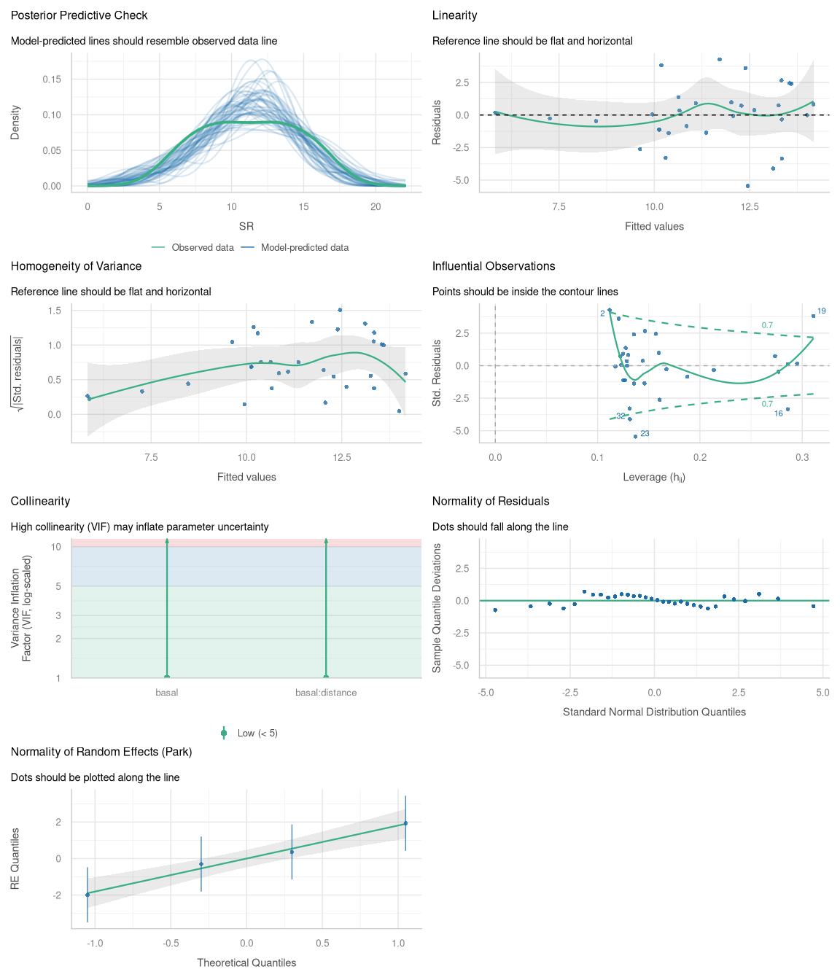
Figure B5. Model diagnostic plot where species richness is the response variable and basal area and the interaction between basal area and distance to trail are the explanatory variables.
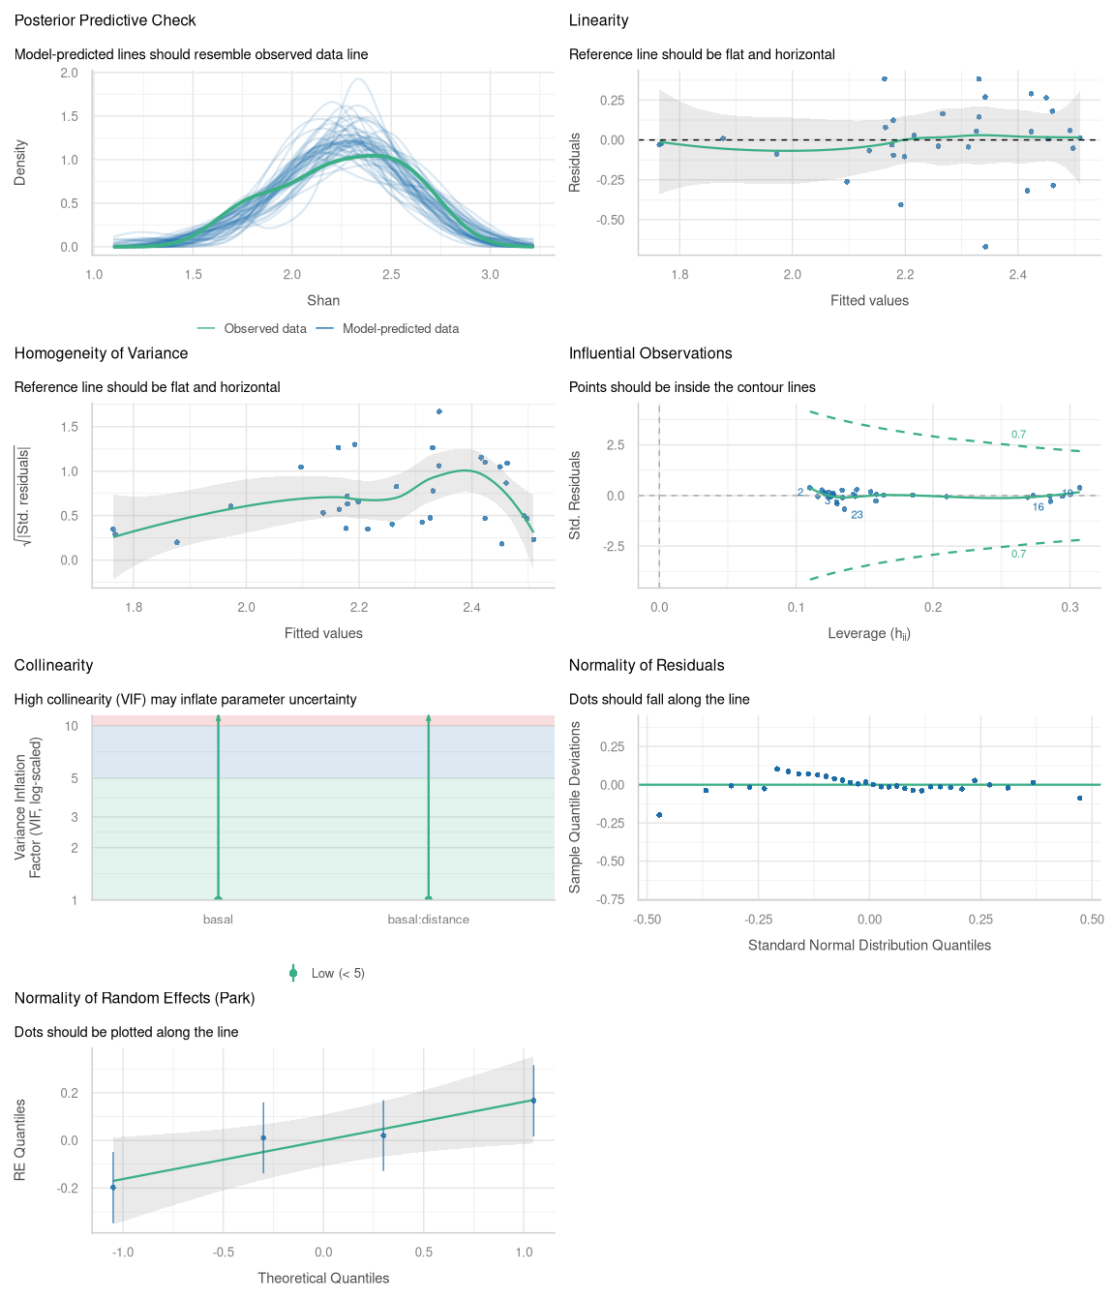
Figure B6. Model diagnostic plot where Shannon diversity is the response variable and basal area and the interaction between basal area and distance to trail are the explanatory variables.
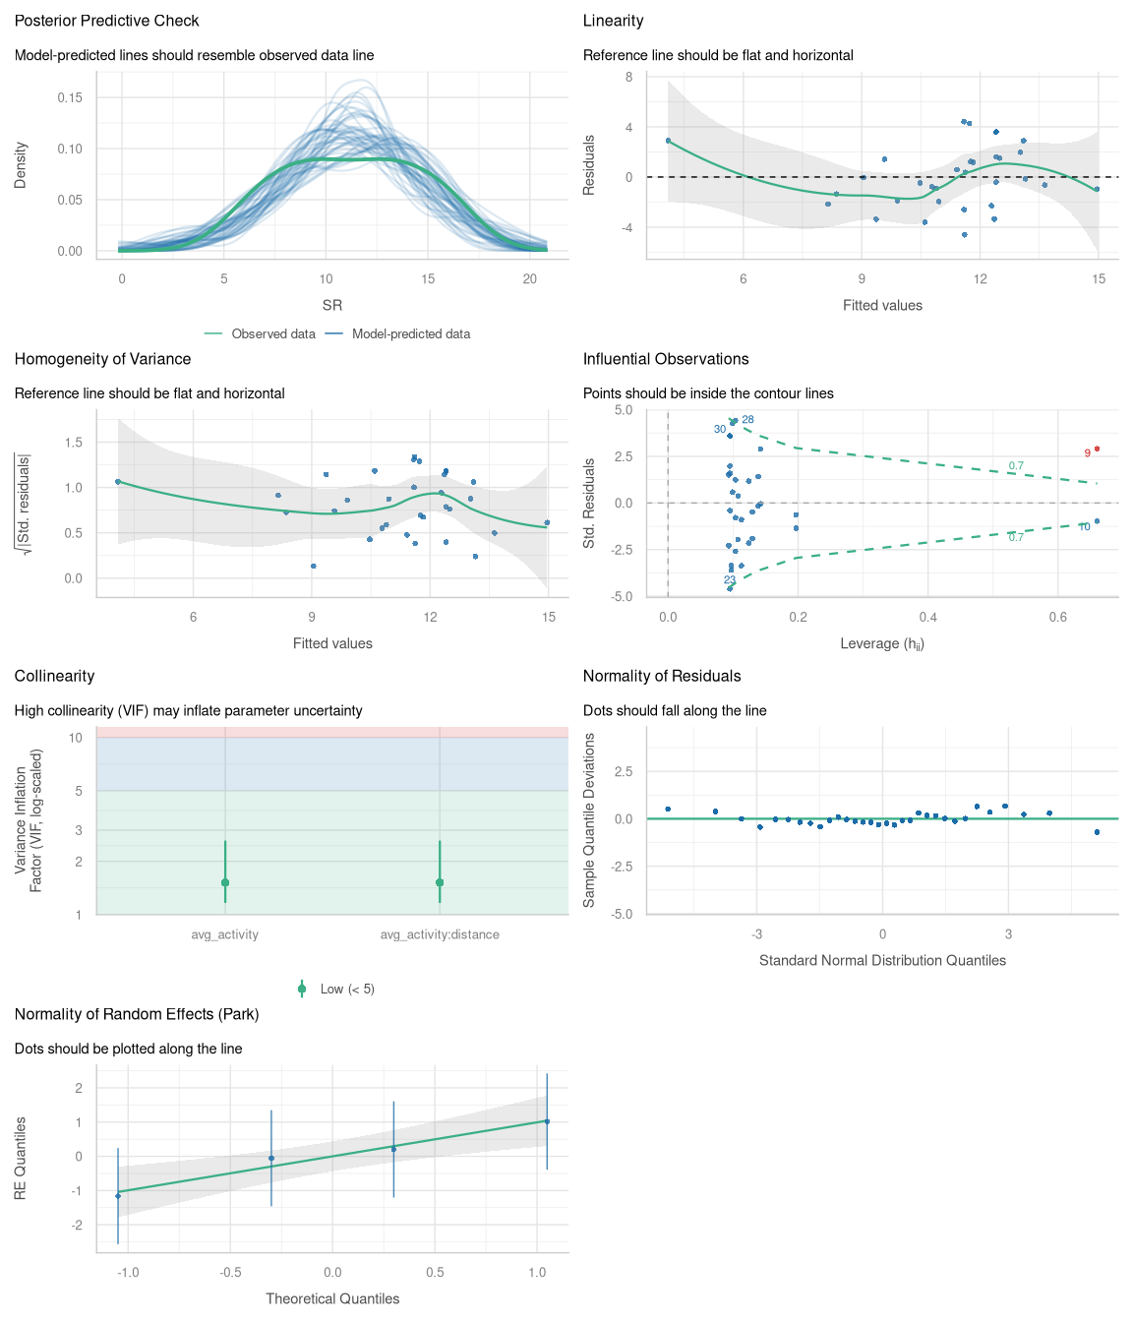
Figure B7. Model diagnostic plot where speciess richness is the response variable and human activity and the interaction between human activity and distance to trail are the explanatory variables.
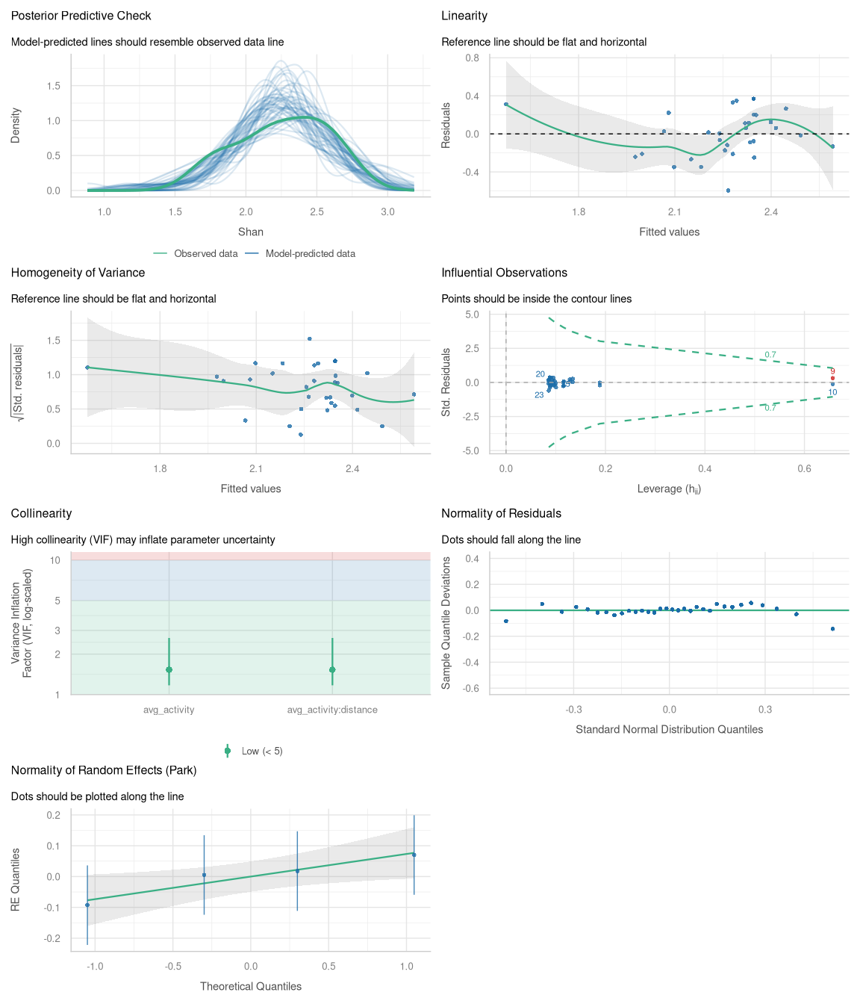
Figure B8. Model diagnostic plot where Shannon diversity is the response variable and human activity and the interaction between human activity and distance to trail are the explanatory variables.

Supplementary Materials C: Ordination Results
Table C1. Relationship between environmental variables and NMDS ordination space for formal sites. avg_activity refers to average levels of human activity (# people/hr) on trails and stem_dens refers to the average stem density of trees (# stems/m2).
***VECTORS
NMDS1 NMDS2 r2 Pr(>r)
avg_activity 0.26127 0.96526 0.236 0.167
stem_dens 0.73643 -0.67652 0.326 0.090 .
---
Signif. codes: 0 '***' 0.001 '**' 0.01 '*' 0.05 '.' 0.1 ' ' 1
Permutation: free
Number of permutations: 999
Table C2. Relationship between environmental variables and NMDS ordination space for informal sites. avg_activity refers to average levels of human activity (# people/hr) on trails and stem_dens refers to the average stem density of trees (# stems/m2).
***VECTORS
NMDS1 NMDS2 r2 Pr(>r)
avg_activity -0.80271 -0.59637 0.2400 0.169
stem_dens 0.59453 0.80407 0.0028 0.981
Permutation: free
Number of permutations: 999

