Bird diversity and community varies with proximity to trails in urban and peri-urban green spaces
Chloe A. Cull, Mackenzie Guest, Isabella C. Richmond, Ana Morales, Carly D. Ziter, Barbara Frei add_p
 Main Takeaways
- SR & Shannon higher in informal sites
- SR & Shannon higher further from trails

Model Results

Model 1: distance from trail + greenspace management
The first model includes both distance from trail and management. It does not include an interaction in the statistical analysis due to small sample size but a plot is included for context.
Model summary:
 | Species Richness | Shannon Diversity
(Intercept) | 7.9 | 2
 | (6.1, 9.8) | (1.8, 2.2)
 | 8.9 | 20
 | 2e-09 | 1e-17
Informal | 2.1 | 0.17
 | (-0.26, 4.5) | (-0.1, 0.43)
 | 1.8 | 1.3
 | 0.08 | 0.2
Far from trail | 4.5 | 0.44
 | (3, 6) | (0.3, 0.58)
 | 6.4 | 6.5
 | 8e-07 | 5e-07
SD (Intercept Park) | 0.92 | 0.11
SD (Observations) | 2 | 0.19
Visualization:
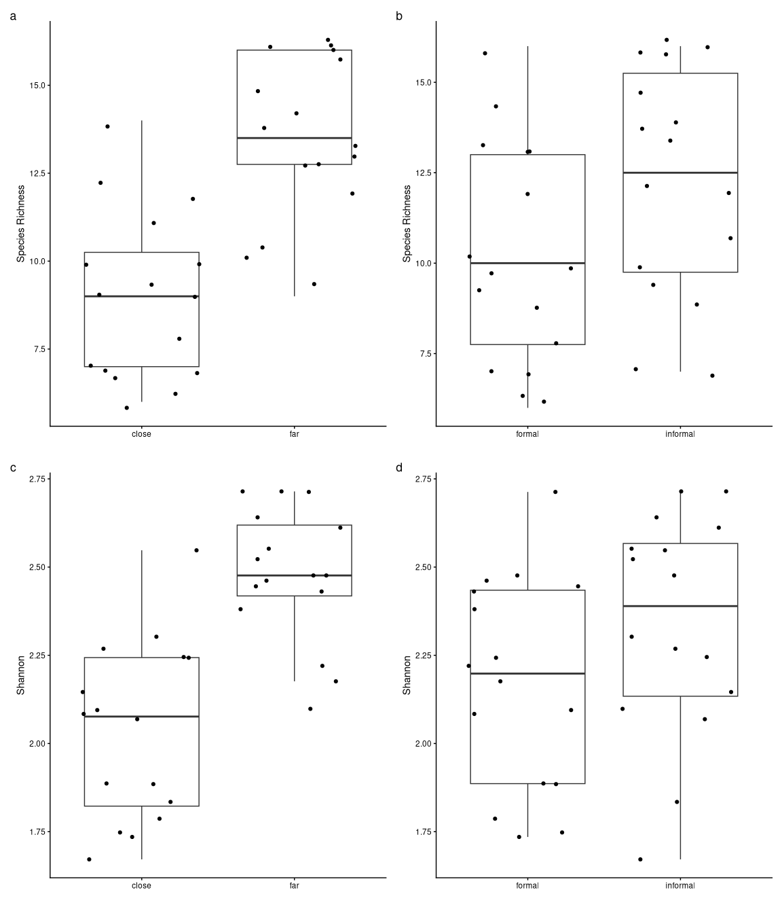

Vegetation
The second model includes stem density and the interaction between stem density and distance from trail.
 | Species Richness | Shannon Diversity
(Intercept) | 11 | 2.2
 | (8.4, 14) | (2, 2.5)
 | 8.4 | 18
 | 5e-09 | 3e-16
Stem Density | -0.081 | -0.0068
 | (-0.19, 0.031) | (-0.018, 0.0044)
 | -1.5 | -1.2
 | 0.1 | 0.2
Stem density : Far from trail | 0.25 | 0.024
 | (0.12, 0.38) | (0.011, 0.036)
 | 4 | 3.8
 | 4e-04 | 8e-04
SD (Intercept Park) | 1.9 | 0.18
SD (Observations) | 2.4 | 0.24
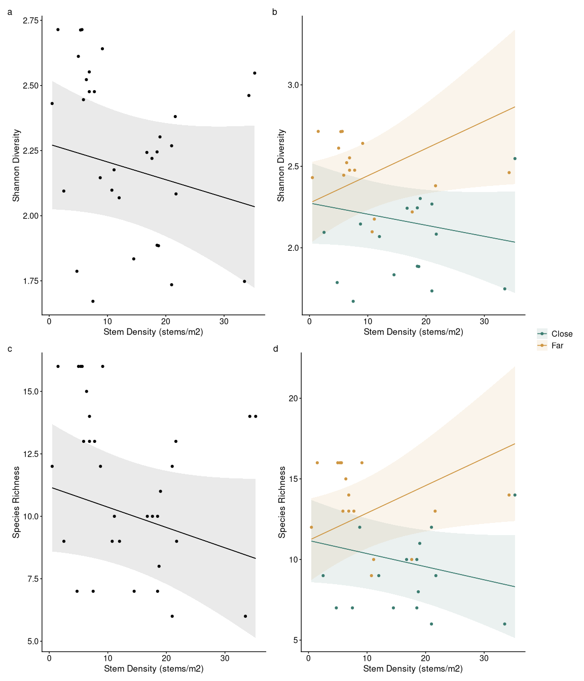
 | Species Richness | Shannon Diversity
(Intercept) | 11 | 2.2
 | (8.3, 14) | (2, 2.5)
 | 8.7 | 18
 | 3e-09 | 1e-16
Basal Area | -0.042 | -0.0033
 | (-0.096, 0.012) | (-0.0087, 0.0021)
 | -1.6 | -1.3
 | 0.1 | 0.2
Basal area : Far from trail | 0.13 | 0.013
 | (0.067, 0.2) | (0.0061, 0.02)
 | 4.1 | 3.9
 | 4e-04 | 6e-04
SD (Intercept Park) | 1.8 | 0.17
SD (Observations) | 2.4 | 0.24
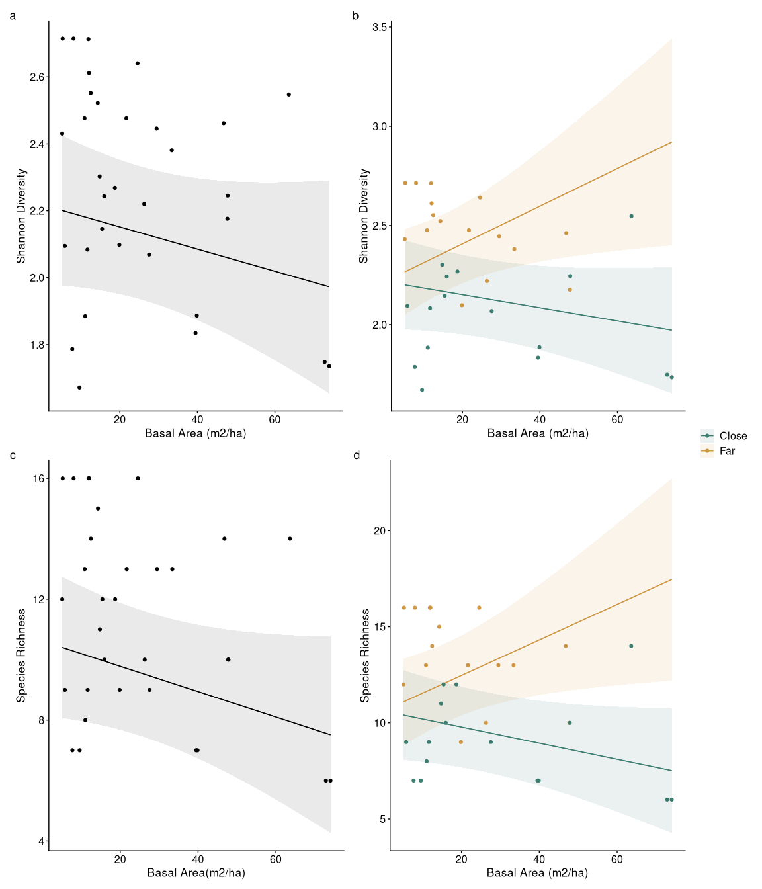

Trail use
The third model includes human activity and the interaction between human activity and distance from trail.
 | Species Richness | Shannon Diversity
(Intercept) | 11 | 2.3
 | (9.7, 13) | (2.1, 2.4)
 | 14 | 30
 | 1e-13 | 3e-22
Human Activity | -0.29 | -0.029
 | (-0.53, -0.057) | (-0.053, -0.0058)
 | -2.5 | -2.6
 | 0.02 | 0.02
Human activity : Far from trail | 0.52 | 0.049
 | (0.24, 0.8) | (0.021, 0.076)
 | 3.9 | 3.6
 | 6e-04 | 0.001
SD (Intercept Park) | 1.2 | 0.096
SD (Observations) | 2.6 | 0.26
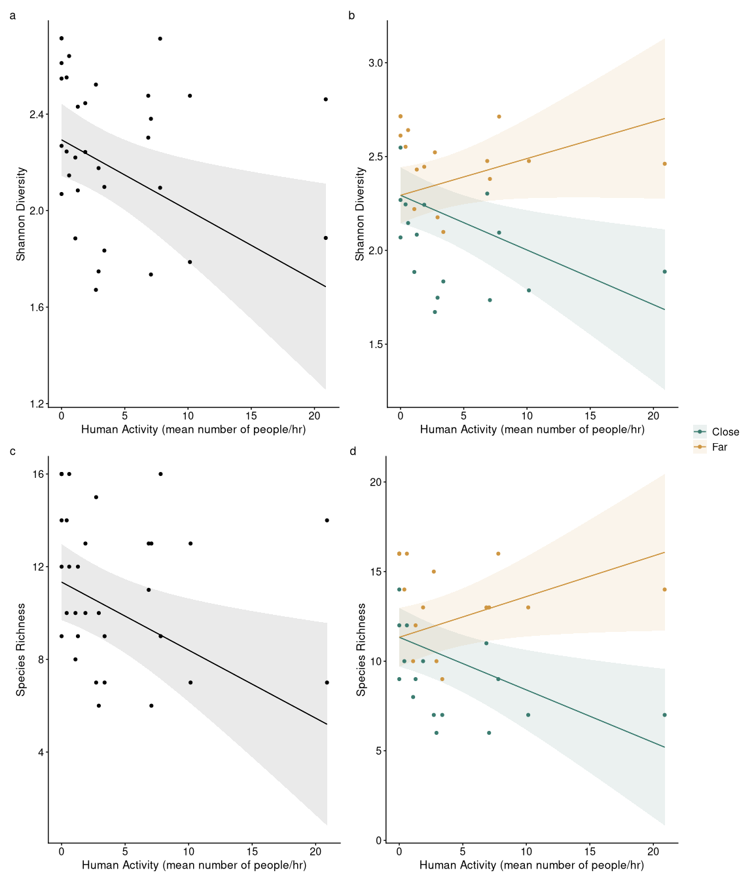

Ordination
