Title: Predictors of land-surface temperature and air pollution across Canadian cities are largely scale and city dependent
Isabella C Richmond
Nicole Yu
Alec L Robitaille
Kayleigh Hutt-Taylor
Dr. Carly D Ziter
Table of contents

* isabella.richmond@mail.concordia.ca

Tables
Table S1a. Mean and standard deviations of all response variables. Scale indicates the scale of the model/data. For the model data, pixel values from satellite images across a city, neighbourhood, or street area were averaged. For this table, the values for each neighbourhood or street in a city were then summarized at the city scale, taking the average and standard deviation. There are no air pollutant measurements at the street scale, as the data is too coarse. Temperature measurements are in degrees Celsius and air pollutant measurements are in mol/m2.
City | Scale | Mean Temperature | Std Dev Temperature | Mean CO | Std Dev CO | Mean NO2 | Std Dev NO2 | Mean O3 | Std Dev O3 | Mean UV | Std Dev UV
Calgary | City | 34 | 3.70 | 0.033 | 0.0100 | 2.9e-05 | 9.0e-06 | 0.15 | NA | -0.24 | 0.69
Halifax | City | 24 | 4.40 | 0.038 | 0.0070 | 1.7e-05 | 6.4e-06 | 0.15 | NA | -0.69 | 0.51
Montreal | City | 32 | 2.40 | 0.039 | 0.0082 | 4.1e-05 | 2.0e-05 | 0.15 | NA | -0.39 | 0.65
Ottawa | City | 28 | 0.79 | 0.039 | 0.0079 | 1.8e-05 | 8.5e-06 | 0.15 | NA | -0.61 | 0.58
Toronto | City | 35 | 2.40 | 0.038 | 0.0066 | 5.8e-05 | 2.7e-05 | 0.15 | NA | -0.54 | 0.59
Vancouver | City | 31 | 4.50 | 0.034 | 0.0076 | 5.5e-05 | 2.3e-05 | 0.15 | NA | -0.38 | 0.73
Winnipeg | City | 30 | 2.20 | 0.040 | 0.0120 | 1.8e-05 | 6.5e-06 | 0.15 | NA | -0.31 | 0.75
Calgary | Neighbourhood | 35 | 1.70 | 0.033 | 0.0098 | 3.1e-05 | 1.5e-05 | 0.15 | 0.0120 | -0.19 | 0.74
Halifax | Neighbourhood | 26 | 0.53 | 0.038 | 0.0075 | 1.9e-05 | 9.3e-06 | 0.15 | 0.0100 | -0.65 | 0.62
Montreal | Neighbourhood | 32 | 0.17 | 0.040 | 0.0084 | 3.9e-05 | 2.3e-05 | 0.15 | 0.0120 | -0.38 | 0.67
Ottawa | Neighbourhood | 30 | 2.00 | 0.039 | 0.0078 | 2.0e-05 | 1.1e-05 | 0.15 | 0.0091 | -0.55 | 0.66
Toronto | Neighbourhood | 34 | 0.78 | 0.039 | 0.0070 | 5.8e-05 | 3.2e-05 | 0.15 | 0.0095 | -0.55 | 0.66
Vancouver | Neighbourhood | 32 | 0.79 | 0.034 | 0.0078 | 5.5e-05 | 2.6e-05 | 0.15 | 0.0110 | -0.37 | 0.76
Winnipeg | Neighbourhood | 31 | 1.30 | 0.040 | 0.0130 | 2.0e-05 | 8.8e-06 | 0.15 | 0.0130 | -0.24 | 0.78
Calgary | Street | 34 | 3.80 | NA | NA | NA | NA | NA | NA | NA | NA
Halifax | Street | 32 | 1.30 | NA | NA | NA | NA | NA | NA | NA | NA
Montreal | Street | 32 | 1.90 | NA | NA | NA | NA | NA | NA | NA | NA
Ottawa | Street | 32 | 3.00 | NA | NA | NA | NA | NA | NA | NA | NA
Toronto | Street | 35 | 2.10 | NA | NA | NA | NA | NA | NA | NA | NA
Vancouver | Street | 32 | 3.50 | NA | NA | NA | NA | NA | NA | NA | NA
Winnipeg | Street | 31 | 3.10 | NA | NA | NA | NA | NA | NA | NA | NA
Table S1b. Mean and standard deviations of all explanatory variables. Scale indicates the scale of the model/data. For the model data,values across the city, neighbourhood, or street area were averaged. For this table, the values for each neighbourhood or street in a city were then summarized at the city scale, taking the average and standard deviation.
City | Scale | Area (km2) | Basal Area (m2/m2) | Stem Density (ind/km2) | Species Richness | Shannon | Functional Group Richness | Functional Group Shannon | Mean DBH (cm) | Std Dev DBH (cm) | Popuation | Mean NDVI | Mean NDBI | Building Cover (buildings/km2) | Building Cover (km2/km2) | Proportion Highway | Road Density (km/km2) | Population Density (ind/km2) | Mean Building Height (m) | Std Dev Building Height (m) | Single Detached Homes (%) | Large Apt Building (%) | Semi-Detached Home (%) | Row House (%) | Duplex Apartment (%) | Small Apt Building (%) | Moving Dwelling (%) | Median Income ($) | Recent Immigrants (%) | Indigenous People (%) | Visible Minorities (%) | Highly Educated (%) | Low-Income (%)
Calgary | City | 920.0 | 2.6e-05 | 500 | 170.0 | 3.1 | 5.0 | 1.30 | 19 | 17 | 1300000 | 0.27 | -0.061 | 430 | 0.084 | 0.0710 | 8.0 | 4100 | 6.0 | 5.4 | 0.610 | 0.053 | 0.064 | 0.096 | 0.041 | 0.130 | 2.8e-03 | 42000 | 0.120 | 0.0300 | 0.41 | 0.43 | 0.090
Halifax | City | 1100.0 | 6.4e-06 | 62 | 210.0 | 3.8 | 6.0 | 1.20 | 24 | 27 | 390000 | 0.48 | -0.240 | 79 | 0.016 | 0.0670 | 2.0 | 3400 | 6.1 | 5.1 | 0.470 | 0.140 | 0.078 | 0.043 | 0.036 | 0.210 | 1.9e-02 | 38000 | 0.061 | 0.0360 | 0.18 | 0.42 | 0.130
Montreal | City | 270.0 | 7.4e-05 | 770 | 260.0 | 3.4 | 6.0 | 1.20 | 26 | 23 | 1600000 | 0.26 | -0.080 | 400 | 0.170 | 0.0430 | 13.0 | 12000 | 7.6 | 7.5 | 0.096 | 0.150 | 0.037 | 0.038 | 0.120 | 0.560 | 3.6e-04 | 35000 | 0.110 | 0.0061 | 0.36 | 0.46 | 0.170
Ottawa | City | 3000.0 | 5.4e-06 | 79 | 140.0 | 3.5 | 5.0 | 1.30 | 22 | 20 | 1000000 | 0.48 | -0.190 | 71 | 0.018 | 0.0370 | 2.4 | 4400 | 5.3 | 5.0 | 0.460 | 0.140 | 0.055 | 0.230 | 0.018 | 0.094 | 2.3e-03 | 46000 | 0.076 | 0.0260 | 0.32 | 0.48 | 0.091
Toronto | City | 670.0 | 7.8e-05 | 890 | 180.0 | 3.7 | 6.0 | 1.20 | 25 | 22 | 2900000 | 0.30 | -0.090 | 490 | 0.150 | 0.0570 | 9.7 | 14000 | 7.3 | 9.3 | 0.280 | 0.400 | 0.070 | 0.063 | 0.049 | 0.130 | 3.2e-05 | 38000 | 0.120 | 0.0058 | 0.56 | 0.48 | 0.130
Vancouver | City | 120.0 | 1.5e-04 | 1200 | 370.0 | 4.2 | 6.0 | 1.10 | 30 | 24 | 690000 | 0.30 | -0.100 | 840 | 0.160 | 0.0180 | 13.0 | 12000 | 7.6 | 9.0 | 0.180 | 0.260 | 0.016 | 0.039 | 0.220 | 0.280 | 5.0e-05 | 39000 | 0.110 | 0.0210 | 0.55 | 0.52 | 0.130
Winnipeg | City | 570.0 | 3.4e-05 | 350 | 100.0 | 2.5 | 6.0 | 1.10 | 29 | 20 | 760000 | 0.32 | -0.120 | 450 | 0.091 | 0.0490 | 6.8 | 4100 | 4.3 | 4.3 | 0.630 | 0.100 | 0.043 | 0.039 | 0.017 | 0.170 | 2.1e-03 | 36000 | 0.120 | 0.1200 | 0.34 | 0.36 | 0.130
Calgary | Neighbourhood | 1.8 | 8.2e-05 | 1100 | 47.0 | 2.6 | 4.6 | 1.20 | 22 | 17 | 4100 | 0.23 | -0.042 | 750 | 0.140 | 0.0730 | 12.0 | 3900 | 6.9 | 4.6 | 0.510 | 0.098 | 0.062 | 0.100 | 0.060 | 0.170 | 1.2e-06 | 43000 | 0.110 | 0.0300 | 0.36 | 0.49 | 0.110
Halifax | Neighbourhood | 27.0 | 7.7e-06 | 120 | 83.0 | 3.2 | 4.9 | 1.10 | 16 | 16 | 20000 | 0.39 | -0.180 | 140 | 0.025 | 0.0490 | 3.2 | 1300 | 4.9 | 3.3 | 0.620 | 0.050 | 0.120 | 0.020 | 0.022 | 0.100 | 5.9e-02 | 39000 | 0.031 | 0.0480 | 0.13 | 0.31 | 0.092
Montreal | Neighbourhood | 22.0 | 7.4e-05 | 860 | 130.0 | 3.2 | 5.7 | 1.10 | 25 | 21 | 110000 | 0.22 | -0.068 | 330 | 0.180 | 0.0500 | 13.0 | 12000 | 8.1 | 6.7 | 0.099 | 0.140 | 0.020 | 0.036 | 0.110 | 0.580 | 3.5e-04 | 35000 | 0.100 | 0.0080 | 0.35 | 0.47 | 0.180
Ottawa | Neighbourhood | 27.0 | 4.3e-05 | 510 | 63.0 | 3.1 | 4.9 | 1.20 | 23 | 18 | 8800 | 0.37 | -0.140 | 440 | 0.110 | 0.0350 | 9.2 | 4100 | 5.1 | 4.1 | 0.470 | 0.160 | 0.053 | 0.220 | 0.016 | 0.086 | 2.4e-03 | 45000 | 0.073 | 0.0270 | 0.30 | 0.48 | 0.095
Toronto | Neighbourhood | 4.1 | 1.0e-04 | 1100 | 93.0 | 3.4 | 5.9 | 1.10 | 25 | 22 | 17000 | 0.28 | -0.085 | 560 | 0.180 | 0.0460 | 11.0 | 14000 | 8.7 | 8.4 | 0.290 | 0.370 | 0.082 | 0.059 | 0.049 | 0.150 | 1.8e-05 | 40000 | 0.110 | 0.0067 | 0.51 | 0.51 | 0.130
Vancouver | Neighbourhood | 5.6 | 1.4e-04 | 1200 | 180.0 | 4.0 | 5.6 | 1.10 | 31 | 23 | 29000 | 0.23 | -0.056 | 890 | 0.160 | 0.0032 | 13.0 | 8100 | 6.6 | 3.8 | 0.210 | 0.100 | 0.023 | 0.059 | 0.250 | 0.340 | 0.0e+00 | 37000 | 0.095 | 0.0290 | 0.51 | 0.51 | 0.150
Winnipeg | Neighbourhood | 1.7 | 7.5e-05 | 700 | 29.0 | 2.0 | 4.6 | 1.00 | 27 | 16 | 3200 | 0.25 | -0.067 | 780 | 0.140 | 0.0600 | 11.0 | 3400 | 5.4 | 3.9 | 0.600 | 0.130 | 0.045 | 0.046 | 0.017 | 0.160 | 2.1e-03 | 37000 | 0.110 | 0.1300 | 0.31 | 0.36 | 0.140
Calgary | Street | NA | 1.7e-04 | 2700 | 6.6 | 1.4 | 3.1 | 0.87 | 22 | 14 | 30 | 0.20 | -0.034 | 1100 | 0.150 | NA | NA | 3600 | 5.3 | 2.5 | 0.640 | 0.032 | 0.070 | 0.075 | 0.059 | 0.120 | 3.3e-05 | 44000 | 0.095 | 0.0290 | 0.32 | 0.45 | 0.085
Halifax | Street | NA | 2.2e-04 | 1700 | 6.5 | 1.5 | 2.7 | 0.76 | 26 | 18 | 24 | 0.31 | -0.110 | 850 | 0.110 | NA | NA | 3200 | 5.5 | 3.0 | 0.510 | 0.088 | 0.093 | 0.045 | 0.057 | 0.200 | 5.7e-03 | 39000 | 0.047 | 0.0340 | 0.16 | 0.46 | 0.110
Montreal | Street | NA | 1.9e-04 | 2100 | 7.6 | 1.6 | 2.9 | 0.80 | 26 | 17 | 77 | 0.22 | -0.061 | 650 | 0.190 | NA | NA | 10000 | 6.9 | 3.1 | 0.140 | 0.094 | 0.051 | 0.038 | 0.120 | 0.560 | 2.3e-04 | 35000 | 0.098 | 0.0058 | 0.35 | 0.46 | 0.160
Ottawa | Street | NA | 1.5e-04 | 1900 | 7.3 | 1.6 | 3.0 | 0.88 | 24 | 15 | 30 | 0.30 | -0.099 | 840 | 0.160 | NA | NA | 3900 | 4.8 | 2.5 | 0.550 | 0.069 | 0.070 | 0.190 | 0.021 | 0.093 | 1.1e-03 | 47000 | 0.058 | 0.0220 | 0.28 | 0.52 | 0.075
Toronto | Street | NA | 2.3e-04 | 2200 | 9.8 | 1.8 | 3.2 | 0.84 | 28 | 20 | 50 | 0.25 | -0.073 | 810 | 0.150 | NA | NA | 7400 | 6.3 | 3.4 | 0.450 | 0.140 | 0.110 | 0.057 | 0.074 | 0.170 | 0.0e+00 | 41000 | 0.082 | 0.0063 | 0.46 | 0.51 | 0.100
Vancouver | Street | NA | 3.1e-04 | 2800 | 7.7 | 1.6 | 2.8 | 0.69 | 30 | 19 | 55 | 0.26 | -0.073 | 810 | 0.110 | NA | NA | 7300 | 6.4 | 3.1 | 0.290 | 0.088 | 0.022 | 0.036 | 0.300 | 0.270 | 8.9e-05 | 38000 | 0.093 | 0.0180 | 0.56 | 0.51 | 0.120
Winnipeg | Street | NA | 1.9e-04 | 2000 | 4.9 | 1.0 | 2.6 | 0.60 | 29 | 13 | 28 | 0.25 | -0.063 | 910 | 0.130 | NA | NA | 3200 | 4.2 | 2.4 | 0.740 | 0.052 | 0.043 | 0.037 | 0.013 | 0.120 | 2.5e-03 | 39000 | 0.091 | 0.1100 | 0.28 | 0.38 | 0.100
Table S2. Data sources used in the study.
Dataset | Area/Link | Data Type
Neighbourhood | Halifax  Montreal  Ottawa  Toronto  Winnipeg  Calgary  Vancouver | Shapefile/CSV
Parks | Halifax  Montreal  Ottawa  Toronto  Winnipeg  Calgary  Vancouver | Shapefile/CSV
Street Trees | Halifax  Montreal  Ottawa  Toronto  Winnipeg  Calgary  Vancouver
Census Metropolitan Areas | National | Shapefile
Roads | National | Shapefile
Dissemination Areas | National | Shapefile
2021 Census | National | CSV
Buildings | National | Shapefile
NDVI/NDBI | International - Sentinel 2 (5 day revisit frequency) | TIFF
Land Surface Temperature | International - Landsat 8 (2 week revisit frequency) | TIFF
Air Pollutants | International - Sentinel 5p TROPOMI (2 day revisit frequency) | TIFF
Table S3. Model Performance Metrics. For each model, the root mean squared error (rmse), R2 (rsq), and mean absolute error (mae) were calculated for the testing and training datasets. A well fitted model should not have large differences in error metric values between the training and testing dataset.
Model | Scale | Dataset | Metric | Value
CO | City | test | rmse | 6.4e-03
CO | City | train | rmse | 5.4e-03
CO | City | test | rsq | 5.2e-01
CO | City | train | rsq | 6.7e-01
CO | City | test | mae | 4.3e-03
CO | City | train | mae | 3.7e-03
NO2 | City | test | rmse | 1.7e-05
NO2 | City | train | rmse | 1.4e-05
NO2 | City | test | rsq | 5.3e-01
NO2 | City | train | rsq | 5.5e-01
NO2 | City | test | mae | 1.1e-05
NO2 | City | train | mae | 1.0e-05
O3 | City | test | rmse | 9.5e-03
O3 | City | train | rmse | 8.0e-03
O3 | City | test | rsq | 4.2e-01
O3 | City | train | rsq | 5.5e-01
O3 | City | test | mae | 7.2e-03
O3 | City | train | mae | 6.1e-03
SO2 | City | test | rmse | 3.1e-04
SO2 | City | train | rmse | 3.5e-04
SO2 | City | test | rsq | 2.8e-02
SO2 | City | train | rsq | 6.6e-02
SO2 | City | test | mae | 2.3e-04
SO2 | City | train | mae | 2.2e-04
Temperature | City | test | rmse | 2.3e+00
Temperature | City | train | rmse | 3.1e+00
Temperature | City | test | rsq | 4.0e-01
Temperature | City | train | rsq | 5.3e-01
Temperature | City | test | mae | 1.8e+00
Temperature | City | train | mae | 2.6e+00
UV | City | test | rmse | 6.8e-01
UV | City | train | rmse | 6.0e-01
UV | City | test | rsq | 8.2e-02
UV | City | train | rsq | 1.6e-01
UV | City | test | mae | 5.3e-01
UV | City | train | mae | 4.8e-01
CO | Neighbourhood | test | rmse | 6.8e-03
CO | Neighbourhood | train | rmse | 6.6e-03
CO | Neighbourhood | test | rsq | 6.1e-01
CO | Neighbourhood | train | rsq | 6.4e-01
CO | Neighbourhood | test | mae | 4.7e-03
CO | Neighbourhood | train | mae | 4.6e-03
NO2 | Neighbourhood | test | rmse | 1.6e-05
NO2 | Neighbourhood | train | rmse | 1.6e-05
NO2 | Neighbourhood | test | rsq | 4.2e-01
NO2 | Neighbourhood | train | rsq | 4.4e-01
NO2 | Neighbourhood | test | mae | 1.1e-05
NO2 | Neighbourhood | train | mae | 1.1e-05
O3 | Neighbourhood | test | rmse | 9.2e-03
O3 | Neighbourhood | train | rmse | 8.9e-03
O3 | Neighbourhood | test | rsq | 4.3e-01
O3 | Neighbourhood | train | rsq | 4.7e-01
O3 | Neighbourhood | test | mae | 7.3e-03
O3 | Neighbourhood | train | mae | 7.1e-03
SO2 | Neighbourhood | test | rmse | 5.4e-04
SO2 | Neighbourhood | train | rmse | 5.1e-04
SO2 | Neighbourhood | test | rsq | 6.3e-02
SO2 | Neighbourhood | train | rsq | 1.8e-01
SO2 | Neighbourhood | test | mae | 3.9e-04
SO2 | Neighbourhood | train | mae | 3.7e-04
Temperature | Neighbourhood | test | rmse | 3.5e+00
Temperature | Neighbourhood | train | rmse | 3.4e+00
Temperature | Neighbourhood | test | rsq | 4.6e-01
Temperature | Neighbourhood | train | rsq | 5.1e-01
Temperature | Neighbourhood | test | mae | 2.6e+00
Temperature | Neighbourhood | train | mae | 2.5e+00
UV | Neighbourhood | test | rmse | 6.1e-01
UV | Neighbourhood | train | rmse | 6.0e-01
UV | Neighbourhood | test | rsq | 3.3e-01
UV | Neighbourhood | train | rsq | 3.8e-01
UV | Neighbourhood | test | mae | 4.9e-01
UV | Neighbourhood | train | mae | 4.8e-01
Temperature | Street | test | rmse | 4.0e+00
Temperature | Street | train | rmse | 3.4e+00
Temperature | Street | test | rsq | 3.7e-01
Temperature | Street | train | rsq | 6.3e-01
Temperature | Street | test | mae | 2.8e+00
Temperature | Street | train | mae | 2.4e+00

Figures
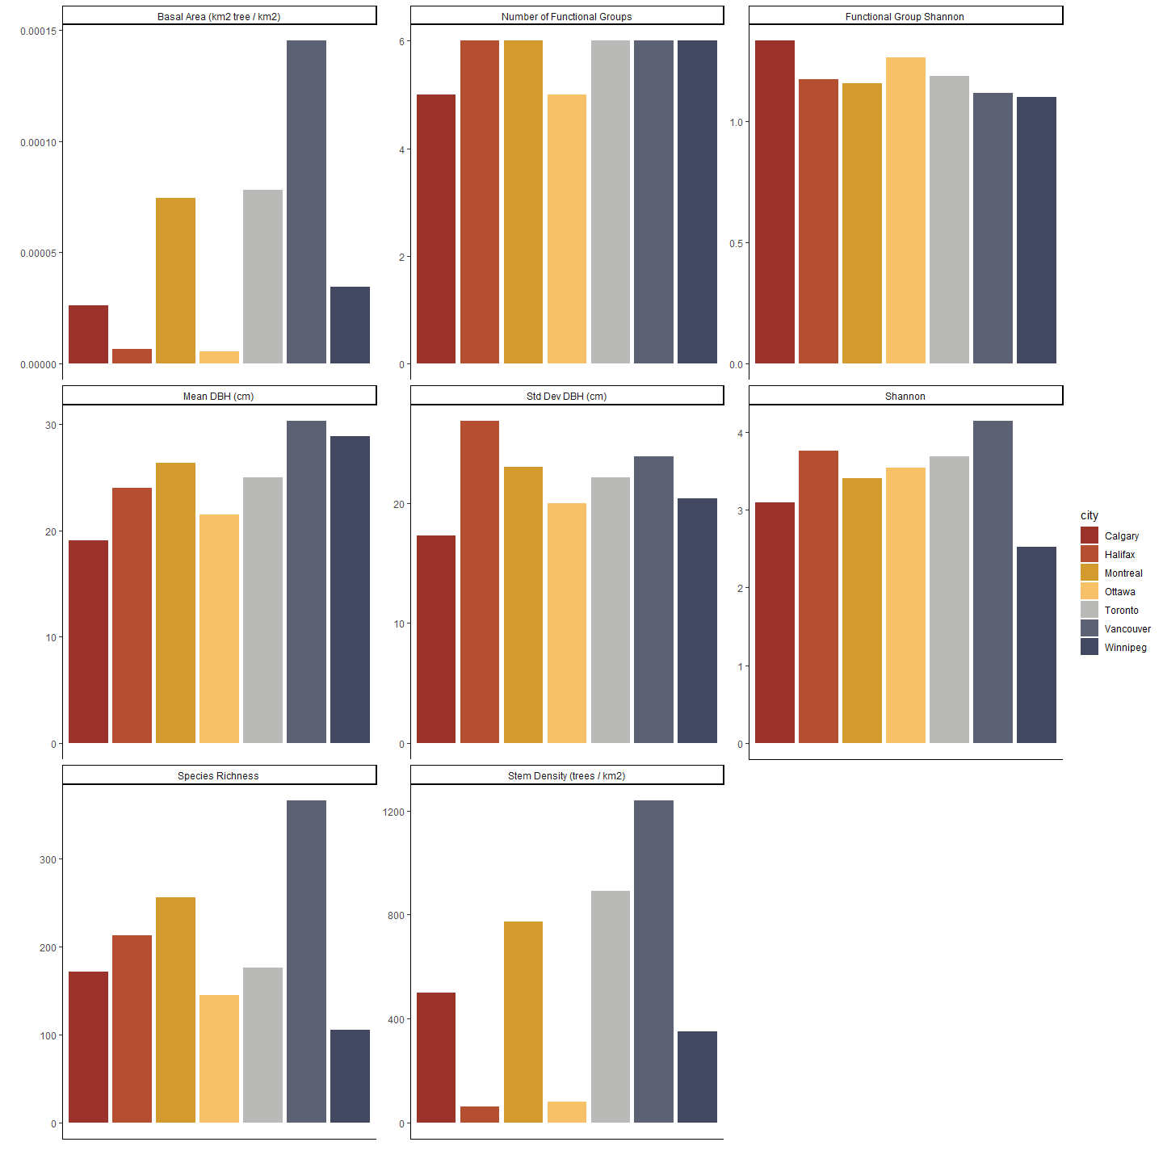
Figure A3.1a. Plot depicting the values for ecological form variables for each city at the city scale.
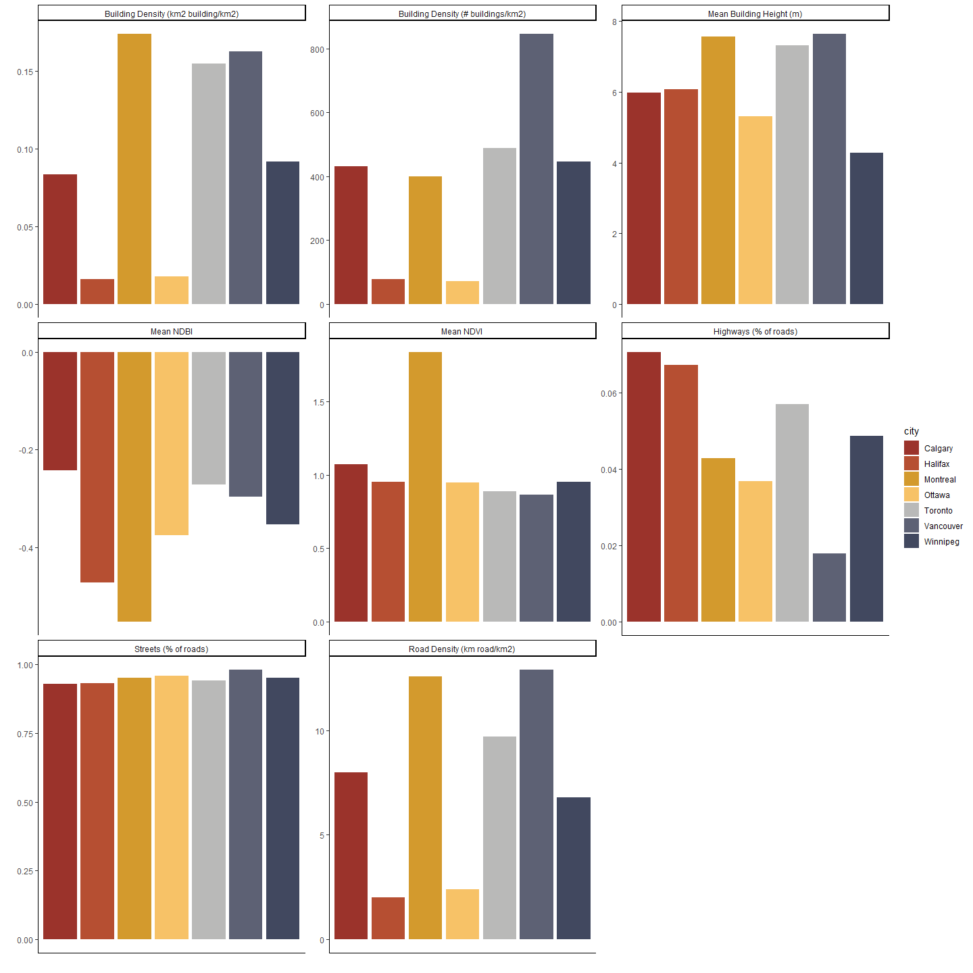
Figure A3.1b. Plot depicting the values for urban form variables for each city at the city scale.
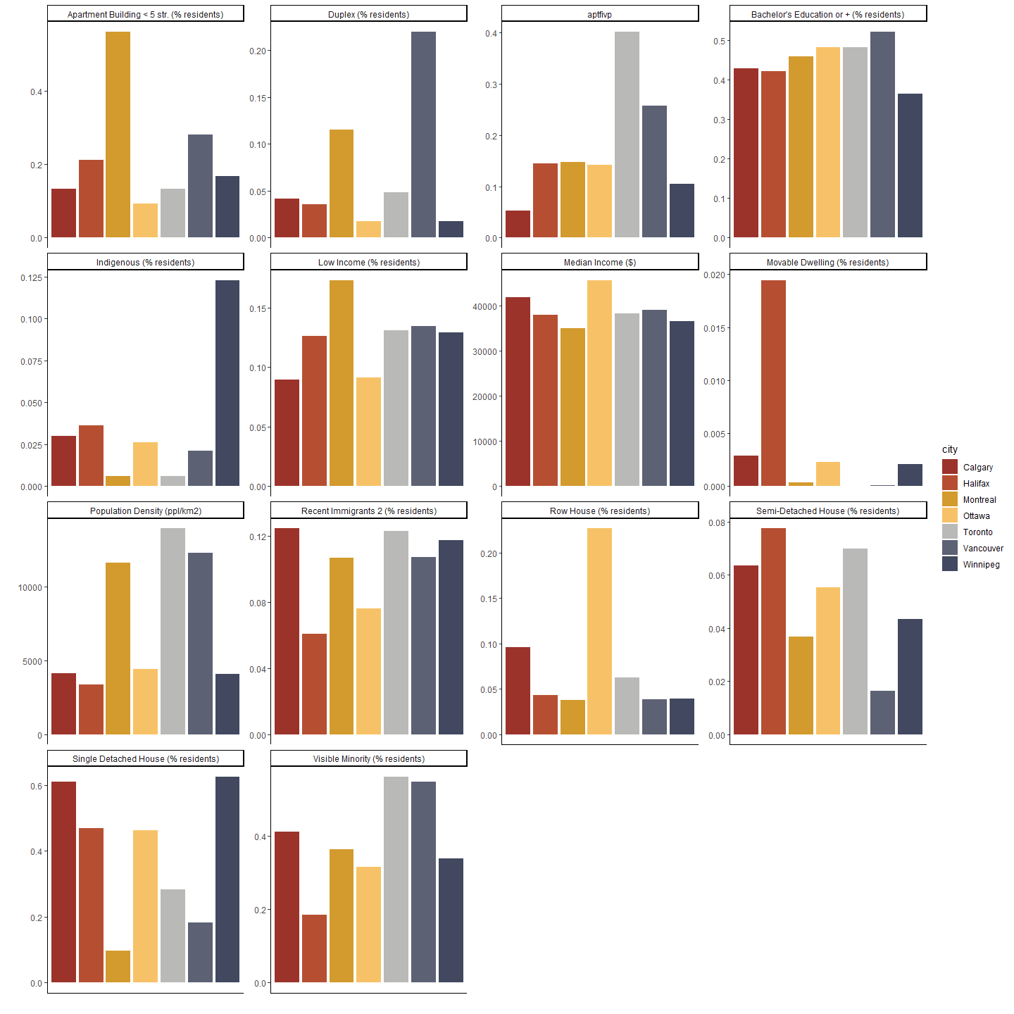
Figure A3.1c. Plot depicting the values for sociodemographic variables for each city at the city scale.
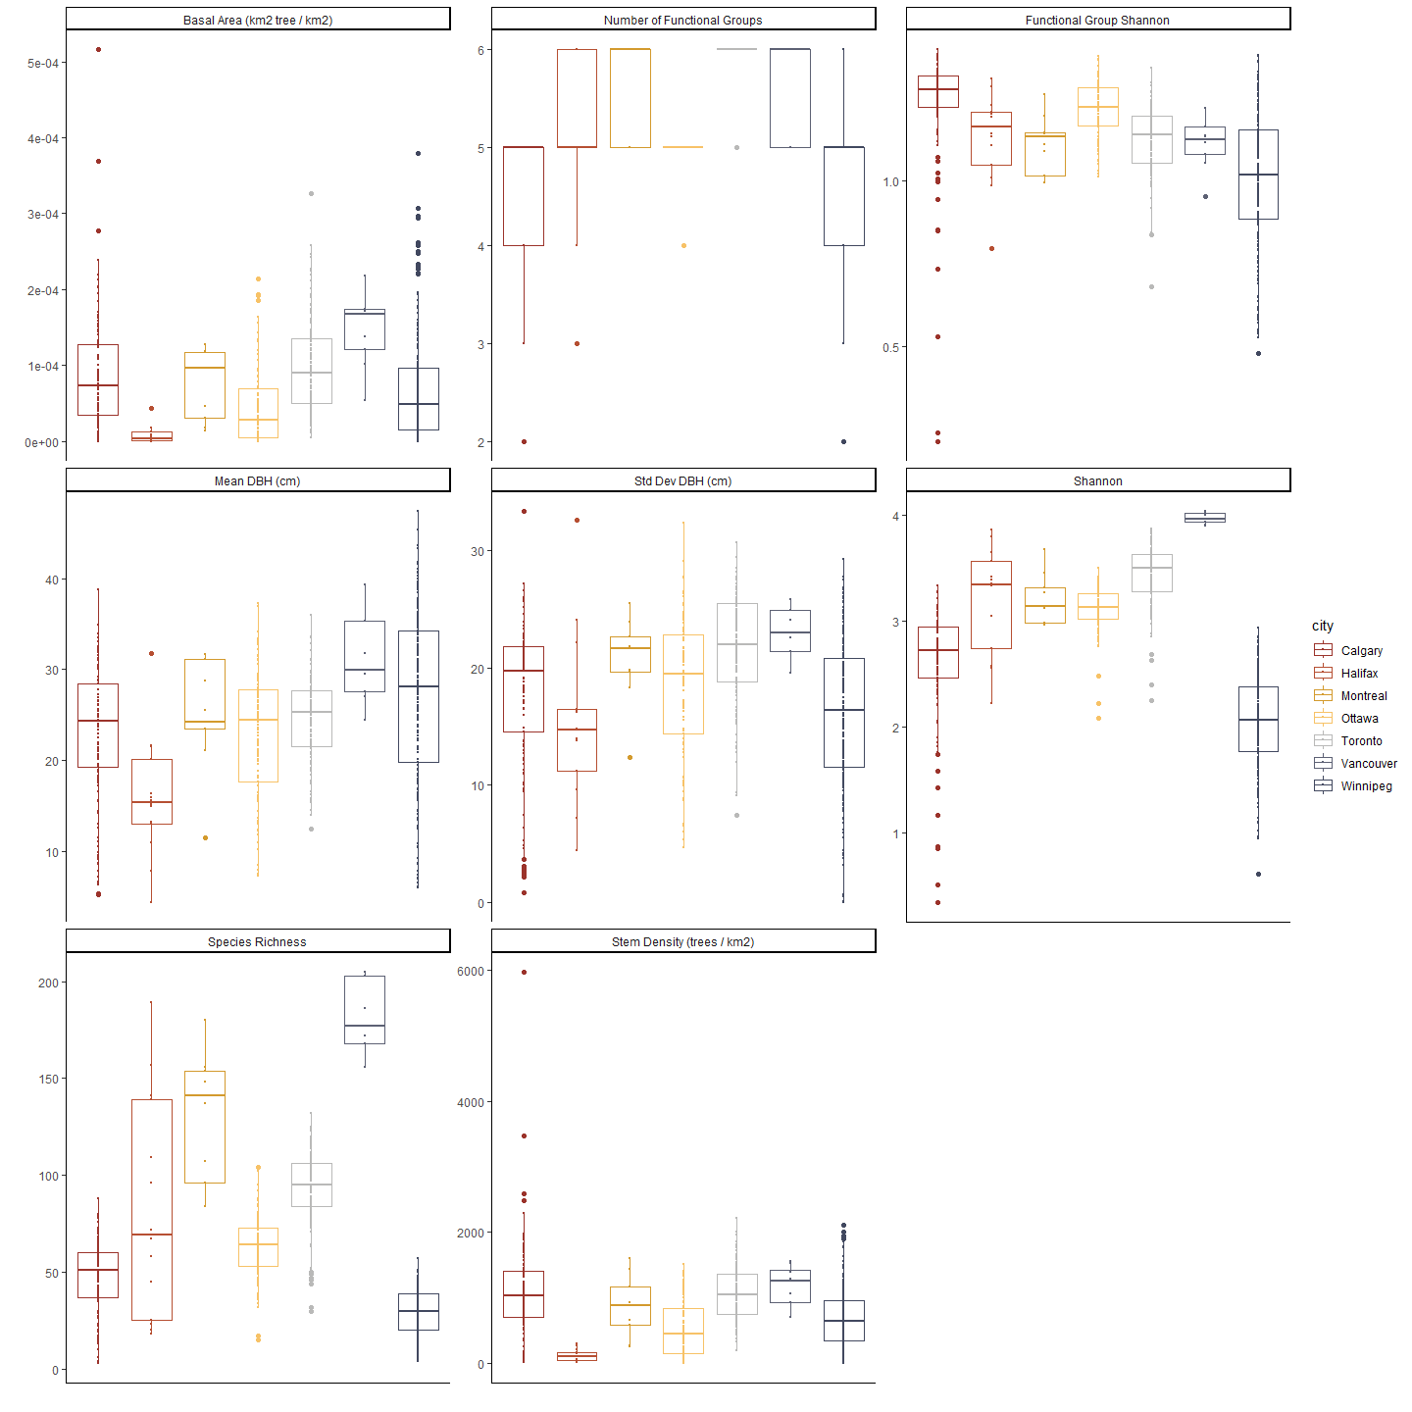
Figure A3.1d. Plot depicting the values for ecological form variables for each city at the neighbourhood scale.
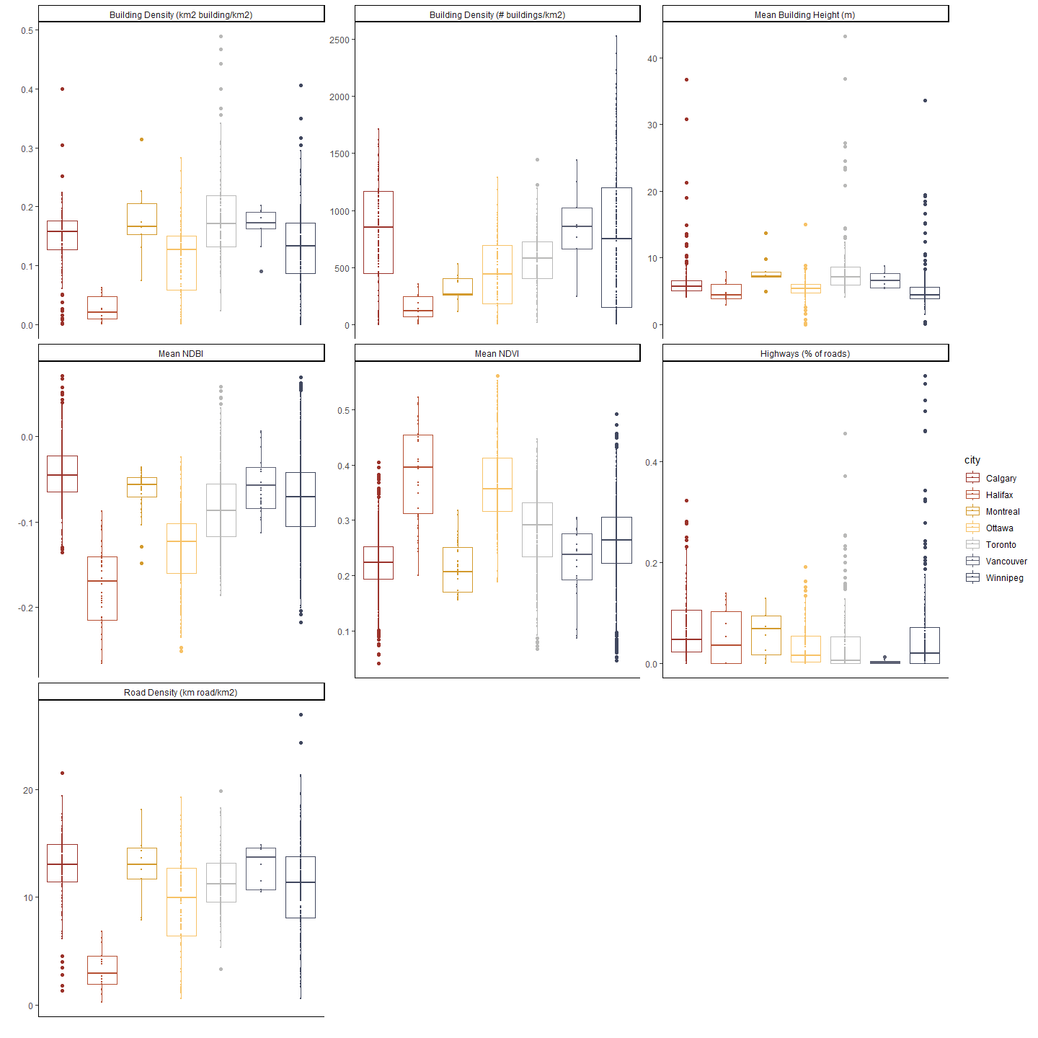
Figure A3.1e. Plot depicting the values for urban form variables for each city at the neighbourhood scale.
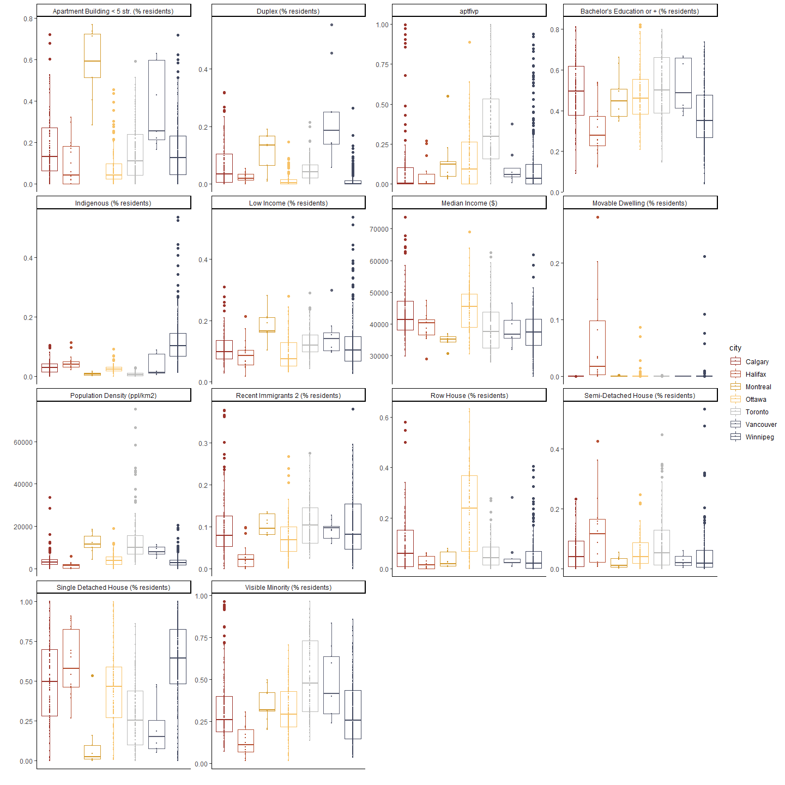
Figure A3.1f. Plot depicting the values for sociodemographic variables for each city at the neighbourhood scale.
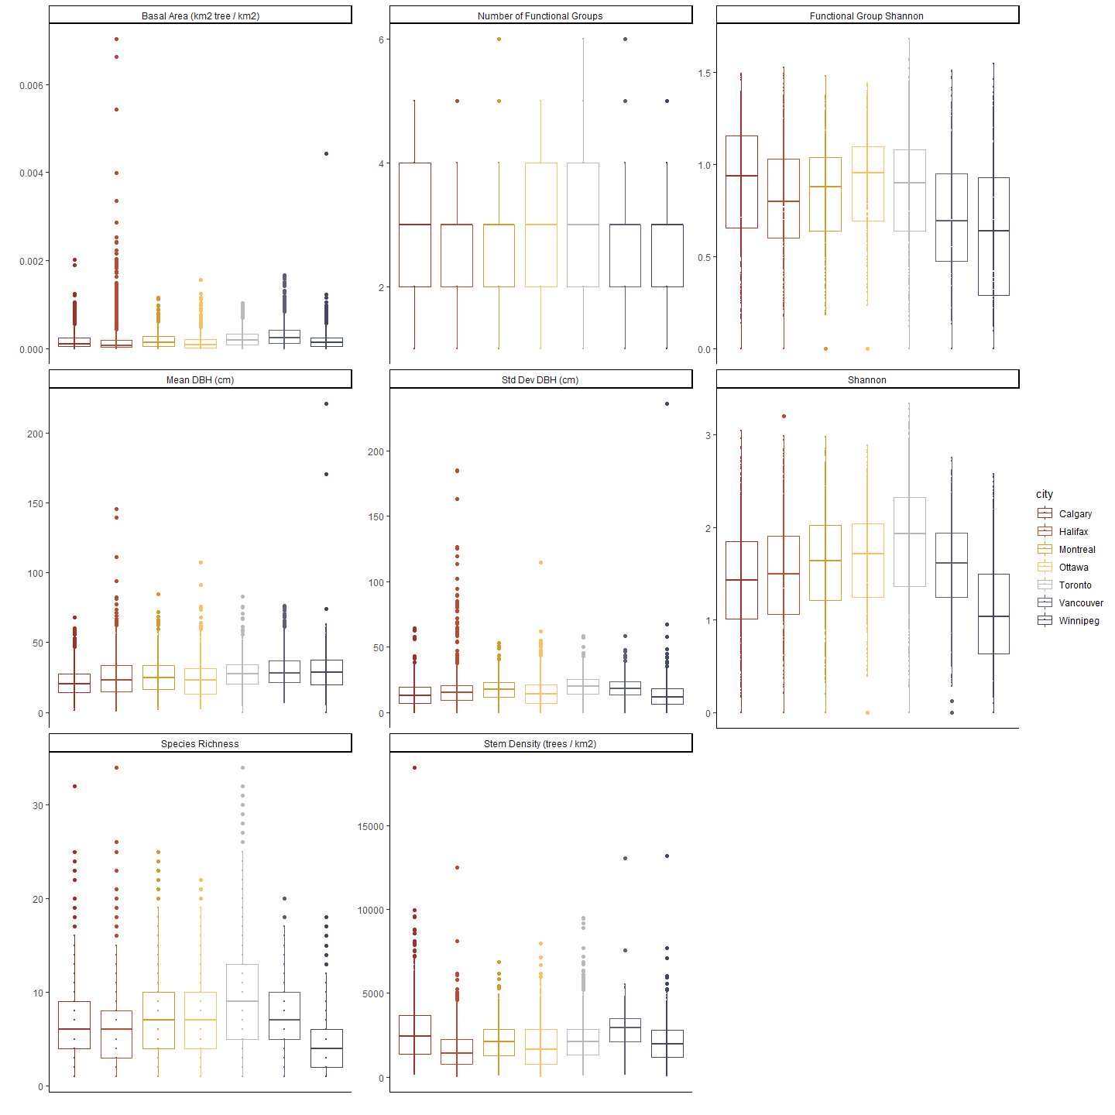
Figure A3.1h. Plot depicting the values for ecological form variables for each city at the street scale.
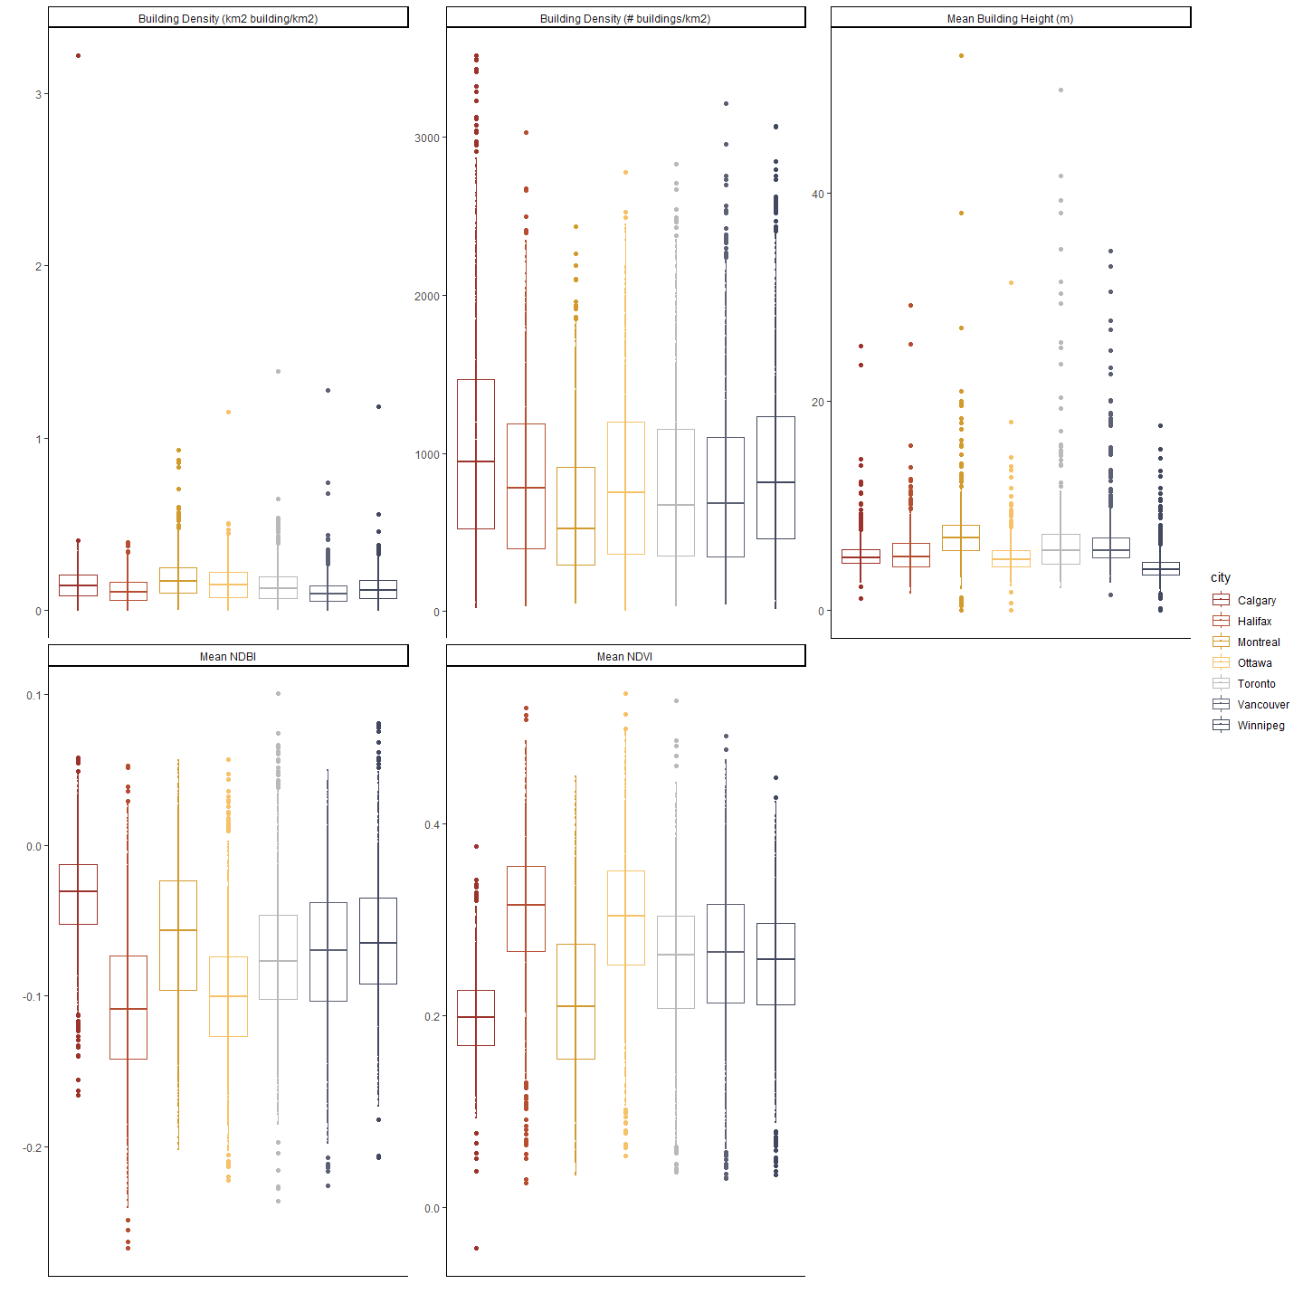
Figure A3.1h. Plot depicting the values for urban form variables for each city at the street scale.
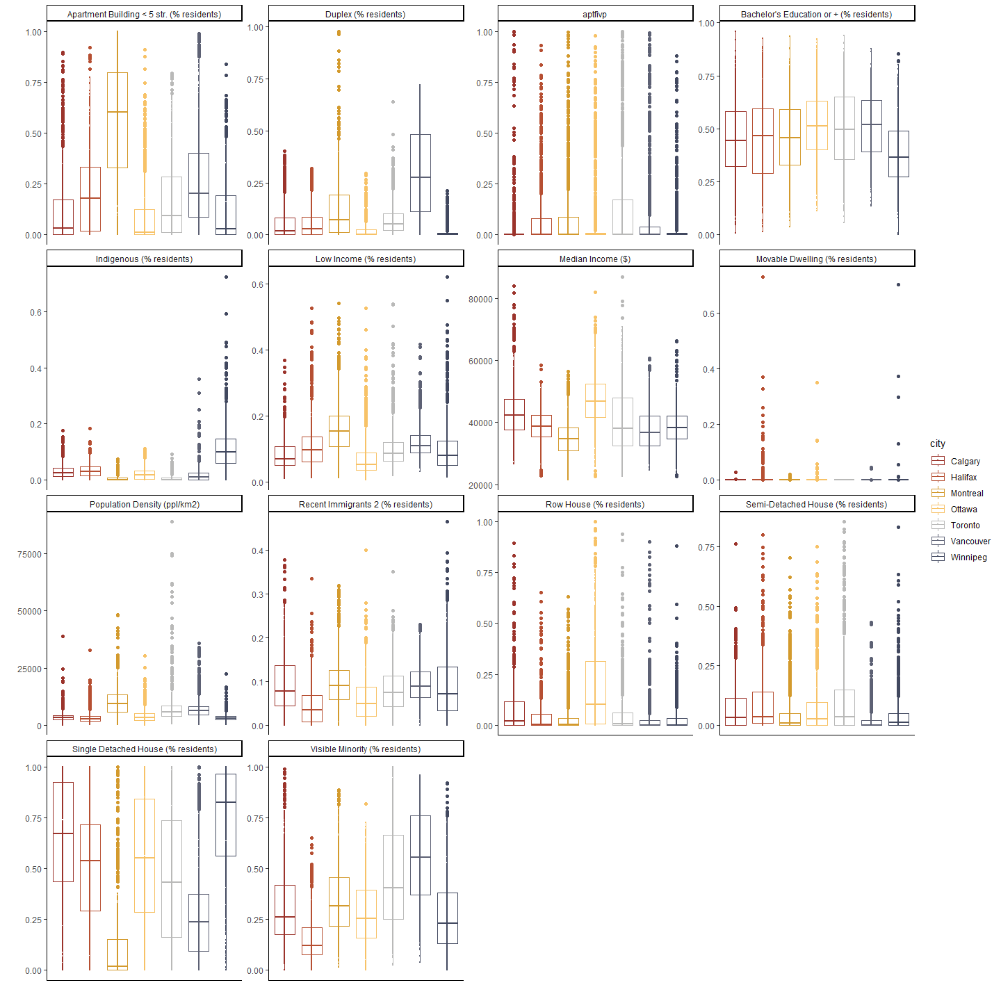
Figure A3.1i. Plot depicting the values for sociodemographic variables for each city at the street scale.
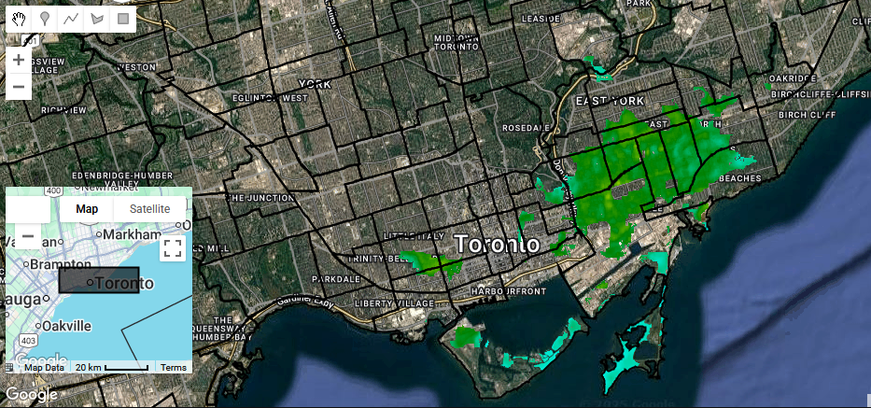
Figure A3.2. Example of satellite image coverage of Toronto neighbourhoods. Depicted is a single satellite image, with cloudy pixels removed. To be included in our analysis, satellite images had to cover an estimated 50% or more of the area of a city or neighbourhood, or 100% of a street area.
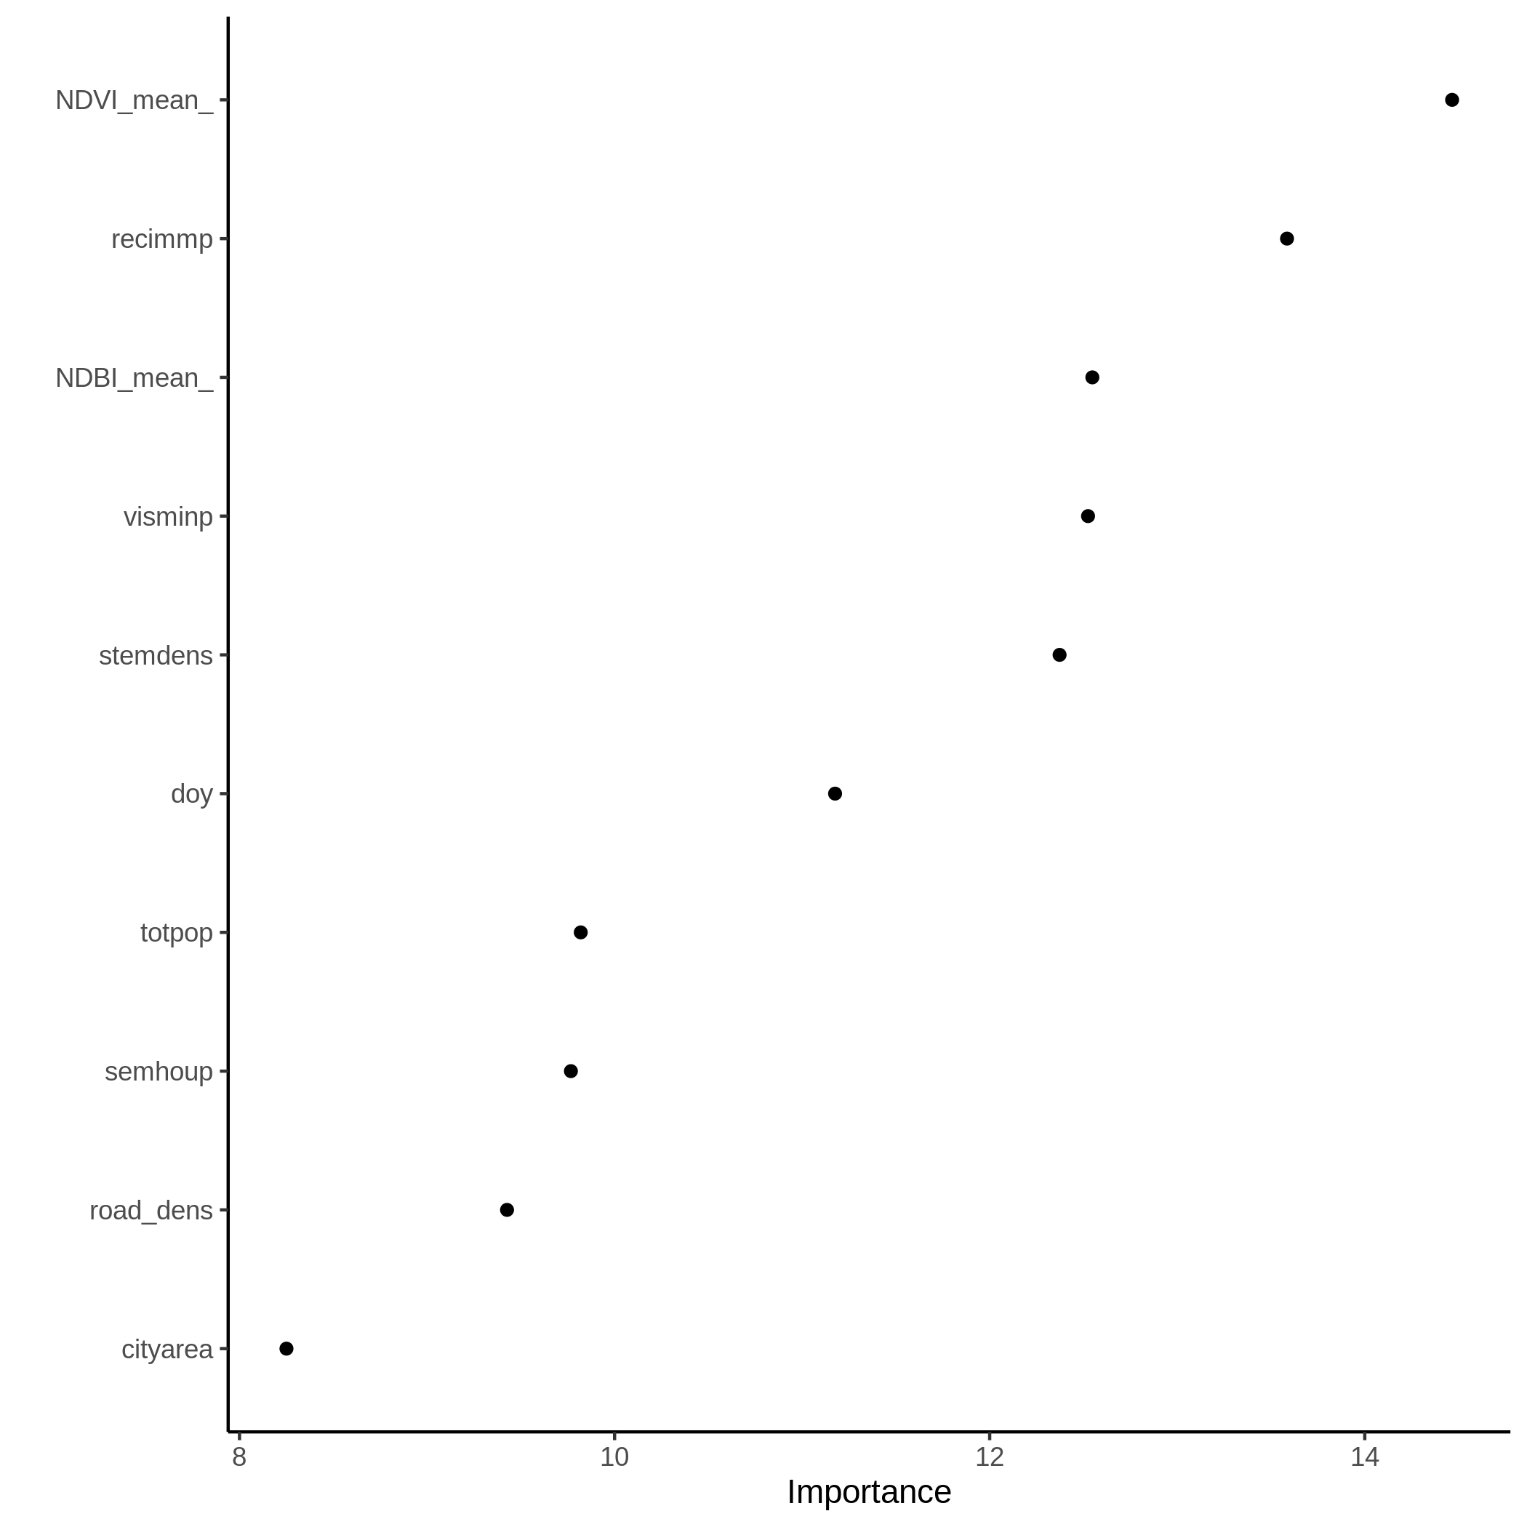
Figure A3.3a. Variable importance plot for temperature model at the city scale.
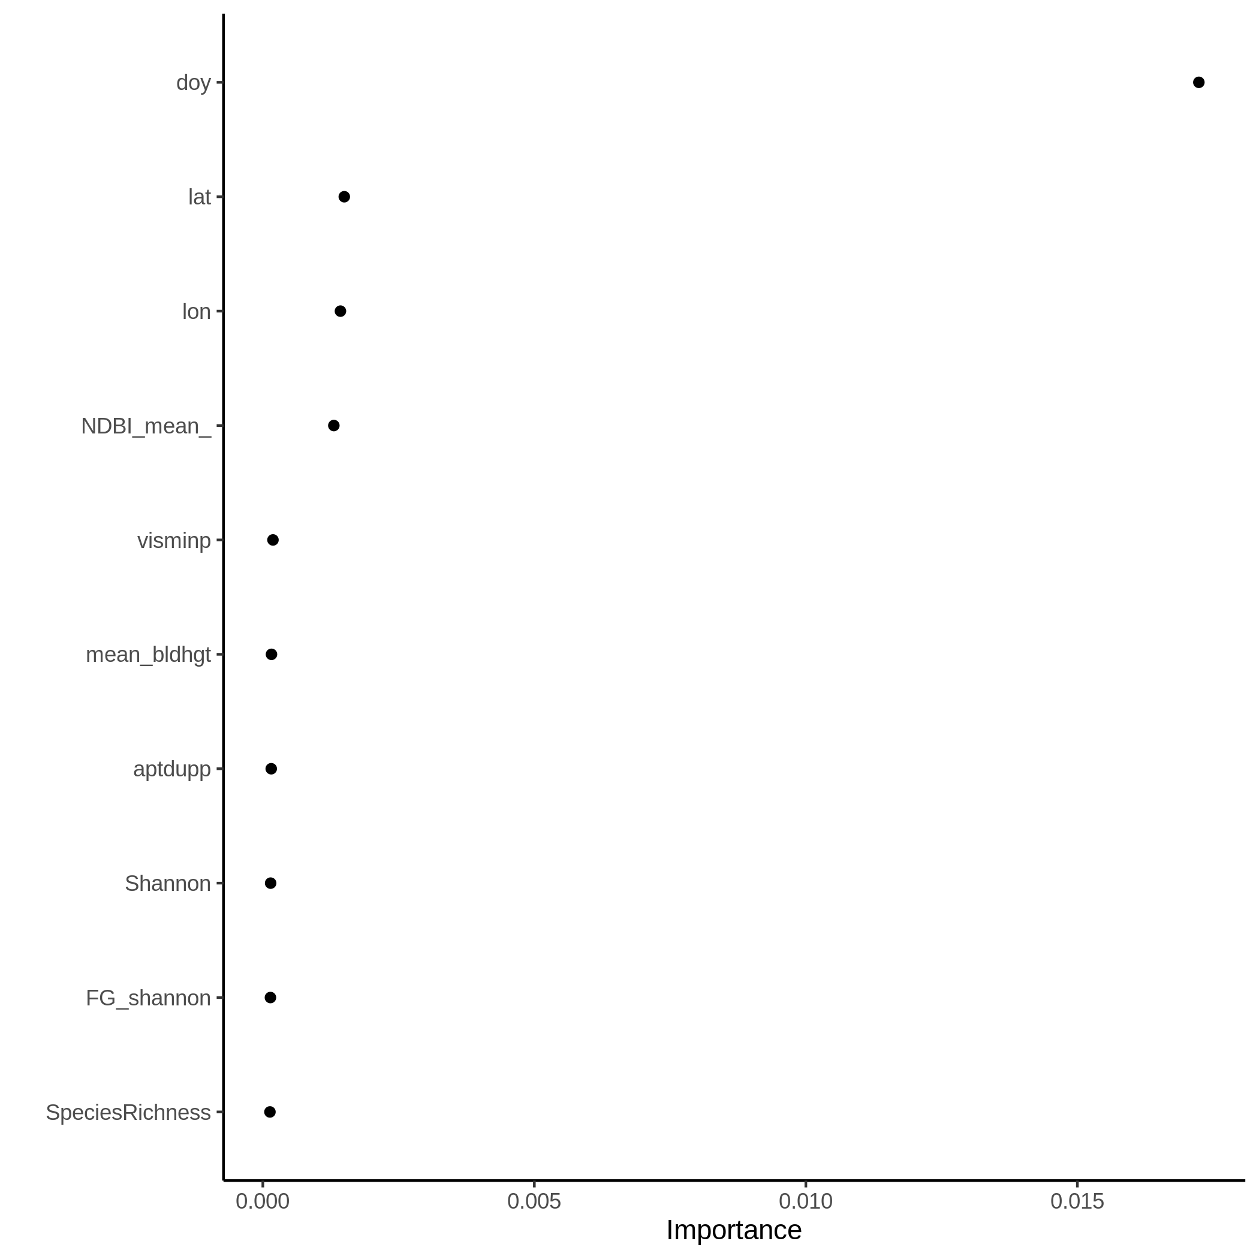
Figure A3.3b. Variable importance plot for carbon monoxide model at the city scale.
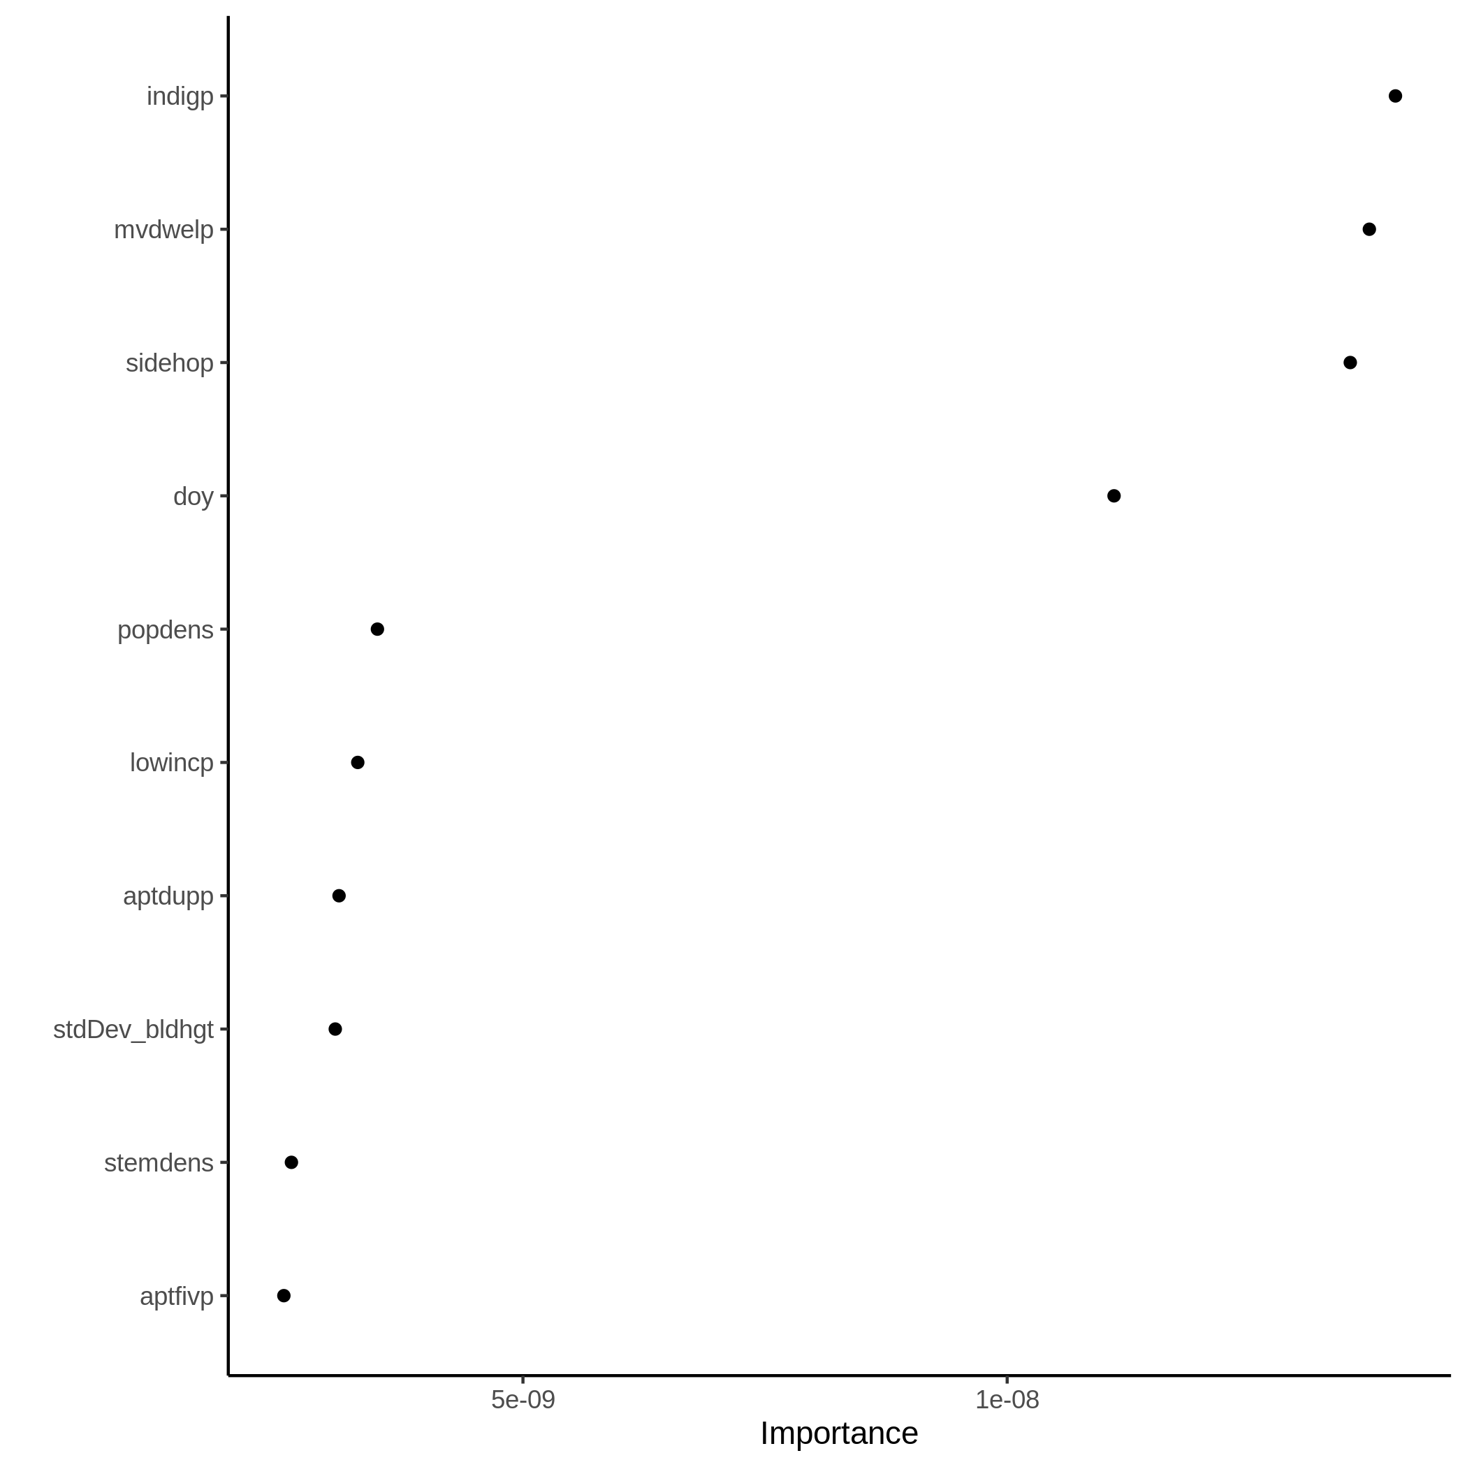
Figure A3.3c. Variable importance plot for nitrogen dioxide model at the city scale.
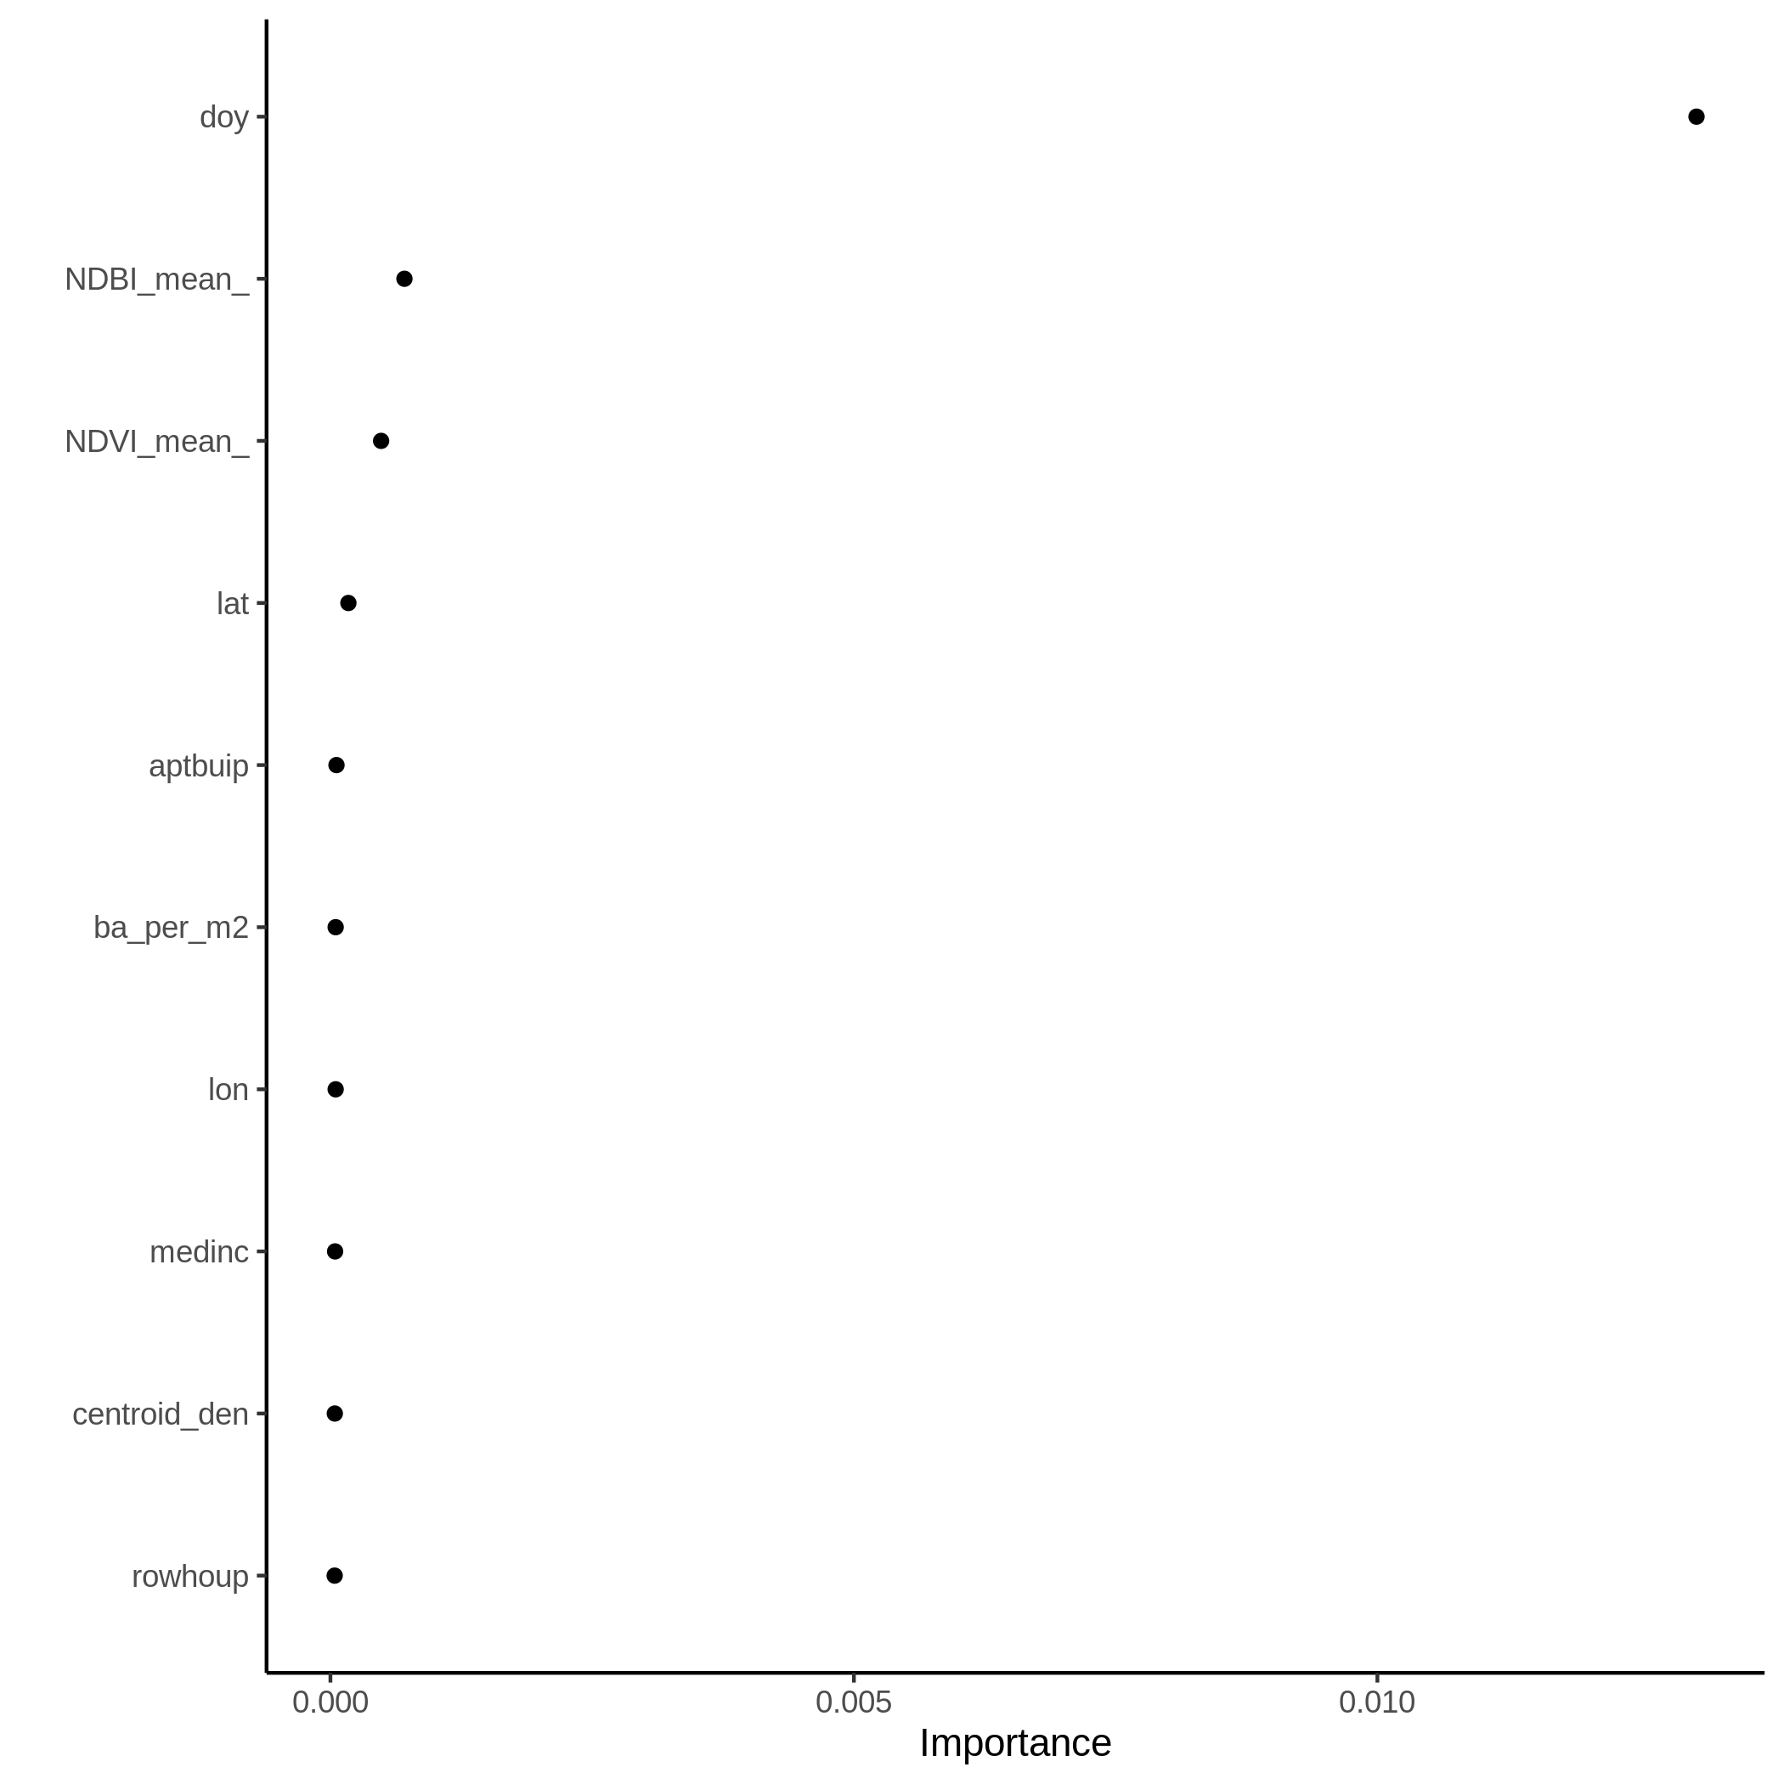
Figure A3.3d. Variable importance plot for ozone model at the city scale.
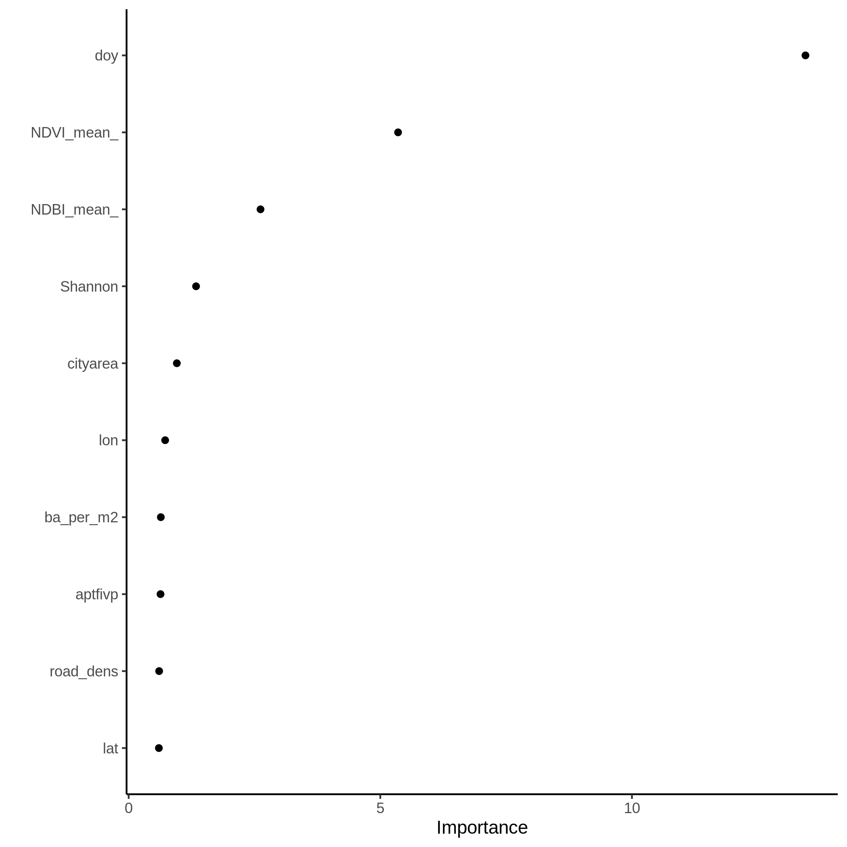
Figure A3.3e. Variable importance plot for UV aerosols model at the city scale.
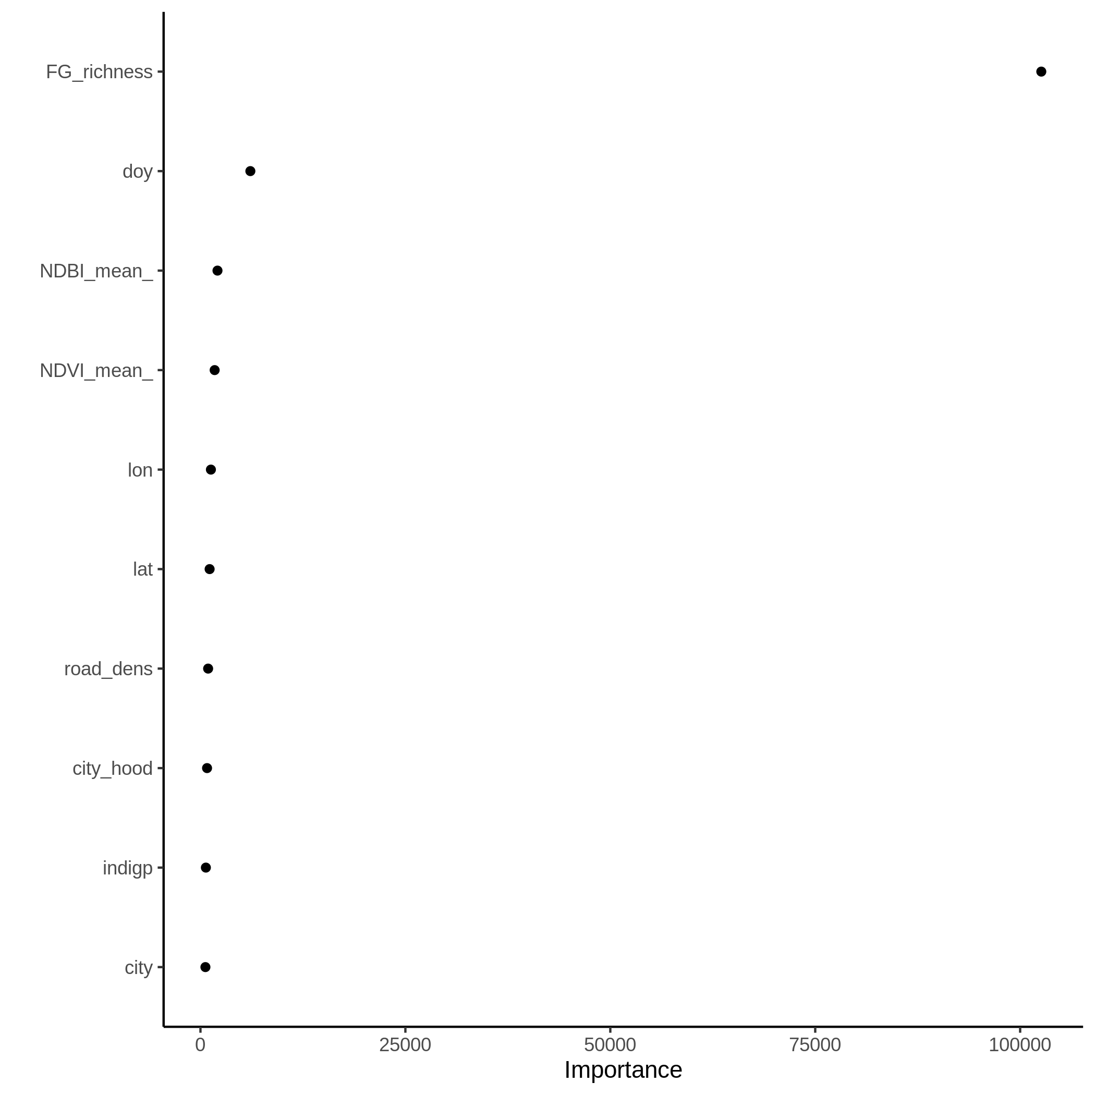
Figure A3.3f. Variable importance plot for temperature model at the neighbourhood scale.
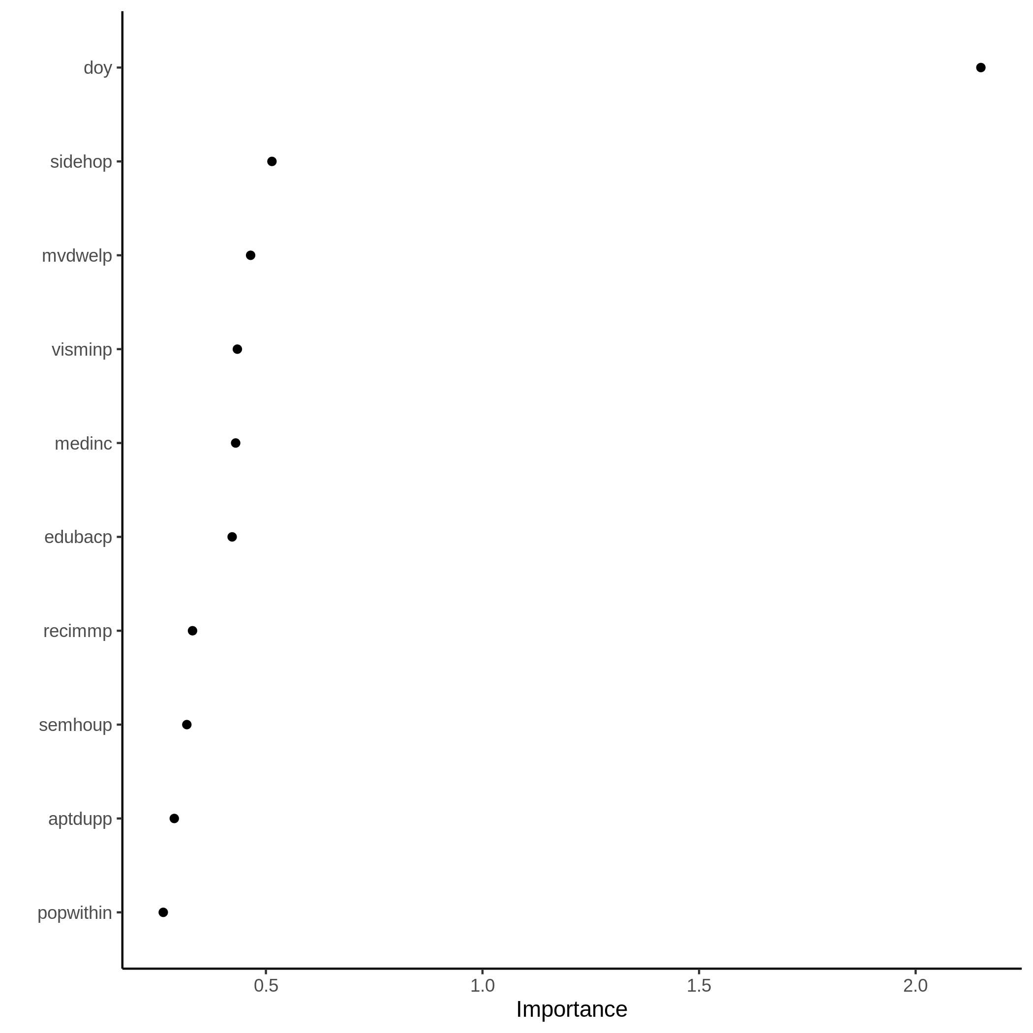
Figure A3.3g. Variable importance plot for carbon monoxide model at the neighbourhood scale.
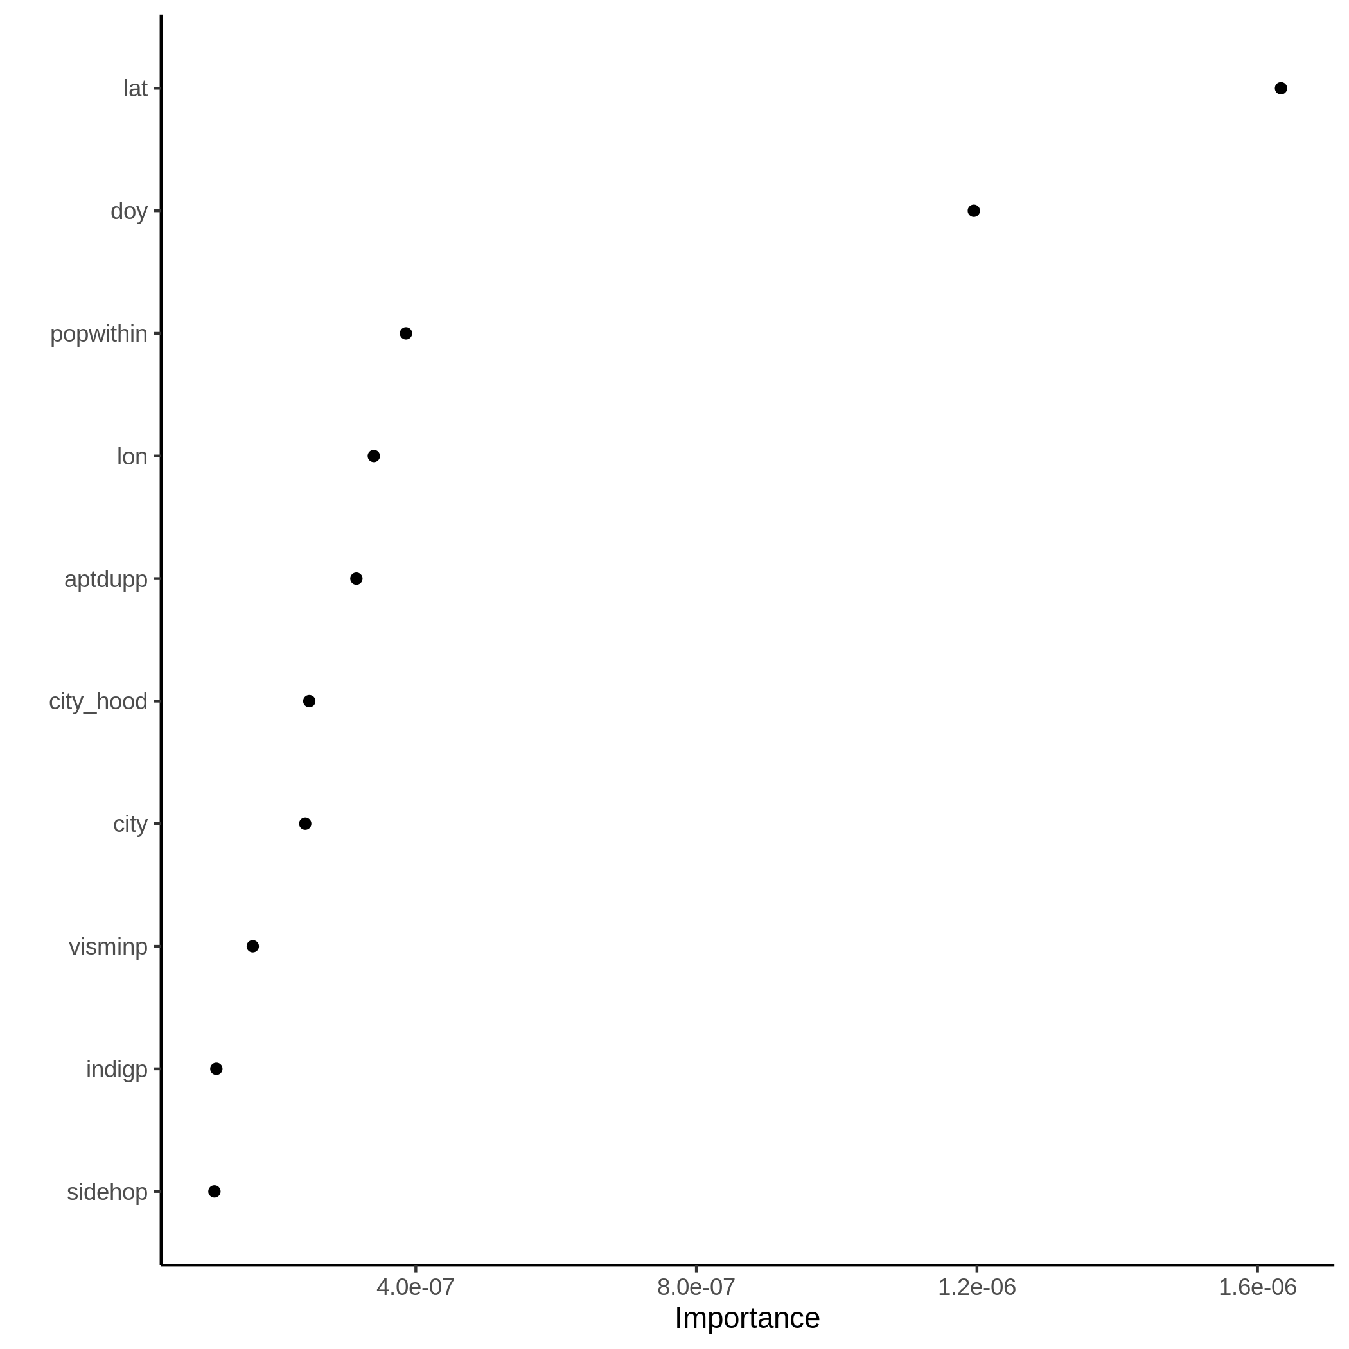
Figure A3.3h. Variable importance plot for nitrogen dioxide model at the neighbourhood scale.
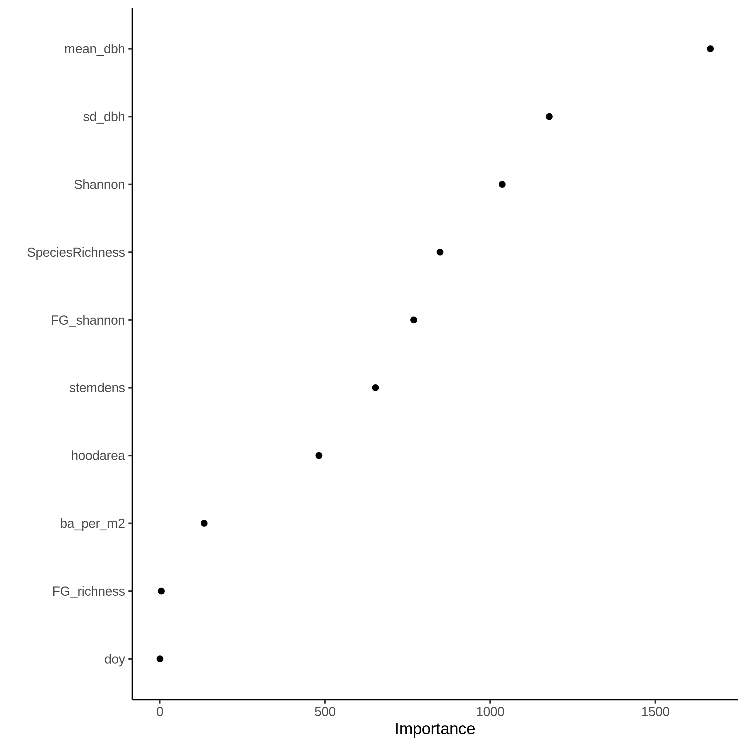
Figure A3.3i. Variable importance plot for ozone model at the neighbourhood scale.
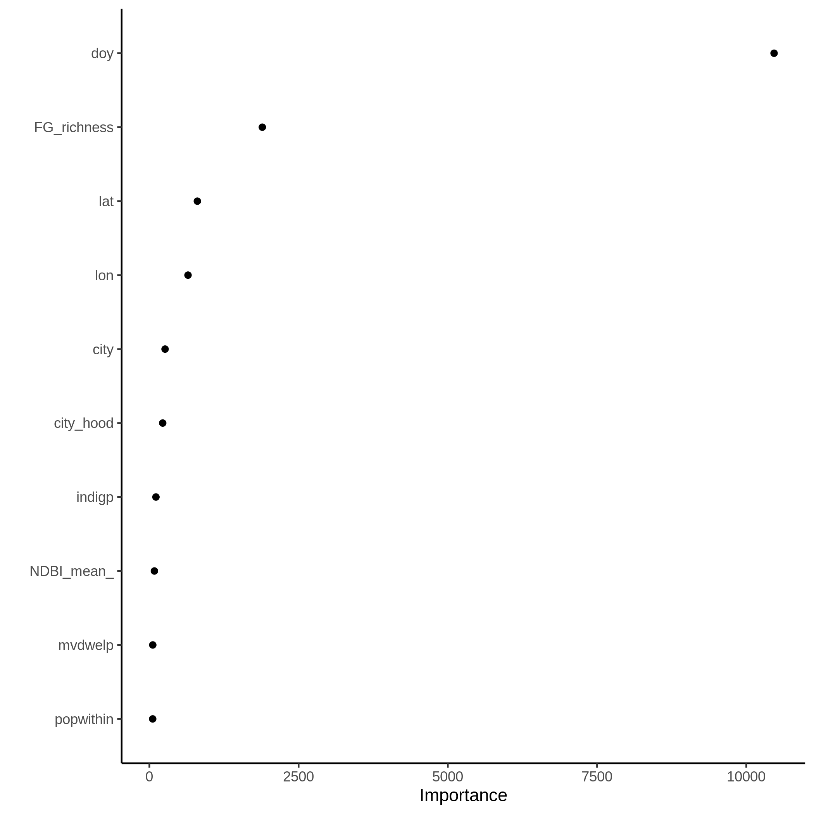
Figure A3.3j. Variable importance plot for UV aerosols model at the neighbourhood scale.
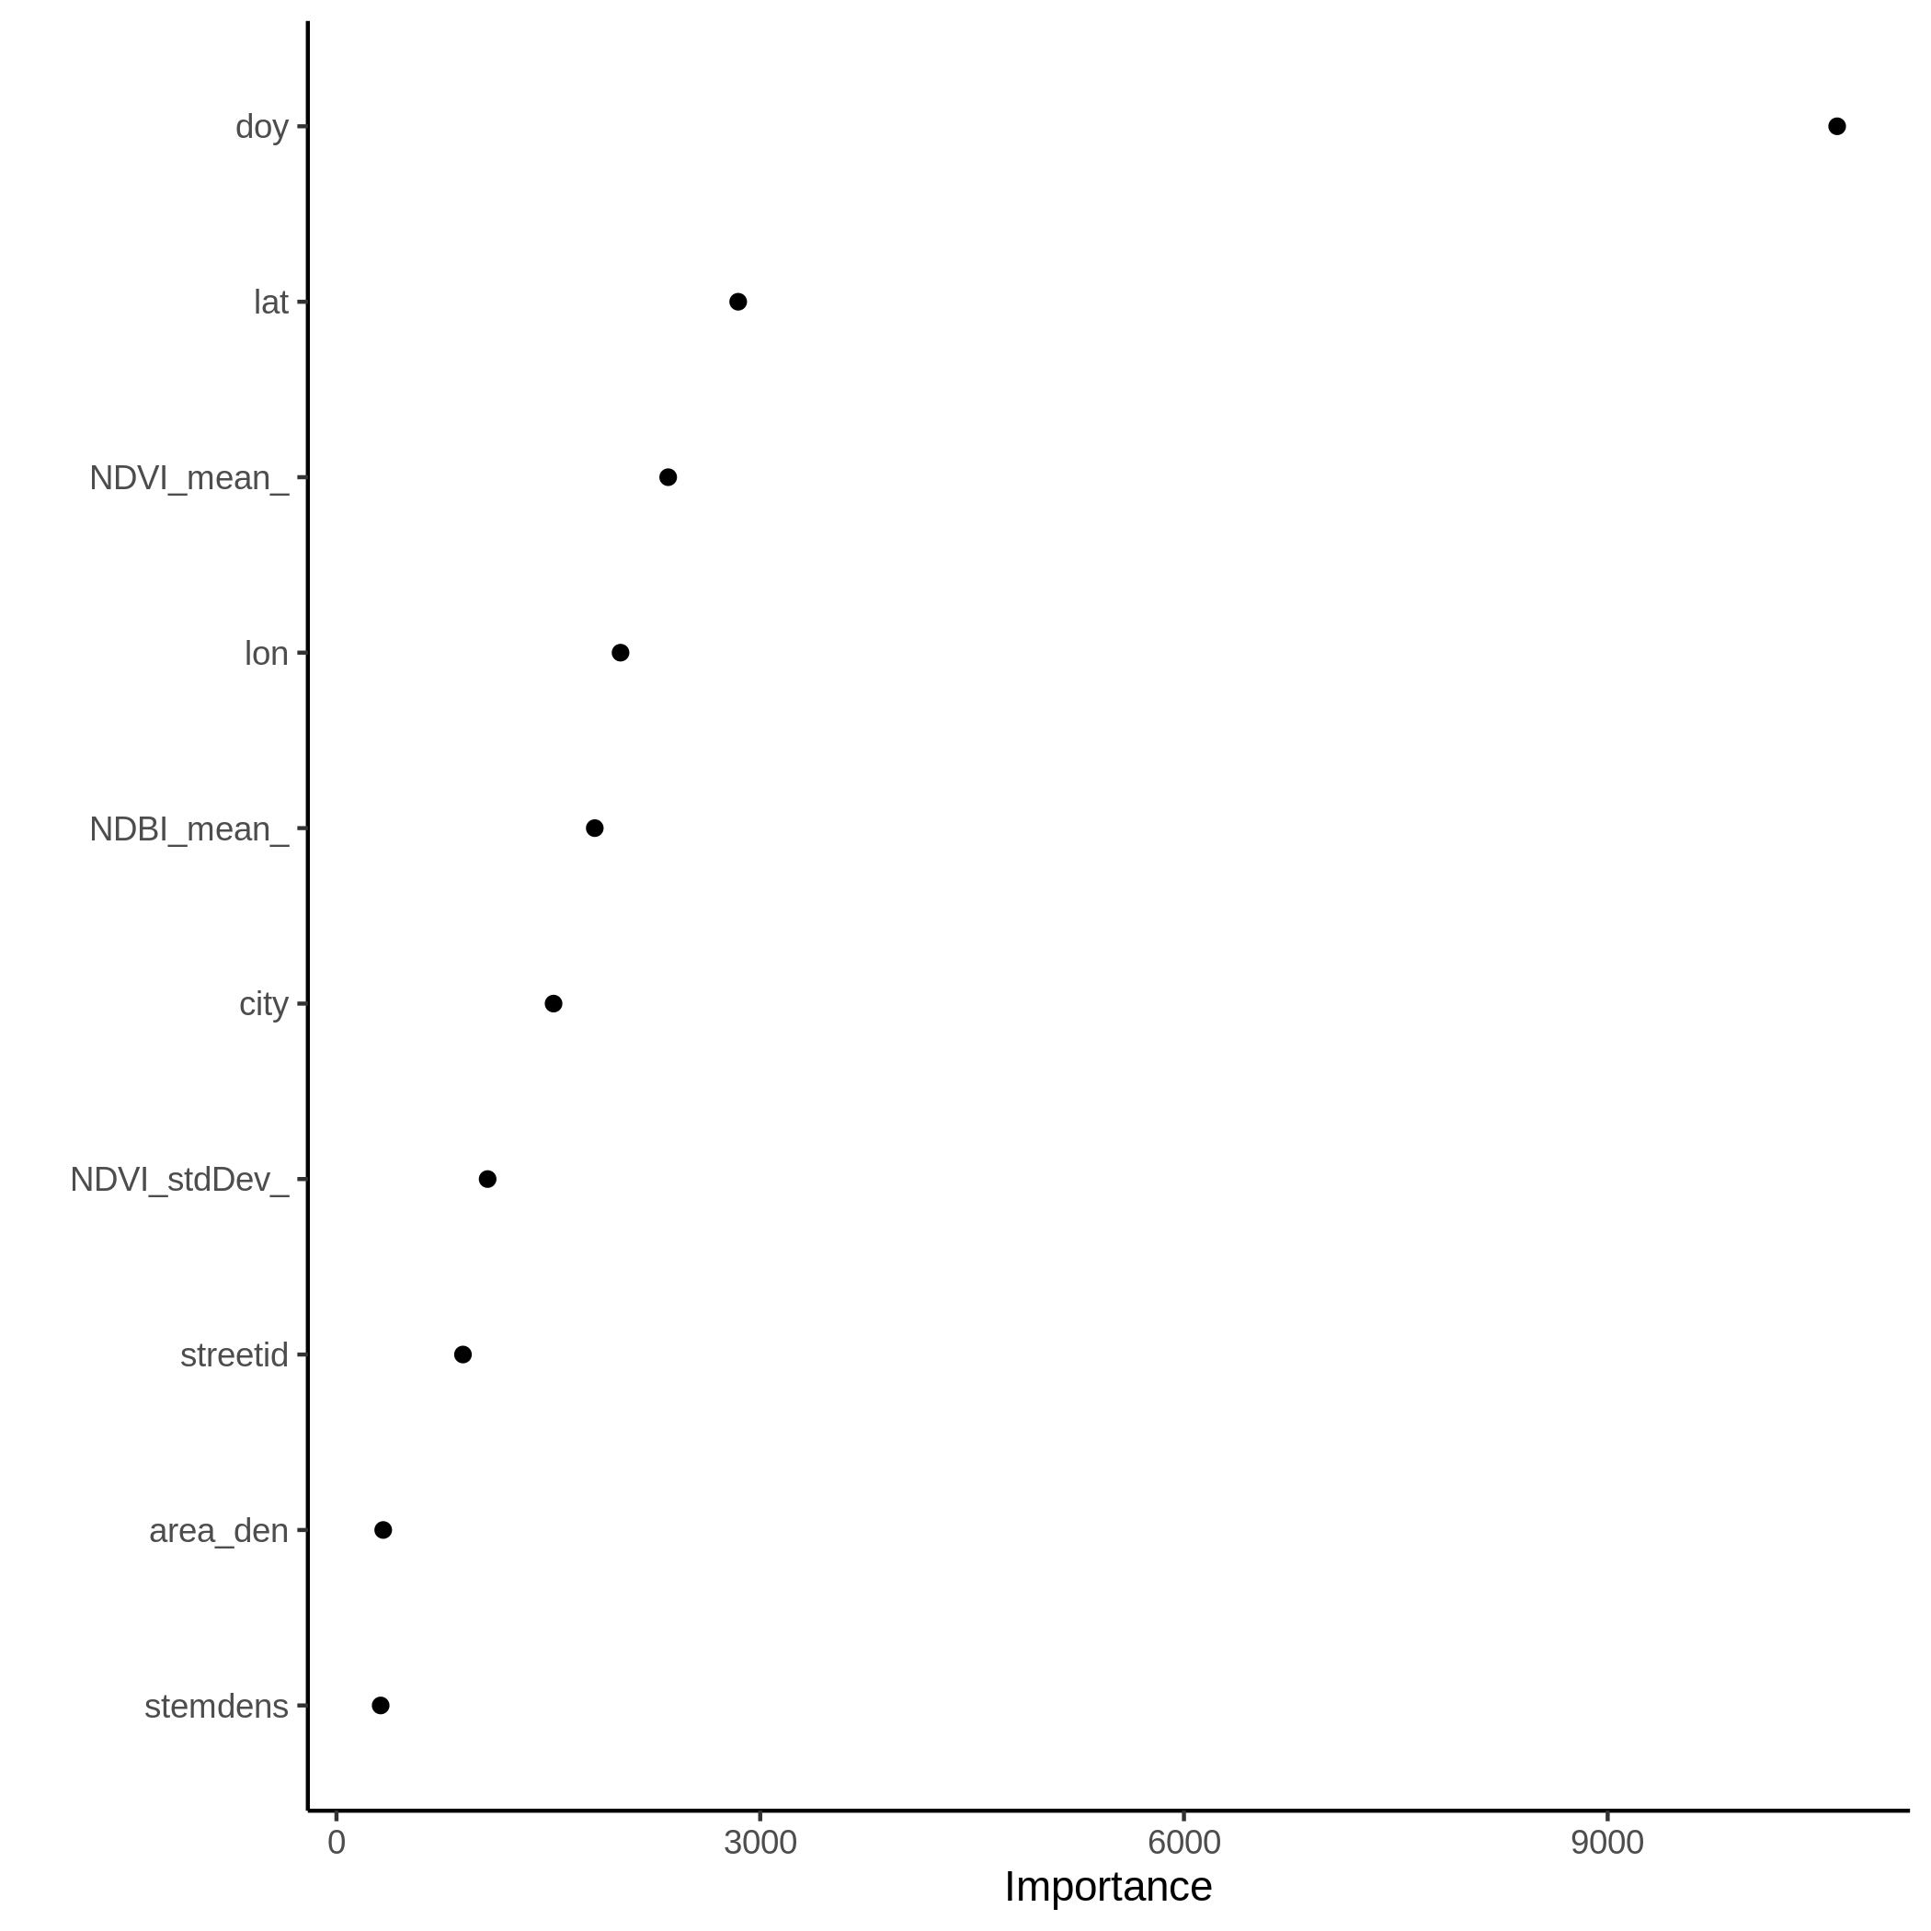
Figure A3.3k. Variable importance plot for temperature model at the street scale.
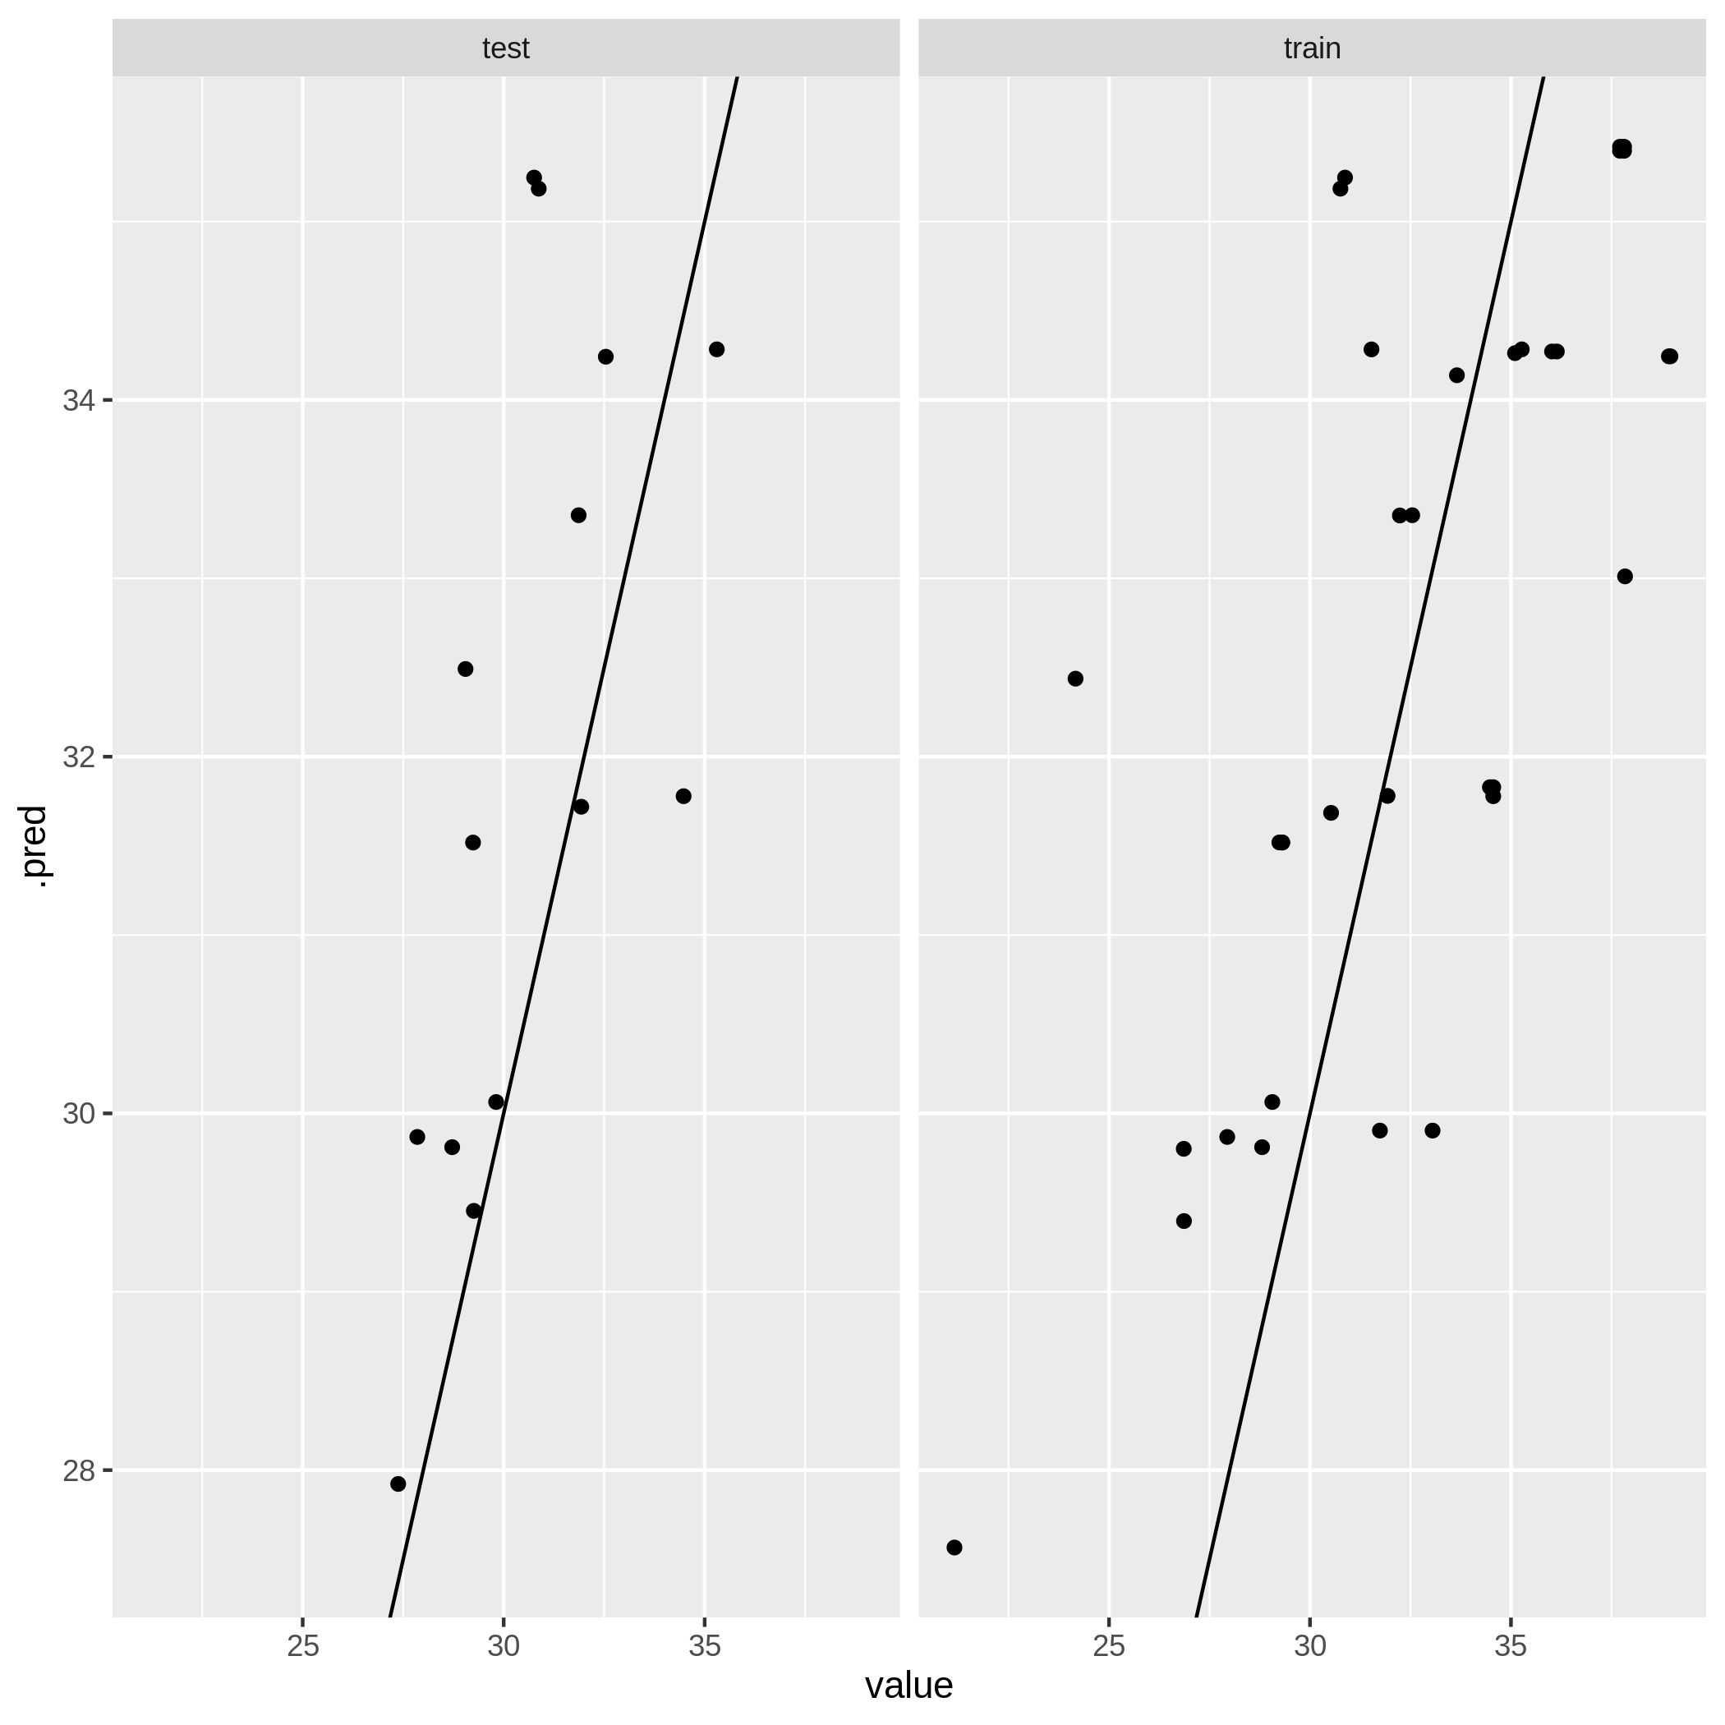
Figure A3.4a. Model performance plot for temperature model at the city scale.
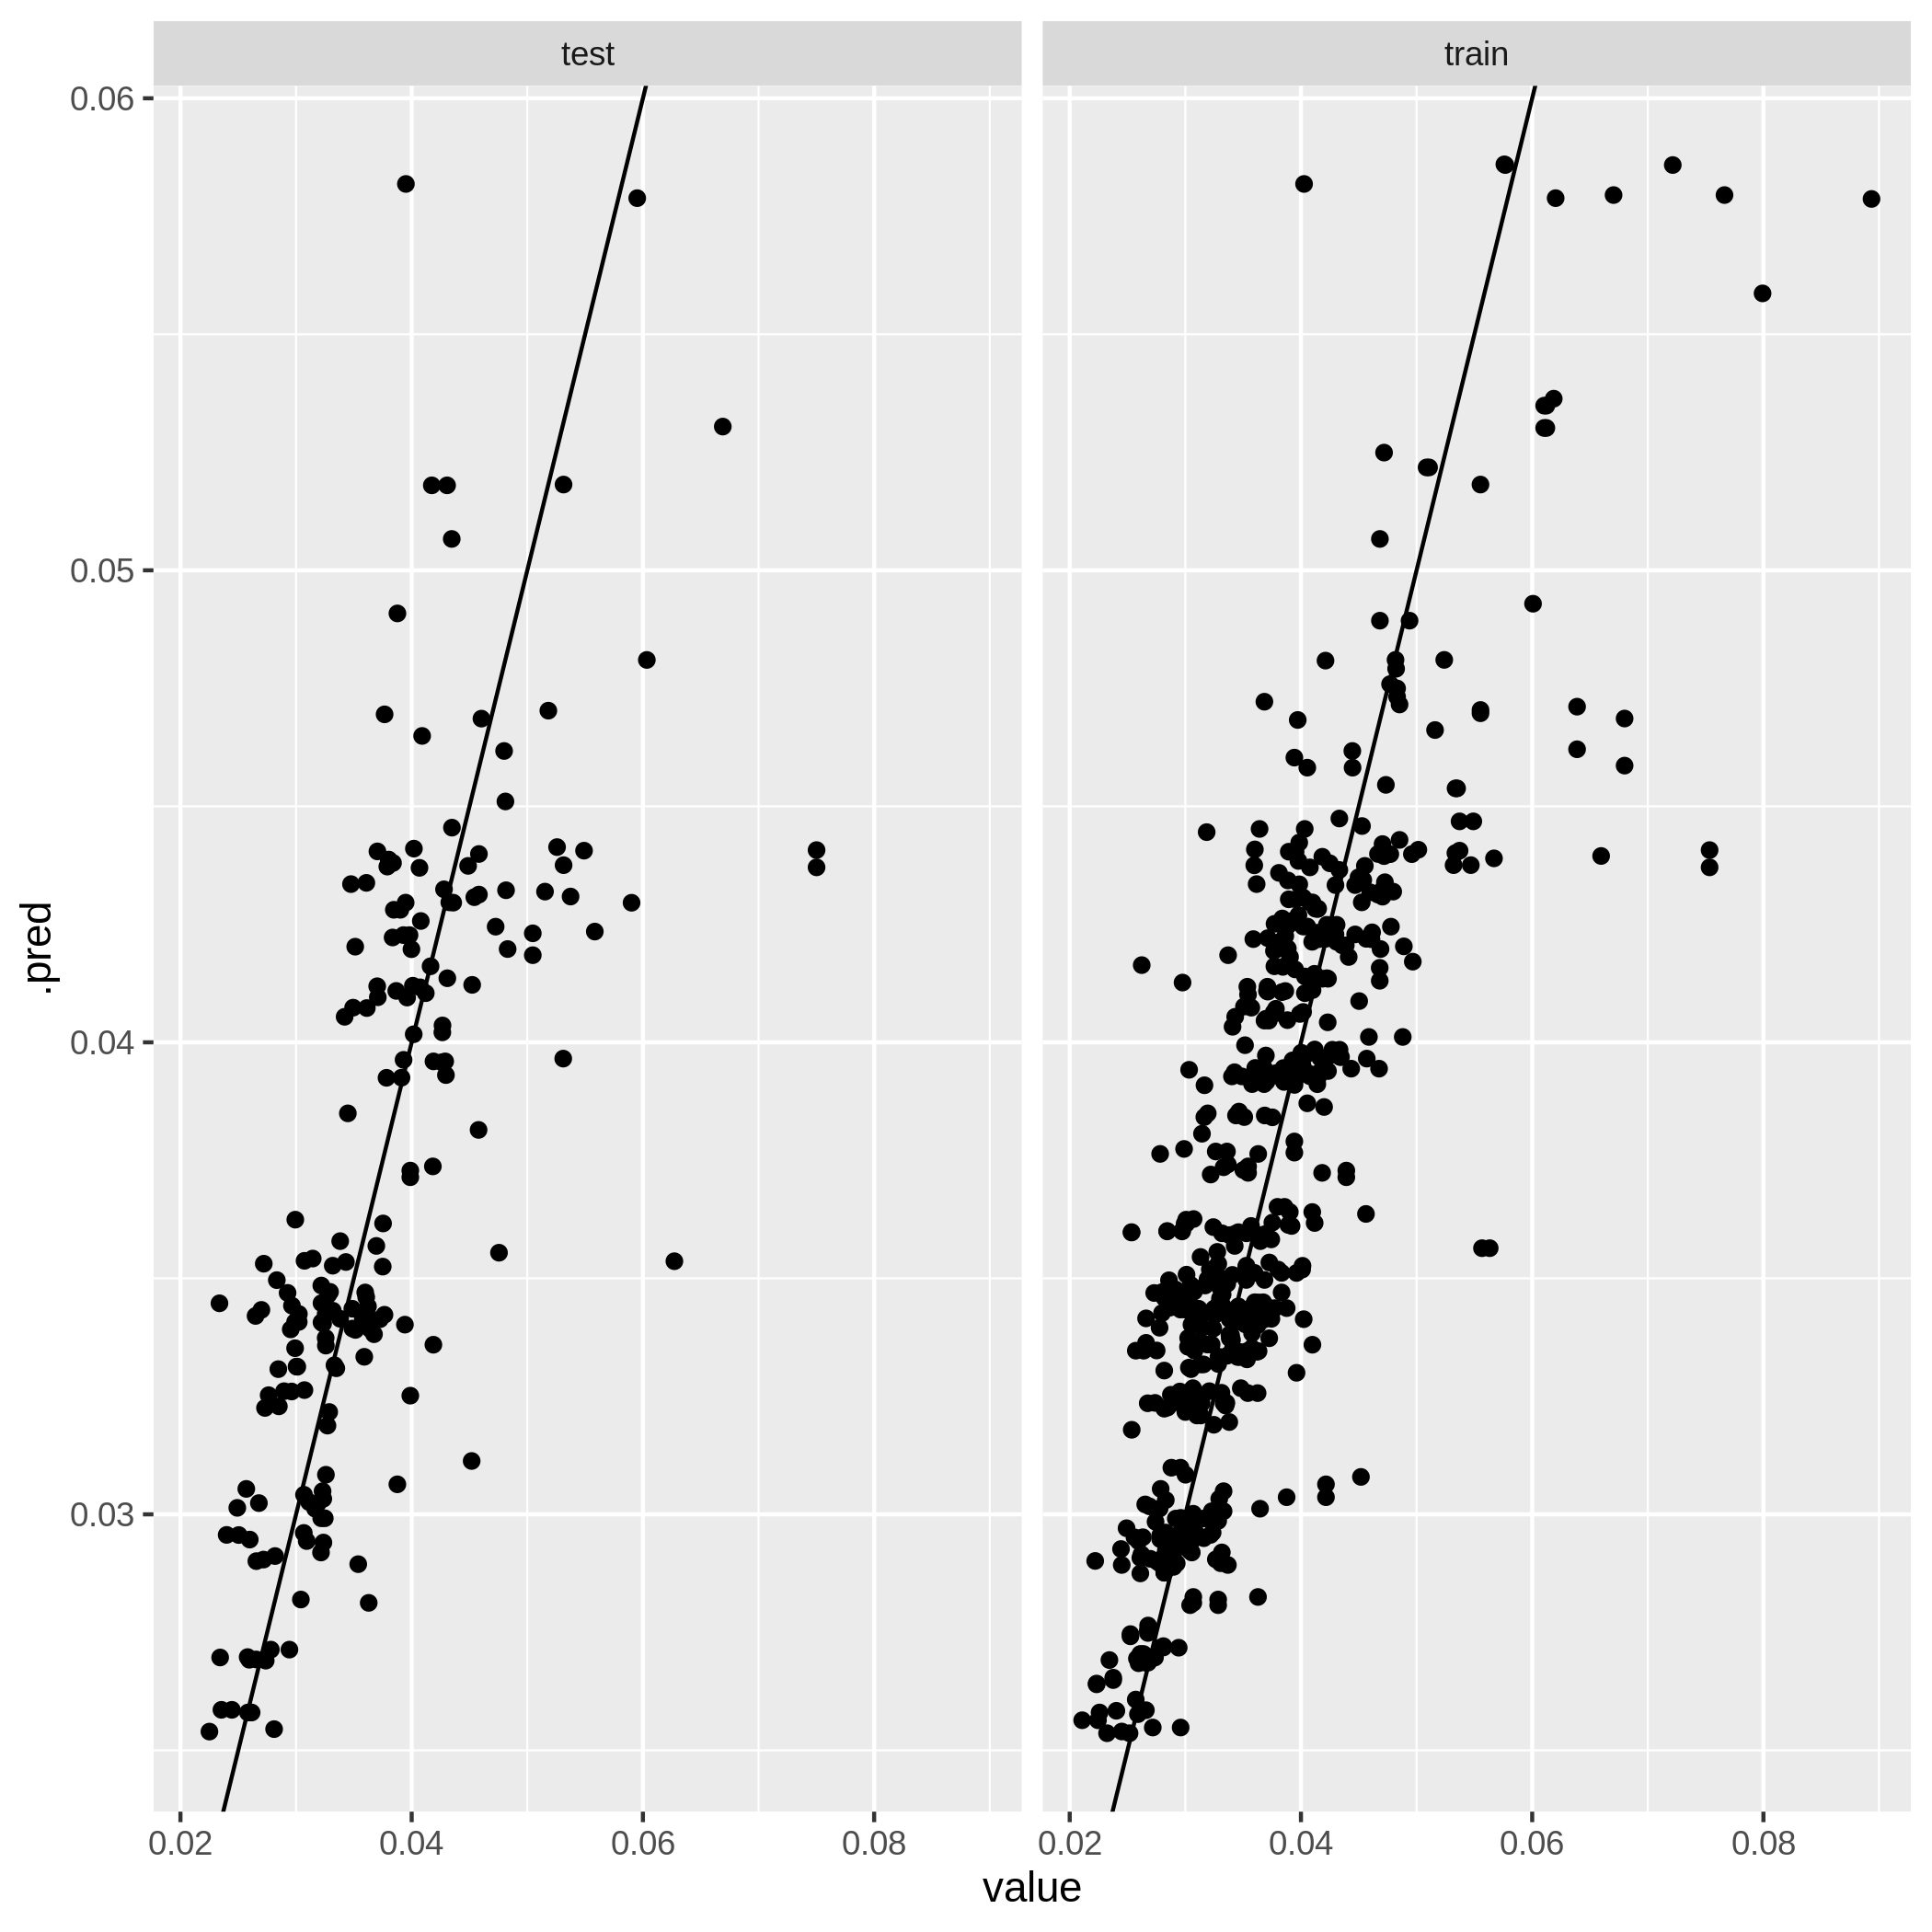
Figure A3.4b. Model performance plot for carbon monoxide model at the city scale.
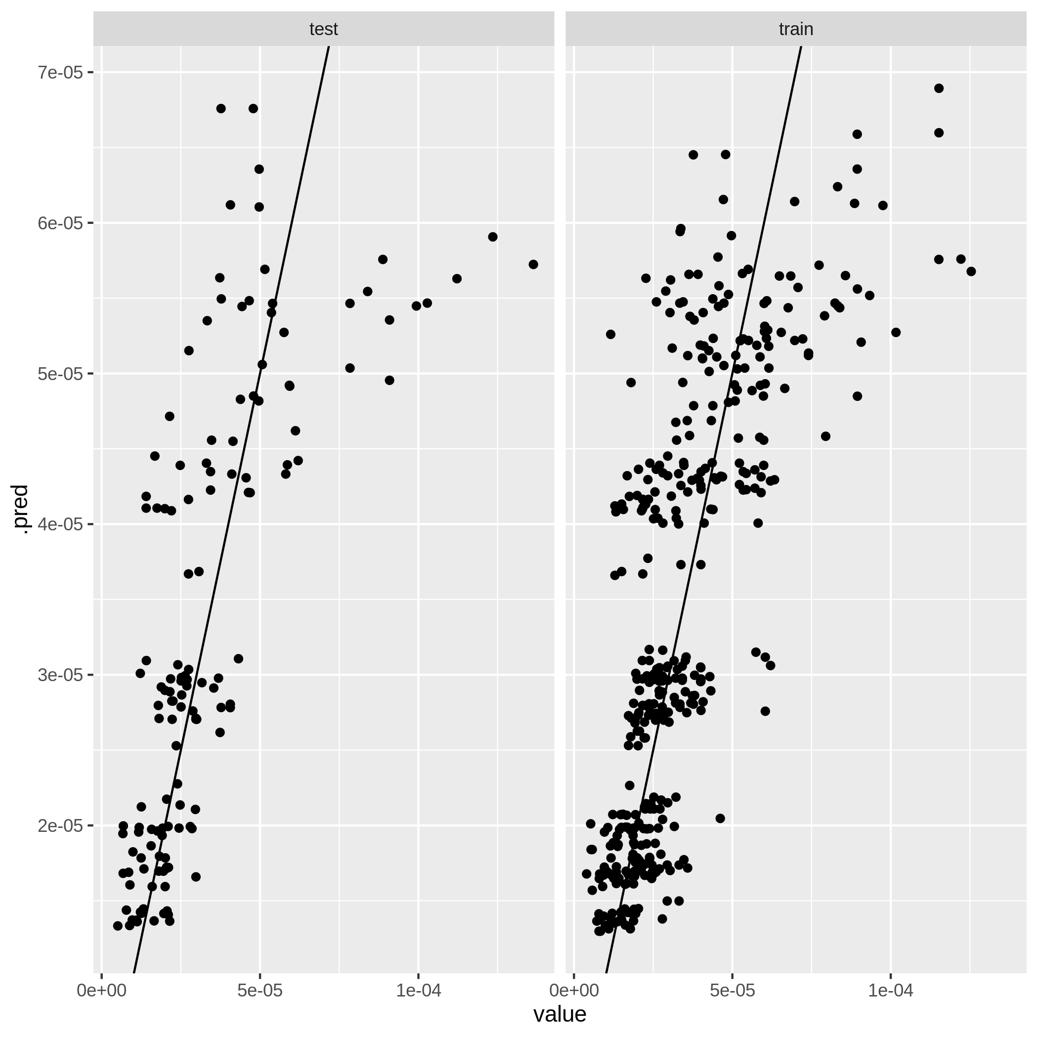
Figure A3.4c. Model performance plot for nitrogen dioxide model at the city scale.
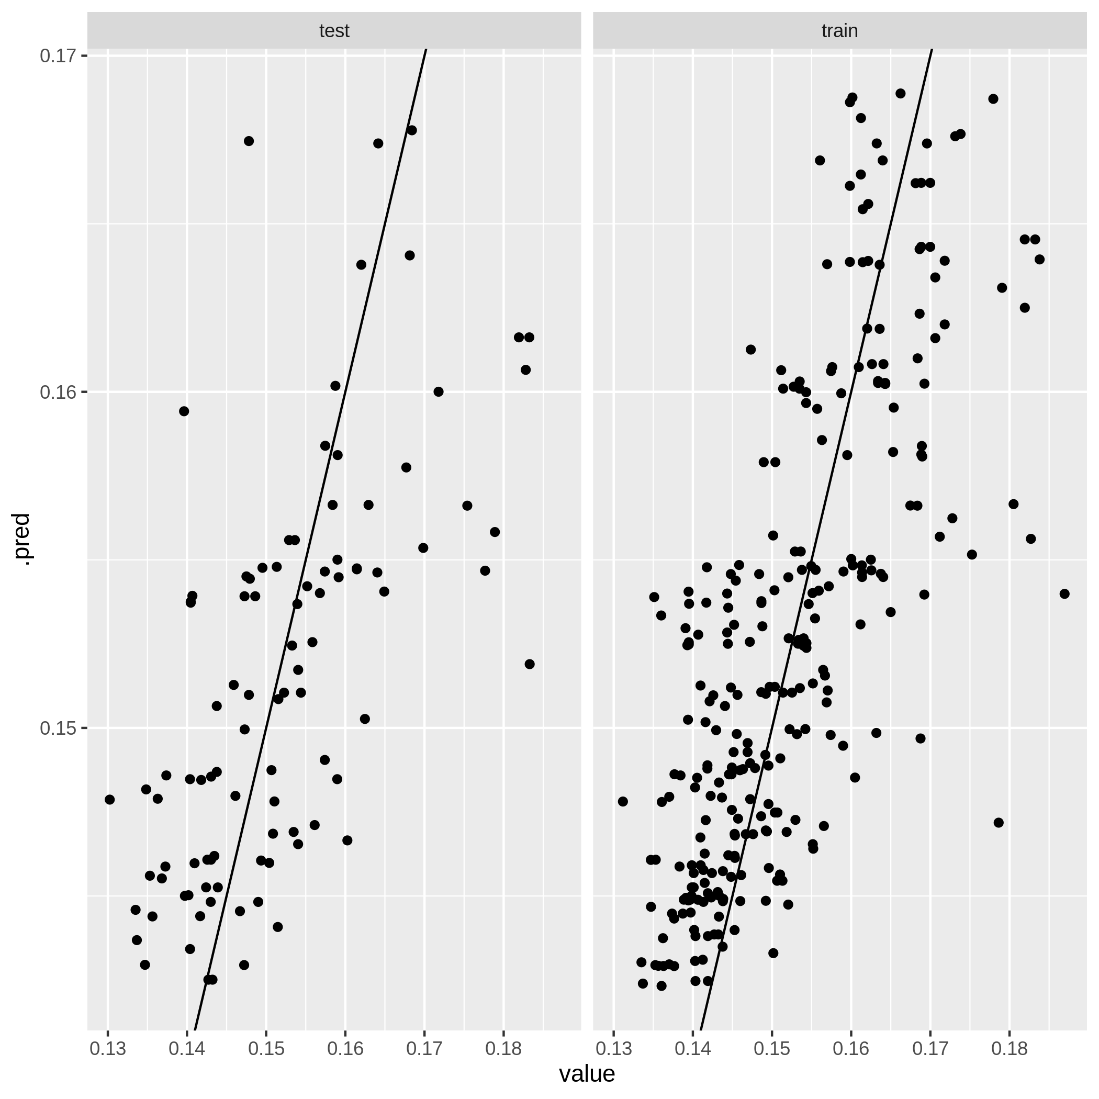
Figure A3.4d. Model performance plot for ozone model at the city scale.
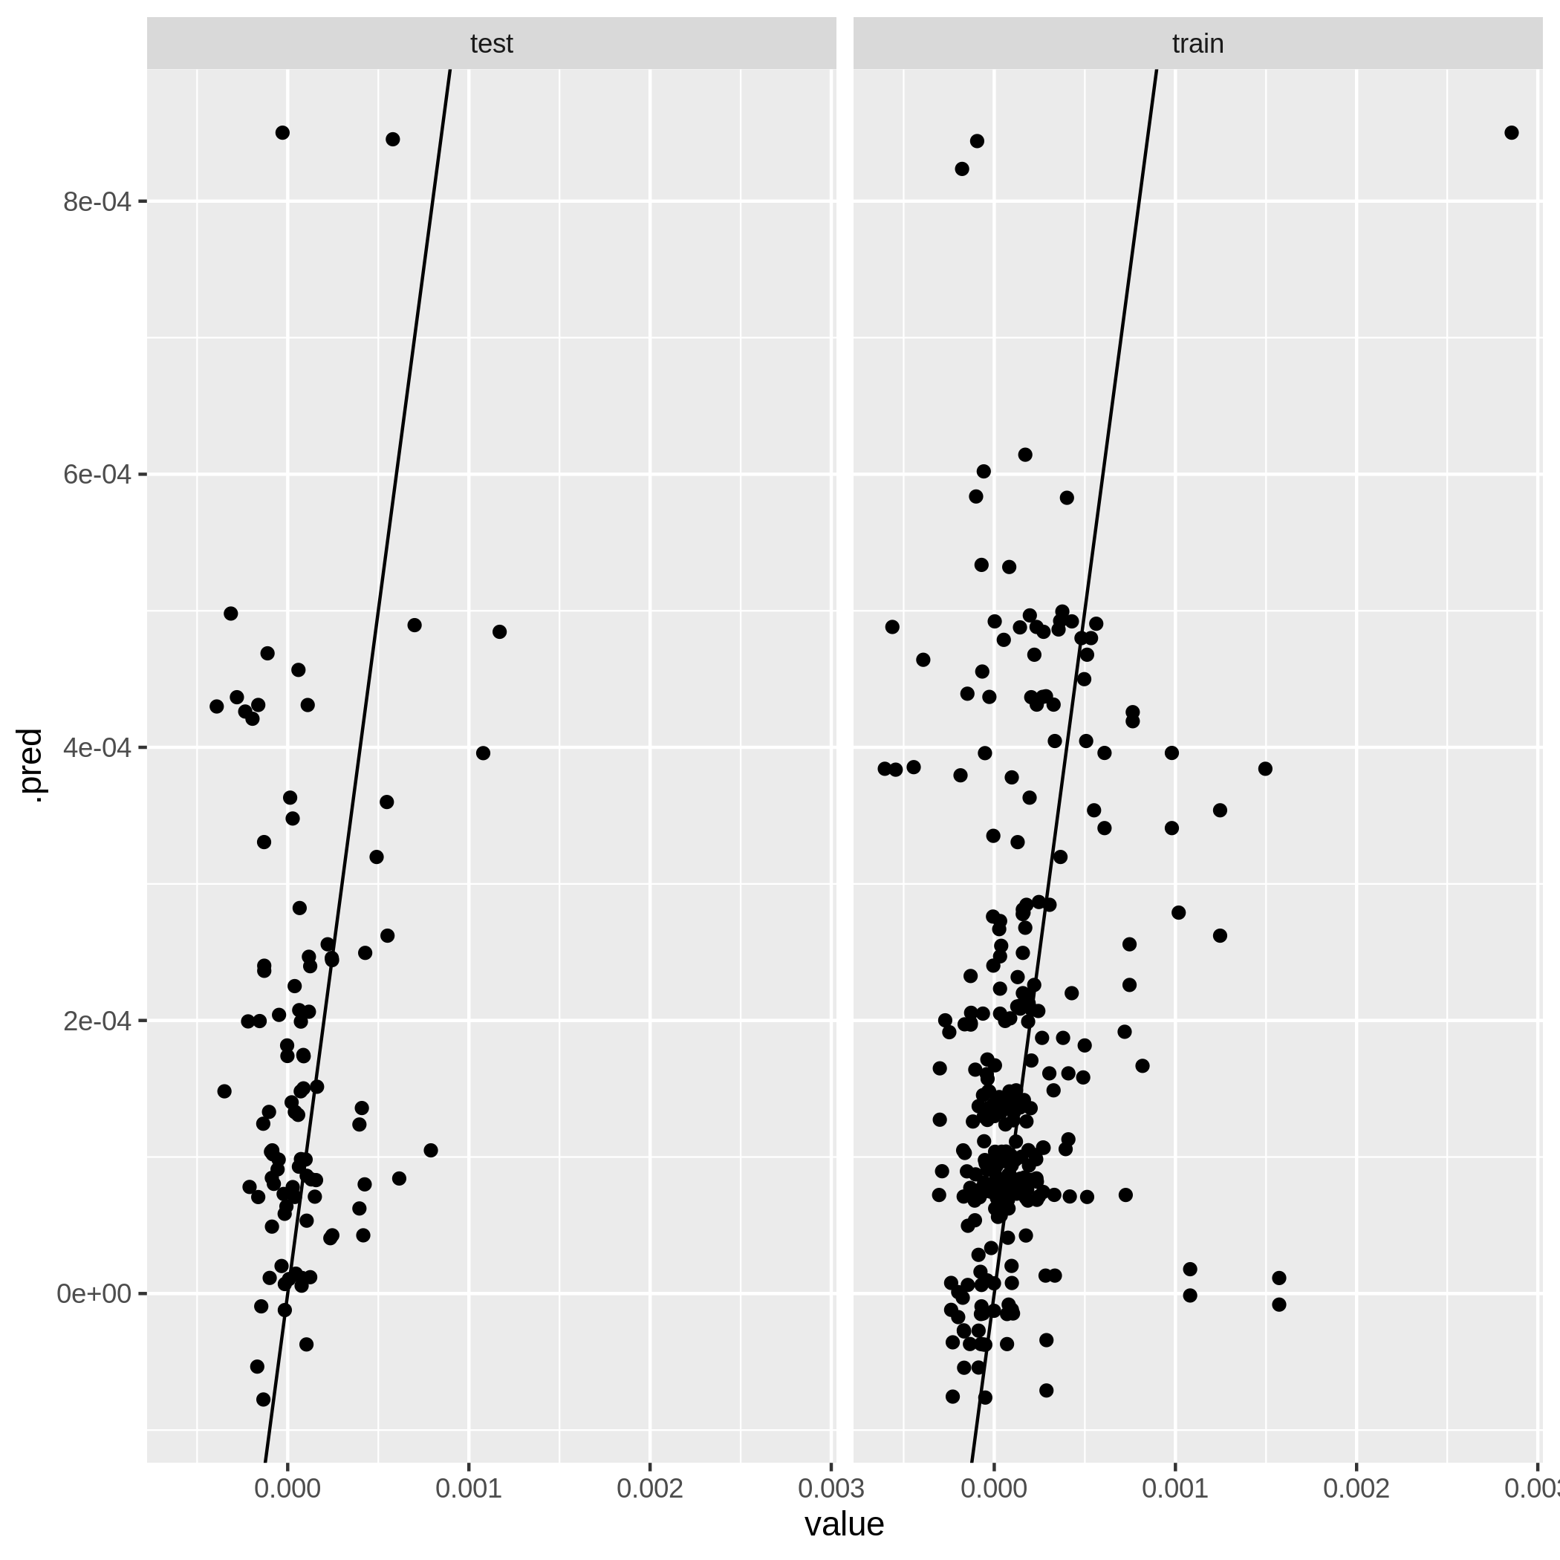
Figure A3.4e. Model performance plot for sulfur dioxide model at the city scale.
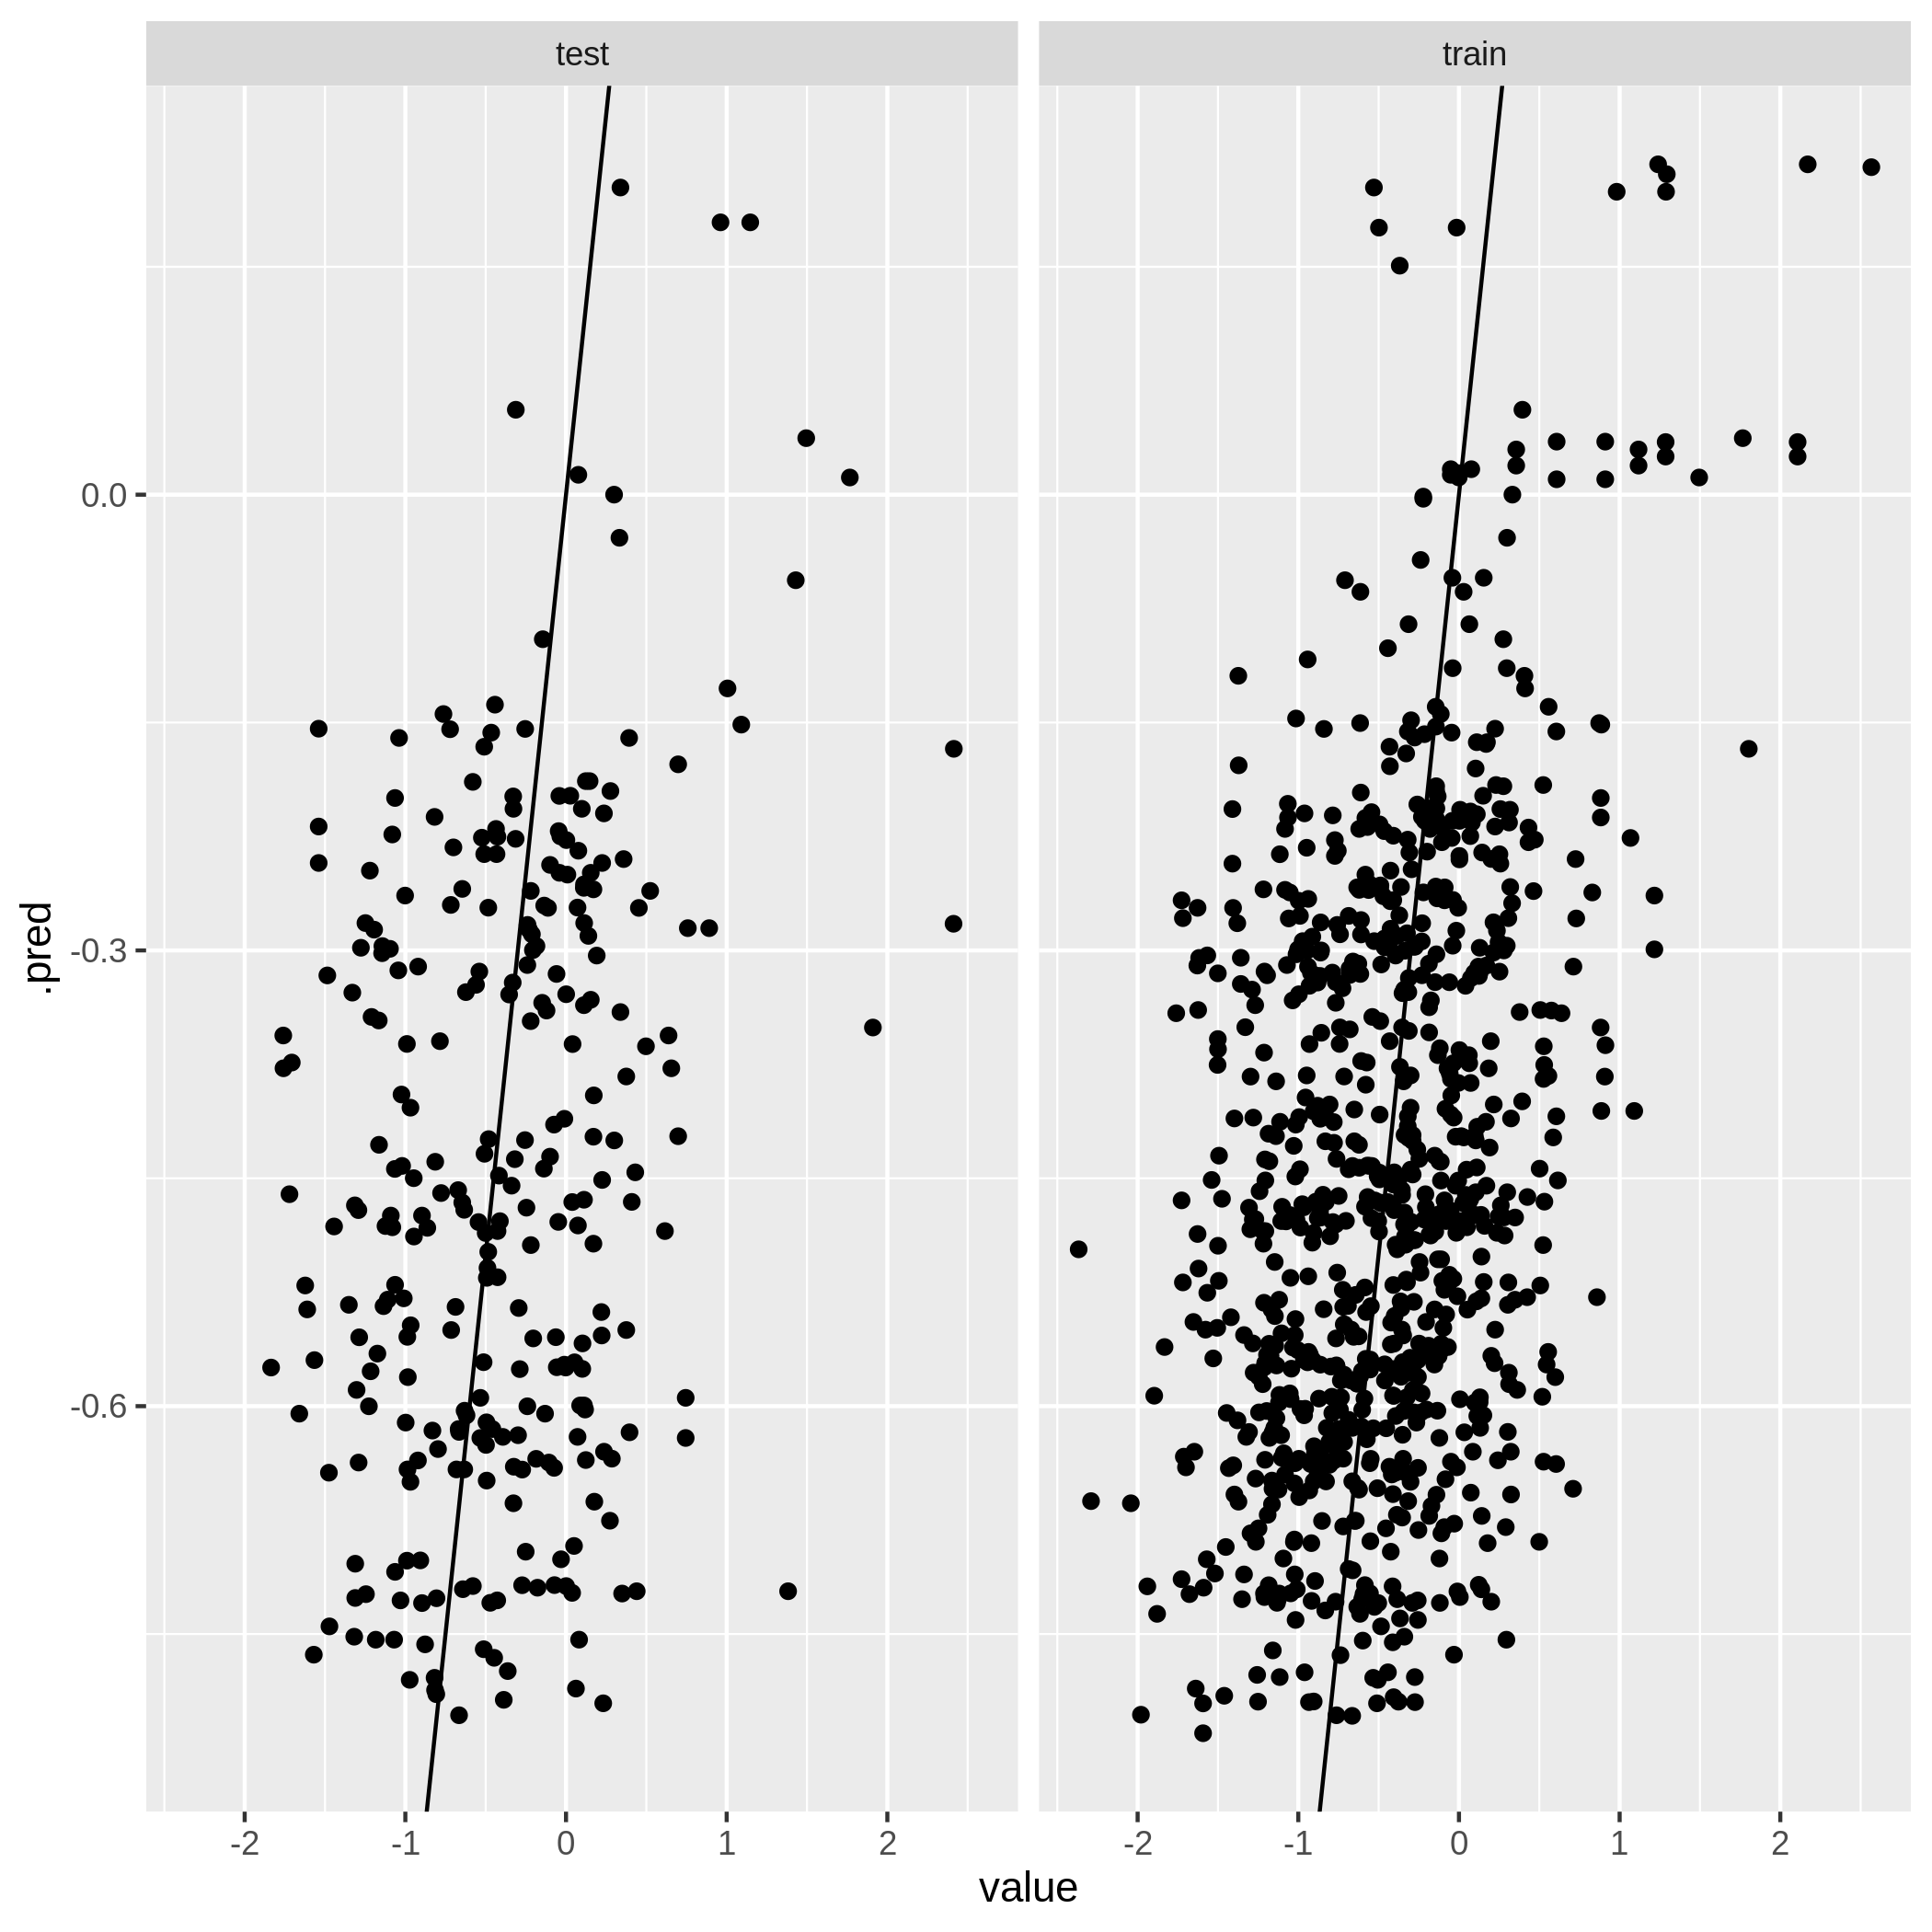
Figure A3.4f. Model performance plot for UV aerosols model at the city scale.
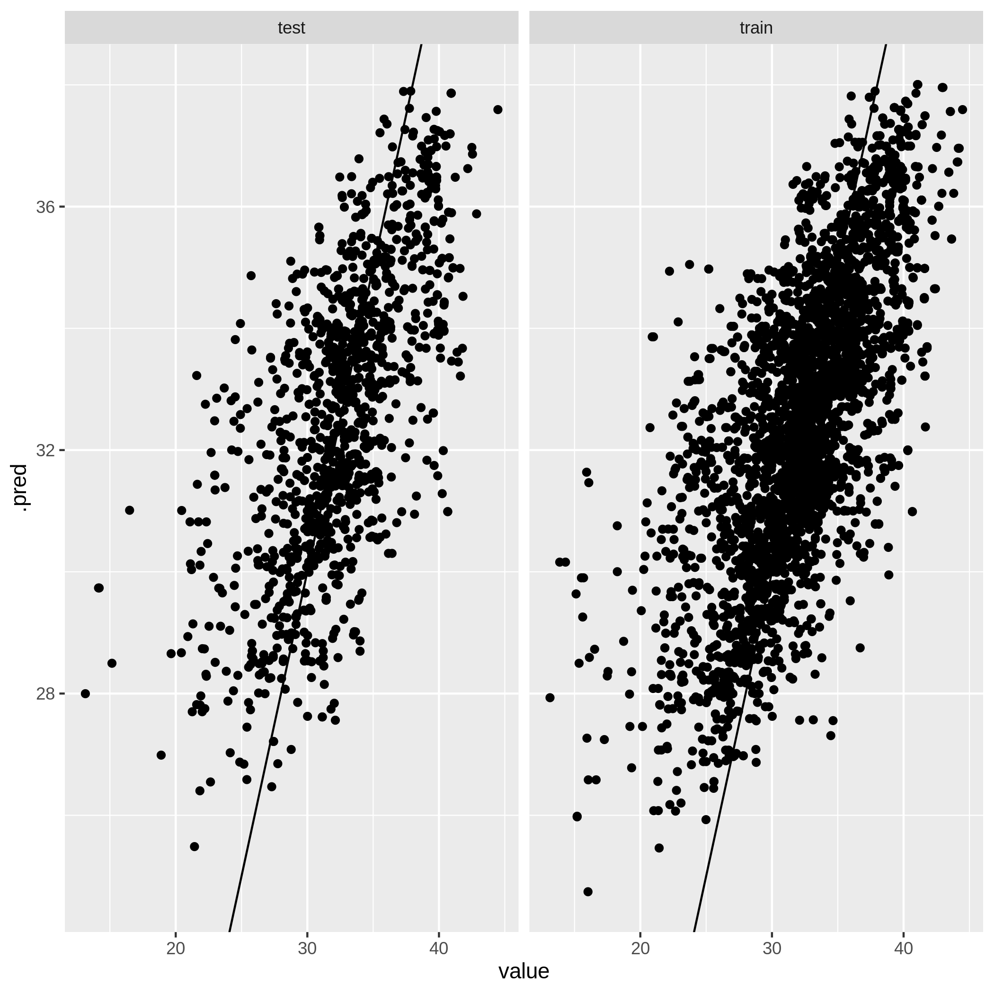
Figure A3.4g. Model performance plot for temperature model at the neighbourhood scale.
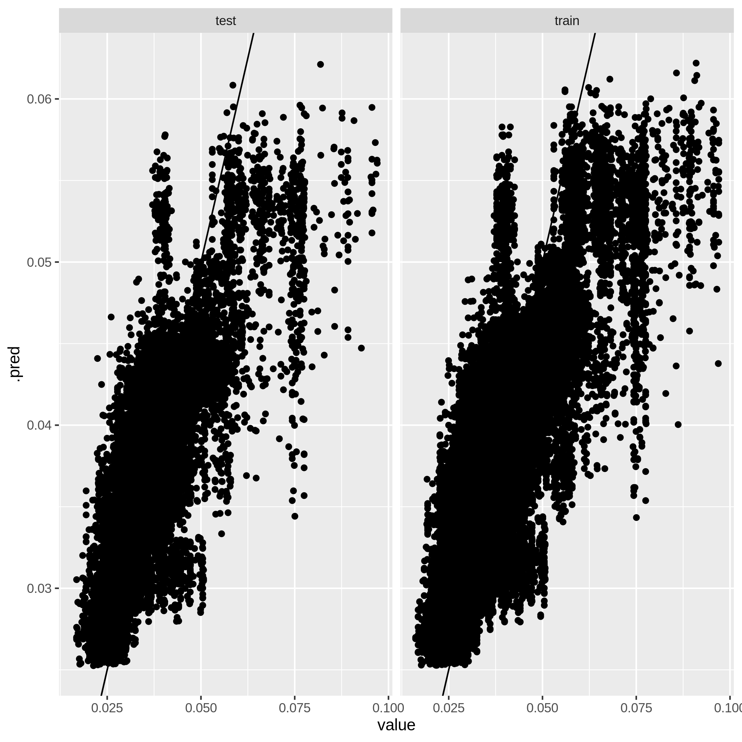
Figure A3.4h. Model performance plot for carbon monoxide model at the neighbourhood scale.
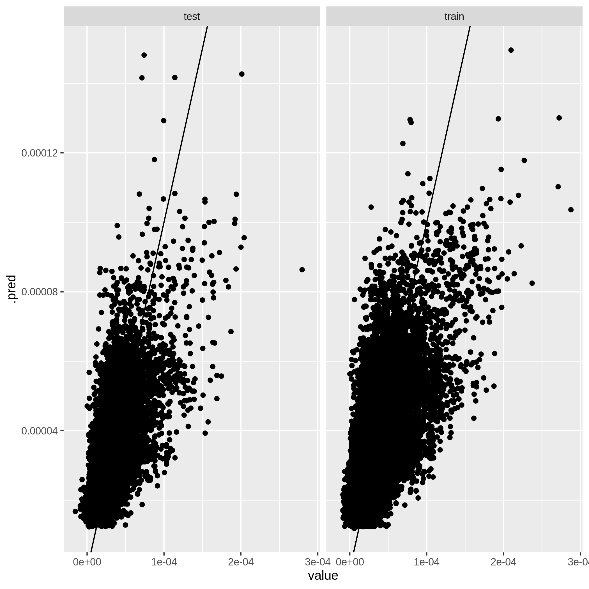
Figure A3.4i. Model performance plot for nitrogen dioxide model at the neighbourhood scale.
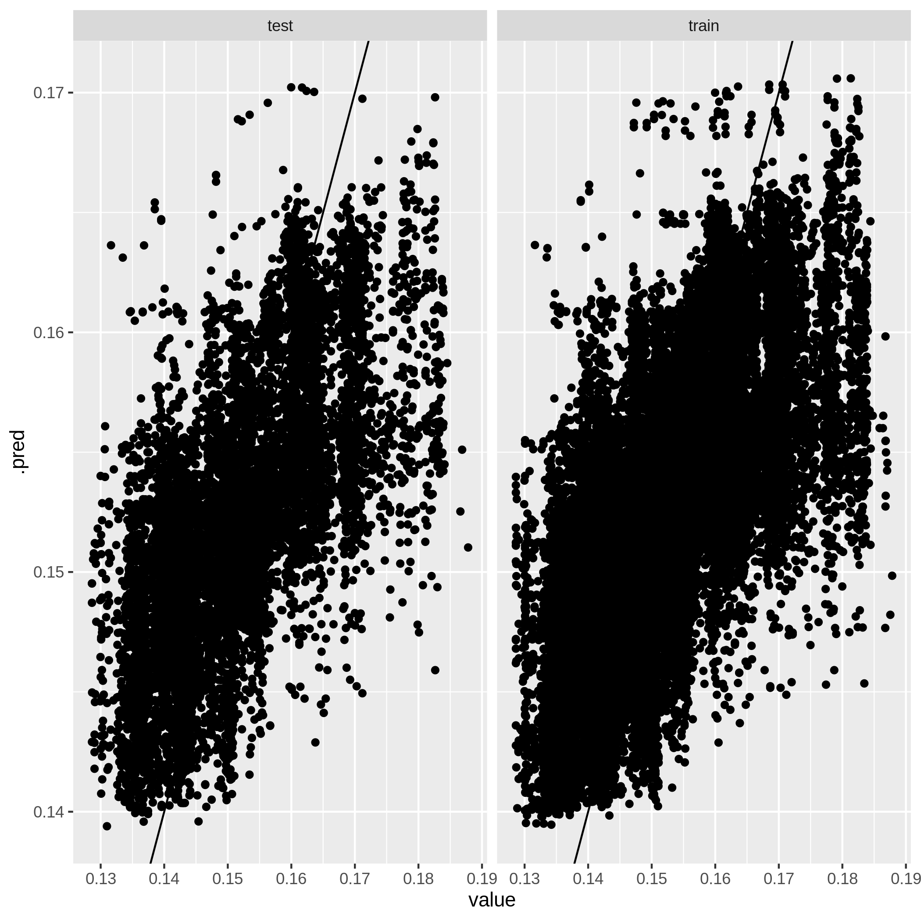
Figure A3.4j. Model performance plot for ozone model at the neighbourhood scale.
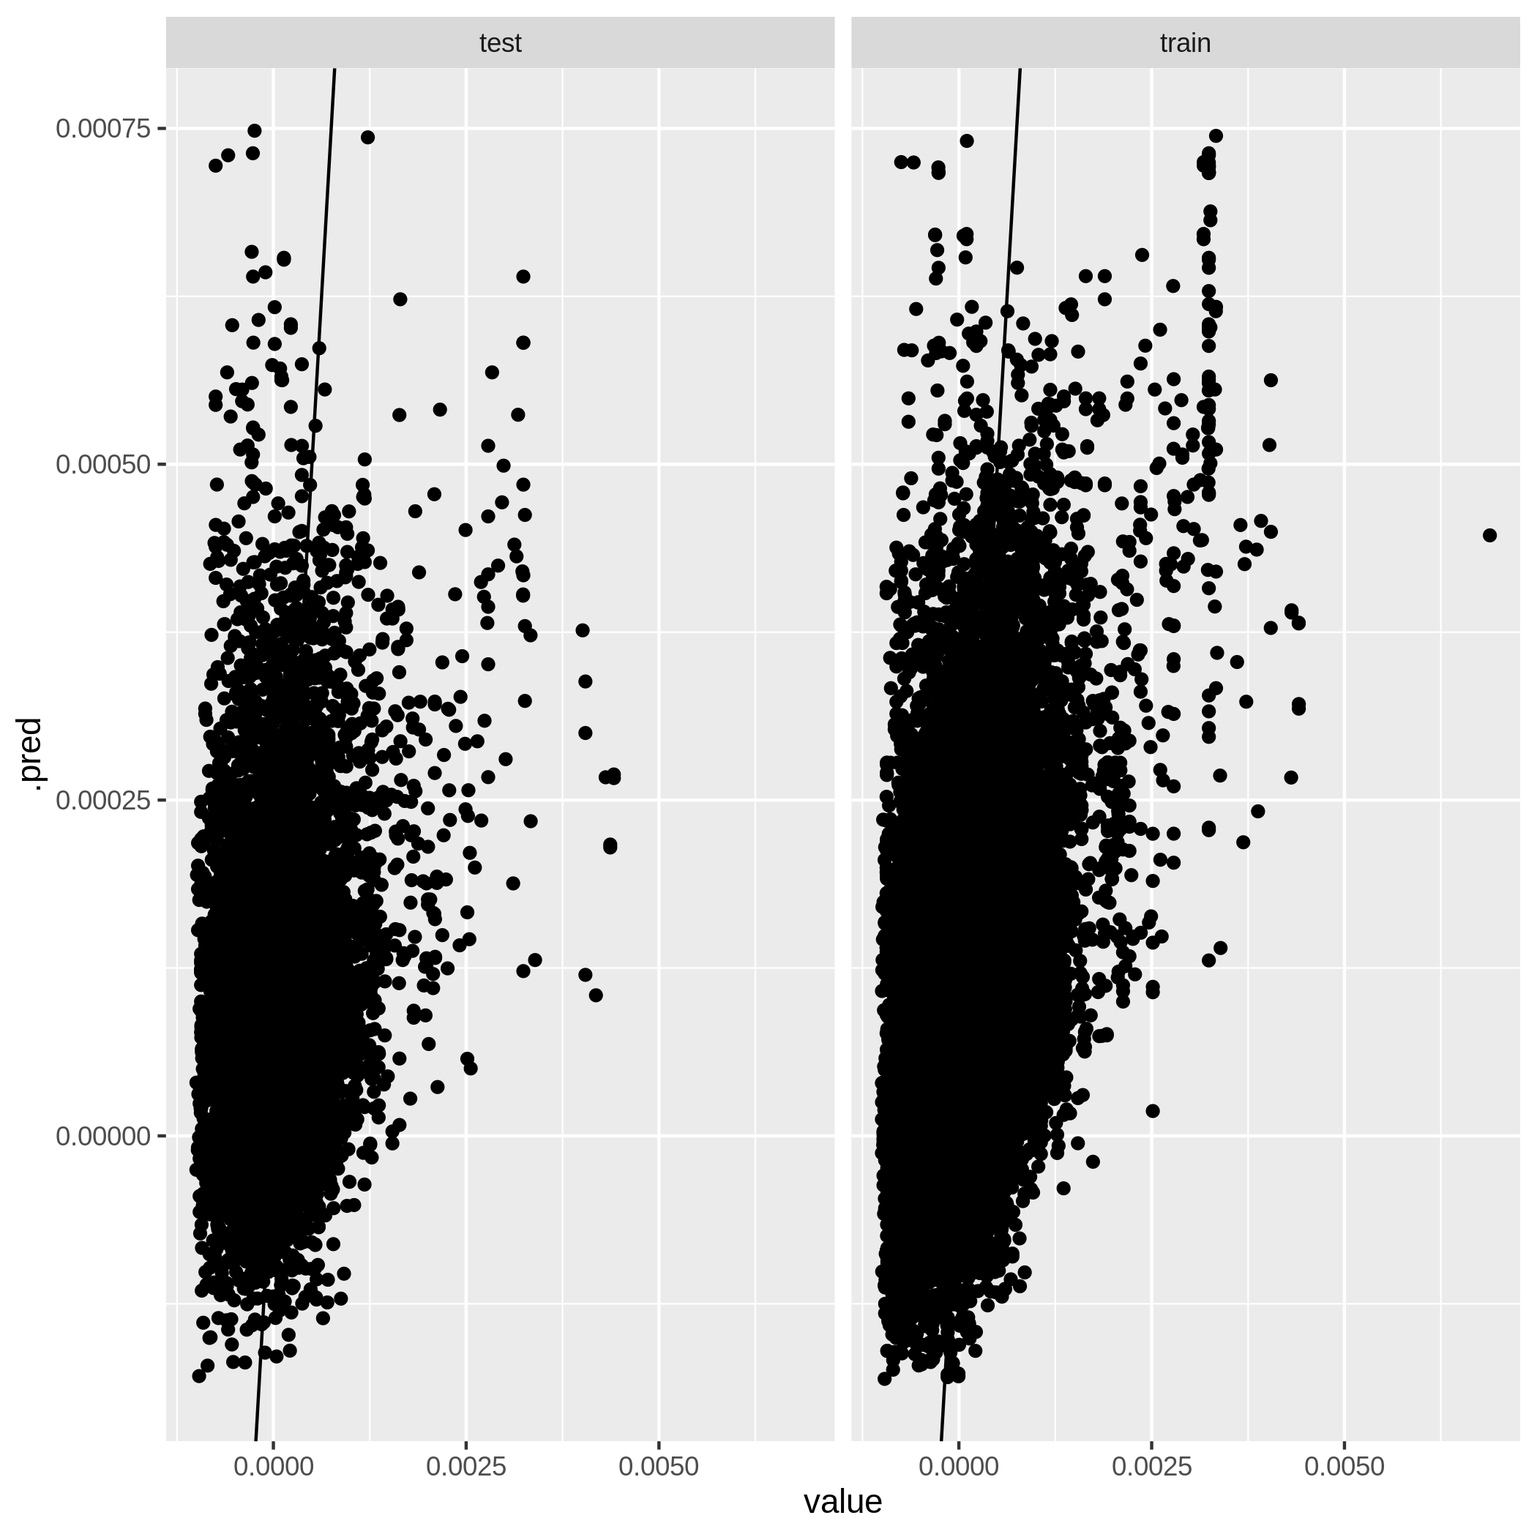
Figure A3.4k. Model performance plot for sulfur dioxide model at the neighbourhood scale.
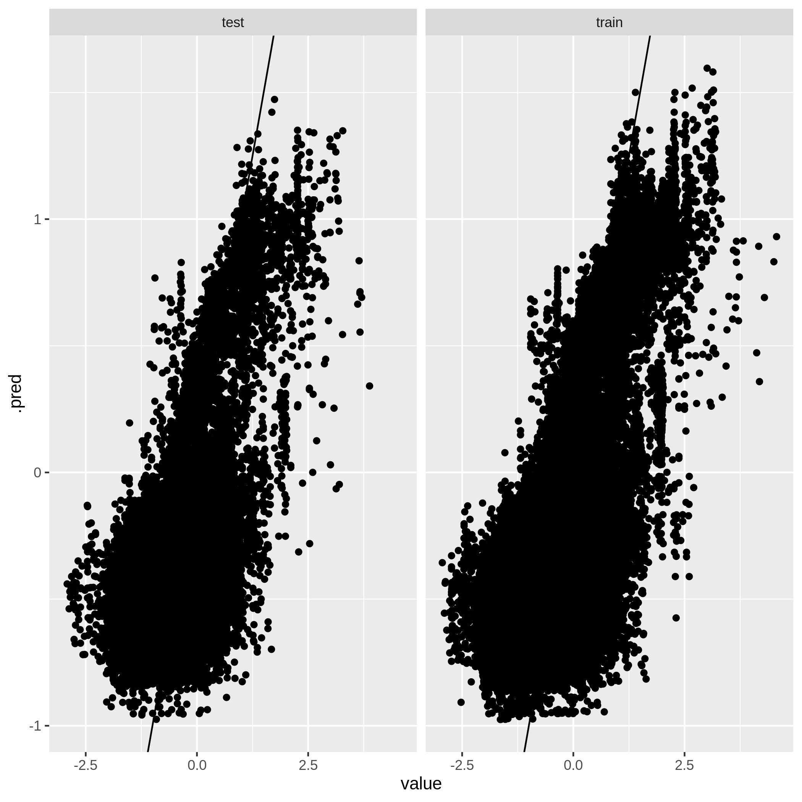
Figure A3.4l. Model performance plot for UV aerosols model at the neighbourhood scale. 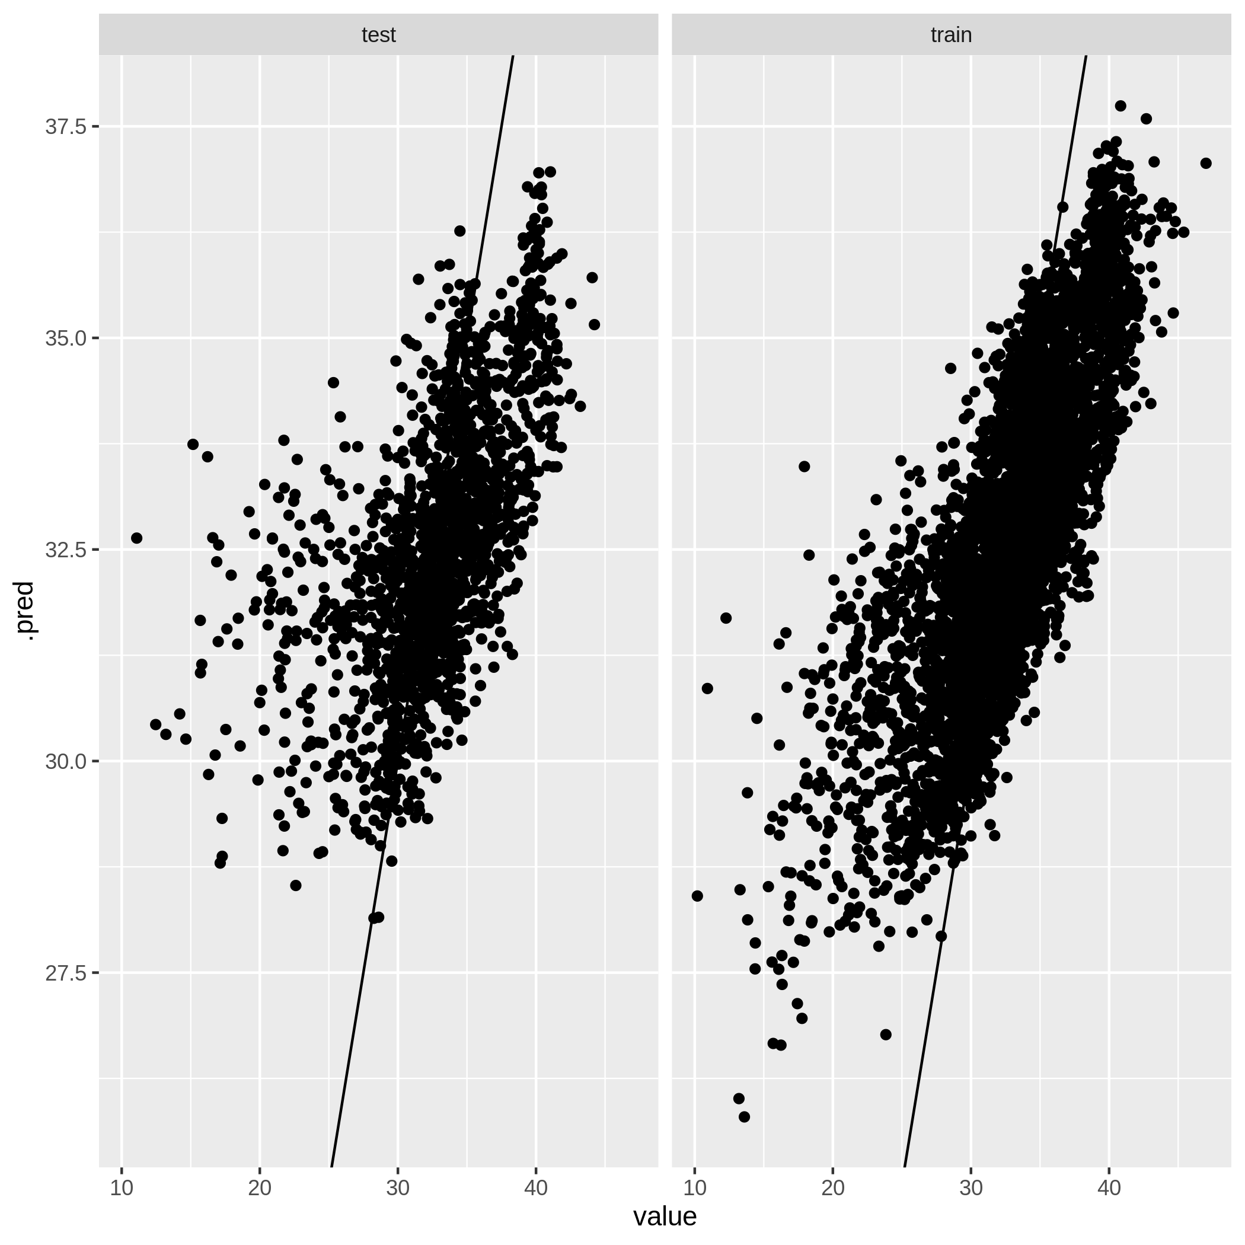
Figure A3.4m. Model performance plot for temperature model at the street scale.
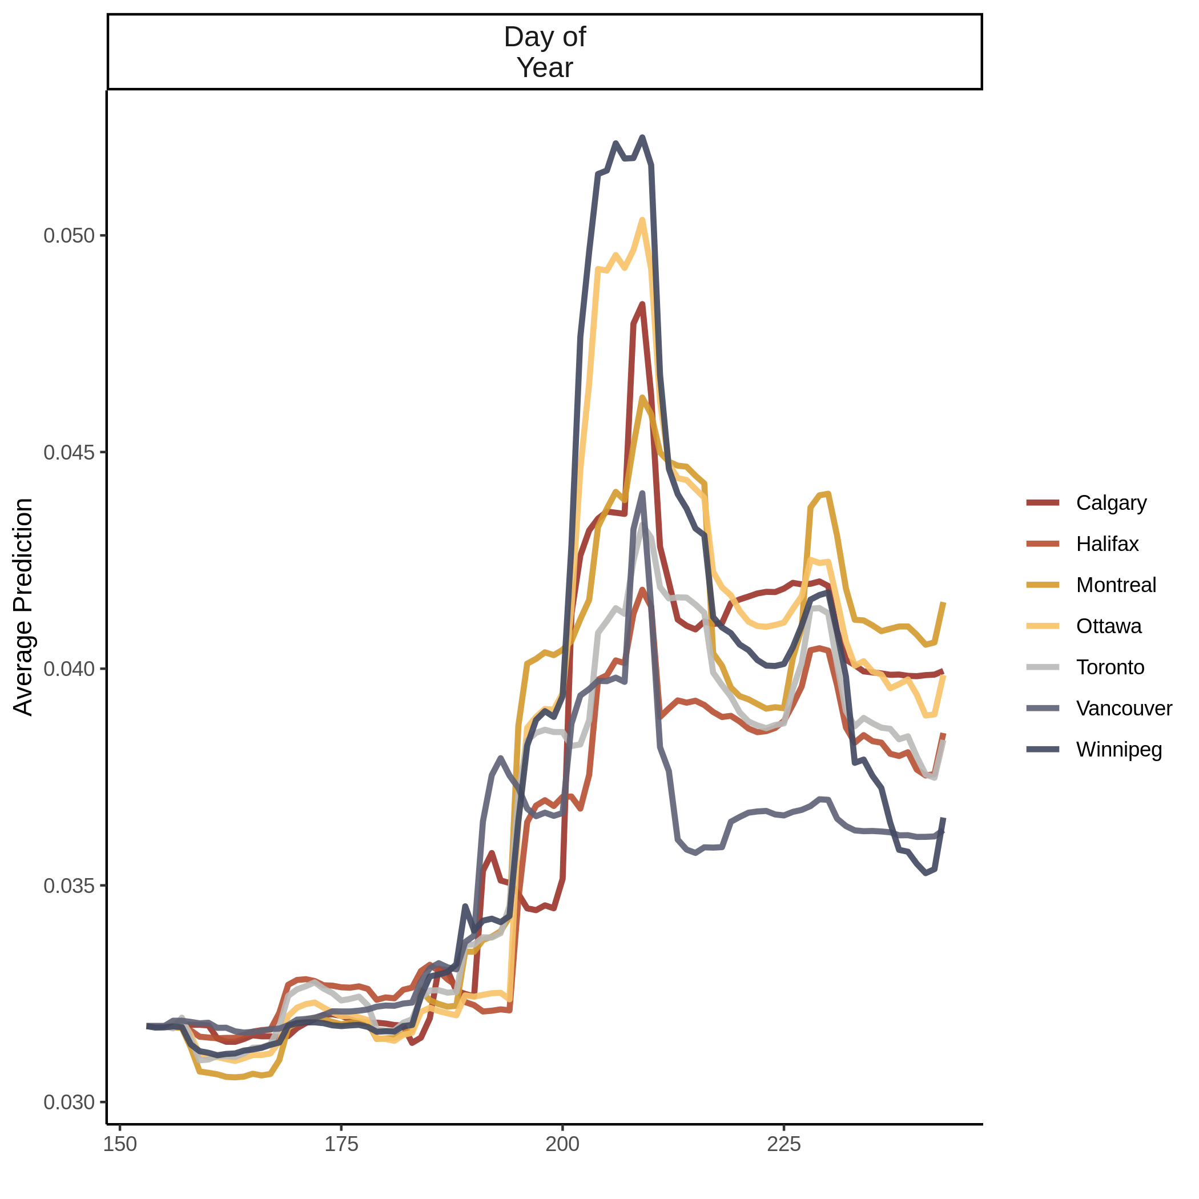
Figure A3.5a. Accumulated local effects (ALE) plot for carbon monoxide model at the city scale.
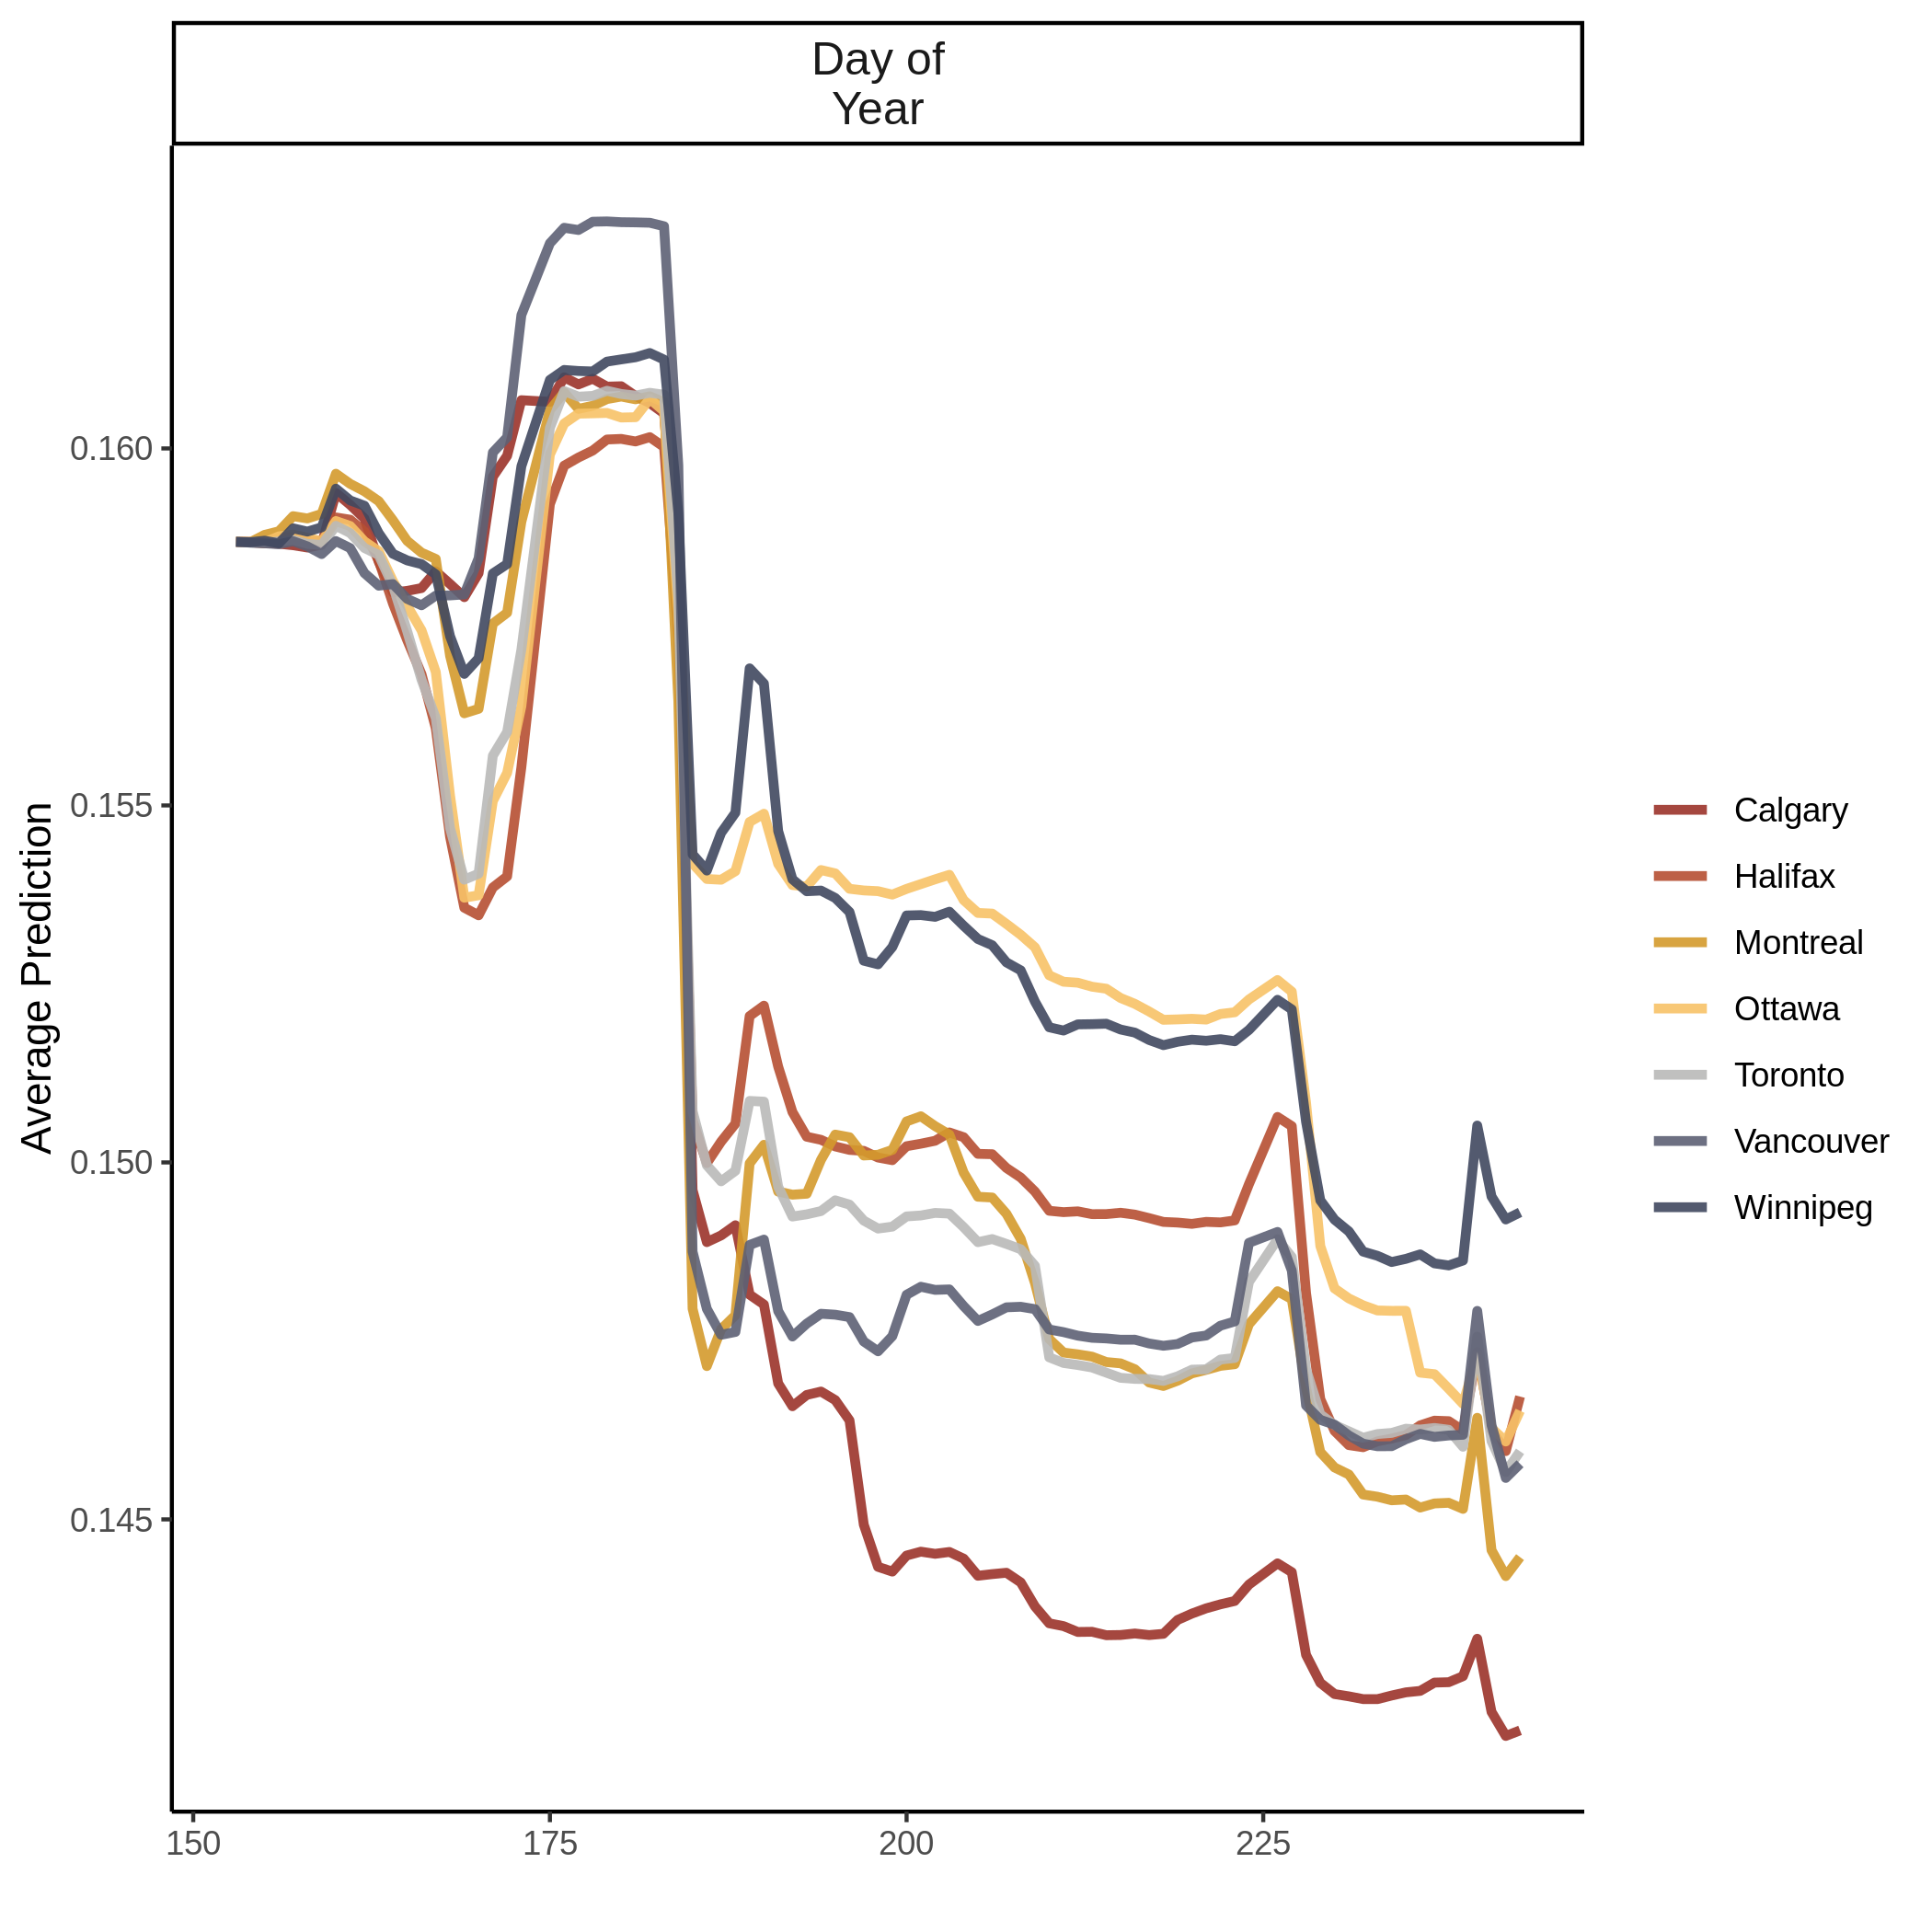
Figure A3.5b. Accumulated local effects (ALE) plot for ozone model at the city scale.
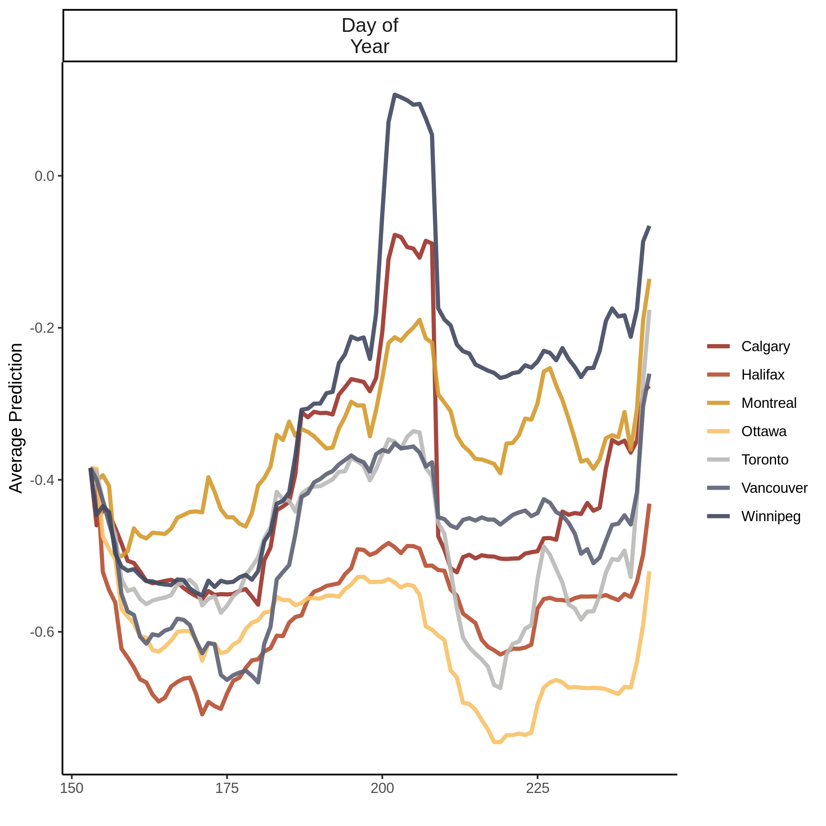
Figure A3.5c. Accumulated local effects (ALE) plot for UV aerosols model at the city scale. 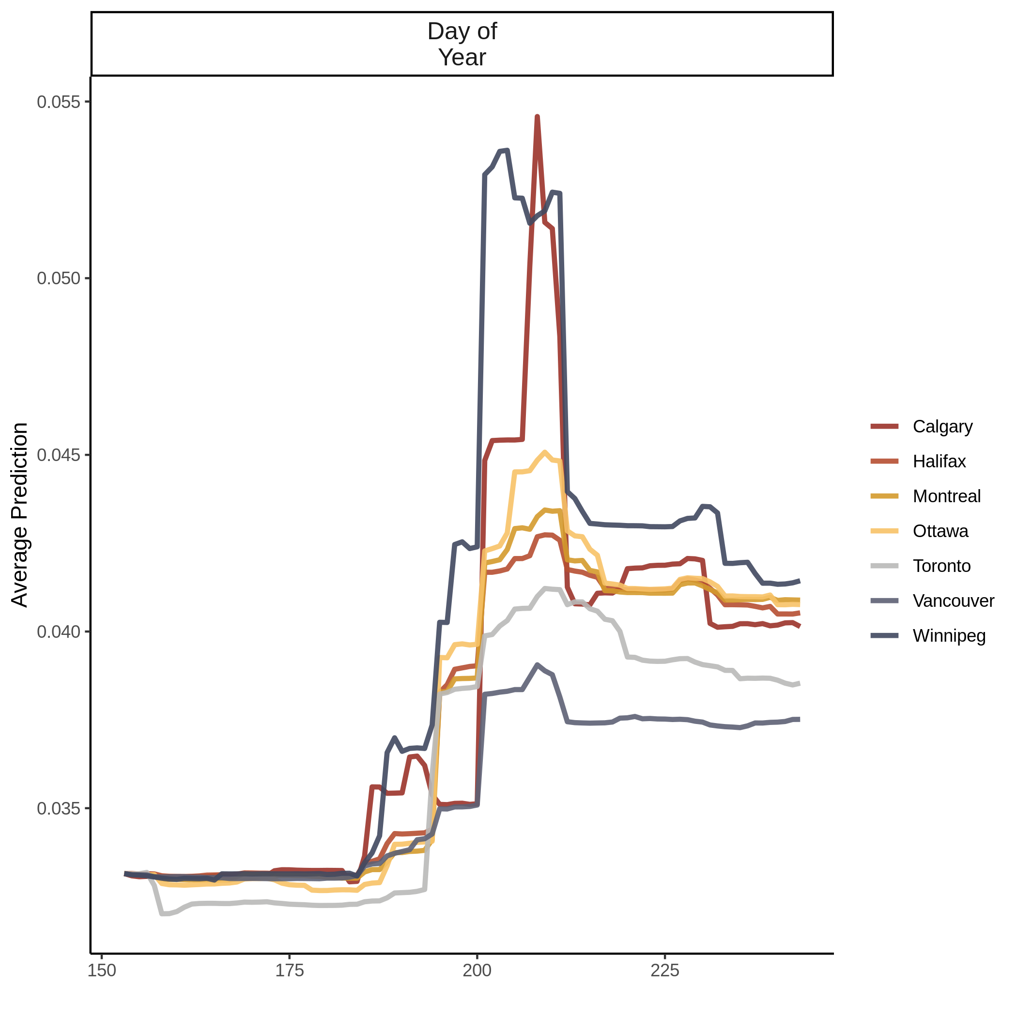
Figure A3.5d. Accumulated local effects (ALE) plot for carbon monoxide model at the neighbourhood scale.
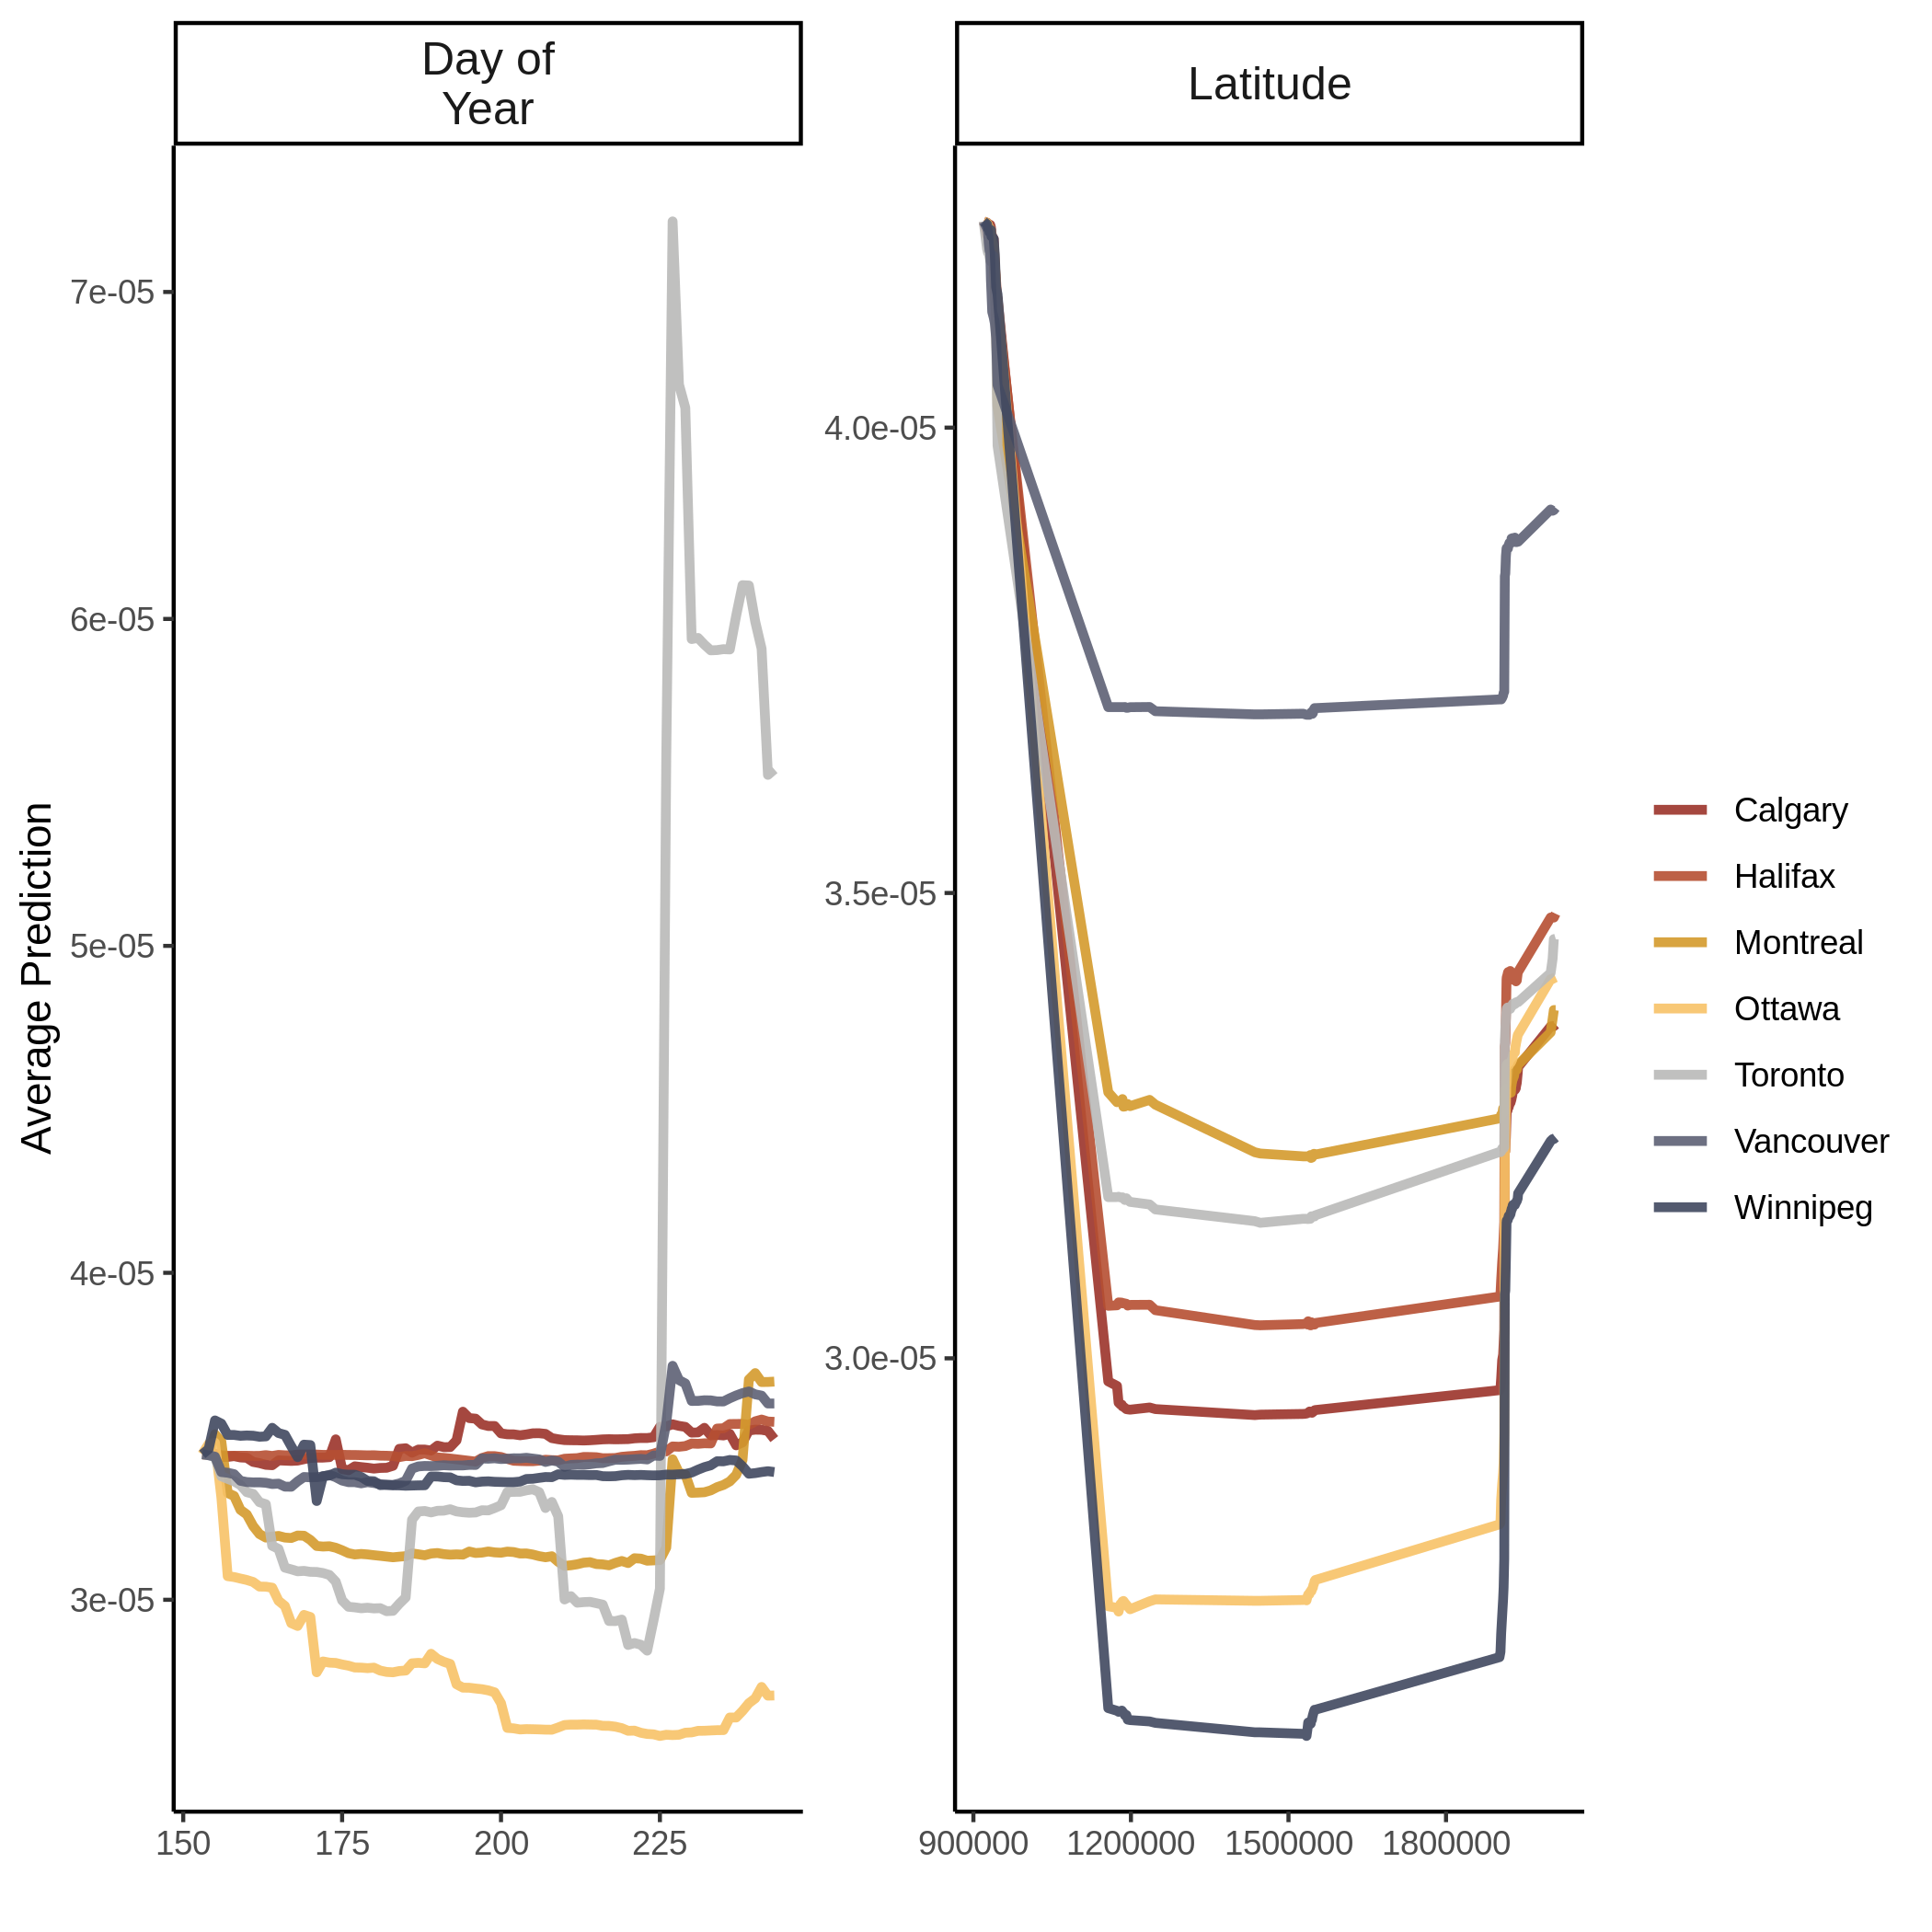
Figure A3.5e. Accumulated local effects (ALE) plot for nitrogen dioxide model at the neighbourhood scale.
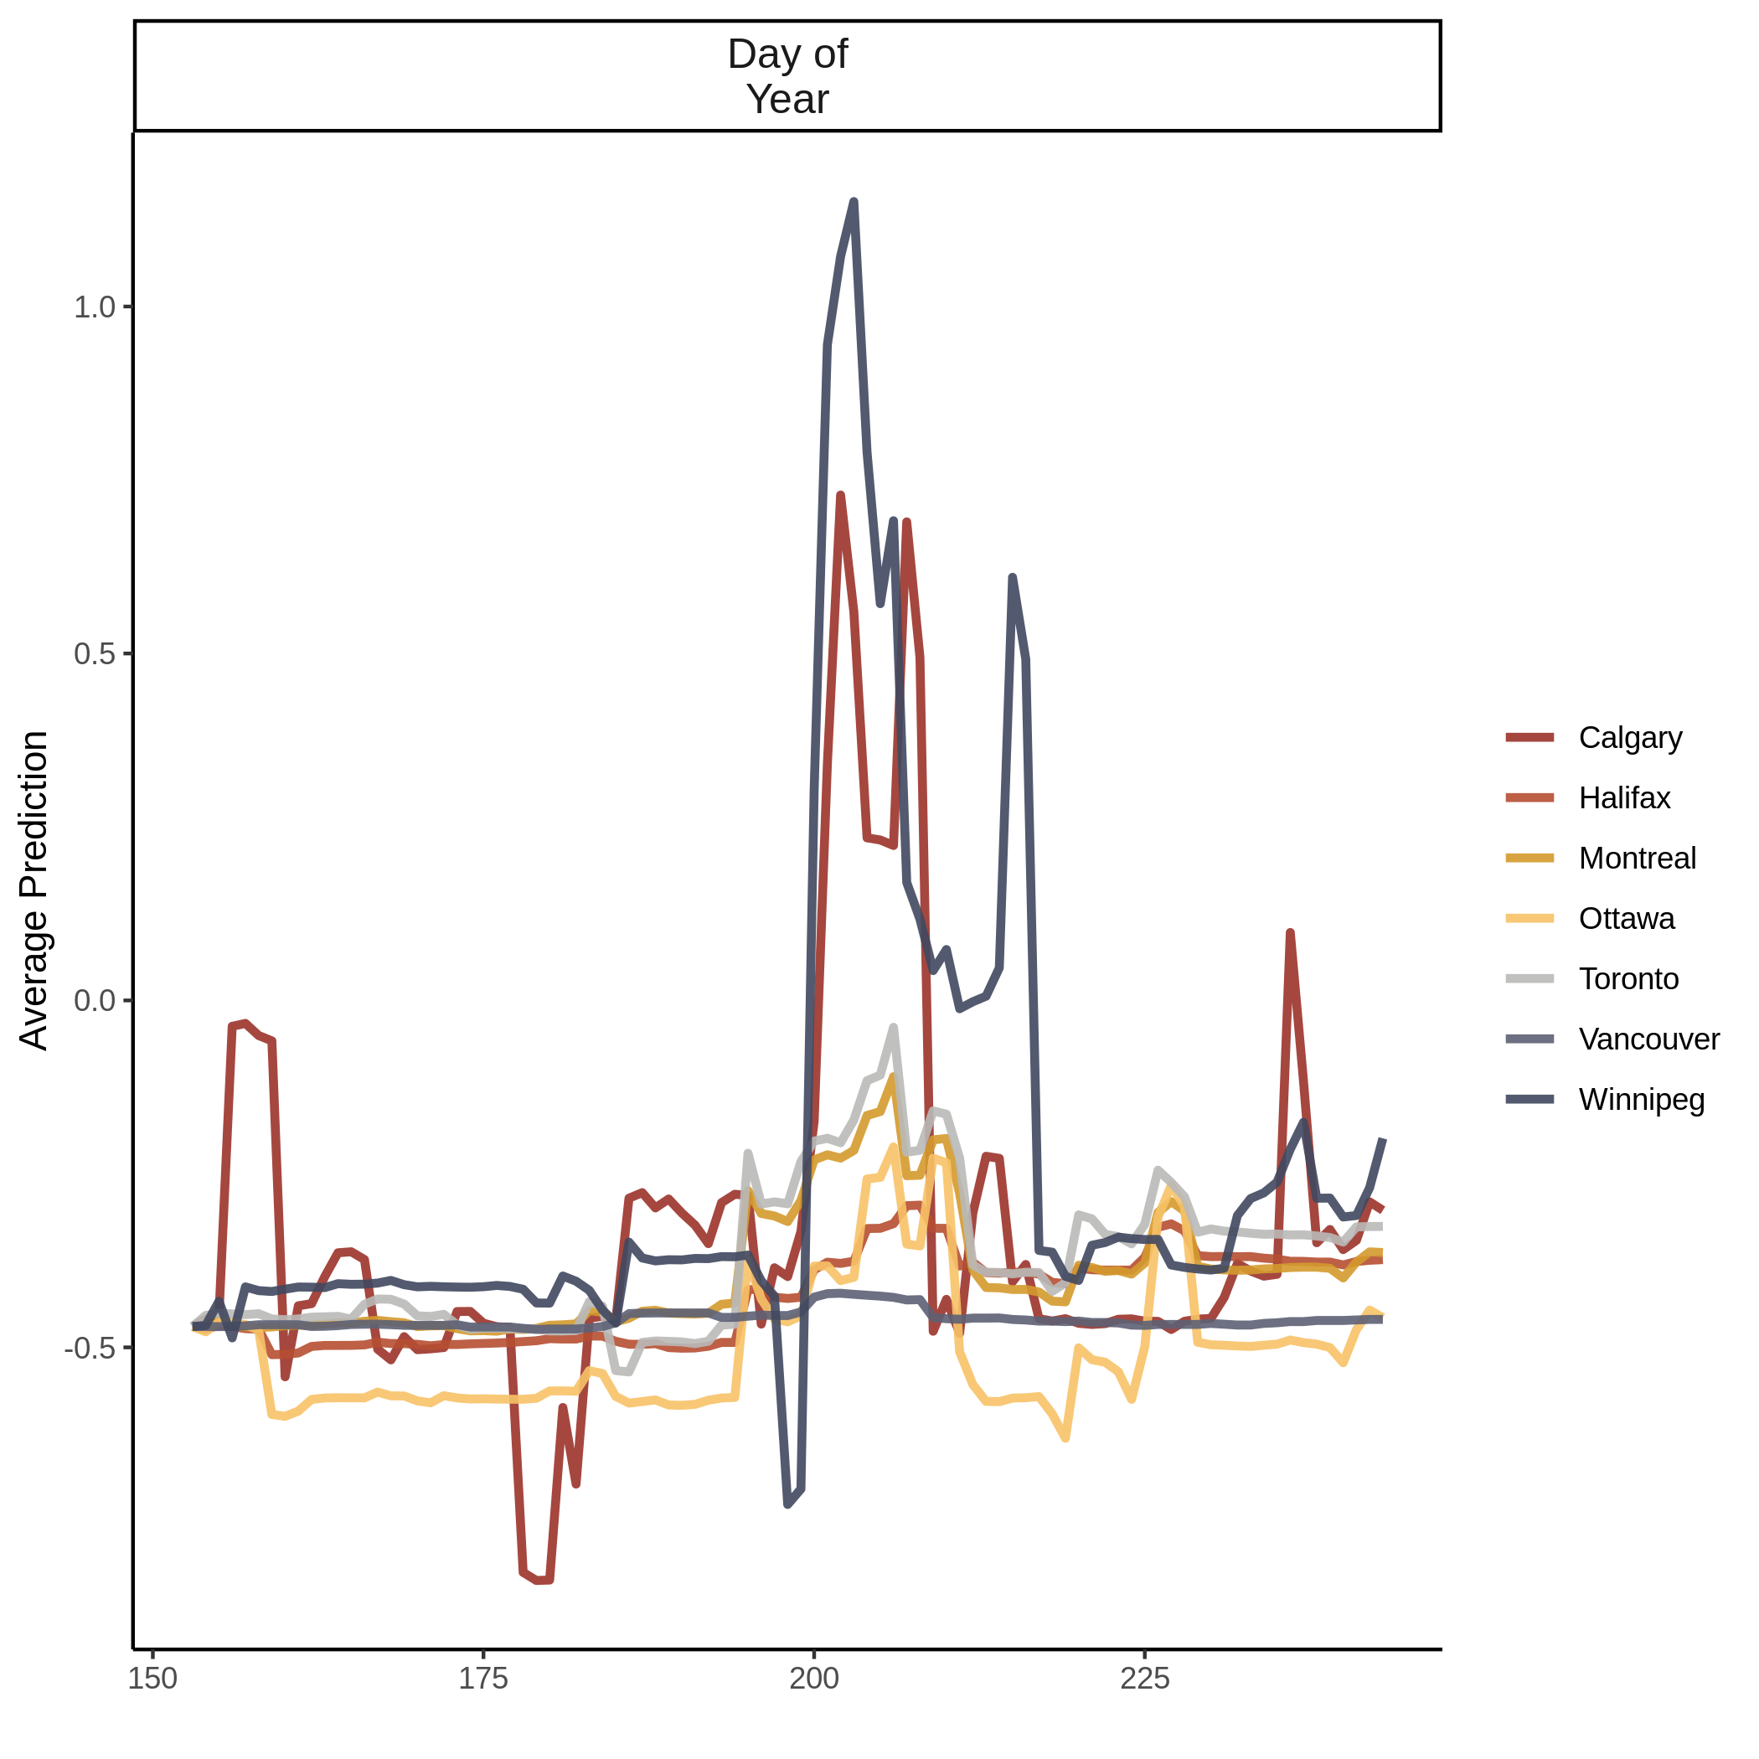
Figure A3.5f. Accumulated local effects (ALE) for UV aerosols model at the neighbourhood scale.
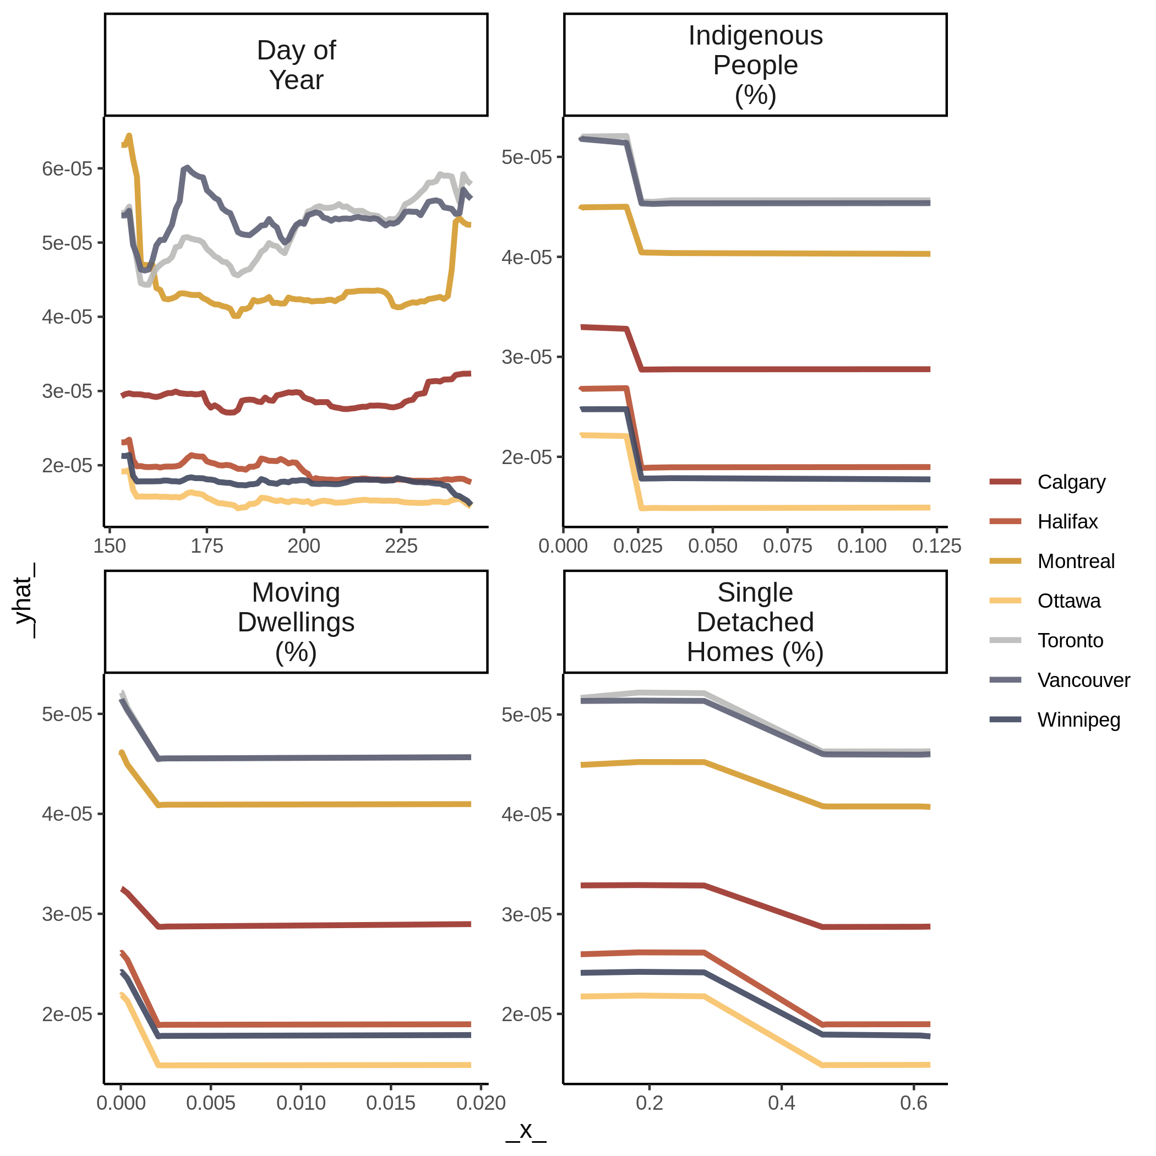
Figure A3.6a. Partial dependency plot for nitrogen dioxide model at the city scale.
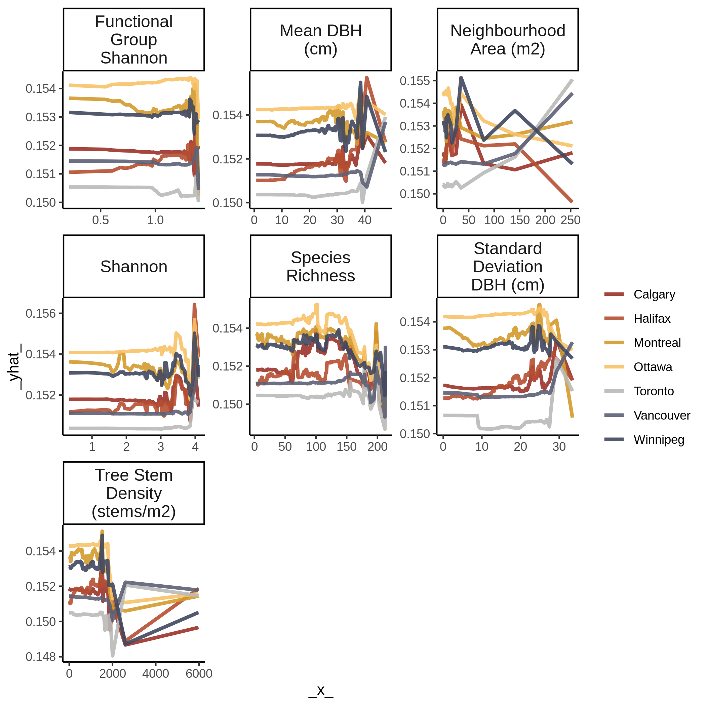
Figure A3.6b. Partial dependency plot for ozone model at the neighbourhood scale.

