### pc consergeria

router 2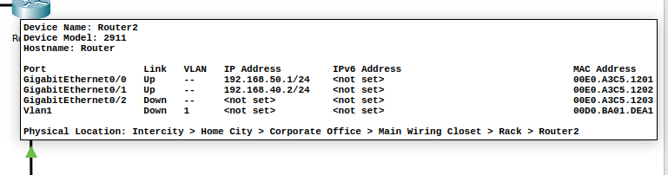

router 1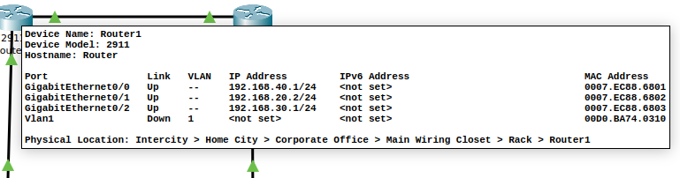

router 0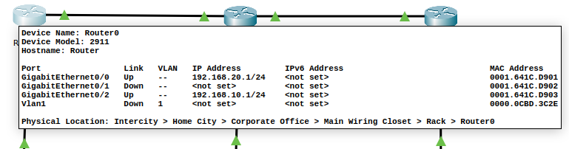

pc0

 