**CPS 633 Lab 1 Part 4**

Zulfikar Yusufali

Joshua Colaco

Emmanuel Sinlao

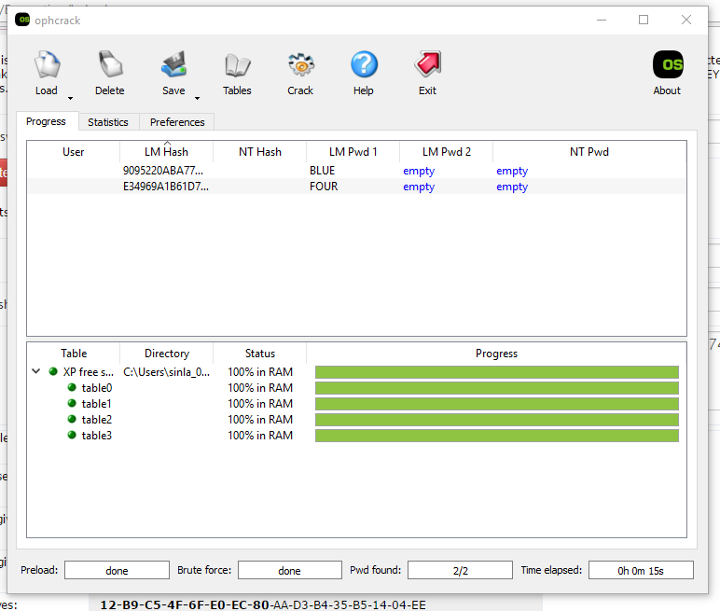

Started of with generating LMHashes for blue and four. It converted both passwords to uppercase due to the algorithm

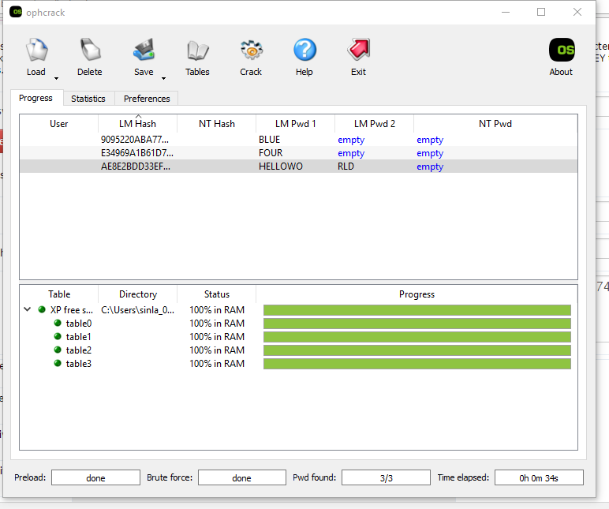

Followed it up with a longer password with “helloworld”. Took longer but it still managed to crack it

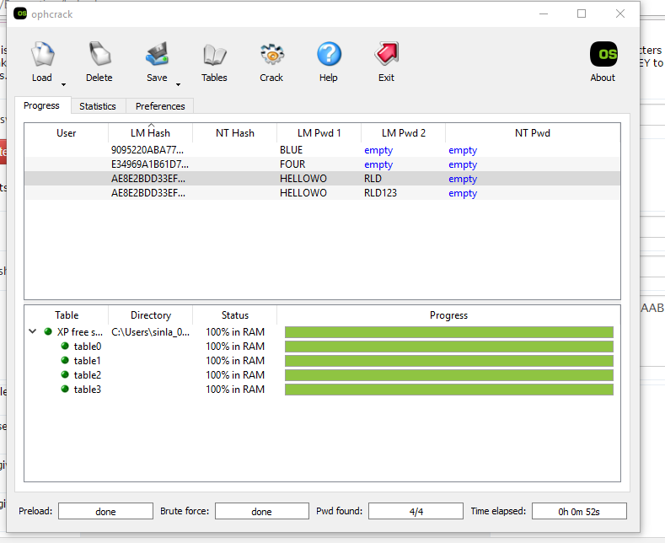

Tried “helloworld123”, took a bit longer but cracked it nonetheless.

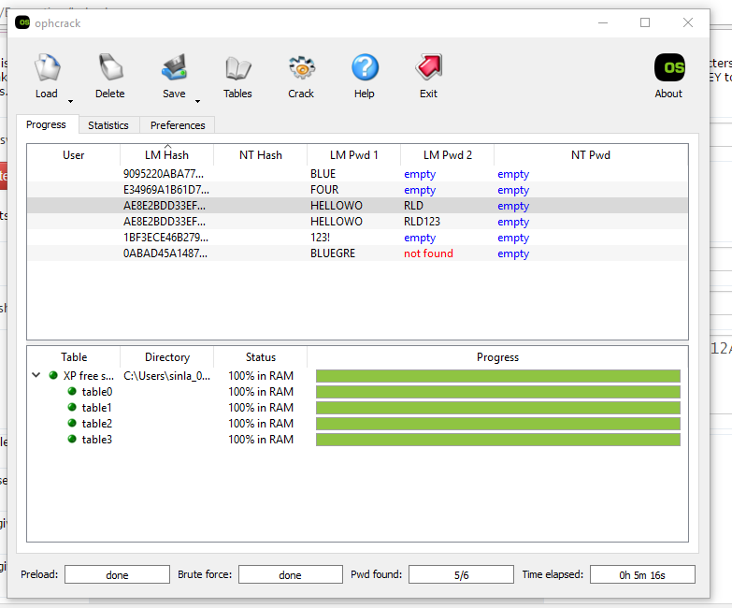Finally tried “ BLUEGREENRED!” and it was not able to find it. Longer length combined with special characters prevented the hash from being found.