EMS : Employee Management System ( AWS Deployement)
Git Push → Jenkins → Maven Build → Docker Image → ECR → ECS / EKS → ALB → Users

I have Employee Management system having Parent Maven multi–module structure, i have microservice like API gateway, auth service, employee service, attendance service, payroll service, notification service. Explain each steps from Git Push → Jenkins → Maven Build → Docker Image → ECR → ECS / EKS → ALB → Users in deep details and step from scratch level

Below is a from-scratch, production-grade explanation of the complete CI/CD + Deployment flow for your Employee Management System with Parent Maven multi-module microservices:
API Gateway, Auth Service, Employee Service, Attendance Service, Payroll Service, Notification Service.

I’ll explain each hop deeply, including what exists beforehand, what happens at runtime, and why it matters.

0️⃣ What You Start With (Baseline Architecture)

Your Project Structure
employee-management-system (parent)
│── pom.xml (packaging = pom)
│
├── api-gateway
├── auth-service
├── employee-service
├── attendance-service
├── payroll-service
├── notification-service
└── common-lib (optional)

Key Assumptions
- Java 17 / Spring Boot
- Maven multi-module build
- Docker per microservice
- AWS deployment
- Jenkins CI/CD
- ECR for images
- ECS or EKS for containers
- ALB as entry point

PART 1 — Git Push → Jenkins → Maven Build → Docker Image

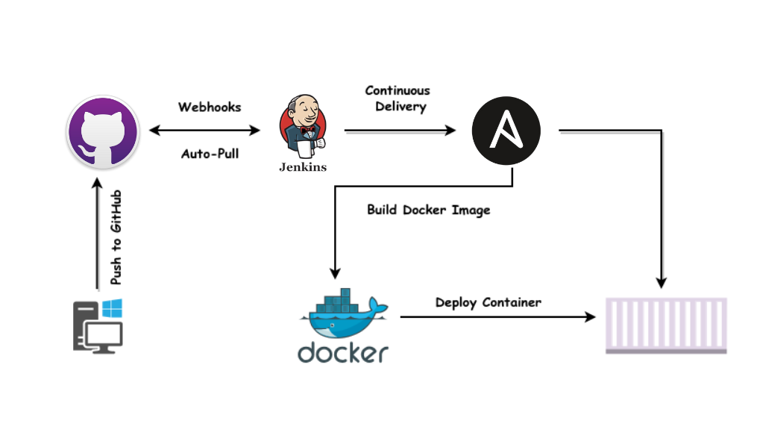
1️⃣ Developer → Git Push (Source Control Trigger)
What You Do
git add .
git commit -m "Payroll calculation fix"
git push origin develop
What Happens Internally
- Code goes to GitHub / GitLab / Bitbucket
- Repository has:
  - Jenkinsfile
  - Dockerfile in each service
- A Webhook is configured:
  - On push → notify Jenkins

Why This Matters
- Git is the single source of truth
- CI pipeline starts automatically
- Branch strategy controls environments:
  - develop → QA
  - main → PROD

2️⃣ Jenkins Receives Webhook (CI Trigger)
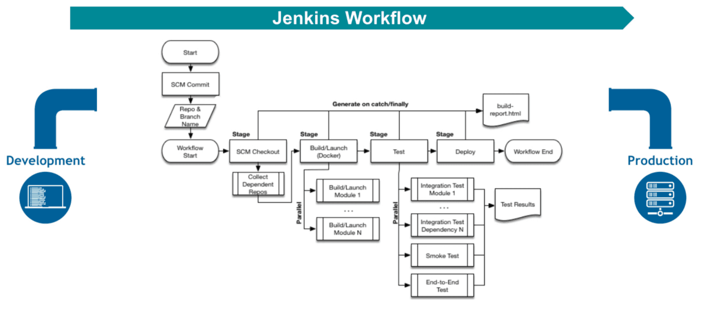
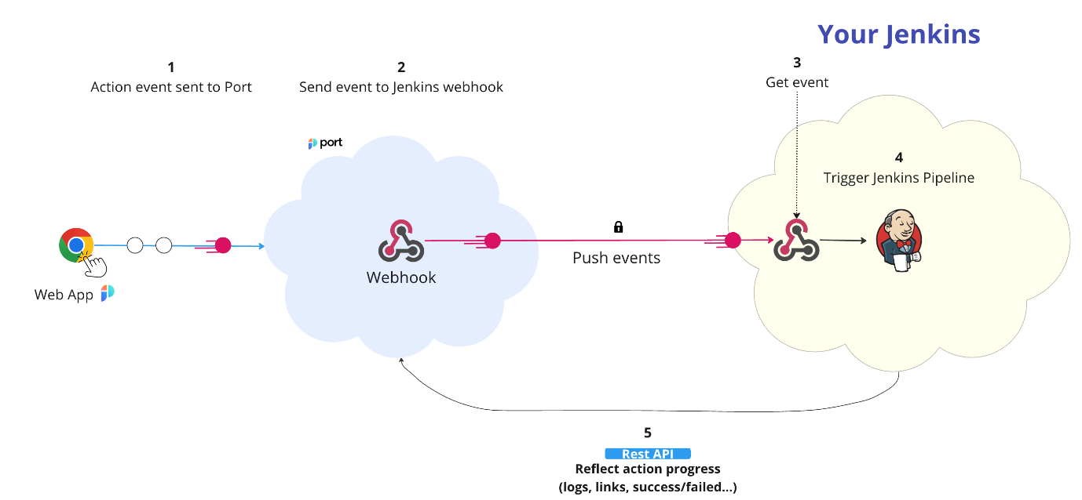
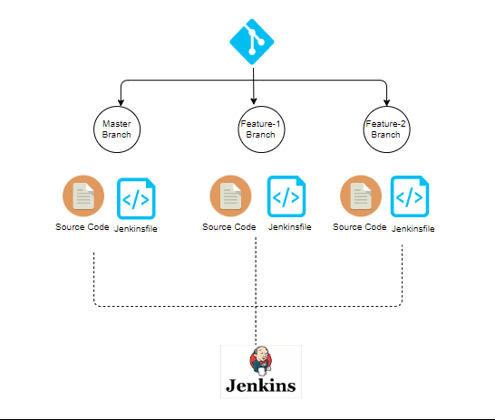
Jenkins Setup (Once)
- Jenkins installed (EC2 / Kubernetes / VM)
- Plugins:
  - Git
  - Maven
  - Docker
  - AWS CLI
  - Pipeline
Jenkins Job Type
✔ Multibranch Pipeline
Jenkins:
- Detects branch
- Reads Jenkinsfile
- Creates pipeline automatically

3️⃣ Jenkins Workspace & Code Checkout
Jenkins Does
git clone https://github.com/org/employee-management-system.git
Directory:
/var/lib/jenkins/workspace/ems-develop/
Why Important
- Each build is isolated
- No dependency on developer machine
- Reproducible builds

4️⃣ Maven Build (Parent → Child Modules)
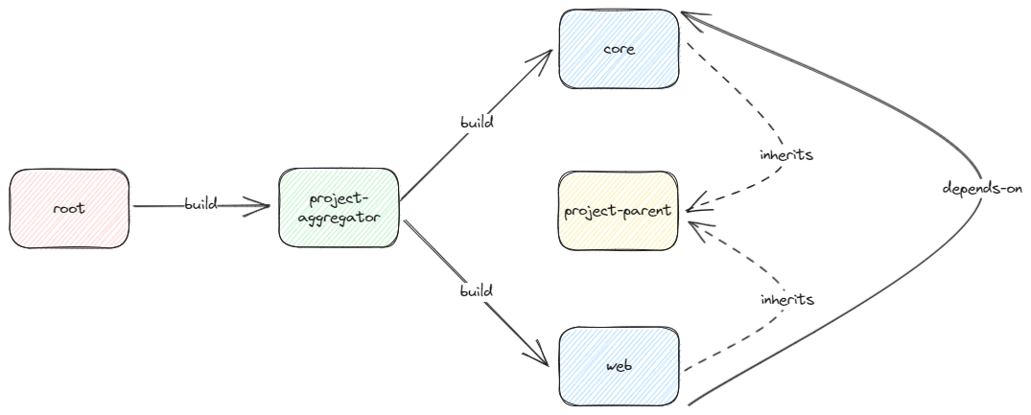
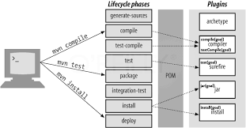
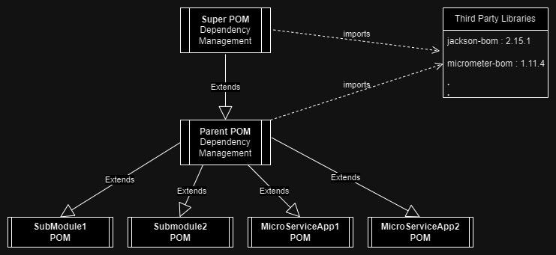
Parent pom.xml
<modules>
<module>api-gateway</module>
<module>auth-service</module>
<module>employee-service</module>
<module>attendance-service</module>
<module>payroll-service</module>
<module>notification-service</module>
</modules>
Jenkins Executes
mvn clean install -DskipTests
Maven Lifecycle (Internals)
Phase | What Happens
validate | Project structure checked
compile | Java → .class
test | Unit tests
package | .jar created
install | Artifacts in local repo
Output
employee-service/target/employee-service.jar
payroll-service/target/payroll-service.jar
Why Multi-Module?
- Shared dependency versions
- Faster builds
- Consistent packaging

5️⃣ Docker Image Creation (Per Microservice)
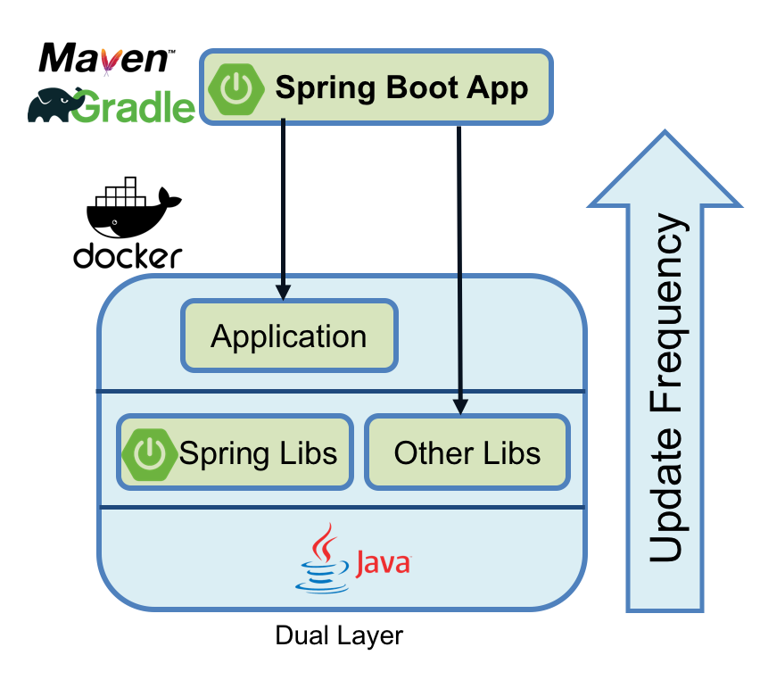
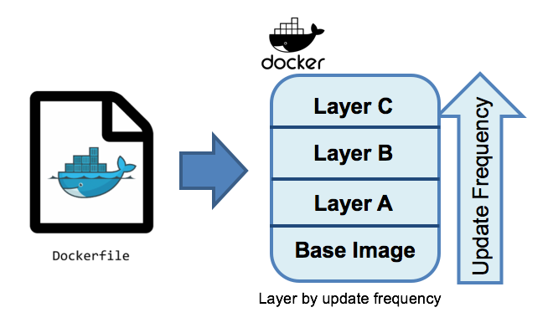
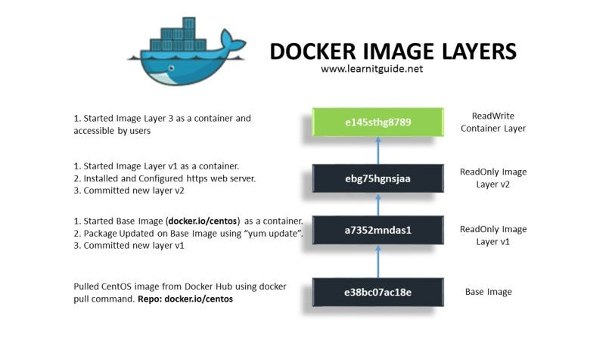
Typical Dockerfile (Employee Service)
FROM eclipse-temurin:17-jre-alpine
WORKDIR /app
COPY target/employee-service.jar app.jar
ENTRYPOINT ["java","-jar","app.jar"]
Jenkins Builds Image
docker build -t employee-service:1.0.3 .
What Happens Internally
- Base image pulled
- JAR copied
- Image layers created
- Image stored locally on Jenkins
Why Docker?
- Immutable artifact
- Same runtime everywhere
- No “works on my machine”

PART 2 — Docker Image → ECR → ECS / EKS → ALB → Users

6️⃣ Push Docker Image to Amazon ECR
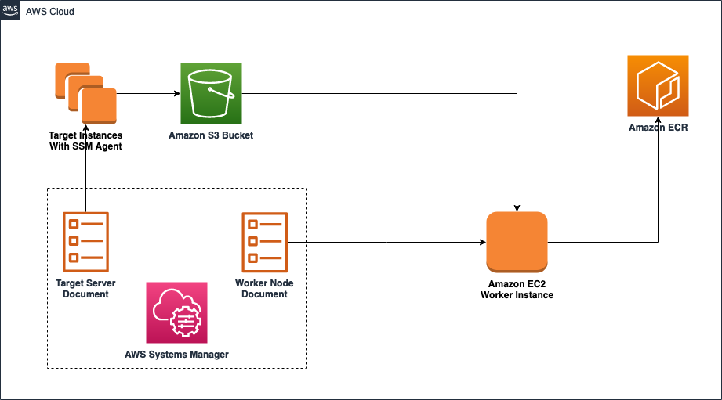
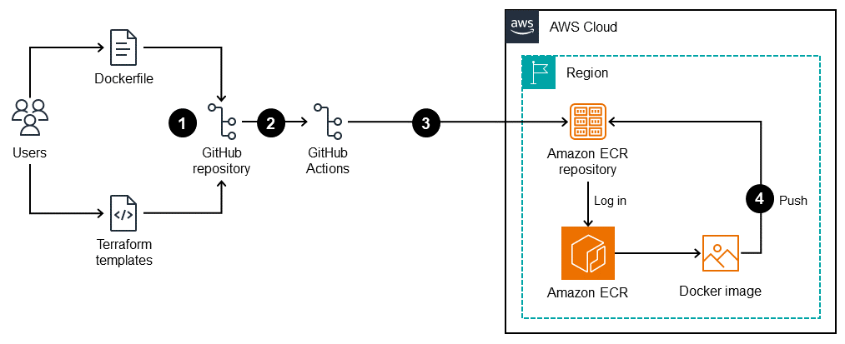
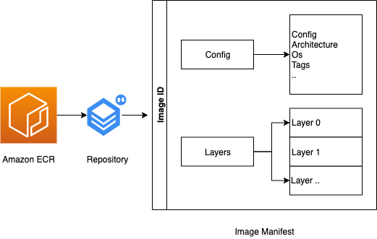
ECR Setup (Once)
- Create ECR repo per service:
  - employee-service
  - payroll-service
Jenkins Login
aws ecr get-login-password | docker login ...
Push Image
docker tag employee-service:1.0.3 \
123456789012.dkr.ecr.ap-south-1.amazonaws.com/employee-service:1.0.3
docker push 123456789012.dkr.ecr.ap-south-1.amazonaws.com/employee-service:1.0.3
Why ECR?
- Secure (IAM-based)
- Native AWS integration
- Versioned images

7️⃣ Deploy to ECS or EKS

🔹 Option A — ECS (Simpler, Managed)
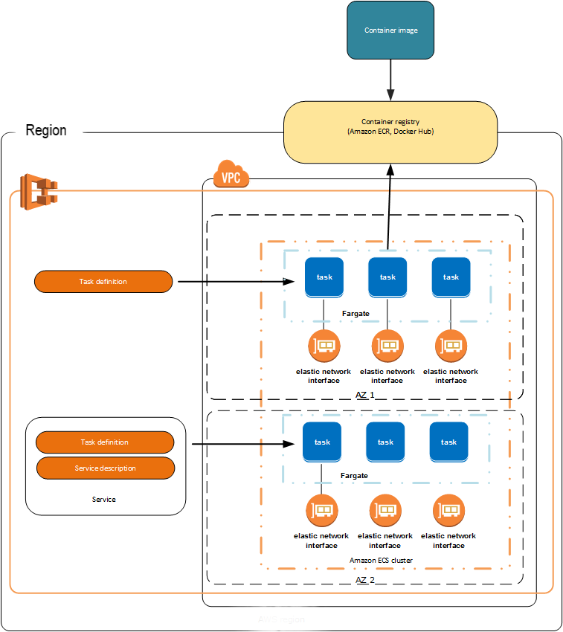
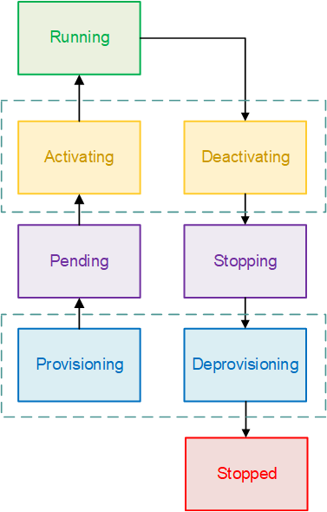
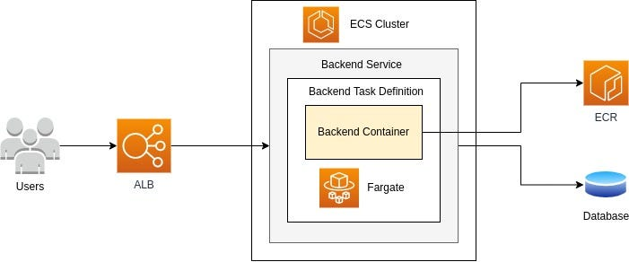
ECS Components
Component | Purpose
Cluster | Compute pool
Task Definition | Docker + CPU + memory
Service | Desired running tasks
Task | Running container
Flow
- New image tag detected
- Task Definition updated
- ECS spins new containers
- Old containers drained
Example Task Definition
{
"image": "employee-service:1.0.3",
"portMappings": [{ "containerPort": 8080 }]
}

🔹 Option B — EKS (Advanced, Kubernetes)
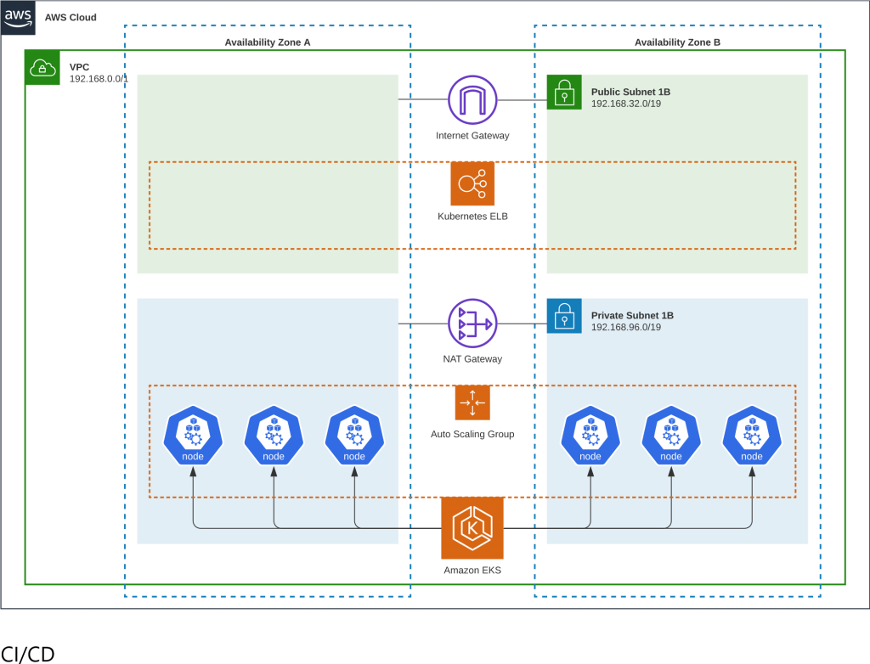
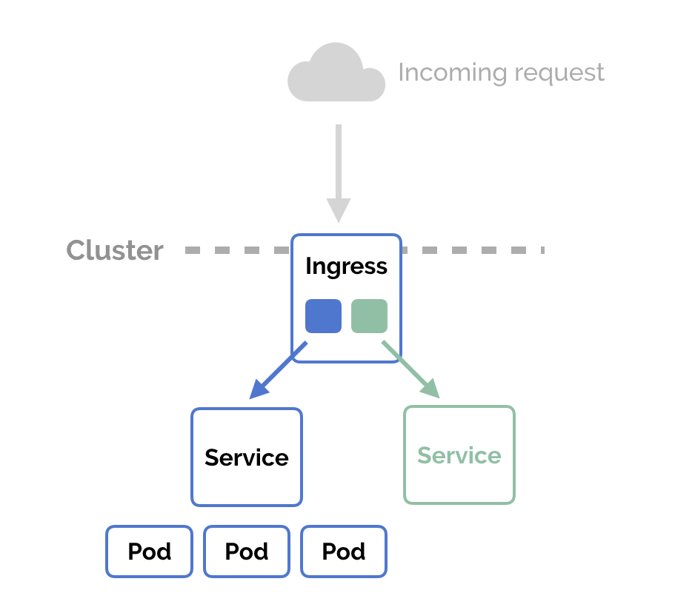

Kubernetes Objects
Object | Role
Deployment | Pods + rolling updates
Pod | Container wrapper
Service | Stable networking
Ingress | ALB integration
Deployment YAML
spec:
replicas: 3
containers:
- image: employee-service:1.0.3
Why EKS?
- Fine-grained control
- Autoscaling
- Cloud-agnostic Kubernetes

8️⃣ Application Load Balancer (ALB)

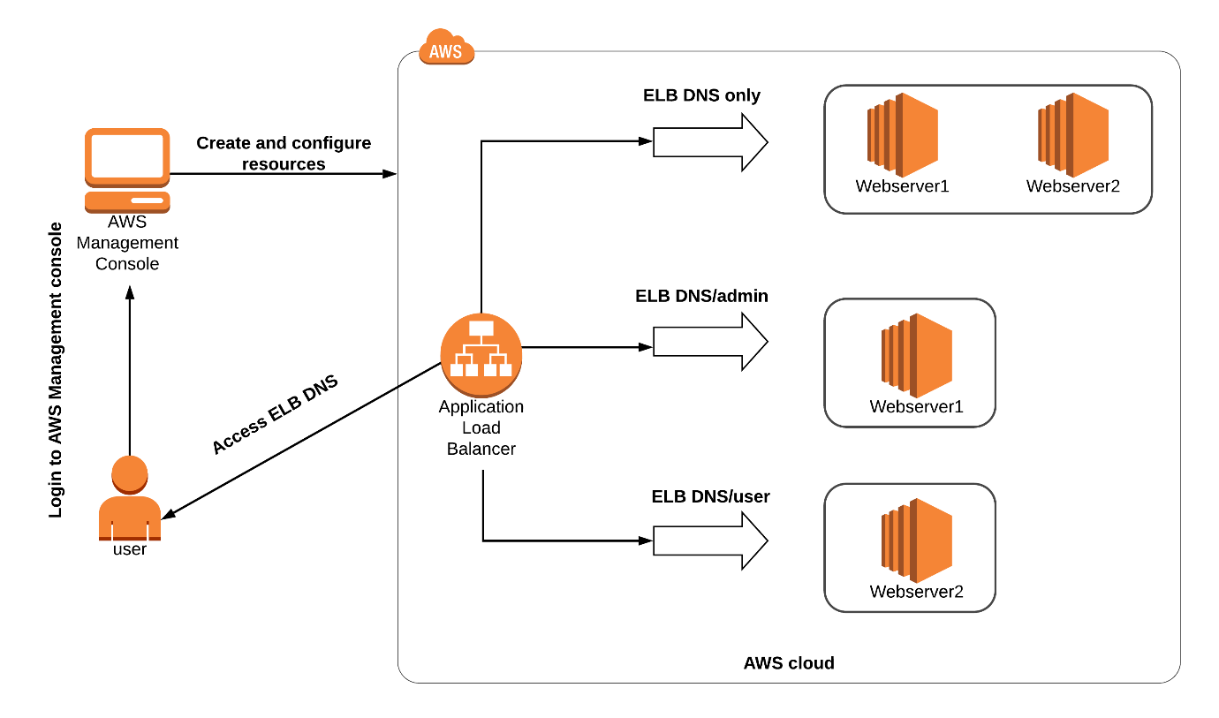
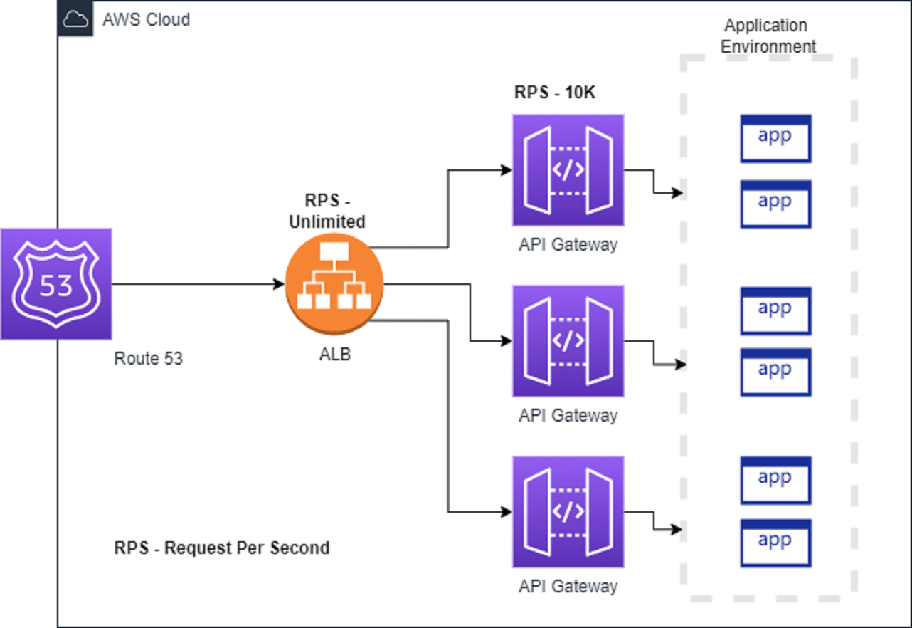
ALB Responsibilities
- Public HTTPS endpoint
- Path-based routing
- Health checks
- SSL termination
Routing Example
Path | Target
/api/auth/** | Auth Service
/api/employees/** | Employee Service
/api/payroll/** | Payroll Service

9️⃣ Users Access the System
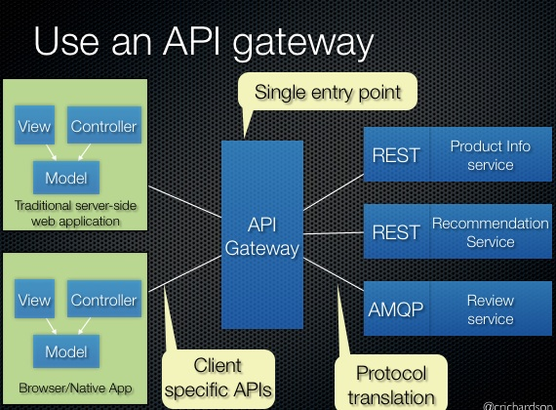
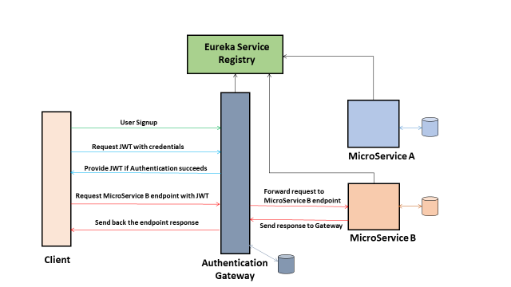
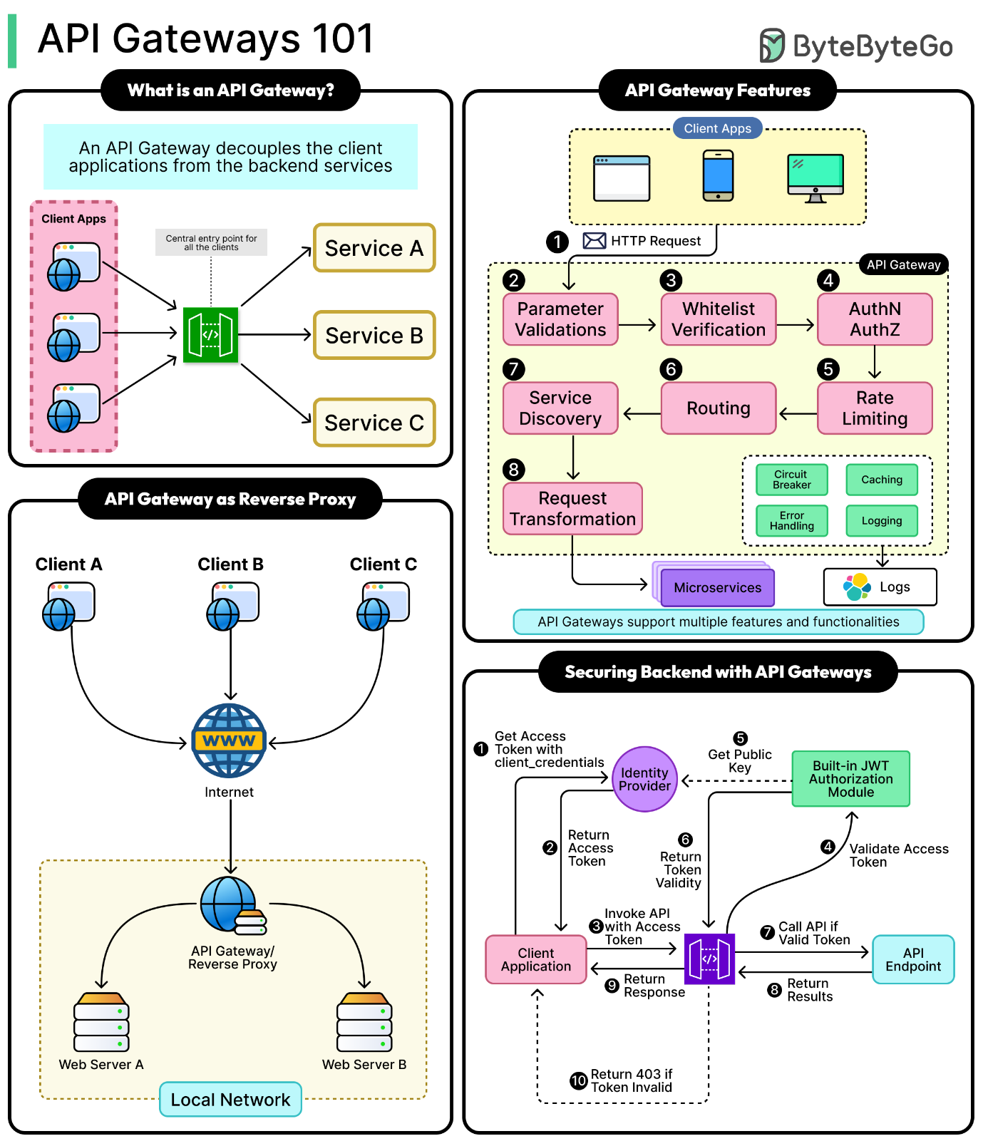
Runtime Request Flow
User → ALB → API Gateway → Auth Service (JWT)
↓
Employee / Payroll / Attendance
↓
Notification Service
What Users Experience
- Single URL
- Secure JWT-based auth
- Zero downtime deployments
- Fast response

🔚 End-to-End Summary
Git Push
↓
Jenkins Trigger
↓
Maven Multi-Module Build
↓
Docker Image (per service)
↓
Amazon ECR
↓
ECS / EKS Deployment
↓
ALB Routing
↓
Users

What I Can Do Next (Highly Recommended)
- ✔ Jenkinsfile (full production-grade)
- ✔ ECS vs EKS decision matrix
- ✔ Zero-downtime rolling deployment
- ✔ Blue-Green / Canary deployment
- ✔ Environment separation (DEV / QA / PROD)
- ✔ Cost-optimized AWS architecture

