Aerodynamic Design and Optimization of the M Configuration Aircraft
Md Zulfikar Mahmud
School of Aeronautics
Northwestern Polytechnical University

Abstract: In this report, the aerodynamic design and optimization of the M transonic transport configuration is performed with the in-house WBCAero analysis code. In the single-point phase, the wing twist distribution is adjusted so that the spanwise loading approaches a near-elliptical distribution, which reduces the induced drag and improves the lift-to-drag ratio at the design condition (Ma=0.78, CL=0.525, Re=50×10^7). A custom elliptical script was used to monitor the singlepoint elliptical lift distribution. In the multi-point phase, a fixed-lift Mach sweep is carried out to extend the achievable cruise Mach number. Whereas the baseline configuration fails to converge beyond Ma≈0.785, the optimized configuration remains converged up to Ma=0.82. By balancing the flight Mach number against the lift-to-drag ratio, an optimal cruise condition near Ma=0.805 is identified. The angle-of-attack sweep was intentionally not emphasized, since the primary objective was to increase the flight Mach number.
Key words: elliptical load distribution; drag-divergence Mach number; Mach sweep; transonic transport; lift-to-drag ratio; WBCAero

Introduction
Transonic civil transport aircraft cruise near Mach 0.8, where the aerodynamic performance is governed by two competing objectives: a high lift-to-drag ratio (L/D) at the design point, and a high drag-divergence Mach number that allows efficient flight at higher cruise speeds. The spanwise load distribution controls the induced drag (and hence L/D), whereas the cruise Mach number is limited by the onset of wave drag. In this course project, the M-configuration, a transonic transport configuration provided within the WBCAero rapid design environment, is designed and optimized with the objective of improving both the lift-to-drag ratio and the cruise Mach number.
The work is carried out in two stages. First, the single-point design at the cruise condition (Ma=0.78, CL=0.525, Re=50×10⁶) is optimized by adjusting the wing twist distribution to reshape the spanwise loading toward a near-elliptical distribution, thereby reducing the induced drag and improving L/D. Second, a fixed-lift Mach sweep is performed in the multi-point mode to determine how far the cruise Mach number can be extended before the drag-divergence limit is reached.

Methodology
All analyses are performed with WBCAero, a civil-aircraft rapid design and analysis code developed in-house. The code is built on a transonic full-potential equation solver for the inviscid outer flow, coupled with the BLWF56 integral boundary-layer solver to account for viscous effects through viscous-inviscid interaction. The flow solution yields component-resolved force coefficients, and the total drag is decomposed into friction, induced and wave-drag contributions. The code outputs the spanwise lift, twist and thickness distributions, surface pressure fields, section pressure distributions and polar curves.

WBCAero supports both single-point and multi-point analyses. In the single-point mode the design state is defined by the Mach number, the Reynolds number and a prescribed lift coefficient (ICL=1), and the angle of attack is solved by the code. In the multi-point mode, a sequence of MACH/AOA/CL/REY states is computed in a single run and a polar is produced. The wing geometry is controlled through the planform (span, inner span, reference area, taper ratio, root chord and leading-edge sweep) and the spanwise twist and dihedral distributions. The fuselage viscous drag is switched on or off through the Fuse.V flag; following the WBCAero manual, the flag is set to 1 for the standard/validation cases and to 0 during optimization for numerical robustness.

The optimization strategy follows two steps: (1) at the single-point design condition (Ma=0.78, Re=50×10⁶, CL=0.525), the spanwise twist distribution is adjusted to shift the spanwise loading toward a near-elliptical distribution and to reduce the induced drag; (2) at fixed lift (CL=0.525), a Mach sweep from Ma=0.78 upward is performed in the multi-point mode to evaluate the drag-divergence behaviour of the baseline and of the optimized design.

Discussion
Research object and calculation conditions. The M-configuration (CASE=2000) is a wing/body combination with engine nacelles and horizontal and vertical tails. The wing planform is defined by a span of 58.0 m, an inner (kink) span of 7.27 m, a reference area of 164.887 m², a taper ratio of 0.2343, a root chord of 10.656 m and a leading-edge sweep of 31.945°. The flight conditions correspond to a cruise altitude of about 11 km (ρ=0.3648 kg/m³, p=22.7 kPa, a=295.15 m/s), with a design Mach number of 0.78, a Reynolds number of 50×10⁶ and a prescribed lift coefficient CL=0.525.
Optimization strategy. The single-point twist distribution is first adjusted to reshape the spanwise loading toward a near-elliptical distribution; the optimized twist distribution is compared with the baseline in Fig. 1, and the resulting spanwise lift distribution is shown in Fig. 2. The design is then carried into the multi-point mode, where a fixed-lift Mach sweep is performed; the resulting lift-to-drag ratio versus Mach number is shown in Fig. 3.

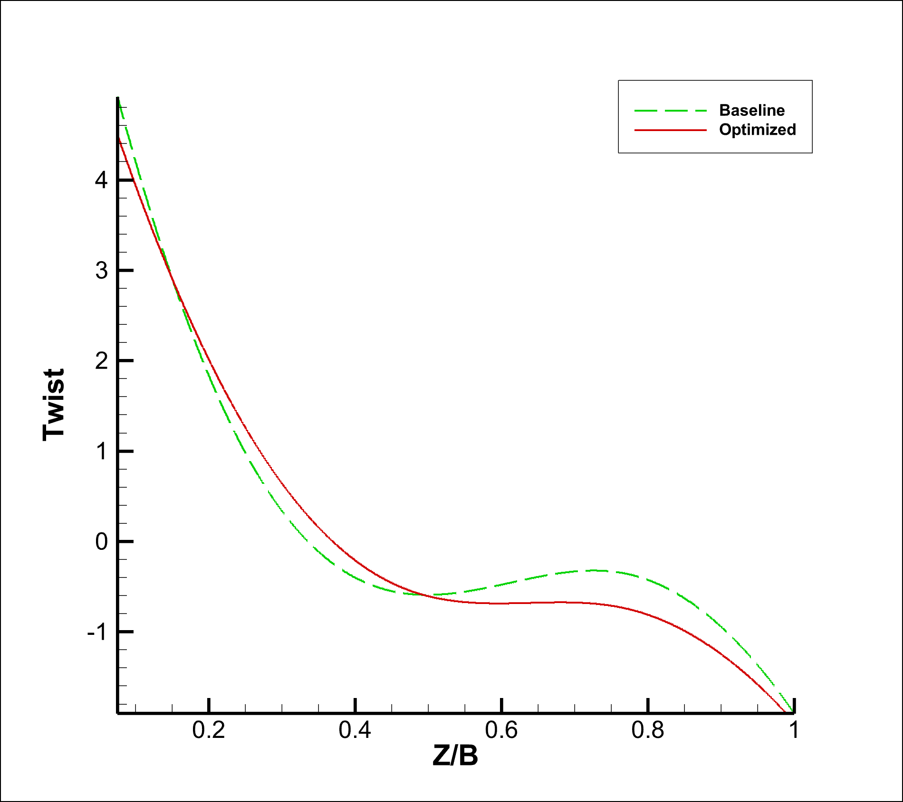
Fig. 1 Comparison of the spanwise twist distribution between the baseline and optimized designs.

The optimized twist applies a stronger washout (more negative twist) toward the wingtip while slightly changing the inboard twist, which unloads the outboard wing and supports the near-elliptical loading target.
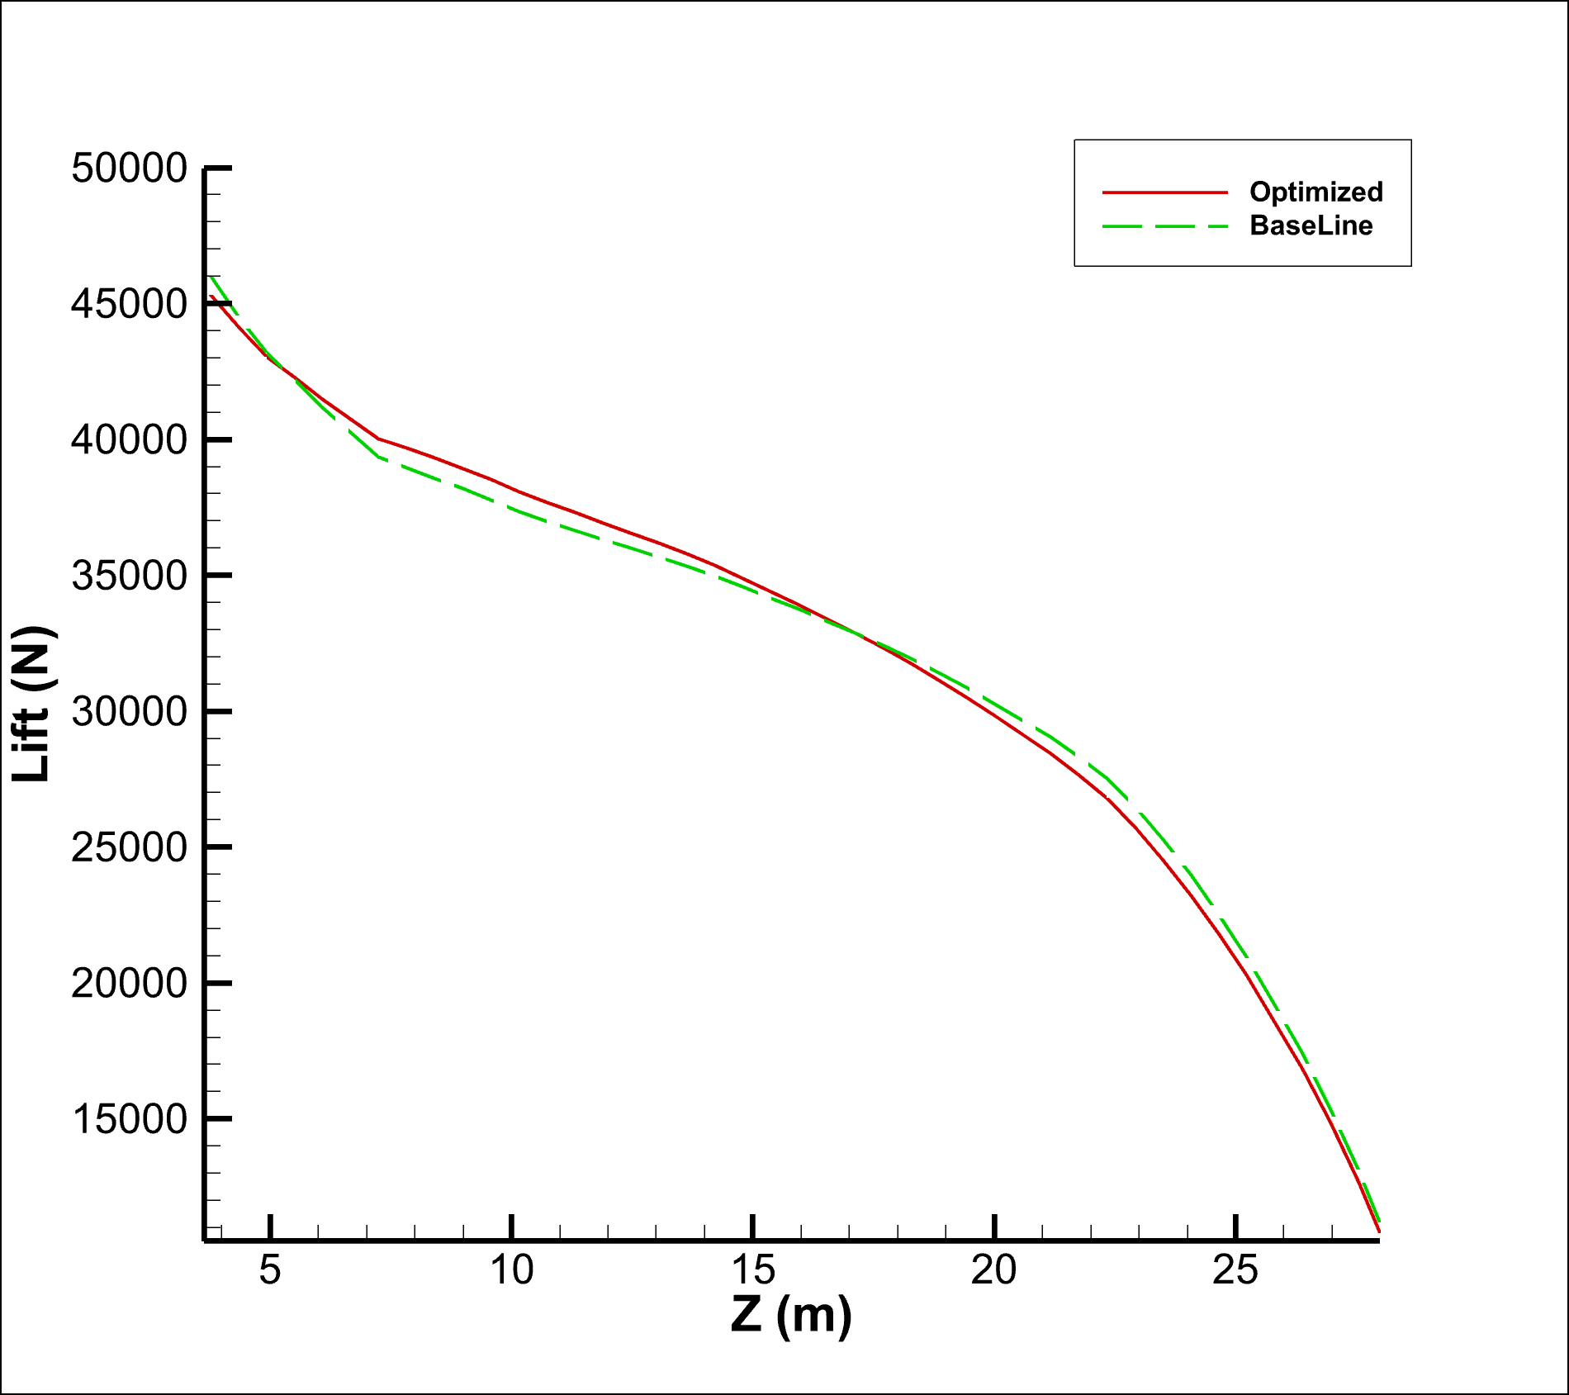
Fig. 2 Comparison of the spanwise lift distribution between the baseline and optimized designs.

The reshaped twist produces the intended change in the spanwise load distribution over the loaded outboard span, moving the loading toward the near-elliptical target used for the induced-drag reduction.
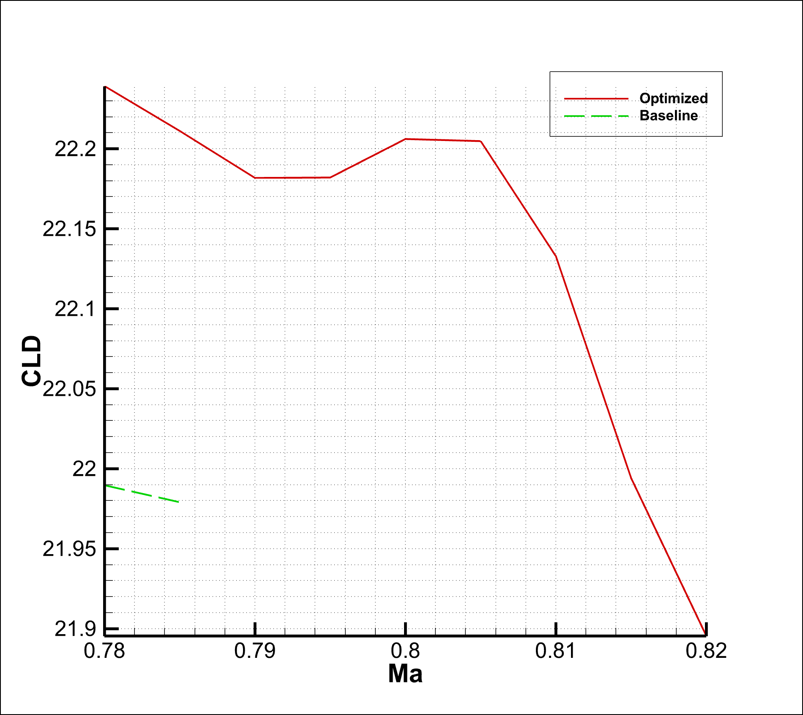
Fig. 3 Lift-to-drag ratio versus Mach number at fixed CL=0.525 for the baseline and optimized designs.

The baseline configuration is converged only up to Ma≈0.785, beyond which the calculation diverges. The optimized configuration converges up to Ma=0.82 and maintains L/D above 22 until Ma≈0.81, after which drag-divergence sets in (L/D falls to 21.90 at Ma=0.82). Balancing the Mach number and the lift-to-drag ratio, an optimal cruise point near Ma=0.805 (L/D≈22.20) is selected.

Parameter | Value
Design Mach number Ma | 0.78
Reynolds number Re | 50×10⁶
Lift coefficient CL | 0.525
Angle of attack, ° | 1.450
Drag coefficient CD | 0.023880
Induced drag coefficient CDi | 0.010490
Wave drag coefficient CDw | 0.000610
Friction + pressure drag CDf | 0.012780
Pitching moment CM | −0.114270
Lift-to-drag ratio L/D | 21.99
Table 1 Single-point aerodynamic characteristics of the baseline design (Ma=0.78, Re=50×10⁶, CL=0.525).
Parameter | Baseline | Optimized
Angle of attack, ° | 1.450 | 1.497
Lift coefficient CL | 0.52511 | 0.52507
Drag coefficient CD | 0.02388 | 0.02361
Induced drag CDi | 0.010490 | 0.010270
Wave drag CDw | 0.000610 | 0.000580
Friction + pressure drag CDf | 0.012780 | 0.007420
Pitching moment CM | −0.114270 | −0.113200
Lift-to-drag ratio L/D | 21.99 | 22.24
Table 2 Comparison of the single-point baseline and optimized designs at Ma=0.78, Re=50×10^7, CL=0.525.

Note: the optimized single-point run used Fuse.V=0 (fuselage viscous drag excluded, as recommended by the WBCAero manual for optimization robustness); its L/D is therefore not directly comparable with the baseline. The physically comparable improvement including fuselage friction is given by the multi-point results in Table 3 (L/D=22.24 versus 21.99 at Ma=0.78).

Ma | Baseline CD | Baseline L/D | Optimized CD | Optimized L/D
0.780 | 0.023880 | 21.99 | 0.023610 | 22.24
0.785 | 0.023890 | 21.98 | 0.023640 | 22.21
0.790 | — | — | 0.023670 | 22.18
0.795 | — | — | 0.023670 | 22.18
0.800 | — | — | 0.023640 | 22.21
0.805 | — | — | 0.023640 | 22.20
0.810 | — | — | 0.023710 | 22.13
0.815 | — | — | 0.023870 | 21.99
0.820 | — | — | 0.023980 | 21.90
Table 3 Fixed-lift Mach sweep (multi-point) of the baseline and optimized designs at CL=0.525, Re=50×10⁶.

The baseline converged only up to Ma=0.785; beyond this the calculation diverged (crashed). The optimized design converged up to Ma=0.82.

Taken together, the single-point optimization reduces the induced drag and improves L/D, while the multi-point Mach sweep shows that the optimized design extends the usable (converged) cruise Mach range from Ma≈0.785 to Ma≈0.82, offering a higher-speed cruise option at a small L/D penalty.

Conclusions
(1) The wing twist of the M-configuration was adjusted so that the spanwise loading approaches a near-elliptical distribution; this reduced the induced drag and improved the lift-to-drag ratio at the design point (Ma=0.78, CL=0.525).
(2) In the fixed-lift Mach sweep, the baseline configuration only converged up to Ma≈0.785, whereas the optimized configuration remained converged up to Ma=0.82, indicating an extension of the usable cruise Mach range.
(3) By balancing the flight Mach number against the lift-to-drag ratio, an optimal cruise condition near Ma=0.805 was identified, where a high cruise speed is obtained with only a small L/D penalty.
(4) The WBCAero full-potential/BLWF56 viscous-coupled solver proved effective both for spanload shaping and for Mach-sweep drag-divergence assessment.

Data Availability
All the data used to make this report is publicly available along with the results at www.github.com/zulfikarMahmud/Mconfig

Acknowledgements
We thank Professor. Zhonghua Han for the help provided during the completion of this report.

References
- 韩忠华，宋文萍，乔志德，应用于跨声速旋翼气动声学计算的两种时域方法的比较, 航空学报, 2006,27(5):756-762
- Han, Z. -H., Görtz, S., and Zimmermann, R., “Improving Variable-Fidelity Surrogate Modeling via Gradient-Enhanced Kriging and a Generalized Hybrid Bridge Function,” Aerospace Science and Technology, Vol. 25, No. 1, pp. 177-189 doi:10.1016/j.ast.2012.01.006

Appendix
Appendix A shows the plot made from the custom elliptical lift distribution script. It helps to monitor the changes made through twist angle change and follow the elliptical path-line of the wing.
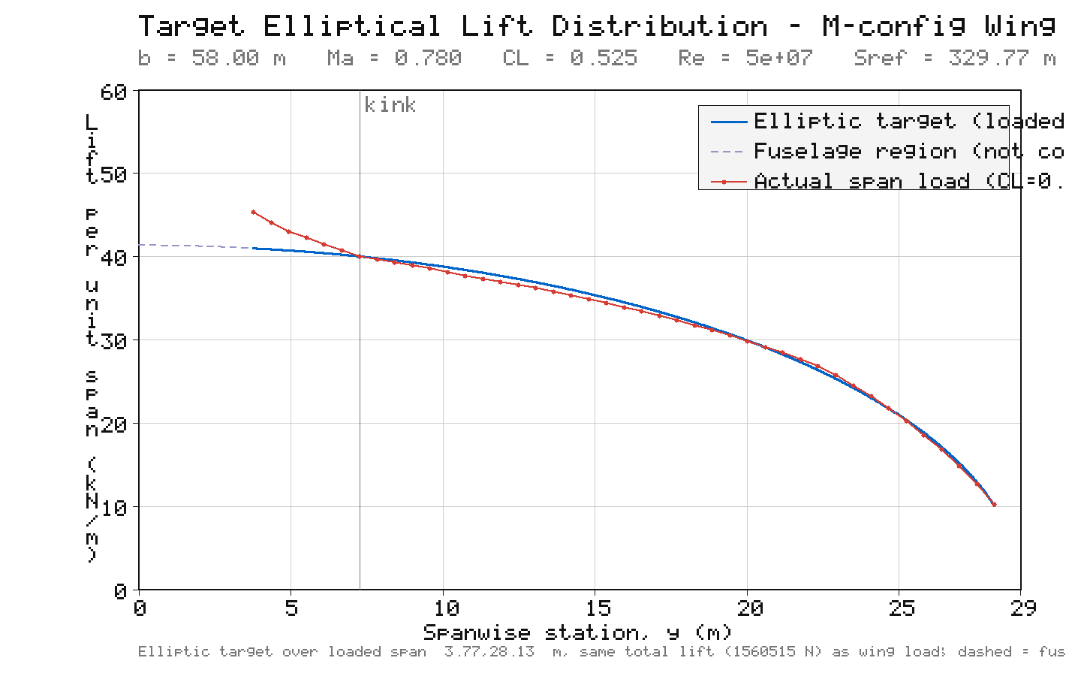
Figure A1: Elliptical Lift Distribution vs M config Lift Distribution of the Wing

