

**COMSATS University Islamabad, Wah Campus**

**Terminal Spring-2020**

Department of COMPUTER SCIENCE

|  |  |
| --- | --- |
| **Class/Program**: BS(CS/SE)/MCS | **Date**: 20-August-2020 |
| **Subject**: Artificial Intelligence | **Teacher**: Dr. Faisal Azam |
| **Submission Date**: 20-August-2020 | **Maximum Marks**: 50 |
| **Student Name:** | **Registration#:** |

**Handwritten Answers Only**

Question Number 1: 20 Marks

**Case:**

Knapsack algorithm is used to maximize the profit of carrying different items with multiple weights and associated benefits. This problem can also be solved using least cost brand and bound strategy. Sometimes it is also termed as 0/1 Knapsack problem. Consider an example in which a war soldier has to fill a knapsack with different ammunition and war related items. Your input will contain the maximum weight his "knapsack" can carry, along with the weight and worth of each item that could be taken. Worth is calculated based upon the usefulness level of any ammunition. For example, a hand-grenade will have more worth with respect to destruction as compared to a simple bullet. Worth is scaled from 0 to 100 level. With 0 as least and 100 as highest worth. Your program should output the maximum worth of the items the soldier could carry in his knapsack.

Inputs

**Item Weight Worth**

Bullet 75gram 15

Hand-grenade 180gram 80

Dagger 2000gram 40

Sabre 500 gram 50

Bayonet 320 gram 30

Sling 60 gram 10

Mine 5000 gram 90

You must select multiple size knapsacks to solve this problem using the following specified questions.

1. Solve Knapsack problem of above example using Genetic Algorithm **5 Marks**
2. Give Output using Table or a Graph containing the different size of knapsack and maximum profits you can carry with respect to each size (at least 3) **5 Marks**
3. Find the optimal size of knapsack to carry maximum items **5 Marks**
4. Draw the flowchart/model of your selected approach **5 Marks**

(**Note:** Valid Implementation results are also acceptable)

Question Number 2: 10 Marks

f(n) = g(n) + h(n). Discuss which thing should be optimal, underestimated, overestimated, admissible or non-admissible. What will happen if you make it monotonic? Can you preserve its admissibility? Answer in tabular format only.

Question Number 3: 10 Marks

Give some alternative solutions to Dijkstra algorithm in state space representation. Can this problem be solved using informed search? Discuss.

Question Number 4: 10 Marks

Class VIVA

**Answer of these Question:**

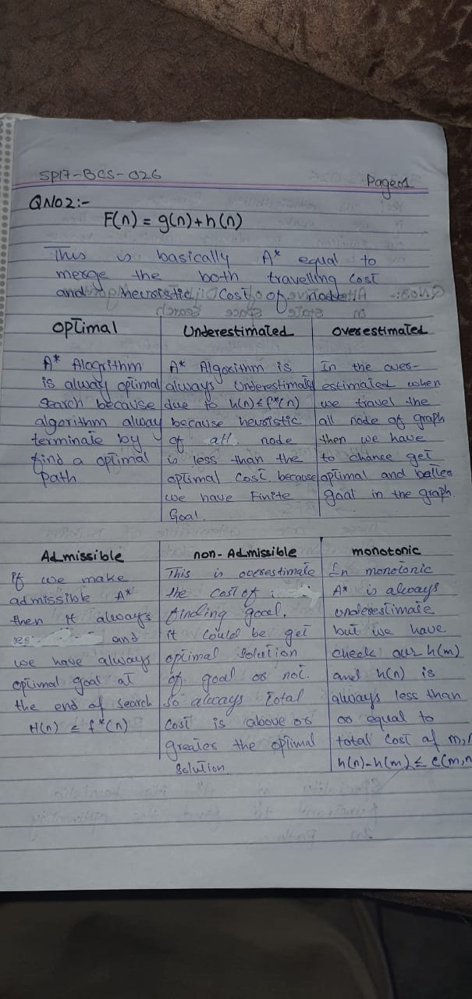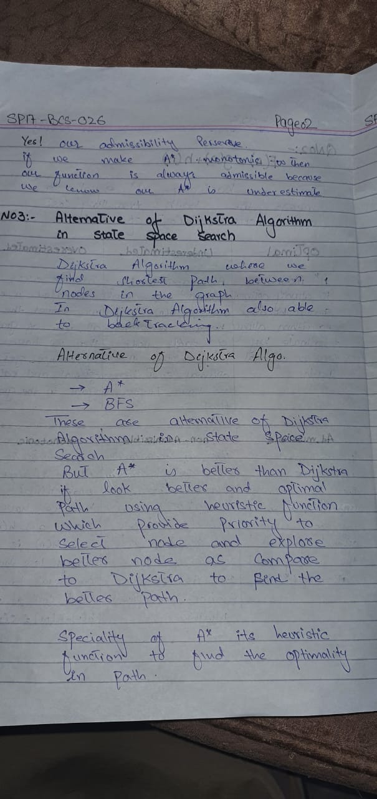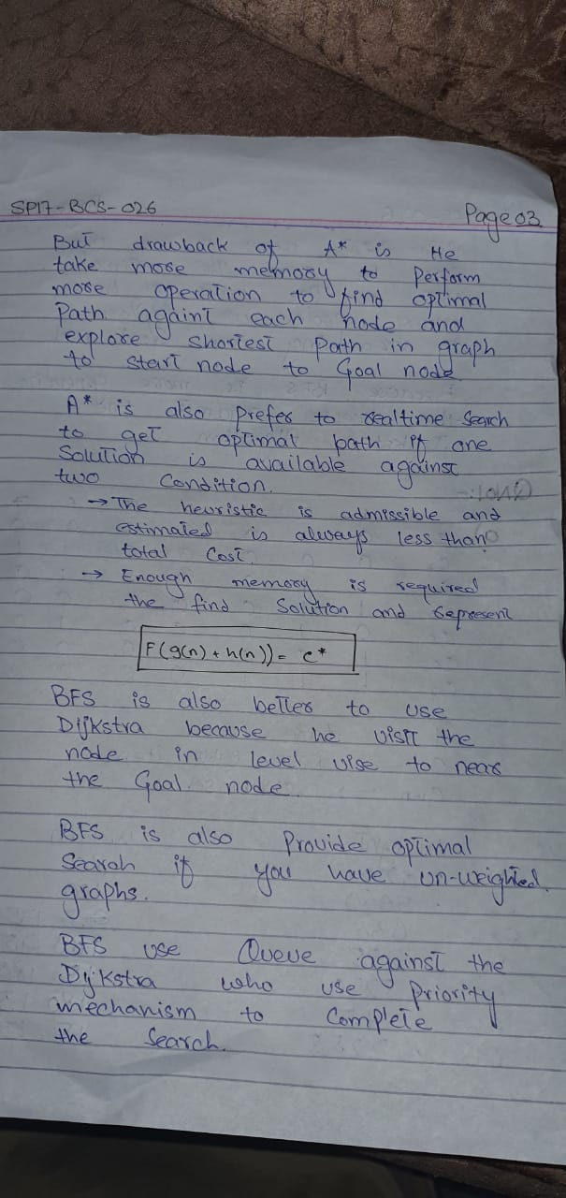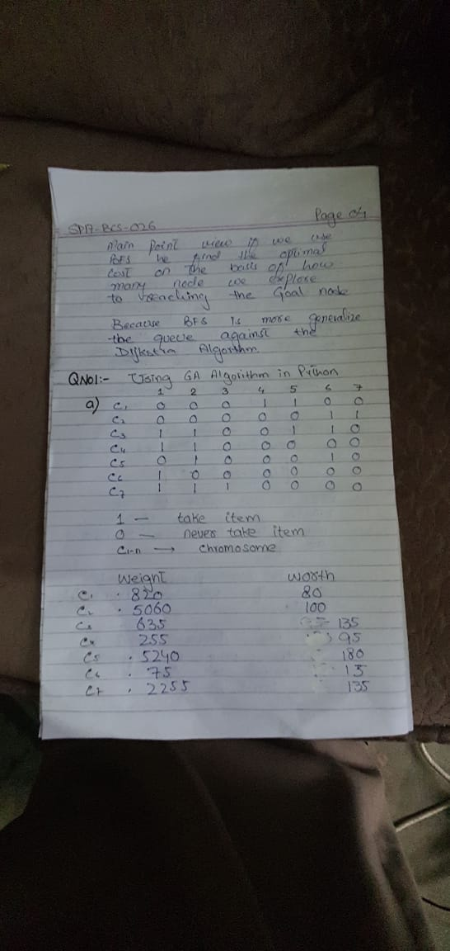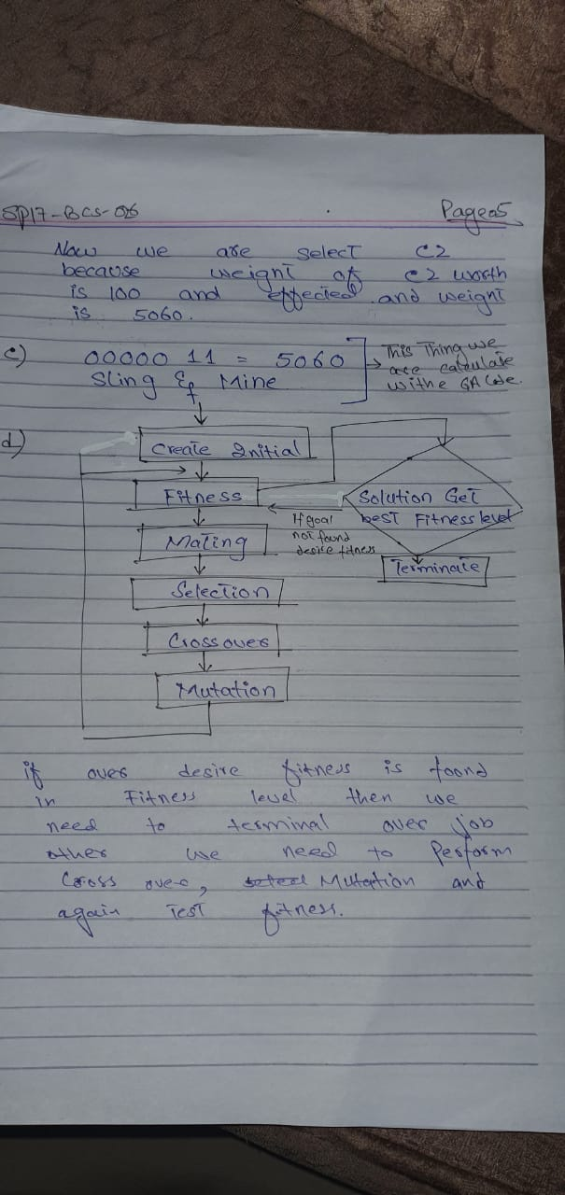

Good Luck