DeClim
Detrend Advisor and Ring-Climate Analyzer (RingClim)
User guide with a worked example on real data — version 2.1
Dr. Zulfiyor Bakhtiyorov
Department of Geography, University of Cambridge, UK
Xinjiang Institute of Ecology and Geography, CAS, China; Khujand Science Center, NAS of Tajikistan
Contact: zb308@cam.ac.uk
Companion document to the article “DeClim: goal-driven tree-ring detrending linked to integrated climate-data retrieval and climate-signal screening”. Programs, source code and this guide: https://github.com/zulfiyor/DeClim. All screenshots were taken from the programs, and all numbers come from data downloaded with the programs (example data of 28 October 2026; screenshots of the version 2.1 functions of 8 November 2026).

Contents
1. What DeClim does 3
2. Installation and folder layout 4
2.1 Requirements 4
2.2 Folder layout 4
2.3 First start 4
2.4 Stand-alone executables 4
2.5 Screenshots with F12 5
2.6 Updates, user guides and contact 5
3. The worked example 6
4. Detrend Advisor step by step 7
4.1 Main window 7
4.2 Importing ring widths from the ITRDB 8
4.3 Choosing the goal 9
4.4 Reading the recommendation 10
4.5 The diagnostic tabs 11
4.6 Pith offsets and tree groups 14
4.7 Exporting the results 14
4.8 Opening RingClim with the results 15
4.9 Custom detrending methods 15
5. RingClim step by step 17
5.1 Main window 17
5.2 Importing files 17
5.3 Analysis settings 18
5.4 Results 19
5.5 Report and export 21
5.6 Filtering the results without re-running 21
5.7 Projects and session recovery 22
6. Online climate data 23
6.1 The Online data window 23
6.2 Download everything for the area 24
6.3 Exporting locations 26
7. ERA5, ERA5-Land and GloFAS with your own Copernicus key 27
8. Moving correlation: is the signal stable in time? 29
8.1 Computing running correlations 29
8.2 Stability statistics 29
8.3 Screening all seasons for the most stable signal 30
9. Spatial correlation: is the signal regional? 32
9.1 Computing a map 32
9.2 Screening all windows for the region 32
10. Interpreting the example 34
11. Comparison with other software 36
12. Troubleshooting 37
13. Citation and data references 38

1. What DeClim does
DeClim is a pair of linked desktop programs for dendroclimatology. Detrend Advisor standardises tree-ring measurements: it computes many detrending methods at once, scores them against the goal of the study and exports the chronologies with a report. RingClim (Ring-Climate Analyzer) correlates chronologies with climate: it imports almost any table layout, downloads climate, drought and station data from public servers, screens all monthly or daily windows of the previous and current year and presents the results as tables, heatmaps and reports.
The two programs are connected: one command in Detrend Advisor opens RingClim with all exported chronologies already loaded. Version 2.0 added direct access to the International Tree-Ring Data Bank (ITRDB) and to twelve climate sources, so that the whole chain from raw ring widths to a climate-response analysis can be done without leaving the programs. Version 2.1 adds custom detrending methods, moving (running) correlations with stability tests, spatial correlation maps, screening of all seasons and windows with a chance control, filters of the results without re-running, faster parallel and incremental analysis, session recovery and built-in updates.
Table 1. Typical tasks and where they are done.
Task | Program and command | Section
Find and import ITRDB ring widths | Detrend Advisor: Project → Import from ITRDB (online) | 4.2
Compare detrending methods for a goal | Detrend Advisor: Goal + RUN | 4.3–4.5
Use pith offsets and tree groups | Detrend Advisor: Project → Import pith info; Tree groups | 4.6
Export chronologies and the report | Detrend Advisor: Actions → Export project outputs | 4.7
Send chronologies to RingClim | Detrend Advisor: Actions → Open RingClim | 4.8
Import any climate or chronology file | RingClim: Data → Add / Import File | 5.2
Download climate for a site | RingClim: Data → Online data… | 6
Use ERA5 / ERA5-Land / GloFAS (own key) | RingClim: Online data → API keys… | 7
Screen climate windows | RingClim: Analysis → Run analysis | 5.3, 10
Read and export results | RingClim: Results, Report | 5.4–5.5
Add splines or running means of any period | Detrend Advisor: Custom methods… | 4.9
Filter the results without re-running | RingClim: Results → Filter bar | 5.6
Recover an interrupted session | RingClim: restore prompt at start | 5.7
Test the stability of a signal over time | RingClim: Analysis → Moving correlation | 8
Map the correlation over a region | RingClim: Analysis → Spatial correlation | 9
Check for updates, guides, contact | Both programs: Updates | 2.6

2. Installation and folder layout

2.1 Requirements
- Windows 10/11, macOS or Linux with Python 3.10 or newer.
- Python packages: numpy, pandas, scipy, matplotlib, openpyxl, PySide6 (RingClim) and Tk (included with Python; Detrend Advisor). Optional: requests, xarray, netCDF4, rasterio (faster downloads and NetCDF files).
- R with the package dplR for the detrending back-end of Detrend Advisor (dplR on CRAN). Install it once in R with install.packages("dplR").
- An internet connection for the online data. A free Copernicus account is needed only for ERA5, ERA5-Land and GloFAS from the Copernicus data stores (Section 7).

2.2 Folder layout
Keep the files together in one folder. The two main scripts load all shared modules from the sub-folder dendro_modules:
File or folder | Purpose
detrend_advisor4.py | Detrend Advisor (main script)
ringclim.py | RingClim (main script)
run_detrend_advisor.bat, run_ringclim.bat | Start the programs on Windows with a double-click
build.bat / build.sh | Build stand-alone executables with PyInstaller
requirements.txt | List of Python packages (pip install -r requirements.txt)
dendro_modules/ | Shared modules: online data (dendro_online*.py, dendro_sources*.py), Copernicus access (dendro_copernicus.py), pith tools (dendro_pith.py), help and F12 capture (dendro_ui_help.py), moving correlation (dendro_moving*.py), spatial correlation (dendro_field*.py), updates (app_update*.py), map outlines

2.3 First start
- Install Python and the packages: open a terminal in the program folder and run pip install -r requirements.txt.
- Install R and dplR (Section 2.1).
- Double-click run_detrend_advisor.bat (or run python detrend_advisor4.py). The main window of Detrend Advisor opens (Figure 2).
- RingClim is normally opened from Detrend Advisor (Section 4.8), but it can also be started alone with run_ringclim.bat or python ringclim.py.

2.4 Stand-alone executables
build.bat (Windows) or build.sh (macOS/Linux) creates executables in the folder dist with PyInstaller. The scripts check that dendro_modules exists, add it to the search path and include the map data. Run them from the program folder after installing PyInstaller (pip install pyinstaller).

2.5 Screenshots with F12
Press F12 in any window of either program to save an image of that window. Images are written to the folder DeClim_screenshots in your home directory (for example C:\Users\<name>\DeClim_screenshots) with the date, time and window title in the file name. Set the environment variable DECLIM_SCREENSHOT_DIR to use another folder. All figures of this guide were made in this way.

2.6 Updates, user guides and contact
Both programs have an Updates button at the bottom of the main window. Its menu checks for a new version (automatically once a day, if Check automatically is ticked), opens the latest release page, downloads or opens the user guides, writes to the developer (Contact the developer…) or opens a GitHub issue, and restores the previous version. A new version is downloaded only after you agree, verified with SHA-256 and installed when all DeClim windows are closed; settings, projects and your own files are kept, and the previous version stays next to the new one for Restore previous version….
The programs, the source code, the ready-to-use packages for Windows and macOS, this guide and the example data are published at github.com/zulfiyor/DeClim (page Releases). Problems and suggestions can be reported there as GitHub issues.
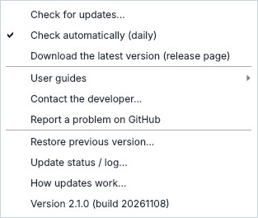
Figure 1. The Updates menu of RingClim (the same menu is in Detrend Advisor).

3. The worked example
All steps of this guide are shown with public data for one site, so that every screenshot and number can be reproduced:
Item | Value
Site | ITRDB KYRG002 “Kyrgyzstan High Bon”, Fergana Range, Kyrgyzstan
Species | Juniperus spp. (JUSP)
Location | 40.17° N, 72.58° E, 2900 m a.s.l.
Data | Total ring width, 33 series, 1346–1995 (contributor: J. Esper)
Source | NOAA NCEI / ITRDB study page (found by the search inside the program)
Climate period | 1951–1995 (overlap of the chronology with most climate products)

The files produced in this example are distributed with this guide in the folder DeClim_example_KYRG002:
- itrdb/ — the ring-width file and all Detrend Advisor exports (chronologies, RWI, EPS/Rbar tables, Excel workbook and the markdown reports with and without POWT).
- DeClim_batch/ — the climate data downloaded in one batch: one CSV file per dataset in data/, batch_data.xlsx, all_monthly_long.csv, summary.csv, README_citations.txt and the location files (locations.kmz, *.geojson, *.csv).
- results/ — the correlation tables exported from RingClim.

4. Detrend Advisor step by step

4.1 Main window
The top area holds the project controls; the notebook below shows the results (Figure 2).
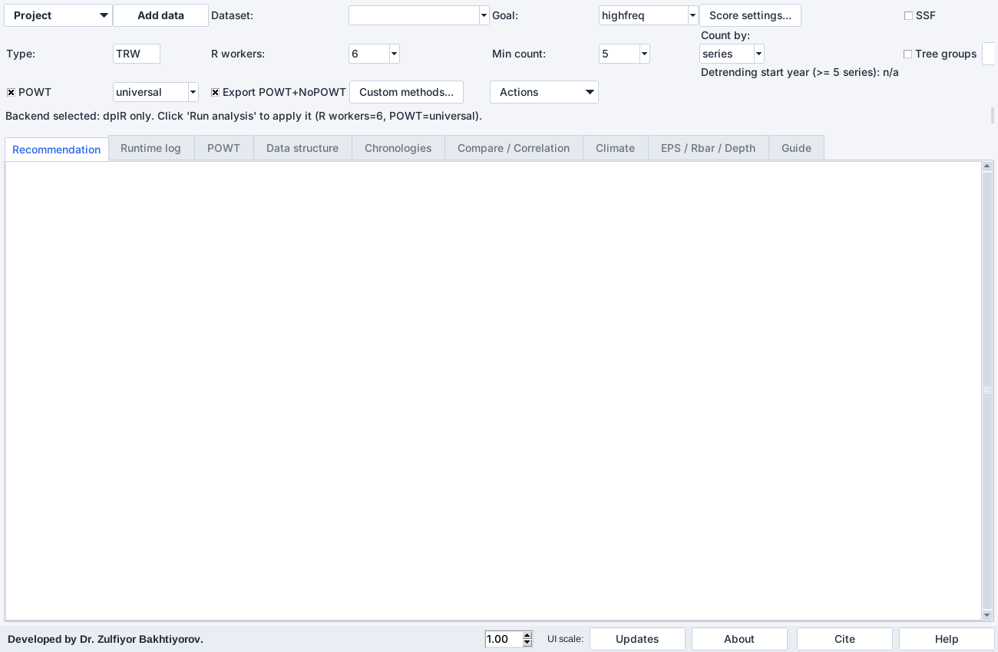
Figure 2. Main window of Detrend Advisor after start, before data are loaded.
Control | Meaning
Project | Menu: new/open/save project, import data, import from ITRDB, import pith information, import climate, export folder
Add data | Adds a file to the current project without removing the loaded datasets
Dataset | The dataset that is analysed, shown and exported
Goal | Objective of the study; it decides how candidates are ranked (Section 4.3)
Score settings… | Weights of the ranking criteria for the selected goal
Type | TRW (ring width) or BI (blue intensity)
R workers | Number of parallel R processes
Min count / Count by | Minimum number of series (or trees) required; defines the detrending start year
SSF, SF-RCS | Add signal-free and signal-free RCS candidates (slower)
Tree groups, … | Group radii into trees and edit the grouping rules (Section 4.6)
POWT | Power transformation before detrending; method universal or cook
Export POWT+NoPOWT | Export both versions so that they can be compared
Actions | Export RWI, export project outputs, open RingClim
RUN | Starts the comparison
UI scale (bottom) | Enlarges fonts and controls on high-resolution screens

4.2 Importing ring widths from the ITRDB
Open Project → Import from ITRDB (online) (Figure 3). Enter a point and a radius (here 40.17° N, 72.58° E, 150 km) or a bounding box, optionally a species code (four letters, e.g. JUSP, JUTU), a period and a text filter, and press Search ITRDB. The sites found are listed with species, coordinates, elevation and period, and shown on the map. Click on the map to set a new point, drag to draw a box, use the mouse wheel to zoom.
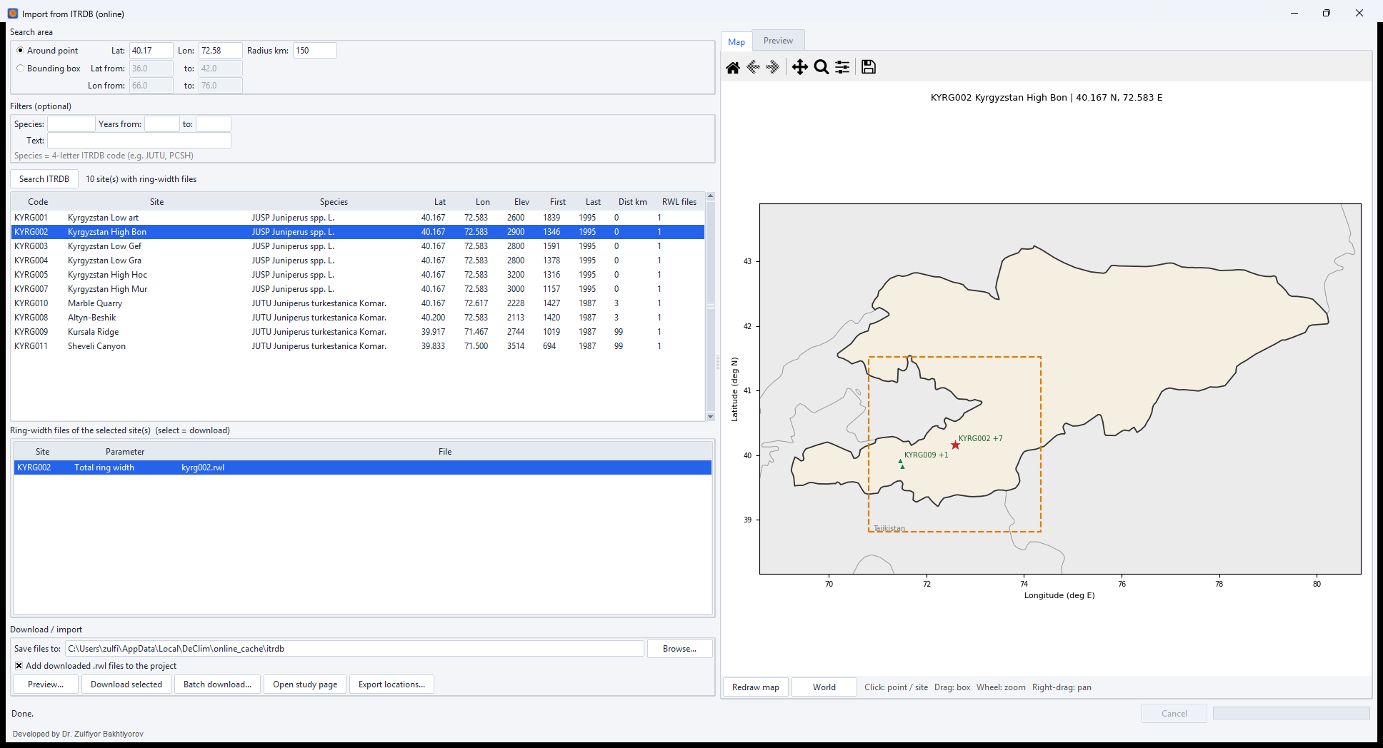
Figure 3. ITRDB search around the example site: ten sites with ring-width files within 150 km.
Select a site to list its ring-width files, select a file and press Preview… to read it in memory: the Preview tab shows the span of every series, the mean ring width and the sample depth (Figure 4). Download selected stores the file in the cache folder and, with Add downloaded .rwl files to the project ticked, adds it to the project. A message confirms the number of series and the period (KYRG002: 33 series, 1346–1995). Batch download… fetches all files of the listed sites, Open study page opens the NOAA page with the metadata and the citation, and Export locations… saves the site locations.
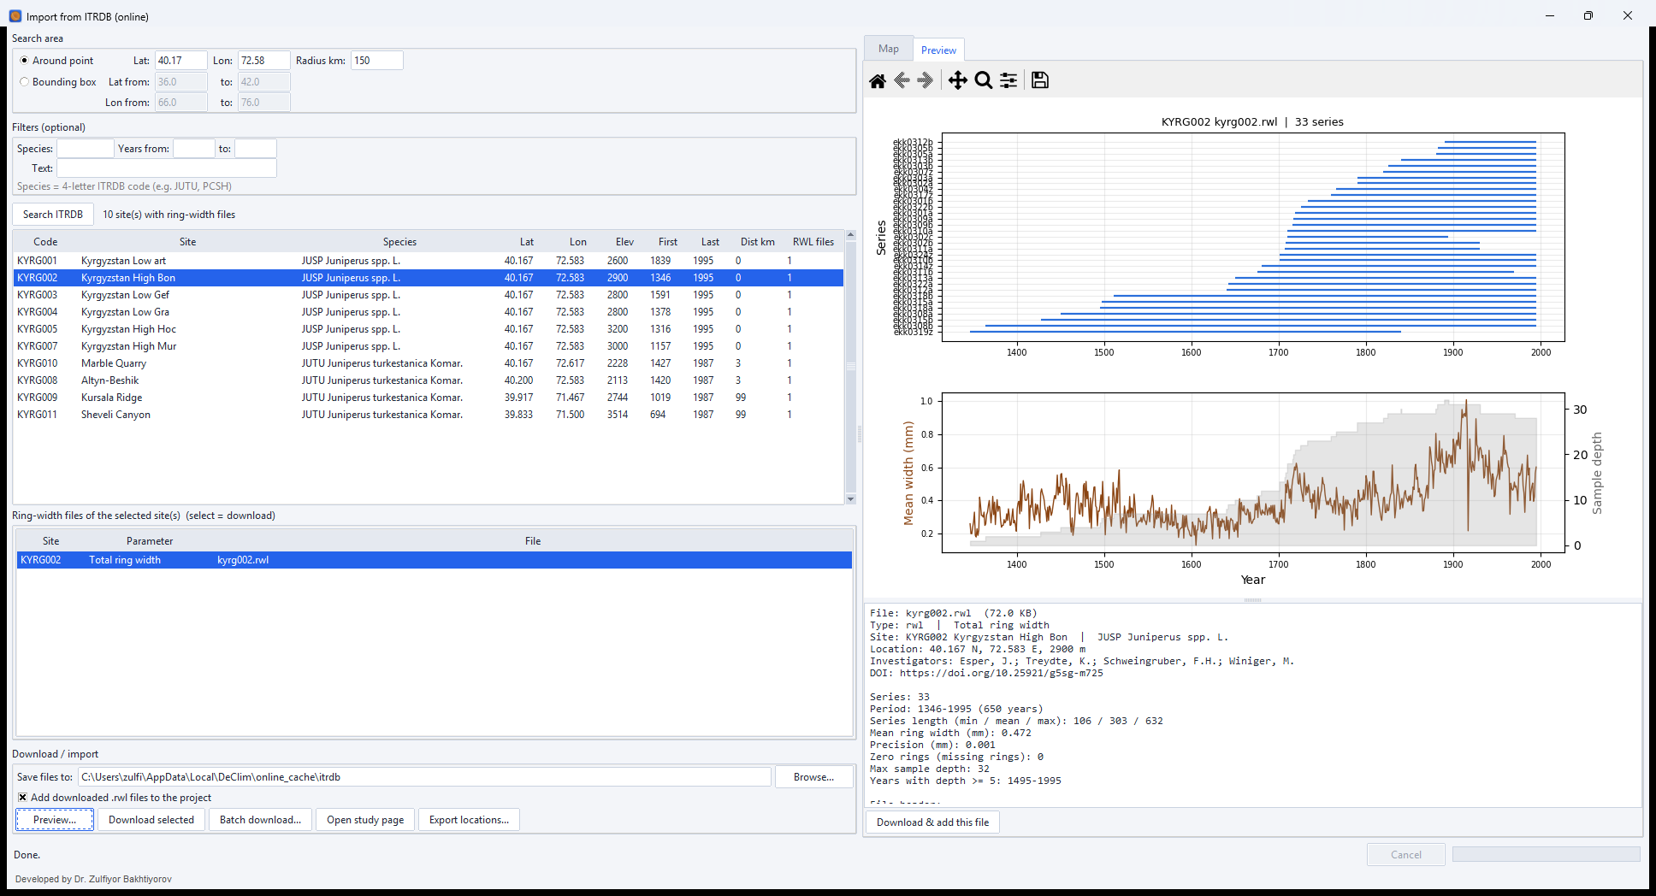
Figure 4. Preview of kyrg002.rwl before import: series spans, mean ring width and sample depth.
Note. Tucson files are read in millimetres. The precision of each series is taken from its end-of-series marker (999 = 0.01 mm, −9999 = 0.001 mm), as in dplR. Only the fixed data columns are read, so flags written after the values in some old ITRDB files are ignored.
Local files are imported with Project → Import data (replace project) or Add data to project: CSV, Tucson (RWL, TUC, DEC, TXT), generic text tables, JSON and Excel workbooks with one year column and one column per series.

4.3 Choosing the goal
The goal tells the advisor what the chronology is for. The candidates are scored differently for each goal:
Goal | Use when | What is favoured
highfreq | Interannual climate signal, pointer years | High-frequency variance, Rbar, EPS
mixed | No clear preference | Balance of high and low frequency
lowfreq | Decadal to centennial variability | Low-frequency variance
temp_recon | Temperature reconstruction | Low-frequency variance with good EPS
runoff_recon | Streamflow reconstruction | Moisture-related, persistent signal
drought_recon | Drought / PDSI reconstruction | Moisture-related signal
variance_check | Diagnostics of variance structure | Stable variance through time

In the example the goal temp_recon, Min count = 5 series and Count by = series were selected; the detrending then starts in 1495, the first year with at least five series. Press RUN. The advisor computes twelve candidate methods with dplR in parallel (here in a few minutes). The 33 cores of KYRG002 come from 19 trees; the cores of a tree are averaged, so EPS and Rbar are computed for trees.

4.4 Reading the recommendation
The Recommendation tab (Figure 5) states the recommended method, the pith situation, the comparison with and without POWT and the reasons for the choice.
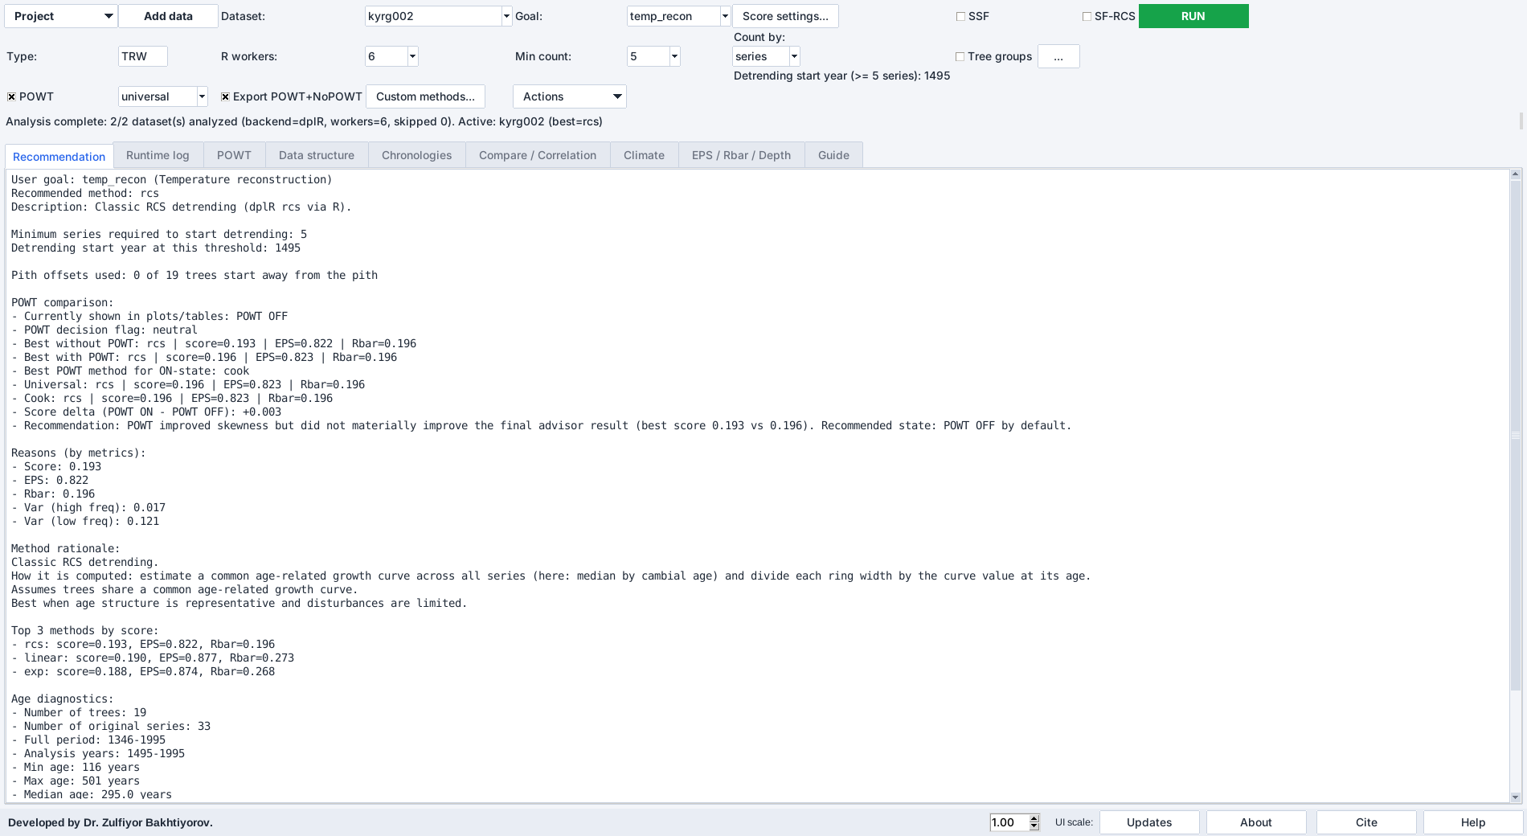
Figure 5. Recommendation for KYRG002 (goal temp_recon): classic RCS, score 0.193, EPS 0.822, Rbar 0.196 without POWT.
In the example, classic RCS ranked first (score 0.193), followed by linear detrending (0.190), the modified negative exponential (0.188) and Hugershoff (0.186). RCS was preferred because it keeps by far the largest low-frequency variance (0.121 against 0.043 for the negative exponential), which the temp_recon goal weights explicitly, although its EPS (0.822) is lower than that of the age-trend methods (0.87–0.88). With POWT the best score was 0.196, but the advisor reports that POWT improved skewness without materially improving the result and recommends the state POWT OFF.
Table 2. Candidate scores for KYRG002 (goal temp_recon, without POWT; from the exported report).
Method | Score | EPS | Rbar | Var(high) | Var(low)
rcs (recommended) | 0.193 | 0.822 | 0.196 | 0.017 | 0.121
linear | 0.190 | 0.877 | 0.273 | 0.017 | 0.045
exp (ModNegExp) | 0.188 | 0.874 | 0.268 | 0.017 | 0.043
hugershoff | 0.186 | 0.870 | 0.260 | 0.016 | 0.041
age_dep_spline | 0.173 | 0.844 | 0.221 | 0.024 | 0.029
mean | 0.172 | 0.830 | 0.205 | 0.020 | 0.041
spline_30 | 0.165 | 0.849 | 0.228 | 0.019 | 0.001
spline_60 | 0.162 | 0.838 | 0.214 | 0.019 | 0.003
runmean_32 | 0.161 | 0.836 | 0.212 | 0.019 | 0.003
lowess | 0.161 | 0.837 | 0.213 | 0.018 | 0.002
ar | 0.159 | 0.831 | 0.205 | 0.023 | 0.002
spline_120 | 0.159 | 0.826 | 0.200 | 0.018 | 0.007

4.5 The diagnostic tabs
Tab | Content
Runtime log | Every step of the run with time stamps, R messages and warnings (Figure 6)
POWT | Mean series and skewness distribution of the raw, universal and Cook transformations (Figure 7)
Data structure | Age distribution, mean growth by cambial age and sample depth (Figure 8)
Chronologies | All candidate chronologies with sample depth (Figure 9)
Compare / Correlation | Chronologies of all methods and their correlation matrix (Figure 10)
Climate | Correlation with a target series when one was imported (Project → Import climate)
EPS / Rbar / Depth | Running EPS and Rbar of the active method with the sample depth (Figure 11)
Guide | Built-in explanation of the methods, goals and scores
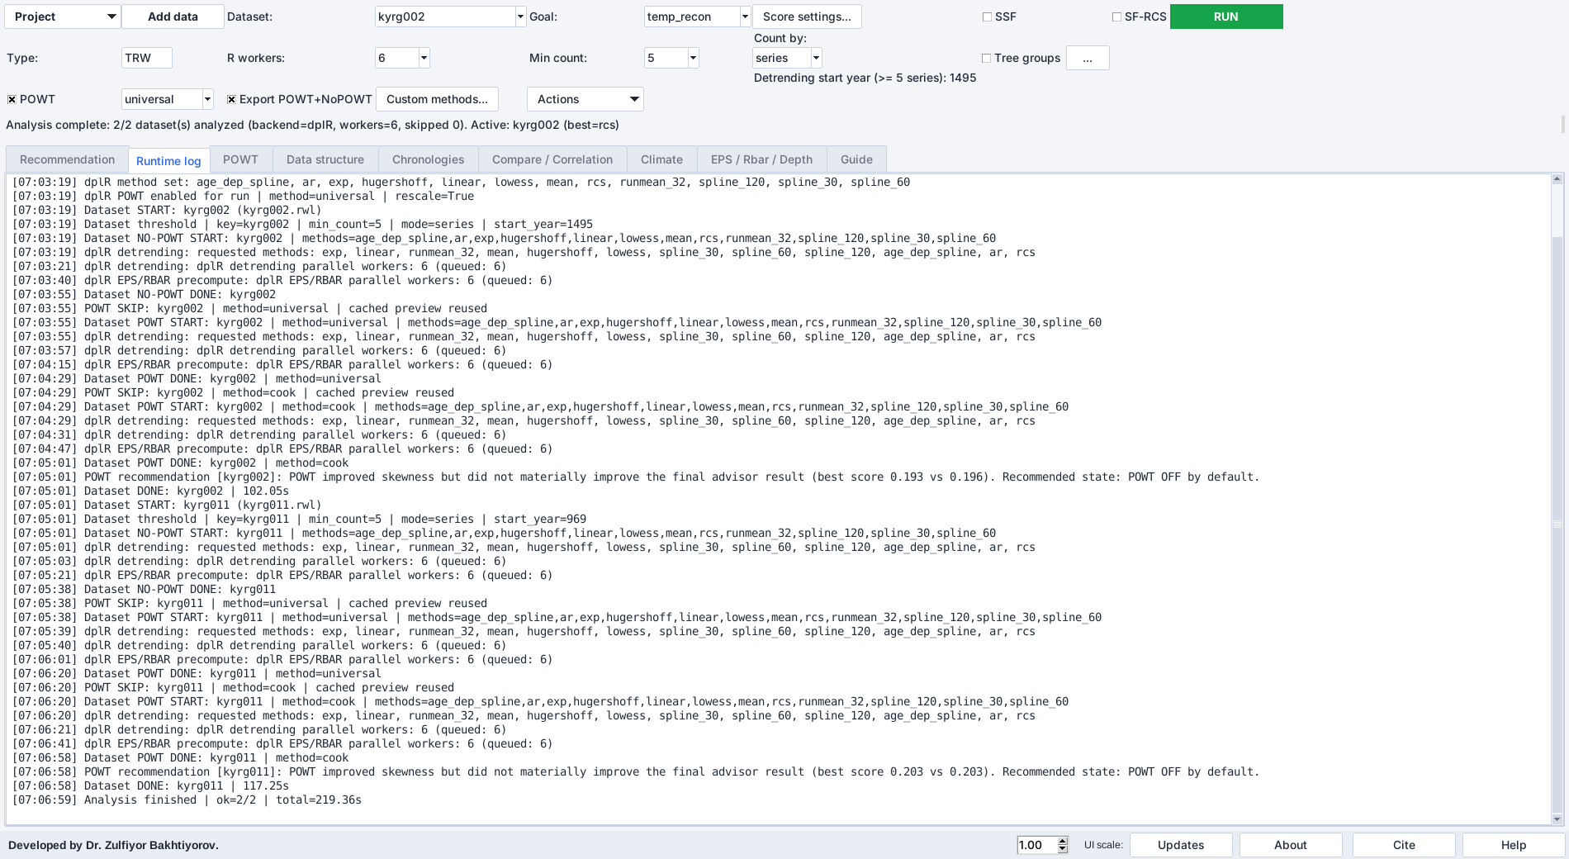
Figure 6. Runtime log of the example run.
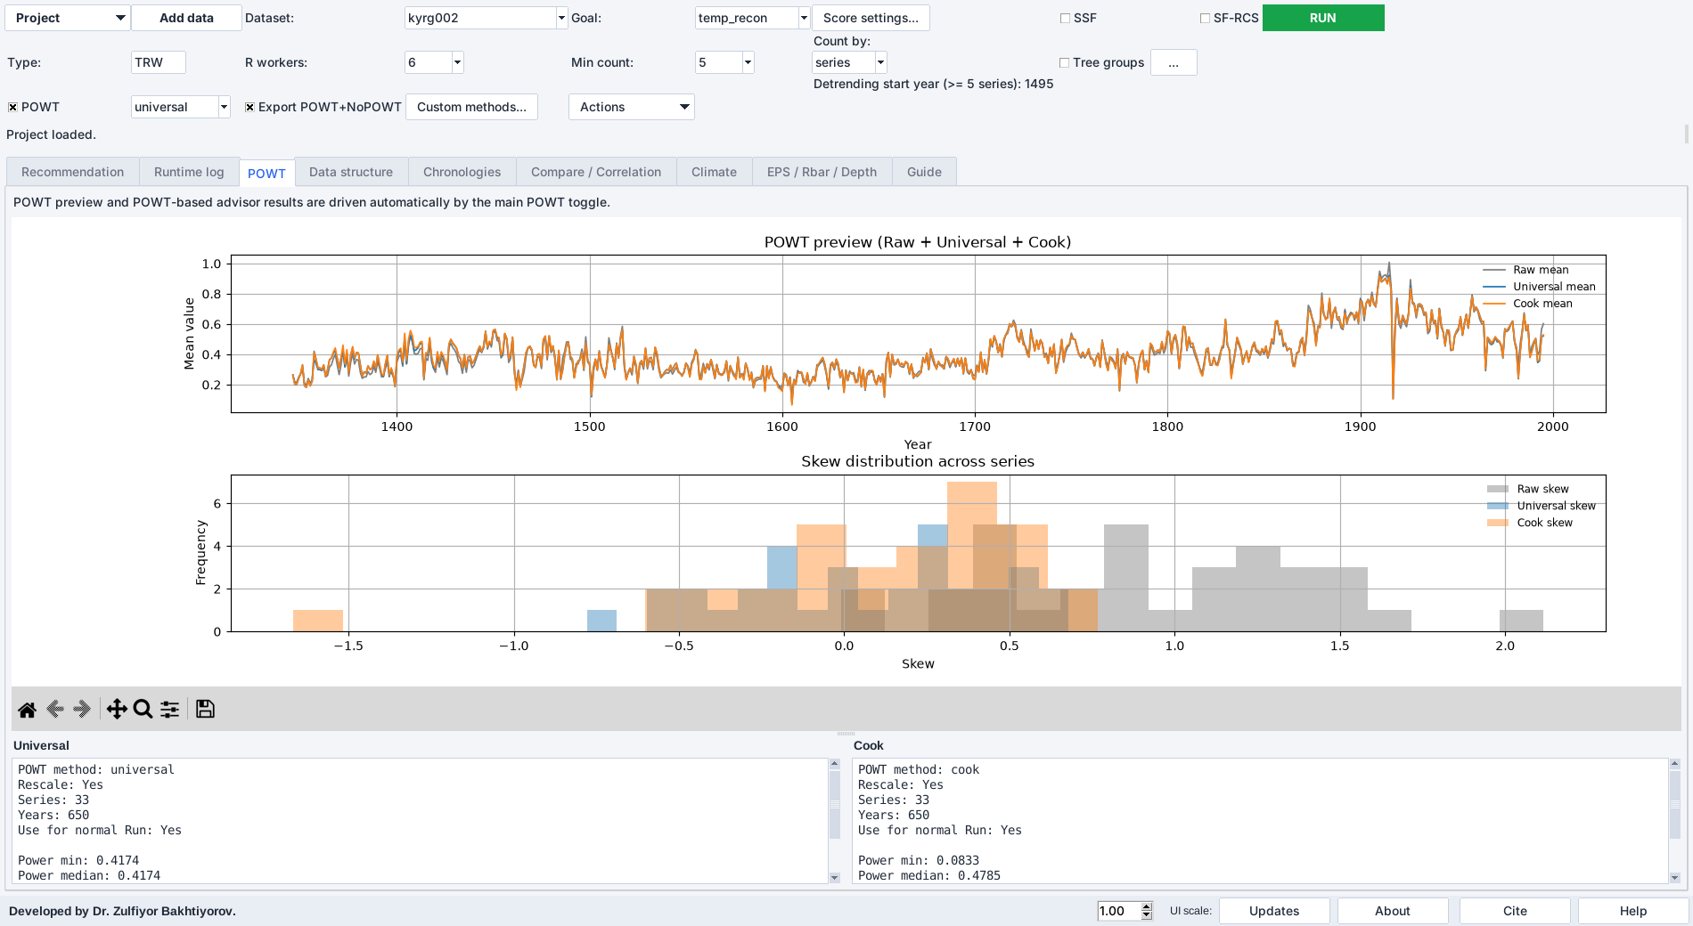
Figure 7. POWT tab: mean of the raw and transformed series and the skewness of all series.
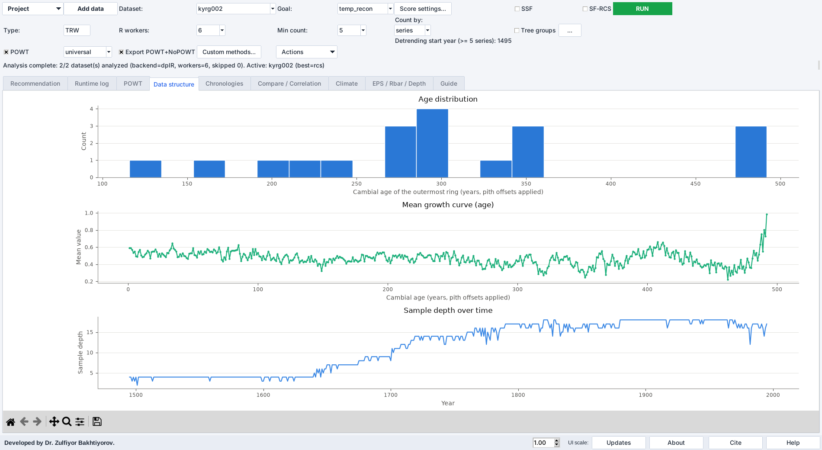
Figure 8. Data structure tab: age distribution, mean growth curve by cambial age and sample depth.
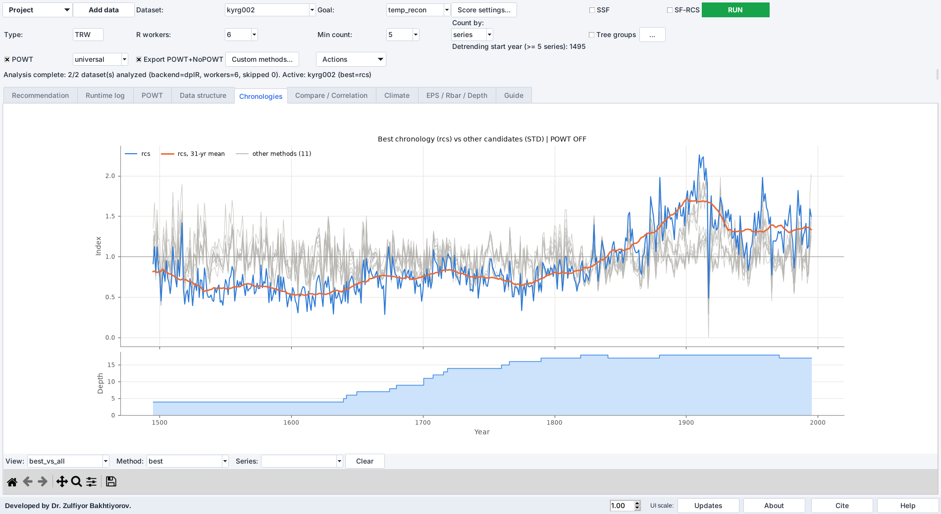
Figure 9. Chronologies tab: all candidate chronologies of KYRG002.
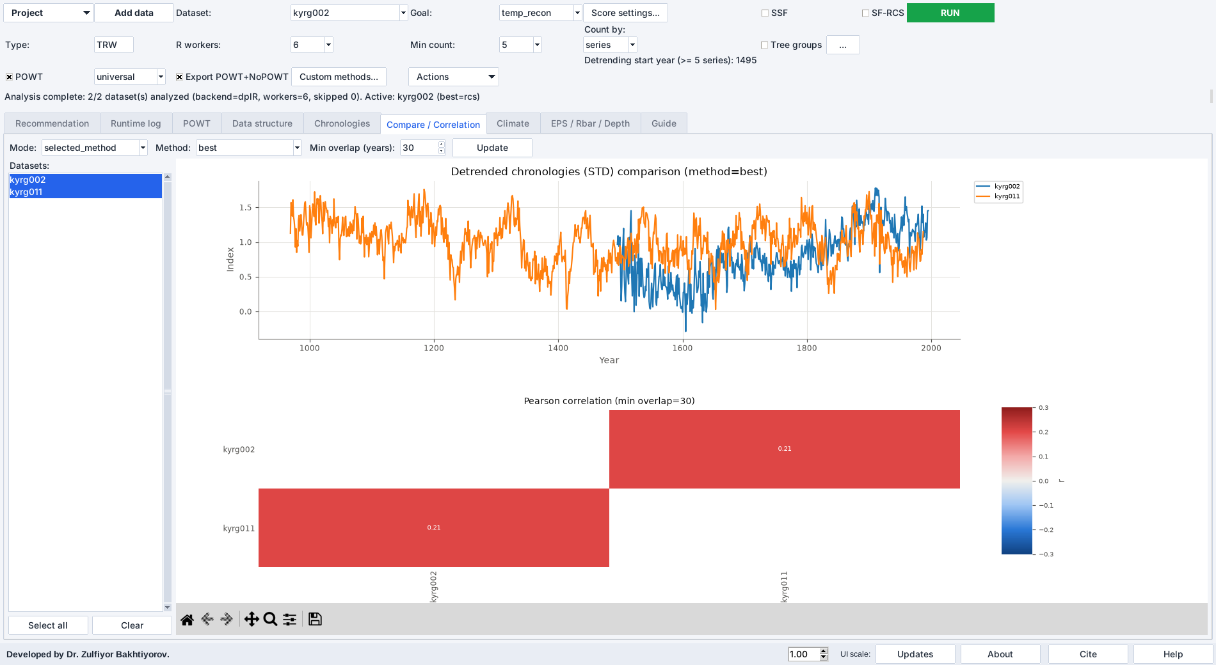
Figure 10. Compare / Correlation tab: chronologies and the correlation matrix between detrending methods.
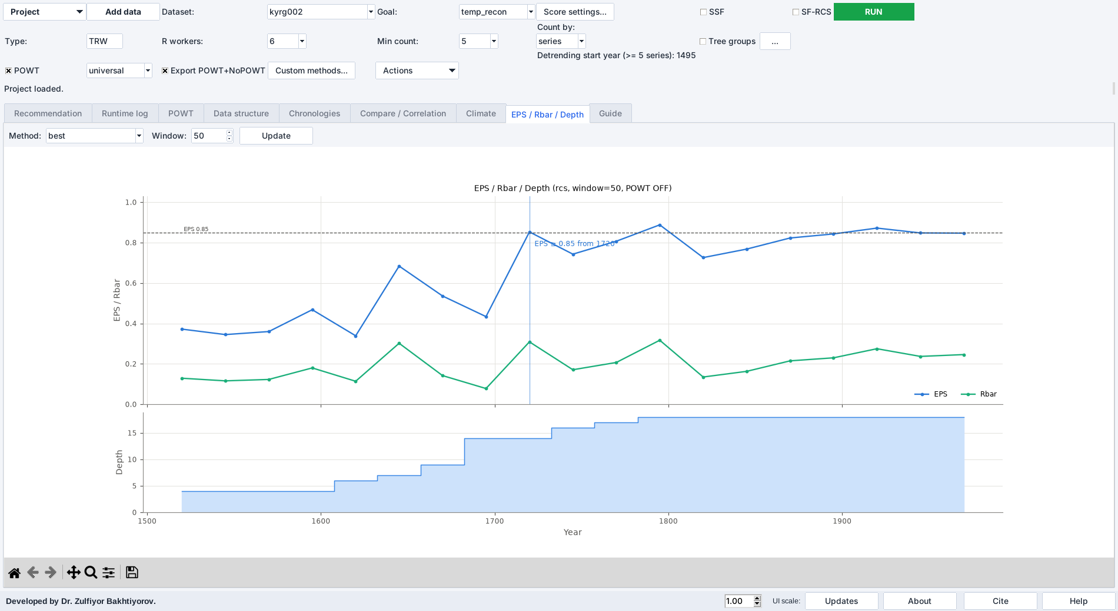
Figure 11. EPS / Rbar / Depth tab: running EPS and Rbar of the recommended RCS chronology with sample depth.
Note. If some methods exclude series (for example too short series) or fail in R, an “Analysis warnings” window lists them with the reason. Methods without problems are not listed.

4.6 Pith offsets and tree groups
RCS aligns series by cambial age, so the distance to the pith matters. Use Project → Import pith info (.pos / .pith.csv) to read CooRecorder or PyTreeRingRecorder position files or a table with the columns series and pith.offset; Import pith info from folder… reads all position files of a folder. The offsets are passed to dplR as pith offsets. Series with unknown pith can be kept (offset 1) or excluded from RCS.
Tick Tree groups to combine radii of the same tree (for example KYR01A and KYR01B → tree KYR01). The button … opens the rules: the program proposes a grouping from the series names and the correlations between radii, and the rule can be edited. With tree groups, sample depth, EPS and Rbar refer to trees. The Recommendation tab reports the pith situation (in the example, no pith information was available, so all series were treated as starting at the pith).

4.7 Exporting the results
Choose the folder with Project → Choose export folder… and use Actions → Export project outputs. For each dataset the program writes the STD and RES chronologies of every method and of the recommended one, the RWI of all series, the EPS/Rbar tables, an Excel workbook with all chronologies and a markdown report. With Export POWT+NoPOWT ticked, both versions are written with the suffixes __powt_off and __powt_on.
File (example) | Content
kyrg002__powt_off_report.md | Report: age structure, RCS feasibility, scores of all candidates, recommendation
kyrg002__powt_off_chron_rcs_std.csv | Standard chronology of RCS (year, value, sample depth)
kyrg002__powt_off_chron_res_best.csv | Residual chronology of the recommended method
kyrg002__powt_off_rwi_rcs.csv | Ring-width indices of all series
kyrg002__powt_off_eps_rbar_rcs.csv | Running EPS and Rbar
kyrg002__powt_off_all_chronologies.xlsx | All chronologies in one workbook

4.8 Opening RingClim with the results
Actions → Open RingClim starts RingClim and passes the exported chronologies through a manifest file. RingClim asks whether all prepared datasets should be included or only selected ones (Figure 12). With Include all, every chronology and RWI table appears in the Data tab with a name that shows the dataset, the POWT state, the method and the product, for example kyrg002__powt_off | best (rcs) | Chronology STD.

Figure 12. RingClim opened from Detrend Advisor asks which prepared datasets to include.

4.9 Custom detrending methods
The standard candidate set covers the usual choices (for example splines of 30, 60 and 120 years and a 32-year running mean). Custom methods… in the top bar adds further methods without any code (Figure 13): choose Spline, Signal-free spline or Running mean, type one or several periods separated by commas (whole years, 3–10 000) and press Add. The spline period is the wavelength at which 50 % of the variance is retained (frequency response 0.5), as in dplR.
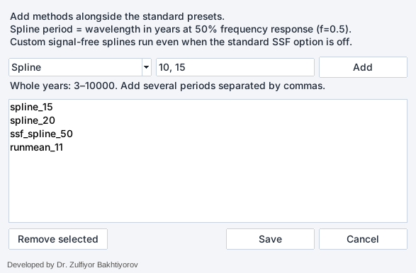
Figure 13. Custom detrending methods: two splines, a signal-free spline and a running mean added to the standard presets.
Press Save and then RUN. The custom methods appear with the names spline_15, ssf_spline_50 or runmean_11 in every tab and table, are ranked by the same goal score as the presets, are explained in the Guide tab and are exported like the other methods. Custom signal-free splines are computed even when the standard SSF option is off. The list is stored in the preferences and in the project file, so that a project re-opens with the same candidates.
Tip. Use custom methods to test whether a recommendation is sensitive to the stiffness of the spline: add, for example, splines of 2/3 of the mean series length and of 50 and 200 years and compare their scores with the presets.

5. RingClim step by step

5.1 Main window
RingClim has four tabs: Data (datasets), Analysis (settings and run), Results (tables and plots) and Report (summary and export). The bottom bar holds the UI scale, citation, help and about buttons. Hovering over a control shows a short explanation.
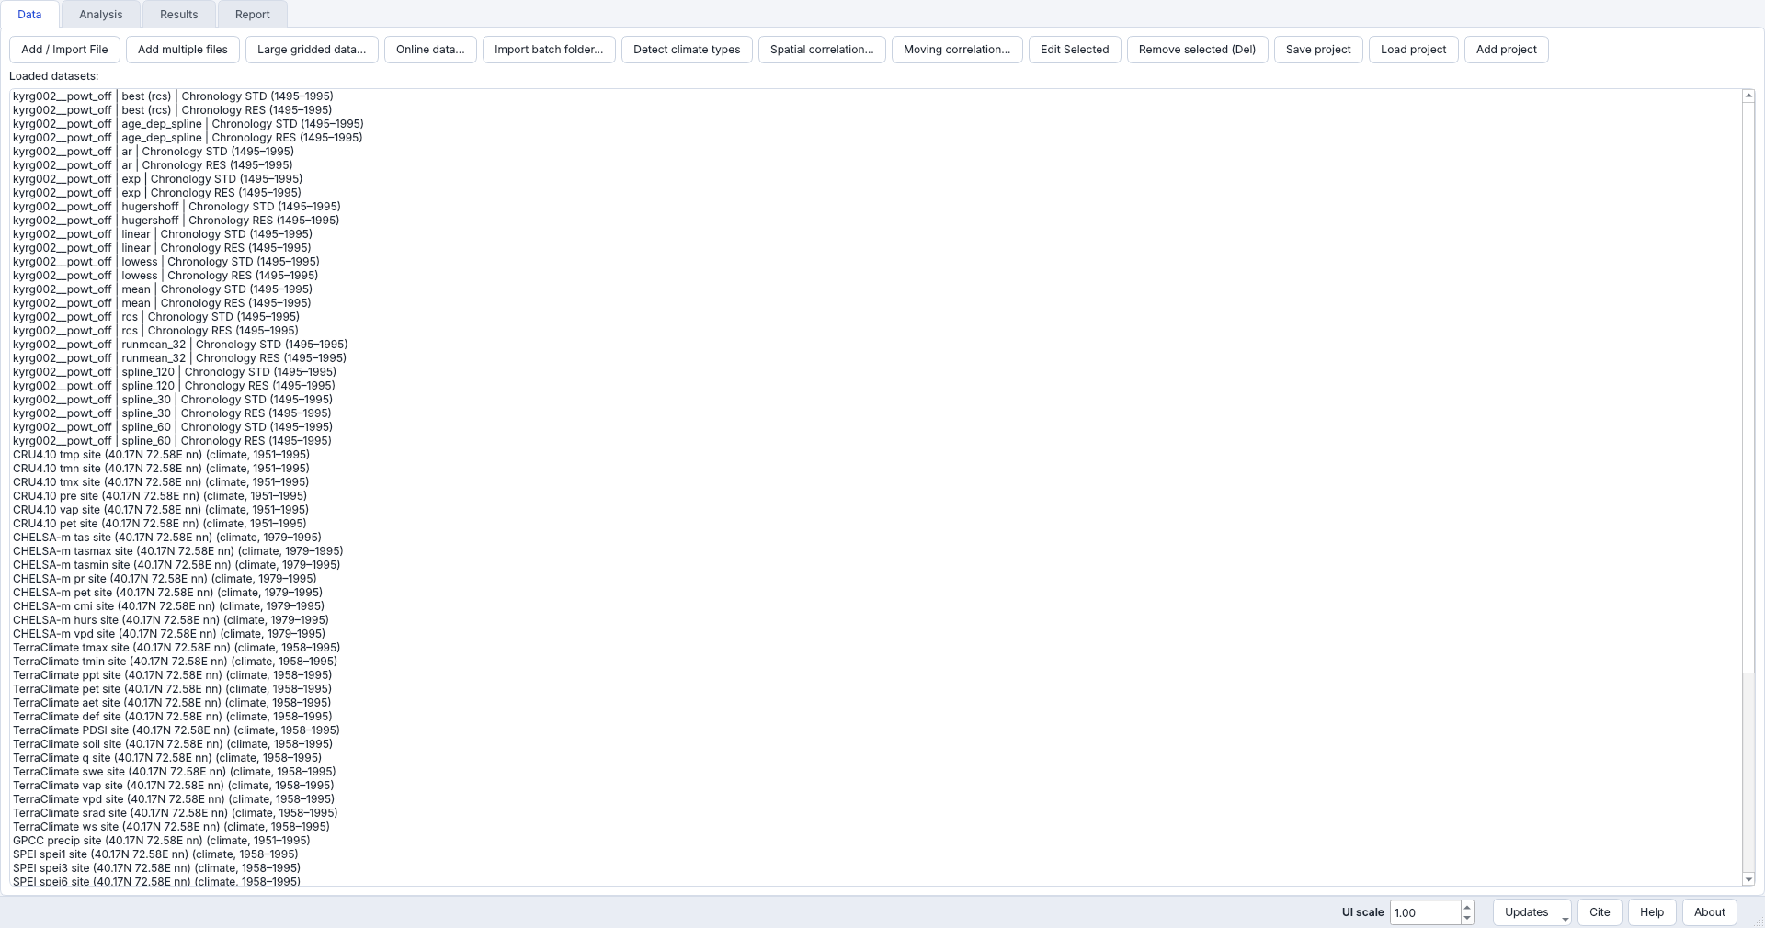
Figure 14. Data tab of RingClim after the hand-over from Detrend Advisor: all chronologies of KYRG002 are loaded.

5.2 Importing files
Add / Import File and Add multiple files read chronologies and climate tables. The import dialog recognises files with and without headers, metadata rows, comment lines, Year + 12 months tables, Year + value tables, stacked monthly tables, daily or hourly date–value series, combined station files and GRDC discharge files. Press Auto-detect first; adjust Skip top rows, the comment option or the column mapping when needed. Large gridded data… extracts a point or box from NetCDF files. Edit Selected renames, removes or reclassifies columns. Save project / Load project store the whole state.
Add multiple files detects the climate type (temperature, precipitation, PET, SPEI, SPI, VPD, humidity, discharge and others) of every file separately, from the file and column names and, for folders written by the batch download, from datasets.json or summary.csv. Detect climate types repeats the detection for the selected datasets, for example after renaming. Selected datasets are removed with the Delete key. The buttons of the Data tab wrap to new lines in narrow windows.
Select a dataset and press Preview selected dataset (Analysis tab) to check the imported values (Figure 15).
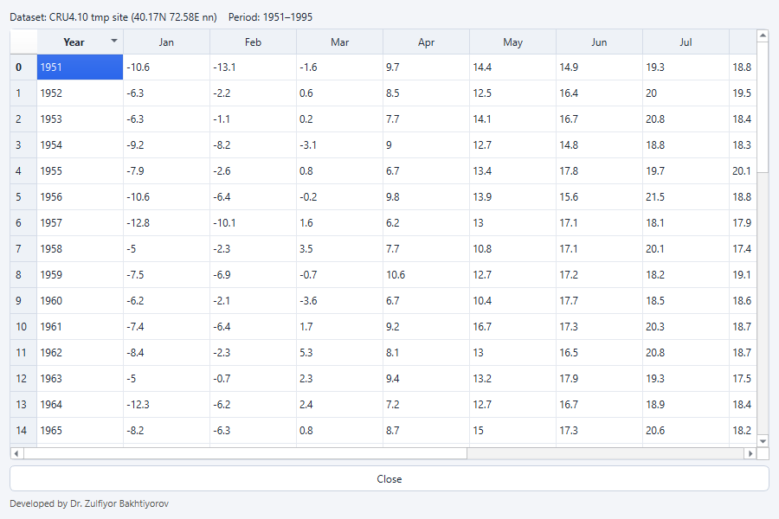
Figure 15. Preview of the CRU TS 4.10 mean temperature extracted for the KYRG002 grid cell (°C, 1951–1995).

5.3 Analysis settings
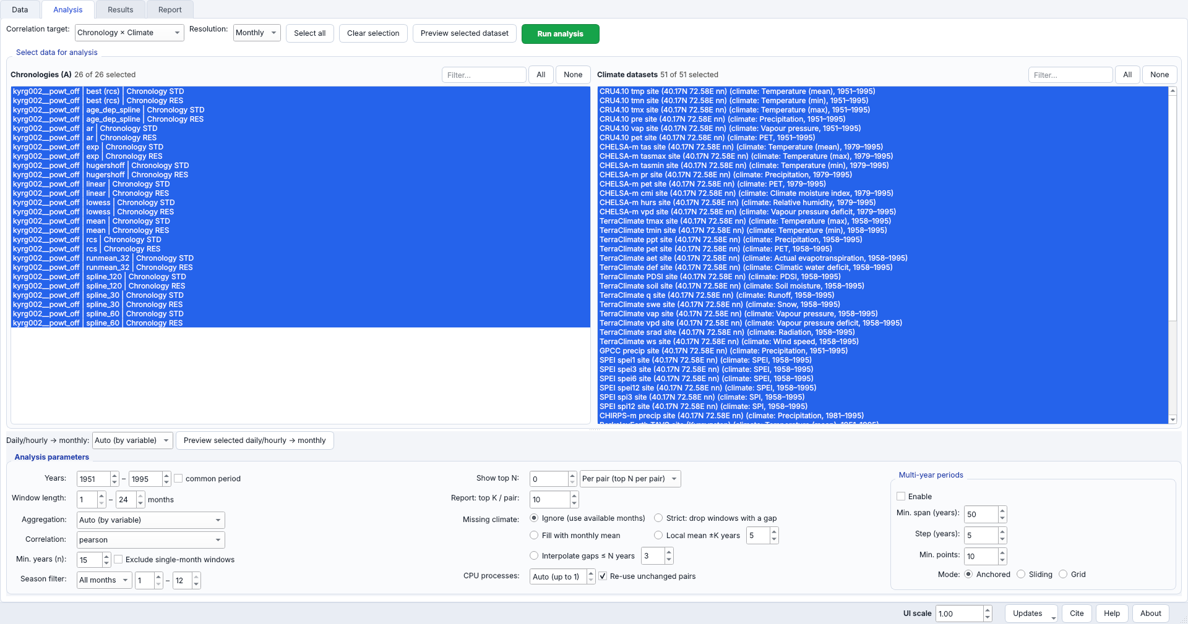
Figure 16. Analysis tab: chronologies on the left, climate datasets on the right, window and missing-value settings below.
Setting | Meaning
Correlation target | Chronology × Climate (usual), or Chronology × Chronology
Resolution | Monthly or Daily windows
Chronologies / Climate datasets | Select with click, Ctrl+click, Shift+click or Ctrl+A; Select all / Clear selection
Daily/hourly → monthly | How daily data are aggregated (Auto by variable: sum for precipitation, mean otherwise)
Year range | Analysis period; Use common period restricts all pairs to the same years
Min / Max window length | Length of the climate windows in months (1–24 in the example)
Aggregation | Sum, mean, auto by variable, or both
Show only top N / Report top K | Limits of the result tables
Exclude single-month windows | Only multi-month windows
Minimum years per correlation (n) | Windows with fewer common years are skipped (default 15; 20 in the example). Protects against very high correlations from short records
Multi-year period analysis | Repeats the screening in anchored or sliding sub-periods
Correlation method | Pearson or Spearman
Missing values | Ignore, strict, fill with monthly mean, fill with local window mean (±K years) or linear interpolation (gaps ≤ N years)
Season filter | All months, warm or cold season, or a custom start and end month

Windows run from previous January (pJan) to current December. A window pJul–pSep is July to September of the year before ring formation. Press Run analysis. The screening runs in the background with a progress window and a Cancel button; for more than 300 chronology–climate pairs RingClim first asks for confirmation, because such runs can take long.
Large runs are computed in parallel worker processes. CPU processes sets their number; the default is the number of processors minus one, limited by the free memory. The progress window is not modal: the other tabs can be used while the analysis runs. With Re-use unchanged pairs ticked, a repeated run computes only the chronology–climate pairs whose data or settings have changed and takes the others from the previous results, so adding one climate dataset to a large analysis takes seconds. Correlations of Chronology × Chronology runs are computed once per pair (no duplicates A×B and B×A).
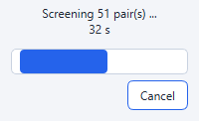
Figure 17. Progress window of the screening (51 chronology–climate pairs).

5.4 Results
The Results tab lists the windows ranked by the absolute correlation with r, p, n, the aggregation and the window, and draws the plots for the selected row (Plot: Overview, Monthly correlations, Window heatmap, Top windows, Time series, Running correlation, Scatter). Click a row to show its window. In the example, all 26 chronologies (STD and RES of the twelve candidates and of the best method) were screened against 51 datasets; for the RCS standard chronology the strongest windows with at least 30 years were previous January–September solar radiation (TerraClimate, r = 0.59) and previous July–September PET (r = 0.53). Export writes the results table to Excel, the climate windows or the merged data of the selected row, or saves the plot as PNG.
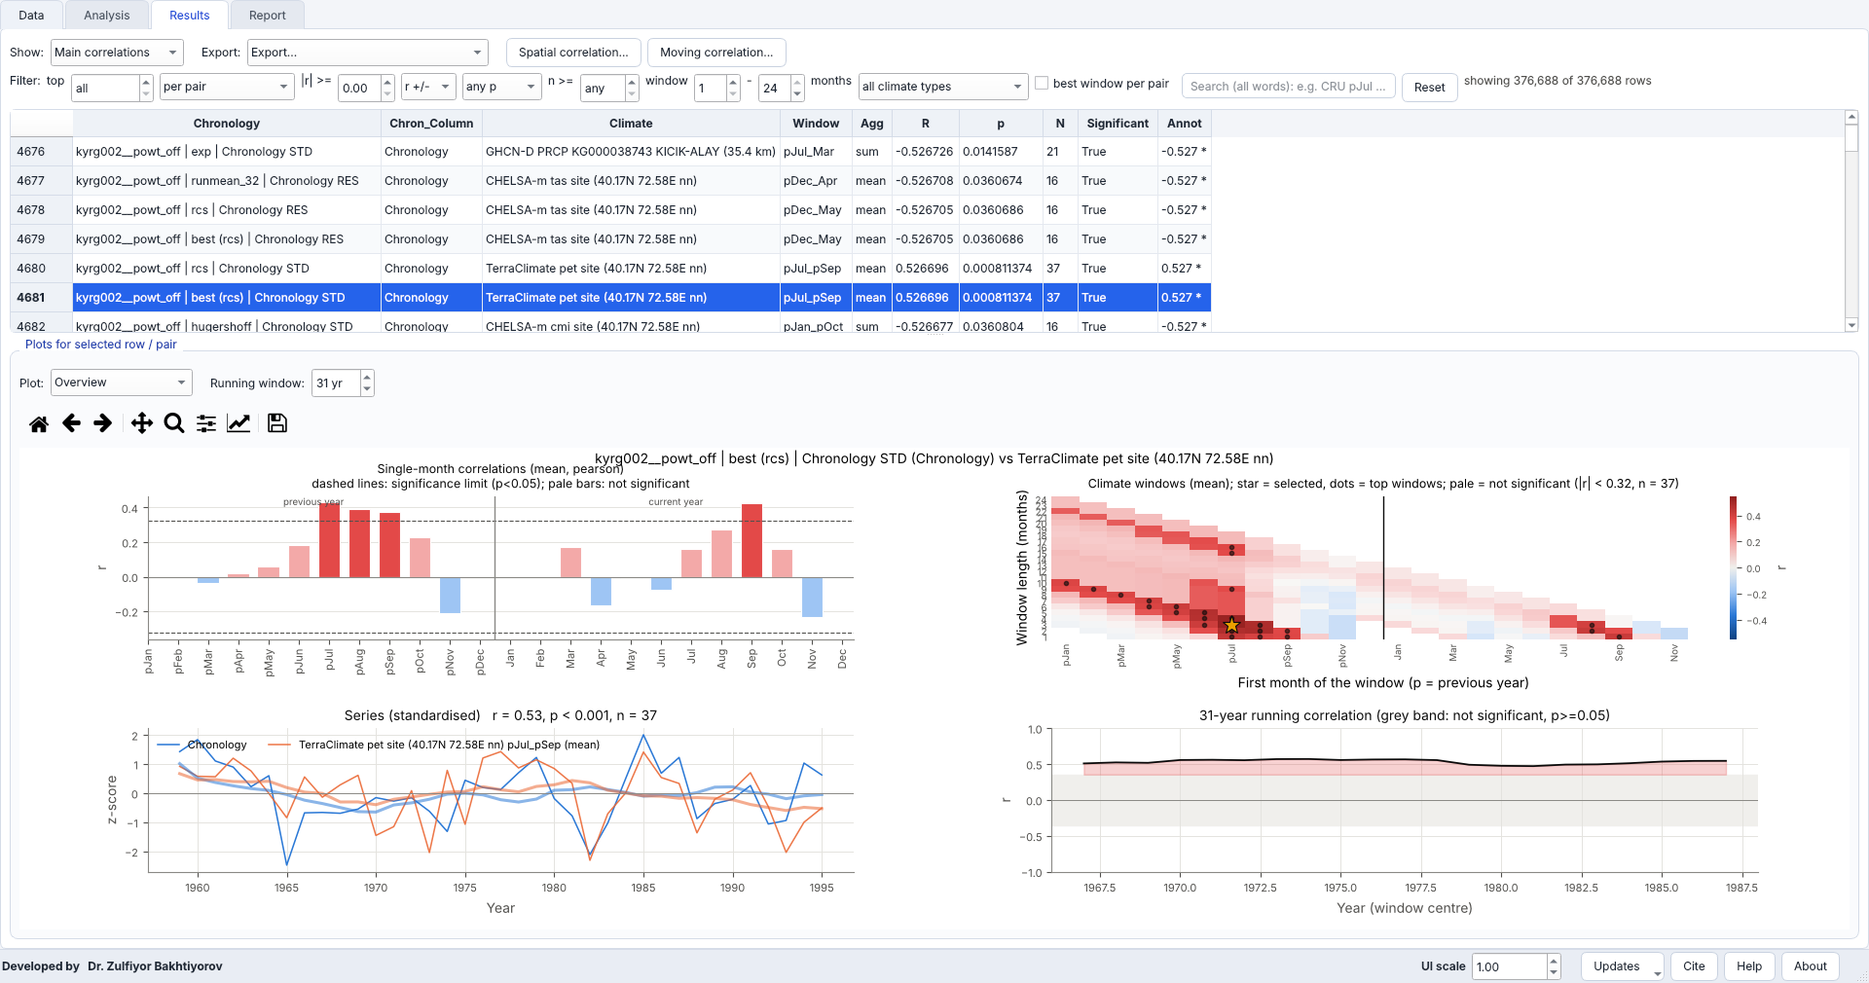
Figure 18. Results tab (Overview) for the RCS chronology and TerraClimate PET: single-month correlations, window heatmap (star = selected window pJul–pSep, r = 0.53), standardised series and 31-year running correlation.
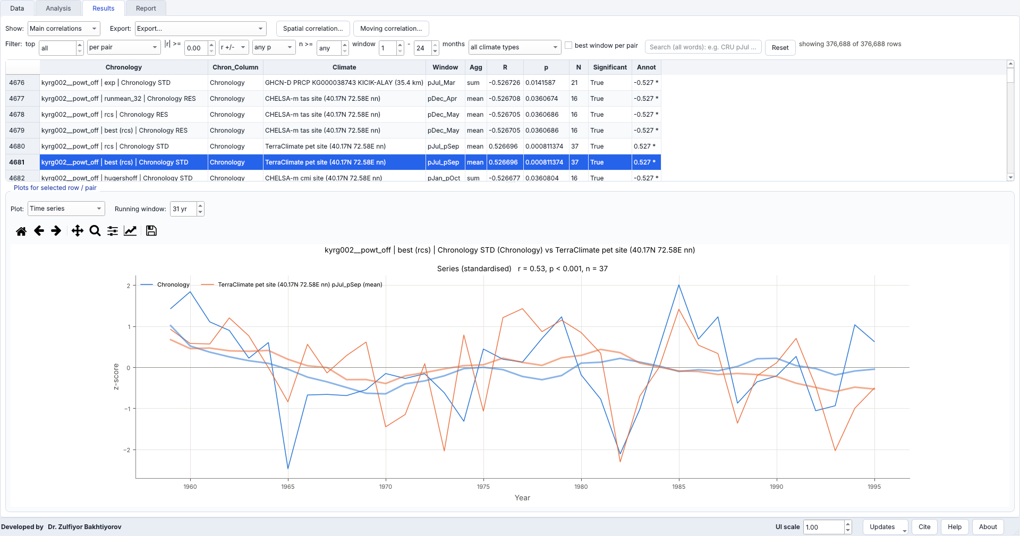
Figure 19. Time-series plot: standardised chronology and previous July–September TerraClimate PET (r = 0.53, n = 37).
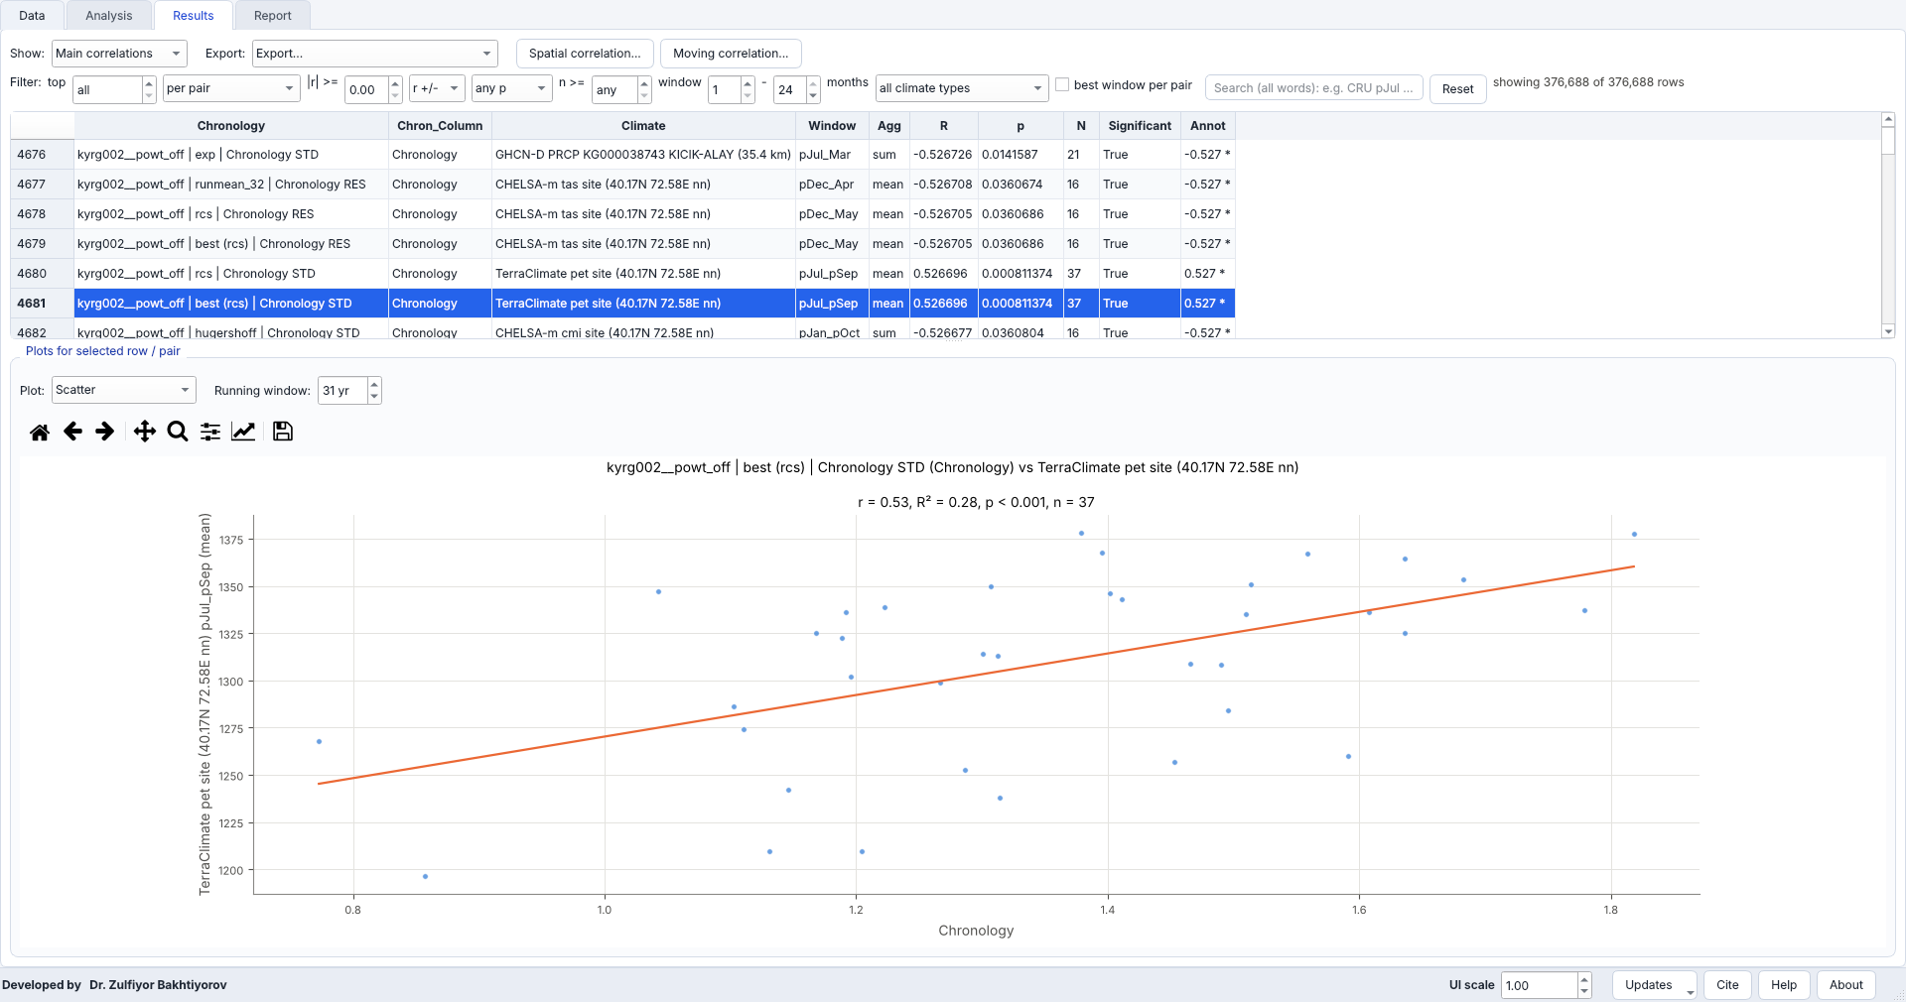
Figure 20. Scatter plot of the same window with the regression line.

5.5 Report and export
The Report tab summarises the best windows per pair. Tables are exported to Excel or CSV and plots to PNG, PDF or SVG; the merged table of the selected chronology and climate windows can also be exported for further work.
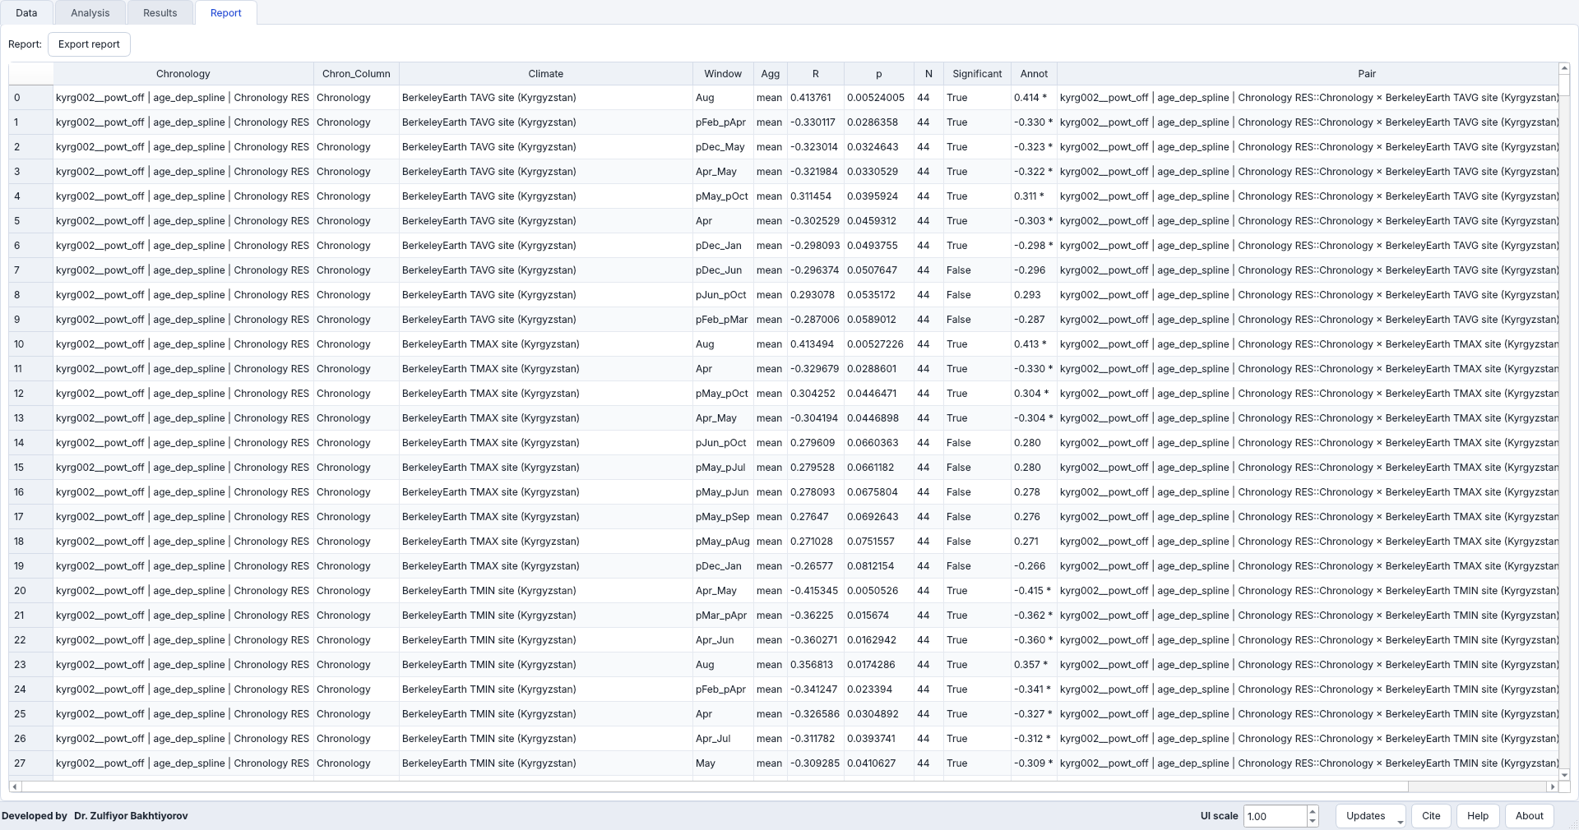
Figure 21. Report tab: the strongest windows per chronology–climate pair; Export report writes it to Excel or CSV.

5.6 Filtering the results without re-running
A large screening returns tens of thousands of rows (376 688 rows for 26 chronologies × 51 datasets × windows of 1–24 months in the example). The filter bar above the results table narrows them at once, without running the analysis again (Figure 22):
- top N of the whole table or per pair, per chronology, per climate dataset or per climate type;
- minimum |r|, the sign (r > 0, r < 0), the significance (p < 0.05 / 0.01 / 0.001) and the minimum number of years n;
- the window length in months (for example only 3–6-month seasons), one climate type, and best window per pair (only the strongest window of every chronology × dataset pair);
- a word search over all columns, for example CRU pJul RES (all words must occur).
Reset shows all rows again; the label on the right reports “showing X of Y rows”. The plots, the export and the Report use the filtered table.
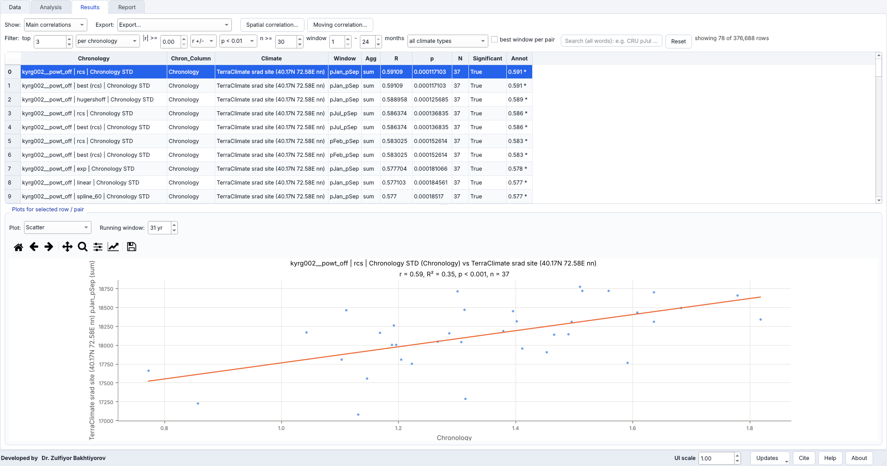
Figure 22. Filter bar: the three strongest windows of each chronology with p < 0.01 and at least 30 years (78 of 376 688 rows).

5.7 Projects and session recovery
Save project stores the datasets, the settings, the results of the analysis and the screenings of the moving and spatial correlation pages, so that a project re-opens without computing again. While you work, RingClim writes a recovery copy of the session after every analysis (folder .ringclim_recovery in the home directory). If the program was closed unexpectedly, it offers to restore that session at the next start. When results have not been saved, closing the program asks whether to save the project.

6. Online climate data

6.1 The Online data window
Data → Online data… opens a window with three tabs: ITRDB, CRU TS (gridded climate) and More climate data (ERA5, CHELSA, GloFAS …). On the left the source, variables, location and period are chosen; on the right the map shows the location and the grid cells used, with their weights (Figure 23).
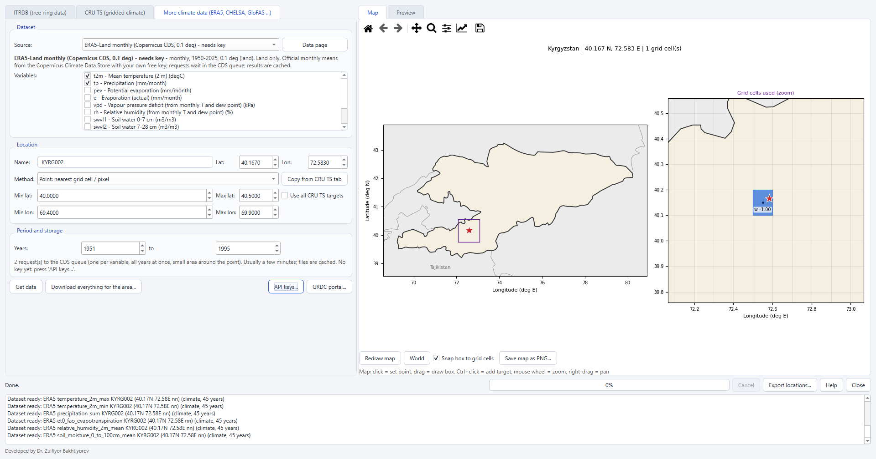
Figure 23. Online data window with the KYRG002 location and the grid cell used (right).
Location: type a name, latitude and longitude, or click on the map. Drag to draw a box (area mean, cos(latitude)-weighted), use Ctrl+click to add more target points and the mouse wheel to zoom. Method chooses nearest cell, bilinear interpolation or area mean; Copy from CRU TS takes over the location of the CRU tab. Get data downloads the selected source only.
Table 3. Climate sources of RingClim 2.0 (periods as listed in the program).
Source | Main variables | Resolution, period | Key
CRU TS 4.10 | tmp, tmn, tmx, pre, vap, pet, cld, wet, frs, dtr | 0.5°, 1901–2024 | no
CHELSA V2.1 | tas, tasmin, tasmax, pr, pet, cmi, hurs, vpd | ~1 km; monthly 1979–2021, daily 1941–2025 | no
TerraClimate | tmax, tmin, ppt, pet, aet, def, PDSI, soil, swe, vap, vpd, srad, ws, q | ~4 km, 1958–2024 | no
GPCC Full Data | precipitation | 0.25–1°, 1891–2024 | no
CRU scPDSI | self-calibrating PDSI | 0.5°, 1901–2024 | no
SPEIbase | SPEI 1–48 months | 0.5°, 1901–2024 | no
SPEI / SPI computed | from TerraClimate or CHELSA P and PET, any scale | as the input | no
CHIRPS v3 | precipitation (monthly, daily) | 0.05°, 1981–2025, 50° S–50° N | no
Berkeley Earth | country/region TAVG, TMAX, TMIN | 1750–2024 | no
GHCN-Daily | PRCP, TMAX, TMIN, SNWD of nearby stations | daily, station record | no
ERA5 via Open-Meteo | temperature, precipitation, ET0, humidity, soil moisture | ERA5 ~25 km, ERA5-Land ~9 km, 1940/1950– | no
ERA5 monthly (CDS) | t2m, tp, d2m, ssrd, swvl, e, pev, VPD, RH | 0.25°, 1940– | own
ERA5-Land monthly (CDS) | as ERA5 (land) | 0.1°, 1950– | own
GloFAS v4 (EWDS) | river discharge | 0.05°, daily, 1979– | own

6.2 Download everything for the area
Download everything for the area… retrieves many sources and variables in one run (Figure 24). The preset Recommended (fast, no large downloads) ticks a fast set; Copernicus adds the keyed sources. Expand a source with the arrow to choose single variables. Options: GPCC grid, ERA5 model (ERA5 or ERA5-Land), source of P and PET for SPEI/SPI, how daily data are imported, the search radius and the number of stations for GHCN-Daily, and the number of parallel sources.
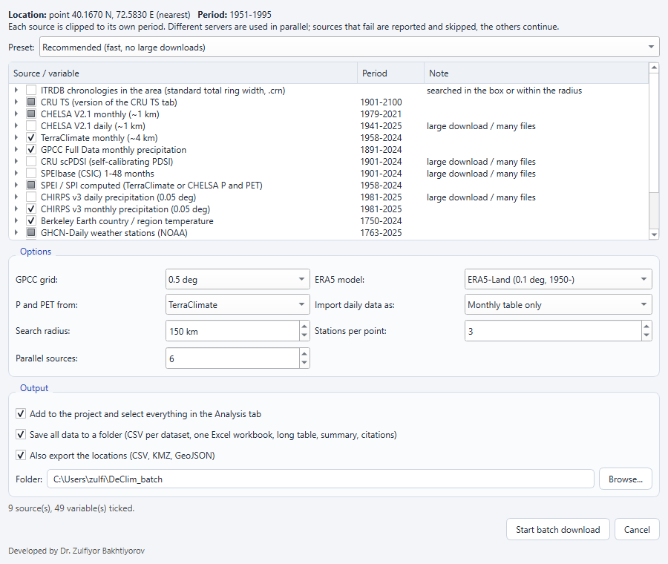
Figure 24. Batch dialog for KYRG002 (1951–1995) with the Recommended preset and the output options.
Sources hosted on different servers run in parallel; the progress window shows every source (Figure 25). A source that fails is reported and the others continue.
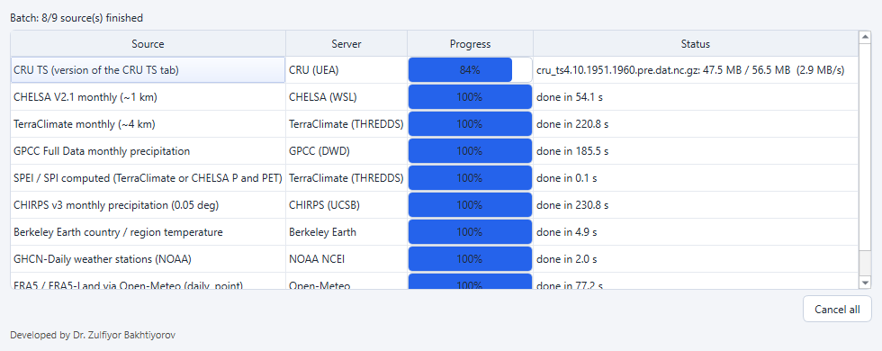
Figure 25. Progress of the batch: nine sources on eight servers, six in parallel.
At the end, a summary lists every dataset with its period, number of years, missing fraction and units, and any source that could not be read (Figure 26). In the example, 50 datasets were added in a few minutes; the CHIRPS server refused access at that moment (HTTP 403), which is reported with advice.
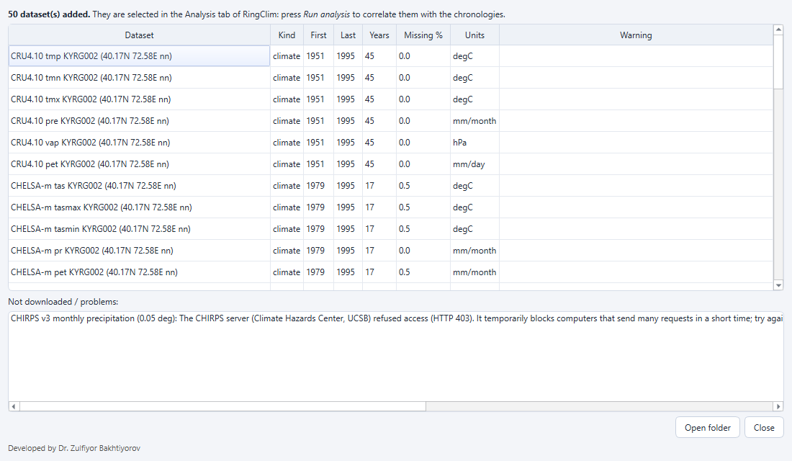
Figure 26. Summary of the example batch: 50 datasets added; problems reported below the table.
Every source that has finished is added to the Data tab at once, so the analysis can start while slower sources are still downloading. Pause stops the running downloads after the current request and keeps what is finished; Resume continues the paused sources, also after the program was restarted (paused batches are stored in the settings). Cancel stops the batch and keeps the finished data. Right-click a source in the progress table to retry it or to apply a suggested fix: for example a smaller box or the point method when CHELSA would need too many pixels, a later request when a server limits access, or the licence page or the API keys when a Copernicus request is refused.
With Save all data to a folder ticked, the folder (by default DeClim_batch in the home directory) receives one CSV per dataset, batch_data.xlsx, all_monthly_long.csv, summary.csv and README_citations.txt with the references of all datasets used. Downloads are cached in %LOCALAPPDATA%\DeClim\online_cache (macOS: ~/Library/Caches/DeClim/online_cache), so repeating a request is fast; the cache is shared by all program windows.

6.3 Exporting locations
Export locations… lists every download and extraction of the session (Figure 27). Choose the layers (ITRDB sites and files, extraction points, grid cells or pixels used, area boxes, weather and gauge stations) and the formats: CSV tables (for ArcGIS XY Table To Point and QGIS), GeoJSON, KMZ (opens in Google Earth with a double-click) and ESRI Shapefile.
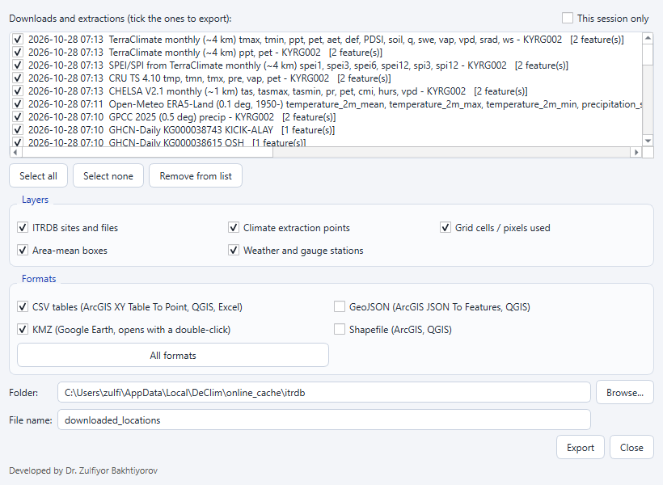
Figure 27. Export of the locations used in the example.

7. ERA5, ERA5-Land and GloFAS with your own Copernicus key
ERA5 and ERA5-Land monthly means come from the Copernicus Climate Data Store (CDS) and GloFAS river discharge from the Early Warning Data Store (EWDS). Both are free but require a personal access token. Every user uses his or her own token; the program never contains a key.
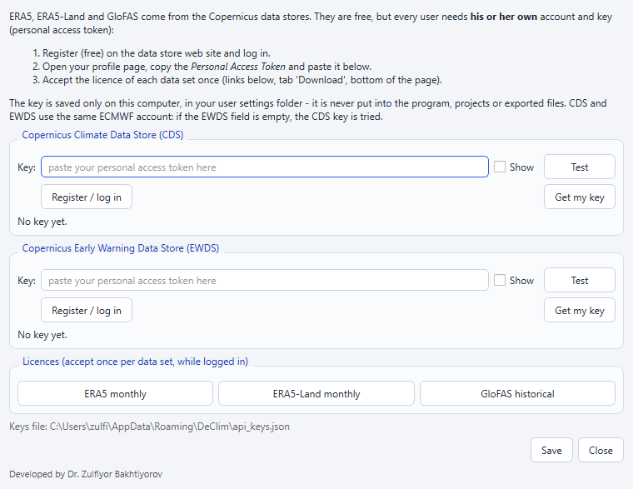
Figure 28. API keys dialog (More climate data tab → API keys…).
- Press Register / log in and create a free account (one account works for CDS and EWDS).
- Press Get my key: the profile page opens. Copy the Personal Access Token.
- Paste the token into the field Key of the CDS section and press Test. The program reports whether the token is accepted. If the EWDS field is empty, the CDS token is used for EWDS as well.
- Press Save. The token is stored only on your computer in %APPDATA%\DeClim\api_keys.json (shown at the bottom of the dialog). The environment variables CDSAPI_KEY/CDSAPI_URL and an existing .cdsapirc file are also recognised.
- Accept the licence of each dataset once: press ERA5 monthly, ERA5-Land monthly or GloFAS historical, log in and accept the licence on the Download tab of the web page.
Requests wait in the Copernicus queue; the progress window shows the state of each request (queued, running, downloading). RingClim submits one request per variable (ERA5, ERA5-Land) or per year (GloFAS), downloads the results, deletes the finished jobs on the server and caches the files.
Conversion | Rule
Temperature | K → °C
Precipitation, evaporation, PET | m per day → mm per month (×1000 × days); evaporation sign changed to positive
Radiation | J m⁻² → MJ m⁻²
VPD, relative humidity | Computed from monthly mean air and dew-point temperature
GloFAS discharge | Daily m³ s⁻¹; the cell with the largest mean discharge within the snap distance (GloFAS snap) is used, so the series follows the main river
Note. “Key not valid”: copy the Personal Access Token again (not the user ID). “Licence not accepted”: open the licence page with the buttons in the dialog and accept it.

8. Moving correlation: is the signal stable in time?
A strong correlation over the whole period can hide a signal that weakens, appears only recently or changes sign. Moving correlation… (Results tab) opens a page that correlates the chronologies with one climate season in windows of a fixed number of years, moved one year at a time, as the moving calibration of treeclim and DENDROCLIM2002. By default the windows are 25 years long and the value is plotted at the centre year; dashed and dotted lines show the thresholds of p < 0.01 and p < 0.05 for the window length (Figure 29).

8.1 Computing running correlations
- Tick the chronologies on the left (the filter field selects, for example, all RES chronologies or one site). Panels draws one panel per dataset, one per column or all lines in one panel.
- Choose the Climate data, the Season (from pJan to Dec) and the Aggregation (auto: sum for precipitation-like variables, mean otherwise). Suggest from results takes the season and the dataset of the strongest correlation of the Analysis; Best season of each chronology lets every chronology use its own strongest season.
- Set the Window (years), the Step, where the value is plotted (centre, end or start of the window), the Correlation (Pearson or Spearman), the Preparation (none, remove the linear trend of the climate or of both series, first differences, or remove the trends inside each window), the period and the minimum share of data in a window. Bootstrap 95% band adds percentile confidence intervals of every window.
- Press Compute moving correlations. Hover over a curve to read the window, r and n; Save figure and Save tables export the plot and the values.
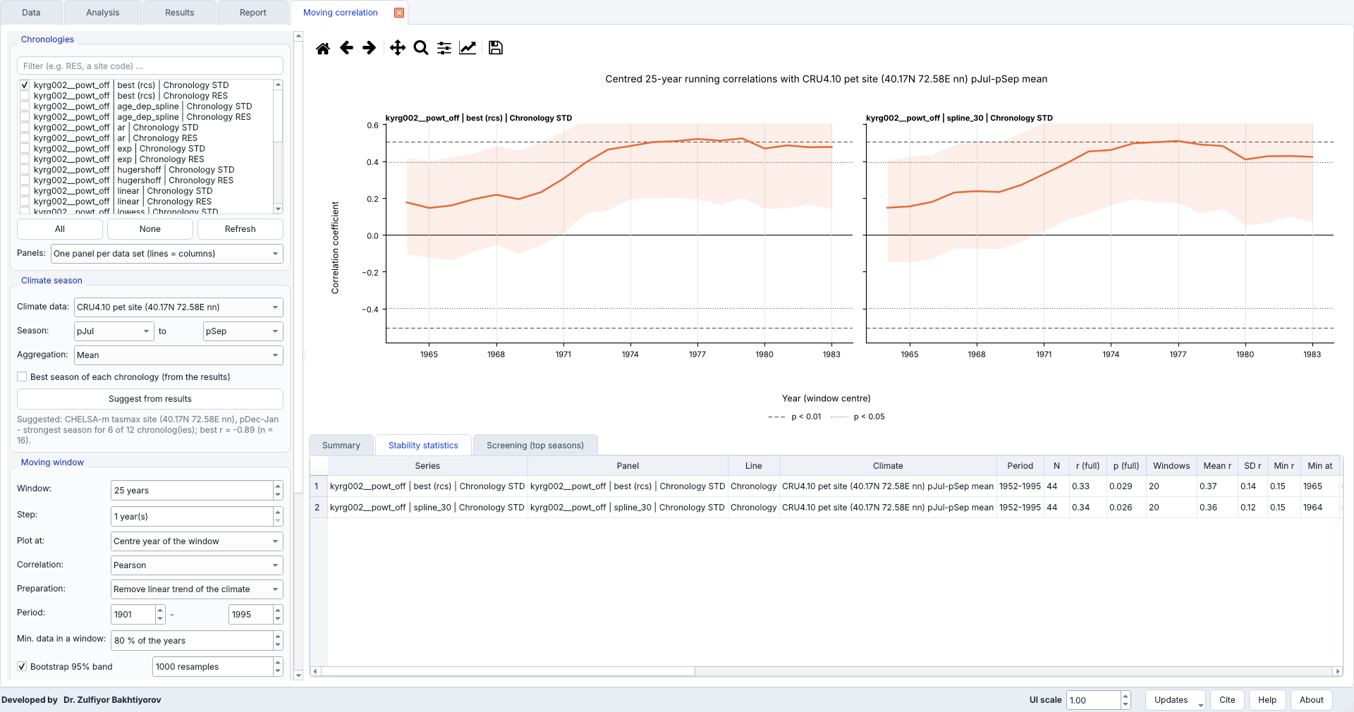
Figure 29. Centred 25-year running correlations of the RCS and SPLINE_30 chronologies with CRU TS potential evapotranspiration of previous July–September (1952–1995, climate detrended) with bootstrap 95% bands; dashed and dotted lines: p < 0.01 and p < 0.05.

8.2 Stability statistics
Neighbouring windows share most of their years, so their correlations are not independent. The tab Stability statistics therefore reports, for every curve, the full-period r, the mean, minimum and maximum of the running r with their years, the share of windows with p < 0.05 and p < 0.01, the trend of r per decade, and a split-period test: the correlations of the first and the second half of the common period are compared with Fisher’s z test. The year with the largest shift of the running r is reported as the probable change year, and a verdict summarises the result: stable, mostly stable, weakening, strengthening, unstable (significant correlations of both signs) or no significant window. The tab Summary lists the verdicts in words.
In the example (Figure 29), the correlation of the RCS chronology with previous July–September CRU TS PET was r = 0.33 (p = 0.03) over 1952–1995, but the running r rose from about 0.15 in the windows centred in the 1960s to 0.5 after the mid-1970s: significant in 55 % of the windows, r = 0.22 in the first and 0.47 in the second half (difference not significant, p = 0.37), largest change around 1978. The verdict is therefore “unstable / weak”: the signal exists, but mainly in the second half of the period.

8.3 Screening all seasons for the most stable signal
Screen all seasons × all climate data repeats the moving correlation for every ticked chronology, every monthly climate dataset and every window of 1–12 or 1–24 months, and ranks the combinations by their stability (share of significant windows, mean |r|, with a penalty when the two halves differ). Top per chronology limits the table. The screening is independent of the correlation analysis and runs in parallel processes.
When the common period of a chronology and a climate dataset is too short for the chosen window, the longest usable window is selected automatically (at least 7 years); the column Window years shows the window used, and a message lists the adjusted pairs and the pairs that were skipped because they are still too short.
Shuffles (chance control) repeats the whole screening with chronologies whose years are shuffled. The column p (shuffled) gives the share of shuffles whose best score reaches the score of the row, and Chance best score (95%) the score that the best row of a random chronology reaches in 95 % of the cases. With hundreds of windows and dozens of datasets, a high score alone is not proof of a real signal; this control shows how unusual the best rows are. Double-click a row or press Plot the top rows of each chronology to draw them (Figure 30).
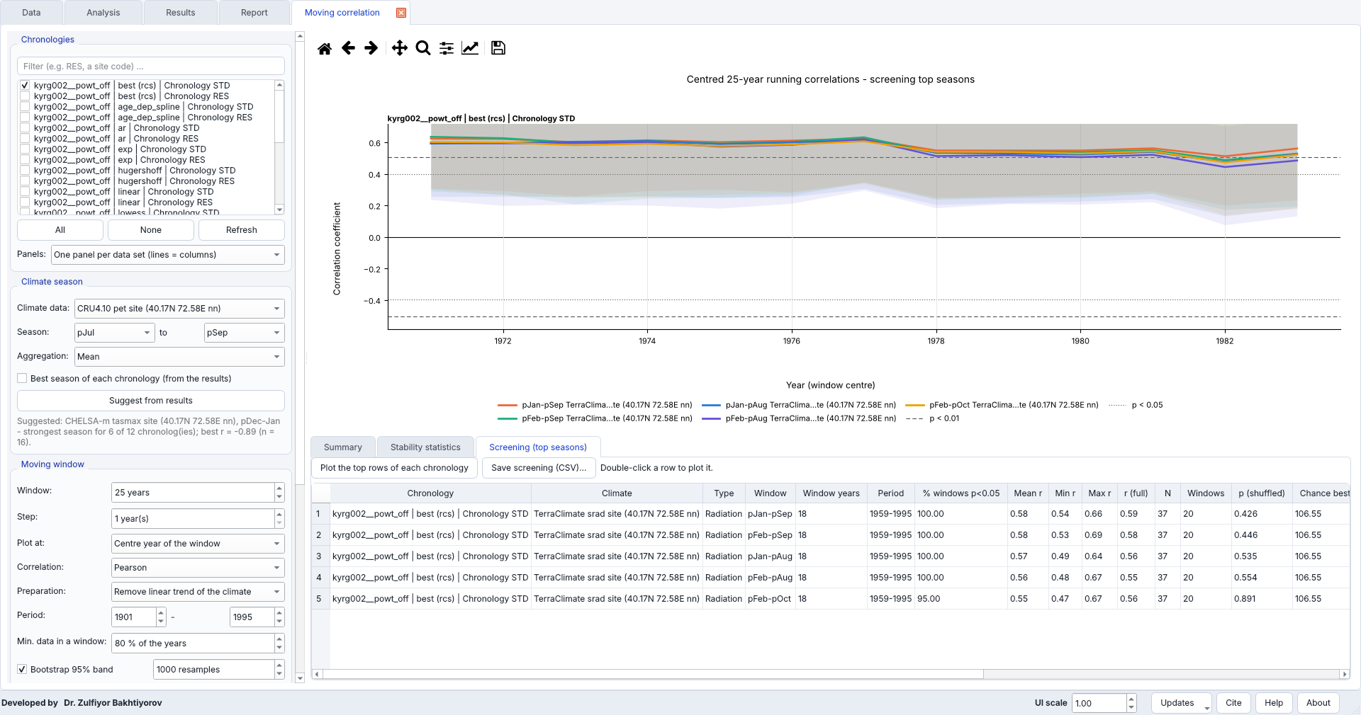
Figure 30. Screening of all seasons of 1–12 months for the RCS chronology and all monthly climate datasets (100 shuffles), with the top rows plotted. Pairs with a common period that was too short for 25-year windows were analysed with shorter windows (Window years = 18).
In the example, the most stable rows were TerraClimate solar radiation of previous January–September (mean running r = 0.58, significant in all 18-year windows of 1959–1995) and of neighbouring seasons. Their p (shuffled) was 0.43–0.55: random chronologies reached equally high scores in about half of the shuffles, because the short common period and the thousands of combinations make high stability scores likely by chance. The stability of these signals is therefore plausible but not proven by the screening alone.

9. Spatial correlation: is the signal regional?
Spatial correlation… (Results tab) correlates a chronology with a climate field around the site and draws the map of r, like the field correlation of the KNMI Climate Explorer. A signal that is coherent over the region around the site is more convincing than one grid cell (Figure 31).

9.1 Computing a map
- The list Suggested maps proposes fields and seasons from the strongest results of the Analysis (variables of the same type, for example precipitation results → CRU precipitation). Double-click a suggestion or press Use selected suggestion; the years of the Analysis are used.
- Or choose the chronology (its coordinates are taken from the data source, can be typed, or picked on the map), the Data set (CRU TS 4, GPCC, CRU scPDSI, SPEIbase, TerraClimate, ERA5 or ERA5-Land monthly with your own key, or any NetCDF file) and the Variable, the season (From … to) and the Aggregation.
- Set the region (Around the site = site ± the half-widths), the years, the correlation method and the preparation, the significance level, Min. years and the map style: Smooth (interpolated, outline p < alpha) or Grid cells; Only significant cells hides the others.
- Press Compute map. CRU files are downloaded once per decade, four files in parallel, and only the region is kept in the cache, so the next map of the same region is drawn in seconds. Click a cell to plot its standardised series with the chronology below the map; Save PNG and Save CSV export the map.
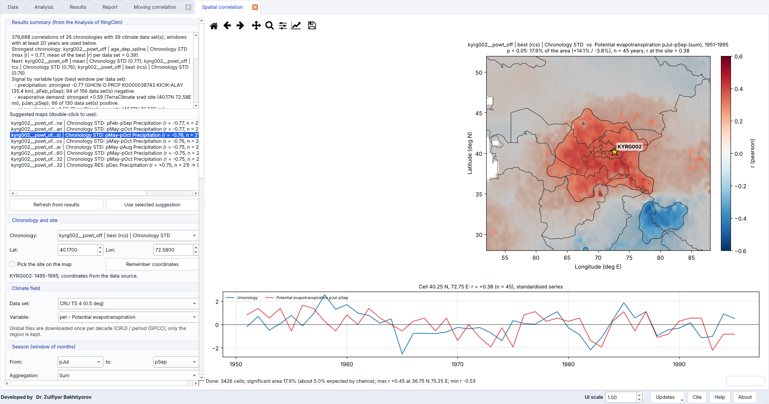
Figure 31. Correlation of the RCS chronology with CRU TS 4.10 potential evapotranspiration of previous July–September, 1951–1995 (smooth style, outline p < 0.05): 18 % of the region is significant (14 % positive, 5 % expected by chance), r = 0.38 at the site; below, the series of the site cell and the chronology.
The title reports the share of the region with p < 0.05 (positive and negative), n and r at the site; the status line compares the significant area with the area expected by chance (5 % at p < 0.05). Neighbouring cells of a gridded product are not independent, so a large significant area is expected even by chance when the fields are smooth; Section 9.2 tests this.

9.2 Screening all windows for the region
Screen windows correlates the chronology with every window of 1–12 (or 1–24) months of each ticked variable and ranks the windows by the significant area of the same sign as r at the site that is connected with the site (km²) — a coherent regional signal around the site rather than distant patches. Other columns give r and p at the site, the share of the region that is significant, the mean r within the radius (default 500 km) and the maximum |r| with its location.
- Account for serial correlation (effective n, as KNMI) reduces the number of years for autocorrelated series: n_eff = n (1 − r1x·r1y) / (1 + r1x·r1y), where r1 are the lag-1 autocorrelations of the chronology and of the climate cell.
- Shuffles repeats the screening of all windows with shuffled chronology years. p (shuffled) is the share of shuffles whose largest connected area reaches the area of the row, and Chance best area (95%) the area reached by the best window of a random chronology in 95 % of the cases.
In the example (CRU TS mean and maximum temperature, precipitation and PET, windows of 1–12 months, 100 shuffles, effective n), the largest connected areas belonged to PET and maximum temperature of previous November–December (r = −0.27 and −0.31 at the site, about 3.2 million km²), but p (shuffled) = 0.40–0.47: shuffled chronologies produced equally large areas in almost half of the cases, because temperature and PET anomalies are coherent over very large regions. Previous-September PET had a smaller area (2.2 million km²) but r = 0.42 at the site (p = 0.005) and p (shuffled) = 0.72. The maps therefore show that the PET signal is regional, but in this short period they do not prove it on their own (Figure 32).
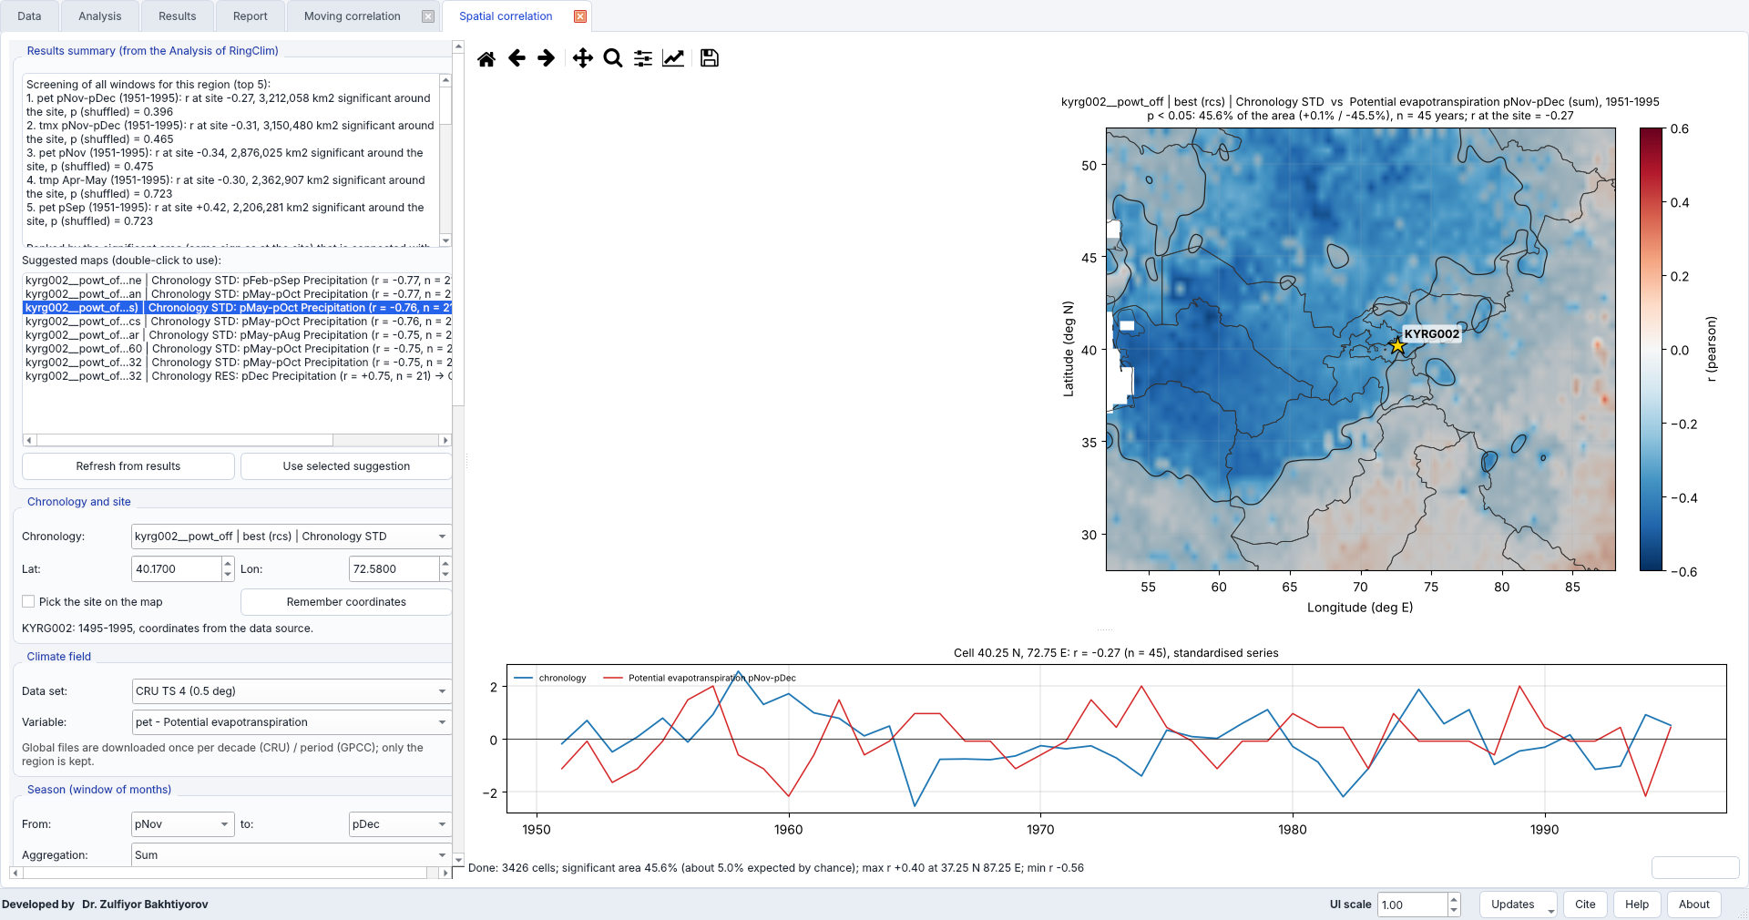
Figure 32. Screening of all windows of 1–12 months for four CRU TS variables (top five on the left) and the map of the best-ranked window (PET of previous November–December, 46 % of the region significant).
Tip. Use the moving and the spatial pages together: a signal that is significant in most running windows, coherent around the site and better than the shuffled chronologies is a robust basis for interpretation or reconstruction.

10. Interpreting the example
The 26 chronologies of KYRG002 (powt_off, recommended) were screened against the climate datasets for 1951–1995 with windows of 1–24 months (Pearson correlation, missing values ignored, Minimum years per correlation = 15). A repeated batch on the same day also obtained CHIRPS, so 51 datasets were screened (376 688 correlations). The 14 488 correlations of the recommended RCS standard chronology are in results/kyrg002_correlations.xlsx. The results agree across independent products: growth is higher after sunny, dry and warm previous summers.
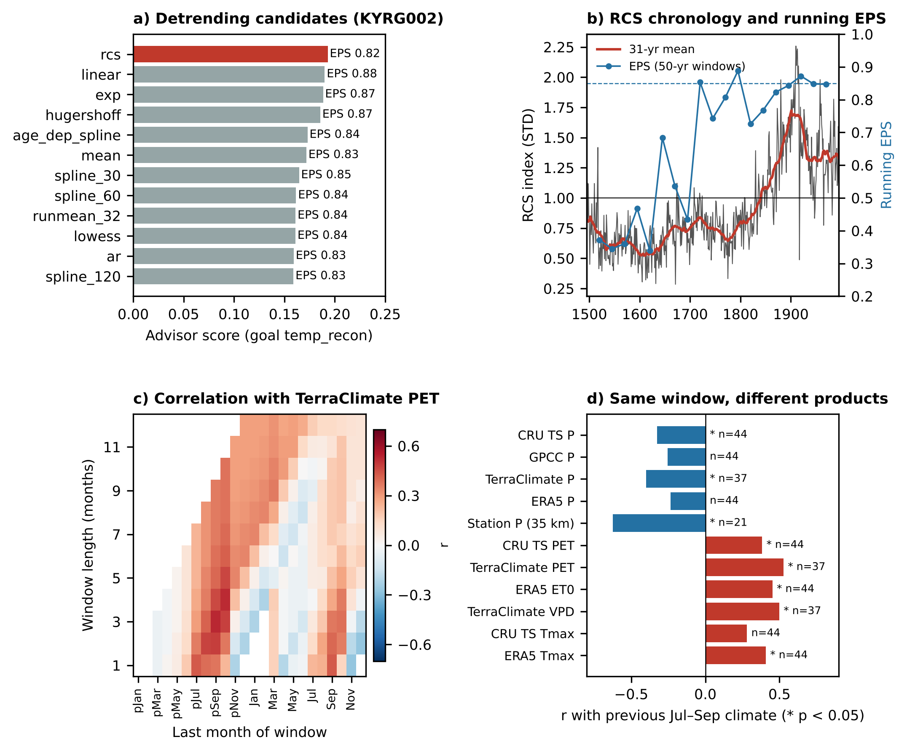
Figure 33. Summary of the example. (a) Scores and EPS (tree level) of the twelve candidates; (b) recommended RCS chronology with running EPS; (c) correlation with TerraClimate PET for all windows; (d) correlation with previous July–September climate in different products.
Table 4. Correlation of the KYRG002 RCS chronology with previous July–September climate (1951–1995).
Product and variable | r | n
TerraClimate PET | +0.53 | 37
TerraClimate VPD | +0.50 | 37
ERA5 ET0 (Open-Meteo) | +0.45 | 44
CRU TS PET | +0.38 | 44
ERA5 Tmax | +0.41 | 44
CRU TS Tmax | +0.28 | 44
GHCN-Daily Kichik-Alay PRCP (35 km) | −0.63 | 21
TerraClimate precipitation | −0.40 | 37
CRU TS precipitation | −0.33 | 44
GPCC precipitation | −0.26 | 44
ERA5 precipitation | −0.23 | 44

With at least 30 years, the strongest single windows were previous January–September solar radiation (TerraClimate r = 0.59), previous July–September PET (r = 0.53), VPD of previous November–December (r = −0.54) and precipitation of previous January–February (r = −0.53). The same sign and season in gridded, reanalysis and station data shows that the signal is not an artefact of one product, while the weaker correlations with GPCC and ERA5 precipitation show how much the precipitation products differ in this mountain region.
The top of the ranked table is taken by the Kichik-Alay station (previous May–October precipitation, r = −0.76) and by CHELSA (r up to 0.74), but these records cover only 21 and 16 years of the period. Short records give larger correlations by chance, which is why the minimum number of years matters: with the default of 3 years used in earlier versions, station series with three common years reached r = 0.99. Version 2.0 skips correlations with fewer years than the value set in Minimum years per correlation (n) (default 15).
Tip. Always check a strong window in more than one product and look at the window heatmap: a coherent patch of neighbouring windows is more convincing than one isolated window. With 50 datasets and hundreds of windows, some high correlations occur by chance.

11. Comparison with other software
DeClim does not replace the established tools; it connects their typical steps. The table summarises the main differences (details and references in the article).
Software | Detrending choice | Climate windows | Built-in data download | Interface
dplR | Many methods; user chooses | — | ITRDB reading only | R code
treeclim | — | Monthly, bootstrapped, moving windows | — | R code
dendroTools | — | Daily and monthly | — | R code
detrendeR | Several methods; user chooses | — | — | R GUI
DENDROCLIM2002 | — | Monthly, bootstrapped, moving and evolving intervals | — | Windows GUI
KNMI Climate Explorer | — | Monthly, spatial correlation maps | Large catalogue (web) | Web
DeClim | Goal-based ranking of 12+ methods and custom splines / running means, POWT, pith, tree groups | Monthly and daily, multi-period, moving correlation with stability tests, spatial maps, screening with chance control | ITRDB + 12 climate sources, batch, GIS export | Desktop GUI, hand-over

12. Troubleshooting
Problem | Solution
CHIRPS or another server returns HTTP 403/429 | The server limits requests per computer for some hours. The batch continues with the other sources; repeat later. Months already read are cached.
Copernicus: key not valid / licence not accepted | See Section 7: copy the Personal Access Token again; accept the licence of the dataset.
R or dplR not found | Install R and dplR; set the path to Rscript if asked.
Fonts too small | Change UI scale at the bottom of the window (e.g. 1.25 or 1.5).
RingClim busy with a large analysis | Use Cancel in the progress window or select fewer datasets; more than 300 pairs need confirmation.
An old ITRDB file appears as many short series | Fixed in version 2.0 (only the data columns are read). Re-import the file.
Outdated cached data | Delete the folder of the source in %LOCALAPPDATA%\DeClim\online_cache.
No climate datasets after a batch | Read problems.txt and the summary; check the internet connection and the period.
A batch source failed or was paused | Right-click the source in the progress table: retry or apply the suggested fix; Resume continues paused sources (Section 6.2).
Moving correlation: empty panels or skipped pairs | The common period is shorter than the window; reduce the window or the period. The screening shortens the window automatically (Section 8.3).
Spatial correlation: slow first map or a warning about a long download | Use a smaller region or a coarser data set (TerraClimate and ERA5-Land are large); the first map of a region downloads the files, the next ones come from the cache.
The program closed unexpectedly | Restart it and accept the offer to restore the last session (Section 5.7).
Check for updates fails | Check the internet connection; the latest version can always be downloaded from github.com/zulfiyor/DeClim/releases.

13. Citation and data references
Please cite the article and the datasets that you use. The file README_citations.txt written by every batch lists the references of the datasets actually downloaded.
- Bakhtiyorov, Z. et al. DeClim: goal-driven tree-ring detrending linked to integrated climate-data retrieval and climate-signal screening (manuscript submitted). Software: https://github.com/zulfiyor/DeClim
- Bunn, A.G. (2008) A dendrochronology program library in R (dplR). Dendrochronologia 26, 115–124. doi:10.1016/j.dendro.2008.01.002
- Trouet, V., van Oldenborgh, G.J. (2013) KNMI Climate Explorer: a web-based research tool for high-resolution paleoclimatology. Tree-Ring Research 69, 3–13. doi:10.3959/1536-1098-69.1.3
- Zang, C., Biondi, F. (2015) treeclim: an R package for the numerical calibration of proxy-climate relationships. Ecography 38, 431–436. doi:10.1111/ecog.01335
- Harris, I. et al. (2020) Version 4 of the CRU TS monthly high-resolution gridded multivariate climate dataset. Scientific Data 7, 109. doi:10.1038/s41597-020-0453-3
- Abatzoglou, J.T. et al. (2018) TerraClimate. Scientific Data 5, 170191. doi:10.1038/sdata.2017.191
- Karger, D.N. et al. (2017) Climatologies at high resolution for the earth’s land surface areas (CHELSA). Scientific Data 4, 170122. doi:10.1038/sdata.2017.122
- Schneider, U. et al. GPCC Full Data Monthly Product. doi:10.5676/DWD_GPCC
- Funk, C. et al. (2015) The climate hazards infrared precipitation with stations (CHIRPS). Scientific Data 2, 150066. doi:10.1038/sdata.2015.66
- Vicente-Serrano, S.M., Beguería, S., López-Moreno, J.I. (2010) A multiscalar drought index sensitive to global warming: the SPEI. Journal of Climate 23, 1696–1718. doi:10.1175/2009JCLI2909.1
- Menne, M.J. et al. (2012) An overview of the Global Historical Climatology Network-Daily database. J. Atmos. Oceanic Technol. 29, 897–910. doi:10.1175/JTECH-D-11-00103.1
- Rohde, R.A., Hausfather, Z. (2020) The Berkeley Earth Land/Ocean Temperature Record. Earth Syst. Sci. Data 12, 3469–3479. doi:10.5194/essd-12-3469-2020
- Hersbach, H. et al. (2020) The ERA5 global reanalysis. Q. J. R. Meteorol. Soc. 146, 1999–2049. doi:10.1002/qj.3803
- Muñoz-Sabater, J. et al. (2021) ERA5-Land. Earth Syst. Sci. Data 13, 4349–4383. doi:10.5194/essd-13-4349-2021
- Harrigan, S. et al. (2020) GloFAS-ERA5 operational global river discharge reanalysis 1979–present. Earth Syst. Sci. Data 12, 2043–2060. doi:10.5194/essd-12-2043-2020
- Zippenfenig, P. (2023) Open-Meteo.com Weather API. doi:10.5281/zenodo.7970649
- Esper, J. et al. Kyrgyzstan High Bon (KYRG002), International Tree-Ring Data Bank, NOAA NCEI. ITRDB

