**ZULHAM MAULANA (17108020)**

* Link Github: https://github.com/zulhammm12/medhealt.git
* 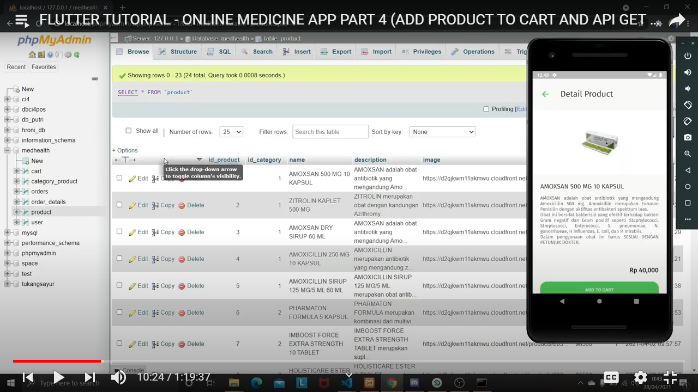Bukti Screenshoot Materi di Youtube
* Sreenshoot Aplikasi

