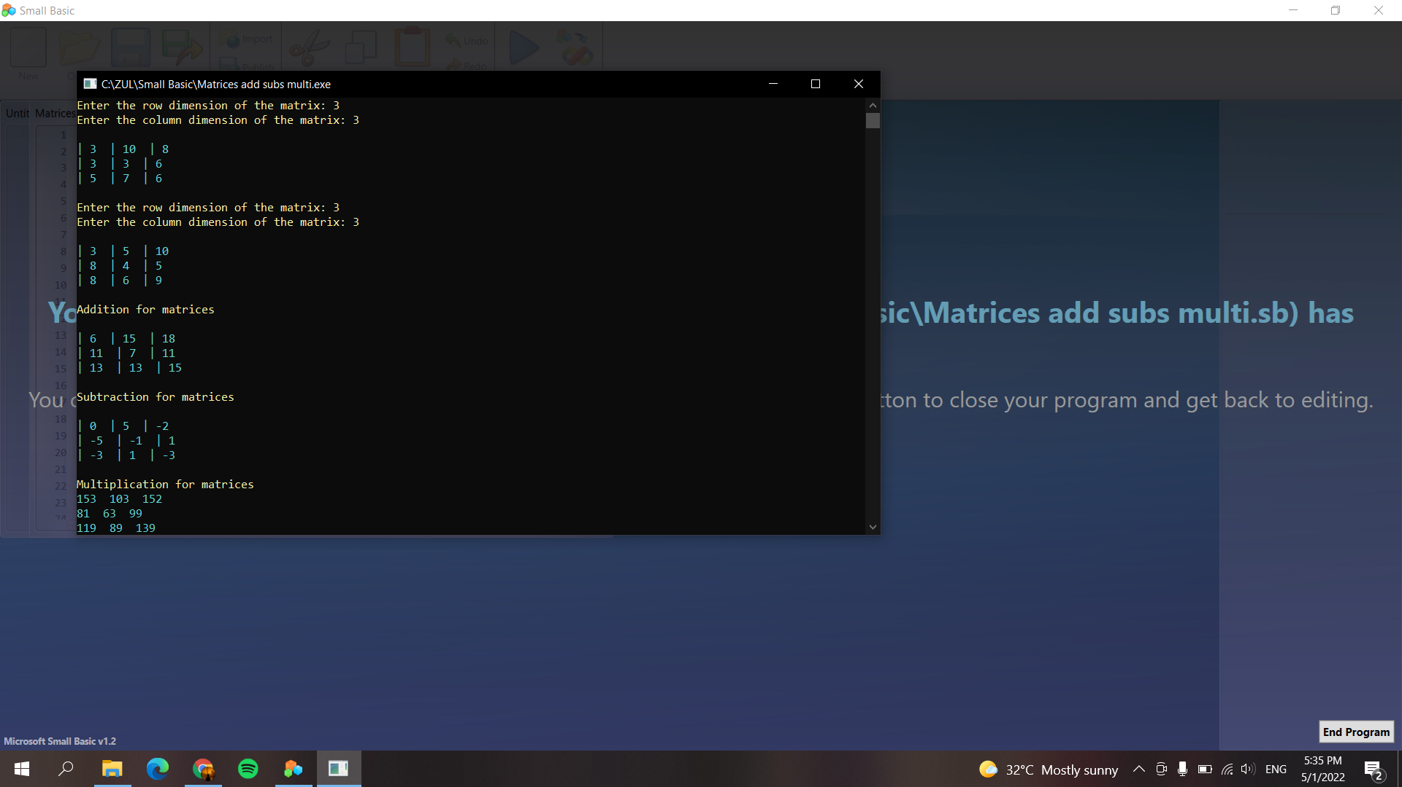

*'Author : MUHAMMAD ZULHILMI BIN ROSLI*

*'Num Matric : S61807*

*'TextWindow.BackgroundColor="Black"*

TextWindow.ForegroundColor="yellow"

TextWindow.write("Enter the row dimension of the matrix: ") *'Ask user to input row*

a = TextWindow.Read()

TextWindow.write("Enter the column dimension of the matrix: ") *'Ask user to input column*

b = TextWindow.Read()

TextWindow.WriteLine("")

TextWindow.ForegroundColor="cyan"

**For** i=1 **To** a **Step** 1 *'Get random number for matrcies A*

**For** j=1 **To** b **Step** 1

matrixA[i][j] = Math.GetRandomNumber(10)

Textwindow.Write("| " +matrixA[i][j] + " ")

**EndFor**

TextWindow.WriteLine("")

**EndFor**

TextWindow.WriteLine("")

TextWindow.ForegroundColor="yellow"

TextWindow.write("Enter the row dimension of the matrix: ")

a = TextWindow.Read()

TextWindow.write("Enter the column dimension of the matrix: ")

b = TextWindow.Read()

TextWindow.WriteLine("")

TextWindow.ForegroundColor="cyan"

**For** i=1 **To** a **Step** 1 *'Get random number for matrcies B*

**For** j=1 **To** b **Step** 1

matrixB[i][j] = Math.GetRandomNumber(10)

Textwindow.Write("| " +matrixB[i][j] + " ")

**EndFor**

TextWindow.WriteLine("")

**EndFor**

TextWindow.WriteLine("")

TextWindow.ForegroundColor="yellow"

TextWindow.Writeline("Addition for matrices") *'Addition operation for both matrices*

TextWindow.Writeline("")

TextWindow.ForegroundColor="cyan"

**For** i=1 **To** a

**For** j = 1 **To** b

Add[i][j] = matrixA[i][j]+matrixB[i][j]

Textwindow.Write("| " +Add[i][j] + " ")

**EndFor**

TextWindow.WriteLine("")

**EndFor**

TextWindow.WriteLine("")

TextWindow.ForegroundColor="yellow"

TextWindow.Writeline("Subtraction for matrices") *'Subtraction operation for both matrices*

TextWindow.Writeline("")

TextWindow.ForegroundColor="cyan"

**For** i=1 **To** a

**For** j = 1 **To** b

Subt[i][j] = matrixA[i][j]-matrixB[i][j]

Textwindow.Write("| " +Subt[i][j] + " ")

**EndFor**

TextWindow.WriteLine("")

**EndFor**

TextWindow.ForegroundColor="yellow"

TextWindow.WriteLine("")

TextWindow.Writeline("Multiplication for matrices") *'Multiplication operation for both matrices*

TextWindow.ForegroundColor="cyan"

**For** i=1 **To** a

**For** j=1 **To** b

**For** k=1 **To** a

Mult[i][j]=Mult[i][j] + matrixA[i][k]*matrixB[k][j]

**endfor** *'end of k loop*

TextWindow.Write(Mult[i][j] +" ")

**EndFor** *'end of j loop*

TextWindow.WriteLine("")

**EndFor**