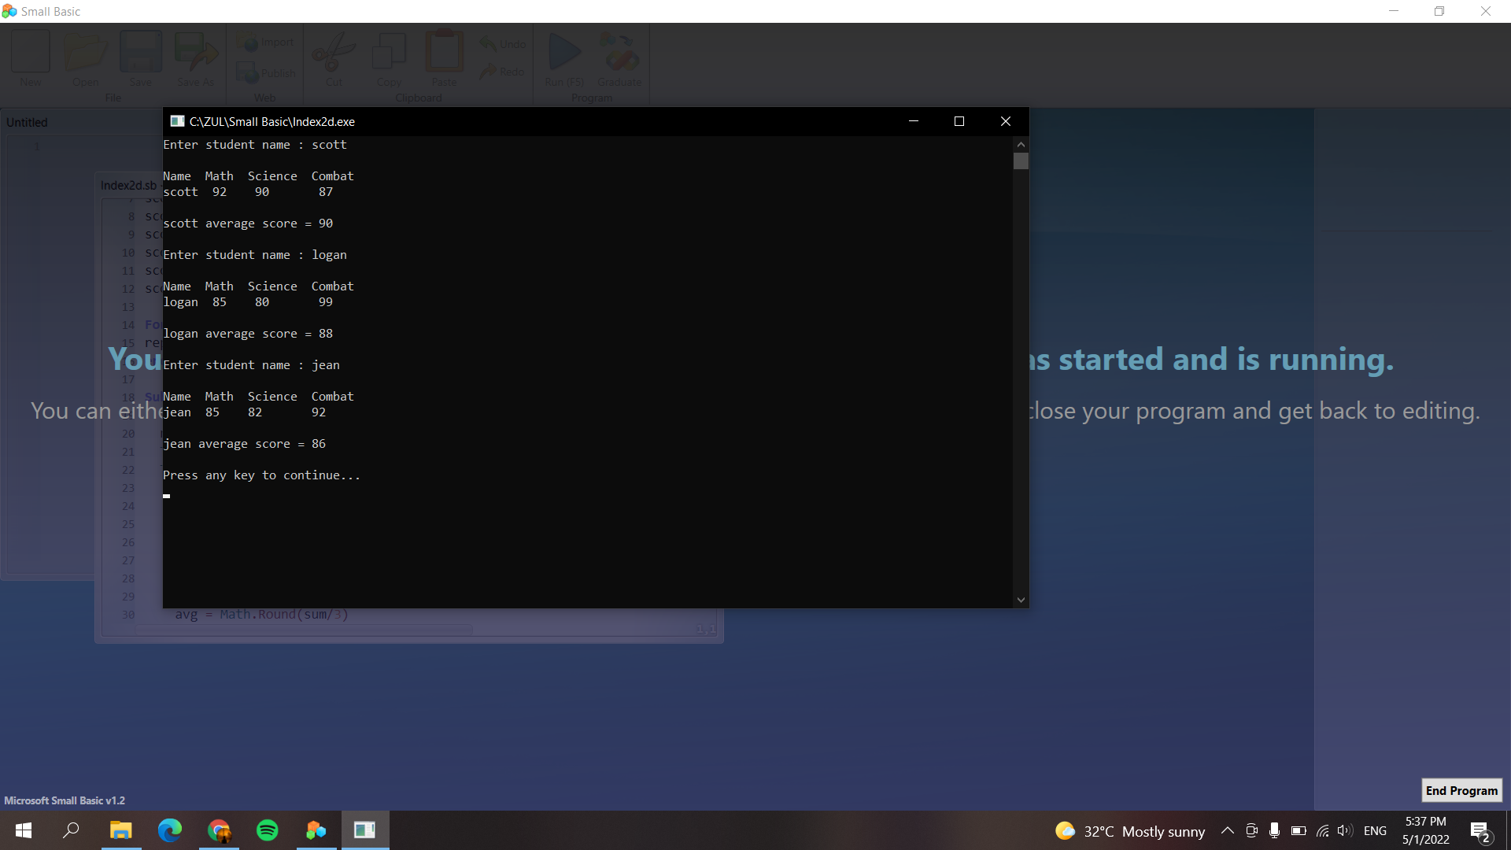

*'Author : MUHAMMAD ZULHILMI BIN ROSLI*

*'Num Matric : S61807*

score["Scott"]["Math"] = 92

score["Scott"]["Science"] = 90

score["Scott"]["Combat"] = 87

score["Jean"]["Math"] = 85

score["Jean"]["Science"] = 82

score["Jean"]["Combat"] = 92

score["Logan"]["Math"] = 85

score["Logan"]["Science"] = 80

score["Logan"]["Combat"] = 99

**For** i=1 **to** 3

repeat()

**endfor**

**Sub** repeat

TextWindow.Write("Enter student name : ")

name = TextWindow.Read()

TextWindow.WriteLine("")

TextWindow.WriteLine("Name Math Science Combat")

TextWindow.WriteLine(name +" " +score[name]["Math"] +" " +score[name]["Science"] +" " +score[name]["Combat"])

TextWindow.WriteLine("")

sum = score[name]["Math"]

sum = sum + score[name]["Science"]

sum = sum + score[name]["Combat"]

avg = Math.Round(sum/3)

TextWindow.WriteLine(name + " average score = " + avg)

TextWindow.WriteLine("")

**EndSub**