3) MYSELF COLLEGE

a) Source Code

*'Author : MUHAMMAD ZULHILMI BIN ROSLI*

*'Matric Number : S61807*

*'Date : 5/11/2021*

TextWindow.BackgroundColor="Darkcyan"

TextWindow.ForegroundColor="Black"

rate=4

Fee=15000

TextWindow.WriteLine("The current tuition fee is " +Fee)

TextWindow.WriteLine("Tuition rate per year is " +rate)

TextWindow.WriteLine("")

TextWindow.WriteLine("Tuition fee for next 10 years : ")

**For** x=1 **To** 10

Increase=(rate/100)*Fee

Fee=Fee+Increase

TextWindow.WriteLine("Tuition fee for year : " +x +" is " +Math.Round(Fee))

**EndFor**

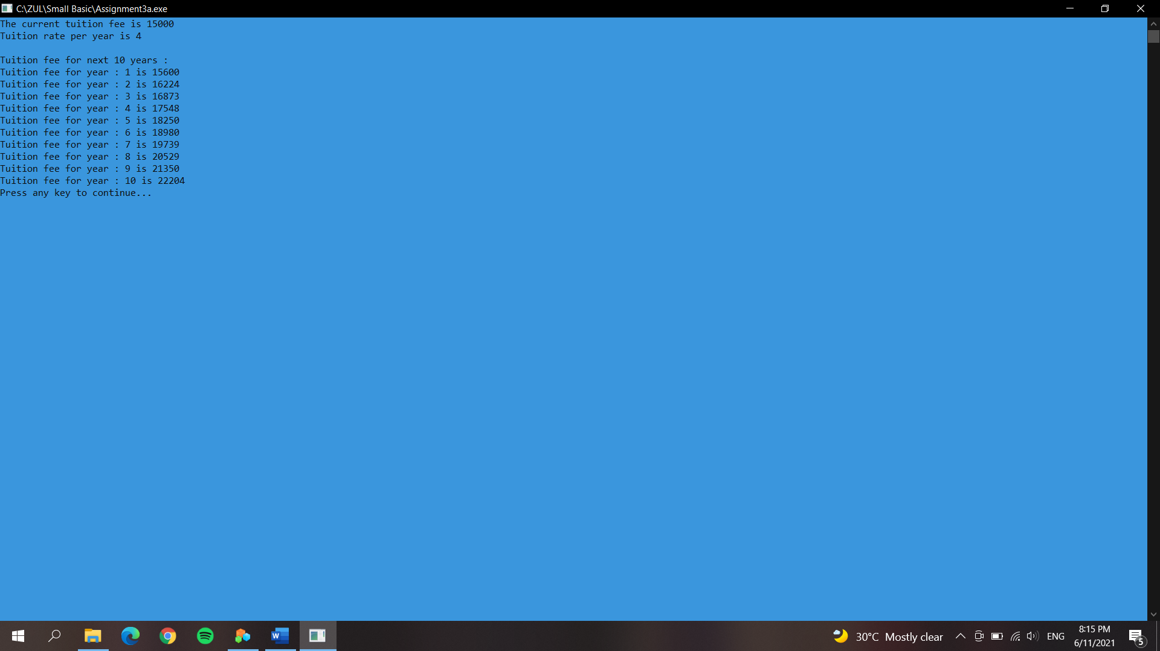

b) Source Code

*'Author : MUHAMMAD ZULHILMI BIN ROSLI*

*'Matric Number : S61807*

*'Date : 5/11/2021*

TextWindow.BackgroundColor="Darkcyan"

TextWindow.ForegroundColor="White"

Fee=15000

TextWindow.WriteLine("Tuition fee is : " +Fee)

TextWindow.Write("Please insert rate : ")

Rate=textwindow.Read()

**For** x=1 **To** 10

Increase=Fee*(Rate/100)

Total=Increase+Fee

Fee=Total

TextWindow.WriteLine("The tuition fee for year "+x +" is : " +Math.Round(Total))

**EndFor**

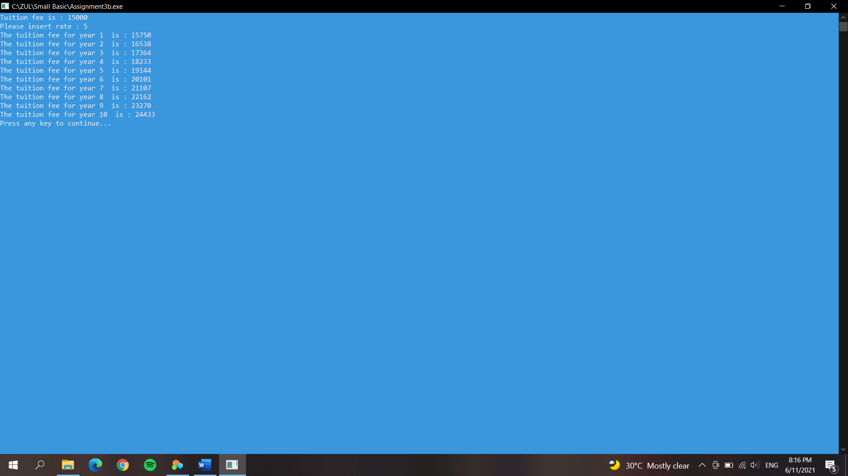

c) Source Code

*'Author : MUHAMMAD ZULHILMI BIN ROSLI*

*'Matric Number : S61807*

*'Date : 5/11/2021*

TextWindow.BackgroundColor="Darkcyan"

TextWindow.ForegroundColor="White"

Fee=15000

TextWindow.Write("Please insert rate for tuition : ")

Rate=textwindow.Read()

TextWindow.WriteLine("*************************************************************************")

**For** x=1 **To** 10

TextWindow.WriteLine("The tuition fee for year " +x +" is : " +Fee)

TextWindow.WriteLine("The rate is " +Rate +" For next year ")

TextWindow.WriteLine("")

*'Calculation*

Increase=Fee*(Rate/100)

Rate=Rate+0.5

Fee=Fee+Increase

**EndFor**

TextWindow.WriteLine("*************************************************************************")

