Your paper title here

Mohamad¹ and Yaacob¹
¹Faculty of Entrepreneurship and Business,
Universiti Malaysia Kelantan,
Malaysia

Email: mohamad@umk.edu.my; yaacob@umk.edu.my
Abstract - Your paper should be produced in accordance with the guidance and formatting instructions contained and embedded within this electronic document. The abstract of your paper should be written in a single paragraph and should not exceed 300 words. Used TNR 10, italics, justified, single spaced. It should typically provide a brief overview of the research including its background, rationale, methodology, and conclusions.

Keywords: Up to 5 keywords should be provided in alphabetical order separated by commas. Formatting should be as described above.

Introduction
The main body of all papers should commence with an introduction section which should explain the background and purpose of the paper. Formatting is described in section 2 below.

Formatting of Main Headings
Main headings, including the introduction, should be formatted by selecting Heading 1 from the “styles and formatting” tool within Microsoft Word.

Formatting of Sub-Headings
Sub-headings can be added by selecting Heading 2 or Heading 3 as appropriate.

Formatting of Additional Levels of Sub-Heading
Additional levels of sub-heading can be added by selecting Heading 3. In the interests of clarity authors are not advised to use more than three levels of subheadings.

Submission of Papers
Papers should be between 4,000 and 7,500 words in length. You should create and submit your paper in Microsoft Word, using Times New Roman 12pt, justified, single-spaced.
Papers should be submitted online thru the conference website (http://fkp.umk.edu.my/ISEB2015/).

Citation and Referencing Styles
All citation and referencing should follow the American Psychological Association (APA) style, 6th edition. Examples for the general format of APA research papers, in-text citations, endnotes/footnotes, and the reference page The ‘References’ section at the end of the paper.
The citation of secondary sources / references to other publications should use the APA referencing style. The full bibliographic description of the cited work should also appear in a ‘References’ section under the final main heading of the paper as described at the end of this document.

Figures and Tables
Figures and tables may be used to better illustrate the points made or to better present data. For figures, the figure caption should be numbered and positioned below the figure as follows.
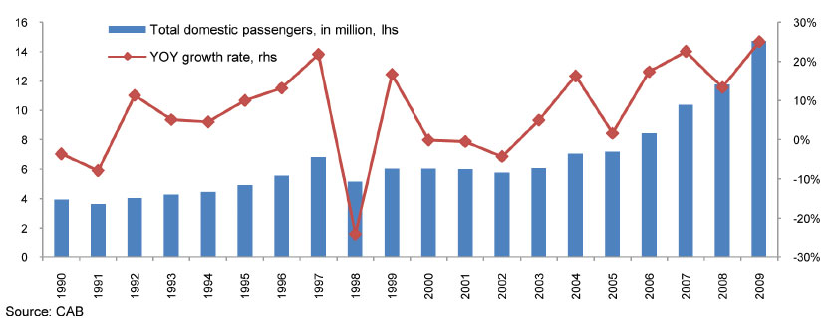

- Domestic air travel, Philippines, millions, growth, 1990-2009
(Source: CAB, 2009)

For tables, the table caption should be numbered and positioned before the table as follows. One space should be added after the table.

- Domestic air travel, Philippines, millions, growth, 1990-2009
(Source: CAB, 2009)
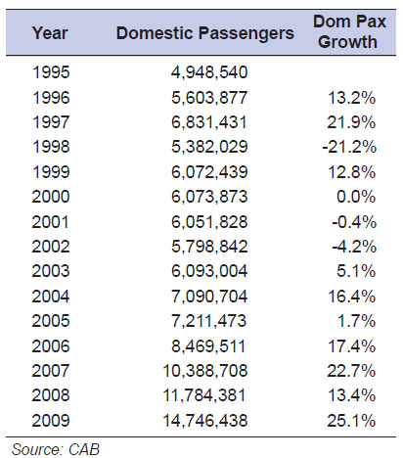

Acknowledgements
Any acknowledgements should be placed in a headed section immediately before the references section.

References
For citation and referencing systems used in this paper, author(s) should always follow the Publication Manual of the American Psychological Association (6th edition) http://fkp.umk.edu.my/journal/download/APA.pdf

