RapidShop 4.5
Version 4.5. Last Update: May 10, 2010
Excel to Shopping Cart eCommerce and Product Management Procurement System
1. System Overview and Requirements
2. RapidShop Licensing, Pricing and Limitations
2.1. Full Version
2.2. Free Limited Version
2.3. Upgrading Free Limited Version to Full Version
3. RapidShop Installation
4. RapidShop Administration Configuration
5. Creating Product Catalog
6. Publishing Online
7. Technical Support and Upgrades
8. Customization
9. Terms of Use
10. Contact

1. System Overview and Requirements
Tailored to the needs of small business and busy professionals RapidShop 4.5 is Microsoft Excel macros-based ecommerce/catalog online publishing program with easy to work interface and full managerial control over Shopping Cart, Discount Levels, Shipping, Tax, Financial Clearance, Product Categories and Subcategories, Product Listings, Images, and other business as well as web development objectives.
RapidShop 4.5 operates offline in any supporting Microsoft Excel 2000/2003 environments (Windows/Mac), yet present version has not been actively tested for all types of mobile devices.

2. RapidShop Licensing and Limitations
Presently RapidShop 4.5 grants two types of annual licenses:
2.1. Full Version
Unlimited product categories.
License up to 100 product listings $99
License up 500 products $139
License up 1000 products $159
License up 2,500 products $179
License unlimited products $199

URL-reference release License $40
2.2. Free Limited Version
Limited up to two categories and up to 10 products catalog fully working version contains ether RapidShop or RapidShop nominated third party advertisement block, and displays large RapidShop copyrights and other legal information reference links.
2.3. Upgrading Free Limited Version to Full Version
Upon testing Free Limited Version user is capable of upgrading it to Full Version by purchasing license and endorsing License Codes into fields “Buy” and “Activate” located in Administration’ <Menu tab of RapidShop.xls>.

3. Installation
RapidShop 4.5 download package represents zip file containing all components of the system.
3.1. Extract zip folder contests on user-administrator’s desktop, make sure that computer you are extracting files to is dedicated for ongoing operations and is same unit that will be covered by license agreement when desired to upgrade from Free Limited Version to Full Version and where license is to be installed.

3.2. Upon extraction of zip-folder contests to the dedicated computer’s desktop, run your Free Limited Version as it explained in chapters 4, 5 and 6.
3.3. To upgrade from Free Limited Version to Full Version, open RapidShop 4.5 MS-Excel file, select Menu tab and proceed with purchase by pressing button “Buy”. You will be forwarded to the financial clearance with presently available following payment options: VISA™, MasterCard™, American Express™, Discover™, Dinners Club™, JCB, PayPal™ and online checking. Your license and software activation code will be send within 24 hours to the originally indicated email address.

3.4. As your receive license and activation code, install your license by clicking button “Activate” from “Menu” worksheet of your RapidShop 4.5 Excel file.

4. RapidShop 4.5 Administration Configuration
4.1. Enabling Macros
In order for the algorithms to work properly, you will need to enable the macros.
In RapidShop 4.5 Excel, select Tools -> Macro -> Security and set the "Medium" Security Level. Save your changes and exit document, and open file again – you will be prompt to enable macros.
4.2. RapidShop 4.5 Contests
Extracted RapidShop.zip folder contains following files:

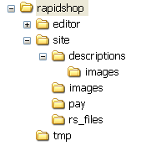
Images: product images can be stored there ether manually or by using wizard.

Descriptions: automatically generated page descriptions storage.
Folder Site: contains all your site’ files
Pay: payflow notifications such as confirmations of successfully processed payment or failed transactions.

Temporary files (rapidshop.html, map.html)

5. Operating RapidShop.xls and Creating Product Listings/Catalog

Enable macros and ether run all commands of RapidShop from “Menu” or from “RapidShop”-tab of the workbook.

Change E-mail address from all@ufatop.ru to your e-mail address: Tab “Settings” → “Enter default email to be used in payment system to receive orders”.

Tab “Products” - edits name, price, quantity, image reference and product descriptions.
To maximize productivity RapidShop 4.5. has been integrated product management wizard allowing product category definitions and product listings enrollment.
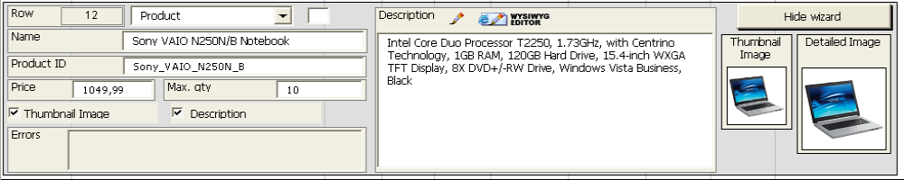
5.0.1. Building your product inventory data base:
Open Wizard and select option Category from drop-down menu <Category, Subcategory 1, Subcategory 2, Product> and enter Category Name into the text field bellow.
5.0.2. Enter Category ID into field <Category ID / Product ID> - numeric or alphanumeric unique identification.
5.0.3. Identify if Category will have associated thumbnail and/or Category Description by check-marking appropriate options. Enter detailed category description into Description field. For user’s convenience RapidShop 4.5 integrated with accessible from Description field WYSWYG Editor allowing greater customization options.
5.0.4. To select appropriate thumbnail and detailed view product images click on corresponding wizard’ button and select image from file, same images must be transferred into folder Images on your server in order to appear on your site. Repeat similar actions to create and enlist all other categories, products and sub-categories.
User can see generated by RapidShop output in the off-line environment computer by accessing appropriate HTML document from folder Site. When category/product data base have been completed, access tab “Settings” of your administration and elect shopping cart settings including e-mail addresses where orders will be forwarded.
5.1. To incorporate RapidShop generated output with your site, please edit template “tpl_pages.html” located in the folder “site”. You must rename your page where you would like publish your output to “tpl_pages.html” and store it into the folder “Site”, or paste your HTML code with your content and references to your original graphics (design template of your site) into “tpl_pages.html”. Remember to insert shopping cart tag {#content#} into exact place where you want shopping cart appear on your pages.

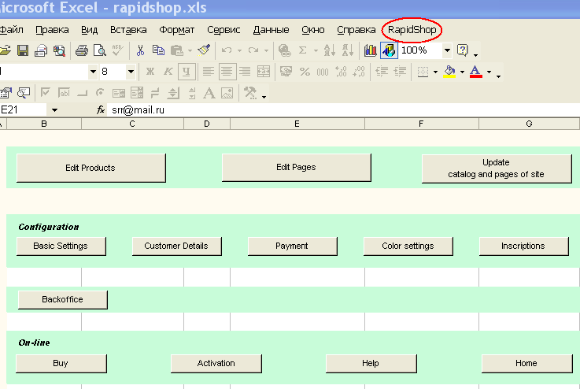

5.2. Run command “Update catalog and pages of site”.
RapidShop creates all pages automatically and saves them into folder “Site”.
Upon your files were saved, test your shopping cart from your computer by double-clicking .HTML file located in the folder “Site”.

6. Publishing your files online
You may upload your files from folder “Site” to your server by using file-manager (FTP-client) from your hosting or any ftp-client (FAR, CuteFTP, MS-FTP, etc.).
7. Technical Support
7.1. Full RapidShop 4.5 Version
Live RapidShop technical support with initial installation, configuration and program set-up; one year free software upgrades.
7.2. Free Limited RapidShop 4.5 Version
Live technical support is not available, yet we’ll reply to your questions in the order they are received whenever possible.
8. Customization
Versatility and scalability of RapidShop allow you to incorporate all your custom graphics and communication, subscriptions, registration and advertisement properties of your page.
If you need assistance with customization and integration of RapidShop with your site please contact us for additional information as we provide such services tailored exactly to your or your client’s objectives.
9. Terms of Use
RapidShop believes that the contents of this software represent technically unique algorithms and methods, yet not guaranteed from any technical malfunctions caused by unauthorized tampering. The contents of this software are subject to change without notice. Your use of this software and its contents is at your own risk, and neither RapidShop nor any party involved in creating or delivering this version shall be liable for damages of any kind that may result from access to, or use of the software, including, but not limited to, any such damages arising from errors improper software usage, or omissions, misprints, inaccuracies, typographical or other errors, or any damage to your computer equipment including, but not limited to, any virus that may infect your computer equipment.

RAPIDSHOP MAKES NO REPRESENTATIONS OR WARRANTIES, EXPRESS OR IMPLIED, INCLUDING WITHOUT LIMITATION ANY WARRANTIES OF MERCHANTABILITY, FITNESS FOR A PARTICULAR PURPOSE OR NONINFRINGEMENT, WITH RESPECT TO THE USE OF THIS SOFTWARE OR ANY INFORMATION OR SERVICES OBTAINED THROUGH RAPIDSHOP’ WEB SITE. IN NO EVENT WILL RAPIDSHOP BE LIABLE FOR ANY DAMAGES OR LOSSES OF ANY KIND RESULTING DIRECTLY OR INDIRECTLY FROM ANY USE OF THIS SOFTWARE OR DEFECT IN THIS SOFTWARE OR ANY INFORMATION CONTAINED IN THIS SOFTWARE VERSION, INCLUDING BUT NOT LIMITED TO CONSEQUENTIAL, INCIDENTAL OR OTHER INDIRECT DAMAGES.

By using this software, you assume the risk that the information, contests and materials of this software may be incomplete, inaccurate, out-of-date, or may not meet your needs or requirements. You also agree not to make, store, transfer, export any additional copies, or temper and/or in any way maliciously damage nor illegally distribute this software.
Please note that some jurisdictions may not allow the exclusion of implied warranties, so some of the above exclusions may not apply to you. Check your local laws for any restrictions or limitations regarding the exclusion of implied warranties.
Export of Information
The United States Export Controls laws prohibit the export of certain technical data and software to certain countries, territories and individuals. No contents of the software may be downloaded for unlawful use or purpose nor exported and exploit in violation of United States law.
Third Party Digital Rights
Third party trademarks, copyrights, and corporate properties. Listed within RapidShop names of third parties product names, product images, and descriptions referring to the third party are used only for non-commercial example purposes, and belong to their respective owners. RapidShop may not be held liable for any damages caused by misuse or accidental or intentional misrepresentation inflicted by RapidShop users, nor for any financial damages associated with use of such names as references and examples.
10. Contact
URL: www.RapidShop.org
Email: Info@RapidShop.org

