CSC3003S Capstone Project — Stage Two

Planning and Modelling [50 Marks]

**Use Case Descriptions** [10]

|  |
| --- |
| **View cafeteria information and reviews**  **Actor:** Visitor, Student or Staff    The Visitor, Student or Staff opens the Foodies app and is presented with a list of vendors/cafeterias. The Visitor, Student or Staff scrolls/searches through the list and selects their desired vendor/cafeteria.    The Visitor, Student or Staff are shown the overall ratings and waiting times of the vendor/cafeteria along with supplementary image/s of the vendor/cafeteria. A menu button and review button are presented as well.    If the menu button is pressed, the Visitor, Student or Staff will be shown the currently selected vendor/cafeteria’s dietary requirements, available products and their corresponding stock availability.   If the review button is pressed, the Visitor, Student or Staff will be shown the reviews and comments made on the currently vendor/cafeteria. A button to leave a review is shown as well. |
| **Log-in to account**  **Actor:** Vendor, Student or Staff    The Vendor, Student or Staff opens the Foodies app and is presented with a log in button and a list of vendors/cafeteria. The Vendor, Student or Staff selects the log-in button and taken to a log in page. The Vendor, Student or Staff is prompted to enter their student number/staff number/vendor number along with their password.  If the credentials are valid, the Vendor, Student or Staff are returned to initial page with the list of vendors/cafeterias but the log-in button is replaced with a log-out button and the Vendor, Student or Staff’s username is presented adjacent to it.    If the credentials are invalid, the Vendor, Student or Staff shown an error message stating that the log-in was unsuccessful due to invalid credentials. The Vendor, Student or Staff may attempt to enter credentials again or they can exit the log-in page. |
| **Report Reviews**  **Actor:** Vendor, Student or Staff    The Vendor, Student or Staff may report any reviews they believe are inappropriate. While logged in and viewing the reviews on a cafeteria/vendor, the Vendor, Student or Staff may select the report button shown adjacent to the review. The Vendor, Student or Staff will be prompted to elaborate on their report. The report is sent once the Vendor, Student or Staff presses the confirm button. |
| **Leave Review on Shop**  **Actor:** Student or Staff  While viewing a cafeteria/vendor’s information, the Student or Staff selects the “leave a review” button presented at the bottom of the screen.    If the Student or Staff is not logged-in, they will be prompted to log-in.    Once logged-in, the Student or Staff will be prompted to select star ratings for various categories. They may leave an additional optional comment as well. The review is sent once the “confirm” button is pressed. The review is now visible to other users. |
| **Change Username**  **Actor:** Student or Staff    The Student or Staff selects the “profile” button. Now on the profile screen, the select the “change username” button. The Student or Staff is prompted to enter in a new username. Their username is changed once the “confirm” button is selected. They may select the “cancel” button to cancel the operation |
| **Sign up for Account**  **Actor:** Student or Staff    While on any screen showing the log-in button, Student or Staff selects the log-in button. They will be prompted to enter their log-in information or press the sign-up button.Once the sign-up button is pressed, the Student or Staff will be prompted to enter their email, password and username.    If the email or the other credentials are not invalid, the Student or Staff will be shown an error message stating that the sign-up was unsuccessful. They may attempt to sign-up again or exit the sign-up screen.  If the email and other credentials are valid, an OTP (One Time Pin) will be sent to the email entered by the Student or Staff. The Student or Staff will be prompted to enter the OTP sent to their email.  If the OTP is not entered within 1 hour, the Student or Staff will be shown an error message stating that the sign-up was unsuccessful. They may press the “re-send button” to request a new OTP to be sent.    If the OTP is entered within 1 hour, a message stating that the sign-up was successful will be shown to the Student or Staff and they will be logged-in automatically |
| **Search for a Vendor**  **Actor:** Student or Staff    While on the main screen, the Student or Staff presses the “search” button at the bottom of the screen. The user will be prompted to type in the name of the vendor/cafeteria they are searching for.    The applicable result will be shown as the Student or Staff types in the name. (Alternatively, applicable result shown once “search” button is pressed.    If there are no applicable vendors, the Student or Staff is shown a message stating that “there are no applicable vendors” |
| **Redeem a voucher**  **Actor:** Student or Staff   The Student or Staff selects the “profile” button. Now on the profile screen, the “redeem voucher” button is pressed.    If the Student or Staff has enough points, it will generate a unique voucher code for them. They will be able to use it by showing the code on their next purchase.    If the Student or Staff does not have enough points, it will show an error message stating that they need x amount of points in order to redeem the voucher |
| **Comment on Customer’s review**  **Actor:** Vendor    A logged in Vendor selects the “reviews” button on their home screen. The Vendor is shown all reviews made on their cafeteria. The Vendor selects the comment button adjacent to the review they want to comment on. The Vendor will be prompted to type a comment. The comment is sent once the “confirm” button is pressed. Alternatively, the comment can be cancelled by pressing the cancel button. |
| **Indicate Voucher was used**  **Actor:** Vendor (& Student or Staff)    A Student or Staff purchasing from the Vendor’s cafeteria shows the voucher code of a voucher they have redeemed. Once the Vendor is logged in, they select the voucher button on their home screen. The Vendor is prompted to enter in a voucher code and enters in the customer’s voucher code.    If the code is valid, the Vendor will select the “used” button next to the voucher code and give the Student or Staff the appropriate reward.    If the code is not valid, the Vendor will communicate this to the Student or Staff. |
| **Update Stock Availability**  **Actor:** Vendor    The logged in Vendor selects the menu button on their home screen. The Vendor is shown all products on their menu. The Vendor selects the desired menu item and edits the stock availability appropriately by toggling the “in stock” button. |

**Analysis Class Model** [10]

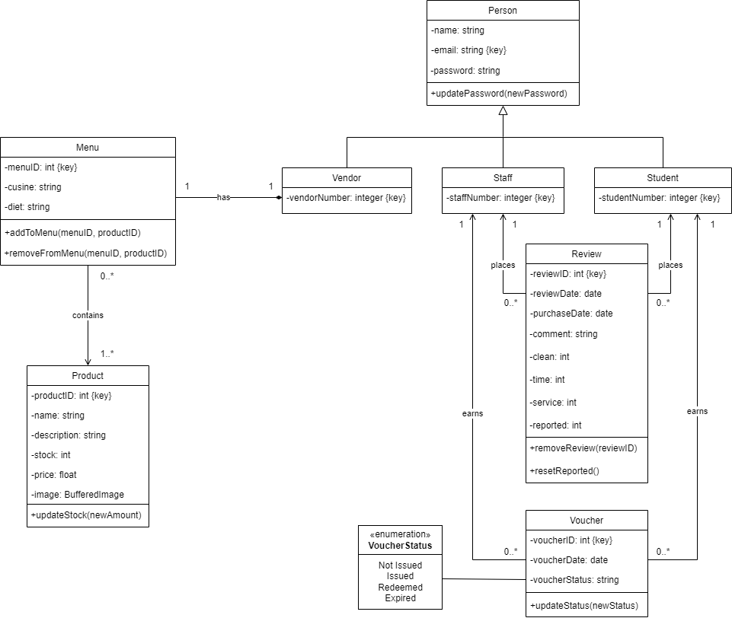

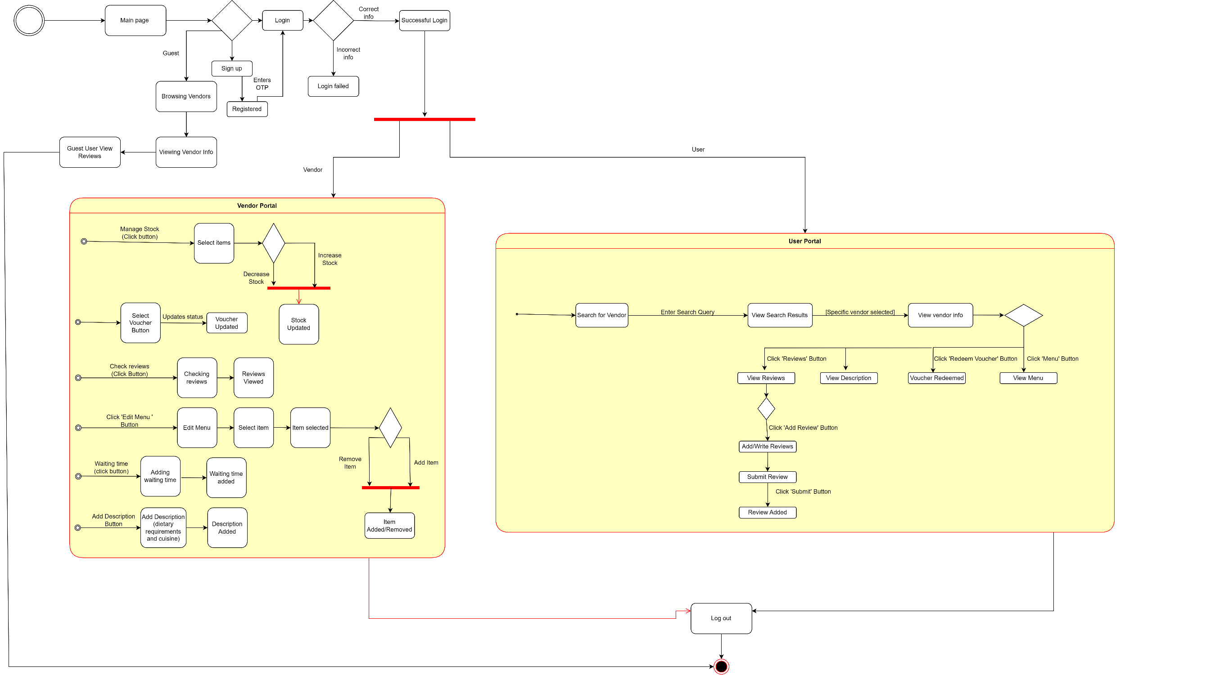**State Machine Diagram** [10]

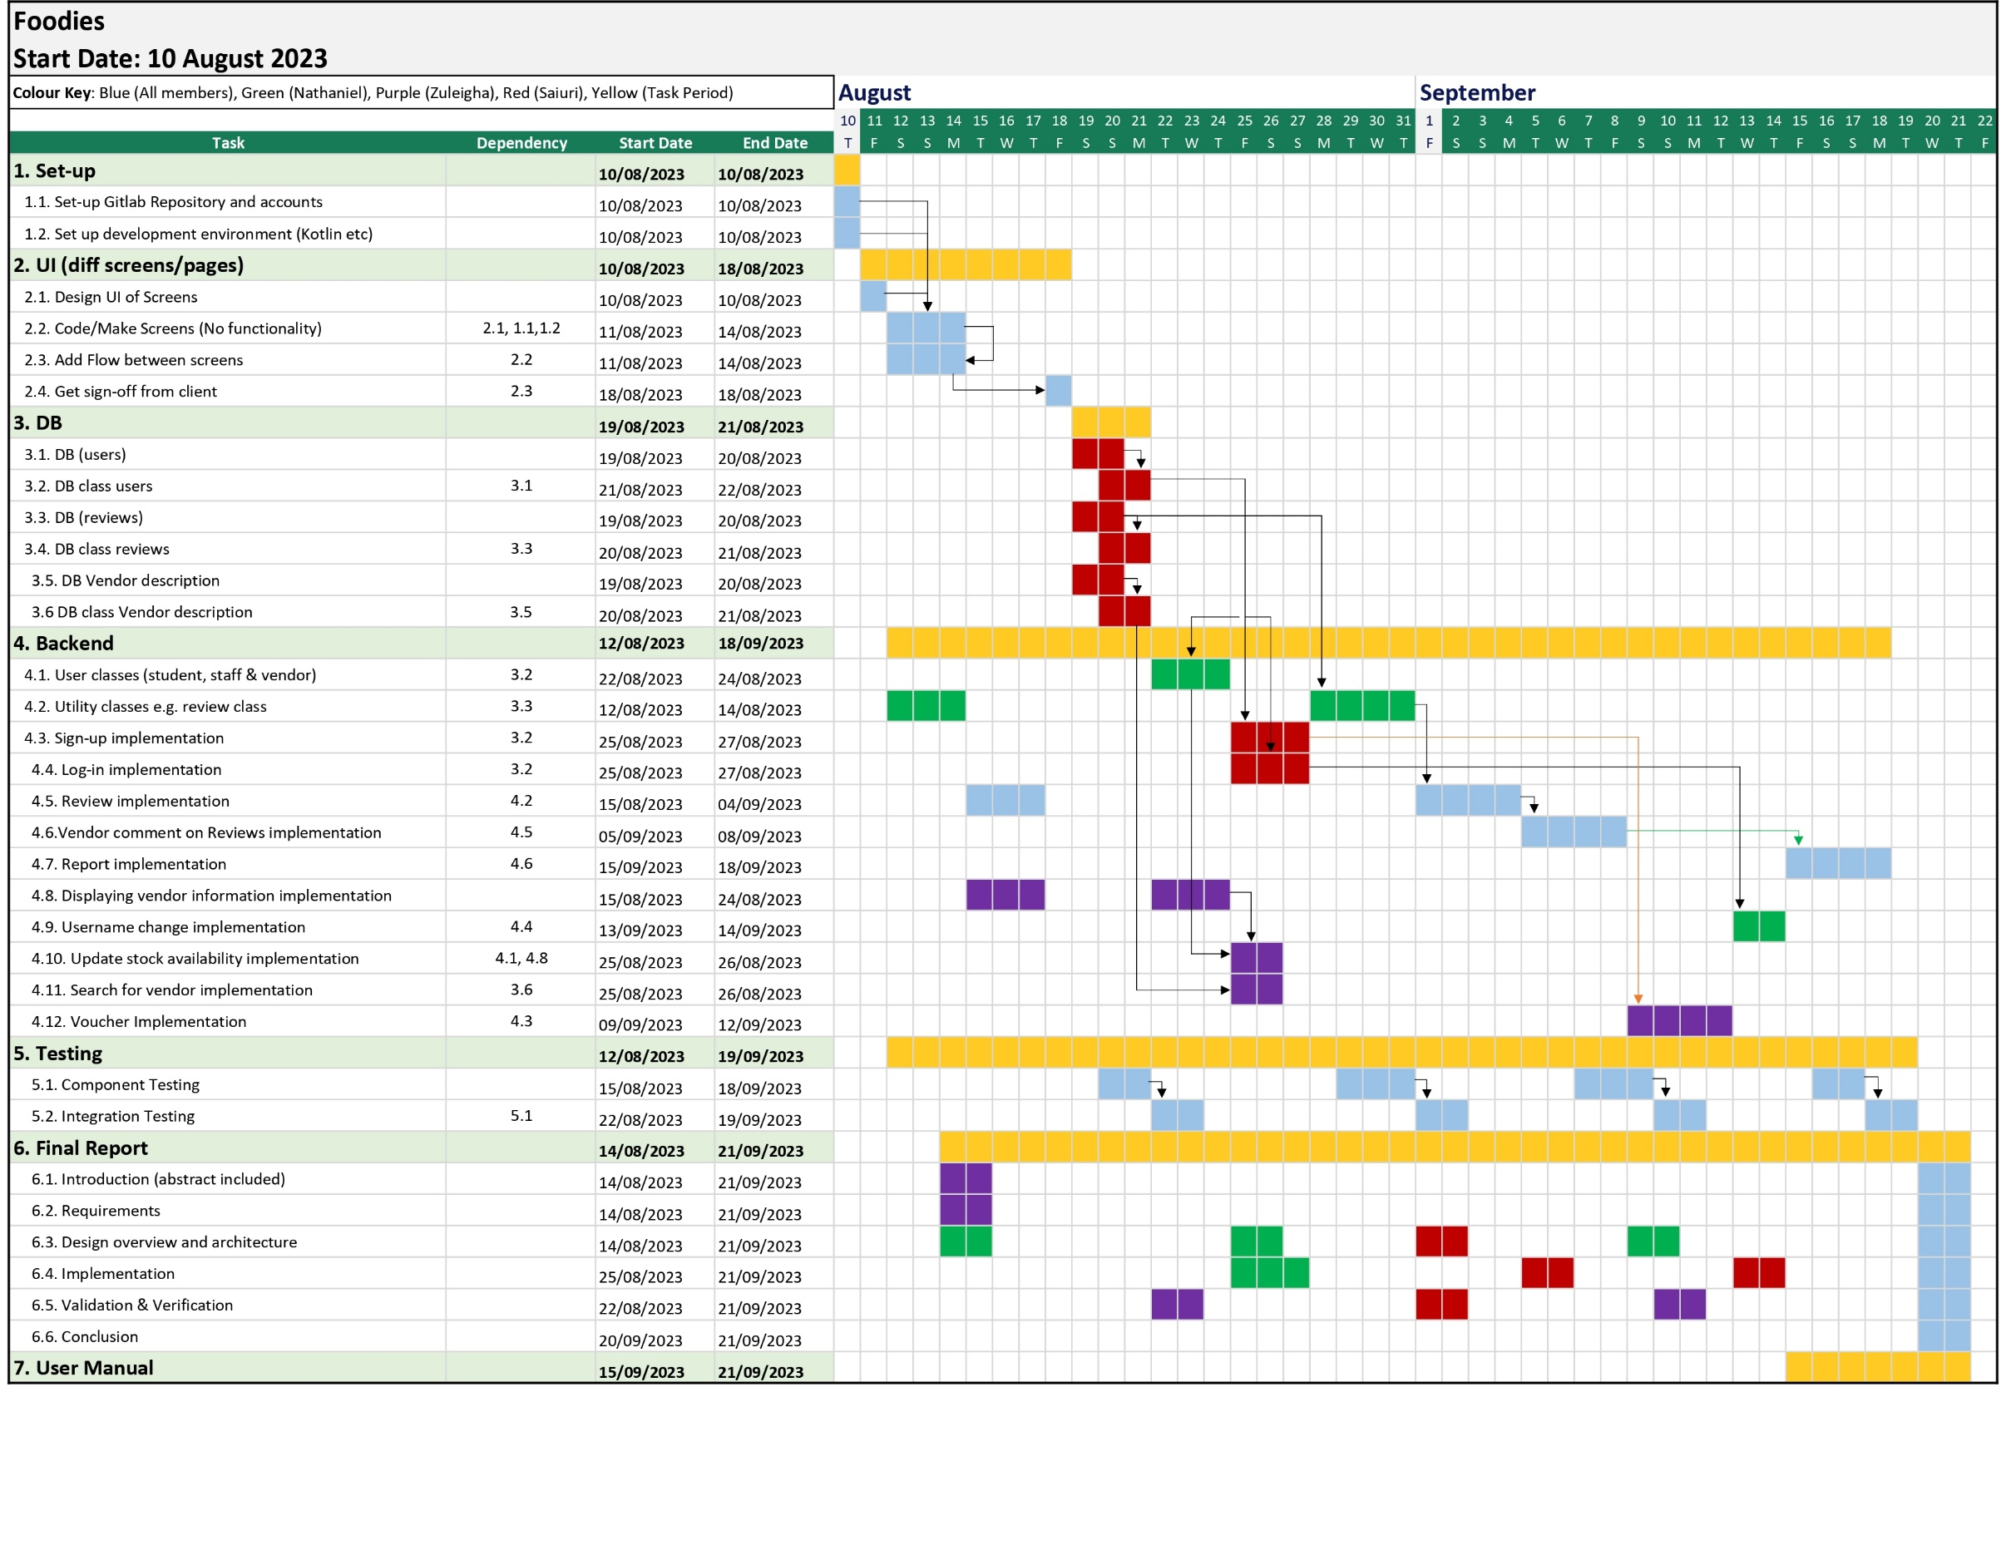

**Project Plan** [10]

q

Total Task Duration

Assigned to Everyone

Assigned to Nathaniel only

Assigned to Saiuri only

Assigned to Zuleigha only

**Test Plan** [10]

|  |  |  |  |  |
| --- | --- | --- | --- | --- |
| # | Test Case | User Action | Test Conditions | Expected Outcomes |
| 1 | Leave Review on Shop | User fills in review form and clicks post button.  User clicks cancel button. | Add review (including star ratings & comment). Cancel review allowed. | New review with correct information displayed on vendor review page. |
| 2 | Sign Up for Account | User enters details (email, password and one-time pin). | Authenticate user information. Add user. | Sign up successful for valid login details. Else, error message displayed. |
| 3 | Log-in to Account | User enters login details (email and password). | Authenticate user information (against details in User table). | Log-in successful for valid login details. Else, error message displayed. |
| 4 | Update Stock Availability | Vendor selects product and uses slider bar to update stock. | Add or remove product and update stock. | Updated menu displayed with updated stock availability. |
| 5 | Maintain Review Information | User reports a review for inappropriate content by clicking report button. | Delete inappropriate reviews. | Reviews displayed respectively under vendor review pages. |