Instructor Manual



CS200-Computer Communication & Networking

B. E. Electrical Engineering
Department of Electrical Engineering
Hamdard Institute of Engineering and Technology
Hamdard University Islamabad Campus

Prepared By:
Engr. Muhammad Asghar Khan

List of Experiments

Lab 1: Network Components 3

Lab 2: Cable Construction .9

Lab 3: Building a Peer-to-Peer Network 15

Lab 4: Building a Switched Network 1 21

Lab 5: Building an advanced Switched Network and controlling an unauthorized access. .. 26

Lab 6: Sharing and Remote Access .. 34

Lab 7: Address Resolution Protocol (ARP) .. 42

Lab 8: Wireshark . 46

Lab 9: Introduction to the Cisco IOS . 57

Lab 10: Cisco Routers- Basic Configurations . 64

Lab 11: IP Routing ....76

Lab 12: VLAN(Virtual LAN) …..87

Lab # 1

Network Components

Objectives:

- Understand some basic information about networks.

- Focusing on network transmission media and its types.

Theory Overview:-
Data Communications: the exchange data between two devices via some form of transmission medium such as a wire cable. A data communications system must transmit data to the correct destination in an accurate and timely manner.

A network: is a set of devices (often referred to as nodes) connected together by communication links to transmit information and for sharing resources.

Network Components:

A data communications system has five components: the message, sender, receiver, medium, and protocol.
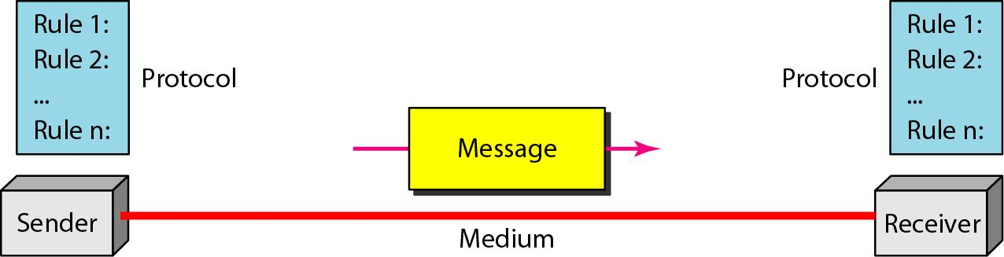

Figure 1: Transmission Media

A transmission media define as anything that can carry information from a source to a destination.

Types of transmission media:

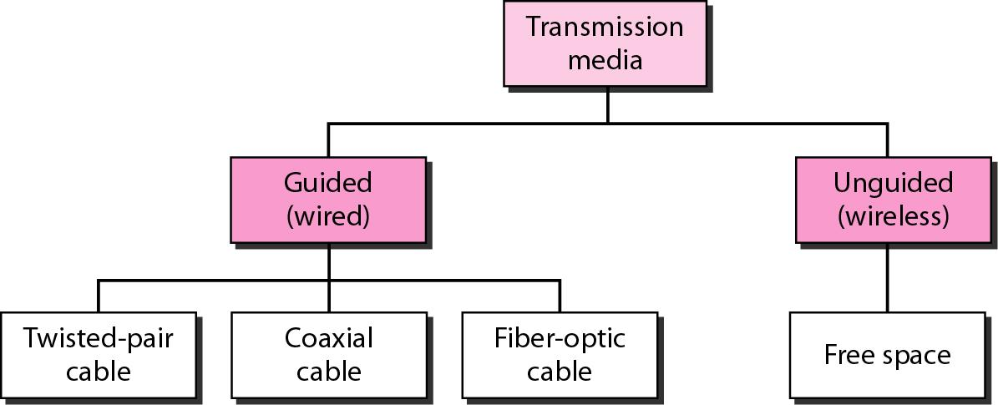

Figure 2: Transmission media

Guided media, which are those e that provide a conduit from one device to another, include twisted-pair cable, coaxial cable, and fiber-optic cable.

1. Twisted-Pair Cable

Two or more pairs of single conductor wires that have been twisted around each other.

Twisting the cables helps to eliminate electromagnetic interference between the two wires.

Shielding can further help to e liminate interference.

1.1 Unshielded Twisted-Pair (UTP)

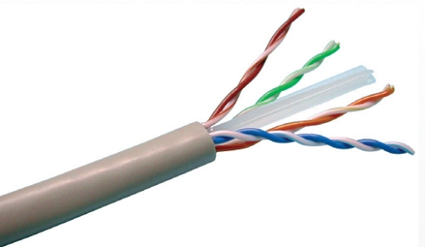

RJ45 connector
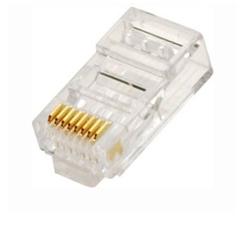

Figure 3: UTP cable and its connector.

1.2 Shielded Twisted-Pair (STP)

more expensive but less susceptible to noise.

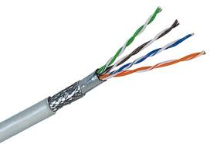

Figure 4: STP cable

Twisted-pair cable Applications:

- Telephone lines.

- Local loop: the line that connects the subscribers to the central telephone office.

- DSL lines.

- LANs

2. Coaxial cable:

- Carries signals of higher frequency ranges than those in twisted-pair cable.

- Central core conductor of solid or stranded wire (usually copper).

- Outer conductor of metal foil, or braid, or a combination of the two.

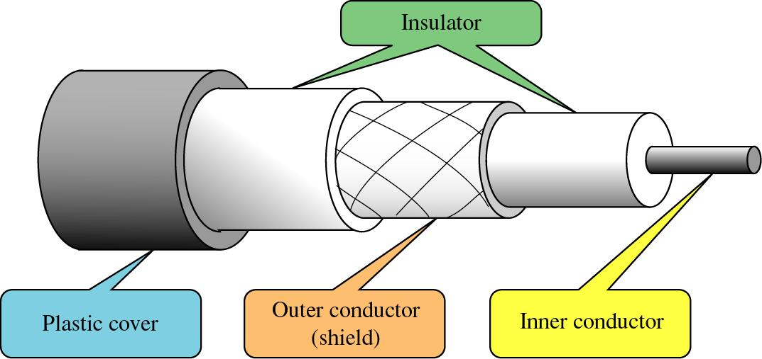

Figure 5: Coaxial cable.

Coaxial cable has two kinds:

Thick(RG-11): it connects 100 devices with range 5000 m (more expensive ).

Thin (RG-58): it connects 30 devices within 185 m (cheaper).

- To connect coaxial cable to device, we need BNC connector.

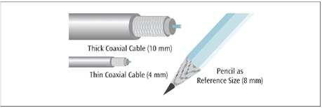

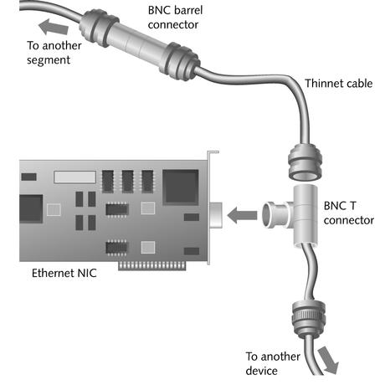

Coaxial cable applications:

- Telephone networks.

- Digital Telephone networks.

- Has largely been replaced today with fiber-optic cable.

- Cable TV networks (near consumer premises).

- Traditional Ethernet LANs.

3. Fiber-Optic Cable:

A fiber-optic cable is made of glass or plastic and transmits signals in the form of light.

A glass or plastic core is surro unded by a cladding of less dense glass or plastic .

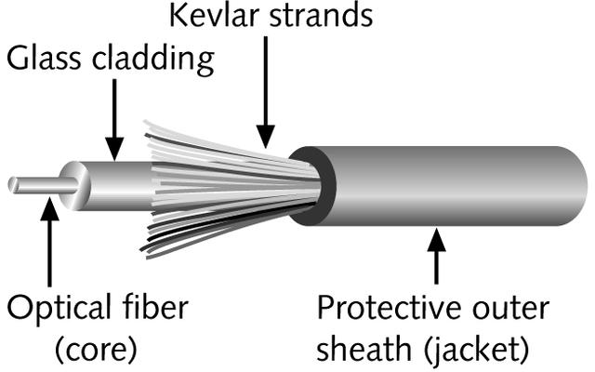

Figure 6: Fiber Optics cable.

Fiber Optic cable modes:

Single-mode fiber: Carries light pulses along single path.

Multimode fiber: Many pulses of light travel at different angles.

Two popular connectors used with fiber-optic cable:

- ST connectors

- SC connectors

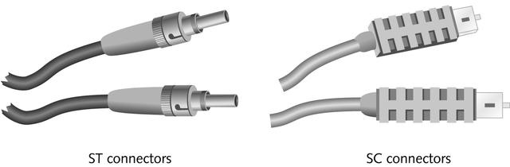

Figure 7: Fiber optic connectors.

Fiber Optic cable applications:

- Backbone networks.

- Cable TV networks.

- LANs.

Network Interface Card (NIC)

In computer networking, a NIC provides the hardware interface between a com puter and a network. A NIC technically is network adap ter hardware.

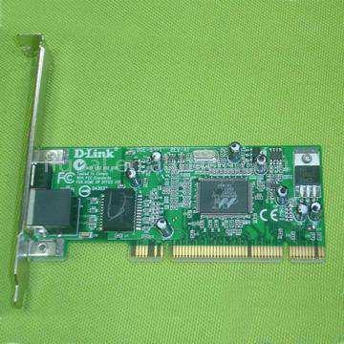

Figure 8: 10/100 Ethernet network LAN Adapter RJ45

Conclusion:-

Lab Task:

1. The student should go through the network lab transmission media.

Lab # 02
Cable Construction

Objectives:

- Understanding the inner details for UTP and STP cables. Make different types of cables; Straight-Through, Crossover and rollover.

- The student should take a demonstration on the network lab devices and tools.

- Understanding the main function for the network lab devices and tools.

- Understanding the main differences between MAC and IP addresses.

Theory Overview:-
In Lab 1, there were many types of network cables used in the real-world applications, such as UTP, STP and Coax cables. In Lab 2, we will continue with the most common used cables (UTP and STP) to know more inner technical details. The inner colored cables in UTP or STP should take an order to do its correct designed function. According to the inner colored cables, these cables categorized as Straight-Through cable, Crossover cable or rollover cable.

Straight through cable

Here, the connections are same on both the ends the cable. This type of cable is used when we connect dissimilar devices [switch and router, router and hub, switch and PC, etc]. The colours of the wires and their respective pin numbers are mentioned below:

White Orange [Pin 1] White Orange [Pin 1]

Orange [Pin 2] Orange [Pin 2]

White green [Pin 3] White green [Pin 3]

Blue [Pin 4] Blue [Pin 4]

White Blue [Pin 5] White Blue [Pin 5]

Green [Pin 6] Green [Pin 6]

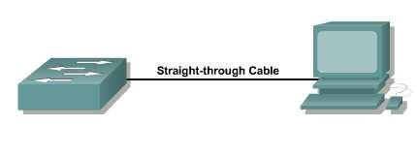White Brown [Pin 7] White Brown [Pin 7]

Brown [Pin 8] Brown [Pin 8]

Figure 1: Straight-through cable

Cross-over cable:

Here, the connections are different with a specific pattern. This type of cable is used when we connect similar devices [router and router, switch and switch, PC and PC, etc] and with some exceptions [switch and hub, Router and PC]. The colours of the wires and their respective pin numbers are mentioned below:

White Orange [Pin 1] White Green [Pin 1]

Orange [Pin 2] Green [Pin 2]

White green [Pin 3] White Orange [Pin 3]

Blue [Pin 4] Blue [Pin 4]

White Blue [Pin 5] White Blue [Pin 5]

Green [Pin 6] Orange [Pin 6]

White Brown [Pin 7] White Brown [Pin 7]

Brown [Pin 8] Brown [Pin 8]
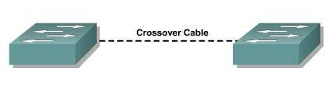

Figure2: Crossover cable

Roll over cable

Here, the connections are made in reverse order. This type of cable is used to connect the router/switch to the PC via console port for management purposes.

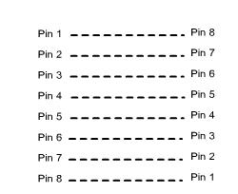

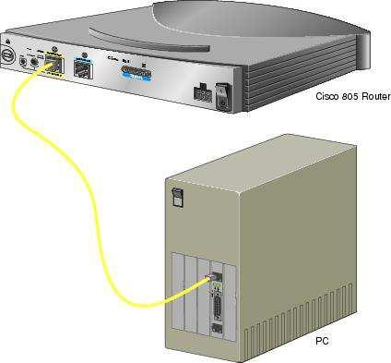

Figure 3: Rollover cable or console cable.

Some networking tools:

- cable crimping tool: is a tool use to crimp or connect a connector to the end of a cable..



- Network cables tester: A cable tester is an electronic device used to verify the electrical connections in a cable or other wired assembly.

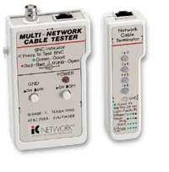

- Rack & Patch Panel:

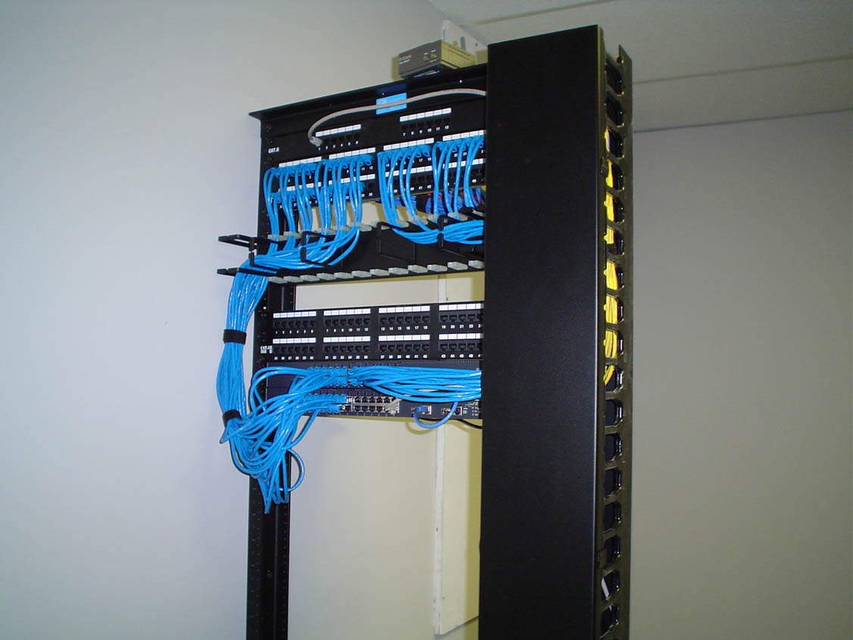

- Cable Tray: a cable tra y system is used to support insulated electri c cables used for power distribution and communi cation. Cable trays are used for cable manage ment in commercial and industrial construction. Th ey are especially useful in situations where ch nges to a wiring system are anticipated, since ne w cables can be installed by laying them in the tray, instead of pulling them through a pipe.

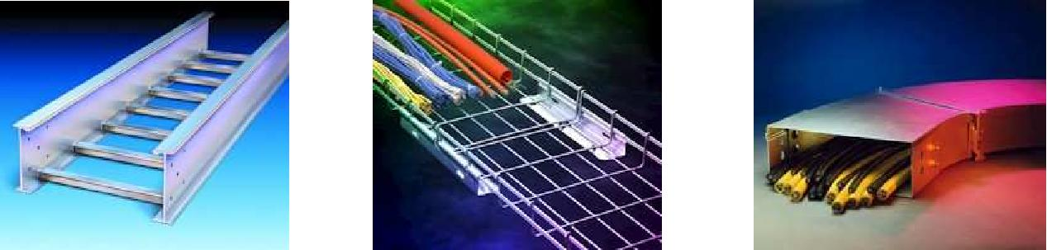

Some Network Devices:

- 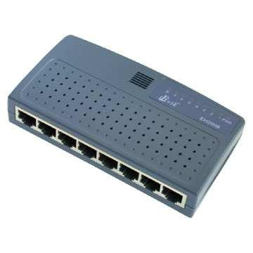HUB: In computer networking, a hub is a small, simple, device that joins multiple computers together. Many network hubs available today support the Ethernet standard. Other types including USB hubs.

- Switch: a network switch is a small hardware device that joins multiple computers together within one local area network (LAN). Technically, network switches operate at layer two (Data Link Layer) of the OSI model.
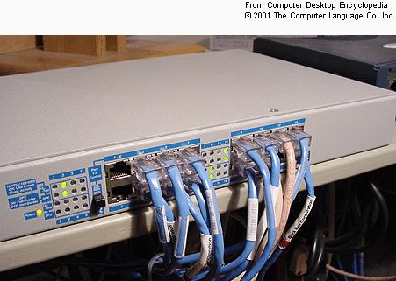

Mainly, switches manage PCs according to their MAC (Medium Access Control) addresses. The MAC address is used by network adapters to uniquely identify themselves on a LAN. MAC addresses are 12-digit hexadecimal (48 bits in length).
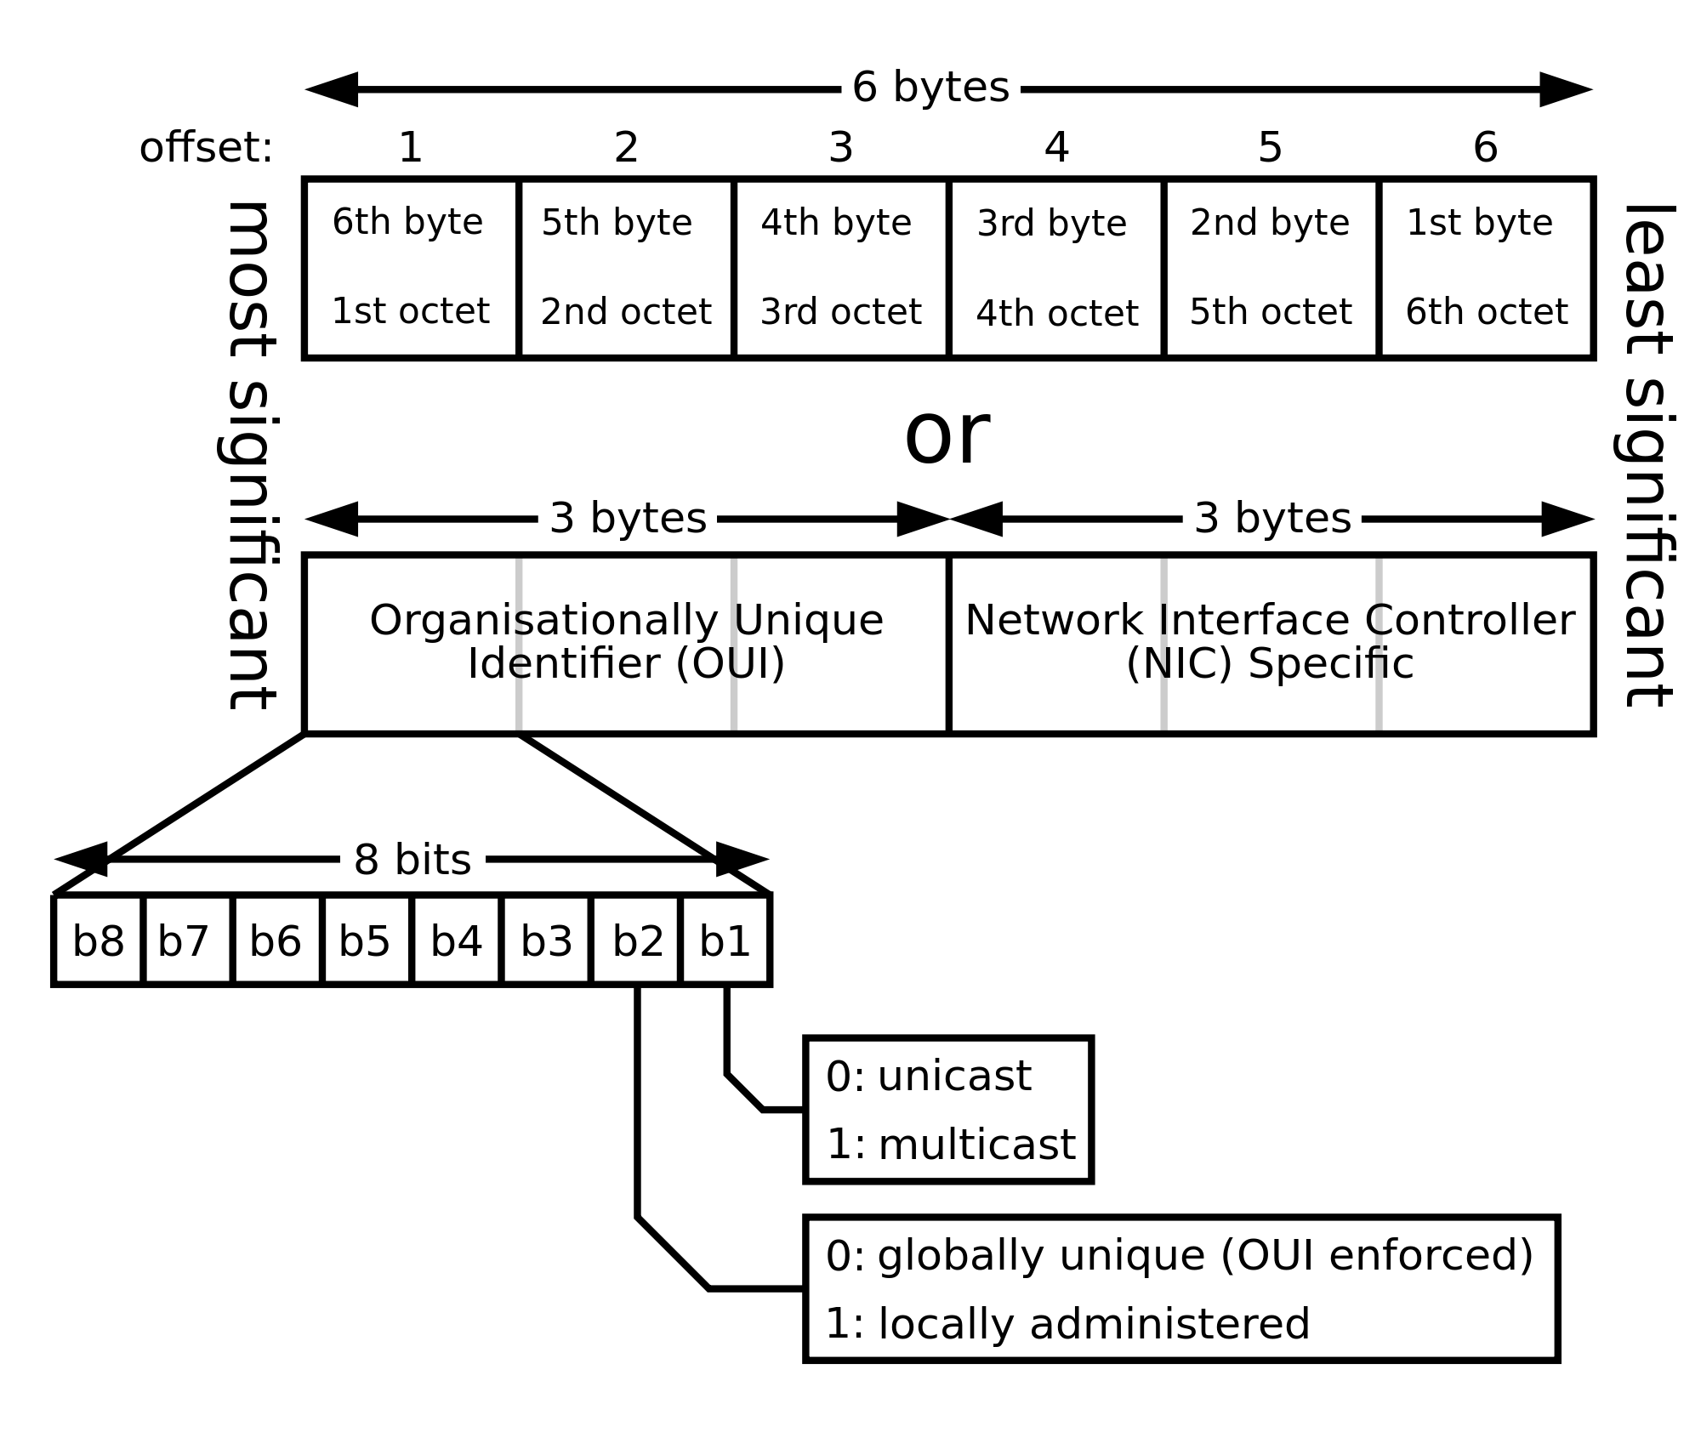

The MAC address is a unique v alue associated with a network adapter. MAC addresses are also known as hardware addresses or physical addresses. They uniquely identify an adapter on a LAN.

The first half(24-bits) of a MAC address contains the ID number of the adapter m anufacturer. These IDs are regulated by an Internet standards body. The second half of a MAC address represents the serial number assigned to the adapter by the manufacturer.

In the example, 00:A0:C9:14:C8:29, the 00A0C9 indicates the manufacturer is I ntel Corporation.

- Routers: A router is a device that forwards data packets between computer networks, creating an overlay internetwork. Router connects different networks.
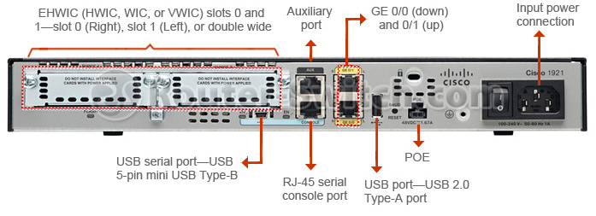

Mainly, routers manage PCs a nd networks according to their IP (Internet Protocol) addresses. An IP Address is a logical address co nsists of 4 numbers that represent the address of any host on in your intranet or Internet. IP Address es are either static of set dynamically by DHCP every time you log in to a network. Each IP address has two parts: A network ID (prefix) and a Host ID.

Lab Steps:

Preparation

- All needed equipments should be prepared before start making cables (UTP or STP cable, crimping tool, tester,..).

- Each student should have a cable.

Main Steps

- Make a crossover cable:

- Cut the cable with the suitable length using the crimping tool.

- Reorder the inner colored cables according to the crossover cable instructions for both sides.

- Make the cable connectors (RJ45) for both sides using crimping tool.

- Test the cable using the tester.

Conclusion:-

Lab Task:

- Make a Straight-Through cable.

- Make a rollover cable.

Lab # 03
Building a Peer-to-Peer Network

Objectives:

- Understanding the concept behind a peer to peer network.

- Understanding the IP address structure.

- Understanding masking concept and subnet mask address structure.

- Create a simple LAN with two PCs (simple peer to peer network) using a single crossover cable to connect the two workstations

Theory Overview:-
A peer-to-peer (abbreviated to P2P) computer network is one in which each computer in the network can act as a client or server for the other computers in the network, allowing shared access to various resources such as files, peripherals, and sensors without the need for a central server. P2P networks can be set up within the home, a business, or over the Internet. Each network type requires all computers in the network to use the same or a compatible program to connect to each other and access files and other resources found on the other computer. Each PC should has a unique IP address to communicate.

Before we go to build a peer to peer network, we have to fully understand the IP address structure and its related issues.

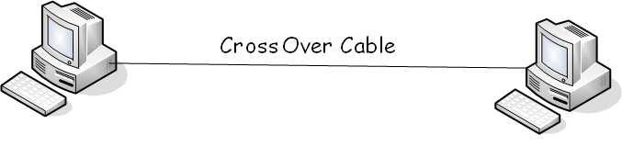

Figure 1: An example of a simple peer to peer network.

IP Address

- An IP address is a logical address of a network adapter. Home computers and many other devices acquire IP addresses to join Internet Protocol networks.
- Logical address used in TCP/IP networking
- Unique 32-bit number

- Divided into four groups of octets (8-bit bytes) that are separated by peri ods.

- E.g., 217.29.240.5 (www.a su.edu.jo)

- Total: 2³² = 4,294,967,296

- The IP represent the addr ess of any host on in the intranet or the Internet.

- IP Addresses are either sta tic of set dynamically by DHCP every time you log in to a network.

ICANN (Internet Corporation for Assigned Names and Numbers): it is a non-profit organization to maintain and assign IP address es. Two IP addressing standards are in use tod ay. The IPv4 standard is most familiar to people and supported everywhere on the Internet, but the newer IPv6 standard is planned to replace it and starting to be deployed.
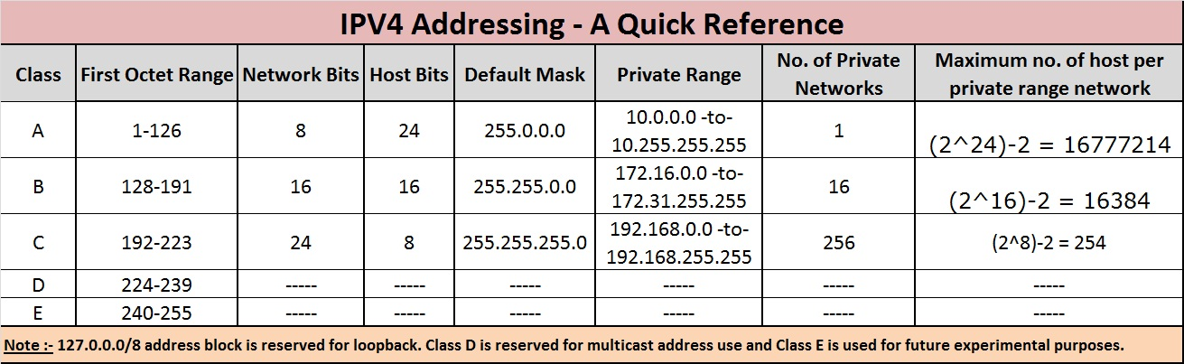

Table 1: IP address classes.

Each IP address has two parts: A network ID (prefix) and a Host ID.

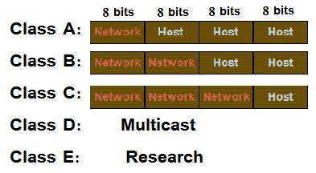

Figure 2: IP address classes parts.

Addresses per class:

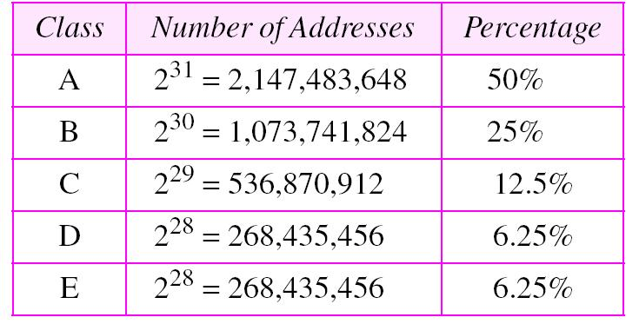

Table 2: Number of IP addresses per class

Loopback address

- The IP address 127.0.0.1 is a special purpose address reserved for use on each computer. 127.0.0.1 is conventionally a computer's loopback address.

- IP address reserved for communicating from a node to itself (localhost)

- Value of the loopback address is always 127.0.0.1

Private and Public IP address:

An IP address can be private - for use on a local area network (LAN) - or public - for use on the Internet or other wide area network (WAN). IP addresses can be determined statically (assigned to a computer by a system administrator) or dynamically (assigned by another device on the network on demand).

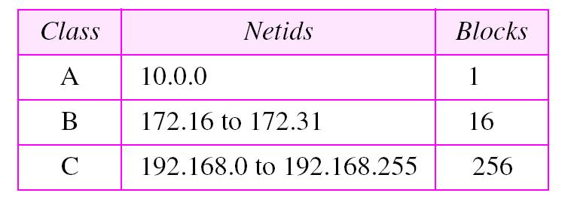

Table 3: IP addresses ranges for private networks
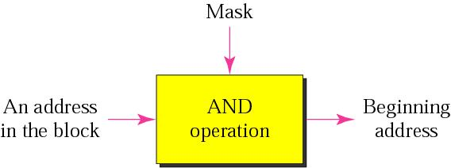

Figure 3: Masking concept

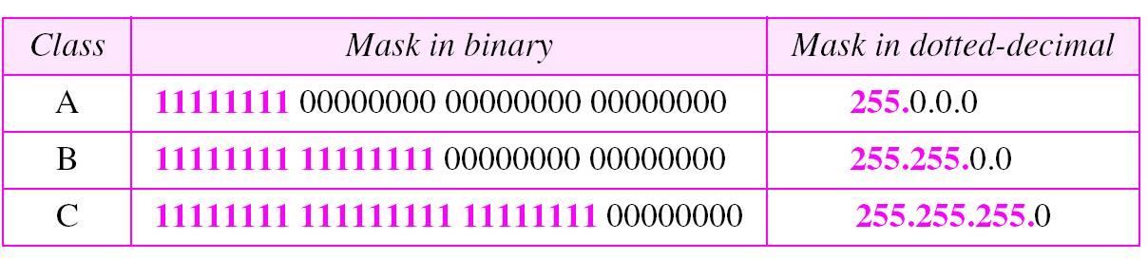

Table 4: Default subnet mask address per class.
The Network address

The network address is the beginning address of each block. It can be found by applying the default mask to any of the addresses in the block (including itself). It retains the NetID of the block and sets the HostID to zero.

Lab Steps:

Preparation

- Each student should have a PC.

- Every two students might work as a team to build the peer to peer network.

- Each two students should have one crossover cable.

Main Steps

- Each team should plug the crossover cable into the two PCs’ NICs.

- Each team should setup its PCs, as following:

  - Check Local Area Network Connections:

Verify the cables (You should check the cables to verify that you have good layer 1 physical connections).

2.2 Check Network Adapters and Protocols:

Check the Network Adapter (NIC): Use the Control Panel System Device Manager utility to verify that the Network Adapter (NIC) is functioning properly for both workstations. Double click on Network Adapters and then right click the NIC adapter in use. Click Properties to see if the device is working properly. If there is a problem with the NIC or driver, the icon will show a yellow circle with an exclamation mark in it with (possible resource conflict) or a red X indicating a serious problem (device could cause Windows to lock up).

2.3 Check the TCP/IP Protocol Settings

Use the Control Panel/Network Connections (or Properties in Context Menu of My Network Places) to display Network Connections Window. Then use Properties in Context Menu of Local Area Connection to display Local Area Connection Properties Window. Select the TCP/IP protocol from the Configuration Tab and click on properties. Check the IP Address and Subnet mask for both workstations on the IP Address Tab.

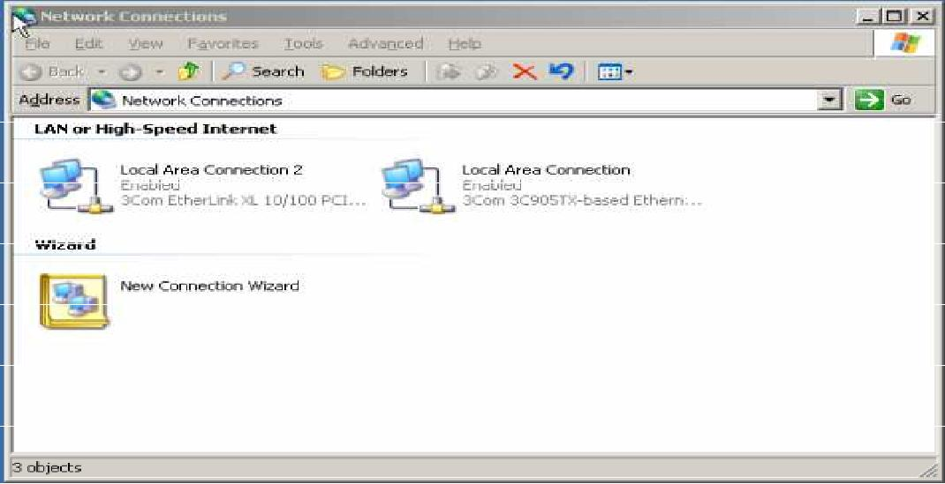

Figure 4:Network Connections Window

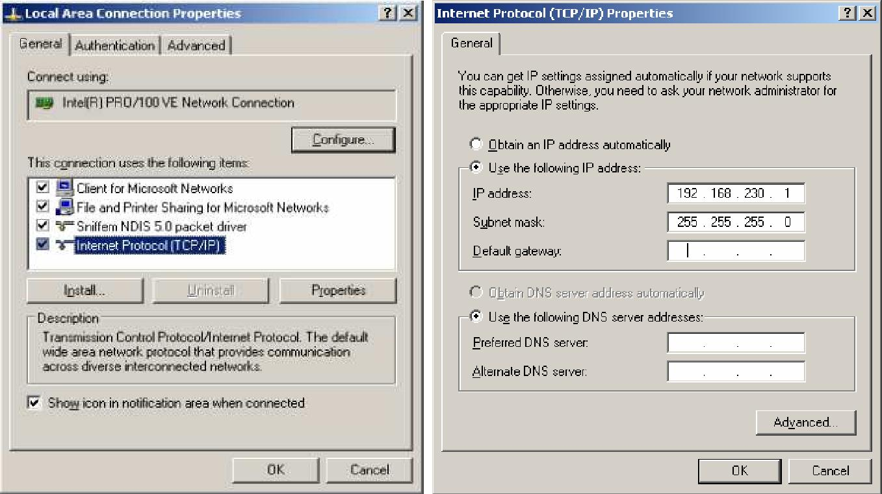

Figure 5: TCP/IP Properties Window

The IP addresses can be set to anything as long as they are compatible and on the same network. Record the existing settings before making any changes in case they need to be set back (for instance, they may be DHCP clients now). For this lab, use the Class C IP network address of 192.168.230.0 and set workstation 1 to static IP address 192.168.230.1 and set workstation 2 to 192.168.230.2.

Note: each team should take into consideration its PCs labelled numbers.

- Set the default subnet mask on each workstation to 255.255.255.0. For the purpose of this lab, you can leave the Gateway and DNS Server entries blank.

- Check the connectivity between the network’s PCs

- Each team should check the connectivity between its network’s PCs using the command PING.

Ping

- Ping is the name of a standard network utility packaged with popular network operating systems.

- The utility can be used to determine if a remote device (such as Web server) can be reached on the network.

- You can ping using the (IP address, Host Name, or a Web site) of the destination

- When you get request time out:

  - There is a physical error such as cable failure

  - The host is not found

  - Or a problem due to the Firewall

Start type “cmd” type ping “the destination IP address” and see the output results.

Conclusion:

Lab Task:

1. For each team, check the connectivity with your neighbor team’s PCs

Lab # 4

Building a Switched Network 1

Objectives

- Understanding the concept behind the switched network.

- The student should be familiar with TCP/IP.

- Learn to create a simple LAN with two PCs using an Ethernet hub (Switched Network).

- Learn to configure and verify the network connectivity.

- Learn to deal with the switch device and examine its LED lamps colors.

- Learn about various network related commands Ping and IpConfig.

Theory Overview:-
A switched network consists of a series of interlinked nodes, called switches. Switches are devices capable of creating temporary connections between two or more devices. In a switched network, some of these nodes are connected to the end systems. Others are used only for routing.

In this lab, we will build a simple switched network which consists of one switch and the other nodes will be workstations (PCs).

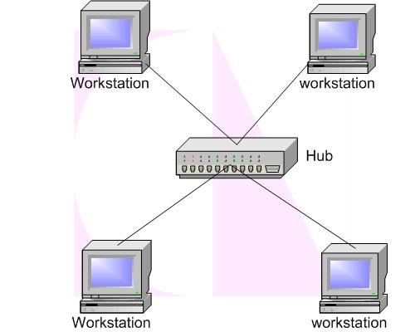

Figure 1: An example of switched network.

Before going to build a switched network, we need to understand the rule of communication using the

TCP/IP.

What is TCP/IP

- TCP/IP is the Internet Communication Protocol. TCP/IP stands for Transmission Control Protocol / Internet Protocol.

- A communication protocol is a description of the rules computers must follow to communicate with each other.

- The Internet communication protocol defines the rules for computer communication over the Internet.

- Internet browsers and Internet servers use TCP/IP to connect to the Internet.

- Your browser uses TCP/IP to access Internet servers, and servers use TCP/IP to send HTML back to your browser.

- Your e-mail program uses TCP/IP to connect to the Internet for sending and receiving e-mails.

- Your Internet address “ ? . ? . ? . ? " is a part of the standard TCP/IP protocol (and so is your domain name "www.???????.???").

Inside TCP/IP

- Inside the TCP/IP standard there are several protocols for handling data communication:

- TCP (Transmission Control Protocol) communication between applications

- UDP (User Datagram Protocol) simple communication between applications

- IP (Internet Protocol) communication between computers

- ICMP (Internet Control Message Protocol) for errors and statistics

- DHCP (Dynamic Host Configuration Protocol) for dynamic addressing It is an application layer protocol.

- DHCP has a pool of available addresses. When a request arrives, DHCP pulls out the next available address and assigns it to the client for a negotiable time period.

Lab Steps:

Preparation

- The workstations should have NIC installed with the proper drivers.

- An Ethernet Switch (has 4 or more ports) and two CAT5 straight-wired cables.

Main Steps

Setting up a simple network:

The two PCs will be connected with a switch between them. The switch allows for more than just two workstations to be connected depending on the number of ports on the switch. Switches can have from 4 to 32 ports.

- Check Local Area Network Connections

- Plug in and connect the equipment

Check the workstations and switch to make sure that the NICs are installed correctly in each workstation. Plug in the workstations and turn them on. Plug the straight through cable from workstation 1 into port 1 of the switch and the cable from workstation 2 into port 2 of the switch. After the workstations have booted, check the green link light on the back of each NIC and the green lights on ports 1 and 2 of the switch to verify that the are communicating. This also verifies a good physical connection between the Switch and the NICs in the workstations (OSI Layers 1 and 2). If the link light is not on it usually indicates a bad cable connection, an incorrectly wired cable or the NIC or switch may not

be functioning correctly.

The switch has number of LED colors, You can monitor switch activity and status by checking the switch LEDs. There are three possible LED states: no light, a steady light, or a flashing light. The steady lights and flashing lights can be green or amber.

The LEDs flash any of these colors during boot, POST, or other diagnostic tests. This is normal and does not indicate a problem unless the LEDs do not indicate a healthy state after all boot processes and diagnostic tests are complete. A healthy state is indicated by a steady green light.

Port LED | Meaning
Solid green | Link is up.
Steady flashing | Link is up
green | Link is up
Flashing green | Link is up (traffic on port).
 | Link is disabled by
Solid amber | software.
Flashing amber | A fault condition exists.
Off | No link.

Network Adapters and Protocols

Check the Network Adapter (NIC), If there is a problem with the NIC or driver, the icon will show a yellow circle with an exclamation mark in it with (possible resource conflict) or a red X indicating a serious problem (device could cause Windows to lock up).

Check the TCP/IP Protocol Settings

The IP addresses can be set to anything as long as they are compatible and on the same network. Record the existing settings before making any changes in case they need to be set back (for instance, they may be DHCP clients now). For this lab, use the Class C IP network address of 192.168.230.0 and set workstation 1 to static IP address 192.168.230.1 and set workstation 2 to 192.168.230.2.

Note: each team should take into consideration its PCs labeled numbers.

Set the default subnet mask on each workstation to 255.255.255.0. For the purpose of this lab, you can leave the Gateway and DNS Server entries blank.

Check the connectivity between the network’s PCs

Each team should check the connectivity between its network’s PCs using the command PING.

Check the TCP/IP Settings with the IPCONFIG Utility:

Ipconfig

is a command line utility available on all versions of Microsoft Windows starting with Windows NT. Ipconfig is designed to be run from the Windows command prompt. This utility allows you to get the IP address information of a Windows computer. It also allows some control over active TCP/IP connections. ipconfig is an alternative to the older 'winipcfg' utility.

Use the command ipconfig /all to see all TCP/IP related settings for your workstation.

Check the connectivity between you and your mate in the switched network using Ping command.

Use the ping command to ping www.yahoo.com, was it successful?

Use tracert command to display the result of the trace, how many hops did it take?

tracert www.yahoo.com

NOTE: the number of hops depends on the path the message traverse through, so it is not a static number

Conclusion:

Lab Task:

- Use ipconfig /? : displays the set of available options.

- Try ipconfig / renew. What are the results?

- Use ping /?

- Try ping IP address –t. what are the results?

- Use tracert /?

- Try tracert -h 5 www.yahoo.com. What are the results?

Lab # 5
Building an advanced Switched Network and
controlling an unauthorized access.

Objectives:

- Building a switched network using static and dynamic addressing.

- The student should be familiar with Windows Firewall settings.

Theory Overview:-
When someone on the Internet or a network tries to connect to your computer, windows call that attempt an "unsolicited request." When your computer gets an unsolicited request, Windows Firewall blocks the connection. If you run a program such as an instant messaging program or a multiplayer network game that needs to receive information from the Internet or a network, the firewall asks if you want to block or unblock (allow) the connection. If you choose to unblock the connection, Windows Firewall creates an exception so that the Firewall won't bother you when that program needs to receive information in the future.

For example, if you are exchanging instant messages with someone who wants to send you a file (a photo, for example), Windows Firewall will ask you if you want to unblock the connection and allow the photo to reach your computer. Or, if you want to play a multiplayer network game with friends over the Internet, you can add the game as an exception so that the firewall will allow the game information to reach your computer.

Although you can turn off Windows Firewall for specific Internet and network connections, doing this increases the risk that the security of your computer might be compromised.

Lab Steps:

Main Steps

Setting the LAN

Know your group and prepare your PC: every 4-7 students (preferably in one line as instructed by your lecturer) will constitute one group with their PCs connected in one LAN. Members of the group shall coordinate the work amongst themselves (one of the group shall be elected o ensure the synchronization of performing the steps). Also make sure, before you move to the next step, that your PC is disconnected (both NICs on your PC are disconnected).

Prepare the Windows Firewall

Windows Firewall protects against unauthorized access to your PC. Configuring the Windows Firewall to allow echo request is essential for pinging (echo request). If at any time pinging was not successful, you may set the Firewall to off, which is not recommended. Windows Firewall may be accessed from the control panel and be set on or off. Windows Firewall is turned on by default for all Internet and network connections. However, some computer manufacturers and network administrators might turn it off. To open Windows Firewall, click Start, click Control Panel, and then double-click Windows Firewall

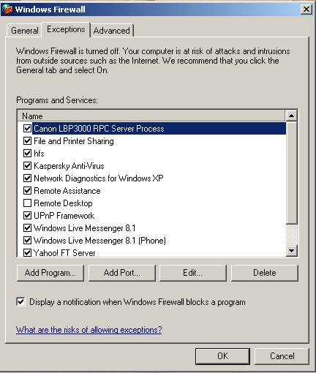

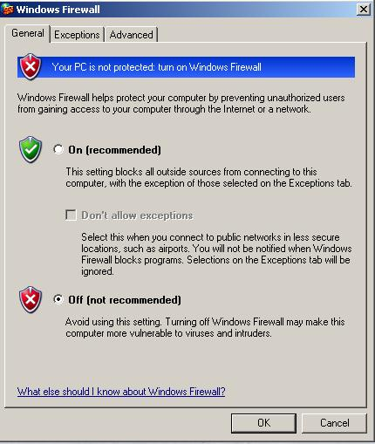

- Windows Firewall is turned on by default, so you cannot use some features of some types of programs, unless the program is listed on the Exceptions tab in Windows Firewall. For example, you might not be able to send photos using an instant messaging program until you add the program to the exceptions list.

- Using the Advanced tab, select ICMP Settings and check whether the "Allow incoming echo request" is ticked. If not, tick it. Doing that allows pinging your computer from another host even if Windows Firewall was set on. It is preferable to check this setting whenever a problem with pinging occurs. Notice that settings for individual NICs can be set for each NIC independently by selecting the required NIC from the Advanced tab.

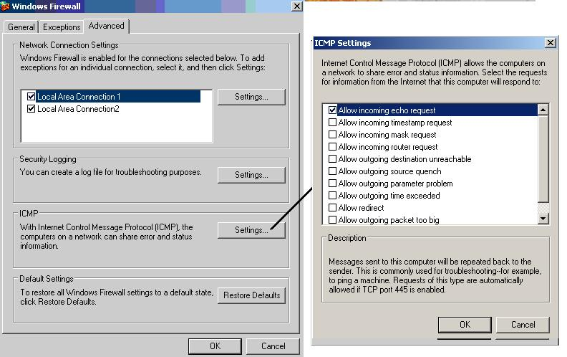

Connecting The Switch to the PCs

The Cisco switch is a 26 port switch with 24 normal connections and 2 Giga bit connections (for backbone purposes). Use UTP cable with RJ45 connectors of the appropriate type and length to connect the 3COM NIC on your PC to one of the 24 (Normal) ports (make sure that this is the only connected NIC and the other one is disconnected).

Configuration obtained for your PC

Make sure that your PCs are configured to obtain IP address automatically. This can be done by configuring the TCP/IP settings. Upon connecting the PCs and turning on the switch, The PCs connected to the switch (that is a non-configured switch) will not obtain an IP address normally. Check the IP address and other TCP/IP settings obtained

The command to use is:

ipconfig or ipconfig/all for more details# Were the results

IP address: 169.254.120.2 (example of possible result) Subnet mask: 255.255.0.0

As the address assigned to the host has net id 169.254, it is in the private range 169.254.0.1 to

169.254.255.254 of the APIPA network which means that the DHCP failed– switch is rewetted and no

DHCP server assigned

You might have noticed that the NIC has shown a limited or no connectivity sign (yellow triangle with the exclamation mark inside).

In the table below is an example of a multiple IP addresses in one group in addition of all hosts.

Student Name | PC name | IP address | Subnet Mask
#Ali # | #PC1# | #169.254.159.208# | #255.255.0.0#
#Salem# | #PC2# | #169.254.155.235# | #255.255.0.0#
#Maha# | #PC3# | #169.254.121.211# | #255.255.0.0#
#Saud# | #PC4# | #169.254.150.134# | #255.255.0.0#
#Mohd# | #PC5# | #169.254.105.212# | #255.255.0.0#
#Zaid# | #PC6# | #169.254.110.113# | #255.255.0.0#

The addresses obtained by the failover mechanisms in the different hosts are assigned by ARP (Address resolution protocol) which means that even in the case of failover, no single host can attain an IP address similar to the other PCs.

In the case below have a multiple IP addresses were all distinct in the LAN because of ARP

Note: all PCs can communicate with each other using APIPA addresses and we can test the connectivity using the ping command with 2 PCs as follows

Connectivity with the PC2 (Salem), I used

Ping 169.254.155.235

Successful result

Connectivity with the PC4 (Saud), I used

Ping 169.254.150.134

Successful result

Configuring your PC using static addresses.

Static addressing may be used when the DHCP mechanism fails. To configure the PCs connected to the switch over your LAN with typical private addresses they must therefore be assigned a static IP address. Use the following IP address for your PC 192.168.9.x with the x value of your PC different from the values of the other PCs (you must coordinate with the others in the group). Write down the addresses of all the PCs in the group.

Student Name | PC name | IP address | Subnet Mask
#Ali # | #PC1# | #192.168.9.1# | #255.255.255.0#
#Salem# | #PC2# | #192.168.9.2# | #255.255.255.0#
#Maha# | #PC3# | #192.168.9.3# | #255.255.255.0#
#Saud# | #PC4# | #192.168.9.4# | #255.255.255.0#
#Mohd# | #PC5# | #192.168.9.5# | #255.255.255.0#
#Zaid# | #PC6# | #192.168.9.6# | #255.255.255.0#

Test your NIC and make sure that it is ready

By using loopback IP address, ping 127.0.0.1 which check your TCP/IP stack isn't corrupt Connectivity with other PCs in the LAN.

Test the connectivity using the ping command such as 3 PCs as follows

Connectivity with the PC2 (Salem), I used

Ping 192.168.9.2

Successful result

Connectivity with the PC3 (Maha), I used

Ping 192.168.9.3

Successful result

Connectivity with the PC4 (Saud), I used

Ping 192.168.9.4

Successful result

Reconfiguring the IP addresses in your LAN

The set of addresses assigned statically in step 4 belong to private addresses range of class C. In this step you are requested to coordinate with your group and assign and test the use of private addresses of other classes

Now we want to give a LAN multiple IP addresses all in class B which its range from 172.16.0.0 through 172.31.255.255 The following table shows the selected addresses:

 | Student Name | PC name |  | IP address | Subnet Mask
 | #Ali # | #PC1# |  | #172.25.10.101# | #255.255.0.0#
 | #Salem# | #PC2# |  | #172.25.10.102# | #255.255.0.0#
 | #Maha# | #PC3# |  | #172.25.10.103# | #255.255.0.0#
 | #Saud# | #PC4# |  | #172.25.10.104# | #255.255.0.0#
 | #Mohd# | #PC5# |  | #172.25.10.105# | #255.255.0.0#
 | #Zaid# | #PC6# |  | #172.25.10.106# | #255.255.0.0#

To test connectivity of your PC and any 2 hosts ping command with 2 PCs as follows:

Connectivity with the PC2 (Salem), I used

Ping 172.25.10.102

Successful result

Connectivity with the PC4 (Saud), I used

Ping 172.25.10.104

Successful result

Now we will select and assign static addresses in private Class A

The range of addresses in private class A is:

From 10.0.0.0 through 10.255.255.255

The following table shows the selected addresses

Student Name | PC name |  | IP address | Subnet Mask
#Ali # | #PC1# |  | #10.10.10.101# | #255.0.0.0#
#Salem# | #PC2# |  | #10.10.10.102# | #255.0.0.0#
#Maha# | #PC3# |  | #10.10.10.103# | #255.0.0.0#
#Saud# | #PC4# |  | #10.10.10.104# | #255.0.0.0#
#Mohd# | #PC5# |  | #10.10.10.105# | #255.0.0.0#
#Zaid# | #PC6# |  | #10.10.10.106# | #255.0.0.0#

Test connectivity of your PC and any 2 hosts. Report the addresses used and the results.

Test the connectivity using the ping command with 2 PCs as follows:

Connectivity with the PC2 (Salem), I used

ping 10.10.10.102 Successful result

Connectivity with the PC4 (Saud), I used

ping 10.10.10.104

Successful result

Connecting to the internet

Connecting the switch to the internet coming to your lab will ensure that DHCP will be administrated through a DHCP server. To do that insure at first that the IP addresses are obtained automatically on all PCs connected to the switch. Connect the external Internet line to any of the remaining switch ports. Set the PCs to obtain the IP address automatically by configuring the TCP/IP settings.

Resources sharing (file sharing)

Step 1. Create a folder in "my documents" under your name

Step 2. To share this folder between the PCs in the designed LAN

- Write click and select "sharing and security"

- Select to share this folder

Step 3. Inform the members in your group to access your shared folder and try to access their shared folder (as explained in step 4).

Step 4. Accessing the shared folder of the other PCs over the LAN a. Select any of the hosts in your group.

Host name: _ _ _ _ _ _ _ IP address: _ _ _ _ _ _ _ _ _ _

- Click Start -> Run

- Type \\ IP address of the selected PC

- Make sure that you accessed the shared folder of this PC. Insert a screen shot of the screen obtained immediately after step c.

- Repeat steps a through c for another host in your group.

- Besides viewing files on a shared folder from a remote computer, determine whether you can edit/delete these files from the remote computer. Investigate the sharing and security folder to find out how you.

can alter the permissions of shared folders. Try them (with the cooperation of a member of your group).

Step 5. Accessing the hosts using their names.

- Repeat Step 4 above (a to d) but using host names instead of IP addresses, e.g. \\PC4, Do you access the PCs _ _ _ _ _

- You can test connectivity (ping command) also using host names, try that, was that successful.

Conclusion:-

Lab # 6
Sharing and Remote Access

Objectives:

- Understanding the sharing system in Microsoft Windows.

- The student should be familiar with file sharing settings.

- Understanding the concept behind the remote desktop access.

- The student should be familiar with remote desktop access settings.

Theory Overview:-
A shared resource or network share is a device or piece of information on a computer that can be remotely accessed from another computer, typically via a local area network or an enterprise Intranet, as if it were a resource in the local machine.

Simple File Sharing

Windows operating system lets you share a computer's disks and folders with other computers on the network, using a method called Simple File Sharing. And it really is simple. If a disk or folder is shared, everyone on the network can access it. There are no user permissions and no passwords. Because sharing in this way is so wide open, Windows tries to protect you from some potential security risks.

Remote Desktop Services in Windows is one of the components of Microsoft Windows (both server and client versions) that allows a user to access applications and data on a remote computer over a network, using the Remote Desktop Protocol (RDP). you can connect to your work computer from your home computer and have access to all of your programs, files, and network resources as though you were in front of your computer at work. You can leave programs running at work and then, when you get home, you can see your work computer's desktop displayed on your home computer, with the same programs running (the most sophisticated form of remote access).

Lab Steps:

Main Steps

Right click the disk or folder that you want to share and select Sharing and Security.

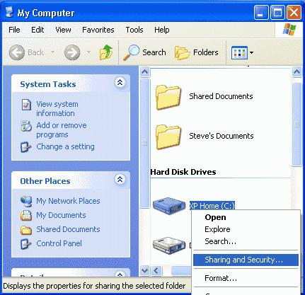

The disk or folder that you share, along with all of the folders that it contains, will be accessible by other network users. If you're sharing an entire disk, Windows XP gives a warning. The implication of the warning is that it's better to share a specific folder, since only that folder (and its subfolders) will be accessible by others, and the rest of the disk will be inaccessible. Click where indicated if you want to go ahead and share the entire disk. This screen doesn't appear if you're sharing a folder.
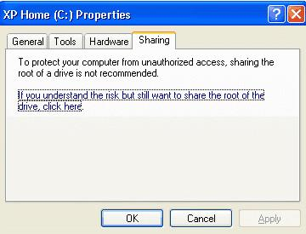

The first time that you set up sharing, Windows XP displays a warning, urging you to use the Network Setup Wizard for safety. Click where indicated to either run the Wizard or to do it yourself.

What great secret does the Wizard know that XP thinks you don't? The Wizard automatically enables the Internet Connection Firewall (ICF) to prevent other Internet users from accessing your shared disks and folders. If you have Service Pack 2 installed, the built-in Windows Firewall should already be running automatically, unless you turned it off.

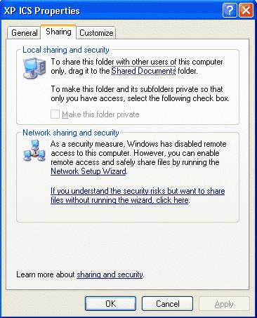

Windows XP displays another warning. If you want the firewall enabled, select Use the wizard to enable file sharing. Otherwise, select Just enable file sharing.

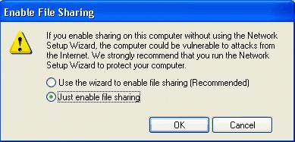

Having successfully run the Wizard's obstacle course, you may now specify a Share name, which users on other networked computers will use to access this disk or folder. For maximum compatibility with all versions of Windows, use 1-12 characters.

By default, users on other computers have full access: they can read, write, and delete shared files. If you only want them to be able to read files, un-check Allow network users to change my files.

Warning: If a user has full access, deleting a file doesn't put it in the Recycle Bin. Once it's deleted, it's gone for good.
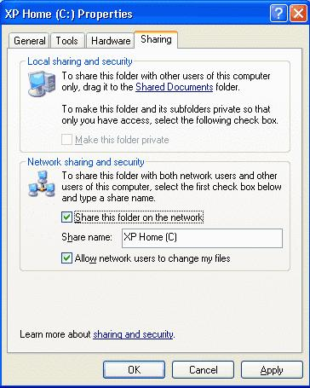

Remote access

Remote Desktop Access:

you can access the desktop of another computer and act as you are on the same computer, using the remote desktop option, this software is installed automatically when installing windows, on client windows operation system ( 98,xp,vista, 7 ), the operating system allow one session to be started on the windows, while on the server OS versions ( server 2000,server 2003, server 2008) you can start ( 2 sessions ,and one console session) concurrently.

Section 1: Setting up the computer you will be connecting to

Before you can connect to a computer using remote desktop, you must make some changes to that

computer’s set-up. You must have a user account with a password on that computer, and you must tell

that computer that it can accept remote connections. You also need to know the IP address of the

computer you will be connecting to.
Step 1: The Control Panel
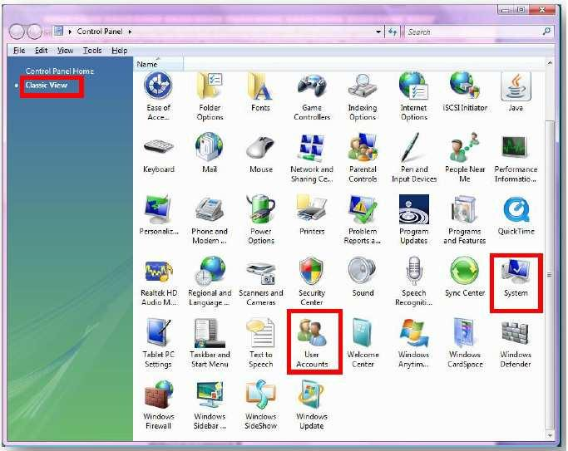

- Open the control panel by going to the start menu and clicking “Control Panel” or click the Computer icon and click “Control Panel”

- Select “Classic View” in the top left hand corner of the control panel

- Select “User Accounts”.

- If you are logged in to the account you will be using to remote in to the machine, select “Create a password for this account”

- If you do not have an account on the machine, select “Manage User Accounts” then “Create an Account”. Follow the prompts to create an account and password.

4. Go back to the control panel and select “System”. Within this screen, you can tell what version of windows you are using. Vista users should select “Advanced System Settings”. If the UAC (User Account Control) asks if you would like to proceed, select yes.

- Select the “remote” tab

- Select the option that allows computers to connect to your computer through remote desktop

- Click “Select Users”. If your user account is not listed, click add and add your user name to the list.

- Press OK until you are back to the control panel and close the control Panel.

Step 2: Command Prompt
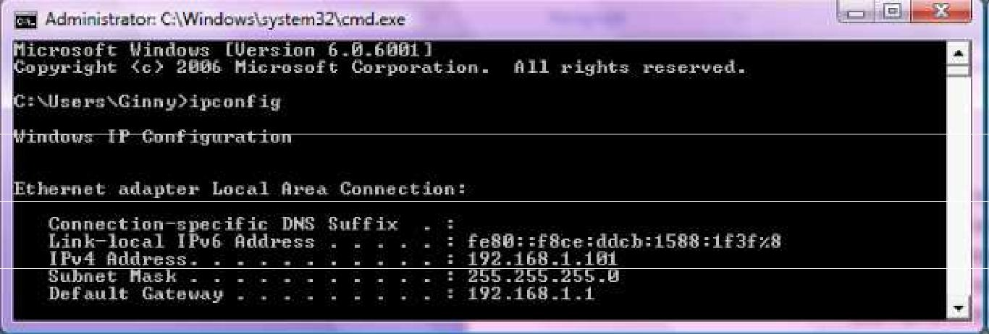

1. Go to the Start Menu, Select Run, Type cmd and press enter

- In the command prompt window, type “ipconfig” (without quotations) and press enter.

- Scroll up until you find the “IPv4 Address”

- Write down the address and close the window.

- Log out of the computer but do not turn it off.

Section 2: Using Remote Desktop:

Step 1: Remote Desktop Application

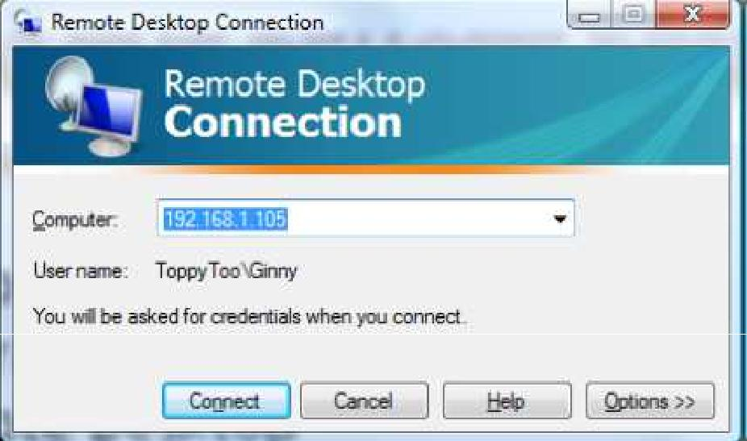

- Go to the Start Menu, Select All Programs, Select Accessories, then Select Remote Desktop Connection

- Type the IP Address that you wrote down earlier into the dialogue box. Press enter.

- You may be asked if you trust the remote connection, select yes or connect.

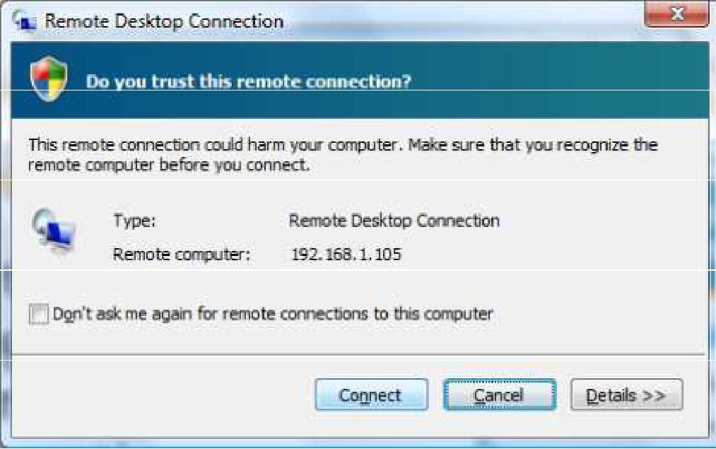

4. Type in the user name and password you set up on the other computer and press enter

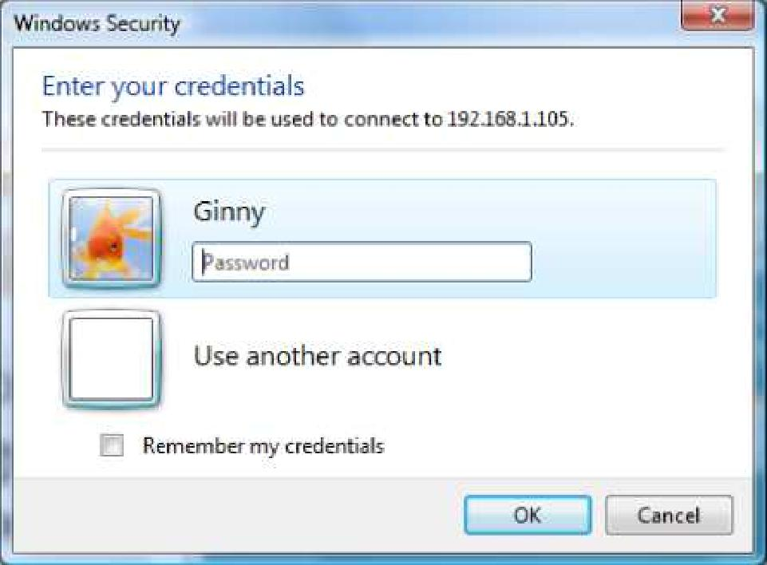

- You should now be logged in to the other computer remotely. You can use this machine just as you would your local desktop.

- To exit, either press the X at the top of the window or go the start menu and select log off.

Section 3: Remote Desktop Additional Options (Advanced):

- Display: Gives the user the option of opening the remote desktop window in full screen mode or on a portion of your desktop. Users can also select color options.

- Local Resources: Allows users to mount local printers, the clipboard, local drives, USB and plug and play devices to the remote computer. This is useful because you can share files between the computers, copy and paste between the computers, and print from the remote computer.

- Programs: Allows a user to open a program upon login to the remote machine.

- Experience: Gives the user different options based on their connection speed. Since remote desktop works over your network connection, the more options you select, the slower remote desktop can potentially be.

- Advanced: Gives options for server authentication and Connect from Anywhere. I do not suggest using these options unless you are a more advanced user.

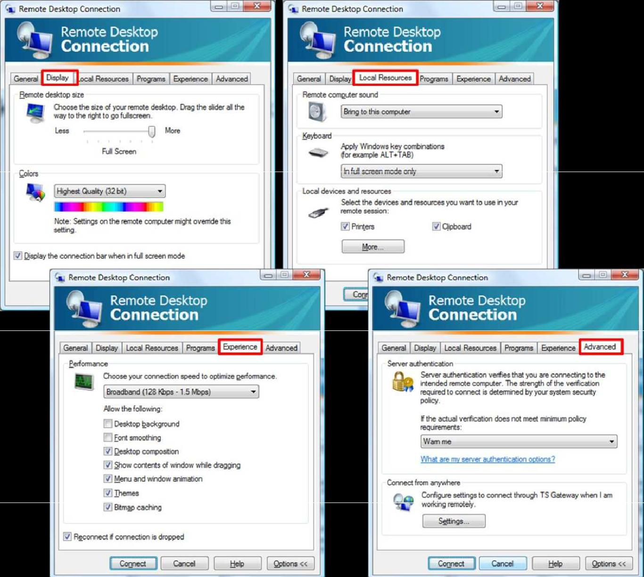

Lab # 7
Address Resolution Protocol (ARP)

Objectives

- Understanding the function of ARP and RARP

- Knows how the ARP works.

- Deals with some ARP utility commands.

Theory Overview:-
Delivery of a packet to a host or a router requires two levels of addressing: logical and physical. We need to be able to map a logical address to its corresponding physical address and vice versa.

ARP is used to find the physical address of the next hop on network. RARP finds the logical address for a machine that only knows its physical address.

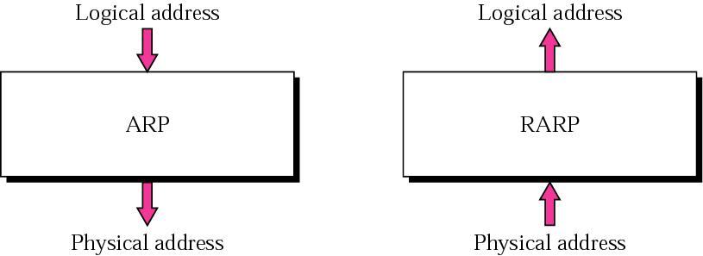

- ARP table

Layer 2 to layer 3 mapping

Database that lists the associated MAC and IP addresses Contains two types of entries:

Dynamic ARP table entries Static ARP table entries

- ARP utility provides a way of obtaining information from and manipulating a device’s ARP table

How does ARP works

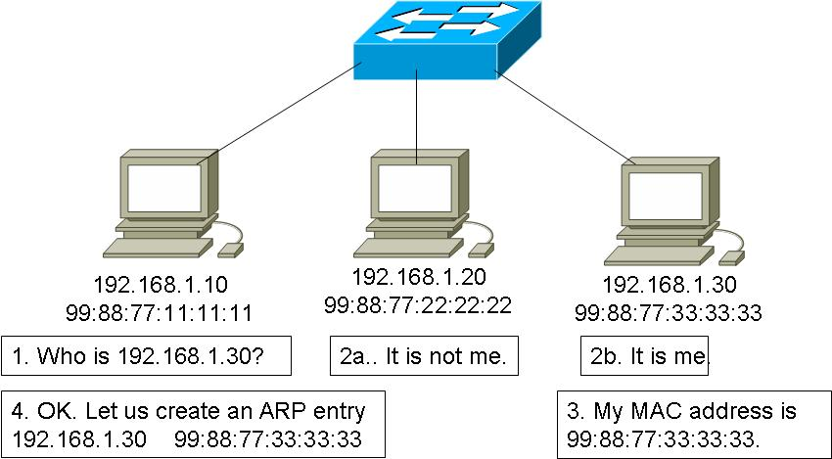

ARP operation

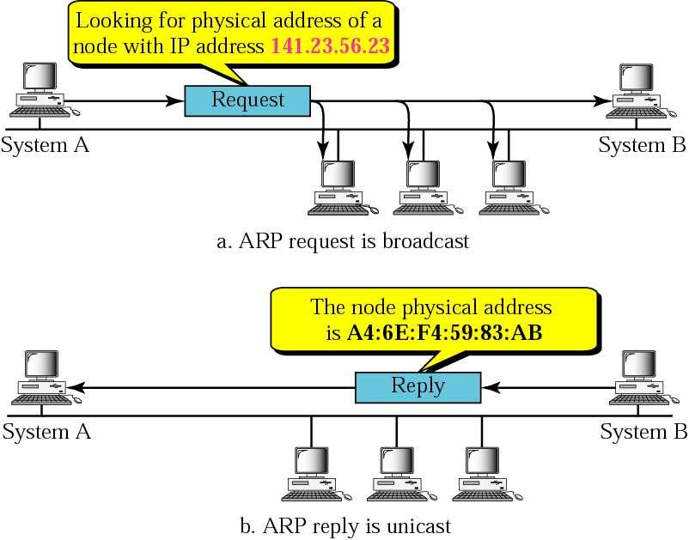

Lab Steps:

Main Steps

ARP Table

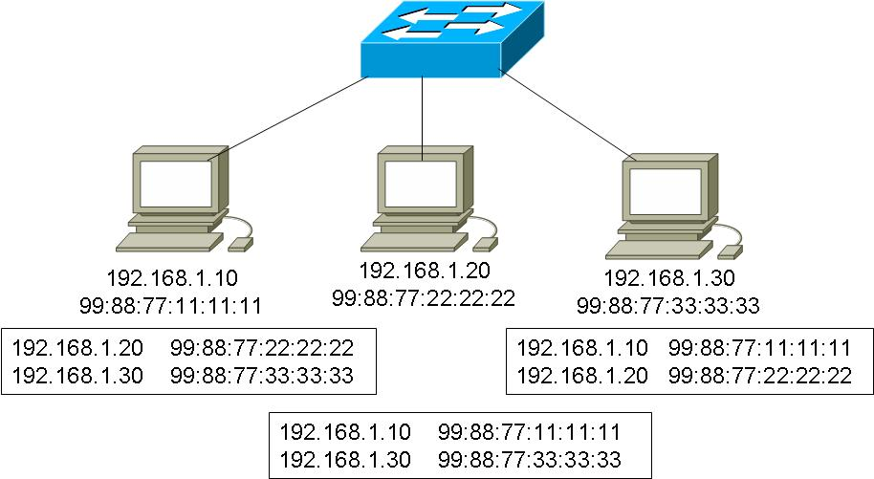

- Try arp –a {Display the entries}

- Try arp -d {Delete all entries]

- Try arp -d 19.100.85.209 {Delete the entry with the specified address}

Conclusion:

Lab Task

- Try arp -s 19.100.85.209 00-aa-bb-62-11-06. What its function?

- When you enter “arp -a”, what is the meaning of the entry 255.255.255.255 ff-ff-ff-ff-ff-ff.

Lab # 8

Wireshark

Objectives:

- Using Wireshark to monitor the LAN.

- Browse and Analyze packets from a live network or from a previously saved capture file.

Theory Overview:-
Wireshark is a free packet sniffer computer application. It is used for network troubleshooting, analysis, software and communications protocol development, and education.

Lab Steps:

Main Steps

Starting Wireshark

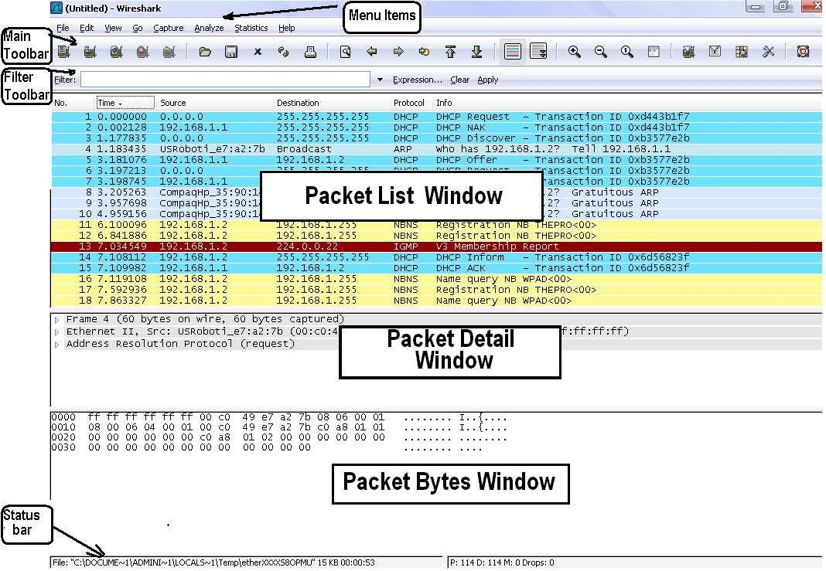

Wireshark is comprised of three main windows, or panes.

The top pane is the packet list pane. It displays a summary of each packet captured.

The middle pane is the packet details pane. It displays the packet selected in the top pane in more detail.

The bottom pane is the packet bytes pane. It displays the data from the packet selected in the top pane, and highlights the field selected in the tree view pane.

In addition to the three main panes, there are four elements of interest on the bottom of the Wireshark main window.

Menu items: a drop down menu of all operations

Main Toolbar: shortcut icons to main operations by Wireshark

Filter Toolbar: for filter construction

The leftmost button labeled "Filter:" can be clicked to bring up the filter construction dialog.

The middle text box provides an area to enter or edit filter strings. This is also where the current filter in effect it displayed.

The right middle button labeled "Clear" clears the current filter.

Status Toolbar: it gives helpful hints about things like

Capturing packets in Wireshark

The Capture Preferences dialog box

Before you start capturing, the capture interface must be specified using capture -> intefaces to

bring up a dialog box similar to the one shown below
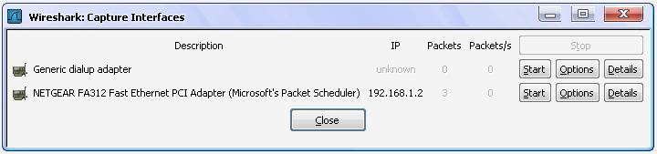

You can select Start to start capturing from a specific interface or you may click on Options for the specified interface to bring a dialog box like the one below. This is the Capture Preferences dialog box:
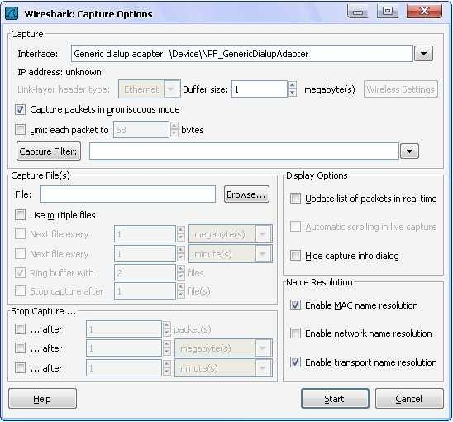

You may arrive immediately at this dialog box from the menu item capture ->options. You can also choose the interface you want to capture on and the filter options plus many other options as shown.

The options are explained as:

Filtering Options:

-Capture packets in promiscuous mode: Usually a network card will only capture the traffic to its own network address. If you want to capture all traffic that the network card can "see”

-Limit each packet to xy bytes: Will limit the maximum size to be captured of each packet, this includes the link-layer header and all subsequent headers. This can be useful when an error is known to be in the first 20 bytes of a packet, for example, as the size of the resulting capture file will be reduced.

-Capture Filter: Use a capture filter to reduce the amount of packets to be captured (will be explained later)

Storing options

-File: You can choose the file to which captured data will be written. If you don't enter something here a temporary file will be used.

-Use multiple files: Instead of using a single capture file, multiple files will be created. The generated filenames will contain an incrementing number and the start time of the capture. For example, if you choose "/foo.cap" in the "File" field, files like "/foo_00001_20040205110102.cap", "/foo_00002_20040205110102.cap”, will be created. This feature can be useful if you do long term capturing, as working with a single capture file of several GB usually isn't very fast.

Stop condition options

These three fields should be obvious; the capture process will be automatically stopped if one of the selected conditions is exceeded.

Display while capturing options

-Update list of packets in real time: Using this will show the captured packets immediately on the main screen.

Don't change the default preferences. Start capturing. Keep capturing for 2-3 minutes during which try to activate the different protocols by invoking different applications (e.g. internet browsing, streaming, email, ASU online, ftp, etc)

While the capture is running, the following dialog box is shown:

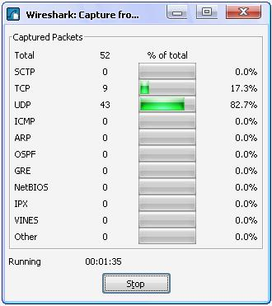

Include a screen shot of the screen obtained similar to the above.
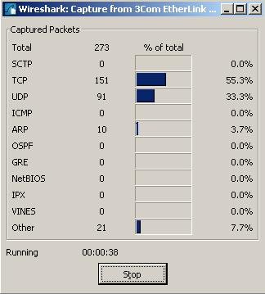

Stop capturing. Try the following:

Repeat capturing while viewing in real time. Include a screen shot of the options.
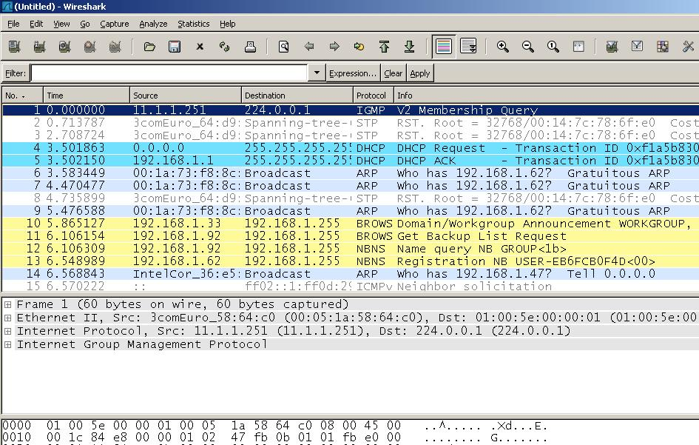

- Capturing 100 Kbytes of data. Include a screen shot of the options.
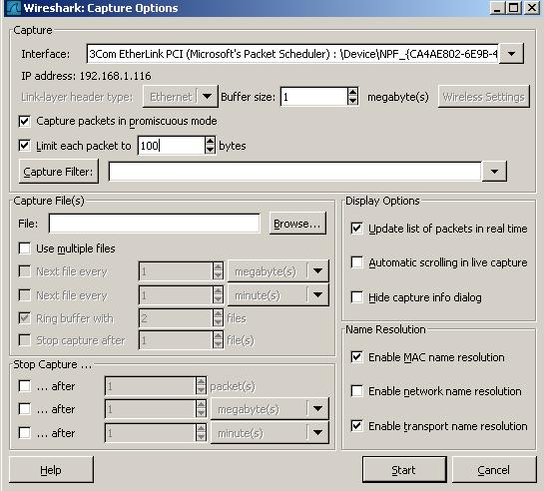

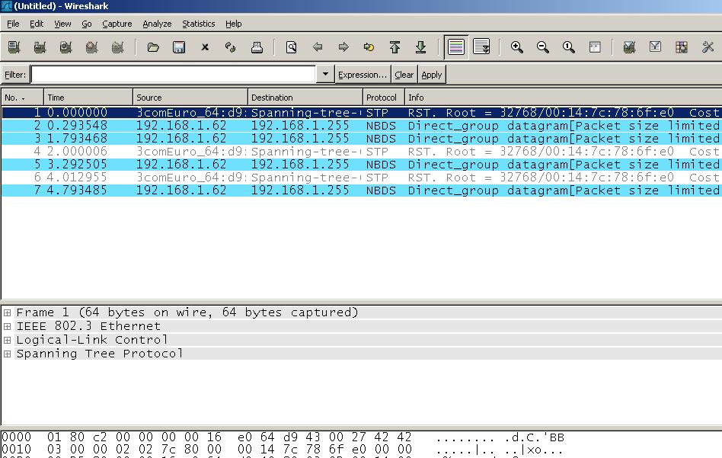

Viewing and saving the captured packets

Once you have captured some packets, or you have opened a previously saved capture file, you can view the packets that are displayed in the packet list pane by simply clicking on that packet in the packet list pane, which will bring up the selected packet in the tree view and byte view panes.

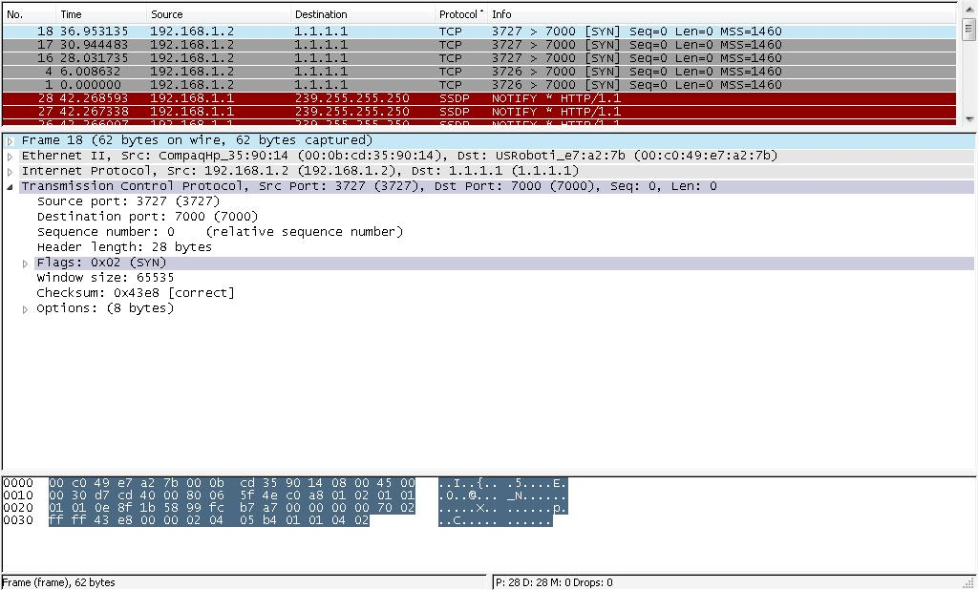

You can save the captured file, try that, close Wireshark and then re-open the captured file. You can open a capture file through the menu "File->Open..." (Or the toolbar).

Please note: the common file extension for capture files is ".cap" (or ".cap.gz" for gzipped ones).

Filtering

Wireshark has two filtering methods: One used when capturing packets, and one used when displaying packets. The first one needs that the filter be specified before capture start while the second one is applied on the previously collected packets

Filtering packets while capturing

Capture Filters are used to filter out uninteresting packets already at capture time. This is done to reduce the size of the resulting capture (file) and is especially useful on high traffic networks or for long term capturing.

Wireshark uses the pcap (libpcap/WinPcap) filter language for capture filters. This language is explained in the tcpdump man page under "expression" (http://www.tcpdump.org and search for "selects which").

Note: This capture filter language is different from the one used for the Wireshark display filters!

Some common examples

(Ethernet example) Capture all traffic to and from the Ethernet address

08:00:08:15:ca:fe

Ans.: ether host 08:00:08:15:ca:fe

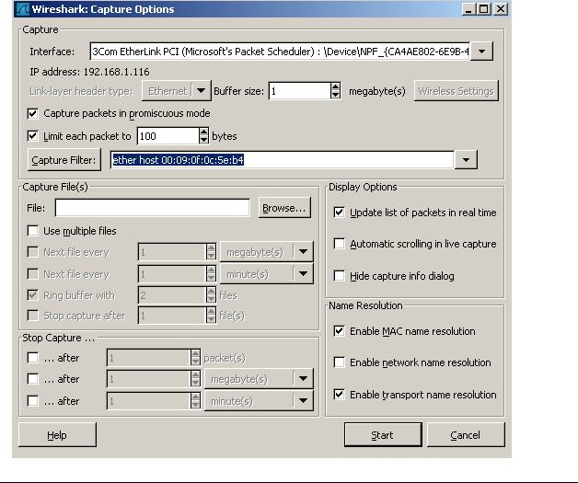

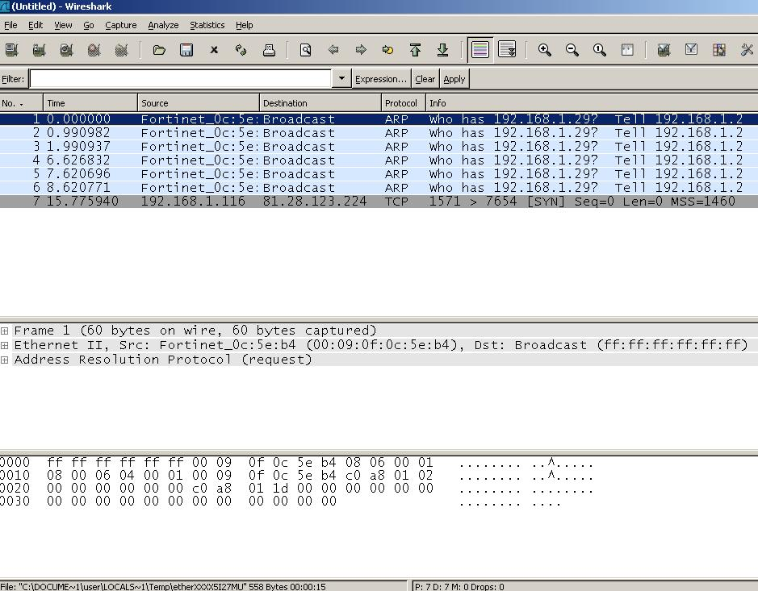

- (Example IP) capture all traffic to and from the IP address 192.168.0.10

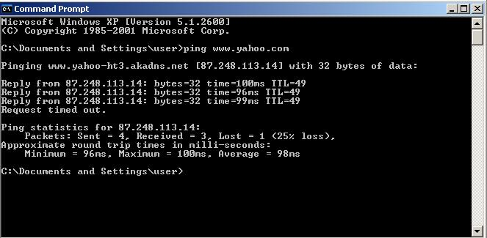

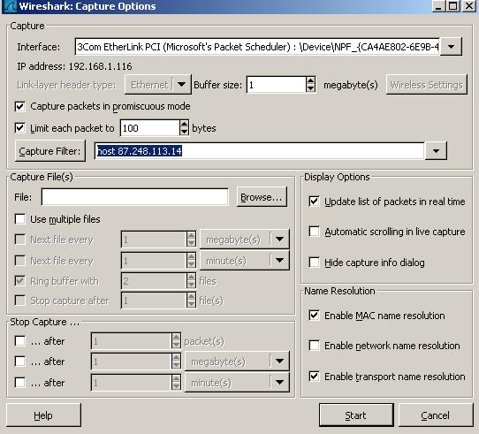

- (Example TCP) capture all traffic to and from the TCP port 80 (http) of all machines

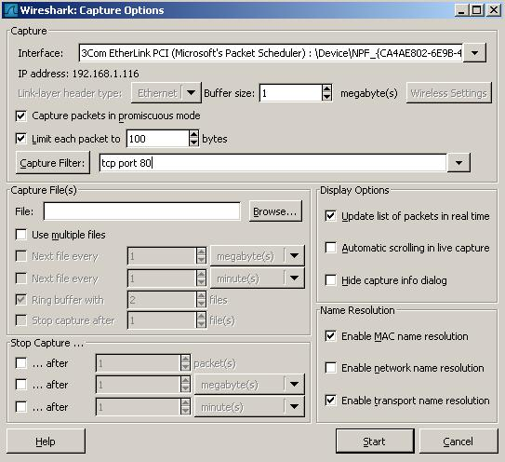

- (Examples combined) capture all traffic to and from 192.168.0.10 except http
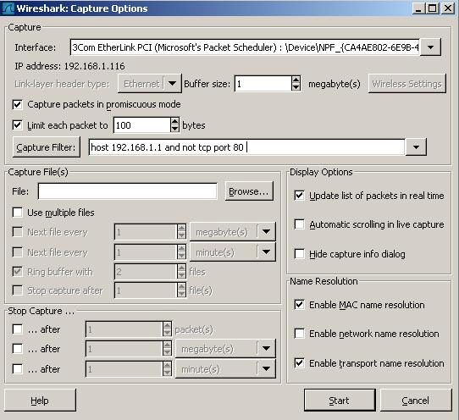

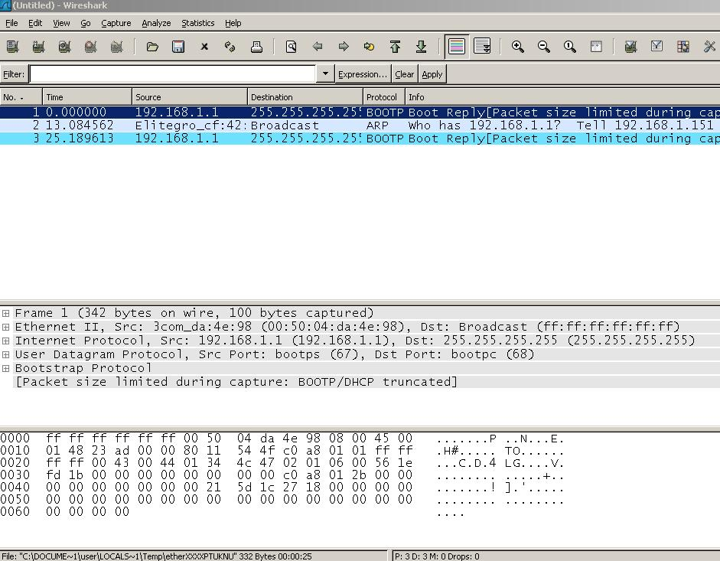

Capture Filter Syntax

The following is a short description of the capture filter language syntax. For a further reference, have a look at: http://www.tcpdump.org/tcpdump_man.html

A capture filter takes the form of a series of primitive expressions, connected by conjunctions (and/or) and optionally preceded by not:

[not] primitive [and|or [not] primitive ...]

A primitive is simply one of the following:

[src|dst] host <host>

ether [src|dst] host <ehost>

gateway host <host>

[src|dst] net <net> [{mask <mask>}|{len <len>}] [tcp|udp] [src|dst] port <port>

less|greater <length> ip|ether proto <protocol> ether|ip broadcast|multicast <expr> relop <expr>

Lab # 9
Introduction to the Cisco IOS

Objectives:

1. Understanding and configuring the Cisco Internetwork Operating System (IOS)
- Connecting to a router

- Bringing up a router

- Logging into a router

- Understanding the router prompts

- Understanding the CLI prompts

- Performing editing and help features

Theory Overview:-
The IOS (Internetwork Operating System) is what runs Cisco routers as well as some Cisco switches, and it’s what allows you to configure the devices as well.

Connecting to a Cisco Router

You can connect to a Cisco router to configure it, verify its configuration, and check statistics. There are different ways to do this, but most often, the first place you would connect to is the console port. The console port is usually an RJ-45 (8-pin modular) connection located at the back of the router—by default, there’s no password set.

You can also connect to a Cisco router through an auxiliary port. This port will lets you dial up a remote router via an attached modem to the auxiliary port if the router is down and you need to configure it “out-of-band” (meaning “out-of-the-net work”). “In-band” means the opposite— configuring the router through the network.

The third way to connect to a Cisco router is in-band, through the program Telnet. Telnet is a terminal emulation program that acts as though it’s a dumb terminal. You can use Telnet to connect to any active interface on a router, such as an Ethernet or serial port.

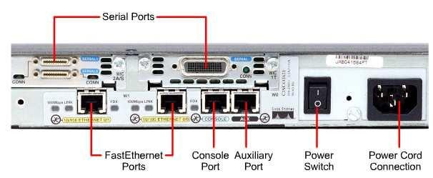

External Connections on a 2600 Router

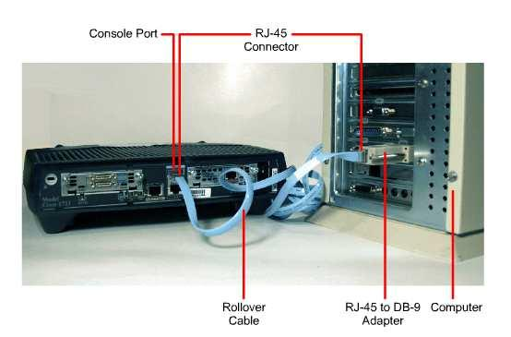

Computer or Terminal Console Connection

Bringing Up a Router

When you first bring up a Cisco router, it will run a power-on self-test (POST). If it passes, it will then look for and load the Cisco IOS from flash memory—if an IOS file is present.

The flash memory is an electronically erasable programmable read-only memory ( EEPROM.). After that, the IOS loads and looks for a valid configuration (the startup-config) that’s stored by default in nonvolatile RAM, or NVRAM.

After the IOS is decompressed into RAM, the IOS is then loaded and starts running the

router, as shown below (notice that the IOS version is stated as version 12.2[13]):

Cisco Internetwork Operating System Software

IOS (tm) C2600 Software (C2600-I-M), Version 12.2(13),

RELEASE SOFTWARE (fc1)

Copyright (c) 1986-2001 by cisco Systems, Inc.

Compiled Tue 17-Dec-03 04:55 by kellythw

Image text-base: 0x80008088, data-base: 0x8080853C

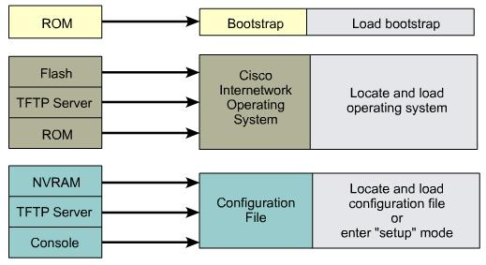

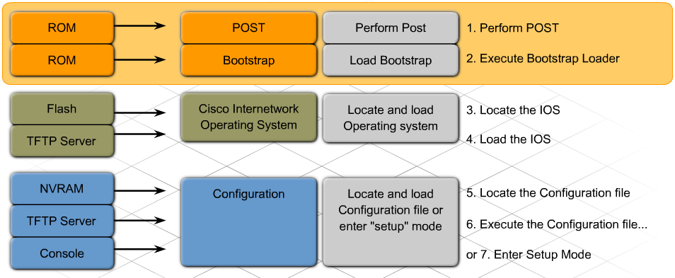

Steps in Router Initialization

Once the IOS is loaded, and up and running, a valid configuration will be loaded from

NVRAM. If there isn’t a configuration in NVRAM, the router will go into setup mode

(a step-by-step process to help you configure the router). You can also enter setup mode at any time from the command line by typing the command setup from something called privileged mode, which I’ll get to in a minute. Setup mode only covers some global commands, but it can be really helpful if you don’t know how to configure certain protocols, such as bridging or DECnet.

Lab Steps:

Main Steps

Connect your router with your PC via the console cable. Then use the terminal emulation software (Hyper Terminal) to start logging to your router.

- Connect a rollover cable to the router console port (RJ-45 connector).

- Connect the other end of the rollover cable to the RJ-45 to DB-9 adapter

- Attach the female DB-9 adapter to a PC.

Connecting Console Interfaces

1. Configure terminal emulation software on the PC for the following: The appropriate com port

9600 baud

8 data bits

1 stop bit No parity

No flow control

Logging into the Router

After the interface status messages appear and you press Enter, the (Router>) prompt will appear. This is called user exec mode (user mode) and it’s mostly used to view statistics, but it’s also a stepping-stone to logging into privileged mode (Router#). You can only view and change the configuration of a Cisco router in privileged exec mode (privileged mode), which you get into with the enable command.

Router>

Router>enable

Router#

Router#disable

Router>

At this point, you can type logout to exit the console:

Router>logout

Router con0 is now available

Press RETURN to get started.

Verifying the Current Configuration

To verify the configuration in RAM, use the show running-config command (sh run for short) like this:

Router#sh run

Question: What is the version of your Router IOS?

Verifying the Stored Configuration

You should check the configuration stored in NVRAM. To see this, use the show startup-config command (sh start for short) like this:

Router#sh start

Question: What is your Router NVRAM size?

Copying the Current Configuration to NVRAM

By copying running-config to NVRAM as a backup, as shown in the following output, you're assured that your running-config will always be reloaded if the router gets rebooted.

Router#copy run start

Destination filename [startup-config]?[Enter]

Warning: Attempting to overwrite an NVRAM configuration

previously written by a different version of the system

image.

Overwrite the previous NVRAM configuration?

[confirm][Enter]

Building configuration...

[OK]

Copying the Configuration to a TFTP Server

Once the file is copied to NVRAM, you can make a second backup to a TFTP server by using the copy running-config tftp command (copy run tftp for short), like this:

Router#copy run tftp

Address or name of remote host []?192.168.0.120

Destination filename [router-confg]?todd1-confg

!!

487 bytes copied in 12.236 secs (40 bytes/sec)

Erasing the Configuration

To delete the startup-config file on a Cisco router, use the command erase startup-config, like this:

Router#erase startup-config

Erasing the nvram filesystem will remove all files!

Continue? [confirm][Enter]

[OK]

Some useful keys:

Backspace……. Deletes a single character.

Ctrl+U…………. Erase a line.

Ctrl+Z………….. Ends configuration mode and returns to EXEC

Tab……………… Finishes typing a command for you.

Up Arrow ……….. returns your last typed commands.

Lab Task:

Lab # 10
Cisco Routers- Basic Configurations

Objectives:

- Gathering basic routing information

- Setting administrative functions

- Setting hostnames

- Setting banners

- Setting passwords

- Setting interface descriptions

Theory Overview:-
It's now time to introduce you to the Cisco Internetwork Operating System (IOS). The IOS is what runs Cisco routers as well as some Cisco switches, and it's what allows you to configure the devices as well. In this lab, you'll learn how to configure a Cisco IOS router using the IOS command-line interface (CLI).

Lab Steps:

Main Steps

Router Administrative Functions

Even though this section isn't critical to making a router or switch work on a network, it's still really important; in it, I'm going to lead you through configuring commands that will help you administrate your network.

The administrative functions that you can configure on a router are:

- Hostnames
- Banners

- Password

- Interface descriptions

Hostnames

This administrative function is used to name or rename the cisco router. Here's an example:

Router#configure terminal

Enter configuration commands, one per line. End with CNTL/Z.

Router(config)#hostname Mohammad

Mohammad(config)#hostname Hijjawi

Hijjawi(config)#

Banners

A banner to give anyone who shows up on the router exactly the information you want them to have.

Message of the day (MOTD) is the most extensively used banner. It gives a message to every person dialing into or connecting to the router via Telnet or auxiliary port, or even through a console port as seen here:

Router(config)#banner motd #

Enter TEXT message. End with the character '#'.

This network is for SALES department.

#

Router(config)#^Z

Router#

Setting Passwords

There are five passwords used to secure your Cisco routers: console, auxiliary, telnet (VTY), enable password, and enable secret.

Let's take a look at each of these now.

Enable Passwords

You set the enable passwords from global configuration mode like this:

Router(config)#enable password todd

This method by default will keep your password unencrypted. However, you can make it encrypted as you will see later. But you can use another method to assign an encrypted password with one command as the following:

Router(config)#enable secret todd

Auxiliary Password

To configure the auxiliary password, go into global configuration mode and type line aux ?. You can see here that you only get a choice of 0-0 (that's because there's only one port):

Router#config t

Enter configuration commands, one per line. End with CNTL/Z.

Router(config)#line aux ?

<0-0> First Line number

Router(config)#line aux 0

Router(config-line)#login

Router(config-line)#password todd

Console Password

To set the console password, use the line console 0 command.

Here's the example:

Router(config)#line console ?

<0-0> First Line number

Router(config)#line console 0

Router(config-line)# password todd1

Router(config-line)# login

Telnet Password

Telnet, part of the TCP/IP protocol suite, is a virtual terminal protocol that allows you to make connections to remote devices, gather information, and run programs.

After your routers and switches are configured, you can use the Telnet program to reconfigure and/or check up on your routers and switches without using a console cable. You run the Telnet program by typing telnet from any command prompt (DOS or Cisco). You need to have VTY passwords set on the routers for this to work.

You can issue the telnet command from any router prompt like this:

Todd2509#telnet 172.16.10.2

Trying 172.16.10.2 ... Open

Password required, but none set

[Connection to 172.16.10.2 closed by foreign host] Todd2509#
To set the user-mode password for Telnet access into the router, use the line vty command. Routers that aren't running the Enterprise edition of the Cisco IOS default to five VTY lines, 0 through 4.

Router(config-line)#line vty 0 4

Router(config-line)# password todd2

Router(config-line)# login

So what will happen if you try to telnet into a router that doesn't have a VTY password set? You'll receive an error stating that the connection is refused because, well, the password isn't set. So, if you telnet into a router and receive this message:

Router#telnet SFRouter

Trying SFRouter (10.0.0.1)...Open

Password required, but none set

[Connection to SFRouter closed by foreign host]

Router#

then the remote router (SFRouter in this example) does not have the VTY (telnet) password set. But you can get around this and tell the router to allow Telnet connections without a password by using the no login command:

Router(config-line)#line vty 0 4

Router(config-line)#no login

Encrypting Your Passwords

Because only the enable secret password is encrypted by default, you'll need to manually configure the user-mode and enable passwords for encryption.

Notice that you can see all the passwords except the enable secret when performing a show unning-config on a router. TRY IT

To manually encrypt your passwords, use the service password-encryption command. Here's an example of how to do it:

Router#config t

Enter configuration commands, one per line.End with CNTL/Z.

Router(config)#service password-encryption

Router(config)#^Z

Router#sh run

Router#config t

If you want to remove the encryption, use the following command:

Router(config)#no service password-encryption

Router(config)#^Z

Router Interfaces

Interface configuration is one of the most important router configurations, because without interfaces, a router is pretty much a completely useless object. Plus, interface configurations must be totally precise to enable communication with other devices. Some of the configurations used to configure an interface are Network layer addresses, media type, bandwidth, and other administrator commands.

A cisco router has two types of communication interfaces; Ethernet or fastethernet (depending on the router specifications) to communicate with a LAN and serial interface to communicate with WAN or with other router.

Now it's time to choose the interface you want to configure. Once you do that, you will be in interface configuration for that specific interface.

If the router has one Ethernet 10BaseT port, and typing interface ethernet 0 can configure that interface, as seen here:

Router(config)#int ethernet ?

<0-0> Ethernet interface number

Router(config)#int ethernet 0

Router(config-if)#

on a 2600 cisco router series, the configuration would be interface type slot/port, as seen here:

Router(config)#int fastethernet ?

<0-1> FastEthernet interface number

Router(config)#int fastethernet 0

% Incomplete command.

Router(config)#int fastethernet 0?

Router(config)#int fastethernet 0/?

I'm going to continue with our router interface discussion in the next sections, and I'll include how to bring up the interface and set an IP address on a router interface.

Bringing up an Interface

You can turn an interface off with the interface command shutdown, and turn it on with the no shutdown command.

If an interface is shut down, it'll display administratively down when using the show interfaces (sh int for short) command:

Router#sh int fasteathernet 0/0

fasteathernet 0/0 is administratively down, line protocol is down

[output cut]

Another way to check an interface's status is via the show running-config command. All interfaces are shut down by default.

You can bring up the interface with the no shutdown command (no shut for short):

Router#config t

Enter configuration commands, one per line. End with

CNTL/Z.

Router(config)#int Fa 0/0

Router(config-if)#no shutdown

Router(config-if)#^Z

00:57:08: %LINK-3-UPDOWN: Interface Ethernet0, changed state to up

00:57:09: %LINEPROTO-5-UPDOWN: Line protocol on Interface Ethernet0, changed state to up

Router#sh int fa 0/0

Ethernet0 is up, line protocol is up

[output cut]

Configuring an IP Address on an Interface

Even though you don't have to use IP on your routers, it's most often what people actually do use. To configure IP addresses on an interface, use the ip address command from interface configuration mode:

Router(config)#int e0

Router(config-if)#ip address 172.16.10.2 255.255.255.0

Router(config-if)#no shut

Serial Interface Commands

Before you jump in and configure a serial interface, there are a couple of things you need to know. First, the interface will usually be attached to a CSU/DSU type of device that provides clocking for the line to the router. But if you have a back-to-back configuration (for example, one that's used in a lab environment), one end—the data communication equipment (DCE) end of the cable—must provide clocking. By default, Cisco routers are all data terminal equipment (DTE) devices, so you must tell an interface to provide clocking if you need it to act like a DCE device.

You configure a DCE serial interface with the clock rate command:

Router#config t

Enter configuration commands, one per line. End with CNTL/Z.

Router(config)#int s0

Router(config-if)#clock rate ?

Speed (bits per second)

1200

2400

4800

9600

19200

38400

56000

64000

72000

125000

148000

250000

500000

800000

1000000

1300000

2000000

4000000

<300-4000000> Choose clockrate from list above

Router(config-if)#clock rate 64000

%Error: This command applies only to DCE interfaces

Router(config-if)#int serial 0/0

Router(config-if)#clock rate 64000

Verifying with the SHOW INTERFACE Command

Another way to verify your configuration is by typing show interface commands, the first of which is show interface ?. That will reveal all the available interfaces to configure. The following output is from
my 2600 routers:

Router#sh int ?
Async | Async interface
BVI | Bridge-Group Virtual Interface
CTunnel | CTunnel interface
Dialer | Dialer interface
FastEthernet | FastEthernet IEEE 802.3
Loopback | Loopback interface
MFR | Multilink Frame Relay bundle interface
Multilink | Multilink-group interface
Null | Null interface
Serial | Serial
Tunnel | Tunnel interface
Vif PGM | Multicast Host interface
Virtual-Template |  | Virtual Template interface
Virtual-TokenRing |  | Virtual TokenRing
accounting | Show interface accounting
crb | Show interface routing/bridging info
dampening | Show interface dampening info
description | Show interface description
irb | Show interface routing/bridging info
mac-accounting |  | Show interface MAC accounting info
mpls-exp | Show interface MPLS experimental accounting info

precedence Show interface precedence accounting info

rate-limit Show interface rate-limit info

summary Show interface summary

switching Show interface switching

- Output modifiers

<cr>

The only "real" physical interfaces are FastEthernet, Serial, and async; the rest are all logical

interfaces. In addition, the newer IOS shows the "possible" show commands that can be used to verify your router interfaces.

The next command is show interface fastethernet 0/0. It reveals to us the hardware address, logical address, and encapsulation method, as well as statistics on collisions, as seen here:

Router#sh int fastethernet 0/0

FastEthernet0/0 is up, line protocol is up

Hardware is AmdFE, address is 00b0.6483.2320 (bia 00b0.6483.2320)

Description: connection to LAN 40

Internet address is 192.168.1.33/27

MTU 1500 bytes, BW 100000 Kbit, DLY 100 usec, reliability 255/255, txload 1/255, rxload 1/255

Encapsulation ARPA, loopback not set

Keepalive set (10 sec)

Full-duplex, 100Mb/s, 100BaseTX/FX

ARP type: ARPA, ARP Timeout 04:00:00

Last input never, output 00:00:04, output hang never

Last clearing of "show interface" counters never

Input queue: 0/75/0/0 (size/max/drops/flushes); Total output drops: 0

Queueing strategy: fifo

Output queue: 0/40 (size/max)

5 minute input rate 0 bits/sec, 0 packets/sec

5 minute output rate 0 bits/sec, 0 packets/sec

0 packets input, 0 bytes

Received 0 broadcasts, 0 runts, 0 giants, 0 throttles 0 input errors, 0 CRC, 0 frame, 0 overrun, 0 ignored 0 watchdog

0 input packets with dribble condition detected

84639 packets output, 8551135 bytes, 0 underruns

0 output errors, 0 collisions, 16 interface resets

0 babbles, 0 late collision, 0 deferred

0 lost carrier, 0 no carrier

0 output buffer failures, 0 output buffers swapped out

The most important statistic of the show interface command is the output of the line and data-link protocol status.

If the output reveals that FastEthernet 0/0 is up and the line protocol is up, then the interface is up and running:

Router#sh int fa0/0

FastEthernet0/0 is up, line protocol is up

The first parameter refers to the Physical layer, and it's up when it receives carrier detect. The second parameter refers to the Data Link layer, and it looks for keepalives from the connecting end. (Keepalives are used between devices to make sure connectivity has not dropped.)

Here's an example:

Router#sh int s0/0

Serial0/0 is up, line protocol is down

If you see that the line is up but the protocol is down, as shown above, you're experiencing a clocking (keepalive) or framing problem. Check the keepalives on both ends to make sure that they match, that the clock rate is set, if needed, and that the encapsulation type is the same on both ends. The output above would be considered a Data Link layer problem.

Router#sh int s0/0

Serial0/0 is down, line protocol is down

If you discover that both the line interface and the protocol are down, it's a cable or interface problem. The output above would be considered a Physical layer problem.

If one end is administratively shut down (as shown next), the remote end would present as down and down:

Router#sh int s0/0

Serial0/0 is administratively down, line protocol is down

To enable the interface, use the command no shutdown from interface configuration mode.
Verifying Your Configuration

Obviously, show running-config would be the best way to verify your configuration, and show startup-config would be the best way to verify the configuration that'll be used the next time the router is
reloaded—right?

Router#ping ?
WORD |  | Ping destination address or hostname
appletalk Appletalk echo
decnet |  | DECnet echo
ip | IP echo
ipx |  | Novell/IPX echo
srb |  | srb echo

<cr>

Traceroute uses ICMP with IP time to live (TTL) timeouts to track the path a packet takes through an internetwork, in contrast to Ping, which just finds the host and responds. And Traceroute can also be

used with multiple protocols.

Router#traceroute ?

WORD |  | Trace route to destination address or hostname
appletalk AppleTalk Trace
clns | ISO CLNS Trace
ip | IPTrace
oldvines |  | Vines Trace (Cisco)
vines |  | Vines Trace (Banyan)
<cr>

Telnet is the really the best tool, since it uses IP at the Network layer and TCP at the Transport layer to create a session with a remote host. If you can telnet into a device, your IP connectivity just has to be good. You can only telnet to devices that use IP addresses, and you can use Windows hosts or router prompts to telnet to a remote device:

Router#telnet ?

WORD IP address or hostname of a remote system

<cr>

From the router prompt, you just type a hostname or IP address and it will assume you want to telnet—you don't need to type the actual command, telnet.

In the following sections, I am going to show you how to verify the interface statistics.

Lab Task:

Lab # 11

IP Routing

Objectives:

In this lab, you'll learn how to configure and verify IP routing with Cisco routers. It will be covering the following:

- Static routing.

- Default routing.

- Dynamic routing.

Theory Overview:-
IP routing is the process of moving packets from one network to another network using routers. But, you must first understand the difference between a routing protocol and a routed protocol. A routing protocol is used by routers to dynamically find all the networks in the internetwork and to ensure that all routers have the same routing table. Basically, a routing protocol determines the path of a packet through an internetwork. Examples of routing protocols are RIP, IGRP, EIGRP, and OSPF. Once all routers know about all networks, a routed protocol can be used to send user data (packets) through the established internetwork. Routed protocols are assigned to an interface and determine the method of packet delivery. Examples of routed protocols are IP and IPX.

Lab Steps:

Main Steps

Routing Basics

Once you create an internetwork by connecting your WANs and LANs to a router, you'll need to configure logical network addresses, such as IP addresses, to all hosts on the internetwork so that they can communicate across that internetwork.

The term routing is used for taking a packet from one device and sending it through the network to another device on a different network. Routers don't really care about hosts—they only care about networks and the best path to each network. The logical network address of the destination host is used to get packets to a network through a routed network, then the hardware address of the host is used to deliver the packet from a router to the correct destination host.

If your network has no routers, then it should be apparent that you are not routing. Routers route traffic to all the networks in your internetwork. To be able to route packets, a router must know, at a minimum, the following:

- Destination address

- Neighbor routers from which it can learn about remote networks

- Possible routes to all remote networks

- The best route to each remote network

- How to maintain and verify routing information

The router learns about remote networks from neighbor routers or from an administrator. The router then builds a routing table that describes how to find the remote networks. If a network is directly connected, then the router already knows how to get to it. If a network isn't connected, the router must learn how to get to the remote network in two ways: by using static routing, meaning that someone must hand-type all network locations into the routing table, or through something called dynamic routing.

In dynamic routing, a protocol on one router communicates with the same protocol running on neighbor routers. The routers then update each other about all the networks they know about and place this information into the routing table. If a change occurs in the network, the dynamic routing protocols automatically inform all routers about the event. If static routing is used, the administrator is responsible for updating all changes by hand into all routers. Typically, in a large network, a combination of both dynamic and static routing is used.

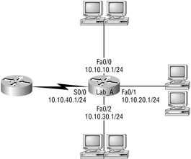Before we jump into the IP routing process, let's take a look at a simple example that demonstrates how a router uses the routing table to route packets out of an interface. We'll be going into a more detailed study of the process in the next section. Figure 1 shows a simple two-router network. Lab_A has one serial interface and three LAN interfaces.

Figure 1: A simple routing example

Looking at Figure 1, can you see which interface Lab_A will use to forward an IP datagram to a host with an IP address of 10.10.10.10?

Here's the output of the routing table that Lab_A uses to make forwarding decisions:

Lab_A#sh ip route

[output cut]

Gateway of last resort is not set

C 10.10.10.0/24 is directly connected, FastEthernet0/0

C 10.10.20.0/24 is directly connected, FastEthernet0/1

C 10.10.30.0/24 is directly connected, FastEthernet0/2

C 10.10.40.0/24 is directly connected, Serial 0/0

The C in the routing table output means that the networks listed are "directly connected," and until we add a routing protocol—something like RIP, IGRP, etc.—to the routers in our internetwork, we'll only have directly connected networks in our routing table.

So let's get back to the original question: By looking at the figure and the output of the routing table, what will IP do with a received packet that has a destination IP address of 10.10.10.10? The router will packet-switch the packet to interface FastEthernet 0/0, and this interface will frame the packet and then send it out on the network segment.

IP Routing in a Larger Network

In the example I gave you in the previous section, the router already has both IP networks in its routing table because the networks are directly connected to it. But what if we add another router? Figure 2 shows three routers: Lab_A, Lab_B, and Lab_C. Remember—by default, these routers only know about networks that are directly connected to them.
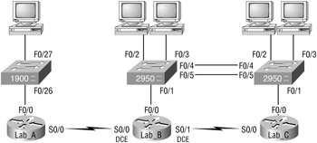

Figure 2: IP routing example with more routers

Figure 2 shows the three 2600 routers connected via a WAN. Each router also has an Ethernet network connected. The idea is that each router must know about all five networks.

The first step is to configure each router correctly. Table 1 shows the IP address scheme I'm going to use to configure the network. After we go over how the network is configured, I'll cover how to configure IP routing. Each network in the following table has a default Class C 24-bit subnet mask (255.255.255.0).

Router |  | Network Address |  | Interface |  | Address
Lab_A |  | 192.168.10.0 |  | fa0/0 |  | 192.168.10.1
Lab_A |  | 192.168.20.0 |  | s0/0 |  | 192.168.20.1
Lab_B |  | 192.168.20.0 |  | s0/0 |  | 192.168.20.2
Lab_B |  | 192.168.40.0 |  | s0/1 |  | 192.168.40.1
Lab_B |  | 192.168.30.0 |  | fa0/0 |  | 192.168.30.1
Lab_C |  | 192.168.40.0 |  | s0/0 |  | 192.168.40.2
Lab_C |  | 192.168.50.0 |  | fa0/0 |  | 192.168.50.1

Table 1: Network Addressing for the IP Network

Router configuration is really a pretty straightforward process, since you just need to add IP addresses to your interfaces and then perform a no shutdown on those interfaces. It will get a tad more complex later on, but first let's configure the IP addresses in the network.

Lab_A Configuration

To configure the Lab_A router, you just need to add an IP address to interface FastEthernet 0/0 as well as the serial 0/0. Configuring the hostnames of each router will make identification easier. And why not set the interface descriptions, banner, and router passwords, too? You really should get in the habit of configuring these commands on every router.

Here is how I did all that:

Router>en

Router#config t

Router(config)#hostname Lab_A

Lab_A(config)#enable secret todd

Lab_A(config)#interface fa0/0

Lab_A(config-if)#ip address 192.168.10.1 255.255.255.0

Lab_A(config-if)#description Lab_A LAN Connection

Lab_A(config-if)#no shut

Lab_A(config-if)#interface serial 0/0

Lab_A(config-if)#ip address 192.168.20.1 255.255.255.0

Lab_A(config-if)#description WAN Connection to Lab_B

Lab_A(config-if)#no shut
Lab_A(config-if)#exit

Lab_A(config)#line console 0

Lab_A(config-line)#password todd

Lab_A(config-line)#login

Lab_A(config-line)#line aux 0

Lab_A(config-line)#password todd

Lab_A(config-line)#login

Lab_A(config-line)#line vty 0 4

Lab_A(config-line)#password todd

Lab_A(config-line)#login

Lab_A(config-line)#exit

Lab_A(config)#banner motd #

This is the Lab_A router

#

Lab_A(config)#^z

Lab_A#copy running-config startup-config

Destination filename [startup-config]? [Enter]

Lab_A#

To view the IP routing tables created on a Cisco router, use the command show ip route. The command output is shown as follows:

Lab_A#sh ip route

Codes: C - connected, S - static, I - IGRP, R - RIP,

M - mobile, B - BGP D - EIGRP, EX - EIGRP external, O - OSPF, IA - OSPF inter area N1 - OSPF NSS external type 1, N2 - OSPF NSSA external type 2 E1 - OSPF external type 1, E2 - OSPF external type 2, E - EGP i - IS-IS,

L1 - IS-IS level-1, L2 - IS-IS level-2, * - candidate default, U - per-user static route, o - ODR, P - periodic downloaded static route, T - traffic engineered route

Gateway of last resort is not set

C 192.168.10.0/24 is directly connected, FastEthernet0/0

C 192.168.20.0/24 is directly connected, Serial 0/0

Lab_A#

Notice that only the configured, directly connected networks are shown in the routing table. This means that the router only knows how to get to networks 192.168.10.0 and 192.168.20.0.

Did you notice the C? When you see it there, it means that the network is directly connected. The codes for each type of connection are listed at the top of the show ip route command with their abbreviations.

Configuring IP Routing in Our Network

Okay, our network is good to go—right? After all, it's been correctly configured with IP addressing! But how does a router send packets to remote networks when it can only send packets by looking at the routing table to find out how to get to the remote networks? Our configured routers only have information about directly connected networks in each routing table.

There are several ways to configure the routing tables to include all the networks in our little internetwork so that packets will be forwarded. Understanding the different types of routing will really help you come up with the best solution for your specific environment and business requirements.

The different types of routing you'll learn about in this section are:

- Static routing

- Default routing

- Dynamic routing

I'm going to start off by describing and implementing static routing on our network because if you can implement static routing and make it work, it means you have a solid understanding of the internetwork. So let's get started.

Static Routing

Static routing occurs when you manually add routes in each router's routing table. Static routing has the following benefits:

- There is no overhead on the router CPU, which means you could possibly buy a cheaper router than if you were using dynamic routing.

- There is no bandwidth usage between routers, which means you could possibly save money on WAN links.

- It adds security, because the administrator can choose to allow routing access to certain networks only.

Static routing has the following disadvantages:

- The administrator must really understand the internetwork and how each router is connected in order to configure routes correctly.

- If a network is added to the internetwork, the administrator has to add a route to it on all routers— by hand.

- It's not feasible in large networks because maintaining it would be a full-time job in itself.

Okay—that said, here's the command syntax you use to add a static route to a routing table:

ip route [destination_network] [mask] [next-hop_address or exitinterface] destination_network The network you're placing in the routing table.
mask The subnet mask being used on the network.

next-hop_address The address of the next-hop router that will receive the packet and forward it to the remote network.

Lab_A

Each routing table automatically includes directly connected networks. To be able to route to all networks in the internetwork, the routing table must include information that describes where these other networks are located and how to get there.

The Lab_A router is connected to networks 192.168.10.0 and 192.168.20.0. For the Lab_ A router to be able to route to all networks, the following networks have to be configured in its routing table:

192.168.30.0

192.168.40.0

192.168.50.0

The following router output shows the configuration of static routes on the Lab_A router and the routing table after the configuration.

Lab_A(config)#ip route 192.168.30.0 255.255.255.0

192.168.20.2

Lab_A(config)#ip route 192.168.40.0 255.255.255.0

192.168.20.2

Lab_A(config)#ip route 192.168.50.0 255.255.255.0

192.168.20.2

After the router is configured, you can type show running-config and show ip route to see the

static routes:

Lab_A#sh ip route

[output cut]

S 192.168.50.0 [1/0] via 192.168.20.2

S 192.168.40.0 [1/0] via 192.168.20.2

S 192.168.30.0 [1/0] via 192.168.20.2

- 192.168.20.0 is directly connected, Serial 0/0

- 192.168.10.0 is directly connected, FastEthernet0/0

Default Routing

We use default routing to send packets with a remote destination network not in the routing table to the next-hop router. You can only use default routing on stub networks—those with only one exit path out of the network.

In the internetworking example used in the previous section, the only routers that are considered to be in a stub network are Lab_A and Lab_C. If you tried to put a default route on router Lab_B, packets wouldn't be forwarded to the correct networks because they have more than one interface routing to other routers. And even though router Lab_C has two connections, it doesn't have another router on the 192.168.50.0 network that needs packets sent to it. Lab_C will only send packets to 192.168.40.1, which is the serial 0/0 interface of Lab_B. Router Lab_A will only send packets to the 192.168.20.2 interface of Lab_A.

To configure a default route, you use wildcards in the network address and mask locations of a static route. In fact, you can just think of a default route as a static route that uses wildcards instead of network and mask information. In this section, you'll create a default route on the Lab_C router.

Router Lab_C is directly connected to networks 192.168.40.0 and 192.168.50.0. The routing table needs to know about networks 192.168.10.0, 192.168.20.0, and 192.168.30.0.

To configure the router to route to the other three networks, I placed three static routes in the routing table. By using a default route, you can just create one static route entry instead. You must first delete the existing static routes from the router and then add the default route.

Lab_C(config)#no ip route 192.168.10.0 255.255.255.0

192.168.40.1

Lab_C(config)#no ip route 192.168.20.0 255.255.255.0

192.168.40.1

Lab_C(config)#no ip route 192.168.30.0 255.255.255.0

192.168.40.1

Lab_C(config)#ip route 0.0.0.0 0.0.0.0 192.168.40.1

If you look at the routing table now, you'll see only the two directly connected networks plus an S*, which indicates that this entry is a candidate for a default route.

Lab_C#sh ip route
[output cut]

Gateway of last resort is 192.168.40.1 to network 0.0.0.0

- 192.168.50.0 is directly connected, FastEthernet0/0

- 192.168.40.0 is directly connected, Serial0/0

S* 0.0.0.0/0 [1/0] via 192.168.40.1

Dynamic Routing

Dynamic routing is when protocols are used to find networks and update routing tables on routers. True—this is easier than using static or default routing, but it'll cost you in terms of router CPU processes and bandwidth on the network links. A routing protocol defines the set of rules used by a router when it communicates routing information between neighbor routers. There is number of routing protocols such as RIP, IGRP, EIGRP and OSPF. In this lab, we will learn the RIP protocol only.

Routing Information Protocol (RIP)

Routing Information Protocol (RIP) is a true distance-vector routing protocol which based on finding the best path o a remote network by judging distance Each time a packet goes through a router, that’s called hop. The route with the least number of hops to the network is determined to be the best route.

RIP sends the complete routing table out to all active interfaces every 30 seconds. RIP only uses hop count to determine the best way to a remote network, but it has a maximum allowable hop count of 15 by default, meaning that 16 is deemed unreachable. RIP works well in small networks, but it's inefficient on large networks with slow WAN links or on networks with a large number of routers installed.

Configuring RIP Routing

To configure RIP routing, just turn on the protocol with the router rip command and tell the RIP routing protocol which networks to advertise. That's it. Let's configure our three-router internetwork (shown again in Figure 3) with RIP routing and practice that.

Figure 3: IP RIP routing example

Lab_A

RIP has an administrative distance of 120. Static routes have an administrative distance of 1 by default and, since you currently have static routes configured, the routing tables won't be propagated with RIP information. So, the first thing you need to do is to delete the static routes off each router.

This is done with the no ip route command:

Lab_A(config)#no ip route 192.168.30.0 255.255.255.0

192.168.20.2

Lab_A(config)#no ip route 192.168.40.0 255.255.255.0

192.168.20.2

Lab_A(config)#no ip route 192.168.50.0 255.255.255.0

192.168.20.2

Notice that in the preceding Lab_A router output, you must type the whole ip route command after the keyword no to delete the entry.

Once the static routes are deleted from the configuration, you can add the RIP routing protocol by using the router rip command and the network command. The network command tells the routing protocol which network to advertise.

Look at the next router configuration:

Lab_A(config)#router rip

Lab_A(config-router)#network 192.168.10.0

Lab_A(config-router)#network 192.168.20.0

Lab_A(config-router)#^Z

Lab_A#
Note the fact that you need to type in every directly connected network that you want RIP to advertise. But because they're not directly connected we're going to leave out networks 30, 40, and 50—it's RIP's job to find them and populate the routing table.

This output shows us the contents of the Lab_A routing table:

Lab_A#sh ip route

[output cut]

- 192.168.50.0 [120/2] via 192.168.20.2, 00:00:23, Serial0/0

- 192.168.40.0 [120/1] via 192.168.20.2, 00:00:23, Serial0/0

R 192.168.30.0 [120/1] via 192.168.20.2, 00:00:23, Serial0/0

- 192.168.20.0 is directly connected, Serial0/0

- 192.168.10.0 is directly connected, FastEthernet0/0

Conclusion:

Lab Task:

According to the following figure and table, create the internetwork using the static routing method and then using the RIP.
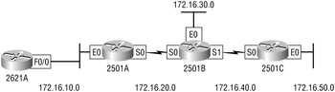

 |  |  |  |  |  |  |  |  | Figure 4: Hands-on lab internetwork
 |  |  |  | Table 2: Our IP Addresses
 |  |  |  | Router |  |  |  | Interface |  |  |  |  | IP address
 |  |  |  | 2621 |  |  |  | F0/0 |  |  |  |  | 172.16.10.1
 |  |  |  | 2501A |  |  |  | E0 |  |  |  |  | 172.16.10.2
 |  |  |  | 2501A |  |  |  | S0 |  |  |  |  | 172.16.20.1
 |  |  |  | 2501B |  |  |  | E0 |  |  |  |  | 172.16.30.1
 |  |  |  | 2501B |  |  |  | S0 |  |  |  |  | 172.16.20.2
 |  |  | Table 2: Our IP Addresses
 |  |  | Router |  |  |  | Interface |  |  |  |  | IP address
 |  |  | 2501B |  |  |  | S1 |  |  |  |  | 172.16.40.1
 |  |  | 2501C |  |  |  | S0 |  |  |  |  | 172.16.40.2
 |  |  | 2501C |  |  |  | E0 |  |  |  |  | 172.16.50.1

Lab # 12
VLAN(Virtual LAN)

Objectives:
- Configure a switch with VLANS and inter-switch communication

- Implement a LAN

- Customize a switch configuration to meet specified network requirements

- Perform LAN and VLAN troubleshooting

Theory Overview:-

As shown in Figure 1, layer 2 switched networks are typically designed as flat networks. Every broadcast packet transmitted is seen by every device on the network, regardless of whether the device needs to receive that data.
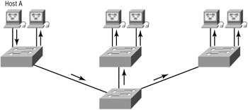

Figure 1: Flat network structure

By default, routers allow broadcasts only within the originating network, but switches forward broadcasts to all segments. The reason it's called a flat network is because it's one broadcast domain, not because its actual design is physically flat.

A VLAN is a logical grouping of network users and resources connected to administratively defined ports on a switch. When you create VLANs, you are given the ability to create smaller broadcast domains within a layer 2 switched internetwork by assigning different ports on the switch to different subnetworks. A VLAN is treated like its own subnet or broadcast domain, which means that frames

broadcast onto the network are only switched between the ports logically grouped within the same VLAN.
I am going to discuss switching characteristics and how switches provide better network services than hubs do in our networks.

- Broadcast Control

- Security

- Flexibility and Scalability
There are several ways that VLANs simplify network management:

- Network adds, moves, and changes are achieved by configuring a port into the appropriate VLAN.

- A group of users needing high security can be put into a VLAN so that no users outside of the VLAN can communicate with them.

- As a logical grouping of users by function, VLANs can be considered independent from their physical or geographic locations.

- VLANs can enhance network security.

- VLANs increase the number of broadcast domains while decreasing their size.

VLAN Memberships

VLANs are usually created by an administrator, who then assigns switch ports to each VLAN. Such a VLAN is called a static VLAN. If the administrator wants to do a little more work up front and assign all the host devices' hardware addresses into a database, the switches can be configured to assign VLANs dynamically whenever a host is plugged into a switch. This is called a dynamic VLAN.

Static VLANs

Static VLANs are the usual way of creating VLANs, and they're also the most secure. The switch port that you assign a VLAN association to always maintains that association until an administrator manually changes that port assignment.

This type of VLAN configuration is comparatively easy to set up and monitor, and it works well in a network where the movement of users within the network is controlled. And although it can be helpful to use network management software to configure the ports, it's not mandatory.

Dynamic VLANs

A dynamic VLAN determines a node's VLAN assignment automatically. Using intelligent management software, you can base VLAN assignments on hardware (MAC) addresses, protocols, or even applications to create dynamic VLANs.

Cisco administrators can use the VLAN Management Policy Server (VMPS) service to set up a database of MAC addresses that can be used for dynamic addressing of VLANs. A VMPS database maps MAC addresses to VLANs.

Identifying VLANs

As frames are switched throughout the network, switches must be able to keep track of all the different types, plus understand what to do with them depending on the hardware address. And remember, frames are handled differently according to the type of link they are traversing.

There are two different types of links in a switched environment:

Access links This type of link is only part of one VLAN, and it's referred to as the native VLAN of the port. Any device attached to an access link is unaware of a VLAN membership—the device just assumes it's part of a broadcast domain, but it has no understanding of the physical network.

Trunk links Trunks can carry multiple VLANs and originally gained their name after the telephone system trunks that carry multiple telephone conversations.

Trunking allows you to make a single port part of multiple VLANs at the same time. This can be a real advantage. For instance, you can actually set things up to have a server in two broadcast domains simultaneously, so that your users won't have to cross a layer 3 device (router) to log in and access it. Another benefit to trunking is when you're connecting switches. Trunk links can carry some or all VLAN information across the link, but if the links between your switches aren't trunked, only VLAN 1 information will be switched across the link by default.

Routing between VLANs

Hosts in a VLAN live in their own broadcast domain and can communicate freely. VLANs create network partitioning and traffic separation at layer 2 of the OSI, and as I said when I told you why we still need routers, if you want hosts or any other IP-addressable device to communicate between VLANs, a layer 3 device is absolutely necessary.

For this, you can use a router that has an interface for each VLAN or a router that supports ISL routing. The least expensive router that supports ISL routing is the 2600 series router. The 1600, 1700, and 2500 series don't support ISL routing.

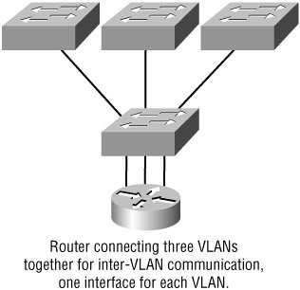As shown in Figure 2, if you had only a few VLANs (two or three), you could get a router with two or three 10BaseT or Fast Ethernet connections. And 10BaseT is okay, but I'd recommend Fast Ethernet— that will work really well.

Figure 2: Router with individual VLAN associations

What we see in Figure 2 is that each router interface is plugged into an access link. This means that each of the routers' interface IP addresses would then become the default gateway address for each host in each VLAN.

If you have more VLANs available than router interfaces, you can either run ISL trunking on one Fast Ethernet interface or buy a layer 3 switch such as the Cisco 3550.

Instead of using a router interface for each VLAN, you use one Fast Ethernet interface and run ISL or 802.1Q trunking. Figure 8.8 shows how a Fast Ethernet interface on a router will look when configured with ISL or 802.1Q trunking. This allows all VLANs to communicate through one interface.

Lab Steps:

Main Steps

Before we are going to configure VLANs on switches, we have to plug the conlsole cable into console port on the configured switch.

Configuring VLANs

Configuring VLANs is actually pretty easy. Figuring out which users you want in each VLAN is not. It's super time-consuming, but once you've decided on the number of VLANs you want to create, and established the users you want to belong to each one, it's time to bring your first VLAN into existence!

To configure VLANs on a 1900 switch, use the vlan vlan# name name [vlan#] command. In the following example, I am going to demonstrate how to configure VLANs on the 1900 switch by creating three VLANs for three different departments (VLAN 1 is the native and administrative VLAN):

>en

#config t

Enter configuration commands, one per line. End with CNTL/Z

(config)#hostname 1900

1900(config)#vlan 2 name sales

1900(config)#vlan 3 name marketing

1900(config)#vlan 4 name mis

1900(config)#exit

After you create the VLANs that you want, you can use the show vlan command to see them. But notice that by default, all ports on the switch are in VLAN 1. To change the VLAN associated with a port, you need to go to each interface and tell it which VLAN to be a part of. Remember that a created VLAN is unused until it is assigned to a switch port or ports, and that all ports are always assigned in VLAN 1 unless set otherwise.

Once the VLANs are created, verify your configuration with the show vlan command (sh vlan for short):

1900#sh vlan
VLAN Name |  | Status | Ports
--------------------------------------
1 | default | Enabled | 1-12, AUI, A, B
2 | sales | Enabled
3 | marketing | Enabled
4 | mis | Enabled

1002 fddi-default Suspended

1003 token-ring-defau Suspended

1004 fddinet-default Suspended

1005 trnet-default Suspended

--------------------------------------

[output cut]

Creating VLANs for the 2950 switch is not very different. You configure them from global configuration mode—but if you do, name them on a separate line.

Switch>

Switch>en

Switch#config t

Enter configuration commands, one per line. End with CNTL/Z.

Switch(config)#vlan 2

Switch(config-vlan)#

At this point, you can name the VLAN, but you don't have to. Let's create a couple more VLANs and then verify our changes.

Switch(config-vlan)#vlan 3

Switch(config-vlan)#name Sales

Switch(config-vlan)#vlan 4

Switch(config-vlan)#name Finance

Switch(config-vlan)#^Z

Switch#

You can't change, delete, or rename VLAN 1, because it's the default VLAN and you just can't change that—period. It's the native VLAN of all switches by default, and Cisco recommends that you use this as your administrative VLAN. Native VLAN basically means that any packets that aren't specifically assigned to a different VLAN will be sent down the native VLAN.

To see the VLAN database, use the show vlan command or the show vlan brief command: Switch#sh vlan brief

VLAN Name |  |  | Status Ports
---- --------------------- --------- -------------------------------
1 | default | active Fa0/1, Fa0/2, Fa0/3, Fa0/4
 |  |  | Fa0/7, Fa0/8, Fa0/9, Fa0/10
 |  |  | Fa0/11, Fa0/12
2 | VLAN0002 |  | active
3 | Sales |  | active
4 | Finance |  | active
1002 fddi-default |  |  | act/unsup
1003 token-ring-default |  |  | act/unsup
1004 fddinet-default |  |  | act/unsup
1005 trnet-default |  |  | act/unsup

Switch#

Now that we can see the VLANs created, we can assign switch ports to specific ones. Each port can be part of only one VLAN. With the trunking I mentioned earlier, you can make a port available to traffic from all VLANs.

Assigning Switch Ports to VLANs

You can configure each port on a 1900 switch to be in a VLAN by using the vlan-membership command. You can only configure VLANs one port at a time. There's no command available with the 1900 switch that lets you assign more than one port to a VLAN at a time.

Remember that you can configure either static memberships or dynamic memberships on a port. Even so, I'm only going to cover the static way.

In the following example, I configure interface 2 to VLAN 2, interface 4 to VLAN 3, and interface 5 to VLAN 4:

1900#config t

Enter configuration commands, one per line. End with CNTL/Z 1900(config)#int e0/2

1900(config-if)#vlan-membership ?

dynamic Set VLAN membership type as dynamic static Set VLAN membership type as static

1900(config-if)#vlan-membership static ?

<1-1005> ISL VLAN index 1900(config-

if)#vlan-membership static 2

1900(config-if)#int e0/4

1900(config-if)#vlan-membership static 3

1900(config-if)#int e0/5

1900(config-if)#vlan-membership static 4

1900(config-if)#exit

1900(config)#exit

Now, type show vlan again to see the ports assigned to each VLAN: 1900#sh vlan

VLAN Name Status Ports

--------------------------------------

1 default Enabled 1, 3, 6-12, AUI, A, B

2 sales Enabled 2

3 marketing Enabled 4

4 mis Enabled 5

1002 fddi-default Suspended

1003 token-ring-defau Suspended

1004 fddinet-default Suspended

1005 trnet-default Suspended

--------------------------------------

[output cut]

And of course it's really different for the 2950. Here's how to configure a 2950 with VLANs: Switch(config-if)#int f0/2

Switch(config-if)#switchport access vlan 2 Switch(config-if)#int f0/3 Switch(config-if)#switchport access vlan 3 Switch(config-if)#int f0/4 Switch(config-if)#switchport access vlan 4 Switch(config-if)#
If you want to verify your configuration, just use the show vlan or show vlan brief command to show you the VLANs with port assignments:

Switch#sh vlan brief

VLAN Name |  | Status |  | Ports
---- ------------------- --------- --------------------------
1 | default | active | Fa0/1, Fa0/5, Fa0/6, Fa0/7, Fa0/8,
 |  | Fa0/9, Fa0/10, Fa0/11, Fa0/12
2 | VLAN0002 | active |  | Fa0/2
3 | Sales | active | Fa0/3
4 | Finance | active | Fa0/4

That's it. Well, sort of. If you plugged devices into each VLAN port, they can only talk to other devices in the same VLAN. We want to enable inter-VLAN communication and we're going to do that, but first you need to learn about trunking.

Configuring Trunk Ports

The 1900 switch only runs the Dynamic Inter-Switch Link (DISL) encapsulation method. To configure trunking on a Fast Ethernet port, use the interface command trunk [parameter].

The following switch output shows the trunk configuration on interface 26 as set to trunk on:

1900#config t
Enter configuration commands, one per line. End with CNTL/Z
1900(config)#int f0/26
1900(config-if)#trunk ?
auto | Set DISL state to AUTO
desirable Set DISL state to DESIRABLE
nonegotiate Set DISL state to NONEGOTIATE
off | Set DISL state to OFF
on | Set DISL state to ON

1900(config-if)#trunk on

On the 2950, you use the switchport command:

Switch#config t

Enter configuration commands, one per line. End with CNTL/Z.

Switch(config)#int f0/12

Switch(config-if)#switchport mode trunk

Switch(config-if)#^Z

Switch#

Configuring Inter-VLAN Routing

By default, only hosts that are members of the same VLAN can communicate. To change this and allow inter-VLAN communication to be possible, you need a router or a layer 3 switch. We're going to take the router approach and use one to connect to both a 1900 and a 2950 switch to make inter-VLAN communication happen.

To support ISL or 802.1Q routing on a Fast Ethernet interface, the router's interface is divided into logical interfaces—one for each VLAN. These are called subinterfaces. To trunk a router port, you must have a 100Mbps port minimum

Anyway, from a Fast Ethernet or Gigabit interface, you can set the interface to trunk with the encapsulation command. For a connection to a 1900 trunk port (ISL), use the following command:

2600#config t

2600(config)#int f0/0.1

2600(config-subif)#encapsulation isl vlan#

The configuration above chooses a subinterface, then sets the encapsulation used for a particular VLAN. The subinterface number is locally significant only, so it doesn't matter at all how the subinterface numbers are configured on the router. Most of the time, I'll configure a subinterface with the same number as the VLAN I want to route. It's easy to remember that way, and since the subinterface number is used only for administrative purposes, that makes it easier to remember.

For a router trunk connection to a 2950 switch (802.1Q), use the following command:

2600(config)#int f0/0.1

2600(config-subif)#encapsulation dot1q vlan#

Conclusion:

Lab Task:

