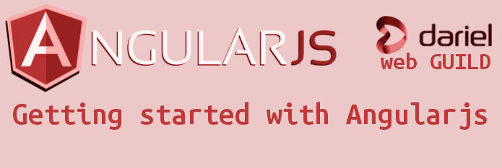
Thursday 12th November 16:00 – 17:00

In the web GUILD this week will be getting started with Angularjs, why Angularjs? Will be looking at key concepts of Angularjs, some web application code before Angularjs and web application code using Angularjs.

This is open to anyone involved in web development or keen on learning web development.

Web Guild Philosophy
Developing for the Web is fairly complex, one has to know multiple languages like HTML,CSS, JavaScript and a server side language. There many frameworks, lots libraries and various ways to do things. The landscape is always changing with new browsers, new devices and etc..
Therefore in the Web Guild we will explore stack & tooling, current best practices.

