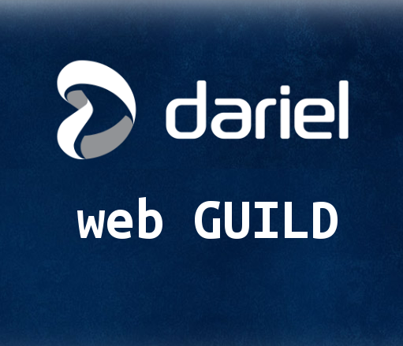

Developing for the Web is fairly complex, one has to know multiple languages like HTML,CSS, JavaScript and a server side language. There many many frameworks, lots libraries and various ways to do things. The landscape is always changing with new browsers, new devices and etc..
Therefore in the Web Guild we will explore stack & tooling, current best practices.
Starting off this week I'll be sharing our current stack & modern web architecture. This is open anyone involved in web development or keen on learning web development.

