Problem Statement: There can be multiple customers, who can place multiple orders on the site. Now a sales person can handle these orders will distribute into multiple sales persons (One order will be assign to one salesperson only). So a sales person can have multiple orders of multiple customers
- Create Database
create database akashdb
- Design Schema and Create Table
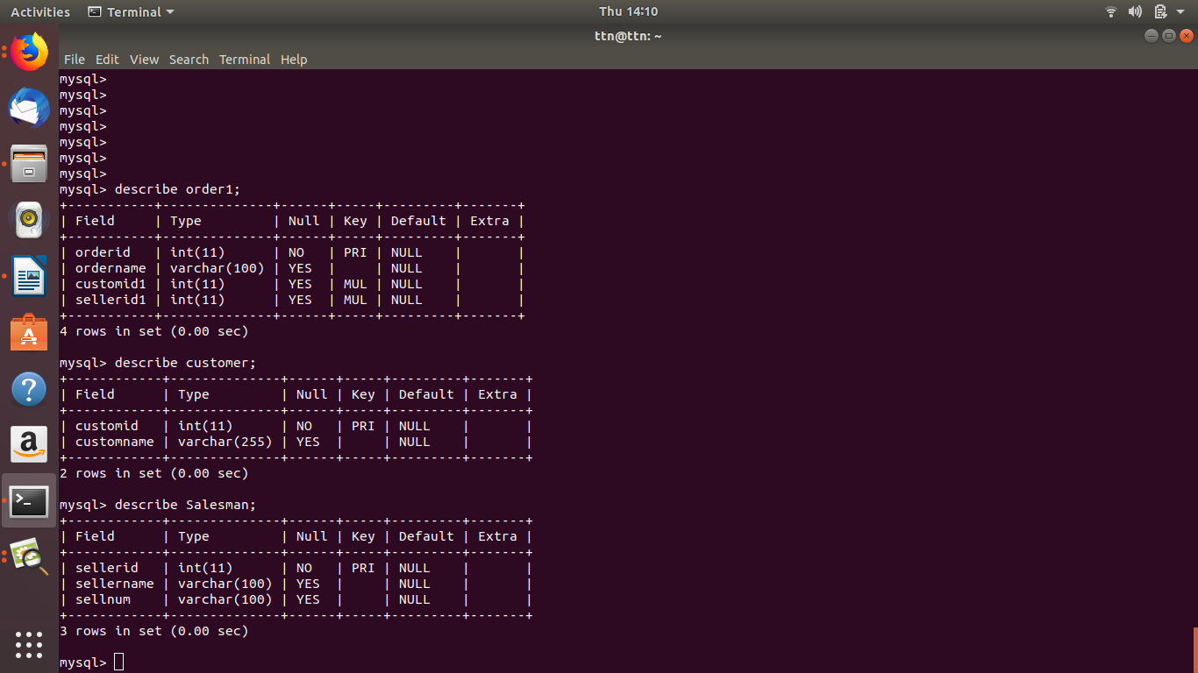
- Insert sample data
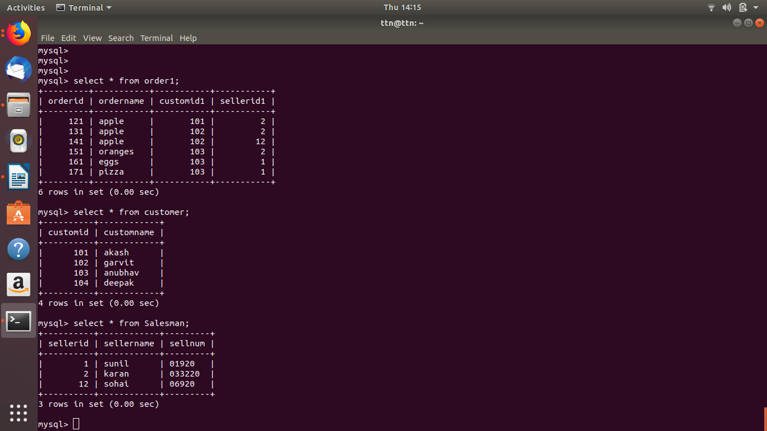
Data is inserted as seen above.

- Find the sales person have multiple orders.

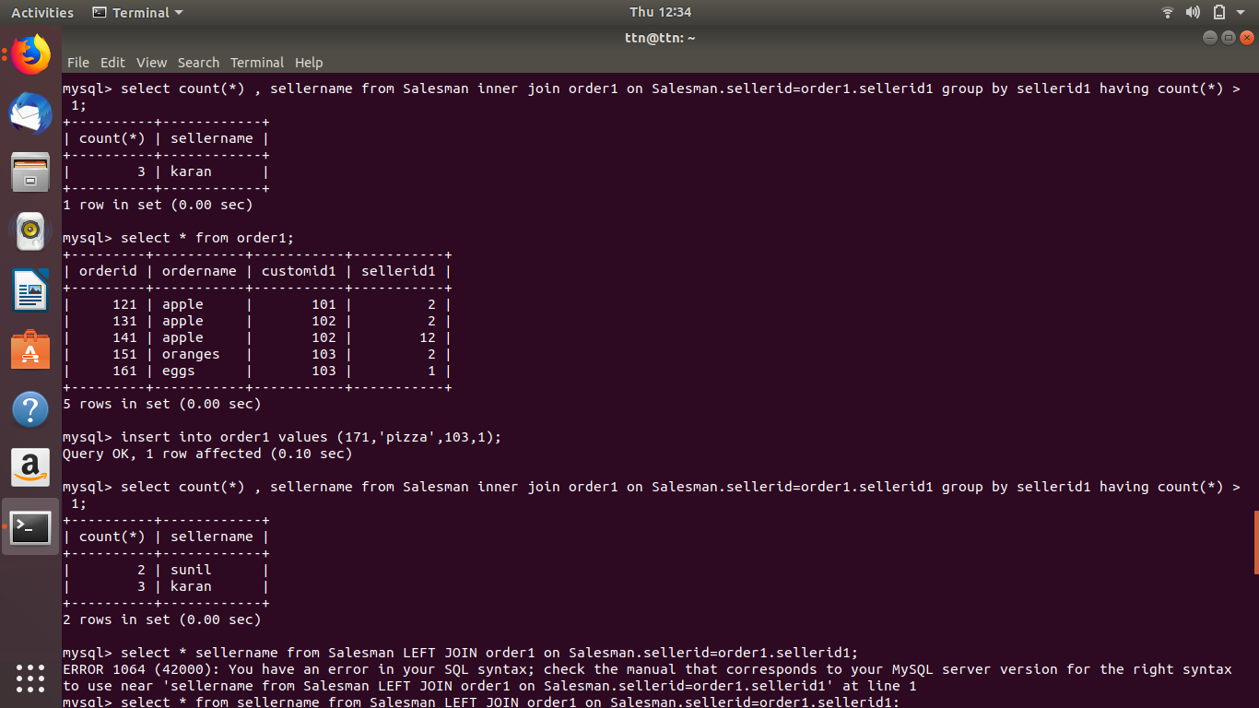
There are two salesman with more than one order that are
sunil
karan

- Find the all sales person details along with order details.
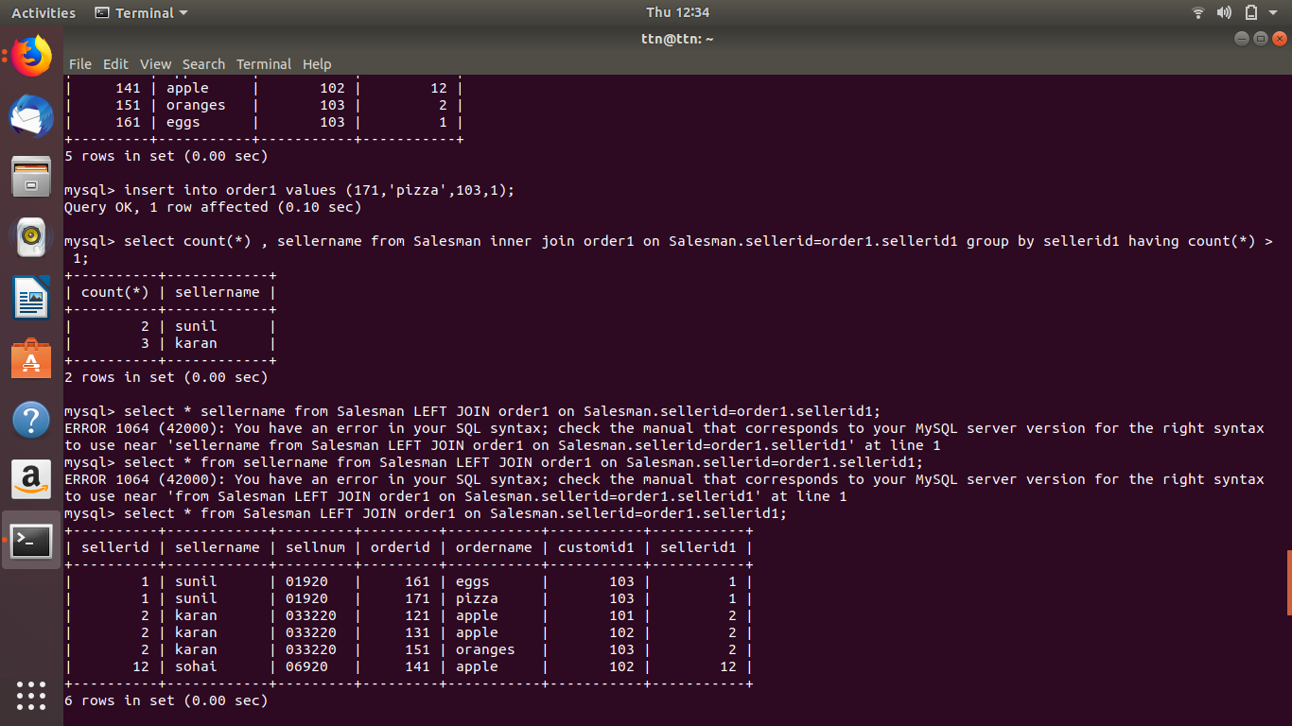
- Create index and How to show index on a table.
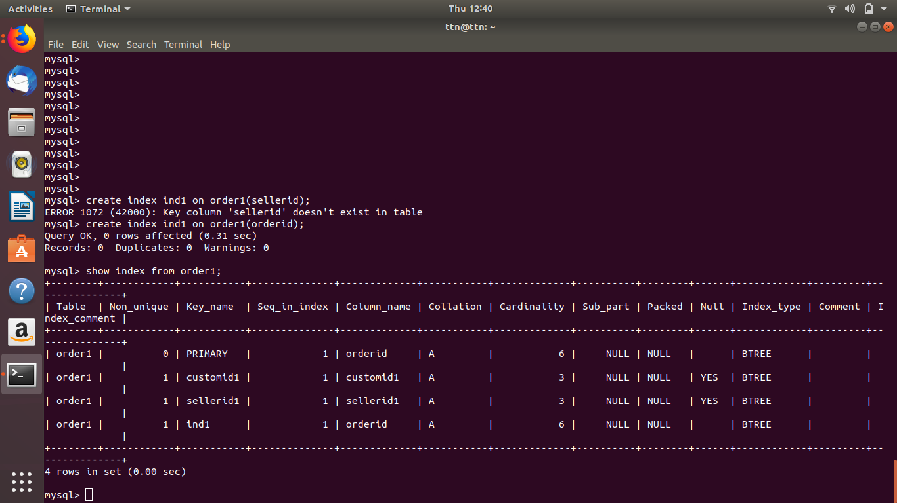
- Find the order number, sale person name, along with the customer to whom that order belongs to
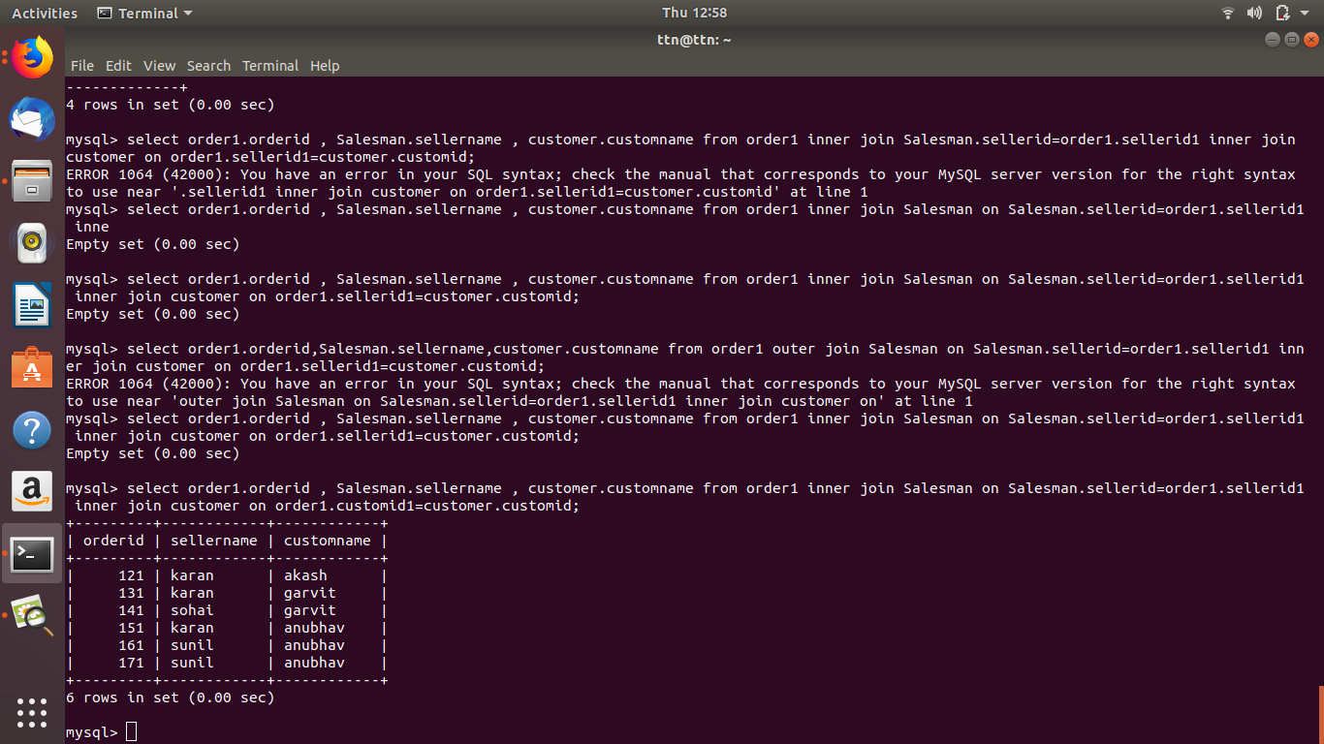
with the help of nested joins.

