1.How are inline and block elements different from each other?
Ans: Block Elements-The <div> element is often used as a container for other HTML elements.
The <div> element has no required attributes, but style, class and id are common.
When used together with CSS, the <div> element can be used to style blocks of content
Inline Elements-The <span> element is often used as a container for some text.
The <span> element has no required attributes, but style, class and id are common.
When used together with CSS, the <span> element can be used to style parts of the text.
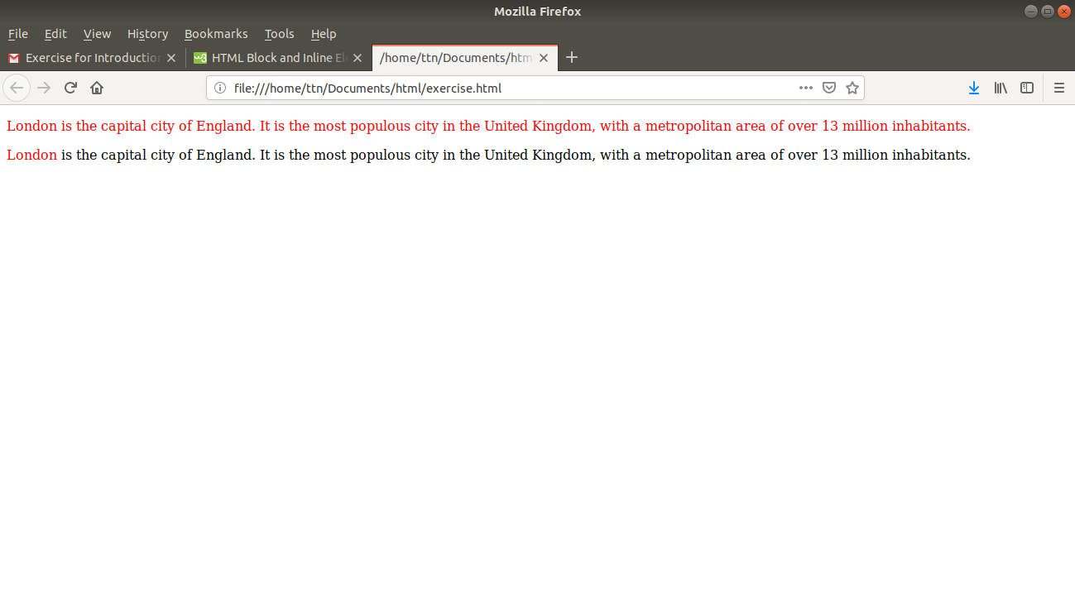
Q2-Explain the difference between visibility:hidden and display:none?
Ans-display:none removes the element from the normal flow of the page, allowing other elements to fill in.
visibility:hidden leaves the element in the normal flow of the page such that is still occupies space.

Q3Explain the clear and float properties.
Ans-The float property is used for positioning and formatting content e.g. let an image float left to the text in a container.
The float property can have one of the following values:
- left - The element floats to the left of its container
- right- The element floats to the right of its container
- none - The element does not float (will be displayed just where it occurs in the text). This is default
- inherit - The element inherits the float value of its parent
Clear-The clear property specifies what elements can float beside the cleared element and on which side.
The clear property can have one of the following values:
- none - Allows floating elements on both sides. This is default
- left - No floating elements allowed on the left side
- right- No floating elements allowed on the right side
- both - No floating elements allowed on either the left or the right side
- inherit - The element inherits the clear value of its parent

Q4-explain difference between absolute, relative,fixed and static.
Ans-static-HTML elements are positioned static by default.
Static positioned elements are not affected by the top, bottom, left, and right properties.
An element with position: static; is not positioned in any special way; it is always positioned according to the normal flow of the page:
relative-An element with position: relative; is positioned relative to its normal position.
Setting the top, right, bottom, and left properties of a relatively-positioned element will cause it to be adjusted away from its normal position. Other content will not be adjusted to fit into any gap left by the element.
fixed-An element with position: fixed; is positioned relative to the viewport, which means it always stays in the same place even if the page is scrolled. The top, right, bottom, and left properties are used to position the element.
A fixed element does not leave a gap in the page where it would normally have been located.
Notice the fixed element in the lower-right corner of the page. Here is the CSS that is used:
absolute-An element with position: absolute; is positioned relative to the nearest positioned ancestor (instead of positioned relative to the viewport, like fixed).
However; if an absolute positioned element has no positioned ancestors, it uses the document body, and moves along with page scrolling.

Q5-Write the HTML code to create a table in which there are 4 columns( ID , Employee Name, Designation, Department) and at least 6 rows. Also do some styling to it.
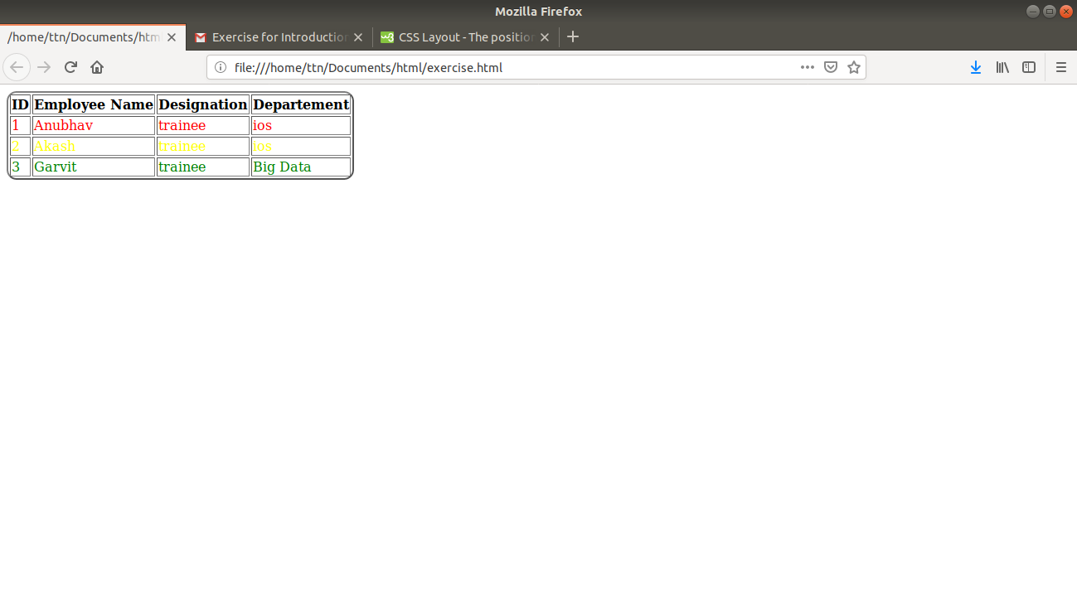
Q6-Why do we use meta tags?
Ans-The <meta> tag provides metadata about the HTML document. Metadata will not be displayed on the page, but will be machine parsable.
Meta elements are typically used to specify page description, keywords, author of the document, last modified, and other metadata.
The metadata can be used by browsers (how to display content or reload page), search engines (keywords), or other web services.
Example 1 - Define keywords for search engines:
<meta name="keywords" content="HTML, CSS, XML, XHTML, JavaScript">
Example 2 - Define a description of your web page:
<meta name="description" content="Free Web tutorials on HTML and CSS">
Example 3 - Define the author of a page:
<meta name="author" content="John Doe">
Example 4 - Refresh document every 30 seconds:
<meta http-equiv="refresh" content="30">
Example 5 - Setting the viewport to make your website look good on all devices:
<meta name="viewport" content="width=device-width, initial-scale=1.0">

Q7-Explain box model.
Ans-All HTML elements can be considered as boxes. In CSS, the term "box model" is used when talking about design and layout.
The CSS box model is essentially a box that wraps around every HTML element. It consists of: margins, borders, padding, and the actual content.
Explanation of the different parts:
- Content - The content of the box, where text and images appear
- Padding - Clears an area around the content. The padding is transparent
- Border - A border that goes around the padding and content
- Margin - Clears an area outside the border. The margin is transparent
Q8-What are the different types of CSS Selectors?
Ans-CSS selectors are used to select the content you want to style. Selectors are the part of CSS rule set. CSS selectors select HTML elements according to its id, class, type, attribute etc.
There are several different types of selectors in CSS.
- CSS Element Selector
- CSS Id Selector
- CSS Class Selector
- CSS Universal Selector
- CSS Group Selector
Q9-Define Doctype.
Ans-The <!DOCTYPE> declaration must be the very first thing in your HTML document, before the <html> tag.
The <!DOCTYPE> declaration is not an HTML tag; it is an instruction to the web browser about what version of HTML the page is written in.
Q10-Explain 5 HTML5 semantic tags.
Ans-A semantic element clearly describes its meaning to both the browser and the developer.
Examples of non-semantic elements: <div> and <span> - Tells nothing about its content.
Examples of semantic elements: <form>, <table>, and <article> - Clearly defines its content.
<article>-The <article>element is one of the major HTML5 semantic tags. It is used to define the article content on your website. It is usually used for big parts of the text.
<aside>-The <aside> semantic element defines the content which will be set to the side. It is occasionally used for creating sidebars but can also be used for less important content sharing.
<details>-This is one of the HTML5 semantic tags that defines the details on your website. The details can either be visible to the audience of hidden.
<footer>-The HTML5 element <footer>describes the footnote for your website or part of the content.

