Harmonic Content: A Musical and Visual Art Installation

ECE4723 Senior Design Project Final Report

Section: A Group: S01

Advisors: Steve Kenney, Noah Posner

Georgia Institute of Technology

North Ave NW, Atlanta, GA 30332

William Kennedy (EE), wkennedy33, wkennedy33@gatech.edu

Andrew Kim (CmpE), akim396, akim396@gatech.edu

Savannah Hearn (CmpE), shearn6, shearn6@gatech.edu

Owen Rohm (ID), orohm3, orohm3@gatech.edu

Submitted

2021 December 13

# Table of Contents

**Executive Summary**

**Nomenclature**

1. **Introduction**
   1. Objective
   2. Background
2. **Design Ideation**
   1. Constraints for Shape and Display
   2. Proposed Design Solutions
   3. Market Research
3. **Technical Specification**
   1. Hardware
   2. Software
4. **Demonstration**
5. **Cost Analysis**
6. **Leadership Roles**

**References**

**Appendix**

# Executive Summary

“Harmonic Content” is an art installation demonstrating signal parameters through music, light, and visualization. It was created for the Georgia Tech School of Electrical and Computer Engineering, and will be mounted on the wall in the Van Leer building. Primarily, it consists of a modular four-voice analog musical synthesizer, with a custom, whimsical user interface designed to encourage passerbys to play music. Above the synthesizer is a mesmerizing LED display that changes to reflect the music. Both the visual LED display and the auditory experience of the music explore the concept of harmonic relationships. In addition to being played through its user interface, it has an autonomous mode that activates when no user input is detected for some time. In this mode, it plays pleasant chord progressions or melodies quietly.

Harmonic Content is designed to be modified and expanded. The project is documented and open source, so that future students can create custom analog filters, add special effects, or play their own musical programs on it.

The installation cost around $3000 in materials, including synthesizer modules, building materials, and electrical components. It measures approximately 6’ x 4’ x 1’.

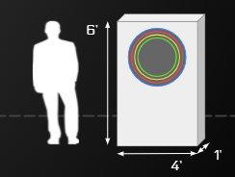

**Figure 1.** Scale of the installation

# Nomenclature

**DAC:** A Digital-to-Analog Converter takes digital signals and converts them to analog signals, most commonly digital to audio signals.

**Eurorack:** A standard format for modular synthesizers, in which oscillators, filters, and amplifiers are controlled via control voltage signals are passed through 3.5mm mono jack cables.

**I2C:** a synchronous, multi-controller/multi-target, packet switched, single-ended, serial communication bus

**MIDI:** Musical Instrument Digital Interface is a commonly used protocol for communicating music. It includes musical features including pitch, velocity, location, tempo, and more.

**SPI:** Serial Peripheral Interface is a 3-wire communication interface used for short-distance communication, primarily in embedded systems.

**Polyphonic:** capable of producing more then one note at a time

**MCU:** microcontroller unit (in this case Teensy 4.1)

# Harmonic Content: A Musical and Visual Art Installation

## 1. Introduction

Harmonic content is an interactive public art sculpture combining visual and audio elements. The heart of the installation includes a custom built synthesizer that can be controlled by users, and a visual element that visually represents signal characteristics of the notes being played in real time. Additionally, the sculpture will be designed to allow expandability by future musicians and engineers. This document gives a high-level overview of the project’s appeal, its design aspects, the expected development timeline, and each team member’s contributions.

### 1.1 Objective

**Interact:** The main role of Harmonic Content is as an interactive art installation. Users can play notes on the instrument using novel and intuitive input elements to control pitch, volume, and signal characteristics. Based on the notes being played, a visual element reacts providing visual cues to the sculpture, connecting sound and sight. Both audio and visual elements will be pleasing and appropriately nonintrusive for presence in a public space.

**Visualize:** Harmonic Content is more than a toy. In addition to being artistic and playful, the sculpture has educational impact as a resource for students studying electricity. Its multimodal representation of analog signals encourages rumination on mathematical concepts including frequency, amplitude, filtering, and rise or fall times, as these concepts are expressed in different ways.

**Expand:** The sculpture will have significant hardware expandability. Future parties will be able to add their own module that they can plug into the system to either modify the sound output or add a visual element. Expandability should promote creativity as well as education and engineering of audio, hardware, and embedded systems.

## 2. Design Ideation

### 2.1 Constraints for Shape and Display

The project will be installed in a hallway in a classroom building, so it is reasonably transportable, not too loud, and electrically sound for connection to a common wall outlet. Additionally, since it is designed to be expanded by future users, it has documented and standardized voltages and control signals. These constraints are summarized in the table below.

| Main Power source | 120V AC | Installation can be powered by wall power |
| --- | --- | --- |
| Size | 6’ x 4’ | Transportable by several people |
| Noise | 50 dB | Max sound levels created |
| Surge Protection | Yes | Ensure circuit protection |
| Module Voltage | 5V/12V/-12V | Voltage to modules |
| Control signals | 3.3V | Voltage into Teensy Microprocessor |

In addition to these constraints, there are some other guiding principles that govern the visual and spatial design of the sculpture. It is engaging to play, while remaining approachable and inviting.

### 2.2 Design Solutions

The microcontroller uses a MIDI interface to control notes being played on the synthesizer. The MIDI interface is a serial bus that is coded for musical notes. The envelopes are created by taking advantage of the control voltages available on the MIDI module.

A patch panel is used that fits in the eurorack standard so all the signals from the MCU can be sent to different modules and signals can be sent into the MCU from our user interface. The visual subsystem will have its own microcontroller and signals must be sent to that for processing and output through the I2C bus. Both the main system and visual system will need their own PCB.

### 

## 3. Technical Specification

### 3.1 Hardware

The proposed device design consists of three main parts: a user interface, a central control system, and a synthesizer module rack, as shown in the diagram below.

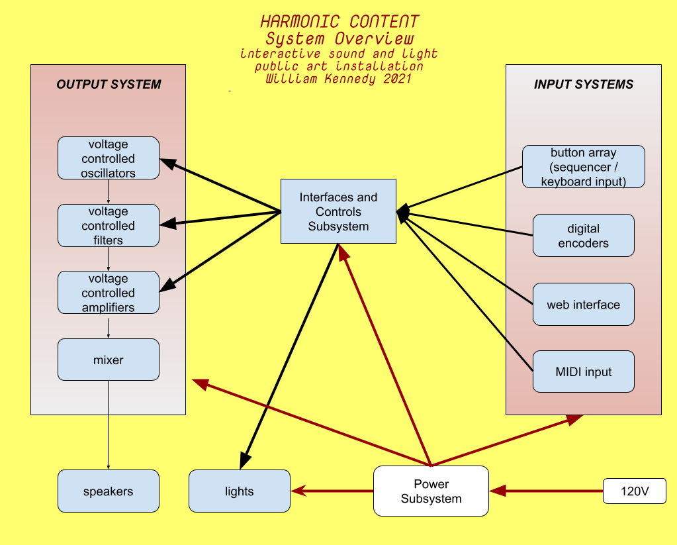

**Figure 2 .** Overall system overview

The central control system consists of two Teensy Microcontrollers, the first of which manages the musical elements of the sculpture. It will take in 0-3.3v analog and digital signals from the user interface elements and process them. MIDI signals are sent out to control the synth modules pitch and envelope. The second Teensy Microcontroller controls the light display and associated motors. It communicates with the first over I2C.

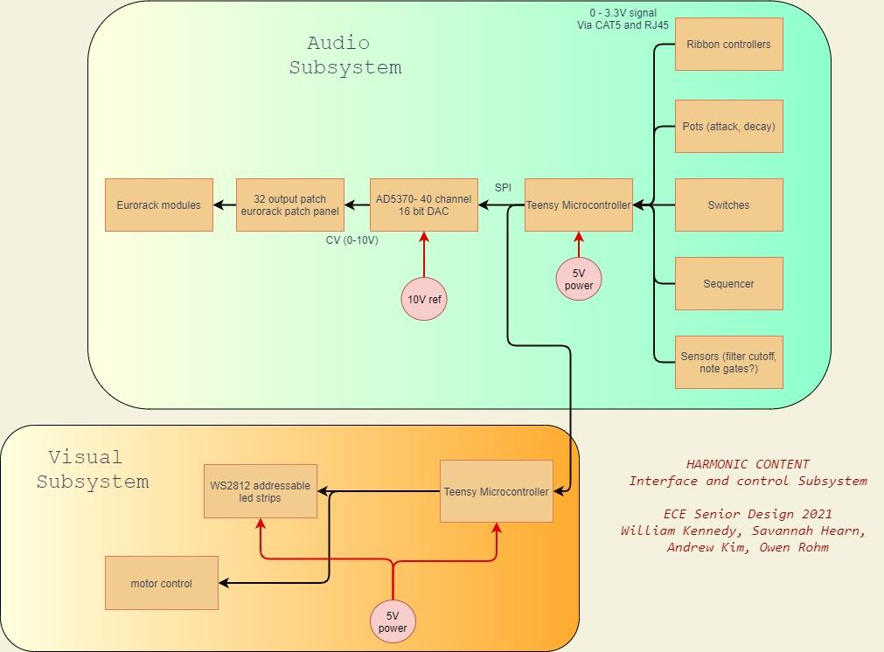

**Figure 3.** Interface and control subsystem block diagram

The musical signals present in the device are summarized in the table below. Additionally, wiring for totally unanticipated signals, whether ones that become necessary later on or ones that are added as expansions, are also included.

| **Signal Name** | **Format** | **Source** | **Destination** |
| --- | --- | --- | --- |
| Pitch Input | Analog 0-3.3v | User Interface | Central Teensy |
| Note Characteristics | Analog 0-3.3v | User Interface | Central Teensy |
| Unused | Analog or Digital | User Interface | Central Teensy |
| Teensy Com | I2C | Central Teensy | Visual Teensy |
| MIDI I/O | Serial | Central Teensy | Synth Panel |
| Extra SPI | SPI | Central Teensy | Undetermined |
| Synth Control Signals | Digital SPI | Central Teensy | DACs |
| Synth Control Voltages | Analog 0-10v | DAC | Synth Panel |
| Unused | Analog 0-10v | DAC | Synth Panel |

Providing extra connections gives a wide ability for future users to explore creative effects not limited to amplitude modulation, frequency modulation, cutoff frequency envelope, and more. Additionally, extra access to the SPI bus is provided from the central Teensy so that future devices can be added to the bus.

The central teensy is mounted on a circuit board with the following schematic.

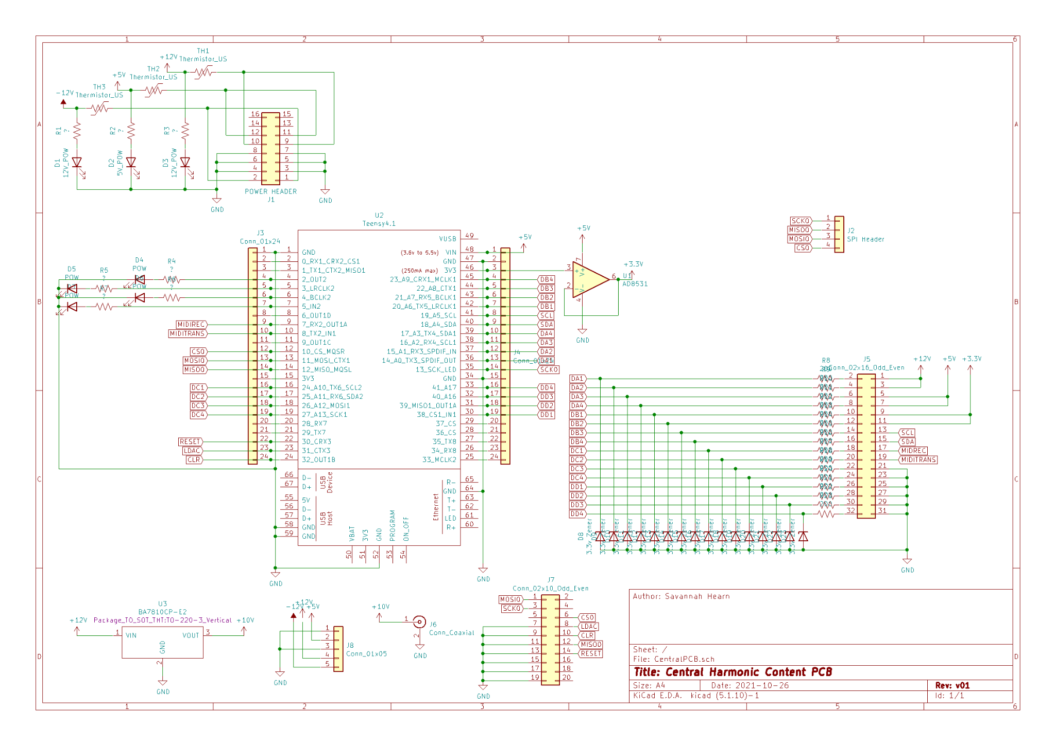

**Figure 4.** Central PCB schematics

### 3.2 Software

A Teensy microprocessor houses the software. In normal operation, the software regularly scans for changing signals from the user interface and output control signals for the display and other peripherals. The software also controls the outputs when the machine is in idle state and when it is being tuned.

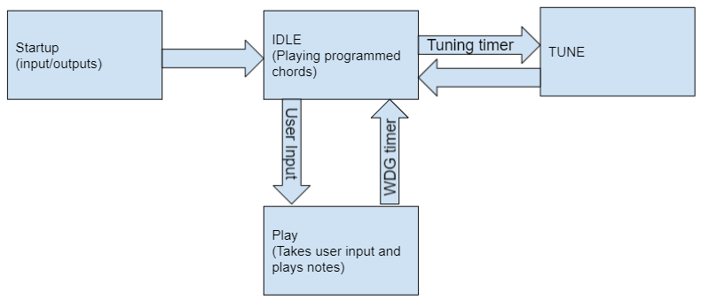

**Figure 5**. Main Software architecture for state machine control

The startup state runs immediately after the system is powered on or the device is reset. At startup, the configuration variables for the inputs, outputs, and control variables will be set. After setup is completed, the software puts the machine into idle state.

In idle state, the machine runs in a mode that plays preprogrammed notes. This is to ensure the machine is pleasant visually and musically when not being used. This state reads inputs to be pushed into the user controlled state, but otherwise ignores all input data. After a while, the machine will go into the tuning state after a timer runs out. The functionality of this state is largely be based on the software that plays notes, but will be automated in the software.

The oscillators need to be tuned to ensure they are musically pleasant. In the tuning state, the software will output digital control for the oscillators and output a controlled note to tune the oscillators. After this is complete, the machine returns to the idle state.

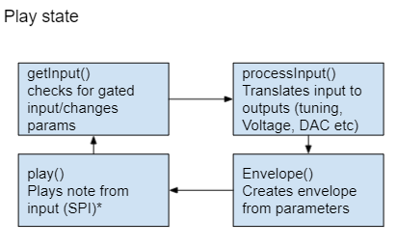

**Figure 6.** The software loop to control the play state

In the play state, the software runs in a loop that reads the user inputs and processes them for output. The software needs to translate the raw inputs to outputs that can be used for the DAC, display, and peripherals. Additionally, some modifications to the signals will be added to add usability and intuitivity of the system. The envelope function steps up the control voltage when a note starts being played and steps down when a note stops being played. Finally, the output signals are generated.

In the overall design, the software is meant to be modified very little by any potential expansion projects. In the case the software needs to be added to or modified, instructions will be created to flash the new software. Additionally, the current software has accompanying documentation and is granularized in a way that promotes simple expansion.

## 4. Demonstration

## 5. Cost Analysis

## 6. Leadership Roles

William Kennedy: Group Leader

William is the primary manager of the project and advises members on the musical and visual aspects of the project. He is managing the sourcing of any larger complete hardware components.

Andrew Kim: Web Master

Andrew is primarily working on the software on the processor as well as the peripheral connections. Included in the work is any supported documentation needed for modification, support, maintenance, and expandability.

Savannah Hearn: Financial Manager

Savannah is primarily working on the electric hardware aspects of the project including any custom fabrication of PCBs needed as well as sourcing parts. Savannah also supports the software and fabrication of the project.

Owen Rohm: Marketing and Design

Owen is working to prototype and gauge interest in certain features in order to determine which can go into the final design through surveys put out. Afterwards, Owen’s primary responsibilities lie in the design and manufacturing of the visual display of the system

# References

*Flow - spiraling pathway of light*. Jen Lewin Studio. (2021, September 12). Retrieved September 22, 2021, from https://www.jenlewinstudio.com/portfolio/flow/.

Martin, J. (n.d.). *Jean Martin: PETER VOGEL'S INTERACTIVE Sound Art*. Peter Vogel: The Sound of Shadows. Retrieved September 21, 2021, from http://vogelexhibition.weebly.com/jean-martin-peter-vogels-interactive-sound-art.html.

“Music and Visual Color: A Proposed Correlation” Alan Wells. Leonardo Vol. 13, No. 2 (Spring, 1980), pp. 101-107 (8 pages). The MIT Press.

Popova, M. (2019, March 19). *The magic and logic of color: How josef albers revolutionized visual culture and the art of seeing*. Brain Pickings. Retrieved September 20, 2021, from https://www.brainpickings.org/2013/08/16/interaction-of-color-josef-albers-50th-anniversary/.

Wikimedia Foundation. (2021, August 21). *Clavier à lumières*. Wikipedia. Retrieved September 22, 2021, from https://en.wikipedia.org/wiki/Clavier_%C3%A0_lumi%C3%A8res.