Harmonic Content: A Musical and Visual Art Installation

ECE4723 Senior Design Project

Section: A Group: S01

Advisors: Steve Kenney, Noah Posner

Georgia Institute of Technology

North Ave NW, Atlanta, GA 30332

William Kennedy (EE), wkennedy33, wkennedy33@gatech.edu

Andrew Kim (CmpE), akim396, akim396@gatech.edu

Savannah Hearn (CmpE), shearn6, shearn6@gatech.edu

Owen Rohm (ID), orohm3, orohm3@gatech.edu

# Table of Contents

**Executive Summary**

**Nomenclature**

1. **Introduction**
   1. Objective
   2. Background
2. **Design Ideation**
   1. Constraints for Shape and Display
   2. Proposed Design Solutions
   3. Market Research
3. **Technical Specification**
   1. Hardware
   2. Software
4. **Schedule**
5. **Leadership Roles**

**References**

**Appendix**

# Executive Summary

A new art installation entitled 'Harmonic Content' has been proposed for the Van Leer

building. It is a wall mounted musical instrument built to be played by passersbys. It is a

novel way of incorporating electrical engineering disciplines with

human-centered artistic practices. It invites people to play with it with a sense of whimsy

and outlandishness. The goal is to encourage students to think creatively with engineering and demonstrate compelling ways that engineering can be used in ways that are unexpected and strange. The foundation of the design revolves around **expandability** and expansion; this installation is designed to be modified and expanded upon. The project will be well documented and open source, and encouragement is placed on students creating new modules and interfaces, whether through a class project or an individual endeavour. A central artistic tenet of its inception is the concept of **harmonic relationships and color relationships** and how they can be related.

This project blends the analog worlds of audio signals and control voltage with the digital worlds of control systems and microprocessors. Due to the time limitations, prebuilt synthesizer modules are being purchased and the project focuses on the interface between the modules and the user interfaces and sculptural elements. There will be four analog voices on the instrument, making it polyphonic; capable of doing chord voicings or simultaneous melodies.

The installation will cost around $3000 in materials, including synthesizer modules, building materials, and electrical components.

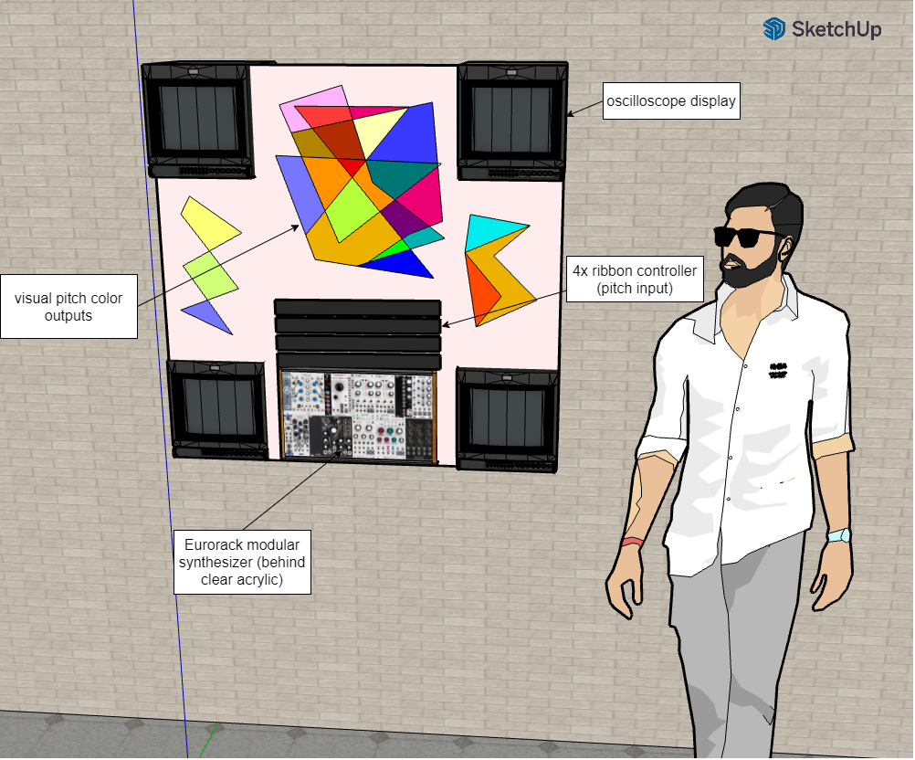

**Figure 1.** Proposed render of the installation

# Nomenclature

**DAC:** A Digital-to-Analog Converter takes digital signals and converts them to analog signals, most commonly digital to audio signals.

**Eurorack:** A standard format for modular synthesizers, in which oscillators, filters, and amplifiers are controlled via control voltage signals are passed through 3.5mm mono jack cables.

**MIDI:** Musical Instrument Digital Interface is a commonly used protocol for communicating music. It includes musical features including pitch, velocity, location, tempo, and more.

**SPI:** Serial Peripheral Interface is a 3-wire communication interface used for short-distance communication, primarily in embedded systems.

**Polyphonic:** capable of producing more then one note at a time

**MCU:** microcontroller unit (in this case Teensy 4.1)

# Harmonic Content: A Musical and Visual Art Installation

## 1. Introduction

Harmonic content is an interactive public art sculpture combining visual and audio elements. The heart of the installation includes a custom built synthesizer that can be controlled by users, and a visual element that visually represents signal characteristics of the notes being played in real time. Additionally, the sculpture will be designed to allow expandability by future musicians and engineers. This document gives a high-level overview of the project’s appeal, its design aspects, the expected development timeline, and each team member’s contributions.

### 1.1 Objective

The main objective of the project is to create an interactive art installation. Users will be able to play notes on the instrument using novel and intuitive input elements to control pitch, volume, and signal characteristics. Based on the notes being played, a visual element will react in a way that adds value and feedback to the sculpture, allowing viewers to visualize the music as signals. Both audio and visual elements will be pleasing and appropriately nonintrusive for presence in a public space.

The sculpture will have significant hardware expandability. Future parties will be able to add their own module that they can plug into the system to either modify the sound output or add a visual element. Expandability should promote creativity as well as education and engineering of audio, hardware, and embedded systems.

## 2. Design Ideation

### 2.1 Constraints for Shape and Display

The project will be installed in a hallway in a classroom building, so it will need to fit within a reasonable space, be not too loud, and be electrically connected to a common wall outlet. Additionally, since it is designed to be expanded by future users, it must have well-defined module voltages and control signals. These constraints are summarized in the table below.

| Main Power source | 120V AC | Installation can be powered by wall power |
| --- | --- | --- |
| Size | 4.5’x3’ | Projected size to be able to fit inside designated space |
| Noise | 50 dB | Max sound levels created |
| Surge Protection | Yes | Ensure circuit protection |
| Module Voltage | 5V/12V/-12V | Voltage to modules |
| Control signals | 3.3V | Voltage into Teensy Microprocessor |

In addition to these constraints, there are some other guiding principles that govern the visual and spatial design of the sculpture. It should be engaging to play, while remaining approachable and inviting. Additionally, certain characteristics of the sound waveforms need to be represented visually. These characteristics include pitch and amplitude, and possibly the presence of harmonics in the signal.

### 2.2 Proposed Design Solutions

We will design the electrical system for signals to get into and out of the microcontroller. The synthesizer uses 0 - 10 V DC signal for control voltage so we will need to convert our 0 - 5V signal coming from the DAC to go to the synthesizer. We will need to design a patch panel that fits in the eurorack standard so all the signals from the MCU can be sent to different modules and signals can be sent into the MCU from our user interface. The visual subsystem will have its own microcontroller and signals must be sent to that for processing and output. Both the main system and visual system will need their own PCB.

### 

## 3. Technical Specification

### 3.1 Hardware

The proposed device design consists of three main parts: a user interface, a central control system, and a synthesizer module rack, as shown in the diagram below.

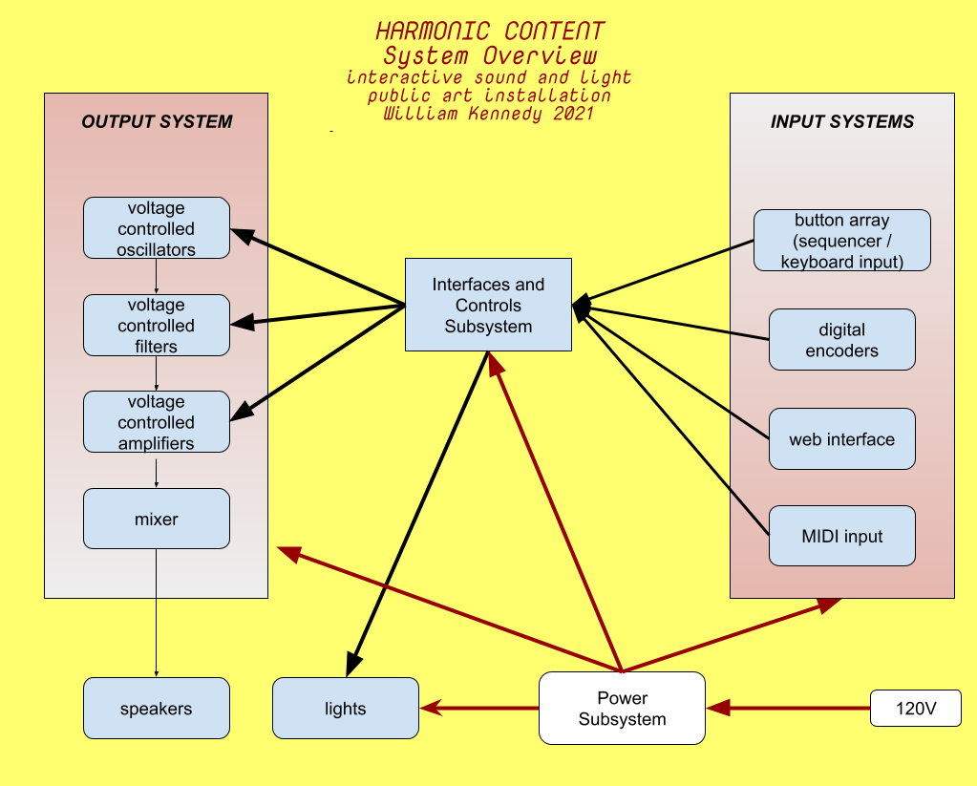

**Figure 2 .** Overall system overview

The central control system will consist of two Teensy Microcontrollers, the first of which will manage the musical elements of the sculpture. It will take in 0-3.3v analog and digital signals from the user interface elements and process them. Instead of outputting directly to the synthesizer modules, it will communicate with two DACs via SPI. These DACs will then output 0-12v analog control signals to the synthesizer modules. The second Teensy Microcontroller will be used to control the light display and any associated motors.

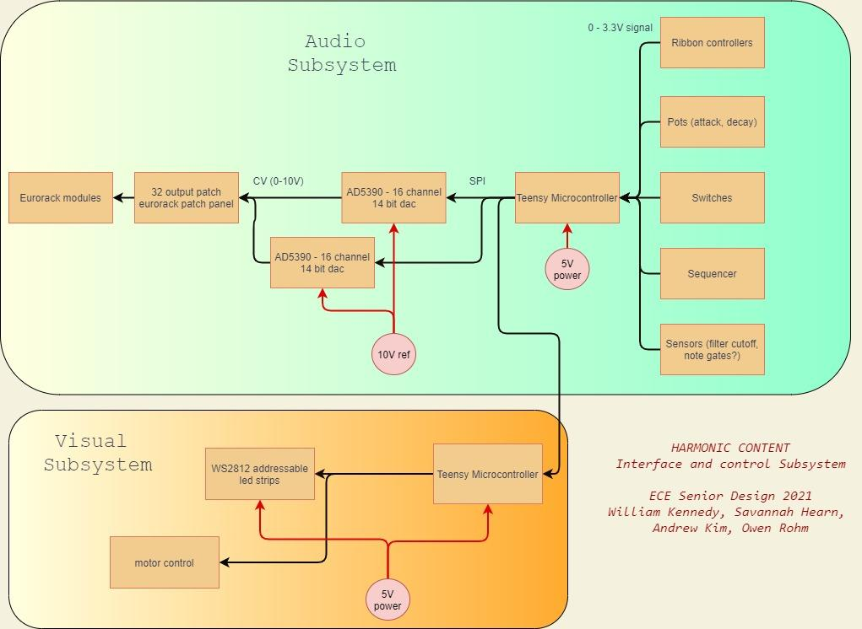

**Figure 3.** Interface and control subsystem block diagram

The musical signals present in the device are summarized in the table below. Though only four voices will be implemented on the device, wiring for six voices is included to allow expandability. Additionally, wiring for totally unanticipated signals, whether ones that become necessary later on or ones that are added as expansions, are also included.

| **Signal Name** | **Quantity** | **Format** | **Source** | **Destination** |
| --- | --- | --- | --- | --- |
| Pitch Input | 6 | Analog 0-3.3v | User Interface | Central Teensy |
| Note Characteristics | 4 | Analog 0-3.3v | User Interface | Central Teensy |
| Sequencer | 5 | Digital | User Interface | Central Teensy |
| Unused | 9 | Analog or Digital | User Interface | Central Teensy |
| Synth Control Signals | 3 | Digital SPI | Central Teensy | DACs |
| Synth Control Voltages | 15 | Analog 0-10v | DACs | Synth Panel |
| Unused | 17 | Analog 0-10v | DACs | Synth Panel |

The number of extra or unused signals were chosen so that the total number of connections from the user interface to the central Teensy is 24, and the total number of connections from the DACs to the synthesizer patch panel is 32. Providing so many connections gives a wide ability for future users to explore creative effects not limited to amplitude modulation, frequency modulation, cutoff frequency envelope, and more.

The exact signals present for the visual display have yet to be decided, but the Teensy controller associated with them will also be attached to the SPI line from the primary Teensy microcontroller to the DACs, and will use this information to control the display.

### 3.2 Software

A Teensy microprocessor will house the software. In normal operation, the software will regularly scan for changing signals from the user interface and output control signals for the DAC, display, and other peripherals. The software also controls the outputs when the machine is in idle state and when it is being tuned.

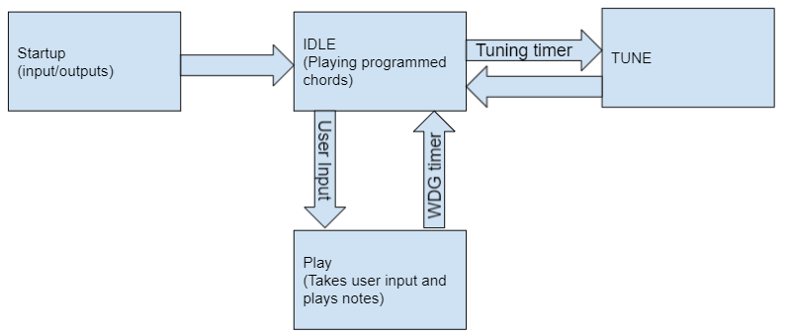

**Figure 4**. Main Software architecture for state machine control

The startup state runs immediately after the system is powered on or the device is reset. At startup, the configuration variables for the inputs, outputs, and control variables will be set. After setup is completed, the software will put the machine into idle state.

In idle state, the machine runs in a mode that plays preprogrammed notes. This is to ensure the machine is pleasant visually and musically when not being used. This state reads inputs to be pushed into the user controlled state, but otherwise ignores all input data. After a while, the machine will go into the tuning state after a timer runs out. The functionality of this state will largely be based on the software that plays notes, but will be automated in the software.

The oscillators need to be tuned to ensure they are musically pleasant. In the tuning state, the software will output digital control for the oscillators and output a controlled note to tune the oscillators. After this is complete, the machine returns to the idle state.

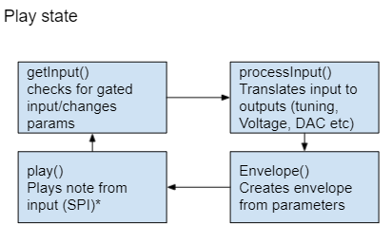

**Figure 5.** The software loop to control the play state

In the play state, the software runs in a loop that reads the user inputs and processes them for output. The software needs to translate the raw inputs to outputs that can be used for the DAC, display, and peripherals. Additionally, some modifications to the signals will be added to add usability and intuitivity of the system. A different function creates the envelope due to the fact that it may be modified and used in other functions. Finally, the output signals are generated. For all DAC outputs, the signals are set through the SPI bus. The address of the signal is set in the software and sent out to the DAC. In the case of a bottleneck sending all the signals down the SPI bus, multithreading can be used to ensure all the outputs are responsive.

In the overall design, the software is meant to be modified very little by any potential expansion projects. In the case the software needs to be added to or modified, instructions will be created to flash the new software. Additionally, the current software has accompanying documentation and is granularized in a way that promotes simple expansion.

## 4. Schedule

The project’s development will require simultaneous development of software, electronic hardware, and installation design. These three elements will be completed independently by October 25th. For software, this will mean both Teensy controllers work as expected with mock inputs and outputs. Electronic hardware at this date will consist of the one or more custom PCB(s) required being fully assembled. Finally, the installation design at this time will be fully defined and available in CAD form. After that, the design will be fabricated and the hardware and software systems combined, with the final project being finished and tested by November 29th. Responsibilities and exact timing of each of these steps are represented in the Gantt chart in the Appendix.

## 5. Leadership Roles

William Kennedy: Group Leader

William is the primary manager of the project and advises members on the musical and visual aspects of the project. He is managing the sourcing of any larger complete hardware components.

Andrew Kim: Web Master

Andrew is primarily working on the software and control inside of the system including any supported documentation needed for modification, support, maintenance, and expandability.

Savannah Hearn: Financial Manager

Savannah is primarily working on the electric hardware aspects of the project including any custom fabrication of PCBs needed as well as sourcing parts. Savannah also supports the software and fabrication of the project.

Owen Rohm: Marketing and Design

Owen is working to gauge interest in certain features in order to determine which can go into the final design through surveys put out. Afterwards, Owen’s primary responsibilities lie in the design and manufacturing of the visual display of the system

# References

*Flow - spiraling pathway of light*. Jen Lewin Studio. (2021, September 12). Retrieved September 22, 2021, from https://www.jenlewinstudio.com/portfolio/flow/.

Martin, J. (n.d.). *Jean Martin: PETER VOGEL'S INTERACTIVE Sound Art*. Peter Vogel: The Sound of Shadows. Retrieved September 21, 2021, from http://vogelexhibition.weebly.com/jean-martin-peter-vogels-interactive-sound-art.html.

“Music and Visual Color: A Proposed Correlation” Alan Wells. Leonardo Vol. 13, No. 2 (Spring, 1980), pp. 101-107 (8 pages). The MIT Press.

Popova, M. (2019, March 19). *The magic and logic of color: How josef albers revolutionized visual culture and the art of seeing*. Brain Pickings. Retrieved September 20, 2021, from https://www.brainpickings.org/2013/08/16/interaction-of-color-josef-albers-50th-anniversary/.

Wikimedia Foundation. (2021, August 21). *Clavier à lumières*. Wikipedia. Retrieved September 22, 2021, from https://en.wikipedia.org/wiki/Clavier_%C3%A0_lumi%C3%A8res.

# Appendix

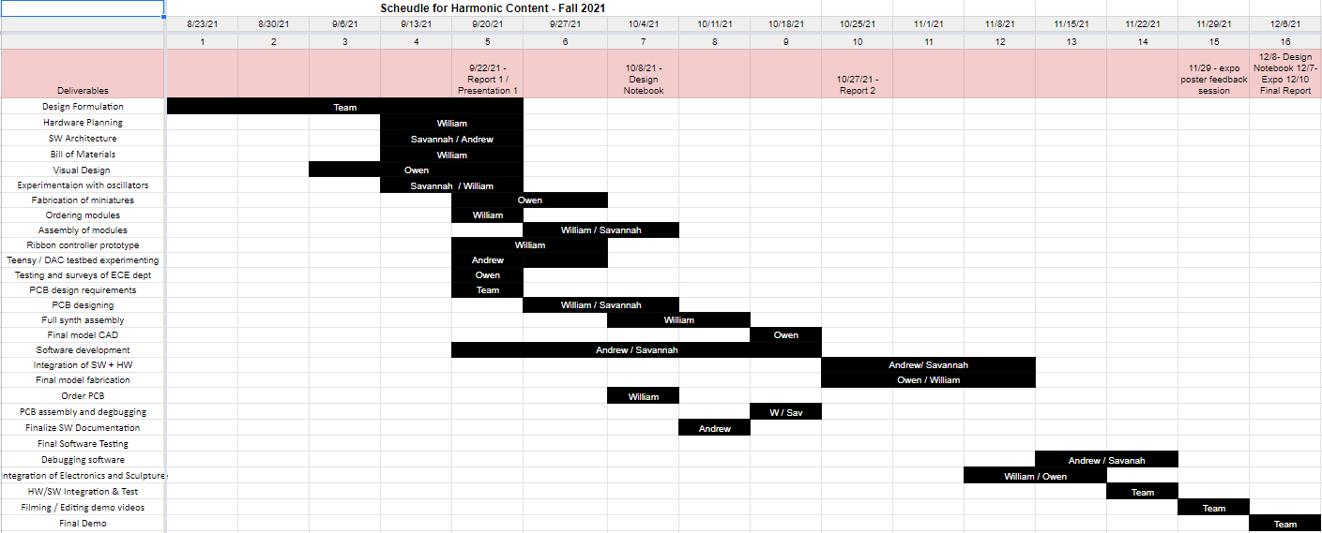

**Figure 6.** Gantt chart for the project timeline and contributions

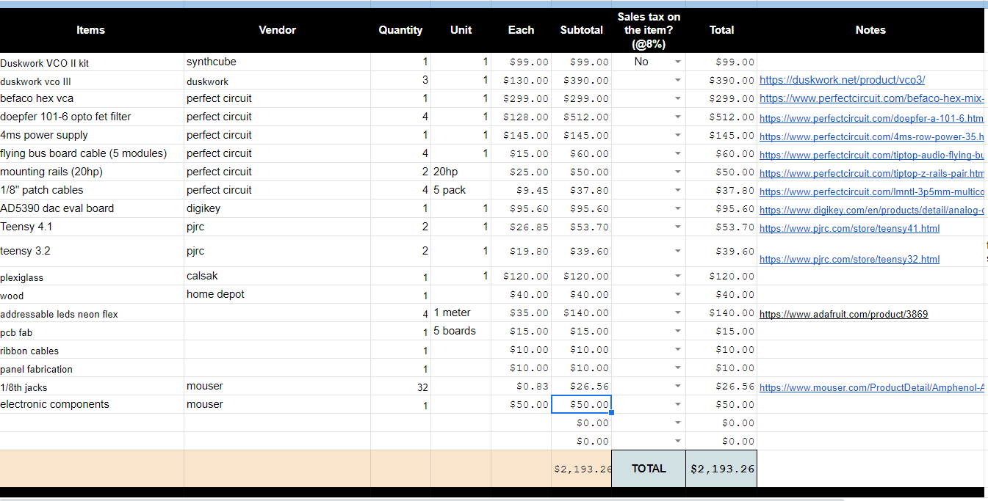

**Figure 7.** Proposed Budget