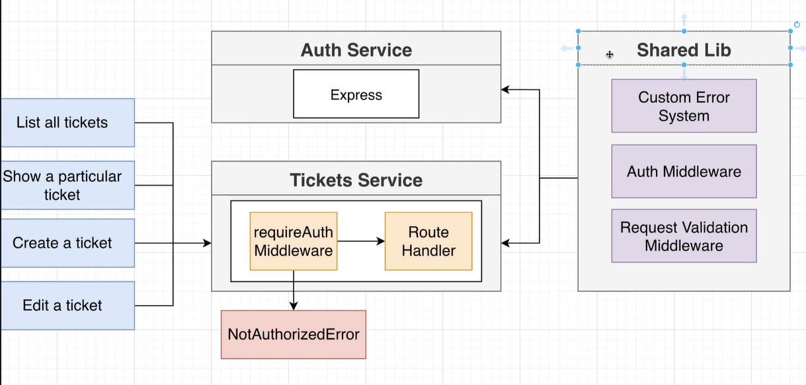

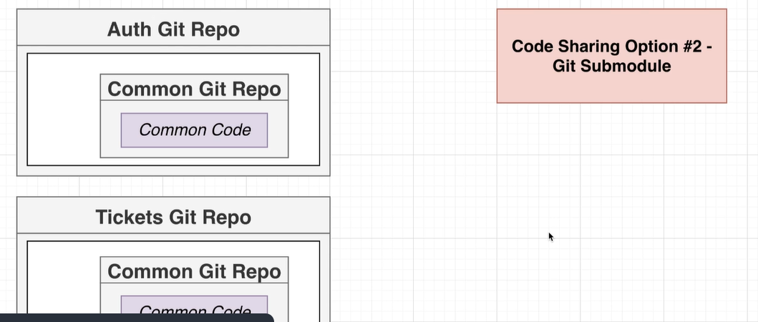

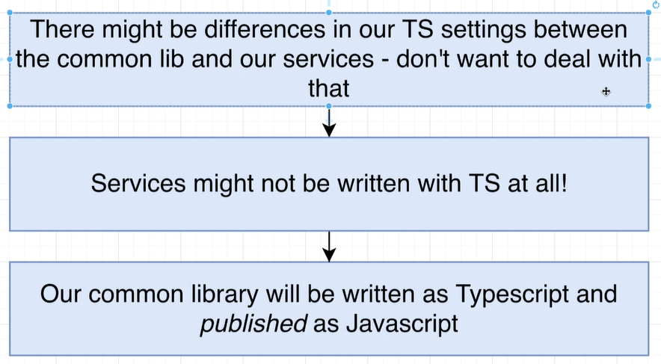

<https://www.udemy.com/course/microservices-with-node-js-and-react/learn/lecture/19123078#questions>

anytime you make changes to npm module make sure you change the version

commit, and publish the changes

