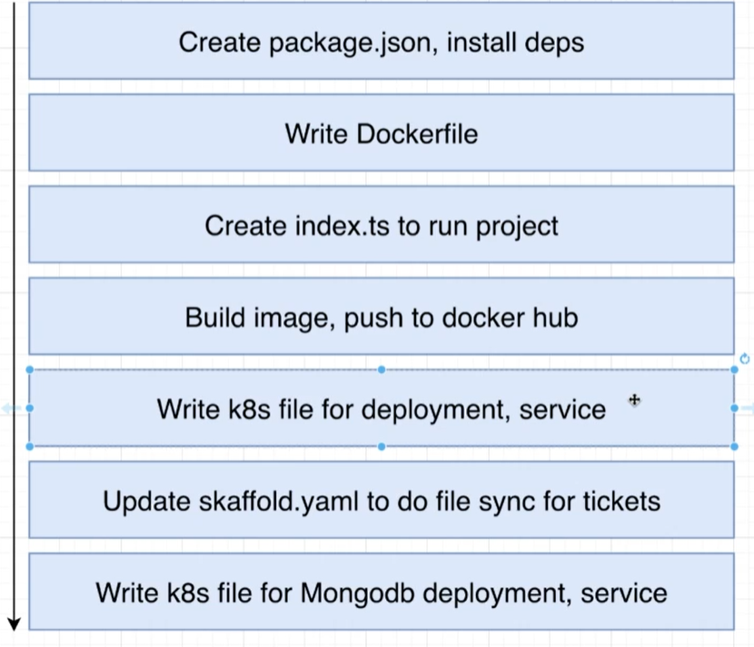

1)First 3 steps copy and paste from other service.

2)make sure you provide environment variable for mongodb.

TEST FIRST APPROCH

api/block