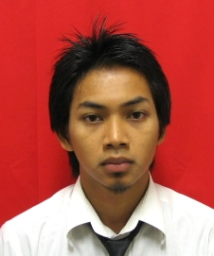

NAME : AIDIL WAFIY BIN ABDUL HALIM

ADDRESS : D1-1-9 PERMAI COURT, TAMAN PUCHONG PERMAI,

47150 PUCHONG, SELANGOR

CONTACT NO. : 017-6662056

EMAIL ADDRESS : aidilwafiy91@gmail.com

**PERSONAL DETAILS:-**

Gender : Male

Age : 23 years old

Date of birth : 10 Sept 1991

Nationality : Malaysia

Marital status : Single

I.C or Passport : 910910-07-5259

Race : Malay

Religion : Islam

**EDUCATIONAL BACKGROUND:-**

2012-Present

* **UNIVERSITI TEKNIKAL MALAYSIA MELAKA (UTeM)**

BACHELOR OF ELECTRICAL ENGINEERING (POWER EECTRONIC & DRIVE)

(2009-2012)

* **UNIVERSITI TEKNOLOGI MALAYSIA (UTM)**

DIPLOMA IN ELECTRICAL (POWER) ENGINEERING

(2007-2008)

* **SEKOLAH MENENGAH TEKNIK SEBERANG PERAI (SMTSPPP)**

SIJIL PELAJARAN MALAYSIA (SPM):-

3A 5B

**EXTRA CURRICULUR ACTIVITIES:-**

* Program Latihan Khidmat Negara(PLKN) 2007

**SKILLS:-**

* PLC, PSPICE software, PROTEUS software, MATLAB software, MICROSOFT OFFICE.
* Develop, design and fabricating PCB board.
* Proficient in both English and Bahasa Malaysia.

**STRENGHTS:-**

* Have the ability to work independently.
* Problem solver.
* Able to work in groups.
* Have good analytical skills and critical thinking.
* Quick Learner.

**REFERENCES:-**

1. Musa Bin Yusup Lada

Lecturer (Academic Advisor)

Faculty of Electrical Engineering

Universiti Teknikal Malaysia Melaka

Phone Number: 012-6704193

E-mail: musayl@utem.edu.my