Output :
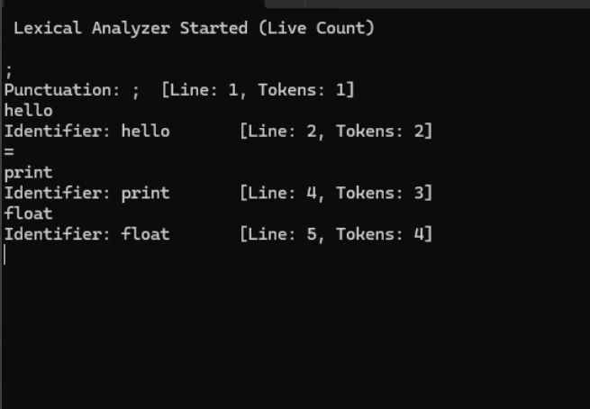

Question 2: Keywords, Meanings, and Example Usage
Keyword | Meaning | Example Usage
initial | Declares an integer variable | int age = 25;
pointed | Declares a floating-point variable | float price = 9.99;
point var | Declares a double-precision floating-point variable | double pi = 3.14159;
alphabet | Declares a character variable | char grade = 'A';
truse | Represents a boolean (true/false) value | bool isReady = true;
then | Used for conditional branching | if (x > 0) cout << "Positive";
swap | Multi-way branch based on value | switch (day) { case 1: cout << "Mon"; break; }
suit-case | Defines a branch in switch | case 2: cout << "Tue"; break;
breakUp | Exits a loop or switch block | if (x == 5) break;
continued | Skips current loop iteration | if (x == 5) continue;
form | Loop that repeats a block of code | for (int i=0; i<5; i++)
white | Exists from a functional and operational value | return 0;
structure | Groups variables under one name | struct Student { int id; string name; };
uni-class | Defines an object-oriented class | class Car { public: void start(); };
@all | Access specifier; members accessible outside class | public: int speed;

Operators
Operator | Meaning | Example Usage
+ | Addition operator | int sum = a + b;
- | Subtraction operator | int diff = a - b;
/ | Division operator | int div = a / b;
* | Multiplication operator | int product = a * b;
% | Modulus operator | int rem = a % b;

Punctuation
Punctuation | Meaning | Example Usage
; | Statement terminator | cout << "Hello";
, | Separator for values or parameters | int x = 5, y = 10;
{} | Used to define code blocks | cout << "Inside block";
[] | Array subscript or indexing | arr[2] = 10;
Regular Expressions
Token Type | R.E (Regular Expression) | Example
Pointed | [0-9]*\.[0-9]* | 1.23
Identifier | [a-zA-Z_][a-zA-Z0-9_]* | count1
String | "[a-zA-Z0-9]*" | "Zunair"
Keyword | (funct) | Num
Operator | (\+) | (no example given)

