Neural Networks and Fuzzy Systems (2017)

Breast Cancer Clasification using Neural Network.

Name: Zunaira Ahmed

UOB# 14031225

DATE: 3-12-2017

NAMAL COLLEGE MIANWALI.

Table of Contents

Abstract: 2

Introduction: 2

Background: 2

Main Part: 3

Targeted Method 3

HYPOTHESIS 1: 3

Settings: 3

Experiment: 1 4

Experiment: 2 4

Analysis: 5

Hypothesis: 2 5

Settings: 5

Experiment: 5

Analysis: 6

Hypothesis: 3 6

Settings: 6

Experiment 1: 6

Result: 7

Experiment 2: 7

Settings: 7

Result: 8

Experiment 2: 8

Settings: 8

Analysis: 9

Hypothesis: 4 9

Settings: 9

Experiment: 10

Analysis: 10

Hypothesis: 5 10

Description: 10

Experiment: 10

Results: 11

REFERENCES: 11

# Abstract:

Artificial intelligence has contributed a lot towards medical science. The system being designed serves the purpose of classification of cancer through neural networks. Multilayer neural network is being used for this purpose. The system is being trained and tested and different hypothesis are being proposed along with that several set of experiments are being performed on those hypothesis.

# Introduction:

Breast Cancer is one of the widely spread disease in current era. It affects one out of eight women whereas the proportion of men being affected by breast cancer is very small (Anon n.d.). Previously the disease was only classified using different medical tests but now as it’s an era of computer science and artificial intelligence has taken control over many things so in order to show the contribution of Artificial intelligence in medical science Artificial neural networks are being used to classify cancer.

# Background:

There are two main classes of neural networks:

**Single layer neural network:**

In single layer perceptron there are no hidden layers. Signals are sent directly from input layer to output layer along with training data which are saved in weights.

**Multi-layer neural network:**

In multilayer neural network along with input and output layers we add a layer of neurons commonly known as hidden layer. In this model each neuron in each layer is connected to its surrounding neurons of other layers. The output of one layer may be connected as an input of another layer and similarly input of one layer may be output of another neuron in another layer.

If we give enough training examples than multi-layer model gives better generalization than that of single layer model because they can fit training examples better than that of single layer model. (Hayashit et al. 1990). For data which is linearly separable we don’t need hidden layers so single layer model works in that case. But for data which is not linearly separable we need to introduce hidden layers and in such cases we need multi-layer model. As in case of breast cancer data is not linearly separable so multi-layer model works best in this case. The main task is to develop a neural network for classification of breast cancer that whether the cancer type is benign or malignant. To classify the cancer type using neural network feed forward neural network is being used which is based on multi-layer perceptron model. In order to determine the parameters of neural network using error back propagation technique we can say that learning algorithm of neural network is supervised learning method by training feed forward neural network (Tike Thein & Mo Tun 2015) .In feed forward neural network input and weights are being forwarded to hidden layer and then the data from hidden layer is forwarded to output layer. In feed forward neural network data moves in one direction. There is no back loop in feed forward neural network.

# Main Part:

The experiment was performed on live data from dataset available at “UCI Machine Learning dataset repository”. The artificial neural network was being trained using 9 attributes which have range from 1-10 as input data and output attribute being represented as 2 or4. Where 2 represents benign and 4 represents malignant. There were 16 missing attributes in data. Those attributes were being replaced by median of that row. For testing we divided the data set available in two parts, where one part was being used for training of neural network whereas the other part was being used for testing of neural network. After training the neural network by giving input, output and activation function we gave data unknown to machine as input and then checked that with how much accuracy machine classified the data. For calculating the accuracy we compared the output of given by machine to the original output.

# Targeted Method

The artificial neural network was implemented in Mat lab. For training the neural network an input matrix focusing on half rows of data and 2nd to 10th column were saved to an input matrix. And 11th column and half rows of total dataset were saved in output matrix. For creating feed forward network built in **newff** function is being used which takes input, target , size of hidden layers, transfer function, networks training function, learning function and performance function as parameters. For training, the system, the network built using newff is being passed to the train function, along with that input and output matrix are being passed, which eventually returns the trained network.

Similarly for testing the network a test input matrix is being created focusing on rest of the data left and similarly corresponding test output matrix is being created. So now for testing the test input is being passed to the net which was trained. The output which we got from this was in decimal so we called built in round function to round the output. The expected output had values 2 and 4 but the network returned us the output matrix with value from 0-4. So in order to map the values to 2 and 4 we introduced a threshold such that in output matrix the values greater than 2 were considered as 10 and values less than or equal to 2 were considered as 01. So for now in order to check the accuracy of our trained function we had to compare it with test output matrix. The testoutput matrix was converted in same form as that of resultant matrix. In order to compare both we subtracted both matrices and saved the result in accuracy matrix. And then we counted the number of zeros in that matrix and calculated the percentage in order to get the accuracy.

# HYPOTHESIS 1:

**The equal division of training and testing data will lead to better performance**

For training and testing the machine the training data should be equal to that of testing data. In order to prove that different experiments were performed.

## Settings:

* The size of hidden layer was set to be 30.
* Epochs or number of iterations was set to 100.
* Parameter goal was set 0.01.
* Weights were initialized to be random and default activation function is used.

## Experiment: 1

In first experiment the training data was set equal to that of testing data. For training the machine half of the total dataset was given. Similarly for testing the rest half rows were given and then the accuracy of result was calculated which was reported to be **96%**

The progress was reported this

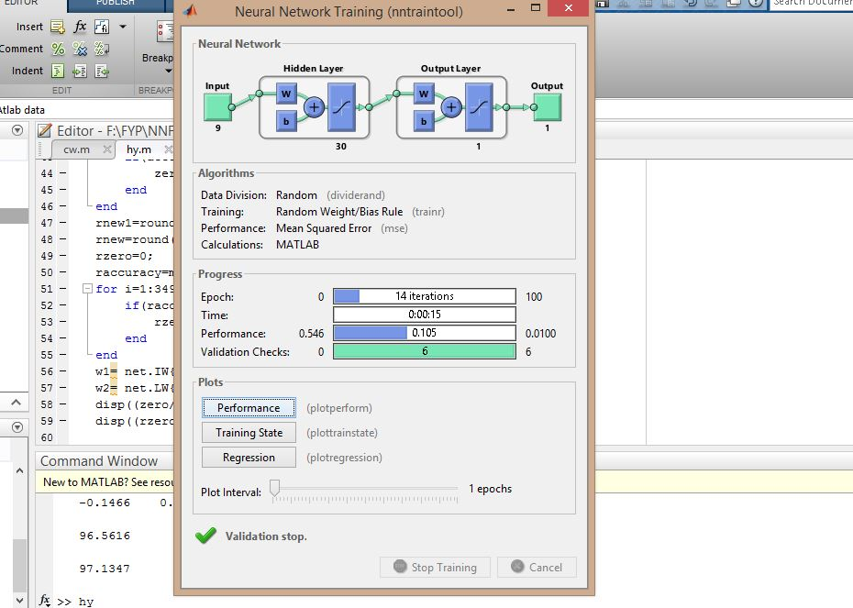

## Experiment: 2

In this experiment we set the training data greater than that of testing data:

In this case 70 % of the data was given to the training function and rest 30% was given to the testing function .In this case the accuracy was 98%.

The progress was:

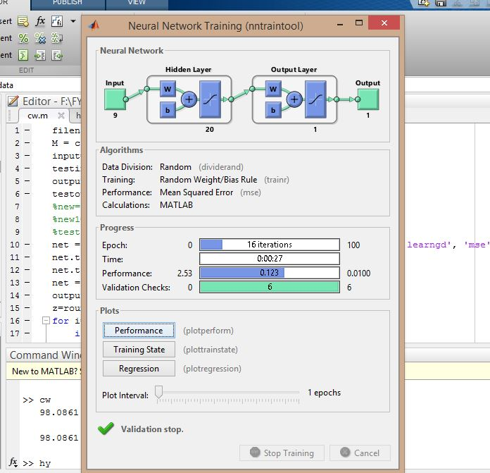

## Analysis:

On the basis of the above experiment performed the hypothesis was proved wrong as in experiment 2 ,when training data was greater than testing data, performed better than that of experiment1 . So on the basis of these experiments we formulated new hypothesis which is given below.

# Hypothesis: 2

**The more the training data will be the better performance of neural network or higher the accuracy will be.**

## Settings:

* The size of hidden layer was set to be 30.
* Epochs or number of iterations was set to 100.
* Parameter goal was set 0.01
* Weights were initialized to be random and default activation function is being used

## Experiment:

As this hypothesis was formed as a correction of previous hypothesis and all the experiments were already performed in previous hypothesis so in this we performed just one experiment that is:

* Setting the training data to 70% and testing data to 30%.

Following results were obtained:

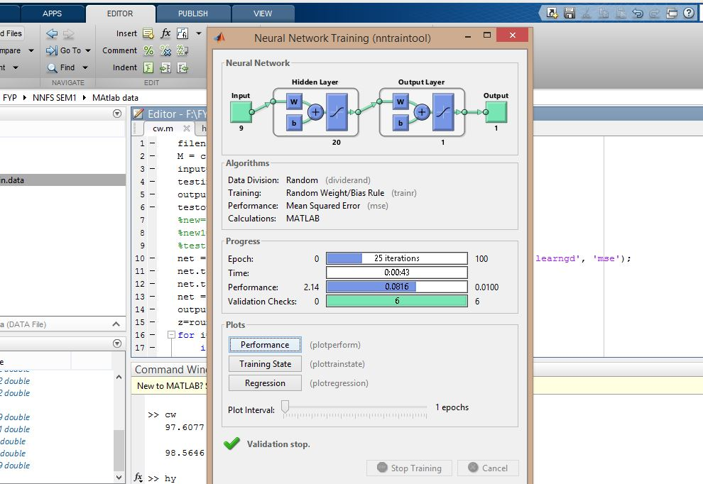

## Analysis:

We noticed that more the machine is given exposure to dataset the better it learns and eventually performs better.

# Hypothesis: 3

**The greater the size of hidden layer will be the lesser mean square error will be:**

## Settings:

* Epochs or number of iterations was set to 100.
* Parameter goal was set 0.01
* Weights were initialized to be random and default activation function is being used
* The training and testing data were set equal to each other. 50% of data was given to train function and 50% of the data was given to test function.

## Experiment 1:

* The size of hidden layer was set to be 200.

## Result:

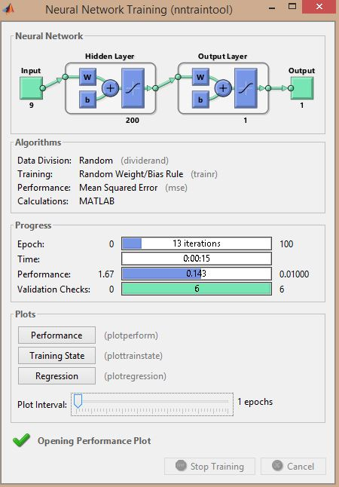

The mean square error was 0.143.

## Experiment 2:

## Settings:

* The size of hidden layer was set to be 50.

## Result:

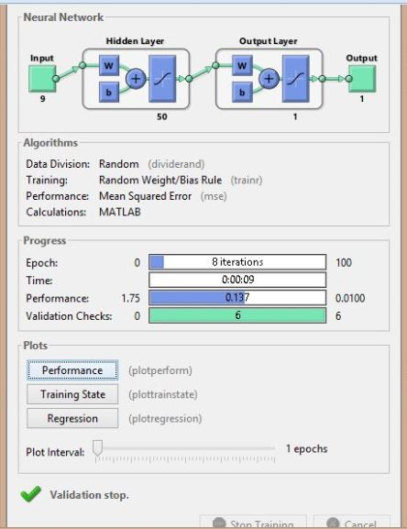

The mean square error was 0.137.

## Experiment 2:

## Settings:

* The size of hidden layer was set to be 10.

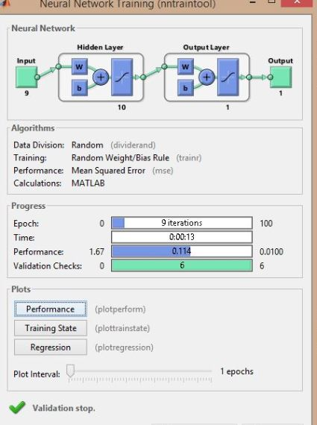

## Analysis:

As we have seen that when size of hidden layer was set to 200 the performance was 0.143. When size was set to 50 the performance was 0.137. Whereas when size was 10 the performance was 0.114. From this if we observe then it is being clear that lesser the size of hidden layer will be the better the performance will be. And through this our hypothesis was proved wrong and on the basis if that we formulated new hypothesis which is given below.

# Hypothesis: 4

**The lesser the size of hidden layer will be the lesser the mean square error will be.**

## Settings:

* The size of hidden layer was set to be 20.

## Experiment:

As this hypothesis was formed as a correction of previous hypothesis and all the experiments were already performed in previous hypothesis so in this we performed just one experiment in which the size of hidden layer was set to 20. The results were as follow:

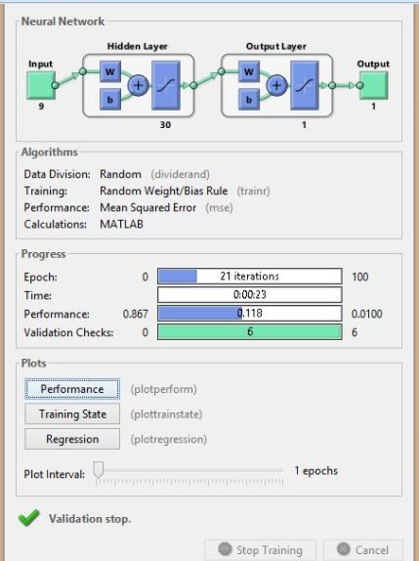

## Analysis:

On the basis of above experiments and hypothesis we can conclude that the error will be less when size of hidden layer is not very large.

# Hypothesis: 5

**Introducing a threshold improves the accuracy of result.**

## Description:

The expected output had values 2 and 4 but the network returned us the output matrix with value from 0-4. And if we calculate accuracy on these values then the accuracy was reported less as compared to accuracy obtained by introducing a threshold such that in output matrix the values greater than 2 were considered as 1 0 and values less than or equal to 2 were considered as 0 b1.

## Experiment:

In the experiment we calculated the accuracy of both that is the one without threshold and the one with threshold the experiment was performed several times and each time the accuracy of the one with threshold was greater than the one without threshold.

## Results:

**1) Without threshold**

96.5616

**With threshold**

98.5673

**2) Without threshold**

97.1347

**With threshold**

97.4212

**3) Without threshold**

96.2751

**With threshold**

97.9943

# REFERENCES:

Anon, Breast Cancer. Available at: https://medlineplus.gov/breastcancer.html [Accessed December 3, 2017].

Hayashit, Y., Sakata, M. & Gallant, S.I., 1990. Multi-Layer Versus Single-Layer Neural Networks and an Application to Reading Hand-Stamped Characters. , pp.781–782.

Tike Thein, H.T. & Mo Tun, K.M., 2015. An Approach for Breast Cancer Diagnosis Classification Using Neural Network. *Advanced Computing: An International Journal*, 6(1), pp.1–11. Available at: http://airccse.org/journal/acij/papers/6115acij01.pdf.