**(DEVELOPING PROFFESIONAL SKILLS)**

**Evaluation of an interface**

**Interface Name : Whatsapp**

**1000 word report**

**BY ZUNAIRA AHMED.**

**UOB#14031225.**

**Abstract:**

This report is an evaluation of an interface as a user. The interface is whatsapp. In this report it’s being told what whatsapp is and being a user the good aspects in whatsapp and flaws of whatsapp have been told and how these flaws can be removed.

**TABLE OF CONTENTS:**

1. Introduction…………………………………………….2
2. Good Aspects of whatsapp………………………2

2.1) Audio messages………………………………..2

2.2) Group discussions……………………………..2

2.3) Listens to users problems………………….3

3) Flaws of whatsapp…………………………………….3

3.1) No clear instructions………………………….3

3.2) Pictures deleted from gallery……………...4

4) Conclusion……………………………………………………4

5) References…………………………………………………4

**1) INTRODUCTION:**

Every person has different way of evaluating things .Users perspective of evaluating thing should be kept in mind by designers before designing anything.

By observing the users interaction with an interface we can gather the information about usability of system

A popular way to gather information about actual use of a system is to observe users

interacting with it.(Dix et al. n.d.)

Some may like one thing and others may dislike that thing so while evaluating an interface everyone has a different opinion .So do I. The interface which I have choosed to evaluate is Whatsapp. Whatsapp is a mobile app. It allows us to send SMS by using internet without any charges of SMS. Pictures, Videos and audio messages can be shared through it. Earlier it was paid service. They had a policy that it would expire every year and then it would be renewed after the user pay for it. But now they have changed the service expiration date to life time without any payment and that’s really a good change for users. It’s an application which automatically checks the contacts from our contact list of mobile and shows us all the contacts on whatsapp who have installed whatsapp. All those who have our number can check whether we have installed whatsapp or not.

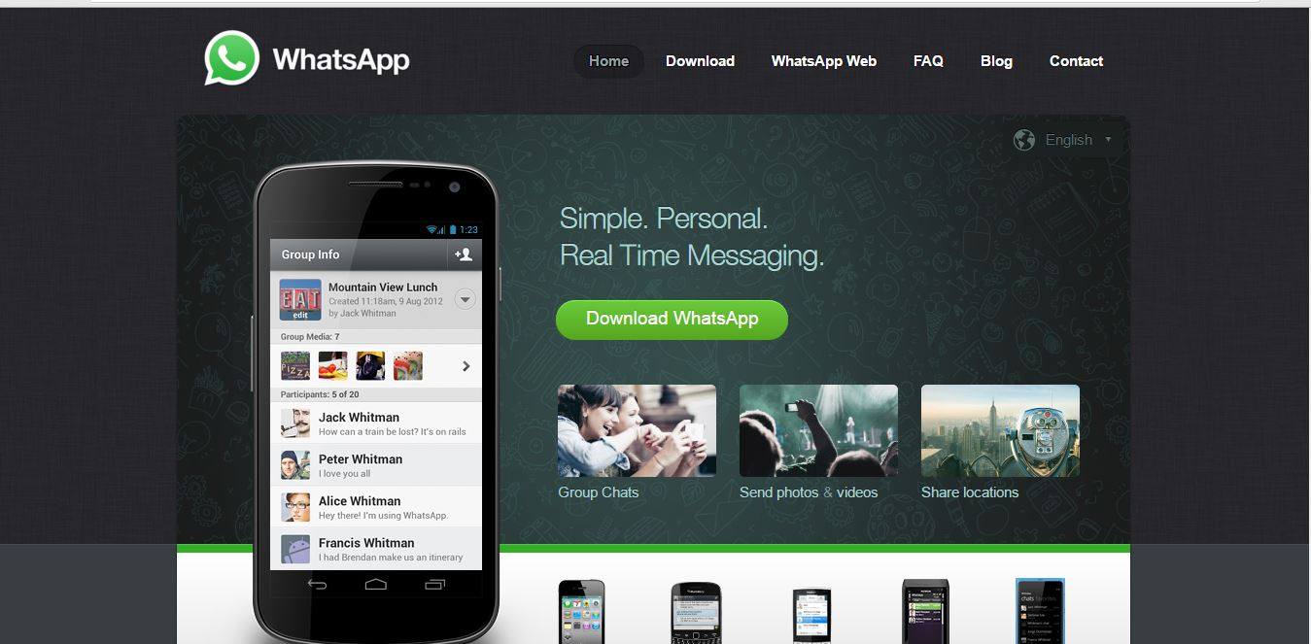

**2) Good aspects of whatsapp:**

Communication from one part of the world to another part of world is easier now and distances are no more barrier.(Choudhary et al. 2015)

The thing that I like about whatsapp is that it’s the free of cost. And we can instantly share pictures, videos and audio messages with anyone.

**2.1) Audio messages:**

As the audio messages are more effective as compared to textual messages because our tone can convey message in more effective way

We may misunderstand the meaning of message if the message is in textual form .The vocal aspect contains many information about message.(Jaimes & Sebe 2007)



**2.2) Group discussions:**

We can create groups on it and have discussion regarding anything. It’s not used for fun purpose only, many companies have created whatsapp group where they have discussion with all the employees regarding sales and all that stuff. Even teachers have set up whatsapp group for students so that student may be able to ask any question from teacher.

In educational aspect whatsapp has many benefits. The open style discussion enables the teachers to understand their students in much better way.

(Bouhnik et al. 2014)

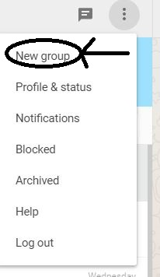

**2.3) Listens to users problems:**

Another god thing about whatsapp is that they have set up an option for contacting them where we may contact them and get solution to our problem regarding whatsapp.

Another thing is that you can delete your account on whatsapp whenever you want to delete it. The best thing about it is that although it’s a mobile app but we can use it on computer as well by scanning whatsapp code.If we are not connected to internet it saves the messages being received and later on shows us when we are connected to internet .It allows us to back up our data on Google drive so that when we change device it allows us to restore our data. We can see the last seen of people in our whatsapp until or unless they haven’t hidden that. And it shows two blue tick to tell us that whether the person on other end have read our message or not.

**3) Flaws of whatsapp:**

The best design is the one which is easy for the users to use and makes the experience enjoyable for the user.

Developing interactive products that are easy to use as well as enjoyable is the central concern.(Rogers et al. n.d.)

**3.1) No clear Instructions:**

Although it’s the efficient way to send messages but according to me it has many flaws in it. The first thing which I noticed is that it’s not user friendly. Because there are no instructions given to do anything in the beginning because the instruction are given in the FAQ and the new user don’t know how to reach the **FAQ**. The one who newly installed whatsapp don’t know how to change their Profile picture. And the option to set profile picture is located in settings and then in profile and one who is using whatsapp for the first time really find it difficult to set profile picture for the first time. And same is the case with setting whatsapp status. No clear information is being given how to set status.

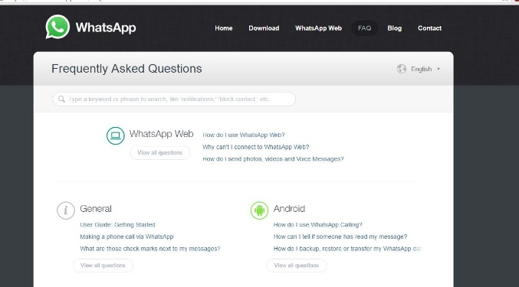

**3.2) Pictures deleted from gallery:**

Another problem which I have observed is that if the user deletes the pictures sent from others from gallery then it’s automatically deleted from whatsapp. But according to me that’s not good and if they have to do that they must inform this thing earlier to user.

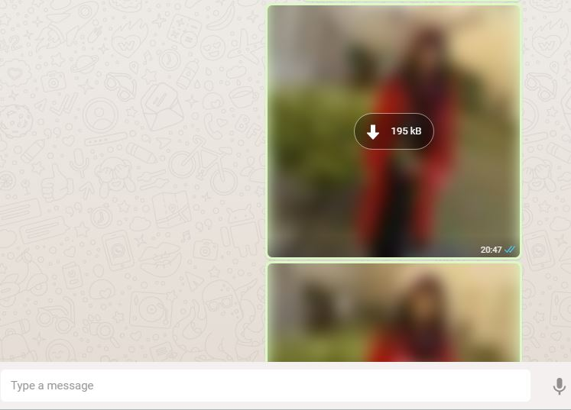

**4) Conclusion:**

The designer must consider user first priority while designing any interface. He should keep this thing in mind that whatever he is designing should be easy to use for the user. If it’s not easy then obviously user will not use it. Before designing anything in real the designer should make prototype and show it to user so that the user may tell that whether it’s meeting or fulfilling his demands or not.

**5) References:**

Bouhnik, D., Deshen, M. & Gan, R., 2014. WhatsApp Goes to School : Mobile Instant Messaging between Teachers and Students. , 13, pp.217–231.

Choudhary, S.R., Momin, M.I.H. & Kantharia, S.L., 2015. ORIGINAL ARTICLE. , 2(17), pp.2506–2511.

Dix, A. et al., INTERACTION,

Jaimes, A. & Sebe, N., 2007. Multimodal human-computer interaction: A survey. Computer Vision and Image Understanding, 108(1-2), pp.116–134.

Top of Form

ROGERS, Y., SHARP, H., & PREECE, J. (2011). Interaction design: beyond human-computer interaction. Chichester, Wiley.

Bottom of Form