INTERNEE.PK — CYBERSECURITY INTERNSHIP
Task 3: Strengthening User Authentication & Data Security
Implementation & Proof-of-Concept Report
Prepared By | Zunaira Shahzad
University | University of Education, Lahore
Internship Provider | Internee.pk — Cybersecurity Internship Program
Task | Task 3 of 3 — Strengthening User Authentication & Data Security
Date | September 1, 2026

1. Introduction
I am Zunaira Shahzad, a student at the University of Education, Lahore, currently completing a hands-on Cybersecurity Internship with Internee.pk. This report documents the third and final task of the internship, focused on strengthening user authentication and protecting sensitive data through three practical security implementations: Two-Factor Authentication (2FA), OAuth 2.0 secure sign-in, and AES-256 encryption. Each control was not only researched but actively implemented and tested using real tools, with evidence captured at every stage to demonstrate that the mechanisms work as intended.

2. Objective
The objective of this task was to strengthen user authentication and data security to protect sensitive information. This was achieved through three complementary security controls, each implemented and independently verified:
- Two-Factor Authentication (2FA) using Google Authenticator (TOTP)
- OAuth 2.0 for secure, standards-based sign-in
- AES-256 encryption to protect sensitive data at rest
Test data was sourced using Mockaroo, which generated a fake but realistic user dataset for use across the AES-256 demonstration, avoiding any exposure of real user records.

3. Two-Factor Authentication (2FA) — Google Authenticator

3.1 Concept
Google Authenticator relies on the Time-based One-Time Password (TOTP) algorithm (RFC 6238). During setup, the server and the user's authenticator app agree on a shared secret key, exchanged via a QR code. From that point onward, both sides independently compute the same 6-digit code every 30 seconds using the secret and the current time — without any further communication. This means that even if an attacker obtains a user's password, they cannot log in without also possessing the physical device running the authenticator app.

3.2 Implementation & Testing
A TOTP secret and matching QR code were generated using an RFC 6238-compliant online generator. The QR code was scanned into Google Authenticator on a physical device, and the live code was confirmed to match between the app and the generator.
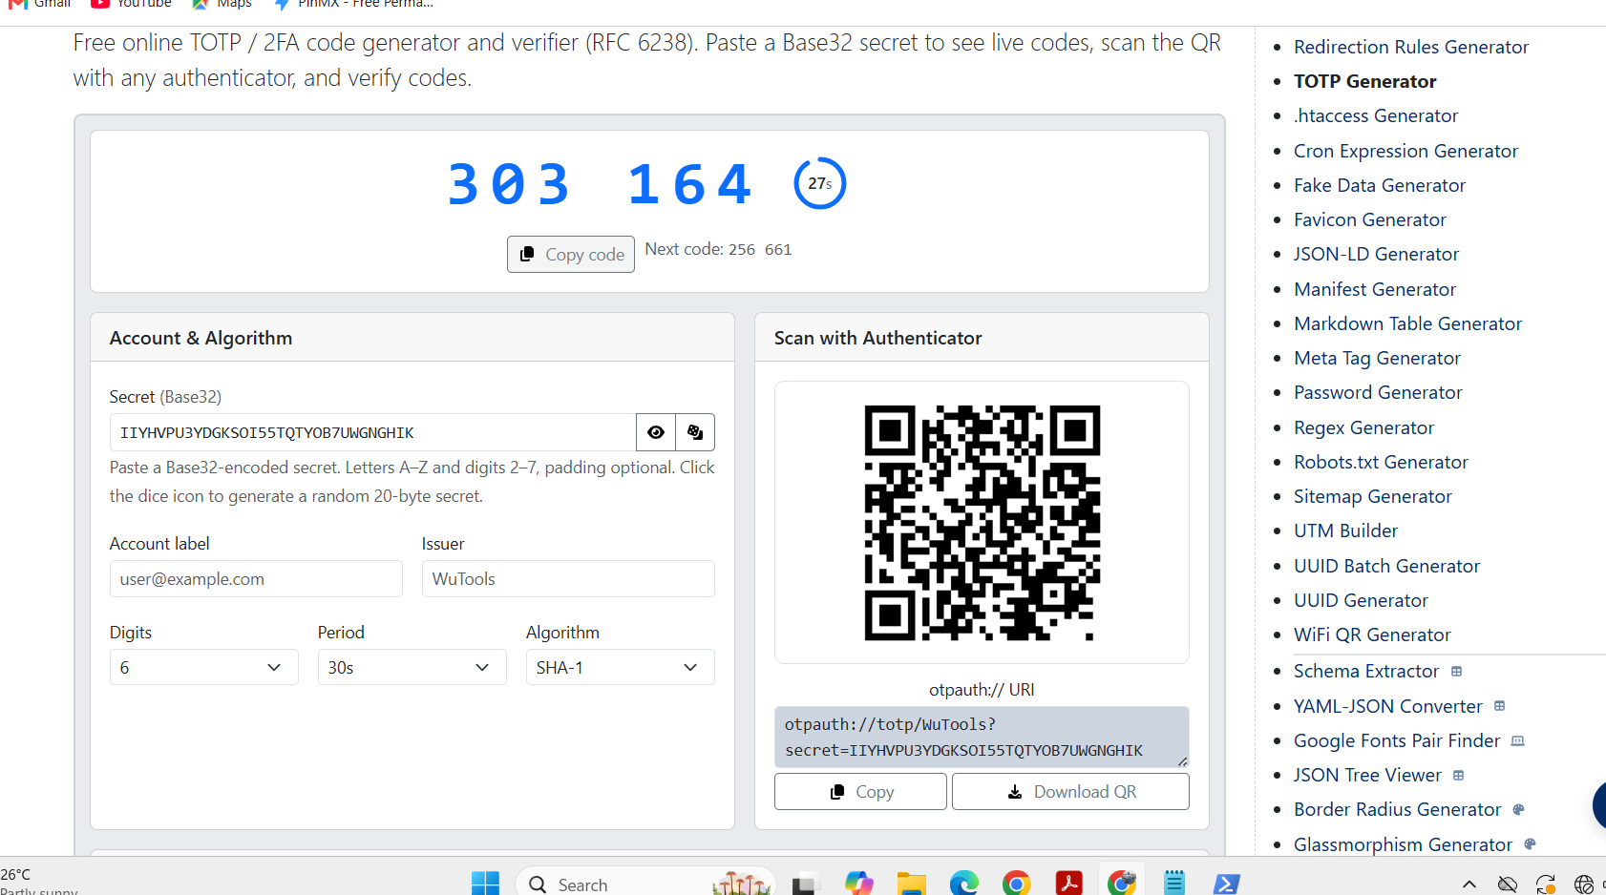
Figure 1 — TOTP secret and QR code generation, with live matching 6-digit codes.
To demonstrate the verification logic in a practical setting, a short Python script was used to gate access to a real project folder behind a live TOTP check. The script independently recomputes the expected 6-digit code from the shared secret and the current time, and compares it against the code entered by the user.
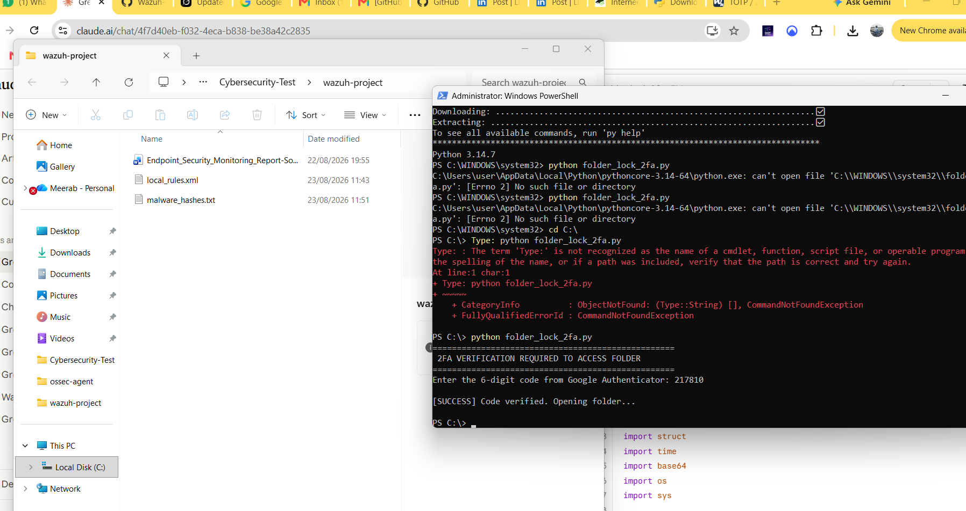
Figure 2 — Script accepts the correct live Authenticator code and opens the protected folder (wazuh-project).
Scope note
This demonstration verifies the 2FA authentication logic (the same check a server performs before granting access to an account or action). It does not itself encrypt the folder or alter Windows file permissions — a user could still open the folder directly through File Explorer without running the script. Protecting the data itself, rather than just the access gate, is handled separately by AES-256 encryption (Section 5).

4. OAuth 2.0 — Secure Sign-In

4.1 Concept
OAuth 2.0 is an authorization framework that allows a user to grant an application limited access to their account on another service, without ever sharing their password with that application. Instead of a password, the application receives a short-lived access token after the user explicitly consents to specific, limited permissions (scopes).

4.2 Implementation & Testing
The full OAuth 2.0 Authorization Code flow was carried out using Google's OAuth 2.0 Playground against a real Google account, in three stages.

Stage 1 — Authorization request
The application requested access to the userinfo.email and userinfo.profile scopes. The user was redirected to Google's consent screen, signed in, and approved the request, after which Google returned a one-time authorization code.
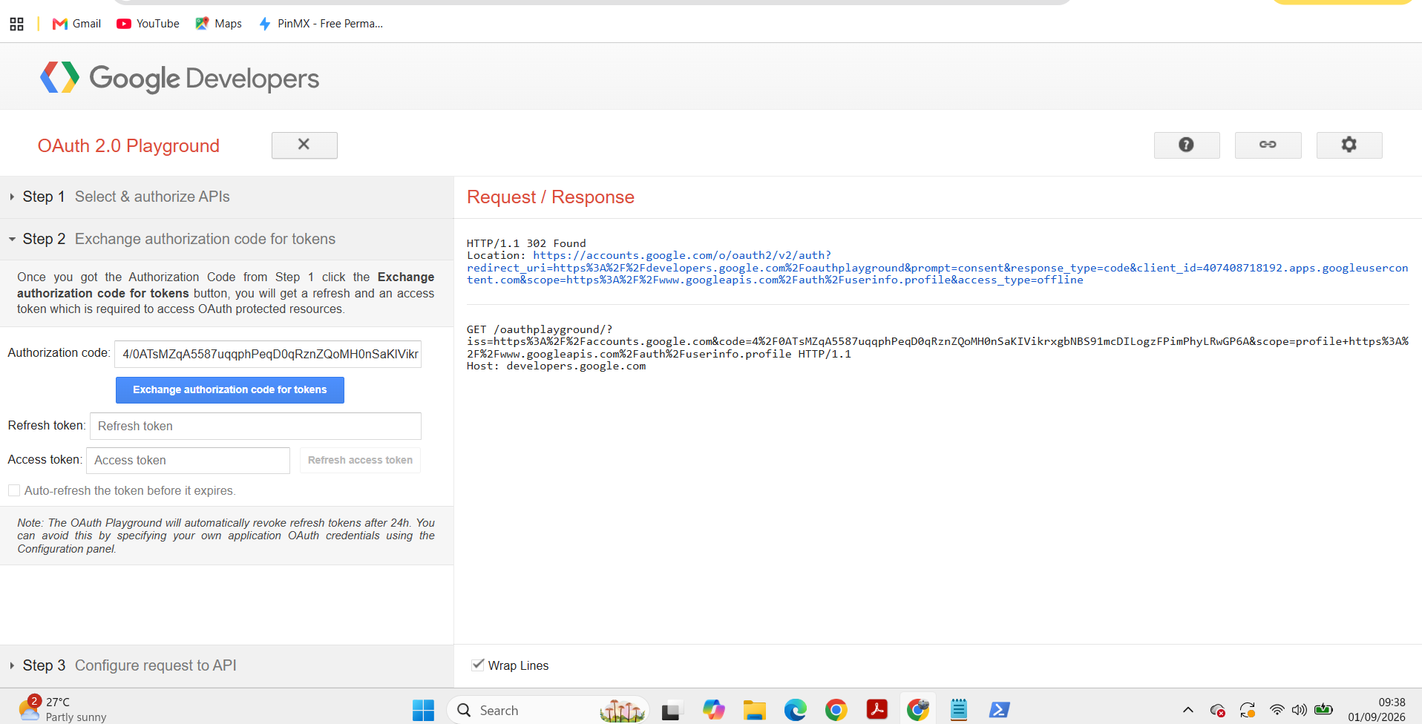
Figure 3 — Redirect to Google's authorization endpoint and receipt of the authorization code.

Stage 2 — Token exchange
The authorization code was then exchanged for a genuine access_token, refresh_token, and id_token, confirming the server-side token issuance step of the flow.
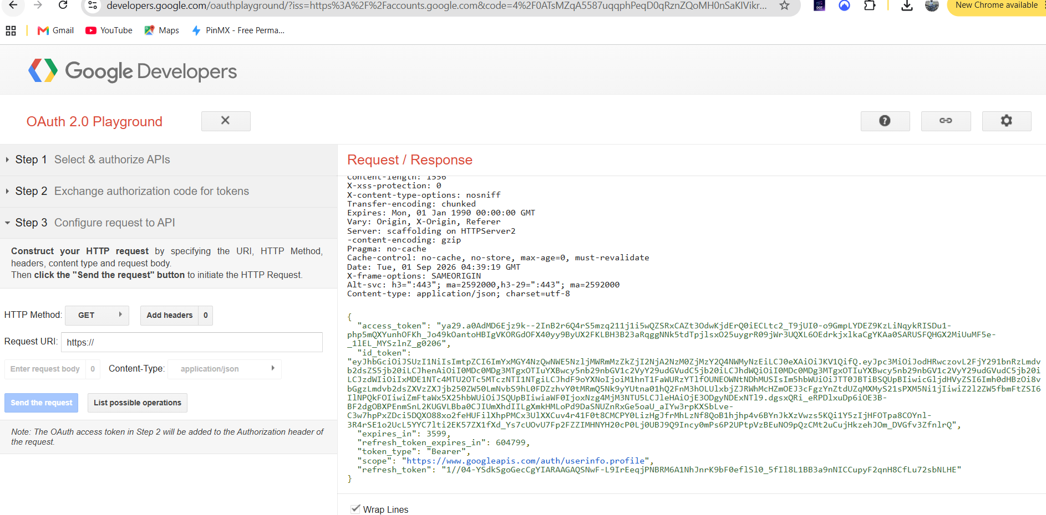
Figure 4 — Authorization code successfully exchanged for access, refresh, and ID tokens.

Stage 3 — Authenticated API request
Finally, the access token was used to call Google's userinfo API endpoint directly, without ever transmitting a password. The API returned the authenticated user's real profile data, confirming that the token was valid and correctly scoped.
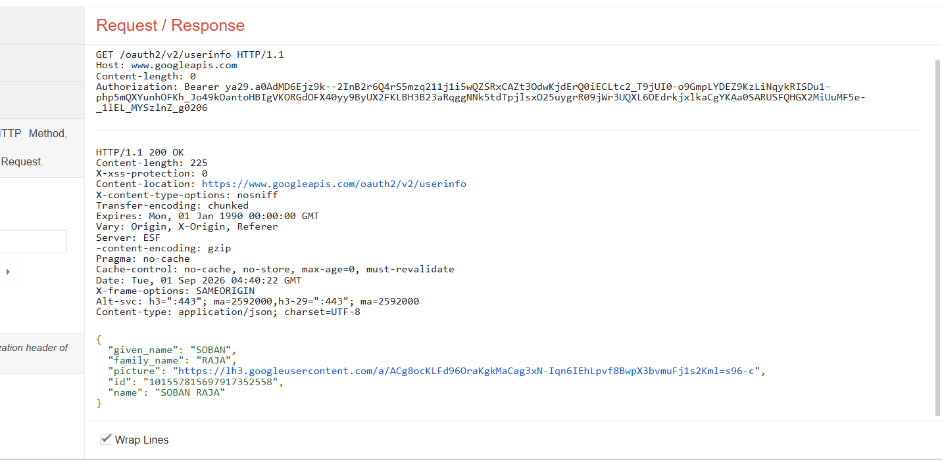
Figure 5 — Authenticated request using the access token returns the user's profile data (200 OK).

5. AES-256 Encryption

5.1 Concept
AES-256 (Advanced Encryption Standard, 256-bit key) is a symmetric encryption algorithm widely regarded as the industry standard for protecting data at rest. Unlike 2FA or OAuth 2.0, which control who is allowed to access a system, AES-256 protects the data itself — even if a file is copied or stolen, its contents remain unreadable without the correct key.

5.2 Test Data Source
A fake sensitive user dataset (names, emails, and other identifying fields) was generated using Mockaroo, avoiding the need to use any real user records from Internee.pk's staging database for this demonstration.
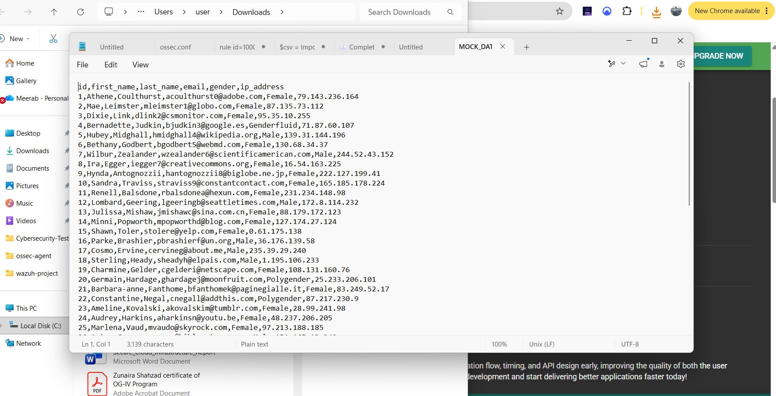
Figure 6 — Mockaroo-generated fake user dataset (MOCK_DATA.csv) used for the encryption test.

5.3 Implementation & Testing
The dataset was encrypted using 7-Zip with the 7z archive format, which applies AES-256 encryption by default, protected with a password key.
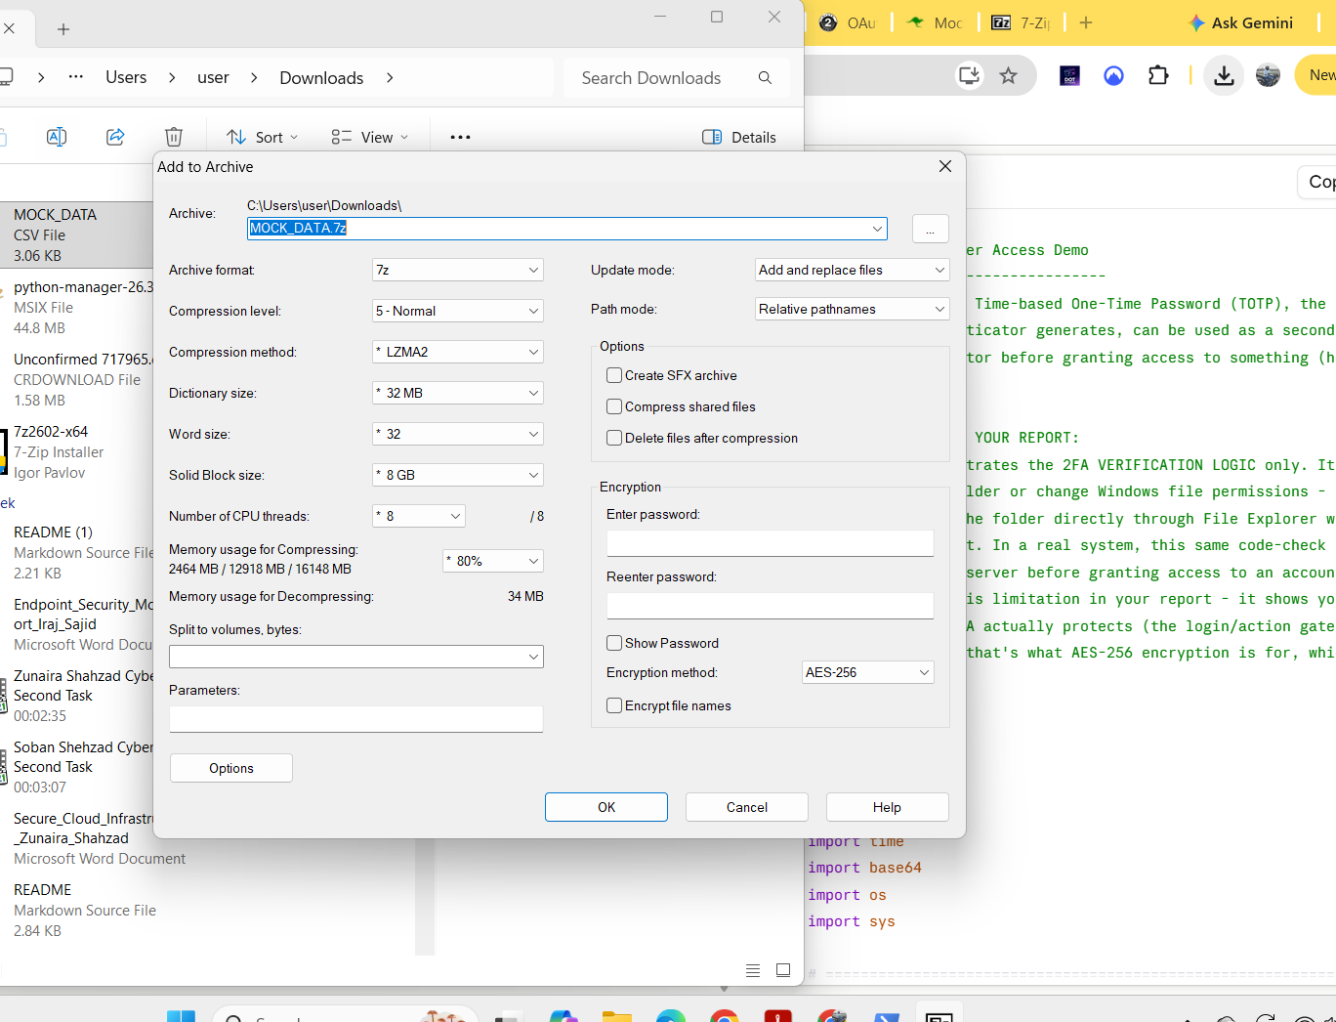
Figure 7 — 7-Zip archive settings confirming AES-256 as the encryption method.
Two access attempts were then made against the resulting encrypted archive to confirm the control works in both directions:
- Incorrect password: decryption failed with a checksum/data error, confirming the archive cannot be read without the correct key.
- Correct password: the archive opened cleanly and the original CSV data was retrievable.
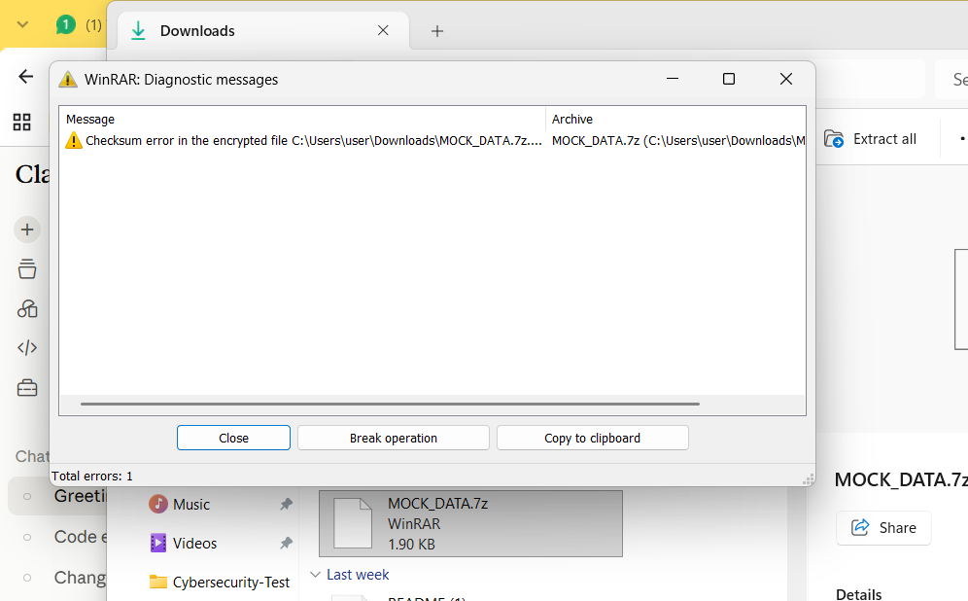
Figure 8 — Incorrect password rejected with a checksum error (access denied).
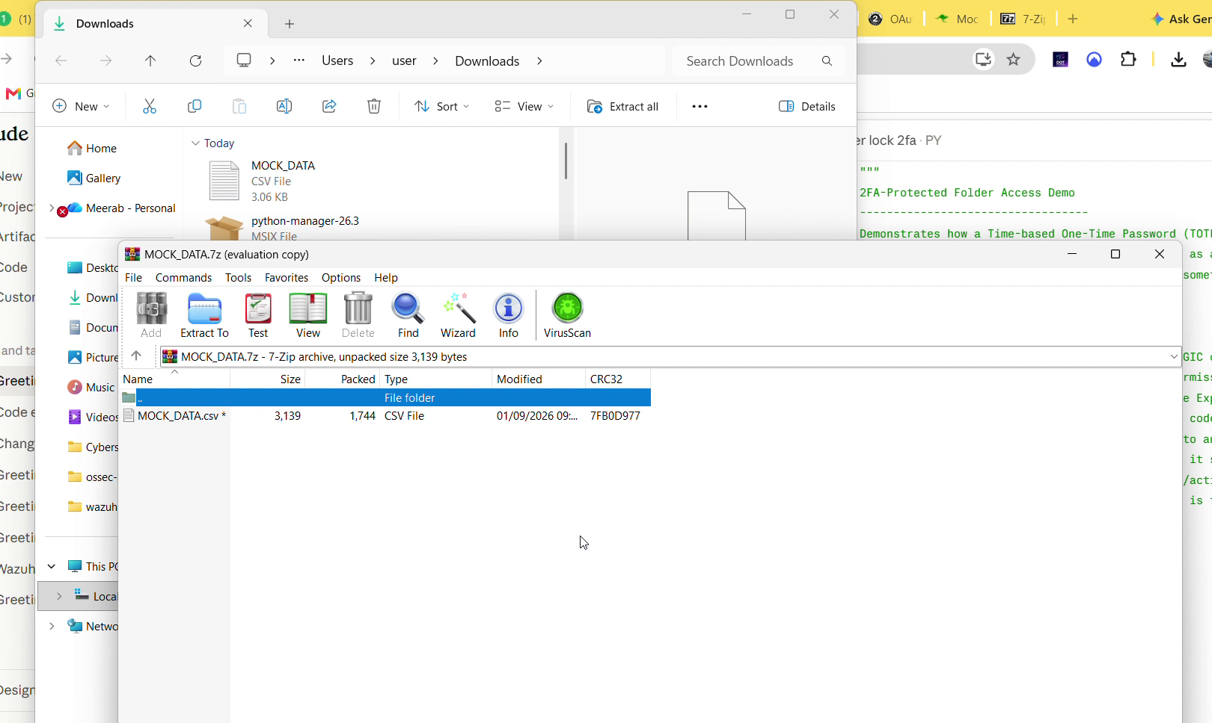
Figure 9 — Correct password accepted; archive opens and the CSV is accessible.

6. Summary
All three security controls specified in the task objective were implemented and independently verified with working, reproducible tests:
- 2FA (Google Authenticator / TOTP): live code generation, correct-code acceptance, verified against a real folder-access gate.
- OAuth 2.0: complete Authorization Code flow — authorization, token exchange, and authenticated API access — carried out against a real Google account.
- AES-256 encryption: Mockaroo-generated test data encrypted with 7-Zip; both incorrect-password rejection and correct-password access were confirmed.
Together, these controls address authentication (2FA), authorization/sign-in (OAuth 2.0), and data-at-rest protection (AES-256) — covering complementary layers of the user authentication and data security objective set out in this task.

